Integration of Neoadjuvant Chemotherapy and Interval Debulking Surgeries in Patients with Advanced Epithelial Ovarian Cancer: Our Experience.

Loaie El-Helw^{1,2}, Abeda Raiyan², Hanaa Elkhenini^{3,4}, Rajanee Bhana²

¹The department of medical oncology, Mansoura University, Egypt, ² The Royal Stoke Hospital, Stoke-on-Trent, UK, ³The department of public health, Mansoura University, Egypt, ⁴The department of E-Health, the University of Manchester, UK
loaieelhelw@hotmail.com, loaie.elhelw@uhns.nhs.uk

Abstract: Purpose: Neoadjuvant chemotherapy (NAC) and interval debulking surgery (IDS) after 3 NAC cycles is an acceptable approach to achieve optimal cytoreduction in patients with advanced epithelial ovarian cancer (AEOC) who are not candidate for primary debulking surgery (PDS). The best timing of cytoreductive surgery and the role of late debulking surgery (LDS) after 6 cycles of NAC are still unclear. We aimed to study the outcome of such patients who were treated in our centre during the last 5 years. Methods: This was a retrospective study of AEOC patients who had NAC with or without IDS/LDS in the Royal Stoke Hospital, Stoke-On-Trent between July 2009 and July 2014. Results: One hundred and eight patients with AEOC were treated under our oncology team during that period. Sixty six patients (61.1%) were in stages III and 42 (38.9%) in stage IV. All patients received NAC; 64 patients (59.3%) had paclitaxel and carboplatin regimen and 44 (40.7%) single agent carboplatin. Response to chemotherapy was assessed after 2 cycles; 81 patients (75%) had partial response, 21 (19.4%) stable disease and 6 (5.6%) progressive disease. Forty one patients (38%) proceeded to IDS after cycle 3 and 11 patients (10.2%) to LDS after cycle 6 but 56 (51.9%) had no debulking surgery (NDS). After a median follow up period of 18 months (6-84 months), 95 patients (88%) had relapsing/progressive disease. The median PFS durations were 13 and 12 months for patients who had either IDS and LDS respectively compared to 8 months for NDS. The 2 years PFS probabilities were 18% for patients who had IDS, 15% for LDS compared to 0% for NDS (P 0.000 Log rank test). The median overall survival (OS) durations were 48, 33 and 18 months for patients who had IDS, LDS and NDS respectively. The 2 years OS probabilities were 75% for patients who had either IDS, or LDS compared to 38% for NDS (P.000 Log rank test). Conclusion: In our study, we documented PFS and OS advantages for patients who IDS or LDS compared to NDS and therefore should be considered whenever possible as part of the primary treatment of AEOC patients. Interval debulking surgery (IDS) offers longer duration and higher probabilities of PFS and OS compared to LDS. More patients-therefore- should be selected for IDS. There is a need for improving NAC possibly with integrating target agents and the use of more intensified schedules. ICON8B trial is currently addressing that.
[Loaie El-Helw, Abeda Raiyan, Hanaa Elkhenini, Rajanee Bhana. Integration of Neoadjuvant Chemotherapy and Interval Debulking Surgeries in Patients with Advanced Epithelial Ovarian Cancer: Our Experience. Cancer Biology 2016;6(4):41-47]. ISSN: 2150-1041 (print); ISSN: 2150-105X (online). http://www.cancerbio.net. 6. doi:10.7537/marscbj060416.06.

Key words: advanced ovarian cancer-neoadjuvant chemotherapy-surgical debulking

- Introduction
Approximately 70% to 80% of the ovarian cancer patients are in stage III or IV when first diagnosed. The current standard treatment for epithelial ovarian cancer (EOC) consists of primary debulking surgery (PDS) followed by paclitaxel and platinum chemotherapy. Optimal cytoreduction-in those patients-to no macroscopic residual disease is difficult to achieve with reported rate of less than 25% despite maximal efforts [1]. Also, most patients diagnosed with advanced epithelial ovarian cancer (AEOC) are elderly, with multiple comorbidities, and poor performance status. Therefore aggressive surgery is significantly limited in these patients.
Neoadjuvant chemotherapy (NAC) is associated with 70-80% response rate in AEOC and can result in adequate tumour shrinkage. Therefore, NAC followed by interval debulking surgery (IDS) has been considered as an alternative to conventional PDS in treating AEOC [2, 3]. The timing of IDS is usually after 2-4 cycles of chemotherapy. The value of late debulking surgery (LDS) after 6 cycles is not clear as there is a chance of emergence of more chemotherapy resistant tumour clones. Therefore, in our study we reviewed the management of our patients who presented with AEOC and were not candidate for PDS. We studied their outcome in relation to timing of debulking surgeries.

- Patients and Methods
This was a retrospective study of patients with advanced ovarian cancer who had NAC with or without IDS/LDS treated in our centre in the Royal Stoke Hospital, UK since July 2009 till July 2014. Electronic patients and gynaecology multidisciplinary (GMDT) meetings records were reviewed. Data analysis was performed using SPSS statistical package version 16. Overall survival (OS) and progression-free survival (PFS) probabilities were analysed using the Kaplan-Meier method. The log-rank test and Cox-regression multivariate analysis were used to investigate the differences in survival between the study groups. P < 0.05 was considered statistically significant.

- Results
Table 1 describes the demographic features of the patients in the study. One hundred and eight patients with AEOC who were not candidate for PDS were included. The median age was 71 years old (range 37-86). Sixty six patients (61.1%) presented in clinical stage (CS) III and 42 (38.9%) CS IV. Serous papillary adenocarcinoma was the most common histologic subtype (92.6%). Eight patients (7.4%) presented with primary peritoneal carcinomatosis (PPC) but the majority (92.6%) had advanced ovarian cancer presenting with adnexal masses and wide spread diseases.

Table (1) Demographic Data of the 108 Studied Patients
Variables |  | Number | Percent
 |  | 108 | 100
Clinical stage | III | 66 | 61.1
 | IV | 42 | 38.9
Grade | Grade 3 | 105 | 97.2
 | Missing data | 3 | 2.8
Histology | Serous | 100 | 92.6
 | Clear cells | 3 | 2.8
 | Carcinosarcoma | 2 | 1.9
 | Endometriod | 1 | 0.9
 | mucinous | 1 | 0.9
 | Undetermined subtypes | 1 | 0.9
Clinical subtypes | EOC | 100 | 92.6
 | PPC | 8 | 7.4
GMDT plan | NAC/IDS | 104 | 96.3
 | Palliative Chemotherapy | 4 | 3.7
NAC | Paclitaxel and carboplatin | 64 | 59.3
 | Carboplatin | 44 | 40.7
EOC: epithelial ovarian cancer, PPC: primary peritoneal carcinoma, val debulking surgery. GMDT: gynaecology multidisciplinary meeting.

All our patients were discussed in the GMDT meetings on initial presentations where their management plans were decided. One hundred and four (96%) patients were considered for NAC/IDS and 4 patients (3.7%) were to have palliative chemotherapy only due to poor performance status (PS). All patients were reviewed once again after 2 cycles of chemotherapy for possibility of IDS. Paclitaxel and carboplatin regimen was the most commonly used NAC (59.3%) and single agent carboplatin was used in the rest of patients (40.7%).
Response to chemotherapy was assessed after 2 cycles of chemotherapy and patients were re-discussed in the GMDT meetings. Eight one patients (75%) had partial response (PR) to chemotherapy, 21 (19.4%) stable disease (SD) and 6 (5.6%) progressive disease (PD) (table 2). Forty one patients (38%) proceeded to have IDS after 3 cycles and 11 (10.2%) had LDS. Overall 52 patients (48.2%) had IDS/LDS. More patients with clinical stage III proceeded to have debulking surgeries than CS IV (59.1% versus 30.9%). Complete surgical cytoreduction was achieved in 46 patients (88.5%) but 6 patients (11.5%) had suboptimal debulking with residual macroscopic disease. Maximal cytoreduction was achieved in all of the 11 patients (100%) who had LDS and in 35 patients of the 41 who had IDS (85.4%) (table 2).
After a median follow up period of 12 months (range 6-40), 95 patients (88%) had relapsing/progressive disease and had a median of 2 (range 1-4) further lines of systemic anticancer treatment (SACT). Thirty seven out of 41 patients (90.2%) who had IDS and 6 out 11 patients (54.5%) who had LDS, have eventually relapsed. Most patients (92.9%) who did not have any debulking surgery had PD. Only 4 patients (4.2%) had single area of relapse and one of them underwent further surgical resection followed by chemotherapy. Forty out of 43 patients (93%) with IDS/LDS had platinum free interval (PFI) of ≥ 6 months compared to only 63.5% for patients with no debulking surgery (P 0.001 Fischer Exact test) (Table 3).
The median progression free survival duration (PFS) for all patients was 11 months (range 10-12 months) and 2 years PFS probability was 10% (Figure 1). The median PFS was 13 months (range 9-16) for patients who had IDS and 12 months (range 10-13) for patients who had LDS compared to 8 months (range 6-9) for NDS (P 0.000 by Log RankTest) (figure 2).
The median PFS durations were 13, 10 and 8 months for patients who had complete, incomplete cytoreduction or no debulking respectively (P 0.000 Log Rank Test) although the difference in median PFS for complete and incomplete cytoreduction was statistically insignificant (p 0.201). None was statistically significant in Cox-regression analysis.
The median overall survival duration for all patients was 27 months (range 5-54 months) and (the 2 years OS probability was 52% (figure 3). The median OS durations in relation to timing of debulking surgery is shown in Figure 4. They were 48, 33 and 18 months for IDS, LDS and NDS respectively (P 0.442 Log Rank Test) (Figure 4).

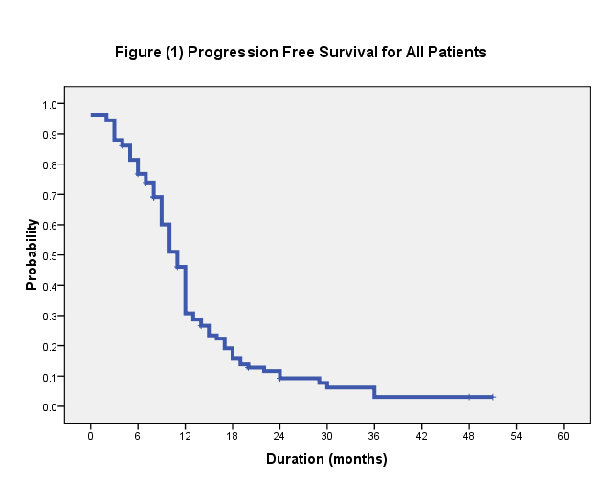
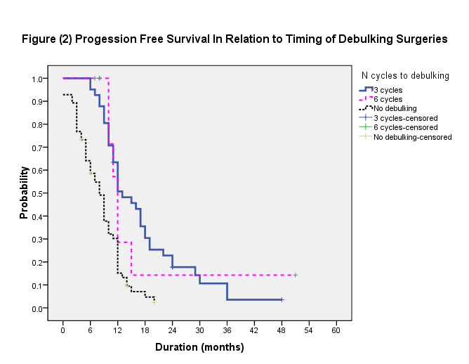

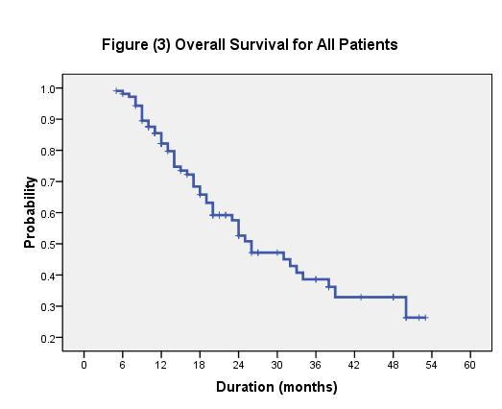

The 2-years survival probability was 75% for patients who had either IDS or LDS compared to 38% for no debulking. All patients with suboptimal debulking are still surviving at a median of 11 months follow up (range 9-12 months).
Patients who had platinum free interval (PFI) of > 12 months have the highest survival probability compared to PFI of 6-12 months, < 6 months and refractory patients. Median durations of OS were (38, 24, 21 and 12 months respectively) (P. 022). In Cox-regression multivariate analysis, none of these variables was statistically significant.

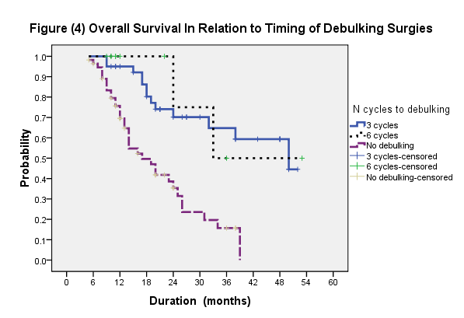

Table (2) Response and Outcome
Variables |  | Number | Percent
Response after 2 cycles | PR | 81 | 75
(108 patients) | SD | 21 | 19.4
 | PD | 6 | 5.6
Number of cycles to debulking | 3 Cycles (IDS) | 41 | 38
(108 patients) | 6 cycles (LDS) | 11 | 10.2
 | No debulking | 56 | 51.8
*Debulking in relation to stage
Clinical Stage III (66 patients) | IDS (after 3 cycles NAC) | 32 | 48.5
 | LDS (after 6 cycles NAC) | 7 | 10.6
 | No debulking | 27 | 40.9
Clinical Stage IV (42 patients) | IDS (after 3 cycles NAC) | 9 | 21.4
 | LDS (after 6 cycles NAC) | 4 | 9.5
 | No debulking | 29 | 69
Surgical Cytoreduction (52 patients) | Complete | 46 | 88.5
 | Incomplete (residual disease) | 6 | 11.5
**Degree of cytoreduction in relation of timing of debulking
IDS (41 patients) | Complete | 35 | 85.4
 | Incomplete | 6 | 14.6
LDS (11 patients) | Complete | 11 | 100
 | Incomplete | 0 | 0
NAC: neoadjuvant chemotherapy, IDS: interval debulking surgery (after 3 cycles), PR: partial response, SD: stable disease, PD: progressive disease. LDS: late debulking surgery (after 6 cycles). * P value= 0.003 (Chi-square), ** P value= 0.000 (Chi-square).

Table (3) Relapse Data among the Studied Patients
Variables |  | Number | Percent
Relapse/progression (108 patients) | Yes | 95 | 88
 | No | 13 | 12
*Relapse in relation to IDS/LDS
IDS (41 patients) | Yes | 37 | 90.2
 | No | 4 | 9.8
LDS (11 patients) | Yes | 6 | 54.5
 | No | 5 | 45.5
No debulking (56 patients) | Yes | 52 | 92.9
 | No | 4 | 7.1
Relapse in relation to degree of cytoreduction
Complete (46 patients) | Yes | 38 | 82.6
 | No | 8 | 17.4
Incomplete (6) | Yes | 5 | 83.3
 | No | 1 | 16.7
Pattern of relapse (95 patients) | Isolated site | 4 | 4.2
 | Multiple areas | 91 | 95.6
Platinum Free Interval (108 patients)
 | Refractory | 4 | 3.7
 | < 6 months | 18 | 16.7
 | 6-12 months | 50 | 46.3
 | >12 months | 36 | 33.3
**Platinum Free Interval
IDS/LDS (43 relapsed patients) | <6 months/refractory | 3 | 7
 | 6-12 months | 18 | 41.8
 | >12 months | 22 | 51.2
No debulking (52 relapsed patients) | <6 months/refractory | 19 | 36.5
 | 6-12 months | 25 | 48.1
 | >12 months | 8 | 15.4
IDS: interval debulking surgery, LDS: late debulking surgery, SACT: systemic anticancer treatment. * P.005 (Fisher Exact test), ** P.001 (Fisher Exact test).

- Discussion
Neoadjuvant chemotherapy and interval debulking surgery (NAC/IDS) is an acceptable approach to achieve optimal cytoreduction in patients with advanced epithelial ovarian cancer who are not candidate for primary debulking surgery [4-6]. The best timing to perform cytoreductive surgery after NAC is still unclear. In a meta-analysis by Bristow and Chi, it was found that increasing the number of chemotherapy cycles prior to the debulking surgery had a negative survival effect. Thus, a definitive operative intervention should be undertaken early in the treatment program as possible [7].
That concept was also reported by Colombo and colleagues who found that patients with AEOC receiving complete IDS after more than 4 cycles of NAC have poor prognosis [8]. However, another meta-analysis did not show that increasing the number of NAC cycles adversely affected OS [3].
In our study, 108 patients with stage III and IV AEOC were not candidate for primary debulking surgery (PDS) and therefore were offered NAC and consideration of IDS. All patients were re-discussed in our GMDT meetings following 2 cycles of NAC with radiological and biochemical assessment for evaluation of responses and eligibility for IDS. Accordingly 41 patients (38%) had adequate response and proceeded to IDS after 3 NAC cycles. Fifty six patients (51.9%) were not candidate -for debulking surgeries for wide spread disease distribution and/or inadequate response to NAC. The rest of our patients (11 patients; 10.2%) showed slow response to NAC based on radiological or laparoscopic assessment and therefore complete cytoreduction was considered non-achievable at that stage. They have been further reassessed following cycle 5 of NAC and proceeded to LDS. Overall, higher PFS was achieved for patients who had IDS or LDS compared to no debulking (13, 12 and 8 months respectively).
The median survival durations were 48, 33, 18 months for IDS, LDS or NDS respectively. The 2 years OS probabilities were 75% for IDS or LDS patients compared to 38% for patients who had NDS. These findings emphasize the importance of debulking surgeries whether IDS or LDS as they are associated with better PFS and OS compared with no debulking.
The definition of ‘optimal cytoreduction’ has moved from its former meaning of a cytoreduction to ≤ 1 cm of residual disease to no residual disease [9, 10]. Tumour resection with > 1 cm of residual disease (15-30% of patients) places these patients at risk of morbidities of the cytoreductive attempt without survival benefit [11]. In agreement with that, our patients who had optimal debulking surgeries, had significantly longer median PFS compared to patients who had suboptimal debulking surgeries or no debulking at all (13, 10 and 8 months respectively). Patients, who had IDS/LDS, had higher chance of having platinum sensitive disease (93%) compared to NDS patients (63.5%) on relapse. As expected the median OS was higher for patients with platinum sensitive relapse compared to platinum resistant or platinum refractory patients (median OS durations of 38, 24, 21 and 12 months respectively).
On conclusion, IDS and LDS offer better PFS and OS for patients with AEOC than NDS. Interval debulking surgery (IDS) offers longer duration and higher probabilities of PFS and OS compared to LDS. Debulking surgeries in patients with AEOC increase the percentage of patients who have platinum free interval of ≥ 6 months and therefore have more chances to respond to further platinum regimens. More patients-therefore- should be selected for IDS/LDS. There is a need for improving NAC possibly with integrating target agents and the use of more intensified schedules. The ongoing ICON8B trial [12] is currently addressing that in a randomised (1:1:1 ratio), three-arm, phase III study designed to evaluate the safety and efficacy of bevacizumab in combination with dose-dense, dose-fractionated carboplatin-paclitaxel chemotherapy compared to either strategy alone for the first-line treatment of ovarian cancer.

Corresponding Author:
Dr Loaie M El-Helw
Address: The Royal Stoke Hospital, Stoke-On-Trent, ST4 6QG, UK.
E-mail,: loaieelhelw@hotmail.com,
loaie.elhelw@uhns.nhs.uk.
Egyptian University Affiliation: Internal Medicine department, Medical Oncology Unit, Mansoura University, Egypt.

References
- Gallo A., and Frigerio L.: Neoadjuvant chemotherapy and surgical considerations in ovarian cancer. Curr. Opin. Obstet. Gynecol., 15(1): 25-31, 2003.
- Morice P., Dubernard G., Rey A., et al.: Results of interval debulking surgery compared with primary debulking surgery in advanced stage ovarian cancer. J. Am. Coll. Surg., 197 (6):955-63, 2003.
- Kang S., and Nam BH.: Does neoadjuvant chemotherapy increase optimal cytoreduction rate in advanced ovarian cancer? Meta-analysis of 21 studies. Ann. Surg. Oncol., 16 (8): 2315-20, 2009.
- Zheng H., and Gao Y.: Primary debulking surgery or neoadjuvant chemotherapy followed by interval debulking surgery for patients with advanced ovarian cancer. Chin, J. Cancer Res., 24(4): 304-309, 2012.
- Keyver-P., Zivanovic O., and Rudlowski C.: Interval debulking surgery in patients with Federation of Gynecology and Obstetrics (FIGO) stage IIIC and IV ovarian cancer. Onkologie., 36(6):324-32, 2013.
- Markauskas A., Mogensen O., dePont Christensen R. et al.: primary surgery or interval debulking for advanced epithelial ovarian cancer: does it matter. Int. J. Gynecol. Cancer., 24 (8): 1420-8, 2014.
- Bristow RE. and Chi DS.: Platinum-based neoadjuvant chemotherapy and interval surgical cytoreduction for advanced ovarian cancer: a meta-analysis. Gynecol. Oncol., 103 (3):1070-6), 2006.
- Colombo PE., Labaki M., Fabbro M., et al.: Impact of neoadjuvant chemotherapy cycles prior to interval surgery in patients with advanced epithelial ovarian cancer Gynecol. Oncol. S0090-8258(14)01305-5, 2014.
- Thigpen T., duBois A., McAlpine J., et al.: First-line therapy in ovarian cancer trials. Int. J. Gynecol. Cancer, 21(4):756-62, 2011.
- Vergote I., Tropé C. and Amant F.: Neoadjuvant chemotherapy or primary surgery in stage IIIC or IV ovarian cancer. N. Engl. J. Med., 363(10): 943-53, 2010.
- Chang S. and Bristow R.: Evolution of surgical treatment paradigms for advanced-stage ovarian cancer: redefining 'optimal' residual disease. Gynecol. Oncol., 125(2):483-92), 2012.
- ICON8 Overview and Protocol: www.ICON8trial.org/about_ICON8B/Overiw_and_protocol.

12/23/2016

