Post-renal transplantation lymphoproliferative disorders: a retrospective review of two cases

Najla Moqadum, SamiaSobki, Najla Besharah, Amira Shaker

Department of Central Military Laboratory and Blood Bank, Prince Sultan Military Medical City, Riyadh, Saudi Arabia. Najlatm2011@hotmail.com

Abstract: Background: Post-transplant lymphoproliferative disorders (PTLD) encompass a heterogeneous spectrum of conditions ranging from reactive plasmacytic hyperplasia to malignant lymphoma. Many PTLD cases are a result of infection with Epstein–Barr virus (EBV). EBV is frequently detected in PTLD cells, and PTLD risk is highest among children and recipients who are EBV seronegative at the time of transplantation. PTLD is identified by having a high index of suspicion in the appropriate clinical setting. The diagnosis is made by histopathological evidence of lymphoproliferation, commonly with the presence of EBV DNA, RNA, or protein detected in tissue. Diagnosis of PTLD is not always straightforward. Despite of improvements with new tolerable therapies, survival of PTLD patients remains inferior, necessitating further international cooperation to improving long-term outcome of PTLD patients. We report here 2 cases of monomorphic B-cell PTLD (multiple myeloma and burkitt lymphoma) after successful renal transplantation. We compare clinicopathological features of these 2 cases with few cases reported in literature.
[Najla Moqadum, Samia Sobki, Najla Besharah, Amira Shaker. Post-renal transplantation lymphoproliferative disorders: a retrospective review of two cases. Cancer Biology 2016;6(4):28-31]. ISSN: 2150-1041 (print); ISSN: 2150-105X (online). http://www.cancerbio.net. 4. doi:10.7537/marscbj060416.04.

Keywords: Renal transplant, PTLD, Multiple myeloma, Burkitt lymphoma

Introduction:
Post-transplant lymphoproliferative disorders (PTLD) are a group of conditions that involve uncontrolled proliferation of lymphoid cells as a consequence of extrinsic immunosuppression after organ or hematopoietic stem cell transplant. PTLD encompass a heterogeneous spectrum of conditions ranging from reactive plasmacytic hyperplasia to malignant lymphoma.[1]
The incidence varies according to the transplanted organ, The overall incidence of PTLD is about 1.5% in all solid organ transplant recipients. PTLD are mostly B-cell neoplasm’s that develop as a consequence of immunosuppressive therapy [1, 2]. Many PTLD cases are a result of infection with Epstein-Barr virus (EBV). [3]a ubiquitous virus, which in the absence of host immune control causes lymphocyte proliferation. EBV is frequently detected in PTLD cells, and PTLD risk is highest among children and recipients who are EBV seronegative at the time of transplantation [4, 5].
PTLD is identified by having a high index of suspicion in the appropriate clinical setting. The diagnosis is made by histopathological evidence of lymphoproliferation, commonly with the presence of EBV DNA, RNA, or protein detected in tissue. The 2008 World Health Organization (WHO) classification system recognizes 4 major histopathologic subtypes of PTLD: (1) early hyperplastic lesions, (2) polymorphic lesions, (3) monomorphic lesions, and (4) classic Hodgkin-type lymphomas [4, 6]. PTLD presents by localized or disseminated disease, often aggressive and rapidly progressive. The patient usually presented by nonspecific symptoms or systemic signs such as fever, unexplained weight loss, fatigue, lymphadenopathy, or hepatosplenomegaly [7,8].
Case 1
This is a 37-year-old lady, has renal impairment treated with renal transplant in June 2006. Unfortunately, her transplant failed in November 2010 and she required restart of hemodialysis. Since that time she has been kept on regular hemodialysis. September 2014, her condition deteriorated and patient had a blood work up, which showed high total protein (94 G/L), Bence Jones proteinaemia, Serum electrophoresis and immunofixation revealed Ig M lambda monoclonal paraprotein (3.54 g/dL).
She had x-ray of her skull, which showed multiple lytic lesions. Her serum calcium was found to be high. She had a bone marrow examination (figure1) which confirmed the diagnosis of plasma cell myeloma and subsequently she had pleural fluid aspirate and liver biopsy, which both of them confirmed the involvement by plasma cell myeloma (figure 2). Patient attended the hematology department for treatment of her myeloma, unfortunately, her condition deteriorated shortly after that mainly due to her massive pleural effusion, which requires respiratory support and admission to ICU. During her stay in the ICU, she was treated with velcade and dexamethasone, but her condition continued to deteriorate despite all measures of support. She died after 2 weeks of admission to ICU.

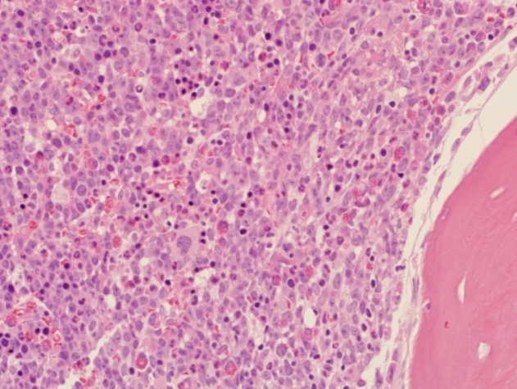
Figure 1A: The bone marrow trephine biopsy is heavily infiltrated by medium to large malignant cells.

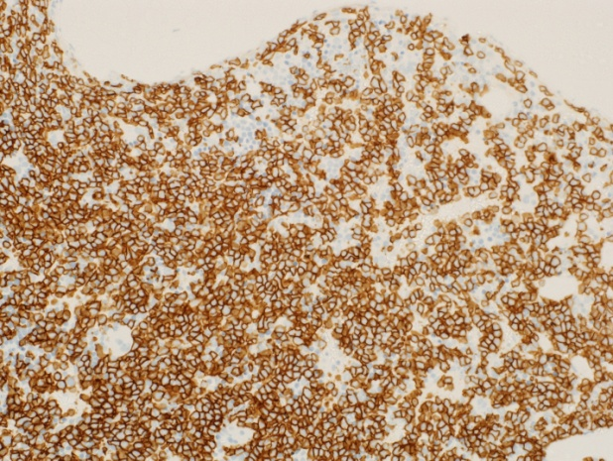
Figure 1B: The malignant cells are stained positive by CD138

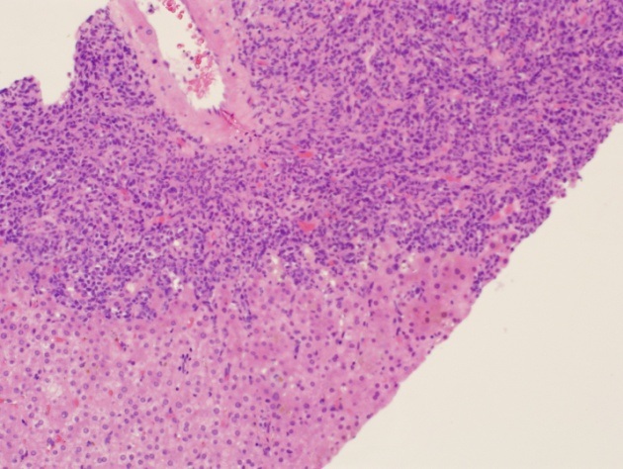
Figure 2 A: Liver biopsy shows infiltration by malignant cells

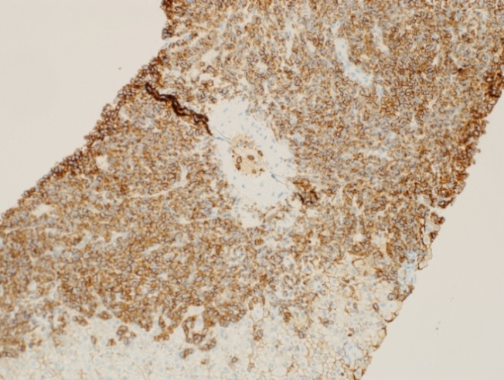
Figure 2B: The malignant cells stain positive by immunohistochemistry to CD138

Case 2
In March 2007, a 45-year-old male with chronic renal failure secondary to diffuse glomerulosclerosis received a renal transplant. In May 2011, he complained weight loss, generalized fatigue and bony pain. He was admitted for investigation His laboratory investigation findings were within normal values. FDG PET/CT scan showed multiple enlarged highly metabolically active bilateral cervical, mediastinal, axillary, abdominal and pelvic lymph nodes associated with metabolically active right lung nodule, multiple peritoneal, omental and subcutaneous nodules mostly representing active wide spread lymphometous lesions (figure 3). Biopsy from cervical lymph node reported as monomorphic PTLD, B-cell phenotype, burkitt-likelymphoma (figure 4).

Discussion:
The current knowledge on all aspects of PTLD is limited due to its rarity, morphologic heterogeneity, and the lack of prospective trials. immune suppression and Epstein-Barr virus (EBV) primary infection/reactivation are key factors in the pathogenesis [9]. The WHO classification categorize PTLD to 4 categories, however, the diagnosis usually is difficult. Diagnostic challenges due to manyreasons as PTLD comprises a wide spectrum of lymphoid and plasmacytic proliferations similar to associated with infection, graft rejection, and graft-versus-host disease. In addition to the exact classification will not always be possible because of overlap between several categories or because PTLDs can present as different morphologic subtypes within different locations in the body or even within a single biopsy sample [9, 10]. In our study, Diagnosisof PTLD is not always straight forward, diagnostic challenges include cases with HL-like polymorphic PTLD subtype is among the most difficult to diagnose because there is a clear overlap with classical HL. Correlation with the clinical presentation is important. Also, differentiating HL-like polymorphic PTLD from HL-PTLD is important. [9, 11- 13].
Molecular studies can support the diagnosis because monomorphic PTLDs typically show clonal immunoglobulin or T-cell receptor gene rearrangements in the B-cell or T-cell populations, respectively.
Due to the immuno suppressed state, monomorphic B-cell PTLDs often contain clonal reactive restricted T-cell populations that can be detected on T-cell receptor polymerase chain reaction (PCR) [15]. Polyclonal B- and T-cells compose early lesions, whereas clonal B-cell populations can be detected in polymorphic PTLDs, typically on a polyclonal background [15].
As different therapeutic approach for EBV− and EBV+ PTLDs; it is therefore recommended to determine EBV association in every biopsy sample, using Epstein-Barr virus–encoded RNA in situ hybridization as the gold standard [16, 17, 18].
18F-FDG–PET/CT is routinely used in the diagnostic workup of PTLD patients in our institute because 18F-FDG–PET/CT is superior to CT alone in evaluating nodal and extranodal involvement due to high sensitivity and specificity and due to the similarity between PTLD and Non-Hodgkin lymphoma/Hodgkin lymphoma.
In summary, diagnosis of PTLD is challenging. The clinical presentation is variable and includes fever, lymphadenopathy, gastrointestinal symptoms and infectious mononucleosis–like syndrome Having a high index of suspicion and clinical vigilance is critical, because patients may present with nonspecific symptoms or systemic signs such as fever, unexplained weight loss, fatigue, lymphadenopathy, or hepatosplenomegaly that may otherwise not initially suggest a diagnosis of PTLD.

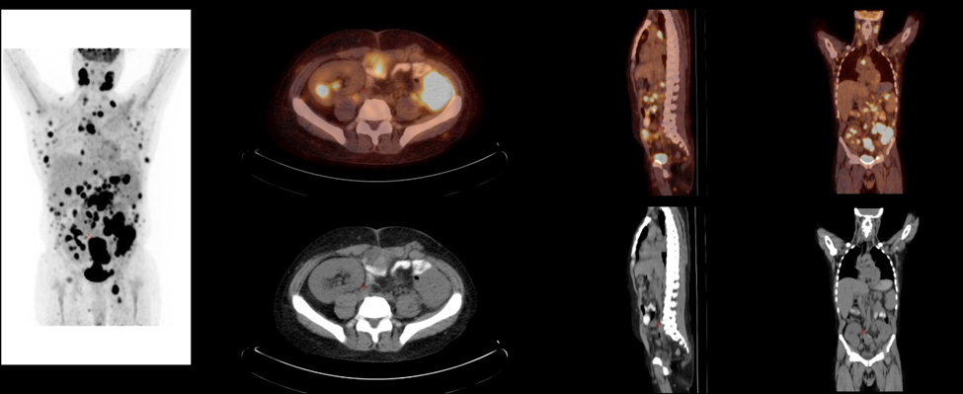
FIGURE (3 ): 45 years old male status post renal transplant, FDG PET/CT scan showed multiple enlarged highly metabolically active bilateral cervical, mediastinal, axillary, abdominal and pelvic lymph nodes associated with metabolically active right lung nodule, multiple peritoneal, omental and subcutaneous nodules mostly representing active wide spread lymphometous lesions.

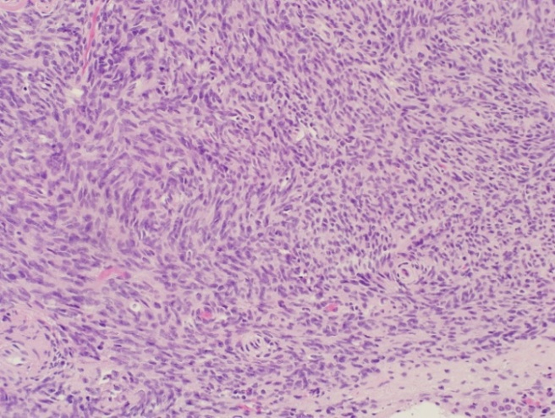
Figure 4: Complete effacement of cervical lymph node by malignant lymphoid cells which satin positive by CD20 (not shown).

Conclusions:
Diagnosis of PTLD is not always straightforward, Despite of improvements with new tolerable therapies, survival of PTLD patients remains inferior, necessitating further international cooperation aimed at improving long-term outcome of PTLD patients. Introducing molecular genetic characteristics is very important to understand the biology of this rare entity.

Corresponding Author:
NajlaMoqadum MD
Histopathology Specialist,
Prince Sultan Military Medical City, Riyadh, Saudi Arabia
Najlatm2011@hotmail.com

References:
- Nalesnik MA. Clinicopathologic features of post transplant lymphoproliferative disorders. Ann Transplant. 1997;2:33–40.
- S. Sharma, C. Rana, P. B. Vinod, and A. Gupta. Plasma cell myeloma in a renal transplant recipient: A case report and review of literature. Indian J Nephrol. 2011 Oct-Dec; 21(4): 270–272.
- Andreone P, Gramenzi A, Lorenzini S, Biselli M, Cursaro C, Pileri S, et al. Posttransplantation lymphoproliferative disorders. Arch Intern Med 2003; 163: 1997–2004.
- Swerdlow SH, Webber SA, Chadburn A, Ferry JA. Post-transplant lymphoproliferative disorder. In: WHO classification of tumours of haematopoietic and lymphoid tissues. Lyon: IARC; 2008, pp. 343–349.
- Cohen JI. Epstein-Barr virus infection. N Engl J Med. 2000 Aug 17. 343(7):481-92.
- Glotz D, Chapman JR, Dharnidharka VR, Hanto DW, Castro MC, Hirsch HH, et al. The Seville Expert Workshop for Progress in Posttransplant Lymphoproliferative Disorders. Transplantation. 2012 Sep 18.
- Meerbach A, Wutzler P, Häfer R, Zintl F, Gruhn B. Monitoring of Epstein-Barr virus load after hematopoietic stem cell transplantation for early intervention in post-transplant lymphoproliferative disease. J Med Virol. 2008 Mar. 80(3):441-54.
- Lee TC, Savoldo B, Rooney CM, Heslop HE, Gee AP, Caldwell Y. Quantitative EBV viral loads and immunosuppression alterations can decrease PTLD incidence in pediatric liver transplant recipients. Am J Transplant. 2005 Sep. 5(9):2222-8.
- Dierickx D, Tousseyn T, Gheysens O. How I treat posttransplant lymphoproliferative disorders. Blood. 2015 Nov 12;126(20):2274-83.
- Taoka K, Nannya Y, Yamamoto G, et al. Progressive transition of Epstein-Barr virus associated lymphoproliferative disease subtypes with the development of lung cancer. Am J Hematol 2009;84(9):600-603.
- Rohr JC, Wagner HJ, Lauten M, et al. Differentiation of EBV-induced post-transplant Hodgkin lymphoma from Hodgkin-like post-transplant lymphoproliferative disease. Pediatr Transplant 2008;12(4):426-431.
- Pitman SD, Huang Q, Zuppan CW, et al. Hodgkin lymphoma-like posttransplant lymphoproliferative disorder (HL-like PTLD) simulates monomorphic B-cell PTLD both clinically and pathologically. Am J Surg Pathol 2006;30(4):470-476.
- Krishnamurthy S, Hassan A, Frater JL, Paessler ME, Kreisel FH. Pathologic and clinical features of Hodgkin lymphoma--like posttransplant lymphoproliferative disease. Int J Surg Pathol 2010;18(4):278-285.
- Deepa Jagadeesh, Sharjeel Hooda, Kathleen B Fenner, Lisa Rybicki, Robert M Dean, Brad Pohlman, Brian T. Hill, Mitchell R. Smith. Post Transplant Lymphoproliferative Disorders (PTLD) after Solid Organ Transplant: Cleveland Clinic Experience Blood 2014 124:3008.
- Morscio J, Dierickx D, Ferreiro JF, et al. Gene expression profiling reveals clear differences between EBV-positive and EBV-negative posttransplant lymphoproliferative disorders. Am J Transplant. 2013;13(5):1305-1316.
- Ferreiro JF, Morscio J, Dierickx D, et al. EBVpositive and EBV-negative posttransplant diffuse large B-cell lymphomas have distinct genomic and transcriptomic features. Am J Transplant. Am J Transplant. 2016 Feb;16(2):414-25.
- Stuhlmann-Laeisz C, Oschlies I, Klapper W. Detection of EBV in reactive and neoplastic lymphoproliferations in adults-when and how? J Hematop. 2014;7(4):165-170.
- Takehana CS, Twist CJ, Mosci C, Quon A, Mittra E, Iagaru A. (18)F-FDG PET/CT in the management of patients with post-transplant lymphoproliferative disorder. Nucl Med Commun. 2014;35(3):276-281.

12/12/2016

