Prognostic and predictive value of excision repair cross-complementation group-1protein expression in locally advanced bladder cancer

Wael Mansour¹, Walid Almorsy¹ and Maha shamloula²

Clinical Oncology Department, Histopathology Department Faculty of Medicine, Tanta University, Gharbia, Egypt.
walidaa1@hotmail.com

Abstract: Background: A viable treatment option for locally advanced bladder cancer includes tri-modality therapy with a combination of transurethral resection of bladder tumor (TURBT), chemotherapy and radiation therapy. Cisplatin is the most important chemotherapeutic agent for locally advanced bladder cancer and is usually administered with Gemcitabine. Increased expression of excision repair cross-complementation group 1 (ERCC1) protein is associated with resistance to cisplatin-based chemotherapy in various tumor types. The aim of the present study was to assess the prognostic and predictive value of (ERCC1) protein in locally advanced bladder cancer patients who received cisplatin-based chemotherapy. Patients and Methods: Seventy eight patients with non-metastatic locally advanced bladder cancer were included in this study between June 2013 and December 2014. Paraffin blocks obtained from all patients were analyzed for ERCC1 in immunohistochemical expression. Results: Complete response rate was higher in patients with negative ERCC1 expression (94.1%) than weak, moderate and strong positive (70%, 50%& 33.3% respectively) which was statistically significant (P= 0.019). The 2-year disease-free survival rates for patients with ERCC1-weak positive was 40%, while it was 16.7% in moderate +ve ERCC1-, and 0% in strong +ve ERCC1, however, it was 70% in ERCC1-negative patients. The interaction term between ERCC1 expression and adjuvant platinol based chemotherapy showed significance for overall survival (P = 0.001) and disease-free survival (P = 0.01). Conclusion: ERCC1appear to be potentially useful prognostic and predictive markers in non-metastatic locally advanced bladder cancer.
[Wael Mansour, Walid Almorsy and Maha shamloula. Prognostic and predictive Valueofexcision repair cross-complementation group-1protein expression in locally advanced bladder cancer. Cancer Biology 2016;6(4):1-8]. ISSN: 2150-1041 (print); ISSN: 2150-105X (online). http://www.cancerbio.net. 1. doi:10.7537/marscbj060416.01.

Key words: locally advanced bladder cancer, ERCC1, cisplatin-based chemotherapy, prognosis.

1. Introduction
Bladder cancer represents 6.9% of all cancers in Egypt. The percent of bladder cancer is 10.7% in males ^{[1].} Cisplatin is the most important chemotherapeutic agent for locally advanced bladder cancer and is usually administered with gemcitabine. Its cytotoxicity is attributed to the formation of DNA adducts, which cause inter- and intra-strand cross-linking that inhibits DNA replication. Cisplatin-induced DNA adducts are removed by the nucleotide excision repair pathway, and the excision repair cross-complementation group 1 (ERCC1) protein; which is rate-limiting in the nucleotide excision repair pathway. Its increased expression is associated with resistance to cisplatin-based chemotherapy in various tumor types ^{[2-7]}
ERCC1 has also been supported by studies that demonstrate cancers with extensive genomic alterations have more malignant phenotype and increased growth rates, also ERCC1 may be representative of the intrinsic DNA damage-repair ability of the cell ^{[8, 9]}
Several studies have shown that high ERCC1 expression is a good prognostic to patients under the most accurate pathologic staging, thereby preventing low risk patients from unnecessary cytotoxicity; and that up-front surgery increases the chances of curing patients with drug-resistant diseases ^{[10].}
In the current study, we studied the expression of ERCC1 in advanced bladder cancer patients who have been treated with platinum based chemotherapy and correlated these data with the clinic-pathological findings, treatment response and survival to assess the predictive and prognostic significance of this marker.

2. Patients and methods:
Between June 2013 and December 2014, a series of 78 patients with pathologically proven non-metastatic invasive bladder cancer (T stage: from T2 to T4a) in Clinical Oncology Department, Faculty of Medicine, Tanta University Hospital were enrolled. Patients were followed up until June 2016.
The patients were primarily chosen on the basis of paraffin blocks availability. All of the 78 patients were free of distant metastases by computed tomography scan (CT) and/or magnetic resonance imaging (MRI) and bone scan at the time of inclusion.
Patients fulfilled the following criteria: - age between 18-65 years, Eastern Cooperative Oncology Group (ECOG) performance status (PS) of ≤ 2, adequate bone marrow reserve (WBC count 3.5 x 10⁹/L, ANC count 1.5 x10⁹/L, platelets 100 x 10⁹/L, and hemoglobin 10 g/dL), adequate renal function (measured creatinine clearance 60 mL/min) and adequate liver function (transaminases less than 2 x upper normal limit, and serum bilirubin concentrations below 1.5 mg/dL).
Treatment Plan:
All patients have been treated with tri-modality therapy:
Surgery:
All patients were eligible for cystoscopy for better visualization of the bladder, adequate TURBT as much as possible withmultiple biopsies from any suspicious areas.
Chemotherapy:
All patients had received induction chemotherapy. Chemotherapy was applied in the form of gemcitabine (1000 mg/m², 30-60 minutes I.V. infusion, day 1, 8 & 15), and cisplatinum (75mg/m², over 60 minutes I.V. infusion day 1). Chemotherapy was repeated every 3 weeks for two cycles. Supportive care included hydration, blood transfusions, growth factors and the administration of antiemetics and analgesics, as appropriate. Prophylactic use of growth factors was not recommended.
Radiotherapy:
All patients received consolidation concurrent chemo radiotherapy in the form of weekly cisplatin of 30 mg/m² with radiation therapy. Radiotherapy was delivered as 3D conformal radiotherapy by a high energy linear accelerator with photon energies 6 and 15 MV to deliver dose of 45 Gy to the pelvic lymph nodes and areas at risk of tumor spread. The whole bladder field received 54 Gy and boost field received 64.8 Gy. The tumor boost field only treats partial bladder and incorporates all information for the location of GTV prior to TURBT. Once-daily fractionation at 1.8 Gray per fraction was used. Dose prescribed at iso-center and CT simulator plan was done taken in consideration the ICRU 50 (International Commission on Radiation Units and Measurements) recommendations (A certain degree of heterogeneity should be kept within +7% and –5% of the prescribed dose) ^{[11, 12].}
Paraffin blocks collection:
Paraffin blocks of the eligible patients were retrieved from the archives of pathology department, Faculty of Medicine, Tanta University. Immunohistochemistry (IHC) was performed using mouse monoclonal antibody for ERCC1 by (Santa Cruz, Biotechnology, Inc., California, US).
Tumor tissue sections have been cut at 4 microns thickness on positively charged adhesive slides then deparaffinized in Tissue Clear (Sakura, Finetek Europe BV, Zoeterwoude, Netherlands), rehydrated in a graded ethanol series, and treated with (3%) hydrogen peroxide to block endogenous peroxidase activity. Antigen retrieval was performed by immersing slides in citrate buffer at pH = 6 and microwaving at high power for 30 minutes. Non-immune serum was used to block nonspecific binding. Afterward, the sections were incubated overnight with primary mouse monoclonal antibodies to ERCC1 in humidity chamber in a dilution of 1:50.
The secondary antibody was ready to be used was bio-tinylated goat (anti-poly-valent HRP) (Lab-vision, California, US) then streptavidin was applied for 10 minutes. The reaction produced visualized using 3-30 di-amino-benzidines (DAB) and the sections were counterstained with Mayer’s hematoxylin, dehydrated in alcohol and mounted with DPX. A distinct brown nuclear immuno-staining was scored positive. At least, 400 cells from 5 randomly selected fields(x400) were counted. Aberrant expression was defined as staining in excess of normal tissues. The staining intensity was evaluated in a semi-quantitative way representing the average intensity of the stained tumor cells (0 = no staining, 1 = weak staining, 2 = moderate staining and3 = strong staining) [5].
Patient assessment:
Assessment of clinical benefit
A tumor response assessment was performed after chemotherapy, 1 month after the end of treatment and after every three months of treatment. Pre- and on-treatment monitoring consisted of medical history, physical examination, CT scan or MRI of the chest, abdomen and pelvis, and bone scan. Criteria of complete response (CR), partial response (PR), stable disease (SD) and progressive disease (PD) were based on the standard definitions according to RECIST criteria with the overall response rate, including complete response and partial response. ^{[13, 14]}
Primary and secondary endpoints:
The primary endpoints of the study were overall response and progression-free survival. Secondary end point was the overall survival.
Statistical analysis:
Overall-survival (OS) rates were calculated from the start of tri-modality therapy to the time of the last follow-up visit or death using the Kaplan–Meier method with SPSS [Statistical package] (version 20) ^{[15].} Progression-free survival was the time elapsed from the date of initiation of tri-modality therapy to the date of first evidence of disease progression or death in the absence of disease progression. Log rank is used for comparison of curves. Mean and standard deviation were estimates of quantitative data. Fisher exact test was used for qualitative data. All P values were two-tailed; a value of ≤0.05 was considered significant.
3. Results
Seventy-eight patients were recruited in the study between June 2013 and December 2014 with pathologically proven non-metastatic locally advanced bladder cancer. All our patients received tri-modality therapy with a combination of transurethral resection of bladder tumor (TURBT), chemotherapy and radiation therapy. The baseline characteristics were listed in table (1), with the mean age 60.4+ 5.0 years, and the median age was 61years (range; 51-65years). Fifty two (66.67%%) patinetes were of high grade, and 55(70.51%) patients were of ECOG performance statusof 1. Sixty four (82.05%) patients were maleswhile 14 (17.95%) patients were females. Pathological review performed in all 78 patients, confirmedthat all had tumors invading the muscularispropria. Sixteen tissue samples (20.51%) of the studied patients were infected by Schistosomahematobium eggs and 62(79.49%) patients were free from Schistosoma affection. All the patients included in this study had a histopathology of transitional cell carcinoma with 22 patients (28.2%) had squamous differentiation. The clinical stage of the primary tumor was T2 in 32 (41.03%) patients, T3 in 36 (46.15%) patients, and T4a in 10 (12.82%) patients.
Immuno-histochemical results:
ERCC1 expression was found to be positive in 44 (56.4%) of the patients’ tumor tissues and negative in 34 (43.6%) of the patients’ tumor tissues (Fig. 1). The tumor’s expression of ERCC1 scored as strong positive in 12 patients (15.4%), (Fig. 2), moderate positivity in 12 patients (15.4%), (fig 3), and weak positive in 20 patients (25.6%).

Table (1): Pretreatment patient and tumor characteristics (n = 78)
Characteristic | No. patients (%)
Age (years)  Mean  Median-Range | 60.4±5.0  61(51-65)
ECOG performance status  0  1  2 | 1 (1.28)  55 (70.51)  22 (28.21)
Gender  Male  Female | 64 (82.05)  14 (17.95)
Initial tumorgrade  Low grade TCC  High grade TCC. | 26 (33.33)  52 (66.67)
Schistosomahematobiumeggs infection  Yes  No | 16 (20.51)  62 (79.49)
Tumor stage  T2  T3  T4a | 32 (41.03)  36 (46.15)  1 0 (12.82)

Table (2): ERCC1 expression and degree of positivity
ERCC1 expression | NO. (total n=78) | %
Negative staining | 34 | 43.6 %
Positive staining | 44 | 56.4 %
Degree of positivity
Weak +ve | 20 | 25.6 %
Moderate +ve | 12 | 15.4 %
Strong +v | 12 | 15.4%

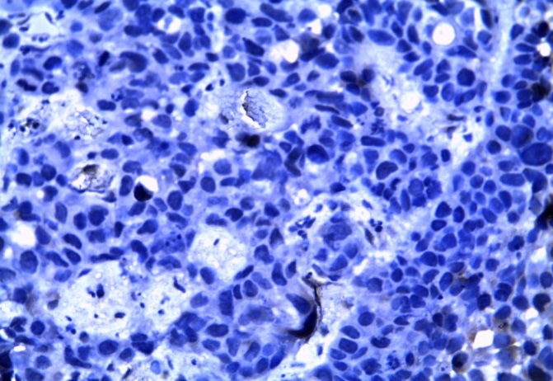  Fig [1]: High grade TCC negative for ERCC1 (IHCx400) | 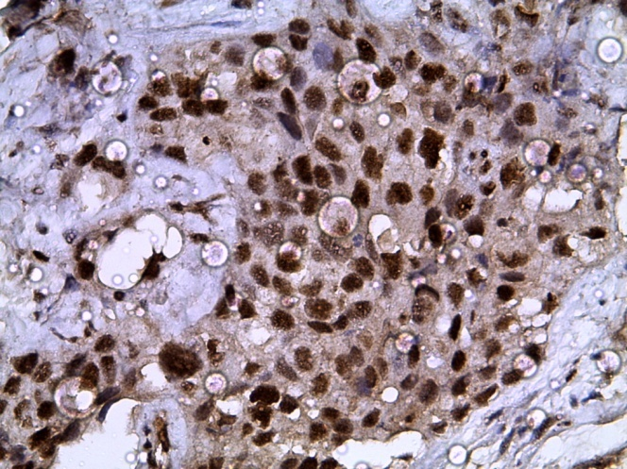  Fig [2]: High grade TCC showing strong nuclear positivity for ERCC1 (IHCx400).
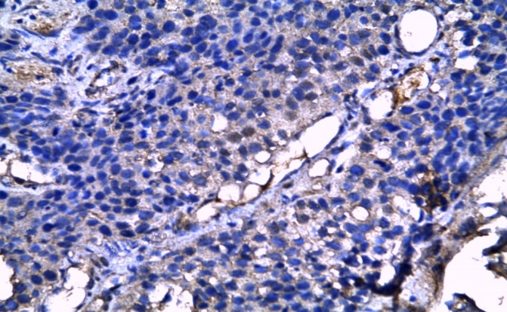  Fig [3]: High grade TCC showing moderatenuclear positivity for ERCC1 (IHCx400 | 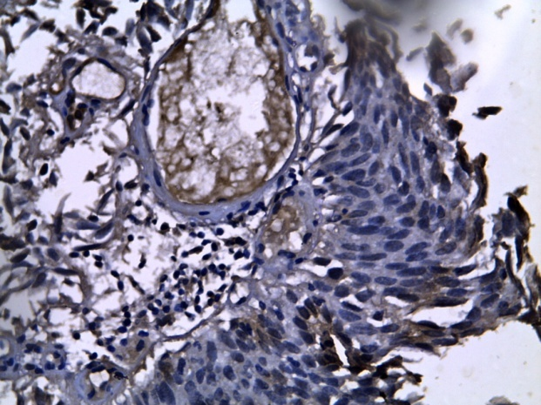  Fig [4]: High grade TCC showing weak nuclear positivity for ERCC1 (IHCx400)

ERCC1expression in relation to patient and tumor characteristics
Regarding to correlation between ERCC1 and different patient’s characteristics, there is no significant relation; All P values were not significant as shown in (table 3).

Table (3): ERCC1expression in relation to patient and tumor characteristics
Basic  characteristics | ERCC1  -ve  (n=34) |  | ERCC1  Weak +ve  (n=20) |  |  |  | ERCC1  Moderate +ve  (n=12) |  |  | ERCC1  Strong +ve  (n=12) |  | Total  (n=78) | X² | P
 | N | % | N |  | % |  | N |  | % | N | %
Histo-pathological types
TCC | 28 | 82.4% | 12 | 60% |  | 8 |  | 66.7% |  | 8 | 66.7% | 56 | 1.779 | 0.620  (NS)
TCC é Sq. diff. | 6 | 17.6% | 8 | 40% |  | 4 |  | 33.3% |  | 4 | 33.3% | 22
Bilharziasis
Absent | 26 | 76.5% | 18 | 90% |  | 8 |  | 66.7% |  | 10 | 83.3% | 62 | 1.432 | 0.698  (NS)
Present | 8 | 23.5% | 2 | 10% |  | 4 |  | 33.3% |  | 2 | 16.7% | 16
Grade
Low Grade | 12 | 35.3% | 6 | 30% |  | 4 |  | 33.3% |  | 4 | 33.3% | 26 | 0.079 | 0.994  (NS)
High Grade | 22 | 64.7% | 14 | 70% |  | 8 |  | 66.7% |  | 8 | 66.7% | 52
T stage
T2 | 18 | 52.9% | 6 | 30% |  | 2 |  |  | 16.7% | 6 | 50% | 32 | 3.933 | 0.686  (NS)
T3 | 14 | 41.2% | 10 | 50% |  | 8 |  |  | 66.6% | 4 | 33.3% | 36
T4a | 2 | 5.9% | 4 | 20% |  | 2 |  |  | 16.7% | 2 | 16.7% | 10
NS: not significant.

The relation of ERCC1 expression and treatment response
Evaluation of treatment response revealed that the overall response rate (CR+PR) was (79.5%) of all patients. Where 71.8% of the patients showed clinical, radiological and pathological evidence of complete remission (CR), 7.7% showed partial response (PR), 7.7% showed stable disease and 12.8% showed disease progression (PD).
Regarding response in relation to ERCC1 status, CR rate is higher in patients with negative ERCC1 (94.1%) than weak positive ERCC1 (70%) as well as moderate and strong positive ERCC1 (50%& 33.3% respectively). The difference is statistically significant (P=0.019).

Table (4): The relation of ERCC1 expression and treatment response
Treatment  Response | ERCC1  -ve  (n=34) |  | ERCC1  Weak +ve  (n=20) |  | ERCC1  Moderate +ve  (n=12) |  | ERCC1  Strong +ve  (n=12)
 | No | % | No | % | No | % | No | %
CR | 32 | 94.1% | 14 | 70% | 6 | 50% | 4 | 33.3%
PR | 2 | 5.9% | 4 | 20% | 0 | 0% | 0 | 0%
SD | 0 | 0% | 0 | 0% | 2 | 16.7% | 4 | 33.3%
PD | 0 | 0% | 2 | 10% | 4 | 33.3% | 4 | 33.3%

Correlation between disease-free survival rate and ERCC1 expression
The 2-year disease-free survival rates for patients with ERCC1-weak positive tumors was 40%, while it was16.7% in moderately +ve ERCC1- tumors, and it was 0% in strongly +ve ERCC1- tumors, however, it was 70% in ERCC1-negative tumors. The interaction term between ERCC1 expression and adjuvantcisplatinumbased chemotherapy showed significance for disease-free survival.

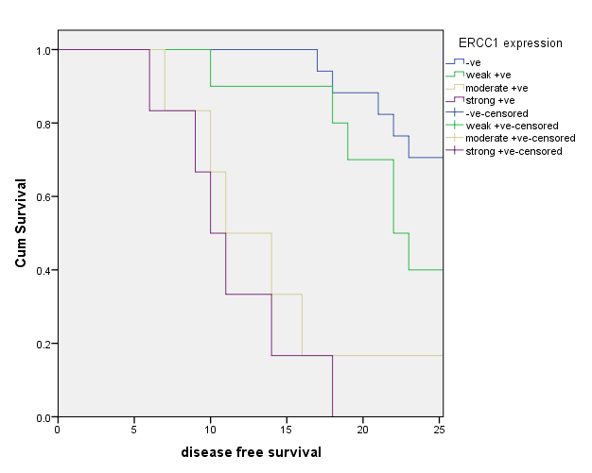
(P = 0.01).
Figure 4: Correlation between disease-free survival rate and ERCC1 expression

Correlation between overall survival rate and ERCC1 expression
The 30 months’ overall survival rate was 56.4% for the total study population (Figure 5).
The 30 months’ overall survival rate for patients with ERCC1-weak positive tumors was 60%, while it was 50%inmoderately +ve ERCC1- tumors, and it was0% in strongly +ve ERCC1- tumors, however, it was 76.5% in ERCC1-negative tumors (Figure 6). The interaction term between ERCC1 expression and adjuvant cisplatinumbased chemotherapy showed highly significant correlation for overall survival (P = 0.001).

Discussion:
In our study, ERCC1 expression provided both prognostic and predictive information in patients with pathologically proven non-metastatic locally advanced bladder cancer. All our patients received tri-modality therapy with a combination of transurethral bladder resection (TURBT), chemotherapy and radiation therapy.
Up to date, the role of adjuvant chemotherapy for bladder cancer has been controversial, with no Level 1 evidence supporting adjuvant chemotherapy. In fact, the available data have not demonstrated a clear benefit of adjuvant chemotherapy. In our study, ERCC1 expression revealed both prognostic and predictive information in patients with resected bladder cancer. The prognostic and predictive value of ERCC1 expression in completely resected bladder cancer was proved by other investigators as well^{[10].}
ERCC1 was assessed by IHC, 43.6% of our patients were ERCC1 negative, 25.6% were weak positive, 15.4% were of moderate positivity and 15.4% were strong positive which was in agreement with Sun et al., ^{[10]} and Sakano et al.,^{[16],} who recorded ERCC1 positive in (58.1% & 52.1% respectively) and negative in (41.9% & 47.9% respectively).

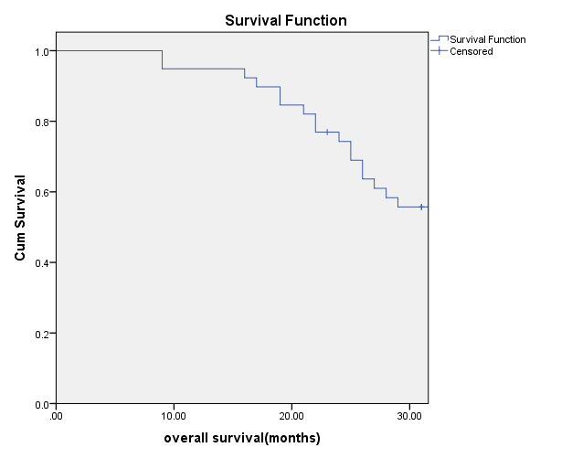
Figure 5: Overall-survival [OS] for all patients.

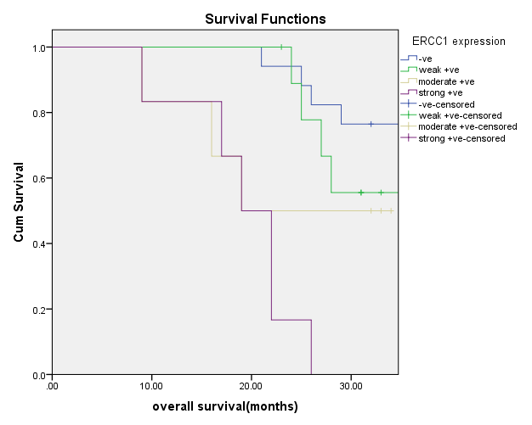
Figure (6): Correlation between Overall-survival [OS] and ERCC1 expression

Our results showed that rate of complete response was higher in tumor tissues with negative ERCC1 expression (94.1%) than weak, moderate and strong positive tissues (70%, 50% & 33.3% respectively) with statistically significant difference (P= 0.019). This was in compatible with study of Kawashima et al., ^{[17],} which reported CR of 85.7% in ERCC1 negative tissues compared with 25% CR in ERCC1 positive tumors (P=0.008). However Shilkrut et al., ^{[18],} reported different findings to the present study with CR rates were lower in patients with high ERCC1 expression than those with lower ERCC1 expression, and the difference was statistically insignificant (67% for high ERCC1 expression vs. 84% for low ERCC1 tissues, [P= 0.39]), this conflict probably as a result of usage of non-unified treatment modality for all of the patients with inclusion of stage IV patients with positive lymph-nodes, in addition to the retrospective nature of this study which was conducted on another marker as well as ERCC1.
The findings of the present study point to ERCC1 expression as a prognostic marker in non-metastatic locally advanced bladder cancer patients. The 2-year disease-free survival rates for patients with ERCC1-weak positive tumors was 40%, while it was16.7% in moderate +ve ERCC1- tumors, and it was 0% in strong +ve ERCC1- tumors, however, it was 70% in ERCC1-negative tumors. This could be compared with study of Sun et al.,^{[10],} which reported 2 years DFS of 64.5% for negative ERCC1 tumors and 46.5% for positive ones but with different treatment strategy (radical cystectomy plus four cycles; adjuvant chemotherapy).
Among patients with carcinoma of the bladder, high expression of ERCC1 correlated with shorter survival in those with adjuvant chemotherapy. A statistically significant interaction between ERCC1 expression and induction chemotherapy indicated potential benefits of neoadjuvant chemotherapy in patients with ERCC1-negative tumors. This was confirmed in our study as overall survival at 30 months were 0%, 50%, and 60% for patients with high, moderate, and weak expression of ERCC1 respectively while it was 76.5% for patients with ERCC1-negative tumors (P = 0.001). This was in agreement with study of Shan Li et al.,^{[19],} who analyzed data for ERCC1 expression and OS reported in six studies with 356 bladder cancer patients, final results indicated that advanced bladder cancer patients with ERCC1 positive/high expression experienced a shorter OS than those with ERCC1 negative/low expression (P < 0.0001). A significant strength was evident in this study of the appropriate selection of patients who could potentially benefit from platinum containing adjuvant chemotherapy based on ERCC1 expression.

Conclusions:
In conclusion, ERCC1 appear to be potentially useful prognostic and predictive markers in non-metastatic locally advanced bladder cancer patients. Because the standard treatment for patients with locally advanced urothelial carcinoma is platinum based chemotherapy, patients with high expression of ERCC1 might benefit from alternative platinum non–containing regimens as ERCC1 may play an important role as a tumor marker in tailored chemotherapy for locally advanced bladder cancer. However, larger number of cases and longer follow up period are necessary to confirm their independent prognostic and predictive value in a multivariate analysis.

References
- Ibrahim AS, Khaled HM, Mikhail NNH, et al. Cancer Incidence in Egypt: Results of the National Population-Based Cancer Registry Program. Journal of Cancer Epidemiology Volume 2014 (2014), Article ID 437971, 18 pageshttp://dx.doi.org/10.1155/2014/437971.
- Sun J-M, Ahn M-J, Park MJ, et al. Expression of Excision Repair Cross-Complementation Group 1 as predictive marker for nasopharyngeal cancer treated with concurrent chemo-radiotherapy. Int J Radiat Oncol Biol Phys. 2011; 80 (3): 655–660.
- Hwang IG, Ahn MJ, Park BB, et al. ERCC1 expression as a prognostic marker in N2(+) non-small-cell lung cancer patients treated with platinum-based neo-adjuvant concurrent chemo-radiotherapy Cancer. 2008; 113(6): 1379–1386.
- Ceppi P, Volante M, Novello S, et al. ERCC1 and RRM1 gene expressions but not EGFR are predictive of shorter survival in advanced non-small-cell lung cancer treated with cisplatin and gemcitabine. Ann Oncol. 2006; 17(12): 1818–1825.
- Olaussen KA, Dunant A, Fouret P, et al. DNA repair by ERCC1 in non-small-cell lung cancer and cisplatin-based adjuvant chemotherapy. N Engl J Med. 2006; 355: 983–991.
- SelvakumaranM, Pisarcik DA, Bao R, et al. Enhanced cisplatin cytotoxicity by disturbing the nucleotide excision repair pathway in ovarian cancer cell lines. Cancer Res. 2003; 63(6): 1311–1316.
- Lord RV, Brabender J, Gandara D, et al. Low ERCC1 expression correlates with prolonged survival after cisplatin plus gemcitabine chemotherapy in non-small cell lung cancer. Clin Cancer Res. 2002; 8(7): 2286–2291.
- Simon GR, Sharma S, Cantor A, et al. ERCC1 expression is a predictor of survival in resected patients with non-small cell lung cancer. Chest. 2005; 127(3): 978–983.
- Rosell R, Pifarré A, Monzó M, et al. Reduced survival in patients with stage-I non-small-cell lung cancer associated with DNA-replication errors. Int J Cancer. 1997; 74(3): 330–334.
- Sun J-M, Sung Ji-Y, Park SH, et al. ERCC1 as a biomarker for bladder cancer patients likely to benefit from adjuvant chemotherapy. BMC Cancer 2012, 12:187.
- Lee N Y, Riaz N, Lu JJ. Target Volume Delineation for Conformal and Intensity-Modulated Radiation Therapy, 1sted, Springer Cham Heidelberg New York, Part VI Genitourinary System. 2014, Pages 377-386.
- Roth B, Wissmeyer MP, Zehnder P et al. A new multimodality technique accurately maps the primary lymphatic landing sites of the bladder. Eur Urol 2010; 57(2):205–211.
- Eisenhauer EA, Therasse P, Bogaerts J, et al. New response evaluation criteria in solid tumours: revised RECIST guideline (version 1.1). Eur J Cancer. 2009; 45:228–47.
- Therasse P, Arbuck SG, Eisenhauer EA, et al. New guidelines to evaluate the response to treatment in solid tumors. European organization for research and treatment of cancer, national cancer institute of the United States, national cancer institute of Canada. J Natl Cancer Inst. 2000; 92:205–16.
- Kaplan EL, Meier P. Nonparametric estimation from incomplete observations. J Am Stat Assoc 1958; 53: 457– 81.
- Sakano S, Ogawa S, Yamamoto Y, et al. ERCC1 and XRCC1 expression predicts survival in bladder cancer patients receiving combined tri-modality therapy. Molecular and Clinical Oncology. 2013; 1: 403- 410.
- Kawashima A, Nakayama M, Kakuta Y, et al. Excision Repair Cross-Complementing Group 1 May Predict the Efficacy of Chemo-radiation Therapy for Muscle-Invasive Bladder Cancer. Clin Cancer Res. 2010; 10: 1078-1158.
- Shilkrut M, Angela WU, Davidd G, et al. RRM1 and ERCC1 expression in muscle invasive bladder cancer. Molecular and Clinical Oncology 2014;2: 479-487.
- Li S, Wu J, Chen Y, et al. ERCC1 expression levels predict the outcome of platinum based chemotherapies in advanced bladder cancer: a meta-analysis. Anti-Cancer Drugs 2014; 25:106–114.

10/15/2016

