Volumetric modulated arc therapy versus Intensity-modulated radiation therapy of head-and-neck cancer: A comparative dosimetric study (Egyptian experience)

Wael H. Elsawy; Hesham A, El Ghasaly; Amin E. Amin; Nashwa E. Nawar; Ahmed Ali E.

ahmedali161984@gmail.com

Abstract: Background: Radiation therapy is an important treatment modality for head and neck carcinoma but the main challenge is to deliver high radiation dose to the target with maximal sparing of the organs at risk which are in close proximity to the disease the aim of this work was to compare two treatment modalities, Volumetric modulated arc therapy (VMAT) and Intensity-modulated radiation therapy (IMRT), by dosimetric evaluation of both plan as regard dose distribution within the target volume, dose received by the organ at risk (OARs) and treatment delivery time. Methods: 38 patients of locally advanced head and neck carcinoma were randomized into two groups. Group A: 38 patient were prospectively selected to be planned with IMRT planning system to deliver a total dose 70 Gray to GTV. Group B: all patients in group A will be replanned using VMAT planning system to deliver the same dose to GTV then both plans were compared dosimetricaly. Results: this dosimetric study revealed that VMAT technique had a significantly better dose distribution than IMRT as regard both dose homogeneity and conformity indices also VMAT technique provided a significantly better sparing of OARs than IMRT technique with significant reduction in treatment delivery time by more than 40%. Conclusion: VMAT technique providea better dose distribution and better target coverage than IMRT with better sparing of OARs than IMRT technique with significant reduction in treatment delivery time which is a major advantage of the VMAT technique over IMRT technique which is more comfortable to the patient and reduce the intrafractional movement, also allow higher number of patients to be treated per day so VMAT is considered as a more advantageous radiation treatment technique than IMRT for treatment of head and neck carcinoma.
[WaelH. Elsawy; Hesham A, El Ghasaly; Amin E. Amin; Nashwa E. Nawar; Ahmed Ali E. Volumetric modulated arc therapy versus Intensity-modulated radiation therapy of head-and-neck cancer: A comparative dosimetric study (Egyptian experience). Cancer Biology 2016;6(3):68-77]. ISSN: 2150-1041 (print); ISSN: 2150-105X (online). http://www.cancerbio.net. 8. doi:10.7537/marscbj060316.08.

Key words: Volumetric modulated arc therapy, Intensity-modulated radiation therapy, dose homogeneity and conformity indices, comparative dosimetric study, head-and-neck cancer

1. Introduction
Head and neck cancer arises from mucous lining of respiratory, digestive tracts and salivary glands. The aim of treatment of head & neck carcinoma is cure with preservation of function and this need multidisciplinary team including oncologist, surgeon, dentist, psychologist and nurses. Radiation oncologist has a major role in treatment in either primary, postoperative or palliative setting(1). A notable difficulty with irradiation of head-and-neck cancer (HNC) is the large number of organs at risk (OAR) in close proximity to regions with disease, including the salivary glands, spinal cord and brainstem, larynx and pharyngeal constrictors, oral mucosae, tongue and lips, masseter as well as eyes and inner ears. The challenging task for the treatment planner is to find the most optimal trade-off in sparing the different OARs for each individual patient. Often better sparing of one OAR implies sacrificing another OAR, and in most patients high-grade radiation-induced toxicity is unavoidable while ensuring sufficient dose coverage of the planning target volume (PTV). This may result in severe consequences for the quality of life of these patients.(2) Intensity-modulated radiation therapy (IMRT) techniques for the treatment of HNC replaced conventional 3D-conformal radiation therapy (3D-CRT) techniques, which resulted in much better dose conformity and sparing of the OARs and, therefore, less radiation -induced toxicity.(3) Recently, the next generation of IMRT techniques, volumetric modulated arc therapy (VMAT) has become widely available. Compared to static-beam IMRT, rotational VMAT is supposed to decrease treatment delivery times with at least similar or even better plan quality (4). A number of studies have been published for VMAT for HNC, these studies observed comparable or better PTV coverage and conformity as well as better sparing of OARs for VMAT compared to IMRT, while delivery times were shortened by 35-60%(5). VMAT plans including double arcs for simultaneous integrated boost treatments of head-and-neck cancer were found to be improved compared to static-beam step-and shoot IMRT plans including 5–9 beam ports regarding dose to OARs and dose conformity, while delivery times were significantly shortened by 50%(6).

2. Patients and method
In this dosimetric study 38 patients with head and neck tumors were selected. Plans were optimized with the aim to assess organs at risk and healthy tissue sparing while maintaining highly conformal target coverage. All patients underwent CT simulation in a supine position with the neck hyper extended using a head rest and custom aqua plastic masks. To reduce the dose to the mandible and tongue, both were separated by bite blocks, and to reduce dose to the shoulder it was brought down by a pull board. CT images were taken at 3 mm slice thickness by means of a devoted CT scanner. The model of the treatment planning system (Eclipse calculation workstation) is: Dell Precision T5600 and its Application Name is External Beam Planning, the Application Version: 13.5DCF Calculation Version:13.contouring 0f:
A) Target volumes including
- GTV: gross disease including the primary tumor and enlarged lymph nodes as demonstrated on imaging modalities.
- CTV1 (high risk disease): includes all gross disease with 2 cm margin with consideration of soft tissue and barrier to spread and all lymph node at same level of the gross disease, the retropharyngeal nodes and bilateral upper cervical nodes including level V and supraclavicular nodes.
- CTV2 (low risk disease) includes low risk nodal regions.
B) Dose limitation to organs at risk (OAR): including brainstem, spinal cord, optic chiasma, Lens, Cochlea, both parotid glands, oral mucosa.
Dose prescriptions:
GTV: 70Gy/2.12 per fraction, CTV1: 60/1.8 per fraction, CTV2: 54Gy/1.64 per fraction in 33 fractions.
Dose limitation to organs at risk (OAR):
Partial brain:maximal dose 60 Gy, brainstem maximal dose 54 Gy, spinal cord: maximal dose 45 Gy, opticchiasma: maximal dose 54 Gy, retina: maximal dose 54 Gy, Lens: maximal dose 10 Gy, Cochlea: maximal dose 45 Gy, parotid mean dose < 26 Gy in at least one gland or 20 cc of both < 20 Gy.
For the IMRT planning:5 to 7 fields isocentric technique using isotropic gantry angles which are adjusted when a risk organ could be avoided for adequate target coverage. For the VMAT planning: VMAT plans were generated using one dual arc (double arc consisted of 2 co-planar arcs with the first arc in clockwise and the other arc in the counter clockwise direction (gantry angles from 181 to 179 and 179 to 181◦, respectively). Collimator was rotated from 35 to 45◦ depending on the plan, to cover the entire tumor volume which reduced the tongue and groove (effect during gantry rotation) after that the accepted plans for both technique are compared dosimetrically as regard:
A) Dose homogeneity within the target volume. Comparison between.
1. V95 % (volume of PTV planning target volume receiving 95 % of the prescribed dose).
2. V107 % (volume of PTV receiving ≥ 107 % of prescribed dose).
3. Volume receiving D min (minimum dose within the target).
4. Homogeneity index (HI) was calculated for each case by the following.

Equation (HI) = Maximum isodose in the target
Reference isodose
5. conformity index(CI) will be calculated for each case by the following equation.
(CI)= Volume of the reference isodose
Target volume
B) Dose received by organs at risk (OARs) will be compared for each contoured structure in terms of mean dose and D max (volume).
C) Treatment delivery time and total monitor units for both system also compared.

3. Result

Table (1): Patient characteristics
Patients characteristics | No | %
Age
50 | 27 | 71.1%
> 50 | 11 | 28.9%
Mean | 47.4
Median | 49
Mode | 49
Range | 20-75
Variance | 105.4
SD | 10.2
Sex | No | %
Male | 26 | 68.4%
Female | 12 | 31.6%
PS | NO | %
>60%, 70% | 8 | 21.1%
> 70% | 30 | 78.9%
Histological grade | NO | %
Grade I | 4 | 10.5 %
Grade II | 14 | 36.8 %
Grade III | 16 | 42.2 %
Grade IV | 4 | 10.5 %

In our study both groups include the same patients. as shown in table(1) the mean age of these patients was 47.4 years old, 68.4% of them were males, 78.9% of them had performance status more than 70%,all of them had squamous cell carcinoma with 42.2% were grad 3, nasopharyngeal carcinoma was the most common primary site and 68.5% of them were clinically stage 3.

Table (2): Dose-Volume statistics for target volume by both technique.
 |  | Mean | Std. Deviation | Minimum | Maximum | Paired t | P value
V107 | IMRT | 0.18 | 0.29 | 0 | 1.11 | 2.09 | 0.04*
 | VMAT | 0.08 | 0.21 | 0 | 0.91
V95 | IMRT | 95.18 | 1.26 | 91.2 | 97.8 | 14.05 | <0.001**
 | VMAT | 97.26 | 1.11 | 94.7 | 99.4
Dmin | IMRT | 64.57 | 1.4 | 61.1 | 66.4 | 7.36 | <0.001**
 | VMAT | 65.91 | 1.08 | 63.2 | 67.9
HI | IMRT | 1.06 | 0.03 | 1.01 | 1.12 | 3.2 | 0.005**
 | VMAT | 1.04 | 0.02 | 1.01 | 1.09
CI | IMRT | 0.94 | 0.01 | 0.91 | 0.96 | 7.31 | <0.001**
 | VMAT | 0.97 | 0.02 | 0.9 | 1
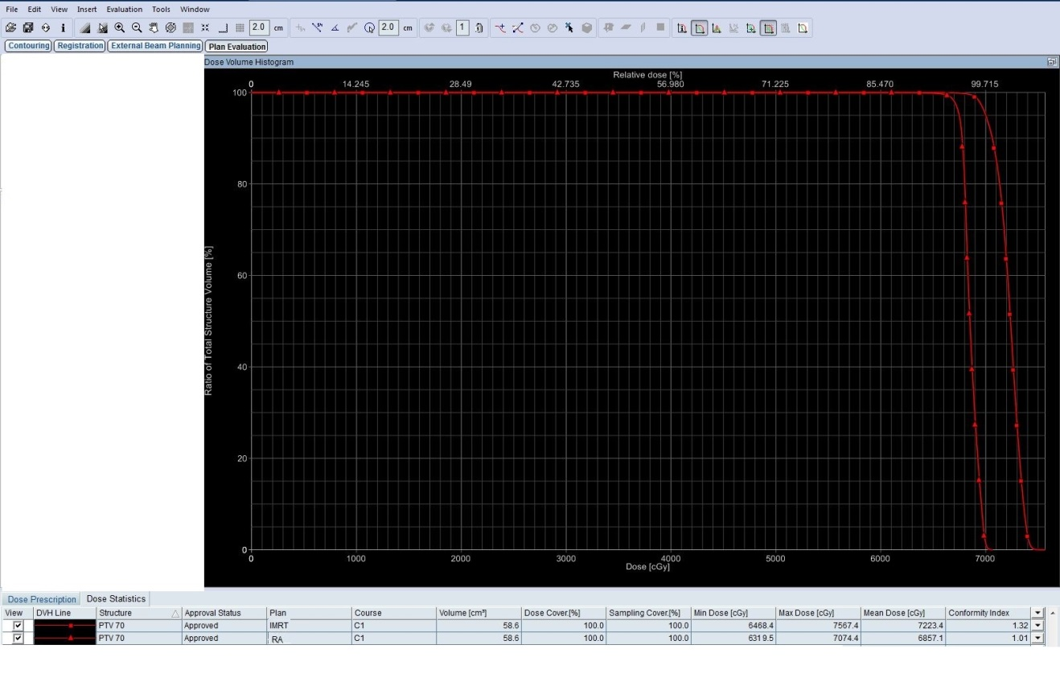
IMRT
RA

Fig.1: Acomparative DVH for both technique as regard PTV70 coverage (acase of nasopharyngeal carcinoma)(▄ IMRT,▲VMAT)

IMRT VMAT
Figure 2: dose coverage of the PTV70 using VMAT plan than IMRT plan (a case of nasopharyngeal carcinoma).

Table 3: Dose-Volume statistic
 |  | Mean | Std. Deviation | Minimum | Maximum | Paired t | P value
RT parotid | IMRT | 24.57 | 2.13 | 21.3 | 28.4 | 11.73 | <0.001**
 | VMAT | 22.58 | 2.47 | 19.2 | 29.1
LT parotid | IMRT | 28.46 | 2.48 | 19.8 | 29.5 | 3.12 | 0.01*
 | VMAT | 23.63 | 6.14 | 17.6 | 28.5
RT Cochlea | IMRT | 43.16 | 5.88 | 31 | 49.1 | 2.88 | 0.02*
 | VMAT | 40.91 | 5.56 | 29 | 48
LT cochlea | IMRT | 41.79 | 6.18 | 30 | 49 | 5.84 | <0.001**
 | VMAT | 40.47 | 5.58 | 30.1 | 47
Spinal Cord | IMRT | 44.08 | 1.19 | 41.3 | 46.1 | 2.6 | 0.03*
 | VMAT | 39.58 | 5.23 | 32.9 | 44.7
Brain Stem | IMRT | 49.82 | 8.06 | 38.8 | 55.8 | 3.1 | 0.02*
 | VMAT | 46.81 | 2.44 | 45.4 | 54.1
Oral Mucosa | IMRT | 38.3 | 2.48 | 33.8 | 41.3 | 51.77 | <0.001**
 | VMAT | 36.42 | 2.51 | 31.8 | 39.6
Chiasma | IMRT | 39.55 | 8.45 | 23.3 | 48.9 | 1 | 0.33 NS
 | VMAT | 39.49 | 8.54 | 22.4 | 48.8
s derived from DVH for normal tissue.

Dosimetric comparison between IMRT and VMAT planning for:
A) Dose homogeneity within the target volume
As shown in Table(2) and Figure 1, Dose distributions for the IMRT and VMAT plans that PTV coverage at the 70 Gy level (V95%) was better in the VMAT plans compared to the IMRT, the mean value was 97.26% (94.7-99.4) and 95.18% (91.2-97.8) respectively, with p value ˂0.001.
Maximum dose in the target (V107%) was higher (more hot spots) in the IMRT plane; 0.18% and 0.08 for the IMRT and VMAT plans respectively (p value 0.04).
VMAT delivered higher minimum PTV dose (65.91 Gy), which was 1.34 Gy higher than the IMRT plan (64.57Gy) (p value ˂0.001).
Conformity index is better with VMAT plans denoting better coverage (p-value ˂0.001). Figure 20, shows improved dose conformity for coverage of the PTV70 using the VMAT plan than the IMRT plan. As regard dose homogeneity it was also better in the VMAT plans (p-value 0.005).

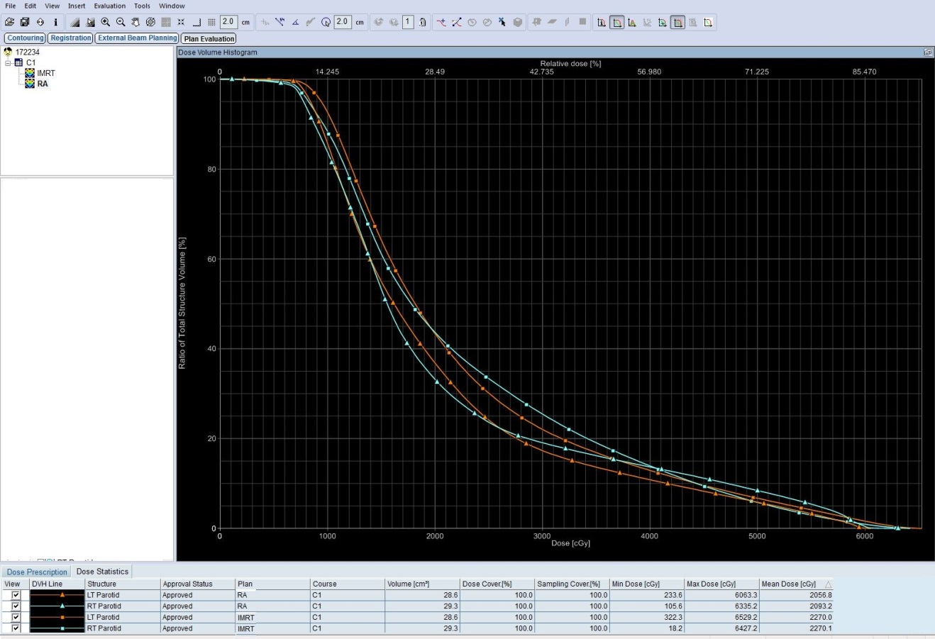
IMRT
RA

Fig.3: A comparative DVH for both techniques regarding dose received by parotid glands (acase of nasopharyngeal carcinoma) (▄ IMRT,▲VMAT)

B) Dose received by organs at risk (OARs) was compared for each contoured structure in terms of mean dose or maximum dose.
Table (3) showing comparison between doses received by different OARs by both IMRT &VMAT plans with the following results:
1. Parotid gland
There is a statistically significant difference between the mean doses received by both parotid glands among patients treated by VMAT and IMRT. Table (3) illustrates comparable but a statistically significant difference between the mean doses received by both parotid glands among patients treated by VMAT and IMRT. The mean dose to the right parotid gland was 22.58 Gy (range, 19.2–29.1 Gy) among patients treated by VMAT compared with 24.57 Gy (range, 21.3-28.1 Gy) for those treated by IMRT (p-value ˂0.001). As for the left parotid gland, the mean dose was 23.63 Gy (range, 17.6–28.5 Gy) among patients treated by VMAT compared with 28.46 Gy (range, 19.8-29.5 Gy) for those treated by IMRT (p-value 0.01).
2. Auditory structure (cochlea)
As shown in Table (3), although both techniques respect dose constrains for the auditory structure (cochlea) but patients treated by VMAT had lower maximum doses to cochlea compared with patients treated by IMRT. The mean dose to the right cochlea was 43.16 Gy (range, 31-49.1 Gy) for those treated by IMRT compared with 40.91 Gy (range, 29–48 Gy) among patients treated by VMAT (p-value 0.02). As for the left cochlea, the mean dose was 41.79 Gy (range, 30–49 Gy) among patients treated by IMRT compared with 40.47 Gy (range, 30.1-47 Gy) for those treated by VMAT (p-value ˂0.001) there was a significant difference in the mean dose to the cochleae between patients treated by VMAT vs. IMRT. (See Figure 4).

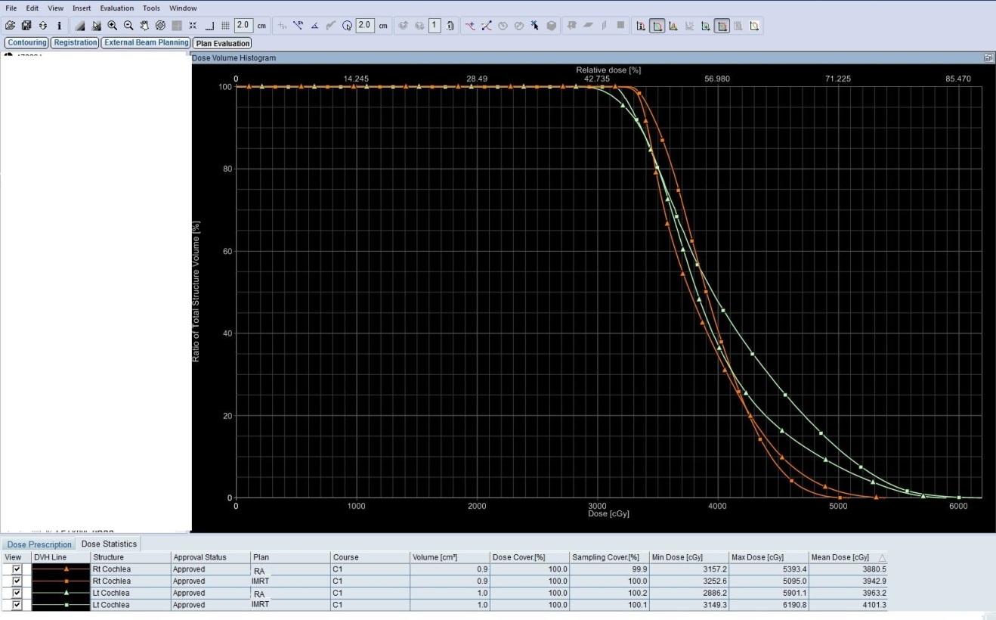
IMRT
RA

Figure 4: A comparative DVH for both techniques regarding dose received by right and left cochlea (▄ IMRT, ▲VMAT).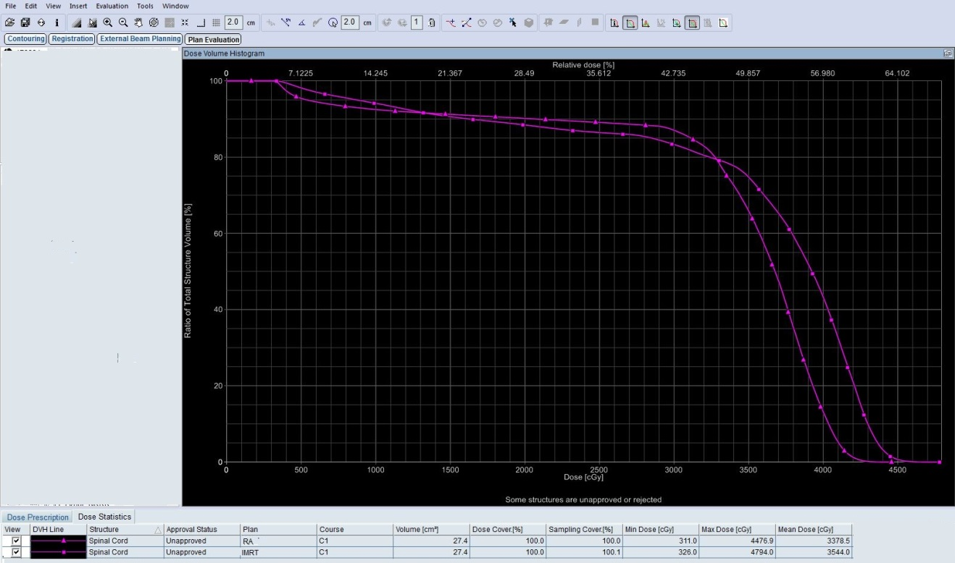
5.1  IMRT  RA  IMRT  RA | 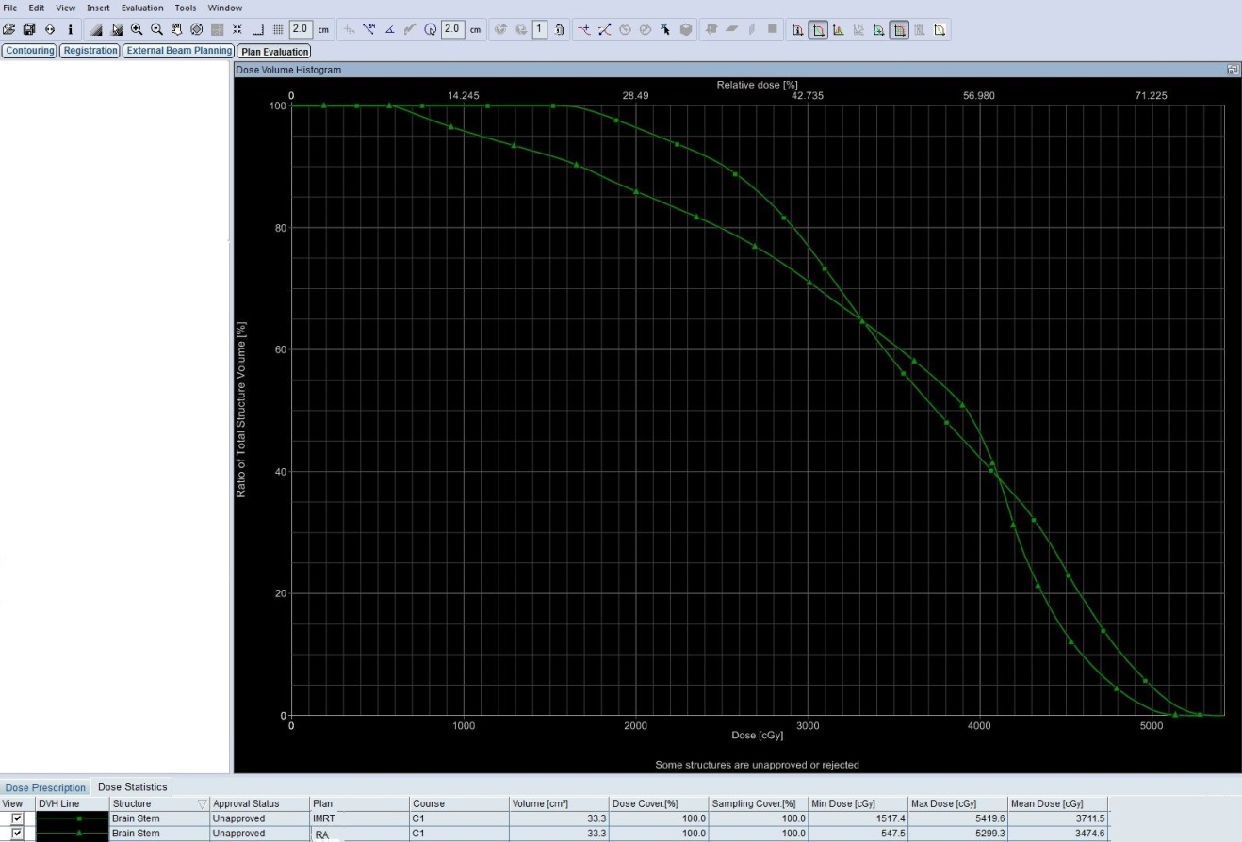5.2  IMRT  RA
Fig.5: A comparative DVH for both techniques regarding dose received by (5.1) spinal cord and (5.2) brainstem (▄ IMRT, ▲VMAT)

3. Spinal cord and brainstem
3. Spinal cord and brainstem
As shown in Table(3), maximum doses to the spinal cord, brainstem was comparable in both plans but there was statistically significant difference that patients treated by VMAT had lower maximum doses to spinal cord and brain stem compared with patients treated by IMRT. The maximum dose to the spinal cord was 46.1 Gy for those treated by IMRT compared with 44.7 Gy among patients treated by VMAT (p-value >0.03). As for the brainstem, the maximum dose was 55.8 Gy among patients treated by IMRT compared with 54.1 Gy for those treated by VMAT (p-value >0.02) there was a statistically significant difference favoring VMAT in sparing the spinal cord and brainstem (Figure 5).
4. Oral mucosa
As shown in table (3) and Figure(6), IMRT was significantly associated with increased mean dose to the oral cavity mucosa that was 38.3 Gy compared to 36.42 Gy in patient treated with VMAT(p = ˂0.001).

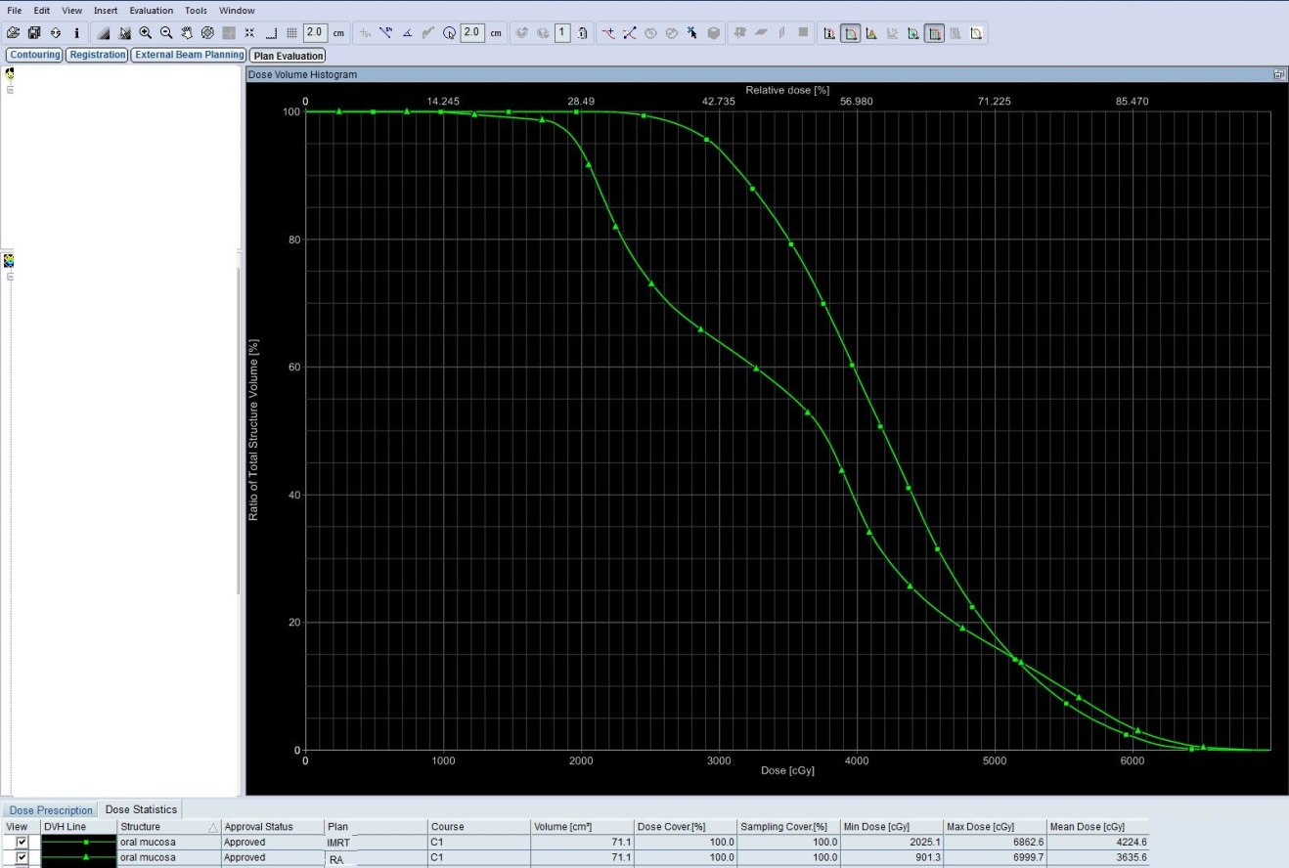
IMRT
RA

Figure 6, demonstrates a comparative DVH for both techniques regarding dose received by oral mucosa (▄ IMRT, ▲VMAT)

5. Opticchiasma
As shown in table (3), there was no significant difference between maximal dose received by optic chiasma by VMAT or IMRT (P=0.33).
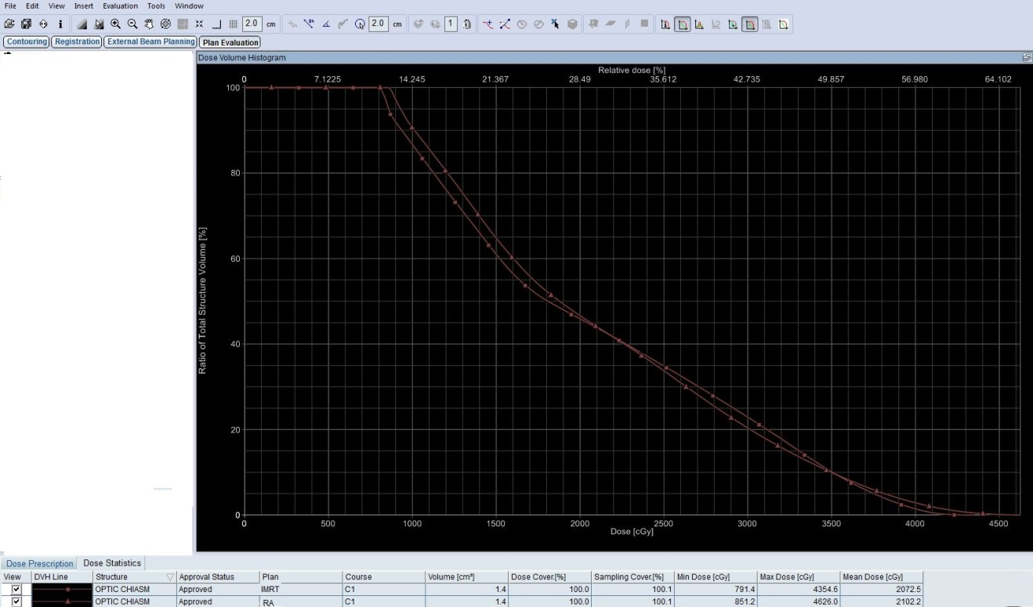
IMRT
RA

Figure 7 (▄ IMRT,▲VMAT), is a comparative DVH for both techniques regarding dose received by optic chiasma in acase of nasopharyngeal carcinoma) that showing acomparable results

C) Treatment delivery time
Table 4, showing the mean delivery time for IMRT is 13.39 minutes compared to 5.39 minutes for VMAT this means that VMAT can shortened treatment delivery time by about 41.8% compared to IMRT (p value ˂0.001). Also VMAT has statistically significant lower monitor unites (mu), (p value ˂0.001).

Table 4: Treatment delivery time for both IMRT and VMAT technique
 |  | IMRT Treatment Delivery time(minutes) | VMAT Treatment Delivery time (minutes) | MuIMRT | MuVMAT
Mean |  | 13.39 | 5.39 | 705.33 | 567.67
Std. Deviation |  | 0.98 | 0.98 | 90.19 | 50.08
Minimum |  | 12 | 4 | 612 | 516
Maximum |  | 15 | 7 | 792 | 616
Paired t |  | 98.96 |  |  | 4.08
P |  | <0.001** |  |  | 0.001**

4. Discussion
This Study is a comparative dosimetric study between two groups of patients, the first group (group A), 38 patient will be prospectively selected to be planned with IMRT planning system to deliver a total dose 70 Gray to GTV (group B). All patient in group A will be replanned using VMAT planning system to deliver the same dose to GTV.
Several dosimetric studies have demonstrated a comparable or better PTV coverage and conformity, as well as better saving of OARs for VMAT compared to IMRT, while delivery times were shortened. (Holt et al. 2013 Wilko et al. 2008; Kan et al. 2014).
In our study both groups include the same patients. The mean age of these patients was 47.4 years old, 68.4% of them were males, 78.9% 0f them had performance status more than 70%, all of them had squamous cell carcinoma with 42.2% were grad 3, nasopharyngeal carcinoma was the most common primary site and 68.5% of them were clinically stage3.(8).
Holt et al. (2013) included five patients in a comparative dosimetric study these patients were previously treated with IMRT then there CT data sets including contouring reused for VMAT planning of the same patients then both plans compared dosimetrically. The included patients were two patients have carcinoma of the base of the tongue and three patients have tonsillar carcinoma. (6).
Wilko et al. (2008) included 12 patients in a comparative dosimetric study 7 patients had oropharyngeal carcinoma,4 had nasopharyngeal carcinoma and one patient had hypopharyngeal carcinoma. 5 patients were stage 4,5 patients were stage 3 and 2 patients were stage 2.(7).
Our study revealed statistically significant difference between VMAT & IMRT as regard dose distribution within the target that PTV coverage was better in the VMAT plans than the IMRT, V95% (volume of the target received 95% of the prescribed dose) was better in the VMAT plans, the mean value was 97.26% (range, 94.7-99.4) and 95.18% (range, 91.2-97.8) respectively, with (p-value ˂0.001).
Also the maximal dose within the target (V107%) was higher (more hot spot) in the IMRT plans, its mean value was 0.18% and 0.08 for the IMRT and VMAT plans respectively (p-value 0.04). Additionally VMAT delivered higher minimum PTV dose (65.91 Gy), which was 1.34 Gy higher than the IMRT plane (64.57Gy) (p value ˂0.001).
Conformity index (CI) was also better in the VMAT plans which denoting better PTV coverage, the mean CI was 0.97 and 0.94 for VMAT & IMRT respectively with statistically significant difference (P<0.005).
Homogeneity index (HI) was also better in the VMAT plans it, the mean HI was 1.04 and 1.06 for VMAT & IMRT respectively (P<0.005) denoting statistically significant difference.
Holt et al. (2013) reported a better dose distribution within the target for VMAT plans versus IMRT plans this was reflected in steeper dose fall of for the corresponding DVHs of the different PTVs and also significantly smaller conformity index(CI) in VMAT plans. The CI95, defined by the ratio of total volume receiving 95% of the prescribed doses and the volume osf the PTV receiving the same dose, was found to be significantly better with VMAT plans compared to IMRT (the mean CI was 1.5± 0.09 and 1.62±0.10 for VMAT & IMRT respectively (P value <0.005) denoting statistically significant difference.(6).
Wilko et al. (2008) reported that the dose homogeneity within the PTV was largely improved by double arc rapid arc(RA) compared with the single arc RA and IMRT as appears from the standard deviations of the PTV dose, and from the V<95 and V>107 though these last two do not show the same significance, the standard deviations of the PTV dose was 1.4 Gy, 2Gy, 1.7Gy for double arc RA, single arc RA and IMRT respectively (P value 0.014), the average value of V<95(volume of the PTV received less than 95% of the prescribed dose)was 0.6%, 1.6% and 1.2% for double arc RA, single arc RA and IMRT respectively (P value 0.097), the average value of V>107 (hot spots) was 3.0%, 13.7%, 6.8% for double arc RA, single arc RA and IMRT respectively(P value 0.043), Also conformity index was best for double arc RA plans with statistically significance difference(the mean value of CI was 1.24, 1.21, 1.14 for double arc RA, single arc RA and IMRT respectively (P value 0.014).(7).
Kan et al. (2014) reported as similar conformity index among three types of planning techniques (triple arc RA, double arc RA and IMRT) the average CI was 0.86±0.02, 0.85±0.03, 0.86±0.02 for triple arc RA, double arc RA and IMRT respectively (P value 0.63 for IMRT VS. triple arc RA and 0.10 for triple arc RA VS. double arc RA). The highest averaged HI value for the double-arc plans indicated that it produced slightly inferior dose homogeneity than that of the IMRT and triple-arc RA plans (the average HI value was 5.30±0.57, 5.92±0.38 and 5.14±0.41 for triple arc RA, double arc RA and IMRT respectively (P value 0.43 for IMRT VS. triple arc RA and 0.00 for triple arc RA VS. double arc RA). When looking at the V<95%, there is no significant difference in PTV coverage between the three plans, the average V<95% was 0.00 ±0.00, 0.00 ±0.00 and 0.01±0.02 for triple arc RA, double arc RA and IMRT respectively (P value was 0.11 for IMRT VS. triple arc RA and 0.16 for triple arc RA VS. double arc RA). V>105% was 0.4% for IMRT, 5.6% for triple-arc RA, and 7.8% for the double-arc RA, indicating that more hot areas appeared in RA plans. These results of non significant difference in dose distribution within the PTV between IMRT and triple arc RA and slightly inferior results of double arc RA may be due to that the all included patients are of early stage nasopharyngeal carcinoma so this small target can be covered adquately by the three techniques. (8).
In this study the comparison of the DVHs of different OARs revealed that VMAT delivered lower doses to these risk organs than IMRT with statistically significant difference except for optic chiasma the difference was not statistically significant (but both plans respect the dose constrains for all OARs).
The mean value of the maximal dose delivered to optic chiasma was 48.8 Gy and 48.9 Gy by VMAT and IMRT respectively (p value 0.33).
VMAT also provide more sparing for both parotid glands, the mean value of the mean dose to the right parotid was 22.58Gy and 24.57Gy for VMAT and IMRT respectively (p<0.001), as regard left parotid the mean dose was 23.63 Gy, 28.46 Gy for VMAT and IMRT respectively (p value 0.01).
Also there was statistically significant difference between the mean dose delivered by the cochlea favoring VMAT plans, for the right cochlea the average mean dose was 40.91 Gy and 43.16 Gy for VMAT and IMRT respectively (p value 0.02)and for the left cochlea average mean dose was 40.47 Gy and 41.79 Gy for VMAT and IMRT respectively (p <0.001).
The average value of the maximum dose (Dmax) received by the spinal cord was 44.7 Gy and 46.1 Gy for VMAT and IMRT plans respectively (p 0.03),as regard the brain stem the average value of Dmax was 54.1 Gy and 55.8 Gy for VMAT and IMRT respectively (p 0.02) indicating statistically significant difference favoring VMAT plans.
VMAT significantly reduce the mean dose received by the oral mucosa than the IMRT (the average value was 36.42 Gy and 38.3 Gy for VMAT and IMRT respectively) (p<0.001).
Andrea Holt et al.,(2013) reported that the VMAT allow more dose reduction to different OARs than IMRT, the Dmax to the spinal cord was 45.1±3.5 and 46.6±3.0 for VMAT and IMRT respectively(p value 0.001) and Dmax to the brain stem was 46.4±5.4 and 47.1±4.7 for VMAT and IMRT respectively(p value 0.641) indicating statistically significant difference for the spinal cord but not for the brian stem but both favored VMAT plans. also there was a significant lower average mean dose (Dmean) for the ipsilateral and contralateral parotid glands and oral mucosa that the Dmean to the ipsilateral parotid gland was 28.0±7.5 and 31±9.1 for VMAT and IMRT respectively(p value 0.001), for the contralateral parotid gland Dmean was 22.0±2.9 and 23.3±2.8 1for VMAT and IMRT respectively(p value 0.001) the Dmean for the oral mucosa was 36.7±7.8 Gy and 39.4±7.3 Gy for VMAT and IMRT respectively (p value 0.001) so VMAT was significantly better than IMRT in sparing OARs.(6).
Wilko F. (2009) reported the double arc RA achieve a similar OARs sparing as seen in the IMRT plans that the average Dmean for the left parotid was 34 Gy and 35 Gy 1for VMAT and IMRT respectively(p value 0.347), and for the right parotid was 36 Gy and 35 Gy 1for VMAT and IMRT respectively(p value 0.384) the Dmean for the oral mucosa was 36 Gy and 35 Gy for VMAT and IMRT respectively(p value 0.238) so VMAT achieved at least similar sparing OARs as IMRT. (7).
Kan.,(2012) reported that the average Dmean to the parotid glands were reduced by 12% and V30 also reduced by 17% by the triple arc RA plan versus IMRT plan, but the average Dmean to the parotid glands was comparable between the IMRT and double arc RA plans while the average V30 was 15% higher in the double arc RA than the IMRT plans indicating that the double arc RA plan produced inferior sparing of the parotid glands IMRT plan and there was improved parotid sparing with the triple arc RA plan versus IMRT plan (p value 0.00), also triple arc RA plan produced better sparing of the spinal cord compared to both IMRT and double arc RA plans which was statistically significant difference that the Dmax in the spinal cord was 41.44±1.63,41,28±1.18, 40.16±0.84 for IMRT, double arc RA and triple arc RA respectively(p valu 0.00 for triple arc RA plan versus IMRT plan and 0.03 for double arc RA plan versus triple arc RA plan), there was no statistically difference between the three plans as regard pituitary Dmean, it was 38.26 ±10.94,36,11 ±9.26 and 36,61 ±9.25 for the IMRT, double arc RA and triple arc RA respectively(p value 0,13 for triple arc RA plan versus IMRT plan and 0.88 for double arc RA plan versus triple arc RA plan)
In our study VMAT shortened the treatment delivery time by 41.8% compared to IMRT (p value <o.05) also the mean value of the total monitor units (Mu) was smaller in VMAT plans than IMRT plans with statistically significant difference it was 571 (range, 516-616) and 712(range, 612-792) for VMAT and IMRT respectively with statistically significant difference favoring VMAT plans.(8).
Holt et al. (2013) reported that VMAT reduced the treatment delivery time by 50% compared to IMRT, the average effective delivery time for VMAT (defined as the time from start of the first arc and the end of the second arc)was 5:54(minutes: seconds) (range, 4:18-7:57) (p value <0.05), also fewer Mu were needed in the VMAT plans than the IMRT plans with statistically significant difference that the average value was 642 and 828 for VMAT and IMRT plans respectively, Indicating statistically significant difference favoring VMAT plans as regard shorter treatment delivery time and fewer Mu.(6).
Wilko et al. (2009) reported a significant reduction in the treatment delivery time for VMAT versus IMRT, delivery time of 2 Gy require <80 seconds with single arc RA and <3 minutes with double arc RA plans and 8-12 minutes for IMRT plans which is a major advantage for the VMAT. also Mu was reduced in the VMAT with the average total Mu was 459, 439 and 1108 for double arc RA, single arc RA and IMRT plans respectively(p valu 0.00)(7).

Conclusion
VMAT technique had a significantly better dose distribution than IMRT as regard both dose homogeneity and conformity indices also VMAT technique provided a significantly better sparing of OARs than IMRT technique with significant reduction in treatment delivery time which is a major advantage of the VMAT technique over IMRT technique which is more comfortable to the patient and reduce the intrafractional movement, also allow higher number of patients to be treated per day so VMAT is considered as a more advantageous radiation treatment technique than IMRT for treatment of head and neck carcinoma.

Reference
- Mirimanoff RO, Wang CC, Doppke KP.: Combined surgery and postoperative radiation therapy for advanced laryngeal and hypopharyngeal carcinoma. Int J Radiat Onco Biolphys 1993; 26:3-a prospective randomized trial. int J Radiat Oncol Biolphys 1993;26:3-11.
- Vergeer MR, Doornaert PA, Rietveld DH, Leemans CR, Slotman BJ, Langendijk JA: Intensity-modulated radiotherapy reduces radiation induced morbidity and improves health-related quality of life: results of a nonrandomized prospective study using a standardized follow-up program. Int J Radiat Oncol Biol Phys 2009, 74:1–8.
- Van Rij CM, Oughlane-Heemsbergen WD, Ackerstaff AH, Lamers EA, Balm AJ, Rasch CR: Parotid gland sparing IMRT for head and neck cancer improves xerostomia related quality of life. RadiatOncol 2008, 3:41.
- Nutting CM, Morden JP, Harrington KJ, Urbano TG, Bhide SA, Clark C, et al. on behalf of the PARSPORT trialmanagement group. Parotid-sparing intensity modulatedversus conventional radiotherapy in head and neck cancer (PARSPORT): a phase 3 multicentrerandomised controlled trial. Lancet Oncol 2011;12:127–136.
- Bertelsen A, Hansen CR, Johansen J, Brink C: Single Arc volumetric modulated Arc therapy of head and neck cancer. Radiother Oncol 2010,95:142–148.
- Andrea Holt etal.: Multi-institutional comparison of volumetric modulated arc therapy vs. intensity-modulated radiation therapy for head-and-neck cancer: a planning study. Radiation Oncology 2013 8:26.
- Wilko F. A. R. et al. (2009): Volumetric Intensity-Modulated Arc Therapy Vs. Conventional Imrt In Head-And-Neck Cancer: A Comparative Planning And Dosimetric Stud, Department of Radiation Oncology, VU University Medical Center, De Boelelaan 1117, 1081 HV Amsterdam, The Netherlands, Int. J. Radiation Oncology Biol. Phys., Vol. 74, No. 1, pp. 252–259, 2009.
- Monica W. K. Kan et al.,(2012): A comprehensive dosimetric evaluation of using Rapid Arc volumetric- modulated arc therapy for the treatment of early- stage nasopharyngeal carcinoma, epartment of Oncology, 1 Princess Margaret Hospital, Hong Kong SAR; Department of Physics and Materials Science,2 City University of Hong Kong, Jou RnALoFAPPLIEdcLInIcALMEdIcAL PHYSIcS, VoLuME 13, nuMBER 6, 2012.

9/5/2016

