Evaluation of TAZ and PKM2 expression in gastric signet ring cell carcinoma

Aliaa Atef, MD and Mohammed Alrashidy, MD.

Department of Pathology, Faculty of medicine, University of Tanta, Egypt.
dr-aliaaatef@hotmail.com

Abstract: Background: Gastric cancer is the fourth most common cancer and the second cause of cancer-related death worldwide. Signet ring cell carcinoma SRCC is a histologic subtype characterized by poor differentiation, strong invasive tendency and poor prognosis. Transcriptional coactivator with PDZ-binding motif (TAZ) is known to bind to a variety of transcription factors to control cell differentiation and organ development. PKM2 (M2 isoform of pyruvate kinase) was identified as a driver of aerobic glycolysis, leading to cell growth and tumor development. Materials and methods: This study was carried out on 46 gastric SRCC cases received as paraffin blocks and as fresh specimens. Results: The immunohistochemical expression of TAZ was positive in the cytoplasm and nuclei of 38 out of 46 (82.6%) gastric SRCC samples. PKM2 expression was also investigated in all 46 gastric SRCC cases. PKM2 expression was positive in 40 (87%) out of 46 cases. PKM2 expression was positive in gastric SRCC compared to negative adjacent normal gastric glands from the same patients. Conclusions: These results show that TAZ and PKM2 might be considered as targets for the treatment of gastric SRCC in the future.
[Aliaa Atef and Mohammed Alrashidy. Evaluation of TAZ and PKM2 expression in gastric signet ring cell carcinoma. Cancer Biology 2016;6(3):42-49]. ISSN: 2150-1041 (print); ISSN: 2150-105X (online). http://www.cancerbio.net. 6. doi:10.7537/marscbj060316.06.

Keywords: TAZ, PKM2, Signet ring cell carcinoma

1. Introduction:
Gastric cancer is the fourth most common cancer with the leading causes of cancer death in East Asian countries and some western countries [Cho et al., 2011 and Jemal et al., 2011]. Signet ring cell gastric carcinoma (SRCC) is a histologic diagnosis based on microscopic characteristics as described by the World Health Organization [Hamilton and Aaltonen, 2004].Signet ring cell carcinoma is characterized by cells with abundant mucin in the cytoplasm and nuclei located at the cell periphery. It has long been thought to have a worse prognosis than other forms of gastric cancer [Taghavi et al., 2012]. The genetic background of SRCC has rarely been investigated, and the molecular basis of their growth and differentiation still remains unclear. Therefore, studies of the molecular profile of gastric SRCC and identification of new molecular markers are both relevant to improve the diagnosis and the prognosis of the tumor.
Transcriptional coactivator with PDZ-binding motif (TAZ), also called WW-domain containing transcription regulator 1 (WWTR1), has been defined for its role in the nucleus [Di Palma et al., 2009]. It functions directly as a transcriptional regulator by interacting with several nuclear factors and plays a central role in the Hippo pathway, which regulates the size and shape of organ development [Varelas et al., 2008]. TAZwas described as controlling gene important for muscle differentiation, lung and respiratory epithelial differentiation, cardiac and limb development, adipogenesis and osteogenesis, and tumorigenesis. TAZ has been identified as an oncogene and has an important role in tumorigenicity of many cancers, such as non-small cell lung cancer [Xie et al., 2012], papillary thyroid carcinoma [De Cristofaro et al., 2011], and colon cancer [Yuen et al., 2013]. They found that TAZ gene expression signature was over-represented in poorly differentiated tumors compared with well-differentiated low-grade tumors. Importantly, TAZ confers cancer stem cell-related traits in breast cancer cells [Zhao et al., 2012], further highlighting its importance in tumor initiation and progression.
Cancer cells take up glucose at higher rates than do normal cells but produce energy mainly by glycolysis, rather than by mitochondrial oxidation of pyruvate. This process, called aerobic glycolysis or the Warburg effect, is very important for tumor growth [Mazurek, 2011]. Glycolysis increases lactate production resulting in acidification of the extracellular environment, which is believed to facilitate cell invasion and metastasis [Gatenby & Gillies 2004]. The M2 isoform of pyruvate kinase (PKM2) was identified as a driver of aerobic glycolysis, and has been shown to be the isoform preferentially overexpressed in tumor cells. Other isoenzymes of pyruvate kinase (pyruvate kinase type M1, pyruvate kinase type L, pyruvate kinase type R) are expressed depending upon the metabolic responsibilities of the various non-cancerous cells and tissues.PKM1 and PKM2 aresplicing products of the M-gene (exon 9 for PKM1 and exon 10 for PKM2) and solely differ in 23 amino acids within a 56-amino acid stretch (aa 378-434) at their carboxy terminus [Christofk et al., 2008].
Two missense mutations (H391Y and K422R) of pyruvate kinase M2 enzyme were found in cells from patients prone to develop cancer. Results show that despite the presence of mutations in the inter-subunit contact domain, the K422R and H391Y mutant proteins maintained their homotetrameric structure, similar to the wild-type protein, but showed a loss of activity of 75 and 20%, respectively. Interestingly, H391Y showed a 6-fold increase in affinity for its substrate phosphoenolpyruvate and behaved like a non-allosteric protein with compromised cooperative binding. However, the affinity for phosphoenolpyruvate was lost significantly in K422R. Unlike K422R, H391Y showed enhanced thermal stability, stability over a range of pH values, a lesser effect of the allosteric inhibitor (Phe), and resistance toward structural alteration upon binding of the activator (fructose 1,6-bisphosphate) and inhibitor (Phe). Both mutants showed a slight shift in the pH optimum from 7.4 to 7.0 [Akhtar et al., 2009]. Interestingly, cells co-expressing PKM2 and mutant (K422R or H391Y) showed significantly aggressive cancer metabolism, compared to cells expressing either wild or mutant PKM2 independently [Iqbal et al., 2014].
PKM2 expression correlates with tumorigenesis. A unique pattern of four expressed genes, including PKM2, was reported to predict outcomes for some tumors [Gordon et al., 2009]. Events that negatively impact tumorigenesis can also reduce PKM2 function. Vitamins K3 and K5 inhibit tumorigenesis along with potently inhibiting PKM2 activity [Chen et al., 2012]. Shikonin, a derivative of a Chinese herb with antitumor activities, induces necrosis and inhibits PKM2 expression in cancer cell lines [Chen et al., 2012]. A reverse correlation was observed between antitumor microRNA-326 and PKM2 in glioma [Kefas et al, 2010]. Finally, the Spry2 tumor suppressor was reported to inhibit hepatocarcinogenesis via the MAPK and PKM2 pathways [Wang et al., 2012].Furthermore, PKM2 possesses activities that directly promote tumorigenesis. Overexpression of PKM2 upregulates Bcl-xL and promotes the proliferation and migration of cancer cells [Kwon et al., 2012 and Zhou et al., 2012]. Knockdown of PKM2 using specific siRNA inhibited cancer cell’s proliferation and invasion in vitro and the formation of xenograft tumors in vivo [Kefas et al., 2010 and Goldberg & Sharp, 2012].
Under hypoxic conditions, cells metabolize glucose by anaerobic glycolysis, a process that is regulated by two master transcription factors, hypoxia-inducible factor (HIFs), and c-Myc. Both transcriptional factors are also critical for aerobic glycolysis in cancer cells. Consistent with PKM2 being essential for aerobic glycolysis, a relationship exists among HIF-1, c-Myc, and PKM2 [Gordan et al., 2007].
HIF-1 is a heterodimeric transcription factor, consisting of HIF-1α and HIF-1β. The β subunit is constitutively expressed, while the α subunit is directly regulated by oxygen (O₂) levels [Semenza, 1998]. Under normoxic conditions, HIF-1α is hydroxylated at prolines (P) 402 and 564 by three prolyl hydroxylase domain proteins (PHD1-3) in the presence of oxygen, α-ketoglutarate, iron, and ascorbate. This results in the ubiquitination of prolyl-hydroxylated HIF-1α by the von Hippel-Lindau (VHL) tumor suppressor and the subsequent degradation of HIF-1α [Jaakkola et al., 2001]. Under hypoxic conditions, HIF-1α is stabilized as a result of inhibiting prolyl hydroxylation, allowing HIF-1α to dimerize with HIF-1β in the nucleus. This leads to transcription of a set of genes to cope with reduced O₂ availability [Kaelin & Ratcliffe 2008 and Song et al, 2008]. These target genes include those responsible for promoting glycolysis [Meijer et al., 2012]. HIF-1 transactivates the glucose transporters GLUT1 and GLUT3, hexokinase (the first kinase in the glycolysis pathway), lactate dehydrogenase A (LDHA), and pyruvate dehydrogenase kinase 1 which phosphorylates and inhibits pyruvate dehydrogenase (PDH)[Semenza, 2010].Consistent with the Warburg effect’s association with synthesis of cellular building blocks, HIF-1 also transactivates glucose-6-phosphate dehydrogenase (G6PD) to channel glucose-6-P into the pentose phosphate shunt for nucleotide and amino acid synthesis[Meijer et al., 2012]. Therefore, the collective actions of HIF-1 transcription activity seem to shift cells from oxidative metabolism to glycolysis. In line with these observations, PKM2 shares an intimate connection with HIF-1. The first intron of the PKM2 gene contains the functional hypoxia-response element (HRE), thus also making it a target of HIF-1 [Luo et al., 2011].
It was also discovered that cells with high levels of PKM2 also demonstrated high c-Myc activity [Clower et al., 2010 and David et al., 2010]. These observations are well in line with a large body of evidence indicating that c-Myc stimulates glycolysis and is required to coordinate with HIF-1 to regulate the cellular response to hypoxia. Thus, evidence suggests that PKM2 plays a role in c-Myc-mediated cancer metabolism and in c-Myc’s communication with HIF-1 [Gordan et al., 2007 and Miller et al., 2012].
However, more studies are needed for clarification of the exact biological function of PKM2 in cancer and its potential as an anti-cancer target. Therefore, we decided to analyze the role of TAZ and PKM2 expression in tumorigenesis in human gastric cancer patients.

2. Materials and methods:
We studied 46 cases diagnosed as gastric signet ring carcinoma by two pathologists. Samples were collected as formalin-fixed, paraffin-embedded tissue blocks, with H&E stained slides from the archive of the pathology department of faculty of medicine, Tanta university and private labs (36) or received as fresh specimens taken by endoscopic biopsy (10). Immunohistochemistry was performed using the immunoperxoidase method on 4-m-thick sections from formalin-fixed, paraffin-embedded blocks. Pretreated sections were incubated with rabbit polyclonal TAZ antibody (1:200, Thermo Scientific, Egypt). Tissue was scored (H score) based on the total percentage of positive cells (≤5%) = 0, (6% - 25%) = 1, (26% - 50%) = 2, (51% - 75%) = 3, and (>75%) = 4) and the intensity of the staining (0, 1, 2, or 3), where 𝐻is the score of the percentage of positive cells multiply intensity score. The sample was considered negative if 𝐻= 0 and positive if 𝐻was more than 0. Positive samples were also categorized as weak (1+) if 𝐻= 1 to 4, middle (2+) if 𝐻= 5 to 8, and strong (3+) if 𝐻was more than 8. We grouped the cases as low expression with (+1) H score and high expression with (+2) and (+3) H score [Yue et al., 2014]. Antibody to PKM2 (1:500, Thermo Scientific, Egypt) was also applied to the sections. The degree of immunostaining was scored according to the proportion of positively stained tumor cells and the intensity of staining. Tumor cell proportion was classified as follows: 0% (negative), 10%-25% (weak), 25%-50% (moderate), and > 50% (strong) PKM2-positive tumor cells. Staining intensity was classified as none, weak and strong staining. We assessed PKM2 expression in non-cancer gastric epithelial cells and malignant lesions. Tumors with more than 25% PKM2-positive cells were considered tumors with positive PKM2 expression, and those with less than 25% PKM2-positive cells were considered negative for PKM2 expression [Lim et al., 2012]. For both antibodies, the antigen retrieval (PBS buffer; pH 7.4) was done for all sections and were incubated with the primary antibody for 2 h at room temperature. The sections were incubated with secondary antibody (HRP-Rabbit/Mouse) for 15 min at room temperature. As a negative control, a section was processed in which the primary antibody was changed by PBS. Immunohistochemical staining was evaluated independently by two pathologists.
Statistical analysis was performed by using Associations between two categorical variables were done by two sample 't' test/Mann Whitney/Analysis of variance/Kruskal-Wallis test. A P value of less than 0.05 was considered statistically significant.

Results:
Immunohistochemical staining results of TAZ:
TAZ protein expressions were positive in 38 out of 46 (82.6%) gastric SRCC samples. TAZ had nuclear and cytoplasmic expression. H score was weak (+1) in 9 cases (low expression), moderate (+2) in 16 cases and strong (+3) in 13 cases (high expression in 29 cases) (Figure 1,2) (Table 1). The correlation of TAZ expression with the clinicopathologic characteristics showed significant relation with the tumor size but no significant relation with age and sex (Table 2).

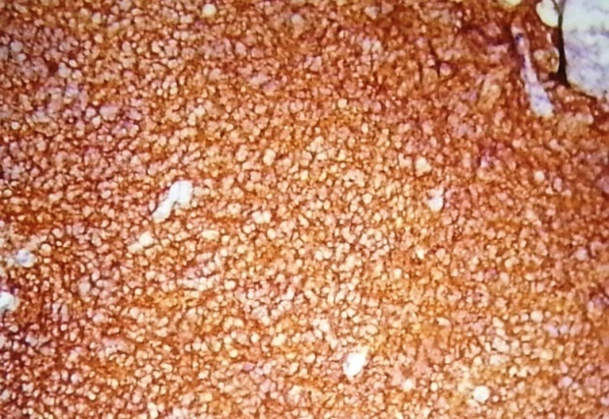
Fig. (1): TAZ protein expression in SRCC showing cytoplasmic and nuclear staining with H score = 12 (x100)

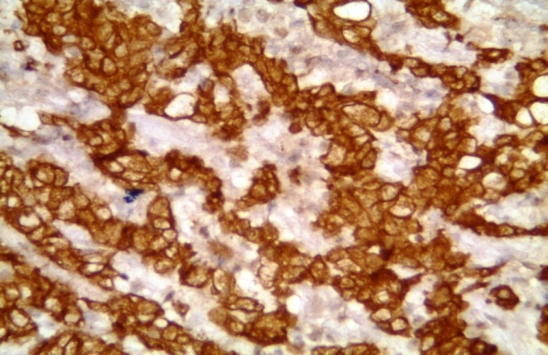
Fig.(2): Cytoplasmic and nuclear expression of TAZ protein in the malignant signet ring cells in a case of SRCC with H score = 6 (x200).

Table (1): The immunohistochemical staining results of TAZ in SRCC cases:
 | Immunohistochemical expression of TAZ in SRCC
 | 0 (Negative)  N = 8 | (Weak H score)  N = 9 | (Moderate H score)  N = 20 | (Strong H score)  N = 9
Intensity of staining  +1  +2  +3 | 0  0  0 | 4  4  1 | 0  11  9 | 0  0  9
Percentage of positive cells  +1  +2  +3  +4 | 0  0  0  0 | 5  3  1  0 | 0  9  9  2 | 0  0  6  3

Table (2): The relation of TAZ expression with the clinical characters of SRCC:
Clinical characters | Low expression  N = 9 | High expression  N = 29 | P
Age  <60  >60 | 4  5 | 13  16 | 0.237
Sex  Male  Female | 7  2 | 25  4 | 0.154
Size  <5cm  >5cm | 6  3 | 7  22 | 0.041*
*Statistically significant (P<0.05).

Immunohistochemical staining results of PKM2:
PKM2 expression was positive in 40 (87%) out of 46 cases. Twelve cases (30%) showed weak positive PKM2 expression, 15 cases (37.5%) showed moderate staining and 13 cases (32.5%) showed strong expression. PKM2 was mainly localized in the cytoplasm of cancer cells. Diffuse and/or intense cytoplasmic statining was noted in only cancer cells. In contrast, PKM2 was either undetectable or only marginally detectable in the normal epithelial gastric body gland from the same patients (Figure. 3,4). Stastical analysis showed significant correlation between positive PKM2 expression and tumor size (Table 3). In the same time, there was a significant difference in expression between tumorous and non-tumorous tissues (Table 4).

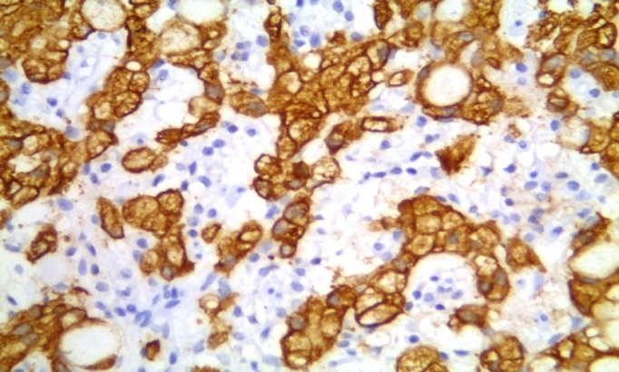
Fig. (3): PKM2 cytoplasmic immunohistochemical expression in malignant signet ring cells (x400).

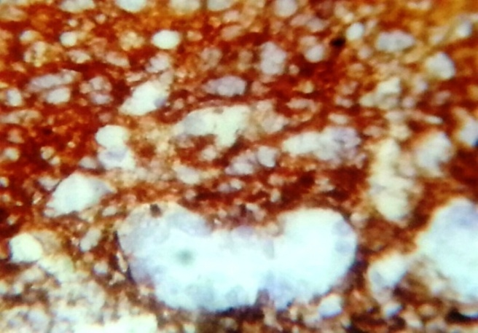
Fig.(4): Cytoplasmic expression of PKM2 in malignant signet ring cells with negative expression in the neighbouring normal (not involved) gastric gland (x400).

Table (3): The correlation of PKM2 expression with the clinical characteristics of SRCC cases:
Clinical characters | Positive expression  N = 40 | Negative expression  N = 6 | P value
Age  <60  >60 | 27  13 | 2  4 | 0.232
Sex  Male  Female | 23  17 | 3  3 | 0.136
Size  <5cm  >5cm | 9  31 | 5  1 | 0.024*

Table (4): Immunohistochemical expression of PKM2 in tumorous and non tumorous gastric tissues:
 | Negative PKM2 expression | Positive PKM2 expression
Signet ring cell carcinoma | 6 | 40
Adjacent non-cancerous glands | 46 | 0
P value | 0.031*

4. Discussion:
In this study, we reported the characterization of TAZ and PKM2 immunohistochemical expression in human gastric signet ring cell carcinomas. TAZ is a transcriptional coactivator that is inhibited by Hippo signalling pathway which regulates cellular proliferation and survival, thus exerting profound effects on normal cell fate and tumorigenesis [Yang et al., 2012]. Aberrant inactivation of the Hippo pathway and/or overexpression of TAZ results. in transcriptional activation of their downstream targets. TAZ overexpression induces cell proliferation and epithelial-mesenchymal transition (EMT) and inhibits apoptosis and contact inhibition. EMT is a process in which cells lose epithelial-like characteristics, such as cell-cell adhesion and polarity, and acquire mesenchymal properties that include increased motility [Zhang et al., 2009]. We found that TAZ expression was positive in 82.7% of the studied SRCC cases with significant correlation with the increasing tumor size.
Yue et al., 2014, reached similar results when they noticed positive immunohistochemical expression of TAZ in 113 (77.4%) out of 146 gastric cancer samples. They stated that high expression of TAZ protein was observed with higher percentage in gastric cancer samples with histology of SRCC than conventional adenocarcinomas. Wang et al., 2013, also examined TAZ expression in colorectal carcinoma. They found that 57.8% of the studied cases showed positive expression of TAZ protein indicating a potential correlation between this protein in colorectal carcinoma. In non small cell lung carcinoma, Xie et al., 2012, demonstrated that TAZ expression was observed in 121 of the 181 (66.8%) specimens with nuclear and cytoplasmic expression.
Similarly, Li et al., 2014 noticed that the positive expression of TAZ protein in glioma tissues was significantly higher than that in normal brain tissue (79.2% vs 15.4%) suggesting that TAZ play a key role in initiation and propagation of human glioma. Chan et al., 2008, also studied TAZ expression in breast cancer cells but they noted that TAZ is overexpressed in only 20% of breast cancer samples.
In contrast, Sun et al., 2014, found that TAZ protein showed a strictly nuclear staining pattern in adenocarcinoma of the esophagogastric junction and dysplasia with immunohistochemistery. Expression of TAZ was higher in dysplasia and adenocarcinoma compared with normal mucosa. TAZ was observed in normal mucosa 16.2%, dysplasia 70.7%, and adenocarcinoma of the esophagogastric junction 40.7%.
On the other hand, it is thought and often quoted in literature that PKM1 is found in many normal differentiated tissues, whereas PKM2 is expressed in most proliferating cells, including all cancer cell lines and tumors [Vander Heiden et al., 2010 and Wong et al., 2013]. Several studies have shown that PKM2 is selectively stained in cancer cells in immunohistochemical assay. It has been suggested that plasma PKM2 could be a valuable tumor marker for diagnosis or monitoring of lung, pancreas, kidney, breast, tongue, and gastrointestinal cancers [Wechsel et al., 1999, Lüftner et al., 2000, Shneider et al., 2002, Yoo et al., 2004, Wong et al., 2008]. However, little is known about the role of PKM2 in cancer and its usefulness in therapy. We found that PKM2 expression was positive in 87% of SRCC cases. 30% of the positive cases showed weak PKM2 expression, 37.5% showed moderate staining and 32.5% showed strong expression compared to the negative staining noticed in the adjacent non timorous tissue. Positive expression was significantly correlated to the larger tumor size.
These results were in approval with those found by Lim et al., 2012. They observed that PKM2 expression was increased more than 2-fold in primary gastric cancers compared to adjacent normal tissues from the same patients. PKM2 protein was detected in 144 of 368 (39.1%) human gastric cancer cases. Sawayama et al., 2014, also studied the expression of glycolytic enzymes as PKM2 in cancer cells. They suggested that PKM2 maybe a significant biomarker for predicting cancer prognosis and may be a therapeutic target in gastrointestinal cancer.
Wechsel et al., 1999, as well, stated that The isoenzyme PKM2 could be demonstrated in renal cell carcinoma and their metastases by immunohistochemistry with a monoclonal antibody specific for pyruvate kinase type M2. In normal kidney cells PKM2 is not detectable. In a similar study, Schneider et al., 2002, studied PKM2 expression in lung cancer and noted that immunohistochemical detection of pyruvate kinase M2 in tissue sections of lung cancer specimens showed selective staining of tumor cells. In addition, immunohistochemical staining results of PKM2 observed by Wong et al., 2008, suggested that PKM2 was overexpressed in tongue squamous cell carcinoma.

Conclusion:
It is important to identify new molecular markers to personalize treatments according to the individual biology of each cancer. Therefore, TAZ as well as PKM2 may play a key role in the discovery of new cancer target therapy.

Acknowledgments:
We wish to thank the department of pathology of faculty of medicine, Tanta university, for providing us with a large part of the cases from the archive of the department and making our work much easier.

References:
- Akhtar K, Gupta V, Koul A, Alam N, Bhat R and Bamezai RN (2009): Differential behavior of missense mutations in the intersubunit contact domain of the human pyruvate kinase M2 isozyme. J Biol Chem. 284, 11971–81.
- Chan SW, Lim CJ, Guo K et al. (2008): A Role for TAZ in Migration, Invasion, and Tumorigenesis of Breast Cancer Cells. Cancer Res, 68, 2592–8.
- Chen J, Jiang Z, Wang B et al. (2012): Vitamin K(3) and K(5) are inhibitors of tumor pyruvate kinase M2. Cancer Letters, 316, 204–10.
- Chen J, Xie J, Jiang Z, Wang B, Wang Y and Hu X (2012): Shikonin and its analogs inhibit cancer cell glycolysis by targeting tumor pyruvate kinase-M2. Oncogene, 30, 4297–306.
- Cho JY, Lim JY, Cheong JH et al. (2011): Gene expression signature- based prognostic risk score in gastric cancer. Clinical Cancer Research, 17, 1850–7.
- Christofk HR, Vander Heiden MG, Harris MH et al. (2008): The M2 splice isoform of pyruvate kinase is important for cancer metabolism and tumour growth. Nature, 452, 230-3.
- Clower CV, Chatterjee D, Wang Z et al. (2010): The alternative splicing repressors hnRNP A1/A2 and PTB influence pyruvate kinase isoform expression and cell metabolism. Proceedings of the National Academy of Sciences of the United States of America, 107, 1894–99.
- David CJ, Chen M, Assanah M et al. (2010): HnRNP proteins controlled by c-Myc deregulate pyruvate kinase mRNA splicing in cancer. Nature, 463, 364–8.
- De Cristofaro T, Di Palma T, Ferraro A et al. (2011): TAZ/WWTR1 is overexpressed in papillary thyroid carcinoma. European Journal of Cancer, 47, 926–933.
- Di Palma T, D’Andrea B, Liguori G et al. (2009): TAZ is a coactivator for Pax8 and TTF-1, two transcription factors involved in thyroid differentiation. Experimental Cell Research, 315, 162–75.
- Gatenby RA and Gillies RJ (2004): Why do cancers have high aerobic glycolysis? Nat Rev Cancer, 4, 891-9.
- Goldberg MS and Sharp PA (2012): Pyruvate kinase M2-specific siRNA induces apoptosis and tumor regression. Journal of Experimental Medicine, 209, 217–24.
- Gordan JD, Thompson CB and Simon MC (2007): HIF and c-Myc: sibling rivals for control of cancer cell metabolism and proliferation. Cancer Cell, 12, 108–13.
- Gordon GJ, Dong L, Yeap BY et al. (2009): Four-gene expression ratio test for survival in patients undergoing surgery for mesothelioma. Journal of the National Cancer Institute, 101, 678–86.
- Hamilton SR and Aaltonen LA (2004): World Health Organisation, Classification of tumours, Pathology and genetics of tumours of the digestive system. Pub. IARC Press, Lyon, 38-52.
- Iqbal MA, Siddiqui FA, Chaman N et al. (2014): Missense mutations in pyruvate kinase M2 promote cancer metabolism, oxidative endurance, anchorage independence and tumor growth in a dominant negative manner. J Biol Chem. 289, 8098-105.
- Jaakkola P, Mole DR, Tian YM et al. (2001): Targeting of HIF-α to the von Hippel-Lindau ubiquitylation complex by O₂-regulated prolyl hydroxylation. Science, 292, 468–72.
- Jemal A, Bray F, Center MM et al. (2011): Global cancer statistics. CA Cancer Journal for Clinicians, 61, 134.
- Kaelin WG and Ratcliffe PJ (2008): Oxygen sensing by metazoans: the central role of the HIF hydroxylase pathway. Molecular Cell, 30, 393–402.
- Kefas B, Comeau L, Erdle N, Montgomery E, Amos S and Purow B (2010): Pyruvate kinase M2 is a target of the tumorsuppressive microRNA-326 and regulates the survival of glioma cells. Neuro-Oncology, 12, 1102–12.
- Kwon OH, Kang TW, Kim JH et al. (2012): Pyruvate kinase M2 promotes the growth of gastric cancer cells via regulation of Bcl-xL expression at transcriptional level. Biochemical and Biophysical Research Communications, 423, 38–44.
- Li PD, Wang X-J, Shan Q et al. (2014): Evaluation of TAZ expression and its effect on tumor invasion andmetastasis in human glioma. Asian Pacific Journal of Tropical Medicine, 7, 757-60.
- Lim JY, Yoon SO, Seol SY et al. (2012): Overexpression of the M2 isoform of pyruvate kinase is an adverse prognostic factor for signet ring cell gastric cancer. World J Gastroenterol. 18, 4037-43.
- Lüftner D, Mesterharm J, Akrivakis C et al. (2000): Tumor type M2 pyruvate kinase expression in advanced breast cancer. Anticancer Res. 20, 5077-82.
- Luo W, Hu H, Chang R et al. (2011): Pyruvate kinase M2 is a PHD3-stimulated coactivator for hypoxia-inducible factor 1. Cell, 145, 732–44.
- Mazurek S (2011): Pyruvate kinase type M2: a key regulator of the metabolic budget system in tumor cells. Int J Biochem Cell Biol. 43, 969-80.
- Meijer TW, Kaanders JH, Span PN and Bussink J. (2012): Targeting hypoxia, HIF-1, and tumor glucose metabolism to improve radiotherapy efficacy. Clinical Cancer Research, 18, 5585–94.
- Miller DM, Thomas SD, Islam A et al. (2012): c-Myc and cancer metabolism. Clinical Cancer Research, 18, 5546–53.
- Sawayama H, Ishimoto T, Sugihara H et al. (2014): Clinical impact of the Warburg effect in gastrointestinal cancer. International journal of oncology, 45, 1345-54.
- Schneider J, Neu K, Grimm H et al. (2002): Tumor M2 pyruvate kinase in lung cancer patients: immunohistochemical detection and disease monitoring. Anticancer Res. 22, 311-18.
- Semenza GL (1998): Hypoxia-inducible factor 1: master regulator of O₂ homeostasis. Current Opinion in Genetics and Development, 8, 588–94.
- Semenza GL (2010): HIF-1: upstream and downstream of cancer metabolism. Current Opinion in Genetics and Development, 20, 51–6.
- Song LP, Zhang J, Wu SF et al. (2008): Hypoxia-inducible factor-1α-induced differentiation of myeloid leukemic cells is its transcriptional activity independent. Oncogene, 27, 519–27.
- Sun L, Chen F, Shi W et al. (2014): Prognostic impact of TAZ and β-catenin expression in adenocarcinoma of the esophagogastric junction. Diagnostic Pathology, 9, 125.
- Taghavi S, Jayarajan SN, Davey A and Willis AI (2012): Prognostic Significance of Signet Ring Gastric Cancer. J Clin Oncol, 30, 3493-8.
- Vander Heiden MG, Christofk HR, Schuman E et al. (2010): Identification of small molecule inhibitors of pyruvate kinase M2. Biochem Pharmacol. 79, 1118-24.
- Varelas X, Sakuma R, Samavarchi-Tehrani P et al. (2008): TAZ controls Smad nucleocytoplasmic shuttling and regulates human embryonic stem-cell self-renewal. Nature Cell Biology, 10, 837–48.
- Wang C, Delogu S, Ho C et al. (2012): Inactivation of Spry2 accelerates AKT-driven hepatocarcinogenesis via activation of MAPK and PKM2 pathways. Journal of Hepatology, 57, 577–83.
- Wang L, Shi S, Guo Z et al. (2013): Overexpression of YAP and TAZ Is an Independent Predictor of Prognosis in Colorectal Cancer and Related to the Proliferation and Metastasis of Colon Cancer Cells. PLoS ONE, 8.
- Wechsel HW, Petri E, Bichler KH, Feil G (1999): Marker for renal cell carcinoma (RCC): the dimeric form of pyruvate kinase type M2 (Tu M2-PK). Anticancer Res. 19, 2583-90.
- Wong N, De Melo J and Tang D (2013): PKM2, a Central Point of Regulation in Cancer Metabolism. Int J Cell Biol, Article ID 242513, 11 pages.
- Wong TS, Liu XB, Chung-Wai Ho A et al. (2008): Identification of pyruvate kinase type M2 as potential oncoprotein in squamous cell carcinoma of tongue through microRNA profiling. Int J Cancer, 123, 251-7.
- Xie M, Zhang L, He CS et al. (2012): Prognostic significance of TAZ expression in resected non-small cell lung cancer. Journal of Thoracic Oncology, 7, 799–807.
- Yang N, Morrison CD, Liu P et al. (2012): TAZ induces growth factor-independent proliferation through activation of EGFR ligand amphiregulin. Cell Cycle, 11, 2922-30.
- Yoo BC, Ku JL, Hong SH et al. (2004): Decreased pyruvate kinase M2 activity linked to cisplatin resistance in human gastric carcinoma cell lines. Int J Cancer, 108, 532-9.
- Yue G, Sun X, Gimenez-Capitan A et al. (2014): TAZ Is Highly Expressed in Gastric Signet Ring Cell Carcinoma. Bio Med Research International, Article ID 393064, 6 pages.
- Yuen HF, McCrudd CM, Huang YH et al. (2013): TAZ Expression as prognostic indicator in colorectal cancer. PLoS ONE, 8.
- Zhang H, Liu C-Y, Zha Z-Y et al. (2009): TEAD transcription factors mediate the function of TAZ in cell growth and epithelial-mesenchymal transition. Journal of Biological Chemistry, 284, 13355–62.
- Zhao D, Zhi X, Zhou Z and Chen C (2012): TAZ antagonizes the WWP1-mediated KLF5 degradation and promotes breast cell proliferation and tumorigenesis. Carcinogenesis, 33, 59–67.
- Zhou CF, Li XB, Sun H et al. (2012): Pyruvate kinase type M2 is upregulated in colorectal cancer and promotes proliferation and migration of colon cancer cells. International Union of Biochemistry andMolecular Biology Life, 64, 775–82.

7/30/2016

