Enzalutamide Effectiveness and Tolerability in Patients with Castration Resistant Prostate Cancer. Our Experience

L.M. El-Helw^{1, 2}

¹ Medical Oncology department, Mansoura University, Egypt
² The Cancer Centre, the Royal Stoke Hospital, Stoke-on-Trent, UK
loaieelhelw@hotmail.com; loaieelhelw@gmail.com

Abstract: In recent years, several second-generation androgen receptors signalling inhibitors have been successfully tested in patients with castration resistant prostate cancer (CRPC). In this work, we aimed to retrospectively study the efficacy and tolerability of the novel antiandrogen enzalutamide in a cohort of CRPC patients who were treated in our centre between June 2014 and December 2015. Thirty six patients were included; 28 (77.8%) had metastatic prostate cancer at initial presentation and 8 (22.2%) had non-metastatic disease but relapsed later on during follow up. Prior to enzalutamide, most patients (52.8%) had 3 lines of hormonal treatment. Eleven patients (30.6%) received docetaxel chemotherapy. Overall, 27 patients (75%) responded to enzalutamide. The median progression free survival (PFS) duration was 5 months and 1 year PFS probability was 37.5%. The median overall survival (OS) duration since starting enzalutamide was 14 months and 1 year OS is 52%. Enzalutamide was well-tolerated by most patients and offered control of CRPC for a reasonable period of time.
[L.M. El-Helw. Enzalutamide Effectiveness and Tolerability in Patients with Castration Resistant Prostate Cancer. Our Experience. Cancer Biology 2016;6(2):79-85]. ISSN: 2150-1041 (print); ISSN: 2150-105X (online). http://www.cancerbio.net. 11. doi:10.7537/marscbj06021611.

Key words: Enzalutamide; castration resistant; prostate cancer

- Introduction
Prostate cancer is the most common malignancy and second leading cause of death from cancer in men [1]. Androgen deprivation therapy (ADT) with luteinizing hormone-releasing hormone (LHRH) analogues or bilateral orchiectomy is the standard of care for first-line treatment in patients with metastatic prostate cancer. However, despite an initial response, most patients will ultimately experience disease progression after a median time of 18–24 months, developing castration-resistant prostate cancer (CRPC) [2] which is defined by disease progression despite ADT and despite achieving castrate level of testosterone (≤ 50 ng/dl) [3-4].
In CRPC, disease progression is mainly driven by androgen receptor (AR) signalling, partly due to overexpression of the AR itself. Consequently, in recent years, several second-generation AR signalling inhibitors have been successfully tested in patients with metastatic CRPC confirming that prostate cancer growth remains dependent on androgen stimulation. The cytochrome P450 (CYP 17) inhibitor abiraterone acetate and the novel antiandrogen enzalutamide have shown improved overall survival (OS) and quality of life in metastatic CRPC patients both in the pre- and post-docetaxel setting [5-7].
In addition, several other non-hormonal treatments such as docetaxel and cabazitaxel chemotherapies, radio-isotope radium-223, and autologous cellular immunotherapy agent sipuleucel-T have recently been approved for the treatment of metastatic CRPC on the basis of improved OS in prospective clinical trials [8-11].
In this work, we present our experience in the use of enzalutamide for the management of a cohort of patients with CRPC.

- Patients and methods
This was a retrospective study of a cohort of patients with metastatic castration-resistant prostate cancer (CRPC) who were treated with enzalutamide in our centre between June 2014 and December 2015.
Patients’ notes and electronic records were reviewed. Satisfactory response to enzalutamide was assessed as ≥30% prostate specific antigen (PSA) response at 4 weeks and ≥50% PSA response at 12 weeks of treatment. Increase of PSA by 25% represented progressive disease (PD) according to the consensus criteria of the Prostate Cancer Working Group (PCWG2) [12].
Progression free and overall survival durations and probabilities were calculated using Kaplan Meier Method. Log rank test was used to assess significance in relation to survival functions. Statistical significance was considered if P value is less than 0.05.

- Results
Thirty six patients with metastatic CRPC were included in this study. The median age at diagnosis of prostate cancer was 70 years (55-85 years).
Table 1 describes the patients’ characteristics. Twenty eight patients (77.8%) had metastatic prostate cancer at initial presentation and 8 patients (22.2%) had non-metastatic disease but relapsed later on during follow up.
Prior to been treated with enzalutamide, most patients (52.8%) had 3 consecutive lines of hormonal treatment and eventually developed CRPC. Eleven patients (30.6%) received docetaxel chemotherapy following failure of hormonal treatment lines. As well, all patients continued on LHRH analogues.
At the start of enzalutamide, 21(58.3%) patients had one site of metastases and 15 patients (41.4%) had 2 or more sites. Eighteen patients (50%) had bone metastases only. The other 18 patients had lymph nodes involvement or visceral metastases with or without bone metastases as shown in table 1. Most patients with bone metastases had 10-20 sites of metastases (72.2%). Twenty six patients had Eastern Cooperative Oncology Group (ECOG) performance status (PS) of 1 (72.2%) and 10 (27.8%) had PS of 2. Enzalutamide was given in 4 weekly cycles with a median of 5 cycles (range 1-15 cycles).

Table 1: Patients Characteristics
Variables |  | N (%)
Relapse | Relapse with DM | 8 (22.2)
 | Primary metastatic PC | 28 (77.8)
N. Hormonal lines Prior to Enzalutamide | Two lines | 17 (47.2)
 | Three lines | 19 (52.8)
Chemotherapy Prior to Enzalutamide | Chemo-naive | 25 (69.4)
 | Docetaxel | 11 (30.6)
Metastatic diseases | One site | 21 (58.3)
 | Two sites | 15 (41.7)
Sites of Metastases | Bones | 18 (50)
 | Bones and LN | 12 (33.4)
 | LN only | 3 (8.3)
 | Bones & visceral met | 3 (8.3)
N of bone metastases | 0-9 | 4 (11.1)
 | 10-20 | 26 (72.2)
 | >20 | 6 (16.7)
Performance status | PS 1 | 26 (72.2)
 | PS 2 | 10 (27.8 )
N: number, DM: distant metastases, PC: prostate cancer, LN: lymph nodes, met: metastases.

Table 2 describes the response to Enzalutamide among the study group. Overall, 27 patients (75%) responded to enzalutamide with decline in PSA as well as subjective improvement. Twenty one patients (58.3%) had ≥30% PSA response at 4 weeks assessment and 19 (52.8%) had ≥50% PSA response at 12 weeks.
Higher PSA response rates were seen in chemo-naive patients compared to those who had previous chemotherapy at 4 weeks assessment (68% versus 36.4%) and 12 weeks assessment (60% versus 36.4%). Also higher responses were seen in patients with PS 1 compared to PS 2 at 4 weeks (65.4% versus 40%) and at 12 weeks assessment (57.7% versus 40%). Patients who had one site of metastases had higher PSA response than those who had more than 1 site (60% versus 50% at 4 weeks and 55% versus 50% at 12 weeks respectively). Similarly, Higher PSA responses were seen for patients with only bone metastases compared to patients who have had visceral and lymph node involvement with or without bone metastases.

Table (2) Prostate Specific Antigen Response to Enzalutamide
PSA Responses | Response at 4 weeks | N (%) | Response at 12 weeks | N (%)
Overall | ≥ 30% | 21 (58.3) | ≥ 50% | 19 (52.8)
 | <30% | 6 (16.7) | <50% | 8 (22.2)
 | PD | 9 (25) | PD | 9 (25)
In relation to previous chemotherapy
Chemo-naïve (25 patients) | ≥ 30% | 17 (68) | ≥ 50% | 15 (60)
 | <30% | 2 (8) | <50% | 4 (16)
 | PD | 6 (24) | PD | 6 (24)
Prior chemotherapy (11 patients) | ≥ 30% | 4 (36.4) | ≥ 50% | 4 (36.4)
 | <30% | 4 (36.4) | <50% | 4 (36.4)
 | PD | 3 (27.2) | PD | 3 (27.2)
In relation to PS
PS 1 (26 patients) | ≥ 30% | 17 (65.4) | ≥ 50% | 15 (57.7)
 | <30% | 4 (15.4) | <50% | 6 (23.1)
 | PD | 5 (19.2) | PD | 5 (19.2)
PS2 (10 patients) | ≥ 30% | 4 (40) | ≥ 50% | 4 (40)
 | <30% | 2 (20) | <50% | 2 (20)
 | PD | 4 (40) | PD | 4 (40)
In relation to number of metastatic sites
One site (20 patients) | ≥ 30% | 13 (60) | ≥ 50% | 11 (55)
 | <30% | 4 (20) | <50% | 6 (30)
 | PD | 3 (20) | PD | 3 (15)
Two or more sites (16 patients) | ≥ 30% | 8 (50) | ≥ 50% | 8 (50)
 | <30% | 2 (12.5) | <50% | 2 (12.5)
 | PD | 6 (37.5) | PD | 6 (37.5)
Types of metastases
Bone only (18 patients) | ≥ 30% | 12 (66.6) | ≥ 50% | 10 (55.5)
 | <30% | 3 (16.7) | <50% | 5 (27.8)
 | PD | 3 (16.7) | PD | 3 (16.7)
Visceral and LN met. Present
(18 patients) | ≥ 30% | 9 (50) | ≥ 50% | 9 (50)
 | <30% | 3 (16.7) | <50% | 3 (16.7)
 | PD | 6 (33.3) | PD | 6 (33.3)
PSA: Prostate Specific Antigen, PS: performance status, PD: progressive disease (≥25%).

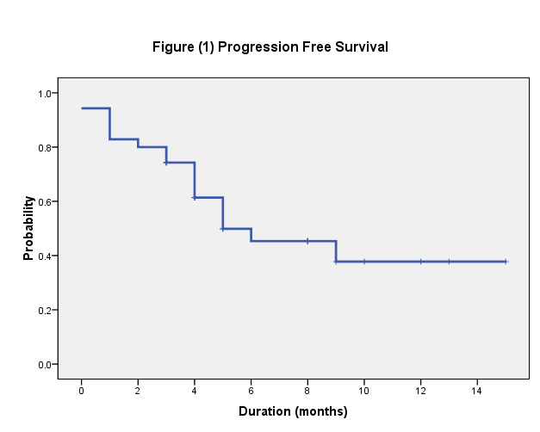

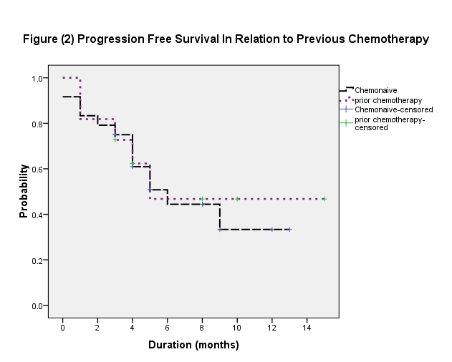

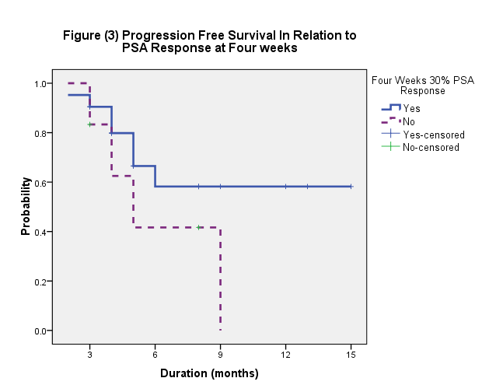

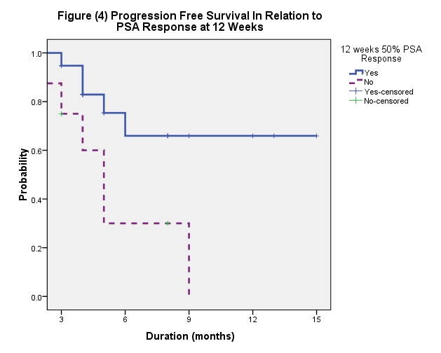

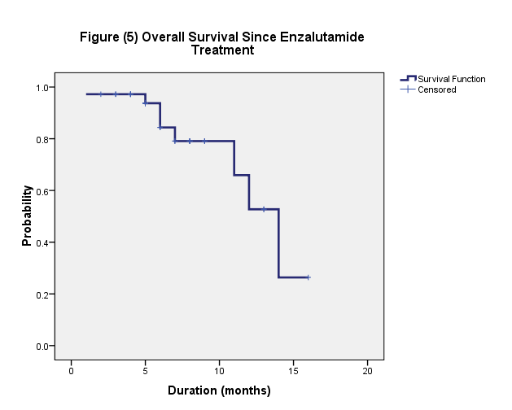

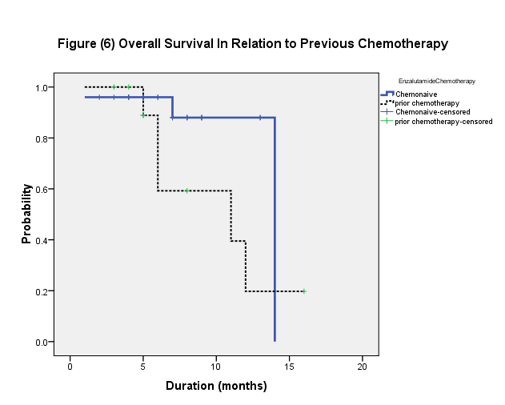

The median progression free survival duration (PFS) was 5 months (range 1-12 months) and 1 year PFS probability was 37.5% (figure 1). Slightly higher PFS was noticed for chemo-naïve patients compared to those who had prior docetaxel chemotherapy (6 versus 5 months respectively; P 0.794) (figure 2).
Higher PFS was seen in patients who achieved ≥30% PSA response at 4 weeks (median not reached) (P 0.17) and ≥50% PSA response at 12 weeks assessments (median not reached) (P 0.018). One year PFS was 66% and 65% respectively in those patients (figure 3 and 4). Median PFS durations were 6 and 5 months for patients with PS1 and PS2 respectively (P 0.851). Similar findings were observed in relation to the number of metastases sites (P 0.776).
The median overall survival (OS) duration since starting enzalutamide was 14 months and 1 year OS is 52% (figure 5). The median OS duration was 14 months for chemo-naïve compared to 11 months for patients who had prior chemotherapy (P 0.109), (figures 6).
Enzalutamide was well tolerated with only 2 patients did need to have had dose reduction. Side effects included hot flushes, gastrointestinal upset and grade 1 hypertension in 3 patients (8.3%).

- Discussion
There is increasing preclinical and clinical evidence that the androgen receptors (AR) remain active in castration resistant prostate cancer (CRPC). The persistence of AR signalling is key to prostate cancer progression [13, 14]. Novel approaches that target the AR signalling axis in CRPC patients are hormonal agents similar to abiraterone and enzalutamide which demonstrated improved overall survival.
Enzalutamide binds to the AR with eight times more affinity than bicalutamide. Enzalutamide is administrated without corticosteroid and has shown improvement in overall survival in both the pre and post chemotherapy settings [15, 16].
Enzalutamide was tested in the phase III AFFIRM trial which was a randomised study of enzalutamide 160 mg/m2 or placebo in patients with metastatic CRPC who had previously received docetaxel. The median OS was 18.4 months in the enzalutamide group versus 13.6 months in the placebo group. The superiority of enzalutamide over placebo was shown with respect to all secondary end points: the proportion of patients with a reduction in PSA level by 50% or more (54% vs. 2%, P<0.001), the quality-of-life response rate (43% vs. 18%, P<0.001), the time to PSA progression (8.3 vs. 3.0 months; P<0.001) [6].
The PREVAIL study, evaluated enzalutamide versus placebo in the chemo-naïve patients with metastatic CRPC. There was 29% reduction in the risk of death in the enzalutamide group. The benefit of enzalutamide was shown with respect to all secondary end points, including the time until the initiation of cytotoxic chemotherapy (hazard ratio, 0.35), the time until the first skeletal-related event (hazard ratio, 0.72), a complete or partial soft-tissue response (59% vs. 5%), the time until PSA progression (hazard ratio, 0.17), and a rate of decline of at least 50% in PSA (78% vs. 3%) (P<0.001 for all comparisons). Fatigue and hypertension were the most common clinically relevant adverse events associated with enzalutamide treatment [7].
In our study, 11 patients received docetaxel prior to enzalutamide. Four of them (36.4%) achieved ≥30% PSA response at 4 weeks assessment and ≥50% PSA response at 12 weeks assessment. In our chemo-naïve patients, the PSA responses were significantly higher at 4 weeks PSA response assessment (86%) and 12 weeks assessment (60%) when compared with responses of 36.4% in patients who had prior chemotherapy (P. values were 0.044 for 4 weeks and 0.149 for 12 weeks assessments). The PSA progression free survival duration was slightly higher for chemo-naïve patients compared to that of patients who were previously treated with docetaxel (6 versus 5 months respectively; p. value was 0.794). For chemo-naïve patients the median overall survival was 14 months compared to 11 months for patients who had chemotherapy prior to enzalutamide (P. 0.109). Enzalutamide-therefore- is more effective in chemo-naïve patients but also it can be of benefit in patients who had been previously treated with chemotherapy.
In conclusion, enzalutamide achieved reasonable response and duration of control in patients with CRPC especially chemo-naïve patients with non-visceral metastases. Therefore it is preferably to be used at an early stage in CRPC management following failure of standard antiandrogen regimens.

Corresponding Author:
Dr Loaie M El-Helw
The Royal Stoke Hospital
Stok-On-Trent, UK, ST4 6QG
Loaieelhelw@hotmail.com, loaieelhelw@gmail.com
Egyptian University Affiliation
Internal Medicine department, Medical Oncology Unit
Mansoura University, Egypt

References
- Edwards BK, Noone AM, Mariotto AB, Simard EP, Boscoe FP, Henley SJ, et al. Annual Report to the Nation on the status of cancer, 1975-2010, featuring prevalence of comorbidity and impact on survival among persons with lung, colorectal, breast, or prostate cancer. Cancer, 120 (9): 1290-314, 2014.
- Eisenberger MA, Blumenstein BA, Crawford ED, et al. Bilateral orchiectomy with or without flutamide for metastatic prostate cancer. N Engl J Med., 339(15): 1036–1042, 1998.
- Saad F and Hotte SJ. Guidelines for the management of castrate-resistant prostate cancer. Can Urol Assoc J., 4 (6): 3804, 2010.
- Recine F and Sternbersg C. Hormonal therapy and chemotherapy in hormone-naïve and castration resistant prostate cancer. Transl. Androl. Urol., 4 (3): 355-364, 2015.
- Ryan CJ, Smith MR, de Bono JS, et al. COU-AA-302 Investigators. Abiraterone in metastatic prostate cancer without previous chemotherapy. N Engl J Med., 368(2):138–148, 2013.
- Scher HI, Fizazi K, Saad F, et al. AFFIRM Investigators. Increased survival with enzalutamide in prostate cancer after chemotherapy. N Engl J Med., 367(13):1187–1197, 2012.
- Beer TM, Armstrong AJ, Rathkopf DE, et al. PREVAIL Investigators. Enzalutamide in metastatic prostate cancer before chemotherapy. N Engl J Med., 371(5):424–433, 2014.
- Tannock IF, de Wit R, Berry WR, et al. TAX 327 Investigators. Docetaxel plus prednisone or mitoxantrone plus prednisone for advanced prostate cancer. N Engl J Med., 351(15):1502–1512. 2004.
- de Bono JS, Oudard S, Ozguroglu M, et al. TROPIC Investigators. Prednisone plus cabazitaxel or mitoxantrone for metastatic castration-resistant prostate cancer progressing after docetaxel treatment: a randomised open-label trial. Lancet, 376(9747):1147–1154, 2010.
- Parker C, Nilsson S, Heinrich D, et al. ALSYMPCA Investigators. Alpha emitter radium-223 and survival in metastatic prostate cancer. N Engl J Med., 369(3): 213–223, 2013.
- Kantoff PW, Higano CS, Shore ND, et al. IMPACT Study Investigators. Sipuleucel-T immunotherapy for castration-resistant prostate cancer. N Engl J Med., 363(5): 411–422, 2010.
- Scher HI, Halabi S, Tannock I, Morris M, Sternberg CN, Carducci MA, Design and end points of clinical trials for patients with progressive prostate cancer and castrate levels of testosterone: recommendations of the Prostate Cancer Clinical Trials Working Group. J Clin Oncol., 26(7):1148-59, 2008.
- Chen Y, Sawyers CL, Scher HI. Targeting the androgen receptor pathway in prostate cancer. Curr Opin Pharmacol., 8(4): 440-8, 2008.
- Edwards J, Krishna NS, Grigor KM, Bartlett JM. Androgen receptor gene amplification and protein expression in hormone refractory prostate cancer. Br J Cancer, 89 (3):552-6, 2003.
- Tran C, Ouk S, Clegg NJ, Chen Y, Watson PA, Arora V, Development of a second-generation antiandrogen for treatment of advanced prostate cancer. Science, 324(5928):787-90, 2009.
- Scher HI, Fizazi K, Saad F, Taplin ME, Sternberg CN, Miller K, Increased survival with enzalutamide in prostate cancer after chemotherapy. N Engl J Med., 367(13):1187-97, 2012.

6/24/2016

