Dft-Qsar Model And Docking Studies Of Antiliver Cancer (Hepg-2) Activities Of 1, 4-Diydropyridine Based Derivatives

Oyebamiji Abel Kolawole and Semire Banjo

Department of Pure and Applied Chemistry, Ladoke Akintola University of Technology, Ogbomoso, Nigeria
E-mail: bsemire@lautech.edu.ng

Abstract: In this paper, combination of Density Functional theory (DFT), Quantitative Structure Activity Relation (QSAR) and molecular docking methods were used to investigate the inhibitory activity of six selected 1,4-dihydropyridine derivatives against liver cancer (HEPG-2). The calculated molecular descriptors from quantum chemical method (DFT) were used to develop QSAR model that related the descriptors to the bioactivity (IC₅₀). Among the molecular descriptors computed, only log P, solvation energy and average electronic charges on all heteroatoms showed fair relationship with the observed cytotoxicity (anticancer activity) of the compounds. Moreover, QSAR model indicated that combination of dipole moment, average of electronic charges on heteroatoms, solvation energy and chemical hardness were important parameters for the observed biological activity. The predicted cytotoxicity (IC₅₀) from QSAR model agreed with the experimental IC₅₀. The binding energy for the non-bonding interactions between the ligand and receptor (PD: 4PYP) as well as important residues for the stabilization of ligand in the active site of the receptor was reported.
[Oyebamiji Abel Kolawole and Semire Banjo. DFT-QSAR Model and Docking Studies of Antiliver Cancer (Hepg-2) Activities of 1, 4-Diydropyridine Based Derivatives. Cancer Biology 2016;6(2):69-78]. ISSN: 2150-1041 (print); ISSN: 2150-105X (online). http://www.cancerbio.net. 10. doi:10.7537/marscbj06021610.

Keywords: 1, 4-Dihydropyridine derivatives, DFT, QSAR, Docking

1.0 Introduction
Cancer, as a second leading cause of death is a disease that significantly strike throughout the whole world. It was discovered to be dangerous after cardiovascular diseases and likely to start the initial cause of death in the years to come (Unger, 1997 and Gibbs, 2000). More than a thousand different cancers affects human beings and their identification is a function of variety and complications. Moreover, obesity, exposure to radiation, tobacco, and some infections were attributed to the cause of cancer (Aanandhi et al. 2010, Pantea et al., 2013 and Mohamed et al., 2016). It affects both children and adult, though few were recorded for children and it can be treated with surgery, chemotherapy and radiation therapy (Jemal et al., 2011).
Hepatocellular carcinoma, a tumor of the liver is a serious challenge to human health with over a million reported cases of death per year throughout the world (Jemal et al., 2005, Ahmet et al., 2013). It is recognized as one of the most familiar malignancies in adults, and it can be found more in men than women (4:1), and it happens in blacks than whites. Liver cancer is known as quick terminal disease for it can kill within the six months of diagnosis and it is the third leading cause of death amidst all cancers (Ferlay et al. 2015, Parkin et al. 2002, Ferlay et al. 2010 and Tabor, 2001). The etiological factors affecting disease incidence include hepatitis B, hepatitis C, and exposure to aflatoxins, alcohol and hemochromatosis (De Angelis, R., et al., 2014, Xavier, B., 2014, Fattovich et al., 2004, Hansch, 1969, El-Serag, 2011, and Jelic et al., 2010).
In 1882, the modification of structure that comprises additions, reductions and condensations in the 1, 2 and 6-positions of the DHP ring in the synthesis of 1, 4-Dihydropyridines (DHPs) were firstly described by Arthur Hantzsch. Moreover, the structural features were recognized to be an essential pharmacophore which treat angina pectoris and few of the commercialized 1, 4-DHP based drugs were felodipine, nifedipine, and nicardipine (Mohammed et al., 2014).
Quantitative Structural Activity Relationship (QSAR) involves the mathematical formula derivation that linked the biological activities of a group of molecule to their physicochemical descriptors. The QSAR is one of the most important areas in chemometrics, and it has being a veritable tool in drug design and medicinal chemistry (Manly et al., 2001, Pourbasheer et al., 2010, Pourbasheer et al., 2011). Once a reliable QSAR model is established, activities of molecules predicted, and know which structural features play a significant role in the biological process. The advances in QSAR studies have widened the scope of rational drug design as well as the search for the mechanisms of drug actions.
Molecular interactions such as protein-protein interactions, drug-protein and drug-nucleic acid as well as ligand-receptor/protein interactions are very important in carrying out biological functions such as signal transduction, enzyme inhibition and couple of multi-domain proteins (Huang et al., 2010, Halperin et al., 2002 and Sousa et al., 2006). Docking studies usually reveal information on ligand-receptor interactions by identifying the active sites in receptor as well as calculation of binding affinity or energy in terms of dock score. Scoring as an arithmetic method used to predict the non-covalent interacting power between two molecules after docking (Taylor et al., 2002 and Jain, 2006).
Therefore, in this work, six compounds as shown in Figure 1 which had been previously synthesized and screened against Hepatocellular carcinoma (HepG-2) by Abbas et al, (2015) were optimized using DFT method for the calculations of molecular descriptors, worked on by calculating virtual screening and binding energy. These compounds are 2-Amino-4-(4-chlorophenyl)-6-(2-mercapto-4-methyl-1-phenyl-1H-imidazol-5-yl)nicotivtino-nitrile (A₁), 2-Amino-6-(2-mercapto-4-methyl-1-phenyl-1H-imidazol-5-yl)-4-(4-methoxyphenyl) nicoti-nonitrile (A₂), 2-Amino-4-(2-hydroxyphenyl)-6-(2-mercapto-4-methyl-1-phenyl-1H-imidazol-5-yl)nicoti-nonitrile (A₃), 4-(4-Chlorophenyl)-6-(2-mercapto-4-methyl-1-phenyl-1H-imidazol-5-yl)-2-oxo-1,2-dihyd-ropyridine-3-carbonitrile (A₄), 4-(2-Hydroxyphenyl)-6-(2-mercapto-4-methyl-1-phenyl-1H-imidazol-5-yl)-2-oxo-1,2-dihyd-ropyridine-3-carbonitrile (A₅) and Ethyl 6-(2-mercapto-4-methyl-1-phenyl-1H-imidazol-5-yl)-4-(4-methoxyphenyl)-2-oxo-1,2-dihydropyridine-3-carboxylate (A₆). The major objectives of the present work are: (i) to use quantum chemical method via DFT to calculate molecular descriptors, (ii) to use calculated descriptors to develop QSAR model that relates the descriptors to the observed bioactivity and (iii) to find suitable conformation as well as calculations of binding affinity of these compounds through molecular docking to the targeted receptor (PDB: 4PYP).

Figure 1: The schematic structures of the studied molecules

2.0 Computational Details
Conformational search was first performed on the six compounds considered in this research work employing semi-empirical AM1 method with Monte Carlo search algorithm and the lowest-energy conformer of this conformational search was taken for further DFT calculations. Density Functional Theory (DFT) with the standard 6-31G (d, p) basis set was used for the equilibrium geometry optimization of the six compounds A₁ to A₆. The DFT method used consist of the three-parameter density functional, that includes Becke’s gradient exchange correction (Becke, 1993) and the Lee, Yang, Parr correlation functional (Lee et al., 1988) i.e. B3LYP. The selection of functional and basis sets was a function of the accuracy of DFT calculations; thus a polarized split-valence 6-31G (d,p) basis set has been proved to be sufficient of for calculations of the properties of ligands (Jacquemin et al., 2008); therefore 6-31G(d,p) basis set was used in research work. These compounds (Abbas et al., 2015) were calculated for molecular parameters that described the cytotoxicity. Also, the optimized structures were used for molecular docking. Some of the molecular parameters calculated are; the LUMO, the HOMO, dipole moment and global molecular descriptors such as chemical hardness, softness and chemical potential. Solvation energy using SM5.4 model, a semi-empirical method (AM1) as implemented on quantum chemical software, Spartan 10. Molecular descriptors calculated using DFT methods were used for development of QSAR model (Karelson, 2000 and Eroğlu et al., 2007).
Furthermore, the selected descriptors were used to develop quantitative structure-activity relationship (QSAR) model that relates biological activity of the group of molecules is a function of its physicochemical properties (Pourbasheer et al., 2009 and Riahi et al., 2009). Multiple linear regression (MLR) analysis; a frequent statistical and mathematical method was used to develop the QSAR model. The QSAR studies have been tools of predicting endpoints of interest in organic molecules acting as drugs. The DFT-QSAR studies have been found to be better correlation to the experimental data than those calculated form semi empirical methods (Dewar et al., 1993, Stewart et al., 1989, Zhang et al., 2004 and Singh et al., 2004). Moreover, the QSAR model was validated using statistical equations by considering cross validation (R²), Adjusted R², standard error, Chi-square, Root Mean Square Error (RMSE) and F-test. Cross validation governs how reliable a QSAR model can be used for a particular set of data. It is also used as an analytic instrument to estimate the prognostic control of an equation. Therefore, it is calculated using equation (1).

$CV.R^{2}=1-\frac{Ʃ(Ү obs-Ү cal)^{2}}{Ʃ(Ү obs-Ῡobs)^{2}}$ (1)

The R² adjusted could be calculated using equation (2)

$R_{a}^{2}= \frac{\left(N-1\right)×R^{2 }-P}{N-1-P}$ (2)

So, the QSAR model could be considered prognostic, if$R_{Pred}^{2}>0.6$.

2.1 Docking and Scoring
The studied protein structure (PDB ID: 4PYP, (Deng et al., 2014) was downloaded from Protein Data Bank (www.PDB.com) and the energy was minimized. The discovery studio was used to treat the receptor by removing the ligands, water molecules, and cofactors that were present. Autodock tool was used to convert the protein and the ligands to pdbqt format and the docking analysis was performed using AutoDock Vina which Darwinian evolution theory motivated to be iterative optimization method (Sapna et al., 2014).

3.0 Results and Discussion
3.1 Molecular Descriptors
To begin with, an attempt was made to correlate the molecular properties calculated to the observed bioactivity of the selected 1, 4-HDPs. Therefore, the molecular parameters calculated in this study were solvation energy (kJ/mol), weight, hydrophobicity (Log P), volume (V), Area, polar surface area (PSA), ovality, dipole moment (DM), heteroatoms (i.e. average of Mulliken charges on all heteroatoms in the compound), the HOMO, and LOMO energies density functional theory (DFT) method as shown in Table 1. The highest occupied molecular orbital (HOMO) which were calculated to be -5.59eV, -5.43 eV, -5.40 eV, -5.91 eV, -5.68 eV and -5.47 eV for A₁ to A₆ respectively. The lowest unoccupied molecular orbital (LOMO) were also calculated to be -1.87 eV, -1.61 eV, -1.56 eV, -2.32 eV, -2.01 eV and -1.47 eV for A₁ to A₆ respectively. These two parameters reveal quantitative details about the excitation properties of molecules (Bouachrine et al., 2009, Yang et al., 2005 and Semire 2012). Therefore, energy band gaps (HOMO-LUMO energies) were calculated to be 3.72eV, 3.82 eV, 3.84 eV, 3.59 eV, 3.67 eV and 4.00 eV for A₁, A₂, A₃, A₄, A₅, and A₆ respectively as shown in Table 1. The easier excitation of electron(s) coupled with ability of a compound to donate the electron (s) to the surrounding molecule are attributed to lower band gap. Thus, it is expected that energy band gap plays a crucial role in protein – ligand interactions, although there was no effective correlation between the calculated band gaps and bioactivity of the selected 1,4-DHPs used in this research work.
Also, Log P which gives formation on ability of a compound to dissolve into lipophilic (non-aqueous) media (Khaled et al., 2011) is an important descriptor. Log P is an approximation of total lipophilicity of a compound that influences its behavior in a range of biological membranes (Hughes et al., 2008). However, despite the importance of log P, there might likely be a problem in oral absorption if the log P valve for a compound is higher than 5 (Meanwell , 2011). The calculated log P were 3.40 for A₁, 2.72 for A₂, 2.45 for A₃, 3.16 for A₄, 2.22 for A₅ and 2.61 for A₆, therefore, these compounds are expected to be effective in term of lipophilicity. The log P fitted into bioactivity of these compounds with R² = 0.5969 (Figure 2a).

Table 1: The parameter generated from the compounds of study for anti-liver cancer
Mol | HOMO  (eV) | LUMO  (eV) | BG  (eV) | DM (Debye) | η (eV) | µ (eV) | Ω (eV) | H (eV) | MW (amu) | Log P | Ovality | A (A²) | V (A³) | PSA (A²)
A₁ | -5.59 | -1.87 | 3.72 | 3.75 | 1.86 | -3.73 | 3.74 | -2.80 | 417.92 | 3.40 | 1.58 | 412.65 | 398.02 | 52.74
A₂ | -5.43 | -1.61 | 3.82 | 2.57 | 1.91 | -3.52 | 3.24 | -3.31 | 413.51 | 2.72 | 1.59 | 426.51 | 411.38 | 59.66
A₃ | -5.40 | -1.56 | 3.84 | 0.86 | 1.92 | -3.48 | 3.15 | -2.80 | 399.48 | 2.45 | 1.57 | 405.12 | 391.53 | 70.19
A₄ | -5.91 | -2.32 | 3.59 | 9.12 | 1.80 | -4.12 | 4.72 | -2.64 | 418.91 | 3.16 | 1.56 | 407.54 | 395.27 | 47.91
A₅ | -5.68 | -2.01 | 3.67 | 5.96 | 1.84 | -3.85 | 4.03 | -3.21 | 400.4 | 2.22 | 1.55 | 399.90 | 388.72 | 64.78
A₆ | -5.47 | -1.47 | 4.00 | 5.55 | 2.00 | -3.47 | 3.01 | -3.62 | 461.54 | 2.61 | 1.66 | 475.24 | 456.30 | 58.68

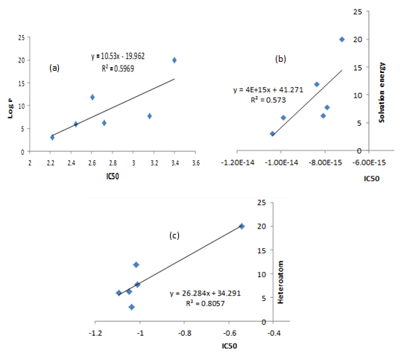
Figure 2: The graph showing the relationship between the observed bioactivity (IC₅₀) and some descriptors: (a) log P, (b) Solvation energy (S.E) and (c) Heteroatoms.

The solvation energy was calculated using SM5.4 model based on semi-empirical (AM1) wave functions (Chambers et al., 1996). The solvation energy comprises of the sum of two terms: the energy required to create a cavity in the solvent (water) and the energy of the electrostatic interaction between the solvent and the solute immediately the solute/molecule is “placed” in the cavity. The equilibrium geometries together with spectra and any properties obtained from the wave function are unaffected by SM5.4 model for solvation energy calculations (Hehre, 2003). Therefore, the calculated solvation energies were -4.5.08 kJ/mol for A₁, -50.50 kJ/mol A₂, -61.66 kJ/mol for A₃, -49.25 kJ/mol for A₄, -64.83 kJ/mol for A₅ and -52.22 kJ/mol for A₆. Compound A₃ and A₄ are expected to have better interactions with the receptor in aqueous media, however high valve of solvation energy or increment in solvation energy can contribute to the drug resistance (Hwanho et al., 2013). The solvation energy fitted into bioactivity of these compounds with R² = 0.573 (Figure 2b).
The dipole moment is a measure of the net molecular polarity, that is, the magnitude of the charge at either end of the molecular dipole times the distance between the charges of the molecule (Fay, 2004) and also the unusual property of individual molecule has been attributed to larger value of dipole moment (Debenedetti, 2003). The calculated dipole moments for the compounds were 3.75 debye for A₁, 2.57 debye for A₂, 0.86 debye for A₃, 9.12 debye for A₄, 5.96 debye for A₅ and 5.55 debye for A_{6.} The nature of are very crucial in ligand – receptor interactions which are affected by dipole moment and the accepted values for dipole moments of molecules range from 3 to 5 kJ/mol (David et al., 2002). All the values for the compounds fall within the accepted range of dipole moment, therefore, the compounds are expected to have robust non-bonded interactions with the receptor. The Mulliken charges on an atom show the availability of electrons on those atoms in a molecule. The average Mulliken charges on all heteroatoms present in each compound (heteroatom) were -2.80, -3.31, -2.80, -2.64, -3.21 and -3.62 for A₁ to A₆ respectively. The heteroatom fitted into bioactivity with R² = 0.8057 as shown in Figure 2c.
3.2 QSAR Model using multiple linear regressions
The IC₅₀ is fairly correlated with heteroatom (r = 0.898) and solvation energy (r = 0.0.757). Some of the descriptors are also fairly correlated to one another, for instance solvation energy is correlated with heteroatom by 0.624 and also ƞ is negatively correlated with DM by -0.501 (Table 2). The Pearson’s correlation obtained is employed to choose the appropriate descriptors for MLR analysis, even though the development of good model required large number of molecules. Therefore, in QSAR modeling of cytotoxicity for selected 1,4-DHPs, four molecular descriptors, dipole moment, solvation energy, chemical hardness and average electronic charges on all heteroatoms were chosen to avoid multi-collinearity from the parameters calculated in Table 1.
These molecular descriptors were used to model the observed bioactivity of these compounds against Hepatocellular carcinoma (HEPG-2). The developed QSAR model related the activities of these compounds to their cytotoxicity as shown in figure 3. This model indicated that all the molecular descriptors in the equation 3 have positive contribution to the bioactivity of these compounds which suggests that increasing in the value of these descriptors should lead to increased activity.

Table 2: Pearson’s correlation matrix for descriptors
 | IC₅₀ | DM | Heteroatom | S.E | $$ƞ$$
IC₅₀ | 1.000
DM | -0.038 | 1.000
Heteroatom | 0.898 | -0.022 | 1.000
S.E | 0.757 | 0.200 | 0.624 | 1.000
$$ƞ$$ | 0.136 | -0.501 | -0.205 | -0.030 | 1.000

Figure 3: Correlation between experimental and predicted IC₅₀

The predicted bioactivity (IC₅₀) is fitted (R² = 0.979) into the experimental values as shown in Figure 2.
This showed that the QSAR model reproduced the observed cytotoxicity of these compounds. Therefore, combination of selected descriptors such as dipole moment (Debye), solvation energy (kJ/mol), chemical hardness (η) and average Mulliken charges on all heteroatom (H) are the molecular parameters that described the anti-cancer HEPG-2 cell line activity of the studied compounds.
Calculated regression parameters for 1, 4-DHPs used in the validation of QSAR model for anti-liver cancer activity includes R², CV.R²,$R_{a}^{2}$ as shown in table 3. The R² which is equal to 0.979 revealed a very good fitness. Also, it specifies that this model as shown in equation 3 can be effectively used to predict the anti-liver cancer activity of 1,4-DHP based molecules. The calculated CV.R² was 0.977. This shows its reliability and acceptability, since it is greater than 0.5 (Marrero, 2004). $R_{a}^{2}$ was calculated to be 0.885. This make the QSAR model to be predictive since it is greater than 0.6.

Table 3: Stepwise regression result for anti-liver cancer activity
Equation | N | p | R² | CV. R² | $$R_{a}^{2}$$
-19.137 + 0.268(DM) + 24.707(H) + 1.061E+15(SE) + 31.717(ƞ) ---------3 | 6 | 4 | 0.979 | 0.977 | 0.885

3.3 Molecular Docking
The docking simulations of the DFT optimized structures of the compounds were carried out against Hepatocellular carcinoma (HEPG-2; PDB ID: 4PYP) and the conformation in each ligand-receptor complex with highest free energy of interactions was considered as best and most suitable conformation. The binding free energies (i.e. free energies of the interactions) for compounds A₁ to A₆ were displayed in Table 3. The binding energies were -2.20, 0.10, -4.00, 2.20, 1.70 and 3.20 kcal/mol for compounds A_{1,} A_{2,} A_{3,} A_{4,} A₅ and A₆ respectively. It was observed that three compounds formed a number of hydrogen bonds (HIs) within the active site: A₂ and A₆ formed one hydrogen bond while A₃ formed two hydrogen bonds with 4PYP in the active gorge respectively. Although, hydrogen boning is just one of such non-bonding interactions like as π-π, cationic-π, anionic-π and other peripheral interactions occur during ligand-receptor complex formation. The hydrogen bond was formed between LEU-24 and LIG: O (methylbenzoate of pyridine ring) for A₂ with HI distance 3.4, LEU-24 and LIG: N (cyano-group of pyridine ring) with HI distance 3.3, GLY-167 and LIG: N (cyano-group of pyridine ring) for A₃ with HI distance 3.2 as well as GLY-167 and LIG: O (methylbenzoate of pyridine ring) for A₆ with HI distance 3.6 (Table 3). However, in A₁, A₄ and A₅ interactions with the receptor other forms of interactions are predominant with the residues in 4PYP (receptor) as shown in binding mode of the compounds in the active site of receptor (Figure 4).

Table 4: Non interactions of the selected 1,4-DHPs with 4PYP and their binding free energies
Mol. | H-Bond Between Amino Acid and Drug | Distance | Number of Hydrogen bonds | Affinity (kcal/mol)
A₁ | Nil | Nil | Nil | -2.20
A₂ | (i) LEU-24 LIG: O | 3.4 | 1 | 0.10
A₃ | (i) LEU-24, LIG: N  (ii) GLY-167 LIG : N | 3.3, 3.2 | 2 | -4.00
A₄ | (i) Nil | Nil | Nil | 2.20
A₅ | (i) Nil | Nil | Nil | 1.70
A₆ | (i) GLY-167 LIG: O | 3.6 | 1 | 3.20

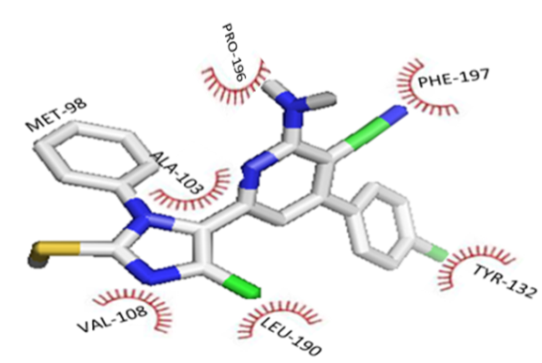
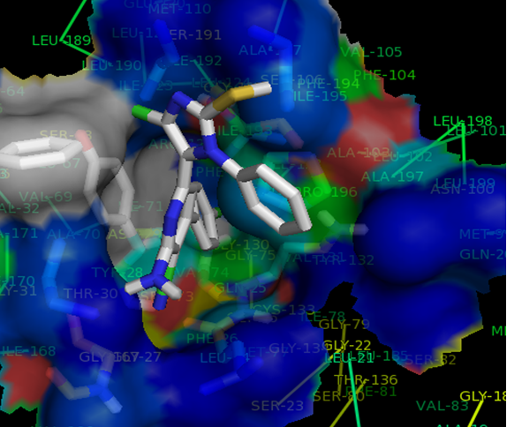

Figure 4a: Binding interaction of Compounds A₁ with 4PYP

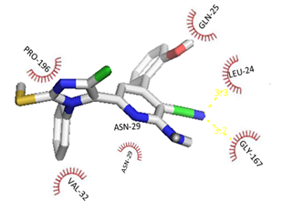
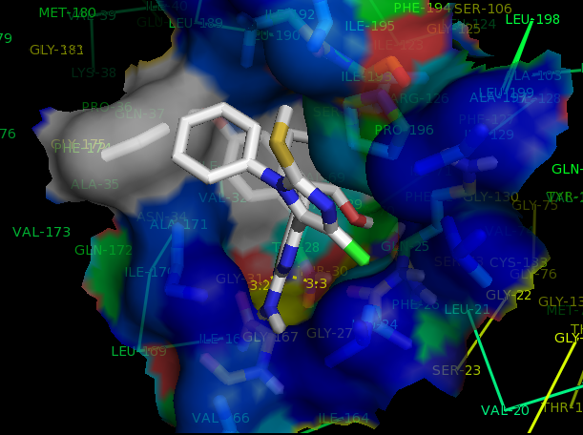
Figure 4b: Binding interaction of Compounds A₂ with 4PYP

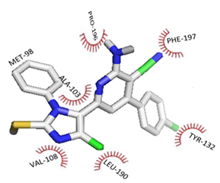
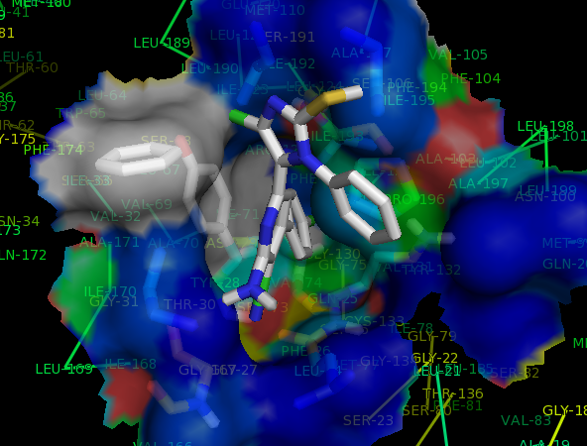

Figure 4c: Binding interaction of Compounds A₃ with 4PYP

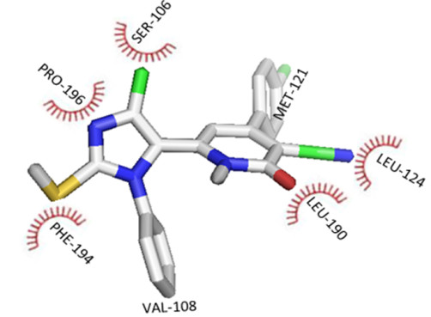
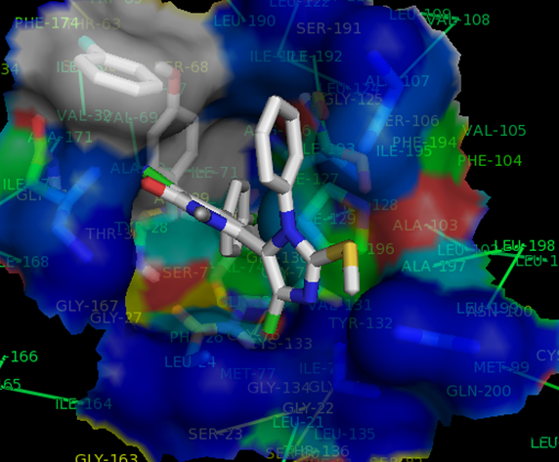

Figure 4d: Binding interaction of Compounds A₄ with 4PYP

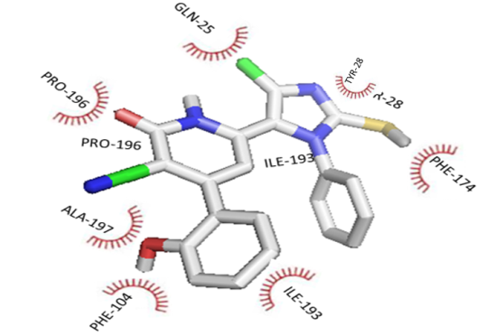
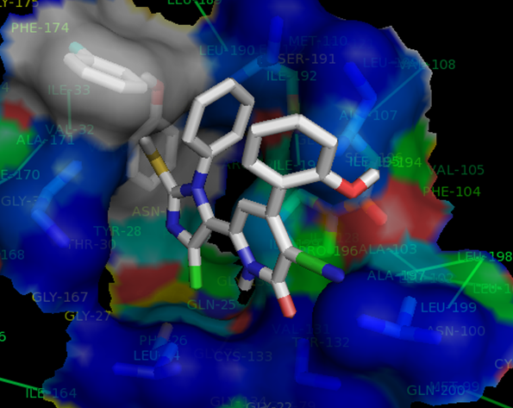

Figure 4e: Binding interaction of Compounds A₅ with 4PYP

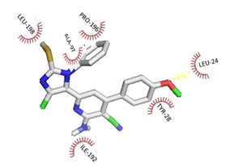
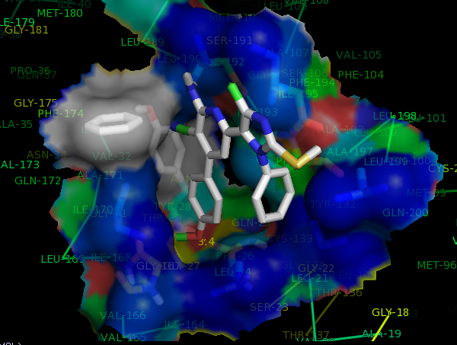

Figure 4f: Binding interaction of Compounds A₆ with 4PYP

Conclusion
The study presented quantum chemical calculations via DFT for calculations of molecular descriptors for the development of a QSAR model that relates the molecular parameters of the studied compounds to their bioactivity. The results of the QSAR models showed that some of the calculated molecular descriptors relate the electronic properties of the molecules to their bioactivities and the QSAR model reproduced the experimental bioactivities of these compounds against HEPG-2. Pharmacophore studies revealed that hydrogen bonds with the amino acid residues in the binding site as well as conformation of the ligand are essential significant features for ligand-receptor binding.

Refeerence
- Aanandhi, V.M, Kalvikkarasi, S, Navamani, A.K, Shanmugasundaram, P. Synthesis, characterization and In-vitro antioxidant activity of Mannich bases of novel 1, 4-dihydro pyridines derivatives. Research Journal of Pharmaceutical, Biological and Chemical Sciences 2010;926.
- Abbas, I., Gomha, S., Elaasser, M., Bauomi, M. Synthesis and biological evaluation of new pyridines containing imidazole moiety as antimicrobial and anticancer agents. Turkish Journal of Chemistry 2015;1410 – 25.
- Ahmet, G., James, P. H, Ayman, K., Zhiping, L., Esteban, M. Hepatocellular Carcinoma (Liver Cancer). 600 North Wolfe Street, Baltimore, Maryland. 2013:21287.
- Becke, A.D. Density functional thermochemistry. III. The role of exact exchange. Journal of physical Chemistry 1993;98:5648 – 5652.
- Bouachrine, M., Hamidi, M., Bouzzine, S. M., and Taoufik, H. Theoretical study on the structure anaelectronic properties of new materials based on thiophene and oxadiazole. Journal of Chemical Research 2009;10:29-37.
- Chambers, C.C., Hawkins, G.D., Cramer, C.J., Truhlar, D.G. A model for aqueous solvation based on class IV atomic charges and first-solvation-shell effects. Journal of Chem. Phys., 1996; 100, 16385.
- David, F.L.L and Howard, B. B. Molecular binding interactions: their estimation and rationalization in QSARs in terms of theoretically derived parameters, the scientific world Journal 2002;2:1776 – 1802.
- De Angelis, R., et al. Cancer Survival in Europe 1999-2007 by country and age: results of Eurocare-5 – a population-based study. Lancet Oncol 2014;15,23-34.
- Debenedetti, P. Condensed Matter. Journal of Physics, 2003;15:1669.
- Deng, D., Xu, C., Sun, P.C., Wu, J.P., Yan, C.Y., Hu, M.X., Yan, N. Crystal structure of the human glucose transporter GLUTI. Nature, 2014;510:121 – 125.
- Dewar, M., Zoebisch, E. G., Healy, E. F., Stewart, J.J.B. Development and use of quantum mechanical molecular models. 76. AM1: A new general purpose quantum mechanical molecular model. J. Am. Chem. Soc., 1993;115:5348.
- El-Serag, H.B. Hepatocellular carcinoma. N. Engl. J. Med. 2011; 365:1118–1127.
- Eroğlu, R., Türkmen, H., Güler, S., Palaz, S. and Oltulu, O. A DFT-Based QSARs Study of Acetazolamide/Sulfanilamide Derivatives with Carbonic Anhydrase (CA-II) Isozyme Inhibitory Activity. Int. J. Mol. Sci. 2007;8:145-155.
- Fattovich, G., Stroffolini, T., Zagni, I., Donato, F. Hepatocellular carcinoma in cirrhosis: Incidence and risk factors. Gastroenterology 2004;127: S35–S50.
- Fay, M. Chemistry fourth edition, Pearson Education, New Jersey. 2004.
- Ferlay, J, Soerjomataram, I, Ervik, M, et al. Cancer Incidence and Mortality Worldwide: IARC Cancer Base. 2015;11.
- Ferlay, J., Shin, H.-R., Bray, F., Forman, D., Mathers, C., Parkin, D.M. Estimates of worldwide burden of cancer in 2008. Int. J. Cancer 2010;127:2893–2917.
- Gibbs, JB. Mechanism-based target dentification and drug discovery in cancer research. Science 2000;287:1969-1971.
- Halperin, I., Ma, B., Wolfson, H., & Nussinov, R. Principles of docking: An overview of search algorithms and a guide to scoring functions. Proteins 2002;47(4): 409-443.
- Hansch, C. A quantitative approach to biochemical structure‐activity relationships. Accounts of Chemical Research 1969;2:232‐239.
- Hassan, M.M., Hwang, L.-Y., Hatten, C.J., Swaim, M., Li D., Abbruzzese, J.L., Beasley, P., Patt, Y.Z. Risk factors for hepatocellular carcinoma: Synergism of alcohol with viral hepatitis and diabetes mellitus. Hepatology 2002;36:1206–1213.
- Hehre, W.J., A guide to molecular mechanics and quantum chemical calculations, Wavefunction, INC, Irvine CA 92612, USA. 2003.
- Huang, S. Y, & Zou X. Advances and challenges in protein-ligand docking, International Journal of Molecular Sciences 2010;11(8):3016-3034.
- Hughes, J.D, Julian, B., David, P., Simon, B., Gary, A.D and Rajesh, D. Physicochemical drug properties associated with in vivo toxicological outcomes, Bioorg. Med Chem. Lett. 2008;18(17):4872 – 5.
- Hwanho, C., Hongsuk, K., and Hwangeso, P. New solvation free energy function comprising intermolecular solvation and intramolecular self-solvation terms, journal of Cheminformatics 2013; 5: 8.
- Jacquemin, D., Perpete, E.A., Ciofini, I., Adamo, C. Accurate simulation of optical properties in dyes, Accounts of chemical Research 2008;42:326 – 3344.
- Jain, A.N Scoring functions for protein-ligand docking, Current Protein Peptide Science 2006;7(5):407-420.
- Jelic, S. and Sotiropoulos, G.C. Hepatocellular carcinoma: ESMO Clinical Practice Guidelines for diagnosis, treatment and follow-up. Ann Oncol 2010;21:59-64.
- Jemal A., et.al. Global cancer statistics. A cancer journal for clinicians 2011;61(2):69-90.
- Jemal, A., Murray, T., Ward, E., Samuels, A., Tiwari, R.C., Ghafoor, A., Feuer, E.J., Thun, M.J. CA Cance. r J. Clin. 2005;55:10-30.
- Karelson, M. (2000) Molecular Descriptors in QSAR/QSPR. J. Wiley and Sons, New York.
- Khaled, A., Petri, R., Sampo, M., Olavi, P. Metabolism of α-Thujone in human hepatic preparations in vitro. Xenobiotica 2011;41:101-111.
- Lee, C., Yang, W., Parr, R.G., Phys. Rev. B. 1988;37:785.
- Manly, C.J., Louise-May, S., Hammer, J.D. The impact of informatics and computational chemistry on synthesis and screening. Drug Discovery Today 2001;6:1101–1110.
- Marrero, Ponce Y., Castillo, Garit J. A., Torrens, F., Romero, Zaldivar V., and Castro, E. A. Atom, atom-type, and total linear indices of the “molecular pseudograph's atom adjacency matrix”: application to QSPR/QSAR studies of organic compounds,” Molecules 2004; 9(12):1100–1123.
- Meanwell, N. A Synopsis of some recent tactical application of biostereses in drug design. Journal of medical chemistry 2011;54(8):2529 – 2591.
- Mohamed, A.A., Diaa, M.E., Yusuf, N. and Saad, E.M.E. Studying the Value of Golgi Protein 73 as a Serum Marker in Hepatocellular Carcinoma Versus Alfa Feto Protein. Nature and Science 2016;14(1):126-129.
- Mohammed, H., Ali, A. Synthesis, characterization, docking studies and bio-efficacy evaluation of novel 1,4-dihydropyridine derivatives, International Journal Of Scientific Research 2014;3(10):2277 – 8179.
- Pantea, P., Ravi, S., Elena, P. Influence of Far Infrared Radiation on cytotoxicity of Human Breast Cancer (MCF7) cells: experimental evaluation. IWBBIO Proceedings. 2013.
- Parkin, D.M., Bray, F., Ferlay, J., Pisani, P. CA Cancer. J. Clin. 2002;55:74-108.
- Pourbasheer, E., Riahi, S., Ganjali, M.R., Norouzi, P. Application of genetic algorithm-support vector machine, (GA–SVM) for prediction of BK-channels activity. European Journal of Medicinal Chemistry 2009;44:5023–5028.
- Pourbasheer, E., Riahi, S., Ganjali, M.R., Norouzi, P. QSAR study of C allosteric binding site of HCV NS5B polymerase inhibitors by support vector machine. Mol. Divers. 2011;15:645–653.
- Pourbasheer, E., Riahi, S., Ganjali, M.R., Norouzi, P. Quantitative structure–activity relationship (QSAR) study of interleukin-1 receptor associated kinase 4 (IRAK-4) inhibitor activity by the genetic algorithm and multiple linear regression (GA–MLR) method. J. Enzyme Inhib. Med. Chem. 2010;25:844–853.
- Ravichandran, V., Harish, R., Abhishek, J., Shalini, S., Christapher, P.V. and Ram, K.A. Validation of QSAR Models - Strategies and Importance. International Journal of Drug Design and Discovery 2011:2(3):511-519.
- Riahi, S., Pourbasheer, E., Ganjali, M.R., Norouzi, P. Investigation of different linear and nonlinear chemometric methods for modeling of retention index of essential oil components: concerns to support vector machine. J. Hazard. Mat. 2009;166:853–859.
- Sapna, R., Ajeet, A. K. Designing of Sulfanilamide/Sulfacetamide Derivatives as Human Topoisomerase II Inhibitor: A Docking Approach. American Journal of Pharmacological Sciences 2014;2(2):42-46.
- Semire, B., Oyebamiji, A. and Ahmad, M. Theoretical Study on Structure and Electronic Properties of 2, 5-Bis [4-N, N-Diethylaminostyryl] Thiophene and Its Furan and Pyrrole Derivatives Using Density Functional Theory (Dft). Pakistan Journal of Chemistry 2012;2(4):166-173.
- Singh, P.P., Srivastava, H.K., Pasha, F.A. DFT-based QSAR study of testosterone and its derivatives. Bioorganic & Medicinal Chemistry 2004;12:171.
- Sousa, S. F., Fernandes, P. A., & Ramos, M. J. Protein-ligand docking: current status and future challenges, Proteins 2006;65(1):15-26.
- Stewart, J.J.B. Optimization of parameters for semiempirical methods II. Applications. J. Comp. Chem. 1989;10:221.
- Tabor E. Hepatocellular carcinoma, Global epidemiology. Dig. Liver Dis. 2001;33:115–117.
- Taylor, R.D, Jewsbury, P.J, Essex, J.W. A review of protein-small molecule docking methods, Journal of Computer-Aided Molecular Design 2002;16:151-166.
- Unger, C. New therapeutic approaches in cancer treatment. Drug Future 1997;22:1337-1345.
- Xavier, B., Matias, J., Philipp, K. The Complex Relationship between Liver Cancer and the Cell Cycle: A Story of Multiple Regulations 2014;6:79-111.
- Yang, L., Feng, J., and Ren, A., Theoretical studies on the electronic and optical properties of two thiophene–fluorene based π-conjugated copolymers. Polymer 2005;46:10970-10982.
- Zhang, L., Wan, J., Yang, G. A. DFT-based QSARs study of protoporphyrinogen oxidase inhibitors: phenyl triazolinones. Bioorganic & Medicinal Chemistry 2004;12:6183.

6/13/2016

