Lithocholic acid induces extrinsic apoptosis in prostate cancer cell lines

Ahmed Gafar, Mohammed Bashandy, Sayed Bakry, Mahmoud A. Khalifa, and Walid Abu Shair

Zoology Department, Faculty of Science, Al-Azhar University, Egypt.
Ahmed.gaffr@gmail.com

Abstract: Lithocholic acid (LCA) is toxic to human prostate cancer cells. We previously studied the effects of LCA on cell viability, cell proliferation and mitochondrial function in LNCaP and PC-3 prostate cancer cell lines. In the present study, we investigated the induction of extrinsic apoptosis by LCA in androgen independent PC-3 and DU-145 cells. In PC-3 and DU-145 cells, LCA triggered extrinsic apoptosis pathways and induced typical extrinsic apoptosis -related proteins, such TRIAL, FasL, FADD, DR5, DR4 and Cleaved caspase8. Treatment of prostate cancer cells with IETD AFC (10 µM), an inhibitor of Caspase 8 partially inhibited apoptosis that induced by LCA. Also, we found Death receptor (DR5) silencing partially Blocked LCA to induced cell death. Collectively, these results indicate that extrinsic apoptosis induced by LCA in PC-3 and DU-145 play a secondary role in cell death and there might be another cell surface receptor that LCA triggers to induce cell death.
[Ahmed Gafar, Mohammed Bashandy, Sayed Bakry, Mahmoud A. Khalifa, and Walid Abu Shair. Lithocholic acid induces extrinsic apoptosis in prostate cancer cell lines. Cancer Biology 2016;6(2):63-68]. ISSN: 2150-1041 (print); ISSN: 2150-105X (online). http://www.cancerbio.net. 9. doi:10.7537/marscbj06021609.

Keywords: Lithcholic acid, prostate cancer, DR5, cell death, apoptosis and caspase8.

1. Introduction
Prostate cancer (PCa) is the second-leading cause of cancer-related deaths in men in the United States. The American Cancer Society has estimated that a total of 233,000 new cases will be diagnosed and 29,480 men will die of PCa in 2014 (American Cancer Society, 2014). Various treatments are available, some more effective than others. To date there is no real cure for the disease beyond surgery and/or radiation when used at early stages of the disease. When recurrence occurs, the cancer can be controlled with hormone ablation therapy (Leuprolide/Lupron®), taking advantage of the growth dependence of PCa on testosterone. However, over time, the cancer develops ways to bypass hormone dependence, becoming highly aggressive, castration-resistant prostate cancer (CRPC) that metastasizes to the lung, liver and bone (Stavridi et al., 2010; Chuu et al., 2011). In addition to the hormone ablation, chemotherapy is available today to treat CRPC, but it is not very effective because PCa cells divide slowly and, like with prostatectomy, the treatments are aggressive and have many side effects (Hoffman-Censits et al., 2013). As a result, researchers are looking for novel strategies to treat PCa.
FDA approved sipuleucel-T (Provenge®) is an autologous cellular immunotherapy to treat metastatic PCa. In the clinical trial on which this approval was granted, the median overall survival rate of patients who received sipuleucel-T improved by only 4.5 months. Treatment is costly but some patients survived much longer than the median (Higano et al., 2010). Novel androgen receptor (AR) antagonists such as enzalutamide (Xtandi®) and androgen biosynthesis inhibitors such as abiraterone (Zytiga®), have shown great promise as androgen deprivation therapies to prolong overall survival rate among patients with metastatic PCa (Sartor and Pal, 2013; Ryan et al.,2013). Another novel drug, Cabozantinib, is a potent dual inhibitor of the tyrosine kinases c-MET and vascular endothelial growth factor receptor 2 (VEGFR2), and has been shown to reduce or stabilize metastatic bone lesions in CRPC patients (Yakes et al., 2011; Smith et al., 2013). The limitations of current standard treatments of prostate cancer has encouraged the search for safer and more effective molecules based on naturally occurring compounds.
Lithocholic acid (LCA) is a secondary bile acid produced by microflora in the gut, which we found to exhibit selective toxicity to human neuroblastoma cells and prostate cancer cells at relatively low concentrations that did not affect normal cells (Goldberg et al., 2011; Goldberg et al., 2013). LCA triggered both intrinsic and extrinsic pathways of apoptotic cell death that were, at least in part, caspase-dependent. In addition, LCA selectively decreased the viability of human breast cancer and rat glioma cells (Goldberg et al., 2011). Various bile acids, have been reported to have anti-neoplastic and anti-carcinogenic properties in a multitude of cancer cell models, chenodeoxycholic acid (CDCA has anticancer against tamoxifen-resistant breast cancer (Giordano et al., 2011), synthetic enantiomers of lithocholic acid (ent-LCA), chenodeoxycholic acid (ent-CDCA) and deoxycholic acid (ent-DCA) have anticancer properties against colon cancer (Katona et al.,2009) . Deoxycholic acid (DCA), ursodeoxycholic acid (UDCA), and their taurine-derivatives; taurodeoxycholic acid (TDCA) and tauroursodeoxycholic acid (TUDCA) have anticancer action against Jurkat human T leukemia cells (Fimognari et al., 2009). These findings indicate that the bile acid structure may form the basis for the development of potent and selective drugs for the treatment of various cancers including those of the prostate. The mechanisms underlying the cytotoxicity of LCA are not very well understood and remain a continuing topic of investigation. Numerous studies have found BAs to induce apoptosis via a variety of mechanisms including extrinsic apoptosis.
To understand more about this mechanism, we tried to determine the effects of LCA on protein expression of death receptors DR4 and DR5 as well as Fas receptor and caspase-8 by immunoblotting. To assess the percentage of dying cells exhibiting features characteristic of the extrinsic apoptotic pathway during BA exposure, we tried to inhibit caspase-8 using 10 μM Ac-IETD-AFC as a fluorogenic substrate and looked for cell viability. Moreover, we silenced DR5 looking for cell viability.

2. Materials and Methods
Cell lines and reagents
PC3 and DU-145 cells were obtained from the American Type Culture Collection (Manassas, VA). PC-3 cells were grown in 1:1 (v/v) Dulbecco’s modified Eagle medium/Ham's F-12 nutrient mix (DMEM/F12) supplemented with 10% FBS and 1% penicillin/streptomycin. DU-145 cells were cultured in RPMI-1640 medium supplemented with 10% fetal bovine serum (FBS), 1% HEPES, 1% sodium pyruvate and penicillin/streptomycin in a humidified atmosphere of 95% air and 5% CO2 at 37°C. (DMEM/F12), RPMI-1640 and (penicillin/streptomycin) were purchased from Gibco by life technologies corporation (Grand Island, NY, USA). HEPES buffer (1 M) and Sodium pyruvate (100 mM) were purchased from Sigma Aldrich (3050 Spruce street, st.louis, MO, USA). Fetal bovine serum was purchased from Corning (Mediatech, Inc, A corning subsidiary Manassas, VA 20109,USA). Caspase inhibitors z-IETD-fmk (BD Biosciences, Franklin Lakes, NJ) were dissolved in 100% DMSO to produce 10mMstock solutions. LCA was purchased from Sigma-Aldrich and dissolved in DMSO as a stock solutions of 100 mM in DMSO and 1000-fold concentrated serial dilutions were prepared for cell exposures.
Cell viability
Each cell type was added to 96-well plates at a density of 1×104 cells/200 µl of medium per well. After 24 h, medium was replaced with fresh medium containing various concentrations of LCA (0, 5, 10, 25, 50 and 75 µM) in a final DMSO concentration in culture medium of 0.1%. Cell viability was assessed using a WST-1 Cell Proliferation Reagent kit (Roche, Laval, QC) according to the manufacturer’s instructions. Absorbance was measured at 440 nm using a Spectra Max M5 multifunctional spectrophotometer (Molecular Devices, Sunnydale, CA).
Fluorescence microscopy
PC-3 and DU-145 cells were added to 24-well plates at a density of 1×105 cells/ml of medium containing 2% dextran-coated charcoal-treated FBS. After 24 h, cells were treated with several concentrations of LCA (0, 1, 3, 10 and 30 μM) in fresh medium and after another 24 h, Hoechst 33342 (Sigma-Aldrich, St Louis, MO) was added at a concentration of 1 µg/ml per well. After a 15 min incubation at 37°C, cells were observed and counted under a Nikon Eclipse (TE-2000U) inverted fluorescent microscope at 20 X magnification. Hoechst- positive cells was made visible using filter cubes with excitation wavelengths of 330–380 nm and 532–587 nm, respectively.
SDS–PAGE and immunoblot analysis
Cells were added to 6-well Cell-Bind plates (Fisher Scientific, Ottawa, ON) in complete culture medium for 24 h. Cells were then exposed to LCA (0, 3, 10, 30 and 50 µM) for 1, 8 or 24 h, dependent on the experiment. Adherent cells were collected using a cell scraper, then rinsed in cold phosphate-buffered saline (PBS) three times followed by centrifugation at 700 × g for 5 min. After removing the PBS, the cell pellets were lysed in RIPA buffer containing 1× protease and phosphatase inhibitor cocktail. Then, cell lysates were centrifuged at 4°C, 15,000 rpm for 15 min and protein concentrations in the supernatant were determined using a BCA protein assay kit (Pierce Biotechnologies, Rockford, IL). Proteins (40 µg) were diluted with loading buffer and boiled for 5 min, then loaded onto 10% sodium dodecyl sulfate-polyacrylamide gels. After electrophoresis, gels were transferred to polyvinylidenediflouride (PVDF) membranes using a Trans-Blot Turbo System (Bio-Rad, Mississauga, ON). Membranes were then blocked using Tris-buffered saline (TBS) containing 5% milk powder (blocking buffer) for 1 h at room temperature, after which the membranes were incubated overnight in blocking buffer with the appropriate primary antibodies (anti TRIAL, FasL, FADD, DR5, DR4, Cleaved caspase8, caspase8 and β-actin at 1:1000 dilution; Cell Signaling, Beverly, MA) at 4°C. The next day, membranes were washed three times with Tris-buffered saline containing 0.1% Tween (TBS-T) followed by an incubation with the appropriate secondary antibody for 1 h at room temperature. Membranes were washed another three times with TBS-T and then incubated with Immobilon Western Chemiluminescent horseradish peroxidase substrate (EMD Millipore, Billerica, MD ) for 5 min to make the bands visible; membranes were sealed in plastic wrap and photographed using a ChemiDoc-It gel documentation system (Bio-Rad). Β-actin was used as reference protein and loading control.
Gene-silencing using small interfering RNA (siRNA)
Cell death DR5 expression was silenced by transfecting PC-3 and DU-145 cells with SMARTpool ON-TARGETplussiRNA oligonucleotides for DR5 (Dharmacon, Lafayette, CO) using lipofectamine RNAiMAX (Life Technologies, Burlington, ON) in serum free Opti-MEM according to manufacturer's protocols. ON-TARGETplus Non-targeting Control siRNAs was used as negative control. After a 24-h transfection period, cells were exposed to various concentrations of LCA (0, 10, 30 and 50 µM) for 24 h.
Statistical analysis
Statistical analyses were performed using GraphPad Prism version 5.0 (GraphPad Software, San Diego, CA). Results are presented as means ± standard deviations of at least three experiments. Statistically significant differences were determined using a two-way analysis of variance (ANOVA) followed by a Bonferroni post-hoc test. A p-value less than 0.05 was considered statistically significant.

3. Results
LCA caused sustained induction of TRIAL at 10 μM in DU-145 cells, although levels of FasL were high at 10, 30 and 50 μM in DU-145. Cleaved Caspase 8 was observed at 30 μM in DU-145 and at 10, 30 and 50 in PC-3 (Fig. 1). In a trial to investigate whether extrinsic pathway plays a vital role or secondary role in cell death induced by LCA, we tested chemical inhibitors of caspase 8 (10 μM Ac-IETD-AFC) and siRNA for death receptor DR5 and we found that at high concentrations of LCA (30 and 50 µM), the 2 inhibitors partially reduced the toxic effects of LCA in PC-3 and DU-145 cells [Figs 2, 3 and 4].

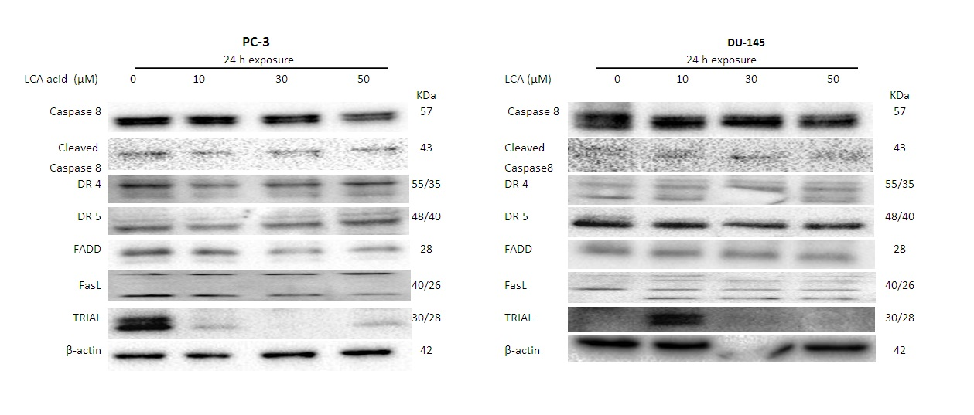
Figure 1. Lithocholic acid (LCA) induces extrinsic apoptosis pathway in PC-3 and DU-145 prostate cancer cells. Cells were exposed to 0, 10, 30 and 50 µM of LCA for 24 h. TRIAL, FasL, FADD, DR5, DR4, Cleaved caspase8, caspase8 and β-actin were detected by western blotting; one of three typical gels is shown.

PC-3 cells
LCA concen. | Hoechst 33342  Control + IETD AFC
0 µM | 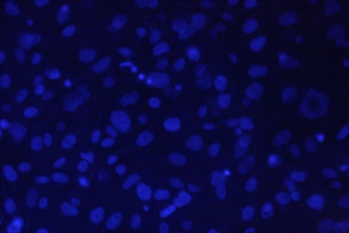 | 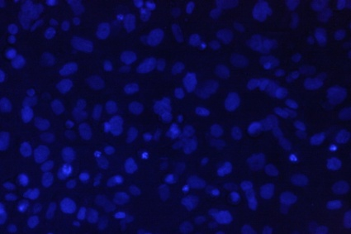
30 µM | 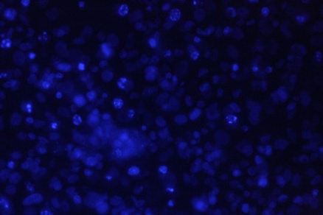 | 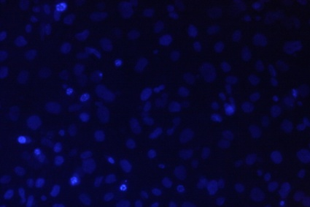
50 µM | 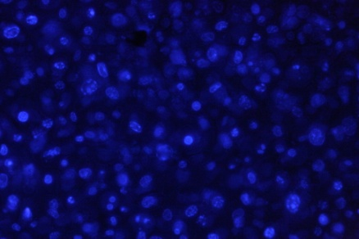 | 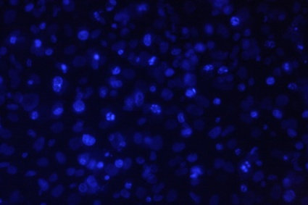
Figure 2. Lithocholic acid-(LCA)-induced apoptosis in PC-3 prostate cancer cells. Blocking caspase 8 partially inhibited apoptosis. Apoptotic nuclear morphology (chromatin condensed nuclei and DNA fragmentation) was observed with Hoechst 33258 staining using fluorescence microscopy.
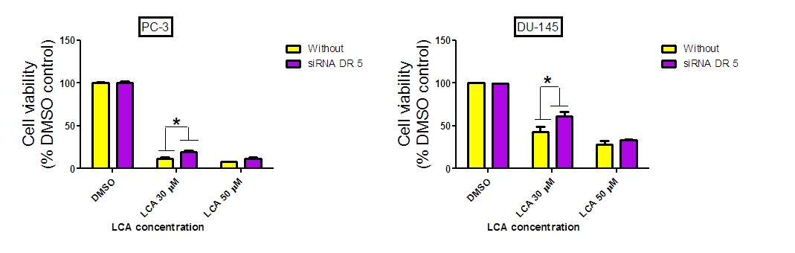
Figure 3. Death receptor (DR5) silencing partially block LCA (30µM) to induce cell death in PC-3 and DU-145 prostate cancer cells. Statistically significant difference in cell viability between DR5 siRNA

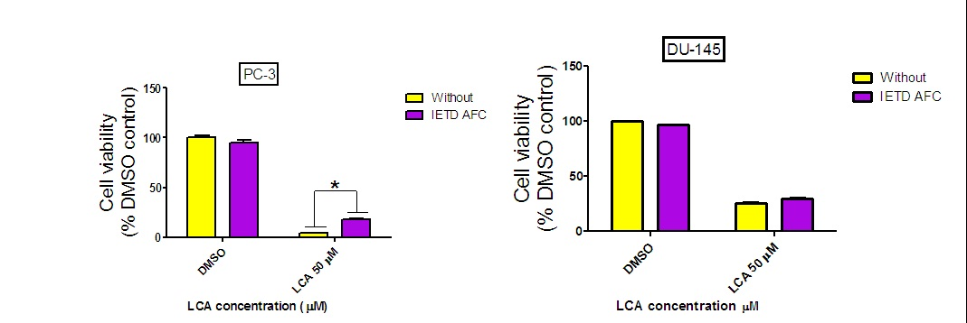
Figure 4. IETD AFC (10 µM) pretreatment partially block LCA (50µM) to induce cell death in PC-3 prostate cancer cells. Statistically significant difference in cell viability between IETD AFC and vehicle control-treated cells were observed by two-way ANOVA and Bonferonni post-hoc test (* p<0.05). Experiments were performed in triplicate using different cell passages; per experiment.

4. Discussion
Apoptosis or programmed cell death is essential for maintenance of development and homeostasis of multicellular organisms by eliminating superfluous or unwanted cells (Danial and Korsmeyer, 2004). Moreover, induction of apoptosis is an important target for cancer therapy (Fesik, 2005). In the present study we investigated the extrnsic pathway of apoptosis induced by LCA in human prostate cancer cell lines (PC-3 and DU-145).
In this study we show that LCA induces extrinsic pathway of apoptosis in human androgen-independent prostate cancer cells (Fig. 1). LCA caused sustained induction of TRIAL at 10 μM in DU-145 cells, although levels of FasL were high at 10, 30 and 50 μM in DU-145. Cleaved Caspase 8 was observed at 30 μM in DU-145 and at 10, 30 and 50 in PC-3 (Fig. 1).
A previous study by (Goldberg et al., 2013) found that LCA triggered both intrinsic and extrinsic pathways of apoptotic cell death that were, at least in part, caspase-dependent in prostate cancer cells. In addition, LCA selectively decreased the viability of human breast cancer and rat glioma cells (Goldberg et al., 2011).
Furthermore, Higuchi et al.(2001) reported that The Bile Acid Glycochenodeoxycholate Induces TRAIL-Receptor 2/DR5 Expression and Apoptosis in a human hepatocellular carcinoma cell line (HuH-7 cells). In addition, Mello-Vieira et al. (2013) reported that Hydrophobic bile acids (BAs) deoxycholic acid (DCA) induce cell death via multiple pathways, including both the intrinsic and extrinsic pathways of apoptosis.
In a trial to investigate whether extrinsic pathway plays a vital role or secondary role in cell death induced by LCA, we tested chemical inhibitors of caspase 8 (10 μM Ac-IETD-AFC ) and siRNA for death receptor DR5 and we found that at high concentrations of LCA (30 and 50 µM), the 2 inhibitors partially reduced the toxic effects of LCA in PC-3 and DU-145 cells [Figs 2, 3 and 4].
This comes in line with what Goldberg (2013) and his colleagues found when they stated that LCA-induced cell toxicity was also alleviated in the presence of the caspase-8 inhibitor, z-IETD-fmk in LNCaP and PC-3 cells.
Cell detachment was observed to enhance TRAIL-induced apoptosis in two TRAIL-resistant ovarian cancer cell lines. This process was accompanied by an increase of caspase activation, which could be blocked by caspase-8 inhibitor IETD. (Lane et al., 2011).

Conclusion:
It’s obvious now that LCA kills prostate cancer cells by triggering apoptosis, but without entering them. These key observations form the basis for our current working hypothesis that LCA may be suitable as potent and selective chemotherapeutic agent against prostate cancer. More research needs to be done on other surface bile acid receptors such as GPBAR1 to induce apoptotic cell death.

Acknowledgements
This study was supported financially by the Egyptian government in the form of a scholarship from the administration of cultural and general affairs and missions. The funders had no role in study design, data collection and analysis, decision to publish, or preparation of the manuscript.

References:
- American Cancer Society. Available online: http://www.cancer.org (accessed on 1 July 2014).
- Chuu, C.P.; Kokontis, J.M.; Hiipakka, R.A.; Fukuchi, J.; Lin, H.P.; Lin, C.Y.; Huo, C. and Su, L.C. (2011). Androgens as therapy for androgen receptor-positive castration-resistant prostate cancer. J. Biomed. Sci., 18, 63.
- Danial, N.N., Korsmeyer, S.J. ( 2004). Cell death: critical control points. Cell 116, 205–219.
- Fesik, S.W. (2005). Promoting apoptosis as a strategy for cancer drug discovery. Nature Reviews Cancer 5, 876–885.
- Fimognari, C., Lenzi, M., Cantelli-Forti, G., and Hrelia, P. (2009). Apoptosis and modulation of cell cycle control by bile acids in human leukemia T cells. Annals of the New York Academy of Sciences1171, 264-269.
- Giordano, C., Catalano, S., Panza, S., Vizza, D., Barone, I., Bonofiglio, D., Gelsomino, L., Rizza, P., Fuqua, S. A., and Ando, S. (2011). Farnesoid X receptor inhibits tamoxifen-resistant MCF-7 breast cancer cell growth through downregulation of HER2 expression. Oncogene 30, 4129-4140.
- Goldberg, A. A., Beach, A., Davies, G. F., Harkness, T. A., Leblanc, A., and Titorenko, V. I. (2011). Lithocholic bile acid selectively kills neuroblastoma cells, while sparing normal neuronal cells. Oncotarget2, 761-782.
- Goldberg, A. A., Titorenko, V. I., Beach, A., and Sanderson, J. T. (2013). Bile acids induce apoptosis selectively in androgen-dependent and -independent prostate cancer cells. PeerJ1, e122.
- Higano, C.S.; Small, E.J.; Schellhammer, P.; Yasothan, U.; Gubernick, S.; Kirkpatrick, P. and Kantoff, P.W. Sipuleucel-T. (2010). Nat. Rev. Drug Discov., 9, 513–514.
- Higuchi, H.; Bronk, S. F.; Takikawa, Y.; Werneburg, N.; Rishu Takimoto, R.; El-Deiry, W. and Gores, G. J. (2001).The Bile Acid Glycochenodeoxycholate Induces TRAIL-Receptor2/DR5 Expression and Apoptosis. J. Biol. Chem. 276:38610-38618.
- Hoffman-Censits, J. and Fu, M. (2013). Chemotherapy and targeted therapies: Are we making progress in castrate-resistant prostate cancer? Semin. Oncol., 40, 361–374.
- Katona, B. W., Anant, S., Covey, D. F., and Stenson, W. F. (2009). Characterization of enantiomeric bile acid-induced apoptosis in colon cancer cell lines. J Biol Chem284, 3354-3364.
- Lane, D., Cartier, A., Rancourt, C. and Piche, A. (2008), Cell detachment modulates TRAIL resistance in ovarian cancer cells by downregulating the phosphatidylinositol 3-kinase/Akt pathway. International Journal of Gynecological Cancer, 18: 670–676. doi: 10.1111/j.1525-1438.2007.01062.x
- Mello-Vieira, J.; Coutinho, A.; Fedorov, A.; Lucas, S. D.; Moreira, R.; Castro, R. E.; Rodrigues, C.; Prieto, M.; Fernandes, F. (2013). The Apoptotic Bile Acid DCA has Preference for Association to Liquid Disordered Lipid Domains and Inhibits the Rigidifying Effect of Cholesterol in Membranes. Biophysical Journal., 104, 586a
- Ryan, C.J.; Smith, M.R.; de Bono, J.S.; Molina, A.; Logothetis, C.J.; de Souza, P.; Fizazi, K.; Mainwaring, P.; Piulats, J.M.; Ng, S.; et al. (2013). Abiraterone in metastatic prostate cancer without previous chemotherapy. N. Engl. J. Med., 368, 138–148.
- Sartor, O. and Pal, S.K. (2013). Abiraterone and its place in the treatment of metastatic crpc. Nat. Rev. Clin. Oncol., 10, 6–8.
- Smith, D.C.; Smith, M.R.; Sweeney, C.; Elfiky, A.A.; Logothetis, C.; Corn, P.G.; Vogelzang, N.J.; Small, E.J.; Harzstark, A.L.; Gordon, M.S.; et al. (2013). Cabozantinib in patients with advanced prostate cancer: Results of a phase II randomized discontinuation trial. J. Clin. Oncol., 31, 412–419.
- Stavridi, F.; Karapanagiotou, E.M. and Syrigos, K.N. (2010). Targeted therapeutic approaches for hormone-refractory prostate cancer. Cancer Treat. Rev., 36, 122–130.
- Yakes, F.M.; Chen, J.; Tan, J.; Yamaguchi, K.; Shi, Y.; Yu, P.; Qian, F.; Chu, F.; Bentzien, F.; Cancilla, B.; et al.(2011). Cabozantinib (xl184), a novel met and vegfr2 inhibitor, simultaneously suppresses metastasis, angiogenesis, and tumor growth. Mol. Cancer Ther., 10, 2298–2308.

6/5/2016

