Circulating tumor cells as an early predictive marker of disease progression in metastatic breast cancer patients

Samy M. Algizawy¹, Hoda H. Essa¹, Ebtesam El-Gezawy², Nagham N Omar³andDouaa M Sayed⁴

¹Department of Clinical Oncology, ²Department of Clinical Pathology and ³Department of Radiology Faculty of Medicine, Assiut University, Egypt, ⁴Department of Clinical Pathology, South Egypt Cancer Institute, Assiut University, Egypt

hodahassanessa@yahoo.com

Abstract: Introduction: Circulating tumor cells (CTCs) are prognostic markers in metastatic breast cancer, but their predictive value to monitor treatment efficacy still needs further investigation. The aim of this study was to test whether persistent elevation of circulating tumor cells (CTCs) at both baseline and before 2nd cycle of a new treatment can serve as an early predictive marker of disease progression in patients with metastatic breast cancer using the predefined 5 CTC/7.5 ml threshold. Methods: From March 2010 to October 2013, 85 patients with stage IV breast cancer who met the eligibility criteria were enrolled in the study. Before starting a new treatment, all patients underwent full imaging studies, and blood sampling for CTC enumeration. Patients with < 5 CTC/7.5 ml blood detected at baseline had no further CTC count. Patients with ≥ 5 CTCs /7.5 ml blood had another blood sampling for estimation of CTC before the 2nd cycle (C2). Objective tumor response was assessed using contrast enhanced 16 multitdetector CTd according to the Response Evaluation Criteria in Solid Tumors (RECIST). Results: At baseline, 44 (51.8%) of the 85 eligible patients did not have increased CTC levels. Of the other 41 patients with ≥ 5 CTCs /7.5 ml blood, only 38 patients had CTCs evaluation at first follow-up before 2nd cycle (CTC_{FU}) that showed 25 (65.8 %) patients had < 5 CTC/7.5 ml blood and 13 (34.2%) patients had ≥ 5 CTCs /7.5 ml blood. Seventy-five patients (75/85, 88.2 %) underwent radiological restaging. According to RECIST, 36 (48%) patients were scored as having a partial response, 19 (25.3%) as having stable disease, and 20 (26.7%) as having progressive disease. Radiologic response was concordant with follow-up CTC levels in 76.5% of cases. Survival of our patients depended significantly on both the results of CTC evaluation and radiological response. The median follow-up was 18.0 [1–60] months. Both median PFS and median OS were significantly shorter in patients with ≥5 CTCs than in patients with <5 CTCs at baseline (7.5 vs. 16.8 for PFS, P = 0.004 and 13 vs. 23 for OS, P = 0.005). The median OS times of 75 patients who underwent radiological restaging were 24 months for patients who had non-progression (PR + SD) vs. 13 months for patients with PD (P < 0.001). Both median PFS and median OS were significantly shorter in patients with ≥5 CTCs than in patients with <5 CTCs at follow up (2.8 vs. 14.2 for PFS, P<0.001 and 6.2 vs. 23.8 for OS, P<0.001). Conclusions: This study supports the significance of elevated CTCs before 2nd cycle in MBC patients starting a new line of chemotherapy as an early predictive marker of disease progression, thus, monitoring treatment benefit. Until proven, computed tomography CT scan is the standard of care for evaluation of disease status of such patients. This study confirmed the independent prognostic significance of CTCs in such patients.
[Samy M. Algizawy, Hoda H. Essa, Ebtesam El-Gezawy, Nagham N Omar and Douaa M Sayed. Circulating tumor cells as an early predictive marker of disease progression in metastatic breast cancer patients. Cancer Biology 2016;6(2):38-50]. ISSN: 2150-1041 (print); ISSN: 2150-105X (online). http://www.cancerbio.net. 6. doi:10.7537/marscbj06021606.

Keywords:Circulating tumor cells, predictive marker, metastatic breast cancer.

1. Introduction
1.1. Background and statement of the problem
Major advances in the treatment of breast cancer have been achieved over the past two decades both in the adjuvant and metastatic settings resulting in significant decrease in breast cancer mortality. Despite this progress, metastatic breast cancer is still considered an incurable disease (1), and the aim of antineoplastic treatment is still palliative (2). In this setting, it is important to be able to assess treatment efficacy in individual patients so that effective therapy can be continued and ineffective but toxic therapy discontinued (3). Decisions on changing to a new drug or regimen or discontinuing treatments are based on the patient’s goals for care and clinical evaluation and judgment of disease progression or response. More effective means are needed to assess the effectiveness of treatment and to guide decisions on systemic therapy in MBC patients (3,4).
Imaging has the upper hand in detection of metastases and pattern of response, being multidetector computed tomography (MDCT) scan is the investigation of choice in this aspect as it allows comprehensive evaluation of lymphatic involvement, soft tissues, bones in addition to the internal organs in very short time. The disadvantages of imaging modalities include failure to capture tumor heterogeneity, unability to differentiate between benign and malignant lesions and time delay of detection of therapeutic resistance or early response to treatment (5-7).
A number of blood-based biomarkers including CA15-3 andCA27.29, carcino-embryonic antigen (CEA) and CA-125 (8-10) have been studied in MBC patients, but prospective trials validating their clinical utility are still limited (11-14). Although serum tumor markers are an easy, quick, and cheap tool, they are rather imprecise, and sometimes misleading in monitoring the treatment efficacy (15). A recent update of the American Society of Clinical Oncology (ASCO) guideline on use of tumor markers in breast cancer recommended "there is no evidence at this time that changing therapy solely on the basis of biomarker results beyond ER, PR, and HER2 improves health outcome, quality of life, or cost effectiveness" (4). For the last two decades, circulating tumor cells (CTCs) have attracted interest as a promising tool to monitor therapy response in women being treated for MBC. "Circulating tumor cells (CTCs) are cells that shed from the tumor and enter the circulation, a process that is required for cancer metastasis"(16). The detection of CTCs in the peripheral blood of MBC patients was proven to have an independent prognostic value by large studies (3,16-25). The presence of ≥5 CTCs/7.5 ml blood at the beginning of a new therapy is strongly associated with reduced overall survival (OS) (3, 10). This threshold was set on the basis of its reproducibility (26) and because 5 CTC/7.5 ml was the median CTC count maximizing the log-rank test results (27).
1.2. Objective
The aim of this study was to determine whether persistent elevation of circulating tumor cells (CTCs) at both baseline and before 2nd cycle of a new treatment can serve as an early predictive marker of disease progression in patients with metastatic breast cancer using the predefined 5 CTC/7.5 ml threshold.

2. Materials and methods
2.1. Research design
From March 2010 to October 2013, patients with stage IV breast cancer who presented to the Department of clinical Oncology, Assiut University Hospital were enrolled in this prospective single-center, non-randomized study.
2.2. Eligibility criteria and evaluations
Principal eligibility criteria were female patients with histopathological diagnosis of breast cancer, evidence of metastatic measurable or evaluable disease from imaging studies, and starting a new line of chemotherapy. Patients with brain metastases were excluded. All patients had Eastern Cooperative Oncology Group (ECOG) scores for performance status of 0 to 2. Prior adjuvant treatment and/or treatment of metastatic disease with a maximum two lines of therapy were permitted. Other criteria were as follows: adequate bone marrow (white blood cell count> 3.0 x 10⁹/L, platelets > 100 x 10⁹/L), renal (serum creatinine< 120 µmol/L) and hepatic functions (serum bilirubin level < 20 µmol/L).The ethics committee of the Faculty of Medicine, Assiut University approved the study protocol, and all patients provided written informed consent. Patients were treated with the commonly established chemotherapeutic regimens for metastatic breast cancer patients chosen according to the clinical practice guidelines of National Comprehensive Cancer Network (NCCN, Breast Cancer V.2.2010). None of our patients were given targeted therapy (trastuzumab, bevacizumab, or others) due to financial reason and limited resources. Before starting a new line of chemotherapy, metastatic sites in every patient were evaluated by means of standard imaging studies; chest and abdomen MDCT scan and whole body bone scan. CT scan of the brain was added when indicated only. Blood sampling was performed within 7 days before 1stcyclefor enumeration of CTC at baseline (CTC_{BL}). Patients with CTC_{BL}<5/7.5 ml blood had no further CTC count, as no treatment-related CTC decrease could be observed in these patients. Patients with CTC_{BL}≥ 5 /7.5 ml blood had another blood sampling for estimation of CTC before the 2nd cycle (C2) (CTC_{FU}). All patients were regularly followed and observed for progression free survival and overall survival. Re-evaluation of disease status was conducted with the same imaging studies that were used at baseline every 9 to 12 weeks. Disease response was assessed according to the Response Evaluation Criteria in Solid Tumors (RECIST)(28). Progressive disease was defined as a ≥25% increase in the sum of all lesions or appearance of a new measurable or non-measurable lesion. Partial response was defined as a decrease in the sum of all lesions of ≥50% and no new lesions. The radiologic responses were classified as stable disease/partial response (non-progression) versus progressive disease (progression) (3). This classification was based on the recognition that MBC patients with stable disease have similar survival rates as those with radiographic tumor regression (29, 30). In addition, in current clinical practice is to continue the same line of therapy as long as there is unacceptable toxicity or evidence of disease progression (29). Patients with progressive disease were switched to another line of therapy or best supportive care according to the NCCN clinical practice guidelines (Breast Cancer V.2.2010).
2.3. Isolation and enumeration of CTC
CTCs detection: CTCs were detected by modification of the method of Hristozova et al., 2011[31]. CTC identification and counting were done by flowcytometry. After lysis of erythrocytes, the cell suspension was incubated for 20 minutes in dark with fluoresceinisothiocyanate (FITC) labeled pan-cytokeratin, phycoerythrin (PE) ladeled CD66e, peridiniumchlorophyll-protein (Per-CP) labeled CD24 and Allophycocyanin (APC) labeled CD44. Allmonoclonal antibodies were purchased from Becton Dickinson (BD) Biosciences, San Jose, USA. After wash with phosphate buffered saline (PBS), the cells were ready for analysis. Flowcytometric analysis wasdone by FACSCalibur with Cell Quest software (BD Biosciences). Isotype-matched negative control was done for each sample. The absolute numbers of CTCs per 7.5 ml blood were determined by recording all events in the whole suspension.

2.4. Radiologic evaluation:
The MDCT scans of the existing lesions were obtained at base line before treatment and 9-12 months after initiation of the first cycle of treatment. All CT examinations were performed on a 16-detector CT scanner (General Electric Bright Speed Elite 16 slice).

MDCT chest: MDCT with contrast was performed in the axial plane at a 0.5mm interval was done with patient in supine position, head first and scanned from the level of lower neck down to diaphragm. The acquisition parameters were a pitch of 4.8 sec scan time, 12 second total exposure time, 5 mm slice thickness, 0.3 mm reconstruction interval FOV. The data are reconstructed on a high spatial resolution (bony) algorithm for optimal lung parenchyma display. CT images were transferred to an independent workstation (AW v 4.1l) for further image reconstruction. Chest multi-planar volume rendering (MPVR) images were collected at the axial, sagittal and coronal views with a minimum intensity projection (MinIP) and 3D transparency lung volume rendering (TLVR) models of the tracheobronchial system.

MDCT abdomen:
Patients were given oral nonionic contrast 2 hours before scanning. The patients were scanned from the base of the lungs to the symphysis pubis after IV injection of 80–100 mL of nonionic contrast in portovenous phase with a scanning delay of 60–90s. Image slices of 10-mm-thickness were obtained followed by reconstruction in sagittal and coronal planes.
Image Analysis:
One blinded observers expert in cancer breast imaging reviews the baseline images together with the follow up ones without consideration to the level of the marker. Lesions assessment includes: lesions size, number, locations, characterizations, enhancement, ascites, effusion, peritoneal cakes, vascular occlusion, haematogenous or lymphatic spread to liver, lymph nodes or bone. The definitions of treatment response were according to Response Evaluation Criteria in Solid Tumors (RECIST)(28).
-Complete response was defined as the complete disappearance of all tumor lesions.
-.Progressive disease was defined as a ≥25% increase in the sum of all lesions or appearance of a new measurable or non-measurable lesion.
- Partial response was defined as a decrease in the sum of all lesions of ≥50% and no new lesions.).
The radiologic responses were classified as stable disease/partial response (non-progression) versus progressive disease (progression) (3). This classification was based on the recognition that MBC patients with stable disease have similar survival rates as those with radiographic tumor regression (29, 30). In addition, in current clinical practice is to continue the same line of therapy as long as there is unacceptable toxicity or evidence of disease progression (29). Patients with progressive disease were switched to another line of therapy or best supportive care according to the NCCN clinical practice guidelines (Breast Cancer V.2.2010).

2.5. Statistical analysis
Patient demographic and clinical characteristics were demonstrated as medians and ranges or numbers and percentages, as appropriate. The Fisher’s exact test was used to compare differences between patients with CTC_{BL}<5/7.5 ml blood and those with CTC_{BL}≥ 5/7.5 ml blood. The same test was used to determine the correlations between the disease response, assessed by radiological imaging after 3-4 cycles, and CTCs values before C2. Progression-free survival (PFS) was defined as the time from the study entry to tumor progression or death from any cause, whichever came first (32). The overall survival (OS) was defined as the time from the date of inclusion until the date of death from any cause (32). The reverse Kaplan-Meier method was used to calculate the median follow-up time. Patients who were alive or showed no progression at last follow-up were regarded as censored observations. Survival curves were compared using log-rank testing. The Cox proportional hazards regression model was used perform multivariate analysis to determine the independent prognostic factors. All P values reported are two sided.

3. Results
From March 2010 to October 2013, 85 patients who met the eligibility criteria were enrolled in the study. Patient characteristics are shown in detail in Table I. The majority of patients (68.2%) had HER2/neunegative disease. Estrogen receptor (ER)-positive disease was found in 57.7%, and in 55.3% for progesterone receptor (PgR). Most patients had ≥3 metastatic site (75.3%) and approximately two-thirds had both visceral and non-visceral metastases. Thirty-three patients (38.8%) had ≥2second-line treatment for MBC. At baseline, 44 (51.8) of the 85 eligible patients did not have increased CTC levels (< 5 CTC/7.5 ml blood) while the other 41 (48.2%) had CTC levels ≥ 5 /7.5 ml blood. Only patients with number of metastases ≥3 was significantly more frequent in the group with ≥5 CTCs/7.5 ml compared to the group with <5 CTCs/7.5 ml (87.8 vs 63.6, P=0.004). Otherwise, there were no significant differences in other patient or tumor characteristics between both groups (Table 1). Of the 41 patients with increased CTC_{BL} (≥ 5 CTCs /7.5 ml blood), 38 patients had CTCs determined at first follow-upbefore 2nd cycle (CTC_{FU}). The median duration between blood sampling for CTC_{BL} and that for CTC_{FU} was 23 days (range 18-30 days). The remaining three patients did not have a second CTC evaluation because one died before 2nd cycle of chemotherapy and 2 patients could not tolerate the treatment and the regimen was changed. The first follow-up CTCs (CTC_{FU}) evaluation showed that 25 (65.8 %) patients had CTC levels that were no longer increased (< 5 CTC/7.5 ml blood) while 13 (34.2%) patients still had increased CTC levels (≥ 5 CTCs /7.5 ml blood).
3.1. The correlation between Radiologic response and CTC_{BL} evaluation (Table 2)
Seventy-five patients (75/85, 88.2 %) underwent radiological restaging. In addition to the 3 patients who did not have a second CTC evaluation, seven more patients didn't undergo radiological restaging due to death for 3 patients, drug toxicity and/or treatment change for 3 patients and refusal to complete treatment course for one patient. Two of the seventy-five patients (2/75) developed rapid progression, so, underwent radiological restaging before the third cycle while the other 73 patients were reassessed after 3-4 cycles with a median duration of 69 days (range 60-85 days) after study entry. According to RECIST, 36 (48%) patients were scored as having a partial response, 19 (25.3%) as having stable disease, and 20 (26.7%) as having progressive disease. No complete responses were observed. Table 2 shows the correlation between radiologic response and CTC_{BL} evaluation. Although this correlation was statistically non-significant (P=0.07), most of the patients with CTC_{BL} <5/7.5 ml blood (33/40, 82.5%) had partial response/stable disease, (an example of those patients is shown in Fig. 1).
3.2. The correlation between Radiologic response and CTC_{FU} evaluation (Table 3)
Of the thirty-eight patients with follow up CTC evaluation, 34 underwent radiological restaging. According to RECIST, 16 (47.1%) patients were scored as having a partial response, 8 (23.5%) as having stable disease, and 10 (29.4%) as having progressive disease. Radiologic response was concordant with follow-up CTC levels in 26 of 34 (76.5%) cases. Nineteen (55.9%) cases were found to have stable disease/partial response by radiologic criteria and <5 CTCs/7.5 mL blood, and 7 (20.6%) cases had progressive disease by radiographic criteria and ≥5 CTCs/7.5 mL blood. Of the 8 (23.5%) discrepant cases, 3 (8.8%) with progressive disease by radiographic criteria had <5 CTCs/7.5 mL blood (an example of those patients is shown in Fig.2), and 5 (14.7%) with stable disease/partial response by radiographic criteria had ≥5 CTCs/7.5 mL blood. (Fisher’s exact test, P = 0.015) (an example of those patients is shown in Fig. 3).
3.3. Survival
Survival of our patients depended significantly on both the results of CTC evaluation and radiological response. The median [95% CI] follow-up of 79 patients was 18.0 [1–60] months. The survival data of the other 6 patients who had treatment change or refused to complete treatment course before reassessment were not included. Figure 4 (A and B) shows the Kaplan-Meier curves for PFS and OS of 79 patients according to CTC status at baseline. Both median PFS and median OS were significantly shorter in patients with ≥5 CTCs than in patients with <5 CTCs at baseline (7.5 months vs. 16.8 months for PFS, [HR= 2.05, 95% CI: 1.28–3.29, P= 0.004] and 13 months vs. 23 months for OS, [HR= 2.11, 95% CI: 1.31–3.40, P = 0.005]). Figure 5 (A and B) shows Kaplan-Meier plots for PFS and OS of 34 patients by CTC_{FU}. Both median PFS and median OS were significantly shorter in patients with ≥5 CTCs than in patients with <5 CTCs at follow up (2.8 months, vs. 14.2 months for PFS, [HR= 6.53, 95% CI: 2.64–16.16, P<0.001] and 6.2 months vs. 23.8 months for OS, [HR= 9.22, 95% CI: 3.34–25.41, P<0.001]). Figure 6(A) shows Kaplan-Meier plots for OS of 75 patients who had imaging restaging by their radiologic response. The median OS times were 13 months for patients with PD vs. 24 months for patients who had non-progression (PR + SD), [HR= 4.58, 95% CI: 2.61–8.06, P<0.001]. Figure 6 (B) shows Kaplan-Meier plots for OS of 34 patients (who had CTC_{FU} estimation) by their radiologic response. The median OS times were 5.7 months for patients with PD vs. 6.83 months for patients who had non-progression (PR + SD), [HR= 6.83, 95% CI: 2.55–18.28, P<0.001].
3.4. Prognostic factors
In multivariate analysis, baseline CTC positivity (≥5 CTC/7.5 ml) was an independent prognostic factor for OS. Other independent prognostic factors included age, performance status, estrogen receptor status, and number of lines (Table 4).

Table 1. Patient characteristics stratified by baseline circulating tumor cell value
P value | Patients with baseline CTC≥5; n (%) | Patients with baseline CTC<5; n (%) | All patients; n (%) | Characteristic
 | 41(48.2) | 44 (51.8) | 85 (100) | Number
 | 55 | 50 | 52 (39-72) | Age (median (range)) (year)
0.179 | 29(70.7)  12(29.3) | 24(54.5)  20(45.5) | 53 (62.4)  32(37.6) | ECOG PS  0-1  2
0.662 | 17(41.5)  24(58.5) | 16(36.4)  28(63.6) | 33 (38.8)  52(61.2) | Menopausal status  Pre-  Post-
0.828  0.130 | 23 (56.1)  18 (43.9)  19 (46.3)  22 (53.7) | 26 (59.1)  18(40.9)  28 (68.3)  16 (41.7) | 49 (57.7)  36(42.3)  47 (55.3)  38 (44.7) | Hormone Receptor  ER  +ve  -ve  PgR  +ve  -ve
0.165 | 16 (39)  25 (61) | 11 (33.3)  33(66.7) | 27 (31.8)  58 (68.2) | HER2/neu  +ve  -ve
0.893 | 4 (9.8)  23 (56.1)  14 (34.1) | 5 (11.4)  26 (59.1)  13(29.5) | 9 (10.6)  47 (55.3)  29(34.1) | Grade:  I  II  III
0.111 | 4 (9.8)  6 (14.6)  31 (75.6) | 6 (13.6)  14 (31.8)  24 (54.6) | 10 (11.8)  20 (23.5)  55 (64.7) | Metastasic sites  -Non-visceral  -Visceral  -Both
0.004 | 5 (12.2)  36 (87.8) | 16 (36.4)  28 (63.6) | 21 (24.7)  64 (75.3) | No. of metastasis  <3  ≥3
0.824 | 26 (63.4)  15 (36.6) | 26 (59.1)  18 (40.9) | 52 (61.2)  33 (38.8) | Lines of therapy  <2  ≥2

Table 2: Correlation between Circulating Tumor Cells at baseline andradiologicalresponseof Seventy-five patients who underwent radiological restaging
 |  | Radiological Response |  |  | P value (Fisher’s exact test)
 |  | Partial Response/ Stable disease; n (%) | Progressive Disease; n (%) | Total; n (%)
CTC_{FU} (7.5 ml blood) | < 5 | 33(82.5) | 7(17.5) | 40(100)
 | ≥ 5 | 22(62.9) | 13(37.1) | 35(100) | 0.070
Total |  | 55(70.6) | 10(29.4) | 75(100)

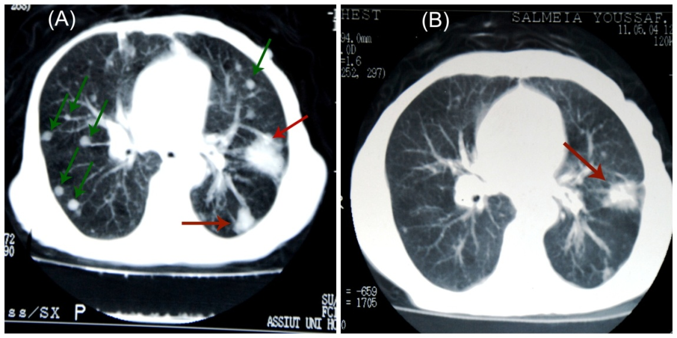

Fig.1: MDCT Axial scan with pulmonary window at the level of carina of 75 years old lady with metastatic breast cancer (chest metastases):
- At Baseline showing multiple right and left metastatic lung nodules (green arrows) and 2 left masses (red arrows).
- After 3 cycles of treatment showing partial response of both the nodules and the masses (>50% remission). The CTC_{BL} was < 5 CTC/7.5 ml.

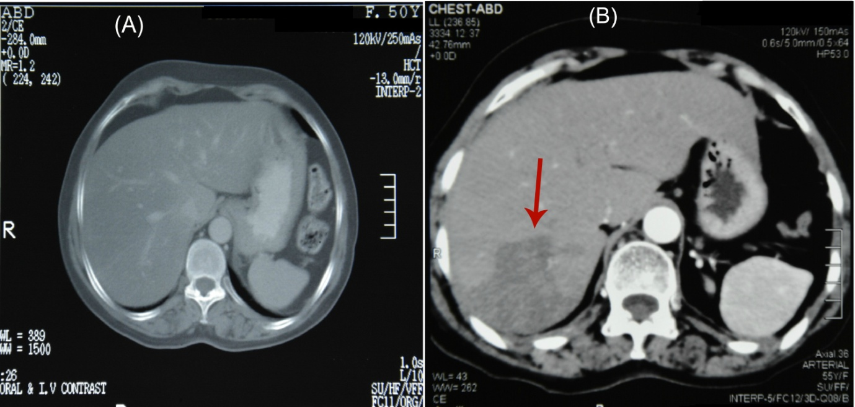

Fig.2: Contrast enhanced MDCT axial scan of the abdomen of 50 years old lady with metastatic breast cancer:
A) At baseline showing normal liver with no metastatic deposits.
B) After 3 cycles of treatment showing a large new hepatic focal lesion at segment 7 denoting progressive disease. CTC_{FU} was < 5 /7.5 ml.

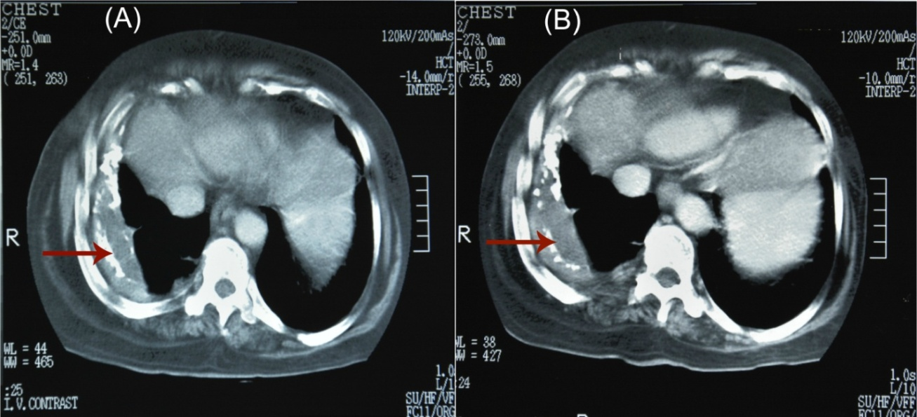
Fig.3: contrast enhanced chest MDCT Axial scan-mediastinal window- at the level of ascending aorta of 50 years old female patient with metastatic breast cancer stationary course
- At baseline showing right pleural effusion
- At Follow up showing stationary course. CTC_{FU} revealed ≥5 CTC/7.5 ml.

Table 3: Correlation between Circulating Tumor Cells before C2 and radiological response of 34 patients who had follow up CTC evaluation and radiological restaging.
 |  | Radiological Response |  |  | P value (Fisher’s exact test)
 |  | Partial Response  / Stable disease; n (%) | Progressive Disease; n (%) | Total; n (%)
CTC_{FU} (7.5 ml blood) | < 5 | 19(86.4) | 3(13.6) | 22(100)
 | ≥ 5 | 5(41.7) | 7(58.3) | 12(100) | 0.015
Total |  | 24(70.6) | 10(29.4) | 34(100)
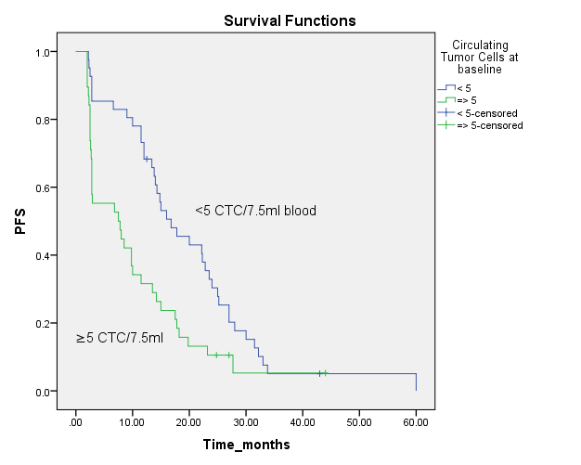
A.
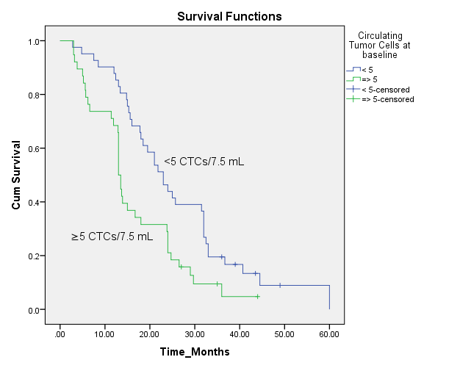
B.
Figure 4: (A): Progression free survival (PFS) in 79 patients with metastatic breast cancer according to circulating tumor cell (CTC) levels at baseline. (B): Overall survival (OS) in 79 patients with metastatic breast cancer according to circulating tumor cell (CTC) levels at baseline.

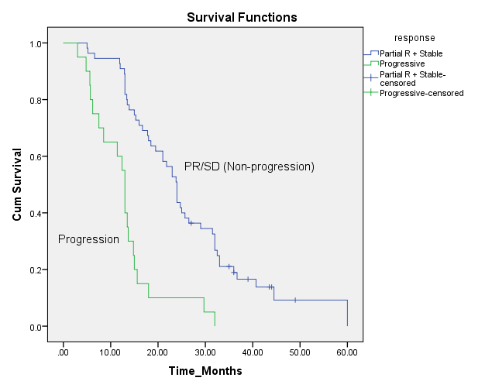
A.
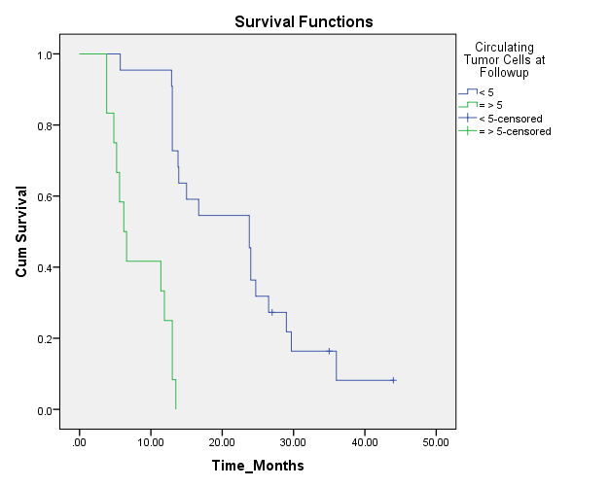
B.
Figure 5: (A) Progression free survival (PFS) in 34 patients with metastatic breast cancer(who underwent CTC evaluation before 2nd cycle and radiological restaging)according to circulating tumor cell (CTC) levels before 2nd cycle.(B) Overall survival (OS) in 34 patients with metastatic breast cancer according to circulating tumor cell (CTC) levels before 2nd cycle.
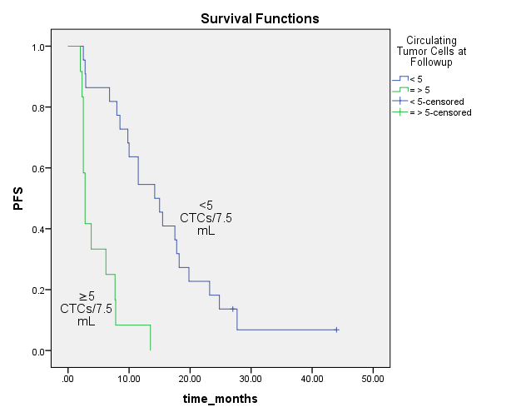
A.

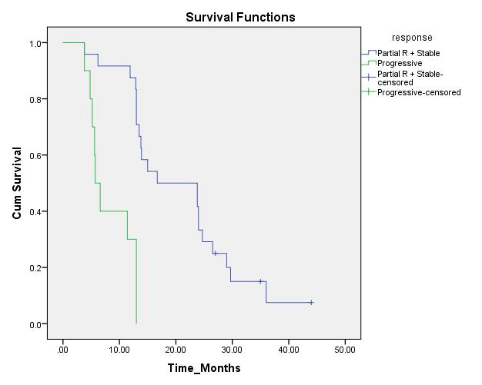
B.
Figure 6: (A) shows Kaplan-Meier plots for OS of 75 patients who had imaging restaging by their radiologic response. (B) Overall survival (OS) in 34 patients with metastatic breast cancer (who underwent follow up CTC evaluation and radiological restaging) according to treatment response.

Table 4: Multivariate analysis of prognostic factors of all (79) patients for overall survival.
Prognostic factor | P value | HR | 95.0% CI for Exp(B)
 |  |  | Lower | Upper
Age | .004 | .942 | .904 | .981
PS | .004 | 2.567 | 1.345 | 4.899
Menopausal | .831 | .926 | .456 | 1.878
Grade | .665 | 1.102 | .711 | 1.707
ER | .014 | .297 | .113 | .783
PR | .593 | 1.283 | .514 | 3.202
HER2neu | .766 | .922 | .539 | 1.575
Metastaticsites | .732 | .901 | .498 | 1.633
Metastaticnumber | .197 | .610 | .288 | 1.293
Lines | .013 | .443 | .234 | .839
CTCBL | .000 | 4.350 | 2.316 | 8.173

4. Discussion
Circulating tumor cells in the peripheral blood of cancer patients represent a unique window on the metastatic process and their count has indeed been reported to be a strong independent prognostic factor in several metastatic tumor types, (32). Our study validated the independent prognostic significance of CTCs in MBC patients receiving palliative chemotherapy. Several studies have evaluated the role of CTCs in metastatic breast cancer and have clearly shown that CTCs are associated with poor prognosis in this setting (3, 16-25). Zhang and colleagues (25) published a comprehensive meta-analysis of studies that investigated the prognostic relevance of CTC in patients with early and advanced disease. A total of 49 studies enrolling 6,825 patients met eligibility criteria. The prognostic value of CTC was significant in both early (DFS: HR, 2.86; 95% CI, 2.19–3.75; OS: HR, 2.78; 95% CI, 2.22–3.48) and metastatic breast cancer (PFS: HR, 1.78; 95% CI, 1.52–2.09; OS: HR, 2.33; 95% CI, 2.09–2.60) (25). However, most of the reviewed studies didn't assess predictive value using clinical utility guidelines (4). The need for novel independent prognostic factors in metastatic breast cancer patients is much lower than the need for dynamic blood markers, which can indicate the treatment efficiency in a reliable and early fashion (15). The main objective of our study was to test whether elevated CTCs before C2 could be used as an early predictive marker of disease progression in patients with metastatic breast cancer. Our results indicate that CTCs enumeration in these patients at baseline and before C2 correlated with radiographic determinations of disease progression after 3-4 cycles. These findings are consistent with data of others (3, 33-35). A similar statistically significant correlation between CTC levels and radiographic progression of the disease was demonstrated by Liu et al. (33) in 68 patients receiving chemotherapy or endocrine therapy. In their study, this correlation applied to CTC results obtained at the time of imaging, 3 to 5 weeks before imaging, and 7 to 9 weeks before imaging (33). Budd et al. (3) compared the use of CTCs to radiology for prediction of OS in 138 patients with metastatic breast cancer. In their study, radiologic response was concordant with CTC levels in 105 of 138 (76%) cases. They concluded that the CTC assay showed useful earlier results than do radiologic studies, and seemed to be a more robust predictor of survival than is radiographic response (3). Likewise, Hartkopf et al. (34) found that changes in CTC level (either negative CTCs (<5 CTCs/7.5 ml blood)turning positive, vice versa, or a change of ±25%) were significantly correlated with radiologic response to therapy in 58 MBC patients (p<0.001).To demonstrate the clinical utility of early CTC changes after one cycle of first-line chemotherapy, the South West Oncology Group conducted a large prospective clinical trial (SWOG 0500 trial) from October 2006 until March 2012 (35). One hundred and twenty patients with MBC whose CTCs were not reduced after the first cycle of first-line chemotherapy, were randomized into two arms: immediate change to second line chemotherapy or continuation of the first line chemotherapy until radiological progression. Although this switching strategy failed to improve patient outcomes (OS or even PFS), their findings suggest that measurement of CTCs might have clinical utility (35).
To explain these negative results, it has been discussed by the study investigators that second line chemotherapy is unlikely to have a significant effect (even when introduced earlier on the basis of elevated CTC count) on breast cancer patients that have a primary resistance to first linechemotherapy (35). Other comments have been made on the trial’s design and concepts (31,36,37). On the basis of these negative results, the 2015 clinical practice guidelines of American Society of Clinical Oncology for CTC count considered reasonable for clinicians to not use CTC count to guide decisions on systemic therapy for patients with metastatic breast cancer(4). Two other trials investigating the clinical utility of CTC count in BC patients are currently ongoing France: The “CirCe01” trial (NCT01349842) and The “STIC CTC” trial (NCT01710605) (38).

5. Conclusions
In conclusion, our findings support the significance of elevated CTCs before 2nd cycle in MBC patients starting a new line of chemotherapy as an early predictive marker of disease progression, thus, monitoring treatment benefit. Our study confirmed the independent prognostic significance of CTCs in such patients. To validate our findings and to investigate that such an early response assessment results in an improved survival or quality of life will need to be prospectively assessed in large randomized clinical trials.

References:
- Howlader N, Noone AM, Krapcho M, Garshell J, Neyman N, Altekruse SF, Kosary CL, Yu M, Ruhl J, Tatalovich Z, Cho H, Mariotto A, Lewis DR, Chen HS, Feuer EJ, Cronin KA (Eds): SEER Cancer Statistics Review, 1975¿2010. Bethesda, MD: National Cancer Institute;, based on November 2012 SEER data submission, posted to the SEER web site, April 2013.
- Lin NU, Thomssen C, Cardoso F, et al: International guidelines for management of metastatic breast cancer (MBC) from the European School of Oncology (ESO)-MBC Task Force: Surveillance staging, and evaluation of patients with early-stage and metastatic breast cancer. Breast 22:203-210, 2013.
- Budd GT, Cristofanilli M, Ellis MJ, Stopeck A, Borden E, Miller MC, Matera J, Repollet M, Doyle GV, Terstappen LW, Hayes DF. Circulating tumor cells versus imaging--predicting overall survival in metastatic breast cancer. Clin Cancer Res. 2006 Nov 1;12(21):6403-9.
- Van Poznak C, Somerfield MR, Bast RC, Cristofanilli M, Goetz MP, Gonzalez-Angulo AM, Hicks DG, Hill EG, Liu MC, Lucas W, Mayer IA, Mennel RG, Symmans WF, Hayes DF, Harris LN. Use of Biomarkers to Guide Decisions on Systemic Therapy for Women With Metastatic Breast Cancer: American Society of Clinical Oncology Clinical Practice Guideline. J Clin Oncol. 2015 Aug 20;33(24):2695-704.
- Nowell PC. The clonal evolution of tumor cell populations. Science.1976;194:23-8.
- Talmadge JE, Wolman SR, Fidler IJ. Evidence for the clonal origin of spontaneous metastases. Science. 1982;217:361-3.
- Simmons C, Miller N, Geddie W, et al. Does confirmatory tumor biopsy alter the management of breast cancer patients with distant metastases? Ann Oncol. 2009;20:1499-504.
- Ebeling FC, Schmitt UM, Untch M, et al. Tumour markers CE Aand CA 15-3 as Prognostic factors in breast cancer--univariate and multivariate analysis. Anticancer Res. 1999;19:2545-50.
- Ebeling FG, Stieber P, Untch M, et al. Serum CEA and CA 15-3 as prognostic factors in primary breast cancer. Br J Cancer. 2002; 86:1217-22.
- Sturgeon CM, Duffy MJ, Stenman UH, et al. National Academy of Clinical Biochemistry laboratory medicine practice guidelines for use of tumor markers in testicular, prostate, colorectal, breast, and ovarian cancers. Clin Chem. 2008;54:e11-79.
- Harris L, Fritsche H, Mennel R, et al. American Society of Clinical Oncology 2007 update of recommendations for the use of tumor markers in breast cancer. J Clin Oncol. 2007;25:5287-312.
- Hayes DF, Zurawski VR, Jr., Kufe DW. Comparison of circulating CA15-3 and carcinoembryonic antigen levels in patients with breast cancer. J Clin Oncol. 1986;4(10):1542-50.
- Hogan-Ryan A, Fennelly JJ, Jones M, Cantwell B, Duffy MJ. Serum sialic acid and CEA concentrations in human breast cancer. Br J Cancer. Apr 1980;41:587-92.
- Tormey DC, Waalkes TP. Clinical correlation between CEA and breast cancer. Cancer. 1978;42:1507-11.
- Bidard FC, Hajage D, Bachelot T, Delaloge S, Brain E, Campone M, Cottu P, Beuzeboc P, Rolland E, Mathiot C, Pierga JY. Assessment of circulating tumor cells and serum markers for progression-free survival prediction in metastatic breast cancer: a prospective observational study. Breast Cancer Res. 2012 Feb 13;14(1):R29.
- Liu Y, Liu Q, Wang T, Bian L, Zhang S, Hu H, Li S, Hu Z, Wu S, Liu B, Jiang Z. Circulating tumor cells in HER2-positive metastatic breast cancer patients: a valuable prognostic and predictive biomarker. BMC Cancer. 2013 Apr 23;13:202. doi: 10.1186/1471-2407-13-202.
- Hayes DF, Cristofanilli M, Budd GT, Ellis MJ, Stopeck A, Miller MC, et al. Circulating tumor cells at each follow-up time point during therapy of metastatic breast cancer patients predict progression-free and overall survival. Clin Cancer Res 2006;12:4218–24.
- Nole´ F, Munzone E, Zorzino L, et al: Variation of circulating tumor cell levels during treatment of metastatic breast cancer: Prognostic and therapeutic implications. Ann Oncol 19:891-897, 2008.
- Gradilone A, Naso G, Raimondi C, Cortesi E, Gandini O, Vincenzi B, et al. Circulating tumor cells (CTCs) in metastatic breast cancer (MBC): prognosis, drug resistance and phenotypic characterization. Ann Oncol 2011;22:86–92.
- Nakamura S, Yagata H, Ohno S, Yamaguchi H, Iwata H, Tsunoda N, et al. Multi-center study evaluating circulating tumor cells as a surrogate for response to treatment and overall survival in metastatic breast cancer. Breast Cancer 2010;17: 199–204.
- Hayashi N, Nakamura S, Tokuda Y, Shimoda Y, Yagata H, Yoshida A, et al. Prognostic value of HER2-positive circulating tumor cells in patients with metastatic breast cancer. Int J ClinOncol 2012;17:96–104.
- Pierga JY, Hajage D, Bachelot T, Delaloge S, Brain E, Campone M, et al. High independent prognostic and predictive value of circulating tumor cells compared with serum tumor markers in a large prospective trial in first-line chemotherapy for metastatic breast cancer patients. Ann Oncol 2012;23:618–24.
- Zhang L, Wu G, Pantel K. Detection of circulating tumor cells by RT-PCR significantly associated with poor prognosis in breast cancer. Breast Cancer Res Treat 2011;130:359–64.
- Jiang ZF¹, Cristofanilli M, Shao ZM, Tong ZS, Song EW, Wang XJ, Liao N, Hu XC, Liu Y, Wang Y, Zeng L, Zhang M. Circulating tumor cells predict progression-free and overall survival in Chinese patients with metastatic breast cancer, HER2-positive or triple-negative (CBCSG004): a multicenter, double-blind, prospective trial. Ann Oncol. 2013 Nov; 24(11): 2766-72. doi: 10.1093/annonc/mdt246. Epub 2013 Jul 14.
- Zhang L, Riethdorf S, Wu G, Wang T, Yang K, Peng G, Liu J, Pantel K. Meta-analysis of the prognostic value of circulating tumor cells in breast cancer.Clin Cancer Res. 2012 Oct 15;18(20):5701-10.
- Kraan, J., Sleijfer, S., Strijbos, M.H., Ignatiadis, M., Peeters, D., Pierga, J.-Y., Farace, F., Riethdorf, S., Fehm, T., Zorzino, L.,Tibbe, A.G.J., Maestro, M., Gisbert-Criado, R., Denton, G., de Bono, J.S., Dive, C., Foekens, J.A., Gratama, J.W. External quality assurance of circulating tumor cell enumeration using the Cell Search system: a feasibility study. Cytometry B Clin Cytom. 2011 Mar;80(2):112-8.
- Cristofanilli, M., Budd, G.T., Ellis, M.J., Stopeck, A., Matera, J., Miller, M.C., Reuben, J. M., Doyle, G.V., Allard, W.J., Terstappen, L. W. M. M., Hayes, D.F., 2004. Circulating tumor cells, disease progression, and survival in metastatic breast cancer. N. Engl. J. Med. 351, 781e791. Cytom. 80, 112e118.
- Eisenhauer EA, Therasse P, Bogaerts J, et al. New response evaluation criteria in solid tumours: revised RECIST guideline (version 1.1). Eur J Cancer. 2009;45:228-47.
- Paterson AH, Cyr M, Szafran O, Lees AW, Hanson J. Response to treatment and its influence on survival in metastatic breast cancer. Am J Clin Oncol1985;8:283–92.
- Robertson J. Prognostic and response markers in the management of breast cancer. Cancer Treat Rev 1997;23Suppl 1:S41–8.
- Hristozova1. T, Konschak1. R, Stromberger. C, Fusi. A, Liu. Z, Weichert. W, Stenzinger. A. Budach. V, Keilholz. UTinhofer. I. The presence of circulating tumor cells (CTCs) correlates with lymph node metastasis in nonresectable squamous cell carcinoma of the head and neck region (SCCHN). Annals of Oncology 2011;22:1878-1885.
- Helissey C, Berger F, Cottu P, Diéras V, Mignot L, Servois V, Bouleuc C, Asselain B, Pelissier S, Vaucher I, Pierga JY, Bidard FC. Circulating tumor cell thresholds and survival scores in advanced metastatic breast cancer: the observational step of the Cir Ce01 phase III trial. Cancer Lett. 2015 May 1;360(2):213-8.
- Liu MC, Shields PG, Warren RD, Cohen P, Wilkinson M, Ottaviano YL, Rao SB, Eng-Wong J, Seillier-Moiseiwitsch F, Noone AM, Isaacs C. Circulating tumor cells: a useful predictor of treatment efficacy in metastatic breast cancer. J Clin Oncol. 2009 Nov 1;27(31):5153-9.

Hartkopf AD, Wagner P, Wallwiener D, Fehm T, Rothmund R. Changing levels of circulating tumor cells in monitoring chemotherapy response in patients with metastatic breast cancer. Anticancer Res. 2011 Mar;31(3):979-84.
- Smerage JB, Barlow WE, Hortobagyi GN, Winer EP, Leyland-Jones B, Srkalovic G, Tejwani S, Schott AF, O'Rourke MA, Lew DL, Doyle GV, Gralow JR, Livingston RB, Hayes DF. Circulating tumor cells and response to chemotherapy in metastatic breast cancer: SWOG S0500. J ClinOncol. 2014 Nov 1;32(31):3483-9.
- Alunni-Fabbroni, M., M€uller, V., Fehm, T., Janni, W., Rack, B., 2014. Monitoring in metastatic breast cancer: is imaging outdated inthe era of circulating tumor cells? Breast Care (Basel) 9, 16e21.
- Bidard, F.-C., Pierga, J.-Y., 2015. Clinical utility of circulatingtumor cells in metastatic breast cancer. J. Clin. Oncol. 33, 1622.
- Bidard FC, Proudhon C, Pierga JY. Circulating tumor cells in breast cancer. Mol Oncol. 2016 Mar; 10(3):418-30. doi: 10.1016/j.molonc.2016.01.001. Epub 2016 Jan 12. Review.

5/18/2016

