Immunohistochemical Detection of P53 in Helicobacter Pylori Gastritis

Afaf T Elnashar¹, Ahmed RH Ahmed¹, Maisa H Mohammed¹, Ghada M Kamal²

Departments of ¹Pathology and ²Tropical Medicine, Sohag Faculty of Medicine, Sohag, Egypt.
elnasharafaf@yahoo.com

Abstract: Aim of the work: This study was designed to detect mutation in P53 in cases of non-neoplastic Helicobacter Pylori (H. Pylori) gastritis. Method: 55 cases of chronic H. Pylori gastritis were selected and we used immunohistochemical technique to detect P53 expression and compared it with the five parameters in Sydney system (gastric atrophy, intestinal metaplasia, chronicity, and activity and H. Pylori infection). Results: Active chronic gastritis was found in 21.8% of cases, gastric atrophy was detected in 41.8%, and intestinal metaplasia in 74.5% of cases. There was a statistically significant correlation between P53 expression and neutrophilic infiltration (p≤0.005). There was a strong correlation between P53 expression and H. Pylori infection in all the studied cases (p> 0.02). Conclusion: Neutrophil infiltration and chronic gastritis are considered a step in the processes of carcinogenesis through P53 mutation in H. Pylori chronic gastritis.
[Afaf T Elnashar, Ahmed RH Ahmed, Maisa H Mohammed and Ghada M Kamal. immunohistochemical Detection of P53 in Helicobacter Pylori Gastritis. Cancer Biology 2016;6(2):30-37]. ISSN: 2150-1041 (print); ISSN: 2150-105X (online). http://www.cancerbio.net. 5. doi:10.7537/marscbj06021605.

Key words: H. Pylori, chronic gastritis, P53, neutrophil.

1. Introduction
Approximately half of the world’s population is infected with Helicobacter Pylori (H. Pylori) and the majority of colonized individuals develop coexisting chronic inflammation with no symptoms (1). However, long-term carriage of H. Pylori significantly increases the risk of developing site-specific diseases. Among infected individuals approximately 10% develop peptic ulcer, 1-3% develop gastric adenocarcinoma and 0.1% develop mucosa-associated lymphoid tissue (MALT) lymphoma (2).
Helicobacter Pylori (H.Pylori) is urease, catalase and oxidase positive, spiral shaped microorganism and possesses 3-5 polar flagella that are used for motility. In addition, the majority of H. Pylori strains express virulence factors that have evolved to affect host cell signaling pathways. H. Pylori have evolved the ability to colonize the highly acidic environment within the stomach by metabolizing urea to ammonia via urease which generates a neutral environment enveloping the bacterium (3). H. Pylori infection induces chronic inflammation accompanied with increased infiltration of immune cells such as T and B lymphocytes, macrophages and neutrophils in the gastric mucosa with over-expression of inflammatory mediators such as TNF-α, IL-1β, IL-6, IL-8, COX-2 as well as activation of oncogenic pathways in gastric epithelial cells (4). These inflammatory mediators and oncogenic pathways also regulate stem cell differentiation either directly or indirectly and are frequently deregulated in tumors (5).Several virulence factors such as urease, vacuolating cytotoxin (Vac A), and cytotoxin associated gene A(Cag A) and neutrophil activating protein (NAP) are well characterized for their roles in bacterial colonization and gastric inflammation during H. Pylori infection. Among them, H. Pylori neutrophil-activating protein (HP-NAP) is mainly localized in the bacterial cytosol and has been reported to participate mainly in the adhesion of H. Pylori to host cells. (HP-NAP) plays a critical role in recruiting neutrophils to inflamed mucosal tissue to trigger the gastric inflammatory response during H. Pylori infection. This protein activates neutrophils by stimulating the production of reactive oxygen species and myeloperoxidase by neutrophils and promotes neutrophils adhesion to endothelial cells (6,7). Later on, HP NAP was also found to be involved in the protection of H. Pylori from DNA damage, supporting the survival of H. Pylori under the oxidative stress (8). The presence of H.Pylori bacteria leads to inflammatory response of the underlying gastric mucosa characterized by a combination of active and chronic gastritis. The presence of neutrophils in the background of chronic inflammation is diagnostic of active gastritis and neutrophilic infiltrate appears to be most susceptible to eradication therapy followed by eosinophils while the numbers of lymphocytes and plasma cells tend to decline at a slower rate (9).
TP53 gene encodes a nuclear P53 protein of 393 amino acids which acts as a potent transcription factor with key role in the maintenance of genetic stability (10).This protein regulates the expression of hundreds of genes and non-coding RNAs as well as the RNA processing complexes activity. When activated in response to cellular stress, P53 triggers adequate cellular response including cell cycle arrest, DNA repair and programmed cell death (apoptosis) and preventing the multiplication of damaged cells (11, 12).
The aim of the work is to detect P53 expression in H. Pylori chronic gastritis and its relation to Sydney parameters.

2. Material and Methods:
Fifty five biopsy specimens were collected from the Department of Tropical Medicine and Gastroenterology, Sohag University Hospital through the period from January 2013 to June 2014. Tissue biopsies were obtained by endoscopic punch biopsy from suspected gastric mucosa and were sent to the Department of Pathology in 10% formalin container. The clinical data including patients’ age, sex, complaint and endoscopic findings were obtained from the Medical reports sheets. Five micron thickness, formalin-fixed, paraffin-embedded tissue sections were divided into three groups of slides, The first group of slides were deparaffinised in xylene, hydrated by graded alcohol (95%-50%), then were stained by Haematoxyline and Eosin stain and mounted. The second group of slides were immersed in Giemsa stain for 30 min after deparaffinization and hydration, and then washed by distilled water. The slides were incubated in 0.5% aqueous acetic acid for 3min at room temperature, and then tissue slide sections were hydrated, cleared in xylene and mounted. The third group of slides (4 µm thickness) were also deparaffinized in Xylene and hydrated in graded alcohol then endogenous peroxidase activity was inhibited by incubation with 0.3% H2O2 for 20 min at room temperature, then the slides were heated in citrate buffer solution 0.01M, pH=6 for 20 min, divided into 4 cycles using microwave oven at 700°C for antigen retrieval, then the slides were washed in BPS. Slide sections were incubated with the primary Anti P53 AB (monoclonal P53 AB DO-7, BP 53-12catalog # MS 738-p0) at 1/50 at 4°C overnight then were washed in PBS and incubated with biotinylated 2ry AB for 30 min at room temperature. Finally, tissue sections were incubated with streptavidin-peroxidase for 10 min, washed in PBS and Diaminobendizin was added, followed by immersion in Mayer’s haematoxyline, washed, dehydrated, cleared and mounted. Cancer colon sections were used as a positive control. P53 immunostaining appeared as nuclear staining. The staining intensity was scored as 1, 2, 3 for weak, moderate and strong intensity. The proportion of positive cells were scored as >1%=1, 1-10%=2, 11-33%=3, 34-66%=4, <66%=5. The final score is the summation of intensity and proportion scores 2-8 according to Allred scoring (13). Statistical analysis was done with the use of SPSS version 16 and with chi square test method and p>0.05 was considered statistically significant. The Giemsa-stained slides were examined to detect H. Pylori infection in the studied cases. Evaluation of the H&E stained slides was done for H. Pylori status and density of gastritis (neutrophils infiltration, lymphocytes aggregation, glandular atrophy, intestinal metaplasia and the presence of atypia) according to Sydney scoring system (14).

3. Results:
Fifty five patients of H. Pylori-induced chronic gastritis; confirmed by Giemsa staining were retrieved for this study including 29 males and 26 females. The age of the investigated patients ranged between 17 and 82 years with mean (SD) and median values of 42.47 (16.98) and 39 years, respectively. The majority of the patients (n=30) were complaining of chronic epigastric heart burn while dyspepsia, repeated vomiting, hematemesis and un-explained chronic anaemia were reported in 10, 10, 4 and 1 patients, respectively.
On standard histological examination; most of the patients (80%) showed mild (n=24) or moderate (n=20) chronic inflammatory response while strong inflammatory reaction was recorded in 11 patients (20%), based on Sydney scoring system. The inflammatory infiltrate is formed predominantly of lymphocytes and plasma cells. Lymphoid aggregates with follicle formation were occasionally detected particularly in cases with severe gastritis (Figure 1A). Neutrophil infiltration, which is the main sign of inflammatory activity, was detected in 12 patients (21.8%)(Figure 1 B) while intestinal metaplasia was detected in 41 cases (74.5%). None of the cases showed dysplastic changes. Gastric atrophy was observed in 23 cases (41.8%) and graded as mild and moderate forms in 18 and 5 cases, respectively. Colonies of H. Pylori was demonstrated by Giemsa staining as aggregates of rod shaped structures at the brush border of surface epithelium or mucosal glands (Figure 1C, D). Based on Sydney scheme, (14) mild, moderate and severe H. Pylori colonization were recorded in 26, 23 and 6 cases, respectively. There was a significant association between the severity of H. Pylori colonization and the degree of inflammatory response [Chi-square (2) =17.19, p=0.002].
Expression of mutated P53 gene product was demonstrated by immunohistochemistry in 18 patients (32.7%) (Figure 1 E, F). The expression was nuclear within the cells lining the mucosal glands and surface epithelial cells with no encountered expression by the intervening stromal or inflammatory cells (Figure (1) E, F). Based on Allred scoring system (13), mild (score 2 and 3), moderate (score 4, 5 and 6) and strong (score 7 and 8) P53 expression were detected in 7, 8 and 3 cases, respectively. The association of P53 expression with different clinical and histopathological parameters of H. Pylori induced gastritis was measured and analysed statistically (Table 1) and (Figures 2, 3). None of these parameters; age, sex, degree of gastric atrophy, presence of intestinal metaplasia and degree of inflammatory reaction was associated with P53 immunohistochemical expression.
The expression of P53 was significantly correlated with high degree of H pylori colonization [Chi-square (2) =7.84, p = 0.020]. Of particular concern is the finding that patients with severe H pylori infection have 13.5 times increased risk of mutated P53 molecule expression compared to patients with mild H. Pylori infection (Binary Logistic regression, p = 0.027, 95% CI= 1.34:137.5). On the other hand, there was a strong association of P53 expression with activity of gastric inflammation [Chi-square (1) =8.03, p = 0.005]. According to this study, patients with active gastritis were 6.6 times more liable for expression of mutated P53 molecule (Binary Logistic regression, p = 0.008, 95% CI= 1.64:26.58) (Figures 2, 3). On multivariate Binary Logistic regression analysis; the activity of gastric inflammation and less likely the severity of H pylori colonization is an independent predictors for expression of mutated P53 molecule (p = 0.045 OR=4.72, CI = 1.03:21.6). Receiver operating characteristic (ROC) curve showed a strong validity of the model using these two parameters in predicting P53 expression (AUC 0.746; SE 0.076; CI 0.60–0.89.6, p < 0.003, Table (1), (Figures 2, 3).

Table (1): The clinic-pathological features of the studied cases in relation to P53 expression.Chi-square test* and Spearman`s correlation co-efficient**. The significant relationships are highlighted.
Item | Number | p53 protein expression |  | P value
 |  | Negative | Positive
Age  - Minimum  - Maximum  - Mean (SD)  - Median | 55 | 17  82  42.5 (18.2)  39 | 19  72  42.4 (14.7)  38.5 | 0.818**
Sex  - Female  - Male | 26  29 | 17  20 | 9  9 | 0.778*
Inflammatory reaction  - Mild  - Moderate  - Strong | 24  20  11 | 18  13  6 | 6  7  5 | 0.471*
H pylori colonization  - Mild  - Moderate  - Strong | 26  23  6 | 19  17  1 | 7  6  5 | 0.020*
Gastric mucosal atrophy  - Not detected  - Detected | 32  23(41.8%) | 20  17 | 12  6 | 0.347*
Intestinal metaplasia  - Not detected  - Detected | 14  41(74.5%) | 9  28 | 5  13 | 0.783*
Inflammatory activity  - Not detected  - Detected | 43  12 (21.8%) | 33  4 | 10  8 | 0.005*

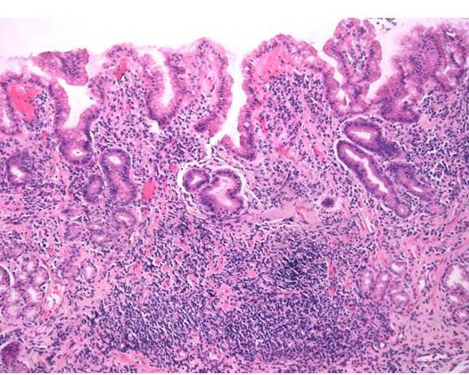 | 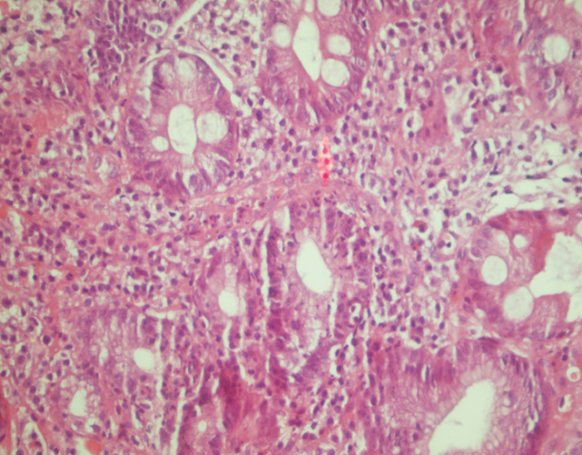
A | B
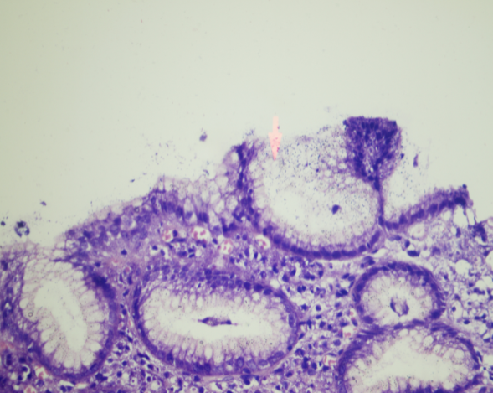 | 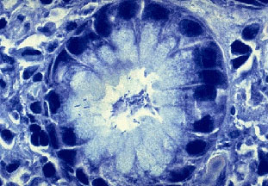
C | D
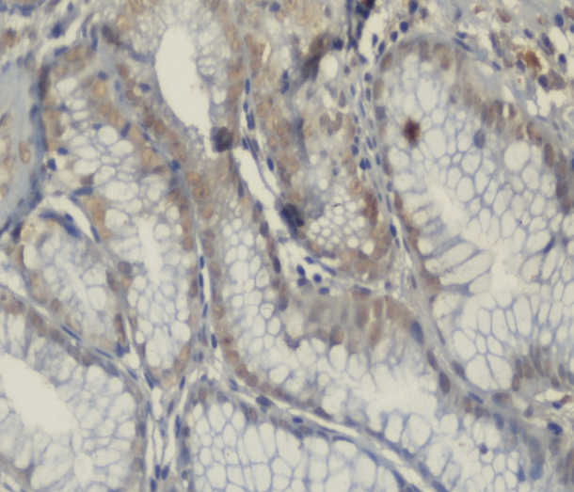 | 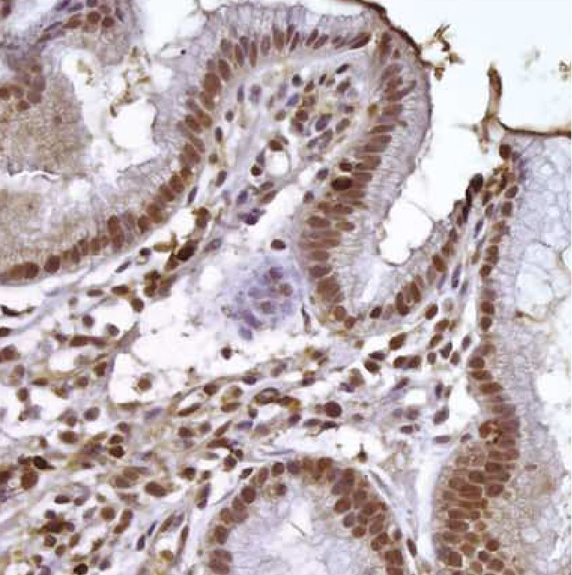
E | F
Figure (1):H. Pylori induced chronic gastritis showed dense lymphocyte (A) and neutrophils infiltration (B). H. Pylori organism was demonstrated by Giemsa staining (C, D) and expression of p53 protein was detected by immunohistochemistry (weak E, strong F).

Figure (2) Graphic demonstration of the relation between P53 expression and H.Pylori intensity and activity of infection.

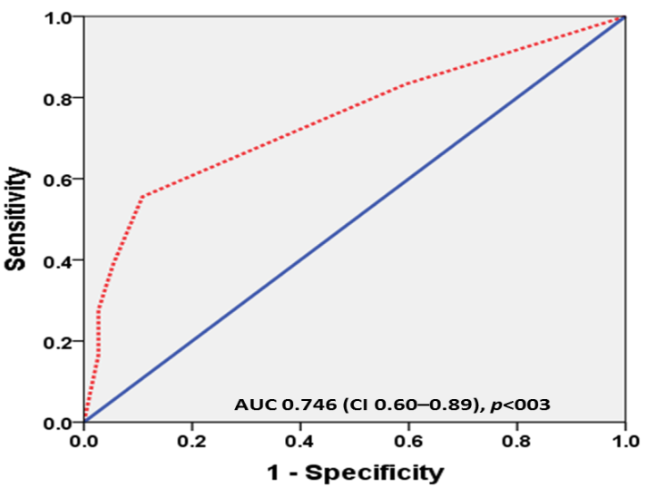
Figure (3): ROC curve for predicting expression of p53 protein using activity of gastritis and severity of H. pylori infection.

4. Discussion:
Helicobacter Pylori (H. Pylori), a microaerophilic, spiral-shaped, Gram-negative bacterium, colonized in human stomach is the major cause of chronic gastritis, peptic ulcers and gastric malignancies including gastric non cardia adenocarcinoma and mucosal-associated lymphoid tissue lymphoma (MALT) (2).
Several studies have assessed the relationship between apoptosis and P53 alterations. In gastric epithelium, a balance between cell proliferation rate and programmed cell death or apoptosis maintains the homeostasis. An imbalance of these two processes leading to increased proliferation of gastric epithelial cells may enhance the effect of carcinogens on DNA, increasing the risk of mutational changes and the development of gastric cancer (15, 16).
In the present study, P53 expression was detected in (32.7%) of the studied chronic gastritis patients. This was similar to the findings of Cesar et al. who detected P53 in 45% and 12% of the chronic gastritis and gastric ulcer respectively (17), while Ozturk et al. in their study on pediatric population revealed P53 alteration in 20% of children with chronic gastritis and H. Pylori infection was found in 91% of the patients with altered P53(18).
In the present study, P53 expression was correlated with H. Pylori colonization (p > 0.02). Independent from other factors that modulate the risk of acquiring gastric cancer, the genotype of the infecting H. Pylori strain is a determining factor. The carcinogenic effects of H. Pylori infection have been linked to its virulence factors, mainly cag pathogenicity island (cag PAI) and the vacuolating cytotoxin gene A (vac A) (2). The cytotoxin-associated gene A (cag A) is the most investigated gene of the (cag PAI) and the main recognized virulence factor. It encodes (Cag A) and oncoprotein that is injected into mammalian cells, undergoes phosphorylation by host cells kinases and affects cytoskeleton and tissue structure as well as cell proliferation. Infection with (cag A)-positive H. Pylori strains is associated with high risk of peptic ulcers and gastric carcinoma (19, 20).Unlike the (cag PAI), the gene (vac A) is present in eventually all H. Pylori strains examined and it encodes (Vac A), a protein that may damage epithelial cells by inducing the formation of vacuoles (21). (VacA) exerts multiple effects on epithelial cells including vacuolation as well as inducing apoptosis and suppressing T cell response which may contribute to the longevity of infection (22). Another pathway through which H. Pylori (Cag A) can increase the risk for gastric cancer is through manipulation of apoptosis, by increasing Spermine oxidase (SMO) production in gastric epithelial cells. Spermine Oxidase (SMO) metabolizes the polyamine spermine into spermidine and generates H₂O₂ which causes DNA damage and selects for a subpopulation of DNA damaged cells that are resistant to apoptosis(23).Cag A interacts with the apoptosis-stimulating protein of P53 (ASPP2) and prevents (ASPP2) from producing apoptosis through activation of P53. This results in proteosomal degradation of P53 and resistant to apoptosis (24) and this finding was the main point of detection of P53 expression in non- tumorous H. Pylori chronic gastritis and could be one step in the carcinogenesis of gastric cancer. Morales-Fuentes et al., found that P53 was expressed in 39.4% of cases with a statistically significant relation between P53 expression and H. Pylori infection (P53 positive in 91% of cases (31/34 cases) of H.Pylori gastritis with p>0.0001 (OR=62; 95% CI, 15.8-241.8). They concluded that P53 expression must be thought of as a marker for cell cycle alteration in patients with active or past H. Pylori infection (25).
In the present study, P53 expression was correlated with activity of H. Pylori gastritis (p>0.005) in agreement with Salih et al. The immune response of the host is the key determinant of the development of gastric cancer by multiple ways as explained by different studies (26).
H. Pylori up regulates several inflammatory molecules including IL-1β, IL-32, IL-10, and TNF-α that play a key role in H. Pylori-induced disease progression (20).IL-1β is a Th1,pro inflammatory cytokine that inhibits acid secretion, and is increased within gastric mucosa of H. Pylori-infected persons (27).TNF-α is a pro-inflammatory, acid-suppressor cytokine that is increased within H. Pylori-colonized human gastric mucosa. Increase TNF-α production is associated with an increased risk of gastric cancer and its precursors. In contrast to IL-1β and TNF-α, decreased IL-10 may increase the risk of distal gastric cancer (28).
In this study, chronic gastritis with intestinal metaplasia was not correlated with the expression of P53 in agreement with Unger et al. who found P53 overexpression in the cases of gastritis-related to H. Pylori with no intestinal metaplasia, and this could be due to the fact that H. Pylori cannot colonize the intestinal metaplasia so its effects on apoptosis disappear (29).
Several studies have shown that the detection of P53 in the presence of low-grade dysplasia is a risk factor for progression to high-grade dysplasia or cancer and 60% of all cancers including gastric cancer showed P53 mutation and/or overexpression (30-33), but none of our study cases showed dysplastic changes.

Conclusions:
Neutrophil infiltration and chronic gastritis are considered a step in the processes of carcinogenesis through P53 mutation in H. Pylori chronic gastritis.

References
- Peek RM and Blaser MJ. H.Pylori and gastrointestinal tract adenocarcinoma. Nat Rev Cancer 2002; 2(1): 28-37.
- Peek RM and Crabtree. Helicobacter infection and gastric neoplasia. J Pathol 2006; 208: 233-248.
- Weeks DL, Eskandari S, Scott DR, Sachs G. A H+ gated urea channel: The link between H-Pylori urease and gastric colonization. Science 2000; 87: 482-485.
- Ding SZ, Goldberg JB, Hatakeyama M. H. Pylori infection, oncogenic pathways and epigenetic mechanisms in gastric carcinogenesis. Future Oncol 2010; 6: 851-862.
- Iliopoulos D, Hirsch HA, Struhl K. An epigenetic switch involving NF- Kappa B, Lin 28, Let-7, Micro RNA and IL-6 link inflammation to cell transformation. Cell 2009; 139: 693-706.
- Satin B, Del Giudice G, Della Bianca V, Dusi S, Laudanna C, Tonello F, Kelleher D, Rappuoli R, Montecucco C, Rossi F. The neutrophil-activating protein (NAP) of H.Pylori is a protective antigen and a major virulence factor. J Exp Med 2000; 191: 1467-1476.
- Wang CA, Liu YC, Du SY, Lin CW, Fu HW. H.Pylori neutrophil-activating protein promotes myeloperoxidase release from human neutrophils. BiochemBiophys Res Commun 2008; 377: 52-56.
- Fu HW. H. Pylori neutrophil-activating protein: From molecular pathogenesis to clinical application. World J Gastroenterol 2014; 20(18): 5294-5301.
- Chey WD and Wong BC. American College Of Gastroenterology Guideline on the management of H. Pylori infection. Am J Gastroenterol 2007; 102(8): 1808-25.
- Belyi VA, Ak P, Markert E, Wang H, Hu W, Puzio-Kuter A and Levine AJ. The origins and evolution of the P53 family of genes “Cold Spring Harber Prospective in Biology” 2010; vol 2 no 6 IDa001198.
- Vousden KH and Lane DP. P53 in health and disease. Nature Reviews Molecular Cell Biology 2007; vol 8, no 4: 275-283.
- Aylon Y and Oren M. New plays in the P53 Theater. Current Opinion in Genetics and Development 2011; vol 21 no 1: 86-92.
- Allred AC, Carlson RW, Berry DA, Burstein HJ, Edge SB, Goldstein LJ, Gown A, Hammond E, Iglehart JD, Moench S, Pierce LJ, Ravdin P, Schnitt SJ, and Wolff AC. NCCN (National Comprehensive Cancer Network) Task Force Report: Estrogen receptors and progesterone receptors testing in breast cancer by immunohistochemistry. J Natl Compr Canc Netw, 2009; Sep, 7suppl 6: S1-S21.
- Rugge M and Genta RM. Staging and Grading of chronic gastritis. Human Pathology 2005; 36, 228-233.
- Yang Y, Deng CS, Peng JZ, Wong BC, Lam SK, Xia HH. Effect of H. Pylori on apoptosis and apoptosis related genes in gastric cancer cells. Molecular Pathology 2003; vol 56 no 1: 19-24.
- Naumann M and Grabtree LE. Helicobacter Pylori-induced epithelial cell signaling in gastric carcinogenesis. Trends in Microbiology 2004; vol 12 no 1: 29-36.
- Cesar CG, Calmon MF, Cury PM, Caetano A, Borim AA and Silva AE. Genetic alterations in benign lesions: Chronic gastritis and gastric ulcer. World J Gastroenterol 2006; Jun 28; 12 (4): 625-629.
- Ozturk Y, Ozer E, Lebe B, Buyukgehiz B. Immunohistochemical evaluation of P53 expression and proliferative activity in children with H. Pylori associated gastritis. J Pediatir Gastroenterol Nutr 2005 Apr; 40 (4): 467-470.
- Hatakeyama M. H. Pylori and gastric carcinogenesis. J Gastroenterol 2009; 44: 239-248.
- Wroblewski LE, Peek RM Jr, Wilson KT. H.Pylori and gastric cancer: factors that modulate disease risk. Clin Microbiol Rev 2010; 23: 713-739.
- Correa P and Piazuelo MB. Evolutionary history of the H.Pylori Genome: Implications for gastric carcinogenesis. Gut Liver 2012; 6(1): 21-28.
- Sundrud MS, Torres VJ, Unutmaz D, Cover TL. Inhibition of primary human T cell proliferation by H.Pylori vacuolating toxin (Vac A) is independent of (vac A) effects on IL-2 secretion. Proceedings of the National Academy of Science of the United State of America 2004; 101(20):7727-32.
- Chaturvedi R, Asim M, Romero-Gallo J, Barry DP, Hoge S, de Sablet T, Delgado AG, Wroblewski LE, Piazuelo MB, Yan F, Israel DA, Casero RA jr, Corrra P, Gobert AP, Polk DB, Peek RM, Wilson KT. Spermine Oxidase mediates the gastric cancer risk associated with H.Pylori (Cag A). Gastroenterology 2011; 141(5): 1696-708.
- Buti L, Spooner E, Van der Veen AG, Rappuoli R, Covacci A, Ploegh HL. H. Pylori cytotoxin-associated gene A (Cag A) subverts the apoptosis-stimulating protein P53 (ASPP2) tumor suppressor pathway of the host. Proceeding of the National Academy of Science of the United State of America 2011; 108(22): 9238-43.
- Morales-Fuentes GA, Zarate-Osorno A, Quinonez-Urrego EE, Antonio-Manrique M, Martinez-Garcia CL, Figueroa-Barojas P, Zamorano-Orozco Y, Leal-Osuna SE, Martinez-Camacho C, Mejia-Cuan LA, Rivera-Nava CA, Sanchez-Chavez X, Ramirez-Ramirez MA. P53 expression in the gastric mucosa of patients infected with H. Pylori. Revista de Gastroenterologia de Mexico 2013; 78 (1): 12-30.
- Salih BA, Gucin Z and Bayyurt N. A study on the effect of H.Pylori infection on P53 expression in gastric cancer and gastritis mucosa. J Infect DevCtries 2013; 7(9):651-657.
- Santos JC, Ladeira MSP, Pedrazzoli J jr and Ribeiro ML. The relationship of IL-1 and TNF-α polymorphism with H.Pylori in gastric diseases in Brazilian population. Braz J Med Biol 2012; 45(9): 811-17.
- El-Omar EM, Rabkin CS, Gammon MD, Vaughan TL, Risch HA, Schoenberg JB, Stanford JL, Mayne ST, Goedert J, Blot WJ, Fraumeni JF jr, Chow W. Increased risk of non-cardia gastric cancer associated with pro-inflammatory cytokine gene polymorphisms. Gastroenterology 2003, 124(5): 1193-1201.
- Unger Z, Molnar B, Pronai L, Szaleczky E, Zagoni T and Tulassay Z. Mutant P53 expression and apoptotic activity of H.Pylori-positive and negative gastritis in correlation with the presence of intestinal metaplasia. Eur J Gastroenterol Hepatol 2003 Apr; 15 (4): 389-393.
- Kodama M, Murakami K, Okimoto T, Sato R, Watanabe K, Kujioka T. Expression of mutant type P53 products in H.Pylori-associated chronic gastritis. World Gastroenterol 2007; 13: 1541-1546.
- Kim N, Cho S, Lee HS, Park JH, Kim JH, Kim JS, Jung HC, Song IS. The discrepancy between genetic polymorphism of P53 codon 72 and the expression of P53 in H. Pylori–associated gastric cancer in Korea. Dig Dis Sci 2010; 55: 101-110.
- Zheng Y, Weng L, Zheng JP, Yang JY, Zhao ZM, Zhang XY. Expression of P53, C-erbB-2 and Ki67 in intestinal metaplasia and gastric carcinoma. World J Gastroentrol 2010; 16(3): 339-344.
- Hegazi A, Hassan E, El-Atrebi KA and El-Bassyouni HT. P53 protein and Ki67 expression in chronic gastritis patients with positive H.Pylori infection. J of Genetic Engineering 2011; 9: 73-76.

5/3/2016

