Prognostic impact of Epidermal Growth Factor Receptor expression in Colorectal Cancer Patients

Walid Al-Morsy¹, Emad Sadaka¹ and Ayman Elsaka²

Clinical Oncology Department¹, Pathology Department², Faculty of Medicine, Tanta University, Gharbia, Egypt.
walidaa1@hotmail.com, walidaa1@hotmail.com

Abstract: Background: EGFR overexpression was thought to be associated with more advanced disease and worse prognosis. The prognostic value of EGFR in colorectal cancer has been investigated. The aim of this study is to evaluate the prognostic impact of EGFR expression in colorectal cancer. Methods: This retrospective study was conducted at Clinical Oncology Department, Tanta University Hospital, between January 2008 and December 2013 on eighty seven patients with histopathologically confirmed colorectal adenocarcinoma. EGFR expression was investigated by immunohistochemistry. Results: the EGFR was significantly correlated with N stage (p=0.012), performance status (p=0.039), lymphovascular invasion (<0.001), metastatic disease (0.006) and intestinal obstruction presentation (0.026), the 3-year overall survival (OS) rate in this analysis was 52.4%. In univariate analysis, there were significant 3-year OS rate with EGFR status (p=0.005), T stage (p=0.043), N stage (p<0.001), grade of differentiation (p=0.004), performance status (p=0.028), intestinal obstruction (p<0.001),), metastatic disease (p<0.001), lymphovascular invasion (p=0.003) and initial serum CEA level (p=0.001). Multivariate analysis showed significant 3-year OS rate with N stage (p=0.009), initial CEA concentration (p=0.015) and metastatic disease (p=0.025). However, EGFR status was not found to be an independent prognostic factor (p=0.715). Conclusion: EGFR overexpression in CRC patients was significantly correlated with TNM (tumor–node–metastasis), performance status, lymphovascular invasion, and intestinal obstruction presentation. However, EGFR was not an independent prognostic factor.
[Walid Al-Morsy; Emad Sadaka and Ayman Elsaka. Prognostic impact of Epidermal Growth Factor Receptor expression in Colorectal Cancer Patients. Cancer Biology 2016;6(1):54-59]. ISSN: 2150-1041 (print); ISSN: 2150-105X (online). http://www.cancerbio.net. 10. doi:10.7537/marscbj06011610.

Key words: Colorectal cancer, EGFR, prognosis.

1. Introduction
Colorectal cancer (CRC) is the third most common and the third leading cause of cancer death in the United States where an estimated 142,820 newly diagnosed cases of CRC and an estimated 50,830 cancer deaths from CRC were reported in 2013. ^{[1]}
After initial surgery, the (TNM) stage and residual disease are independent factors for survival in colorectal carcinoma. Other factors such as tumor grade, obstruction, venous invasion, perineural invasion, age, sex or allelic loss of chromosome 18q has been shown to have an impact on patients' survival and prognosis. ^{[2]}
The development of targeted therapies allowing progress in colorectal cancer treatment. One of the most promising targets is the epidermal growth factor receptor (EGFR) which is a transmembrane tyrosine kinase receptor that belongs to the ErbB family of cell membrane receptors. This receptor contains an extracellular ligand-binding region, a single membrane spanning region, and a cytoplasmic tyrosine-kinase-containing domain.^{. [3,4]}
This family of receptor tyrosine kinases has been found to be deregulated in many tumor types, such as head and neck, lung, breast, and colorectal cancers and this lead to an overexpression and amplification of EGFR which has been correlated with a more aggressive clinical course.^{[5,6]} Inspite that EGFR overexpression was thought to be associated with advanced disease and worse prognoses, the prognostic impact of EGFR in CRC has been investigated extensively, but it remains controversial. ^{[7-10]}
Cheirsilpa et al., 2007 investigated 99 colorectal cancer patients for expression of EGFR. Neither age nor sex was correlated with the presence of EGFR. There was a statistically significant correlation between EGFR expression and the tumor stage (p<0.01), lymph node status (p=0.03), higher grade of differentiation (p=0.05), and high initial serum carcinoembryonic antigen (CEA) concentration (p=0.01). Patients with EGFR expression had a higher risk for disease recurrence compared with those EGFR negative (p=0.04). However, there was no relationship between EGFR expression and overall survival (p=0.40). ^{[11]}
The present study was performed to evaluate retrospectively EGFR immunohistochemical reactivity in CRC patients and to explore the relationship between the extent of its expression and histological and clinical characteristics and its impact on overall survival.

2. Patients and methods
This retrospective study was conducted at Clinical Oncology Department, Tanta University Hospital, between January 2008 and December 2013 on eighty seven patients with histopathologically confirmed colorectal adenocarcinoma.
Patients data were recorded including; age, sex, performance status (PS), according to European Collaborative Oncology Group (ECOG), physical examination, detailed histopathological findings (mucinous or non-mucinous) degree of histological differentiation (well/moderate/poor), depth of invasion (T), number of invaded lymph nodes (N) counted during the slide review, lymphovascular invasion and expression of Epidermal growth factor receptor (EGFR).
Laboratory investigations including blood chemistry (liver and renal functions tests), complete blood profile, carcinoembryonic antigen (CEA) were reviewed. Imaging studies (Chest X-ray, abdominopelvic ultrasound, CT, MRI and bone scanning), and colonoscopy. Details of received treatment (chemotherapy and radiotherapy) were reviewed.
EGFR expression method:
Formalin-fixed, paraffin-embedded tissue blocks for these patients were retrieved from the Pathology department archive and Immunohistochemical analysis for EGFR expression were done. Blocks were cut into 3 μm sections and deparaffinized, rehydrated, and autoclaved at 121°C for 5 min in Target Retrieval solution, pH 6.0, to retrieve antigens.
Endogenous peroxidase was blocked by 3% H₂O₂ for 5 min at room temperature. After washing with a Tris buffer solution, the sections were incubated with EGFR for 1 hour at room temperature. Then, DAKO REAL EnVision Detection System-HRP (DAKO, Glostrup, Denmark) was applied for 30 minutes at room temperature. Finally, sections were incubated in 3 diaminobenzidine for 5 minutes, followed by Mayer’s hematoxylin counterstaining. Dehydration was performed through two changes of 95% ethanol and two changes of 100% ethanol, and the samples were cleared in three changes of xylene and then mounted. Negative controls were obtained by replacing the primary antibody with non-immune serum. Immunoreactivity of EGFR was evaluated.

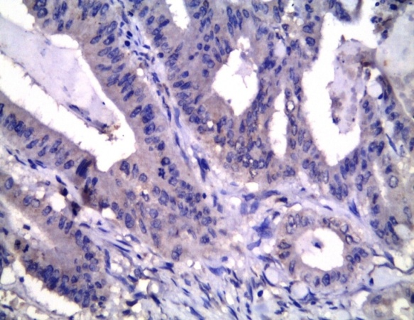 | 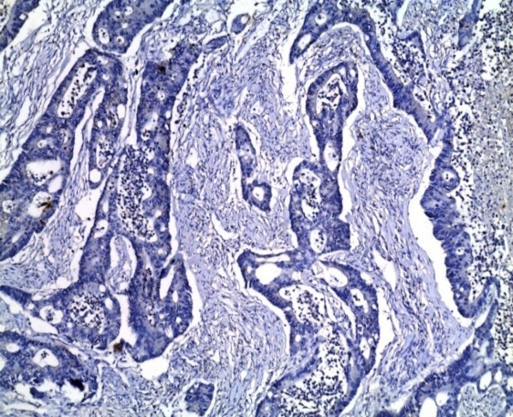
Fig (1b): Weak cytoplasmic expression for EGFR (+1). [Streptavidin Biotin x200] | Fig (1a): Negative cytoplasmic expression for EGFR (Streptavidin Biotin x100)
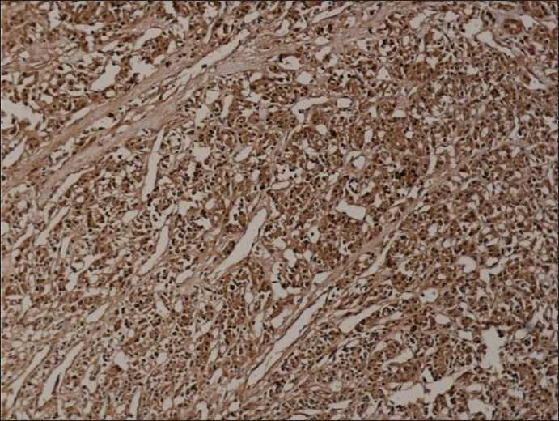 | 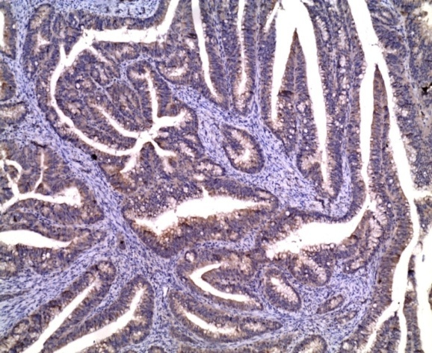
Fig (1d): Strong cytoplasmic expression for EGFR (+3). [Streptavidin Biotin x200]. | Fig (1c): Moderate cytoplasmic expression for EGFR (+2). (Streptavidin Biotin x100)

Expression patterns of EGFR were determined in a semi-quantitative manner by light microscopy. Immunoreactivity for EGFR (membrane staining) was categorized according to the presence of tumor cell staining and staining intensity. Negative EGFR expression means absence of membrane staining above background in all tumor cells (figure 1a). The intensity of EGFR immunoreactivity was scored with as follow: 1+ weak intensity (Figure 1b), 2+ moderate intensity (figure 1c) and 3+ strong intensity (figure 1d). Positive EGFR expression is defined as any IHC complete or incomplete membrane staining of tumor cells, including intensity +1, +2 or +3. ^{[12]}

Statistical analysis
All data were statistically analyzed using the Statistical Package for the Social Sciences, version 21.0 (SPSS Inc., Chicago, IL, USA). The correlation between clinicopathological features and EGFR expression was compared using a Chi-square test. Overall survival was calculated by the Kaplan-Meier method, and the differences in survival rates were analyzed by the log-rank test. The Cox proportional-hazards model was used for multivariate analyses to identify the independent prognostic factors for OS. P value less than 0.05 was considered to be statistically significant.

3. Results
This study evaluated a total of 87 patients with colorectal carcinoma. Patients' age ranged from 41 years to 71 years (median 55 years) with 28 months median follow-up period (range 8 to 72 months). Table 1 shows the correlation between the EGFR and clinicopathological characteristics; the EGFR was significantly correlated with N stage (p=0.012), perfprmance status (p=0.039), lymphovascular invasion (p<0.001), metastatic disease (p=0.006) and intestinal obstruction presentation (p=0.026), the 3-year OS rate in this analysis was 52.4%. Fig (3)
As shown in table (2), in univariate analysis, there were significant 3-year OS rate with EGFR status (p=0.005), T stage (p=0.043), N stage (p<0.001), grade of differentiation (p=0.004), performance status (p=0.028), intestinal obstruction (p<0.001), metastatic disease (p<0.001), lymphovascular invasion (p=0.003) and initial serum CEA level (p=0.001).
In multivariate analysis (table 2) there were significant 3-year OS rate with N stage (p=0.009), initial CEA concentration (p=0.015) and metastatic disease (p=0.025). However, EGFR status was not found to be an independent prognostic factor (p=0.715).

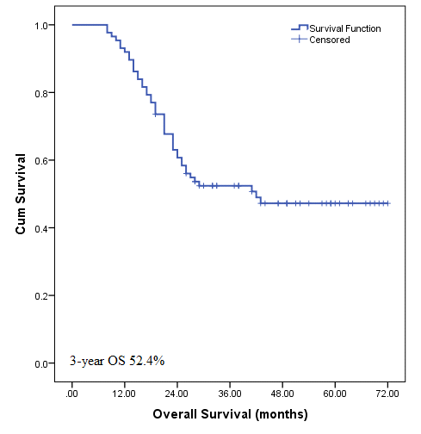
Fig. (2) Overall survival for the whole group

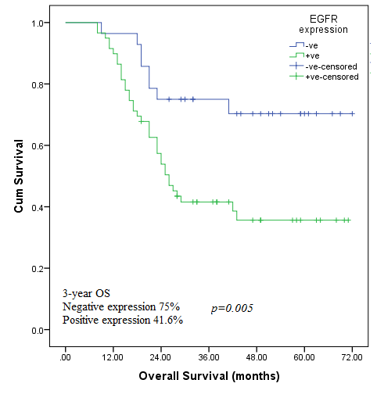
Fig. (3): Overall survival according to EGFR expression

Table (1): Patient characteristics according to EGFR expression
Characters | Negative  28 (32.2%) | Positive  59 (67.8%) | p-value | All group  87 (100%)
Age  ≤55 years  >55 years | 16 (36.4%)  12 (27.9%) | 28 (63.6%)  31 (72.1%) | 0.399 | 44 (100%)  43 (100%)
Sex  Male  Female | 17 (35.4%)  11 (28.2%) | 31 (64.6%)  28 (71.8%) | 0.474 | 48 (100%)  39 (100%)
T stage  2  3  4 | 4 (36.4%)  21 (35.6%)  3 (17.6%) | 7 (63.6%)  38 (64.4%)  14 (82.4%) | 0.359 | 11 (100%)  59 (100%)  17 (100%)
N stage  0  1  2 | 14 (53.8%)  10 (27.8%)  4 (16%) | 12 (46.2%)  26 (72.2%)  21 (84%) | 0.012* | 26 (100%)  36 (100%)  25 (100%)
Metastasis  No  Yes | 24 (42.1%)  4 (13.3%) | 33 (57.9%)  26 (86.7%) | 0.006* | 57 (100%)  30 (100%)
Performance status  0  1  2 | 16 (48.5%)  8 (22.2%)  4 (22.2%) | 17 (51.5%)  28 (77.8%)  14 (77.8%) | 0.039* | 33 (100%)  36 (100%)  18 (100%)
Lymphovascular invasion  -ve  +ve | 21 (56.8%)  7 (14%) | 16 (43.2%)  43 (86%) | <0.001* | 37 (100%)  50 (100%)
Intestinal Obstruction  Yes  No | 9 (20.9%)  19 (43.2%) | 34 (79.1%)  25 (56.8%) | 0.026* | 43 (100%)  44 (100%)
CEA  Normal  Elevated | 11 (28.9%)  17 (34.7%) | 27 (71.1%)  32 (65.3%) | 0.569 | 38 (100%)  49 (100%)
Grade  Low  High | 17 (42.5%)  11 (23.4%) | 23 (57.5%)  36 (76.6%) | 0.057 | 40 (100%)  47 (100%)
Pathology  Mucin  Non-mucin | 14 (26.9%)  14 (40%) | 38 (73.1%)  21 (60%) | 0.200 | 52 (100%)  35 (100%)
* Significant p<0.05

Table (2) Univariate & multivariate analysis of factors affecting OS survival
Factors |  | 3-year OS | Univariate analysis | Mutivariate analysis
 |  |  | p-value | HR (95% CI) | p-value
Age | ≤55 years  >55 years | 50.3%  43.9% | 0.543 | - | -
Sex | Male  Female | 59.9%  43.6% | 0.284 | - | -
T stage | 2  3  4 | 81.8%  51.9%  35.3% | 0.043* | - | 0.567
N stage | 0  1  2 | 76.9%  60.0%  16.0% | <0.001* | 2.18 (1.21-3.91) | 0.009*
Metastasis | No  Yes | 73.5%  13.3% | <0.001* | 2.56 (1.13-5.79) | 0.025*
Performance status | 0  1  2 | 69.7%  46.3%  33.3% | 0.028* | - | 0.974
Lymphovascular invasion | -ve  +ve | 69.7%  39.7% | 0.003* | - | 0.660
Intestinal Obstruction | Yes  No | 28.9%  74.9% | <0.001* | - | 0.154
CEA | Normal  Elevated | 76.1%  34.1% | 0.001* | 2.68 (1.21-5.95) | 0.015*
Grade | Low  High | 65.0%  41.3% | 0.004* | - | 0.684
Pathology | Mucin  Non-mucin | 46.1%  62.3% | 0.170 | - | -
EGFR expression | Low  High | 75.0%  41.6% | 0.005* | - | 0.715
*P significant <0.05, HR (95% CI): Hazard Ratio (95% confidence interval)

4. Discussion
Among 87 patients with colorectal carcinoma evaluated in this study, the EGFR expression was significantly correlated with N stage (p=0.012), performance status (p=0.039), lymphovascular invasion (p<0.001), metastatic disease (p=0.006) and intestinal obstruction presentation (p=0.026). There was no significant correlation between EGFR and age (p=0.399), sex (p=0.474), pathology (p=0.2) and initial CEA (p=0.569). Although there was no significant correlation between EGFR and grade, it was near significant (p=0.057).
These results nearly concede with the findings reported by Cheirsilpa et al., 2007 where they studied 99 colorectal carcinoma patients and they found a statistical significant correlation between the presence of EGFR and tumor stage (p<0.001), N stage (p=0.003), high initial CEA concentration (p=0.02), disease recurrence (p=0.04) and There was near significant correlation with tumor grade (p=0.05). ^{[11]}
Huang et al., 2013 evaluted patients with synchronous or metachronous metastatic colorectal cancer and reported a statistical significance correlation between EGFR and hitological grade (p=0.044), tumor size (p=0.04) while there was no significant correlation with age, sex, N stage, retrieved LNs, LVI, stage and initial CEA concentration. ^{[13]}
Spano et al., 2005 evaluated 148 patients with colorectal carcinoma for impact of EGFR expression on prognosis and survival and only the tumor stage showed a statistical significance correlation (p =0.006). No significant correlation with sex (p=0.21), age (p=0.41), grade (p=0.59), tumor size (p=0.24), N stage (p=0.12), vascular emboli (p=0.24), metastatic disease (p=0.88) and high initial CEA concentration (p=0.88). The EGFR was not an independent prognostic variable for overall survival. ^{[2]}
There was significant association between EGFR expression and overall survival in the present study. The 3 year OS rate in patients with positive expression of EGFR was 41.6% while it was 75% in patients with negative EGFR expression (p=0.005). The multivariate analysis showed significant 3-year OS rate with N stage (p=0.009), initial CEA concentration (p=0.015) and metastatic disease (p=0.025). However, EGFR status was not found to be an independent prognostic factor (p=0.715).

5. Conclusion:
EGFR overexpression in CRC patients was significantly correlated with TNM (tumor–node–metastasis), performance status, lymphovascular invasion, and intestinal obstruction presentation. However, EGFR was not an independent prognostic factor. As EGFR remains a controversial prognostic factor, further studies needed to clarify its role as a prognostic and predictive factor.

Corresponding author:
Name: Walid Ahmed Almorsy
Address: Clinical oncology Department, Faculty of medicine, Tanta university, Tanta 11312, Gharbeiah- Egypt
Email: walidaa1@hotmail.com

References:
- Siegel R, Naishadham D, Jemal A.: Cancer statistics, 2013.CA Cancer J Clin, 2013, 63:11–30.
- Spano JP, Lagorce C, Atlan D, Milano G, Domont J, Benamouzig R, et al.: Impact of EGFR expression on colorectal cancer patient prognosis and survival . Ann Oncol 2005, 16 :102–108.
- Skibber JM, Minsky BD, Hoff PM.: Cancer of the colon. In DeVita VT.; Hellman S. & Rosenberg SA. (eds): Cancer: Principles and Practice of Oncology, 6th edition. Philadelphia, PA: Lippincott Williams and Wilkins, 2001, p1216–1271.
- Yarden Y.: The EGFR family and its ligands in human cancer: signaling mechanismsn and therapeutic opportunities. Eur J Cancer, 2001; 37 (suppl 4):S3-S8.
- Sibilia M, Kroismayr R, Lichtenberger BM, Natarajan A, Hecking M, Holcmann M.: The epidermal growth factor receptor: from development to tumorigenesis. Differentiation. 2007; 75(9):770-787.
- Mendelsohn J. and Baselga J.: Status of epidermal growth factor receptor antagonists in the biology and treatment of cancer. J Clin Oncol, 2003; 21(14):2787-2799.
- Ljuslinder I, Melin B, Henriksson ML, Öberg Å, and Palmqvist R.: Increased epidermal growth factor receptor expression at the invasive margin is a negative prognostic factor in colorectal cancer. Int J Cancer 2011, 128:2031–2037.
- Galizia G, Lieto E, Ferraraccio F, De Vita F, Castellano P, Orditura M, et al.: Prognostic significance of epidermal growth factor receptor expression in colon cancer patients undergoing curative surgery. Ann Surg Oncol 2006, 13:823–835.
- Giralt J, de las Heras M, Cerezo L, Eraso A, Hermosilla E, Velez D, et al. Grupo Español de Investigacion Clinica en Oncologia Radioterápica (GICOR): The expression of epidermal growth factor receptor results in a worse prognosis for patients with rectal cancer treated with preoperative radiotherapy: a multicenter, retrospective analysis. Radiother Oncol, 2005; 74(2):101–8.
- Azria D, Bibeau F, Barbier N, Zouhair A, Lemanski C, Rouanet P, et al.: Prognostic impact of epidermal growth factor receptor (EGFR) expression on loco-regional recurrence after preoperative radiotherapy in rectal cancer. BMC Cancer 2005, 20:5–62.
- Cheirsilpa A, Ruangvejvorachai P, Karalak A, Sangprakarn S, Pummai S, Sangrajrang S.: determination of epidermal growth factor receptor (EGFR) in patients with colorectal cancer(Institutional series) Cancer Therapy 2007; 5: 137-142.

Hutchinson R A, Adams R A, McArt DG, Salto-Tellez M, Jasani B, Hamilton PW, et al.: Epidermal growth factor receptor immunohistochemistry: new opportunities in metastaticcolorectal cancer. Journal of Translational Medicine 2015, 13:217.
- Huang CW, Tsai HL, Chen YT, Huang CM, Ma CJ, Lu CY, et al.: The prognostic values of EGFR expression and KRAS mutation in patients with synchronous or metachronous metastatic colorectal cancer. BMC Cancer 2013, 13:599.

3/13/2016

