Outcome of Radiotherapy Using Prone Versus Supine Treatment Position in Breast Cancer Patients With Conservative Surgery

Elwan A, Sarhan A, Nawar N and Farouk Sh.

Clinical Oncology Department, Faculty of medicine, Zagazig University
Essawy1951@gmail.com, toamira_elwan@yahoo.com

Abstract: Purpose: To assess the treatment outcome of breast cancer patients receiving adjuvant radiotherapy in the supine position versus prone position. Patients and method: Eighteen patients with large pendulous breasts were conducted to the study. Each patient underwent two plans in supine and prone positions, evaluation of both plans were done regarding the best target coverage and the less complications to the organs at risk as well as cosmoses issue. Each patient received the best plan for her using conventional fractionation 50 Gy∕ 25 fractions∕ 5 weeks followed by electron boost 10 Gy∕ 5 fractions∕ 1 week. Patients are still under clinical follow up and investigational care. Analysis of data was done by fisher test. Results: Both plans showed satisfactory target coverage with 95% of the prescribed dose. Prone position was significantly better than supine position regards, the mean doses of ipsilateral lung doses were 166.3 cGy ± 206 in prone position versus 611.6 cGy ±519 in supine position (p=0.001), and non significantly better than supine regards the mean doses to heart and liver, regards cosmetic aspect, results were satisfactory in both treatment groups with only patient (10%)in prone position treatment showed grade 0. Unfortunately prone position showed a significant doses to the contra lateral breast with mean doses of 481 cGy ± 223 (P =0.000) in comparison to supine position plan. Prone plan had proven non significant superiority than supine regards acute skin toxicity in the form of erythema, pigmentation, moist desquamations and breast edema. Conclusion: The prone position allowed adequate target coverage as well as a significant decrease of ipsilateral lung dose and contra lateral lung dose in all patients and a favorable trend for heart dose in patients with left sided cancer and liver dose in patients with right sided cancer rather than supine position. Prone approach, however, does not prevent the exposure of normal tissue as contra lateral breast outside the field to low doses generated by scattered radiation, but with satisfactory acute skin toxicity profile and cosmetic outcome.
[Elwan A, Sarhan A, Nawar N and Farouk Sh. Outcome of Radiotherapy Using Prone Versus Supine Treatment Position in Breast Cancer Patients With Conservative Surgery. Cancer Biology 2016;6(1):46-53]. ISSN: 2150-1041 (print); ISSN: 2150-105X (online). http://www.cancerbio.net. 9. doi:10.7537/marscbj06011609.

Keywords: Breast cancer, prone, supine, toxicity, plan.

1. Introduction
The American Cancer Society estimates that in 2014 about 232,000 new cases of invasive breast cancer diagnosed, as well as 62,500 cases of breast carcinoma in situ. The majority of the patients underwent breast-conserving surgery followed by radiation, breast irradiation has been shown to decrease the risk of local recurrence after breast-conserving surgery with few adverse effects⁽¹⁾.In Egypt, breast is estimated to be the most common cancer among females accounting for 37.7% of their total with 12,621 new cases in 2008. It is also the leading cause of cancer-related mortality accounting for 29.1% of their total with 6546 deaths. The incidence to mortality ratio is poor (1.9:1)⁽²⁾.
Radiation factors identified as potentially causative include increased dose inhomogeneity from medial to lateral separation of the breast and bolus effect on skin, where there is increased skin-on-skin contact effect in the infra-mammary folds. In addition, patients may receive increased doses to critical structures such as the heart or lungs owing to the positioning of the breast on the chest wall when the patient lies supine. Prone breast irradiation aims to improve some of the technical limitations and constrains associated with treating large and pendulous breasts and it may limit radiation doses to organs at risk such as lung and heart ⁽³⁾.

2. Patients and Methods
The study was conducted in Clinical Oncology & Nuclear medicine Department, Zagazig University Hospitals from May 2014 to March 2016.
Inclusion criteria:
- Histopathological confirmation of invasive unilateral breast carcinoma.
- Patient underwent conservative surgery.
- No previous radiotherapy.
- Patients with large breast (Bra size ≥38 or ≥ D cup)⁽⁴⁾.
- Adjuvant chemotherapy if planned should be completed before starting radiation.
- Patients not planned to receive nodal irradiation.
Study design
This study is an experimental (interventional) clinical trial. Every patient had two plans: plan1 in supine position and plan 2 in prone position.
Sample size
As V5% of the lung (cc) was 10 ± 3.2 in prone while 18.4 ± 8.0 in supine the estimated sample was 18 patients at 80% power and 95% CI (Open Epi)⁽⁵⁾.
Patient preparation
1-Patient consent.
2-Proper history and clinical examination.
3-Complete blood count,,liver & kidney function tests.
4- tumor marker CA15.3.
5-Chest radiograph, diagnostic bilateral mammography.
6-Radiologic evaluation of liver by pelvi abdominal ultrasongraphy.
7-Bone scan was considered if the patient was symptomatic or found to have elevated alkaline phosphatase.
8-Cardiac assessment e.g echocardiography
9- Magnetic resonance imaging of the breast in case of young patients or those with very dense breast parenchyma.
10-Measurment of weight, height and body mass index.
11-Inspection of the cosmetic aspect of the patient, pictures of the patient was picked.

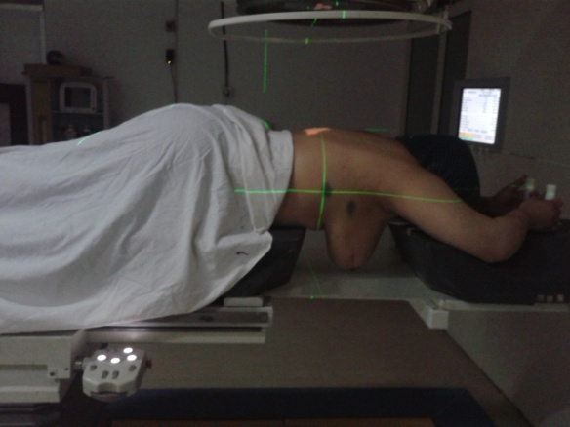 | 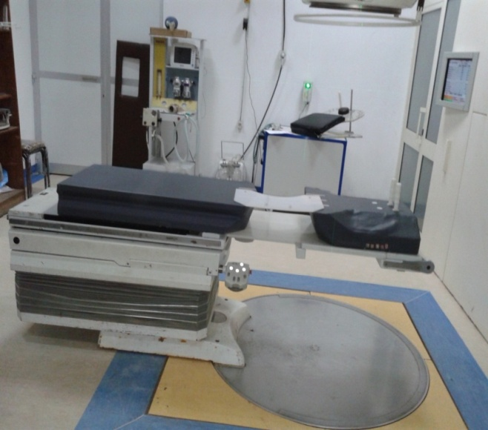
Figure (1): Patient in prone position with laser alignment. | Figure (2): Prone breast board.

Treatment
Radiotherapy plan steps:-
- Simulation and patient positioning.
Plan (1) supine position
In supine position the patient lied comfortably on breast board while the patient head on head rest, with proper elevation of surface of the body in parallelism with the surface of the couch, rotation of head to opposite side with arm elevation, patient can catch A or B or C arms in comfortable tolerated manner as much as possible and with abduction and slight rotation of the arm. Patient must be centralized on the simulator, laser alignment was applied and tattooing of the patient was done to create X, Y and Z points (references) with lead marks on them during imaging process, with measurement of tanges separation in supine position, actually each patient had 6 points of tattooing; 3 for supine, one at mid of medial tange at patient front midline and 2 at mid axillary line while those for prone plan; one at patient back and 2 at posterior axillary line.
Plan (2) prone position.
In prone position(fig.1), fixation of a lead wire at the cranial aspect of the breast was done to facilitate delineation step without confusion with patient fats later on. Patients lied prone on a (fig.2) 15 cm thick Prone breast board which consists of head shoulder support, wedge and lower body support with a space for location of treated breast, which should be placed in the centre of this space. Caution must be taken in fine lifting of the contra lateral breast away from the treated breast with confirmation of keeping it in its location of the device(wedge). Tattooing was done as guidance of reference points of X, Y and Z, with lead marks on, after proper centralization with minor patient body tilt in the direction of treated side and laser alignment on the simulator. All of the above steps should be under the coverage of the maximum satisfaction and comfortability of patients.

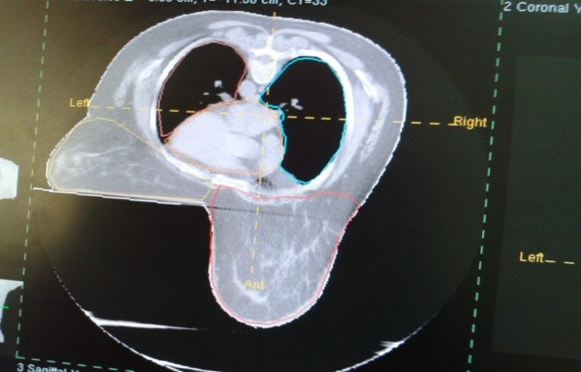
Figure (3):Delineated right breast cancer plan.

2-Image acquisition, input and reconstruction.
Multislice CT every 0.3-0.5cm on same simulated position was done for each patient, the created CD applied to allow reading, reconstruction, contouring, and saving data of each patient on the computerized planning system.
3- Anatomy definition:
Delineation and displaying of target volume and organs at risk was done according to RTOG guidelines⁽¹⁰⁾:
Breast Clinical Target Volume (CTV)
Considers referenced clinical breast at time of computed tomography (CT), includes the apparent CT glandular tissue, incorporates consensus definitions of anatomical borders, contouring of the breast after appropriate lumpectomy was done taking into account that, a-Cranial border is highly variable depending on breast size and patient position. Lateral aspect can be more cranial than medial aspect depending on breast shape and patient position, b-Lateral border is highly variable on breast size and amount of ptosis, c-Medial border is highly variable depending on breast size and amount of ptosis, clinical reference needs to be taken into account and should not cross midline(fig.3).
4-Dose prescription and fractionation.
50 Gy in 25 fractions over 5 weeks with boost 10-16 Gy in 5-8 fractions over 1-2 weeks⁽⁵⁾.
5-Beam technique selection and computer optimization.
Beam arrangement was done with digital reconstructed graph (DRR), and beam modification with proper wedge selection and weighting adjustment.
6- Dose calculation.
7- Plan evaluation with dose volume histogram (DVH) analysis.
Prescribed isodose should cover at least 95% of the planned target volume (PTV), no more than 20% should receive > 110% of the prescribed dose, no more than 1% should receive < 93% of the prescribed dose, no more than 1% of normal tissue outside the PTV should receive > 110% of the prescribed dose ⁽⁶⁾.
8- Plan review and documentation
Plan review was done with beam eye view in both treatment positions (fig.4).

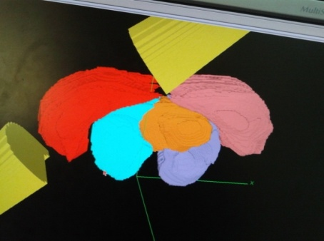 | 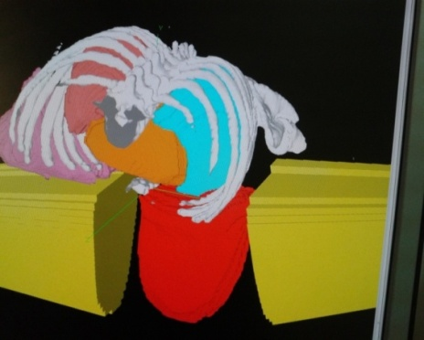 | 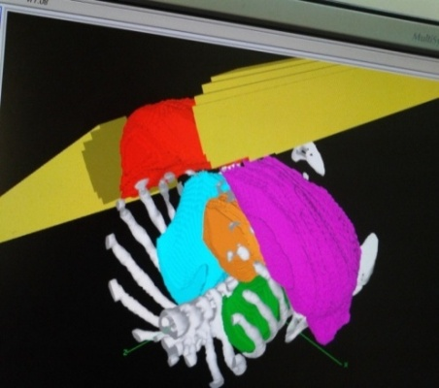
(A) | (B) | (C)
Figures (4): A, B and C : Different beam views in different plans in supine and prone positions.

9-Plan implementation and verification.
Set up was done with review of opened fields on patient during treatment, verification with simulation film and DRR. Portal film could be done for each patient only once because of financial consideration. Figure 5 shows opened lateral tange field in prone treatment position.
Follow up and evaluation of acute skin toxicity according to WHO grading system⁽¹¹⁾, and cosmoses according to EORTC cosmetic rating system⁽¹²⁾were done.

3. Results
After evaluation of prone and supine treatment plans for each patient, 8 patients were treated in supine position and 10 patients in prone position. Patient and treatment characteristics are shown in table 1.

Table (1): Patient's characteristics.
Characteristics | parameter | value
Age | Mean  Median  ±SD  Range | 46 year  45  11.46±  76-32
Laterality | Right  Left | 8(44.4%)  10(55.6%)
Body mass index | Mean  Median  Range | 36.67  36.2  44-26
Tumor stage | IA  IIA  IIB | 4(22.3%)  11(61%)  3(16.7%)
Pathological nodal status | Negative  Positive | 14(77.2%)  4(22.8%)
Hormonal estrogen status | Negative  Positive | 3(16.7%)  15(83.3%)
Patient under hormonal therapy | Yes  No | 5(27.8%)  13(72.2%)
Optimal position | Prone  Supine | 10(55.6%)  8(44.4%)
Separation in)cm( | Mean  ±SD  Range | 21.46  2.29±  24.4-17

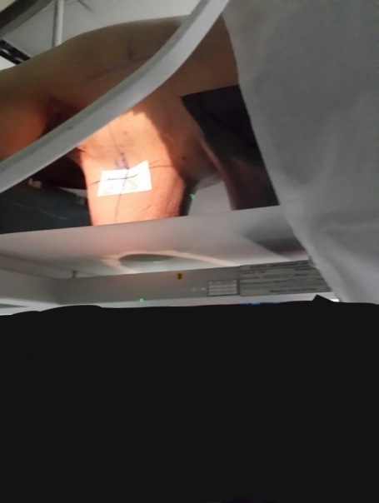
Figure (5): Opened lateral tange field in prone treatment position.

All patients received 50 Gy/ 25 fraction followed by a boost of 10 Gy/5 fraction. Prone position was significantly better than supine position regards, the mean dose of ipsilateral lung (fig.6): dose was 166.3 cGy ± 206 in prone versus 611.6 cGy ±519 in supine position (p=0.001) while it was non -significantly better than supine regards the mean doses to heart and liver (table 2). Unfortunately prone position showed a significant doses to the contra lateral breast (fig. 7), with mean dose of 481 cGy ± 223, (P =0.000) in comparison to supine position plan. Both plans showed satisfactory target coverage with 95% of the prescribed dose(fig.8 and 9).Prone plan had proven non significant superiority over supine regards acute skin toxicity in the form of erythema as 4 patients (50%) manifested grade 1 in supine treatment position versus 4 patients (40%) in prone position, regards pigmentation, 3 patients (37.5%) manifested grade 1 toxicity in supine position versus 3 patients (30%) in prone position. Moist desquamation was manifested in 3 patients (37.5%) as grade 2 in supine position versus no patients in prone position (Table 3). Edema of the breast (Fig.10), was manifested in five patients (62.5%) in supine position treatment group; 2 (25%) with grade 1and 3 (37.5%) patients with grade 2, while in prone position only 2 (20%) patients showed breast edema of grade 1 and 2,those toxicities were observed in infra mammary area in supine and cranial part of the breast in prone position mainly, and were observed at 4th – 5th weeks of radiotherapy. Cosmetic results(table 4) were satisfactory in both treatment groups with,6 patients (60 %) in prone showing grade1 edema versus 3 patients (37.5%) in supine position, 3 patients in each group showed grade 2 cosmetic changes.Radiation pneumonitis was not manifested in any patient in either treatment positions.

Table 2:The mean,SD and the median doses of the target and organs at risk.
Target & organ at risk (OARs) in cGY | Supine plan |  |  | Prone plan |  |  | P value
 | Mean | ±SD | Median | Mean | ±SD | Median
Target | 4848.7 | ±142.8 | 4786 | 4950 | ±94 | 4882.5 | 0.9
Contra lateral breast | 63.8 | ±44.5 | 52.5 | 481 | ±223 | 482 | 0.000
Contra lateral lung | 227.1 | ±341 | 54 | 49.6 | ±123 | 51.5 | 0.005
ipsilateral lung | 611.6 | ±519 | 792 | 166.3 | ±206 | 73 | 0.001
Heart | 374 | ±290 | 333 | 316.1 | ±316 | 174 | 0.4
Liver | 249.6 | ±274.9 | 180 | 210.4 | ±225.5 | 99 | 0.6

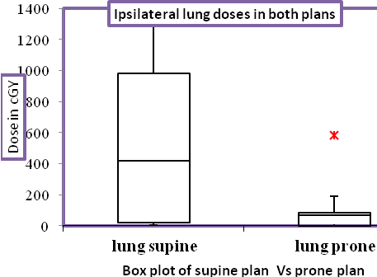
Figure(6): Box plot showing doses to ipsilateral lung in prone Vs supine plan

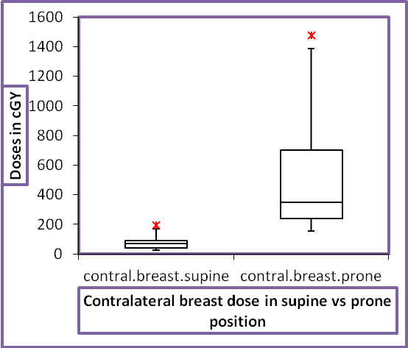
Figure(7): Box plot showing doses to contralateral breast in prone Vs supine plan.

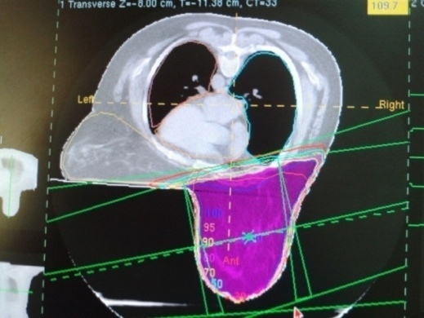
Figure (8): Calculated prone plan with point of maximum of 109.7% of dose with satisfactory distribution of 95% of volume by 95% of dose

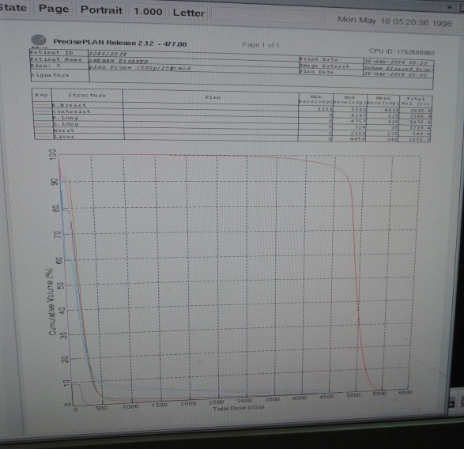 | 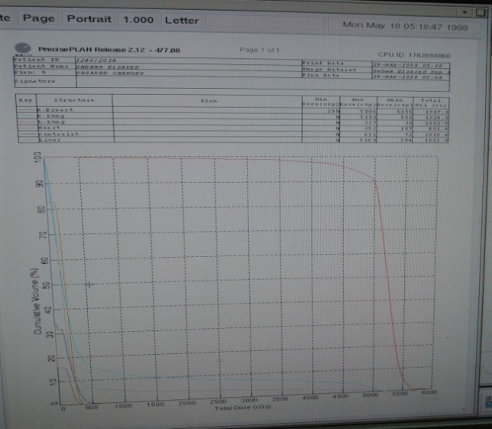
(A) | (B)
Figure (9): DVH of prone (A) and supine (B) plans of the same patient showing dose coverage of the target and organs at risk.

Table(3): Different toxicity grades in supine vs prone position
P value | Prone plan |  | Supine plan |  | Toxicity
0.2 | % | No | % | NO
 |  |  |  |  | Erythema
 | 20 | 2 | 0 | 0 | None
 | 40 | 4 | 50 | 4 | Grade1
 | 30 | 3 | 12.5 | 1 | Grade2
 | 10 | 1 | 37.5 | 3 | Grade3
0.8 |  |  |  |  | Pigmentation
 | 60 | 6 | 50 | 4 | None
 | 30 | 3 | 37.5 | 3 | Grade1
 | 10 | 1 | 12.5 | 1 | Grade2
 | 0 | 0 | 0 | 0 | Grade3
0.07 |  |  |  |  | Moist desquamations.
 | 80 | 8 | 37.5 | 3 | None
 | 20 | 2 | 25 | 2 | Grade1
 | 0 | 0 | 37.5 | 3 | Grade2
 | 0 | 0 | 0 | 0 | Grade3
0.1 |  |  |  |  | Breast edema
 | 80 | 8 | 37.5 | 3 | None
 | 10 | 1 | 25 | 2 | Grade1
 | 10 | 1 | 37.5 | 3 | Grade2
 | 0 | 0 | 0 | 0 | Grade3

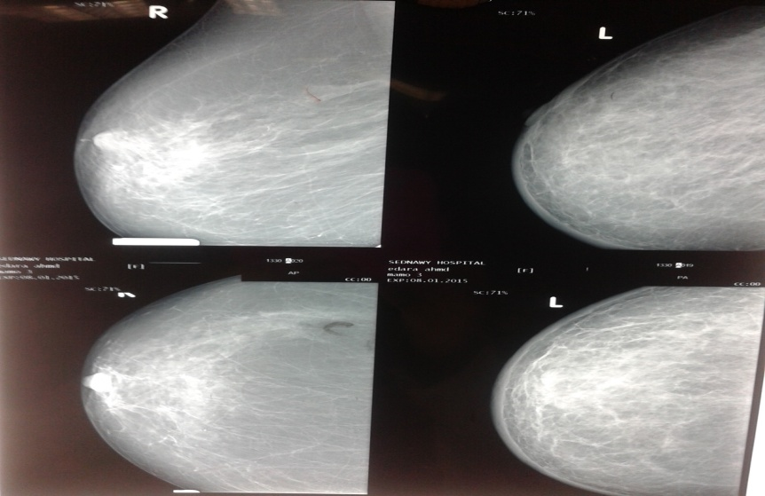
Figure(10): Shows mammography with breast edema toxicity.

Table(4): Grades of cosmoses in both plans
P value | Prone plan |  | Supine plan |  | Grade
0.2 | % | No | % | No
 | 10 | 1 | 0 | 0 | None
 | 60 | 6 | 37.5 | 3 | Grade1
 | 30 | 3 | 37.5 | 3 | Grade2
 | 0 | 0 | 25 | 2 | Grade3
 | 100 | 10 | 100 | 8 | Total

4. Discussion
In the present study and after evaluation of prone and supine treatment plans for each patient, 8 patients were treated in supine position and 10 in prone position. The mean doses of ipsilateral lung in cGy were 611.6 ± 519, the mean doses of contra lateral lung in cGy were 227.1±341in supine plan while in prone position, the mean doses were 166.3±206 for ipsilateral lung with p-value of 0.001, the mean doses were 49.6 ± 123 for contralateral lung. The mean doses of the heart in supine position in cGy were 374 ± 290; with no significant difference from that seen in prone position 316.1± 316(P=0.4). In the study of Kurtman et al.,⁽⁷⁾, the mean doses to the ipsilateral lung were 8.3 ±3.6 Gy for the supine position and 1.4 ± 1.0 Gy for the prone position (P=0.043). The values for the contra lateral lung were 1.3 ±0.7 versus 0.3 ± 0.1 Gy (P=0.043) and the values for cardiac tissue were 4.6 ± 1.6 versus 3.0 ± 1.7 Gy (P=0.079), respectively. These results showed that the mean doses delivered to the lungs were significantly lower in the prone position than in the supine position. Total dose used in the currant study was 50 Gy, followed by 10 Gy as a boost to tumor bed, in Basanta et al.,⁽⁸⁾ as well as, many studies^{(5, 9)} had typically treated patients with standard whole-breast irradiation to a total dose of 5,000 cGy in the supine position. This standard of care technique, however, had been known to result in substantial levels of radiation delivered to nearby organs including the ipsilateral lung and the heart⁽⁸⁾.
In the current study, prone position was better than supine position regards the mean doses to the liver which were 210.4 and 249.6 cGY in prone and supine positions respectively but with no statistical significance (P=0.6). Bieri et al.⁽⁹⁾ determined the effects of treatment techniques, such as supine and prone positioning, on the absorbed dose in organs at a distance from the irradiated breast, peripheral doses delivered to the abdomen and lung were significantly higher for supine than for prone tangential breast irradiation.
In our study, prone plan had proven non significant superiority over supine regards acute skin toxicity in the form of erythema as 4 patients (50%) manifested grade 1 in supine treatment position versus 4 patients (40%) in prone treatment position, regards pigmentation, 3 patients (37.5%) manifested grade 1 in supine position versus 3 patients (30%) in prone position. Moist desquamation was manifested in 3 patients (37.5%) as grade 2 in supine position versus no patient in prone position. Edema of the breast, was manifested in five patients (62.5%) in supine position treatment group; 2 (25%) with grade 1and 3 (37.5%) patients with grade 2, while in prone position only 2 (20%) patients showed breast edema of grade 1 and 2, those toxicities were observed in infra mammary area in supine and cranial part of the breast in prone position mainly, and were observed at 4th – 5th weeks of radiotherapy. Regards acute toxicity in Krengli` study⁽⁵⁾, 18/41 of patients (43.9%) developed grade 1 and 19 (46.3%) developed grade 2 dermatitis consisting of moderate to brisk erythema, skin desquamation, typically located in the infra-mammary skin fold. Grade 3 acute dermatitis was observed in 4 patients (2.6%) with diffuse breast edema, pain and skin desquamation. In our study cosmetic results were satisfactory in both treatment groups with no one patient in prone position and only 2(25%) patients in supine position showing grade 3 cosmetic changes. In Kenneth` study⁽⁶⁾ better breast shape was associated with less thoracic respiratory movements with reduced hot spots inside PTV, resulting in better cosmetic outcome in prone position.
We faced some problems in the form of:-
1. Our board thickness is 15 cm but the majority of our patients have large pendulous breast, so hanging of the treated breast was aimed so as to avoid lateral rotation of the target.
2.The dose of the heart in prone position became more in the radiation field by gravity observation, rotation of the head to the same treated side, use of modified breast devices, and application of IMRT and IGRT may be problem solving.
3. We found that the liver suffered from radiation especially in patients with hepatomegaly as there was enlargement of both lobes right and left, especially in right breasted patient in prone position (gravity effect) and in supine position in both right and left treated breast. Use of IMRT may solve this problem.

Conclusions
The prone position allowed adequate target coverage as well as a significant decrease of ipsilateral lung dose and contra lateral lung dose in all patients and a favorable trend for heart dose in patients with left sided cancer and liver dose in patients with right sided cancer rather than supine position. Prone approach, however, does not prevent the exposure of normal tissue as contra lateral breast outside the field to low doses generated by scattered radiation, but with satisfactory acute skin toxicity profile and cosmetic outcome.

Recommendations
Therapeutic benefits in treating breast cancer patients with large pendulous breasts wishing to have breast conservative surgery in their treatment strategies, must be carefully weighted against the known radiation toxicities especially in absence of advanced procedures, techniques and plans in the form of IMRT and 4D.In the future we would like to obtain more recent breast devices for such patients with more incorporation of tumor biological data.

References
- Beck R, Kim L, Ning J. Yue, Bruce G. Haffty, Khanand A. Sharad Goyal. What are the Key Statistics about Breast Cancer? (2014). Available from: www. Cancer.org/ cancer/ breast cancer/ detailed guide/breast-cancer-key-statistics.
- Ferlay J, Shin H, Bray F, Forman D, Mathers C, Parkin D. GLOBOCAN 2008 v1.2, Cancer Incidence and Mortality Worldwide: IARC Cancer Base No. 10. Lyon, France: International Agency for Research on Cancer 2010 [accessed on 24.09.2012].
- Formenti S, Addeo G, Goldberg J, et al.: Phase I–II trial of prone accelerated intensity modulated radiation therapy to the breast tooptimally spare normal tissue. J Clin Oncol 2007, 25(16):2236–2242.
- Lanea M. Keller M, Cohen R, Dennis M. Sopka, Li T, LiL, Penny R, Anderson, Barbara L. Fowble, Gary M. Freedman. Effect of bra use during radiation therapy for large-breasted women: Acute toxicity and treated heart and lung volumes Practical Radiation Oncology (2013) 3, 9–15.
- Krengli, Masini L, Caltavuturo T, Pisani C, ApicellaG,Negri E, Deantonio L Brambilla M and Gambaro G. Radiation Oncology 2013, 8:232. http://www.rojournal.com/content/8/1/232.
- Kenneth S, Hu and Harrison. Decision making in radiation oncology. Jiade J. Lu, Luther W. Brrady. H, Heilmann M, Molls, NiederC, (editors). chapter 3. Volume 1-100, 2011.
- Kurtman C, Andrieu N, Hiçsönmez A. and Çelebiolu B. Department of Radiation Oncology Medical Faculty, Ankara University Cebeci Hospital, Dikimevi Barazilian journal 2003,36.1441,1446.
- Basanta A, Ko J, Babcock M, et al. Coverage of axillary lymph nodes in supine vs. prone breast radiotherapy. Int J Radiat Oncol Biol Phys 2009;73:745e751.
- Bieri S, Russo M, Rouzaud M & Kurtz J (1997). Influence of modifications in breast irradiation technique on dose outside the treatment volume. International Journal of Radiation Oncology, Biology, Physics, 38: 117-125.
- Li X, Tai A, Arthur D, et al.Variability of target and normal structure delineation for breast cancer radiotherapy: an RTOG multi-institutional and multiobserver study. Int J Radiat Oncol Biol Phys. 2009;73(3):944–51. PMC free article PubMed.
- World Health Organization (1979):WHO Handbook for report in results of cancer Treatment, vo 48, offset publication, Geneva: World Health Organization
- Aaronson N, Bartelink H, Dongen V, Dam V. Evaluation of breast conserving therapy: Clinical, methodological and psychosocial perspectives. Eur J Surg Oncol 1988;14:133-40.

3/13/2016

