Weekly Docetaxel and Cisplatin with Concomitant Radiotherapy in Addition to Consolidation Chemotherapy in Locally Advanced Non-Small Cell Lung Cancer

Hanan G. Mostafa and Mohamed-Alaaeldeen H. Mohamed

Department of Clinical Oncology and Nuclear Medicine, Faculty of Medicine, Assiut Universityو Assiut, Egypt.
mostafahanan36@yahoo.com

Abstract: Introduction: Concurrent chemo-radiotherapy (CCRT) is the standard of care for the treatment of patients with locally advanced non-small cell lung cancer (NSCLC). To improve outcomes, additional chemotherapy following CCRT was developed. The study aim was to evaluate outcomes and prognostic factors of CCRT with cisplatin and docetaxel followed by consolidation by the same regimen in patients with stage III NSCLC in a prospective phase II study. Methods: Patients with stage III NSCLC were included. They received 60 Gy thoracic radiotherapy and weekly 20 mg/m² docetaxel & 20 mg/m²cisplatin concomitantly. Consolidation chemotherapy using docetaxel 75 mg/m² & cisplatin 60 mg/m² every 3 weeks for 3 cycles followed local therapy in all patients. Results: From February 2012 to March 2014, eligible 46 patients were included. Four (9%) patients achieved complete response (CR), 23 (50%) showed partial response (PR), stable (SD) and progressive disease (PD) was shown in 17.4% and 19.2% respectively. The median follow-up was 14 months (range: 5-48months) the median overall survival (OS) and progression-free survival were 15 and 7 months respectively. Esophagitis in 4 (8.7%), neutropenia in 3 (6.5%) and pneumonitis in 4 (8.7%) patients were detected as grade III-IV toxicity due to CCRT. Tumor stage (IIIA vs. IIIB, p=0.003) and clinical tumor response (CR+ PR vs. SD+ PD, p=0.001) were significant prognostic factors for OS. Conclusions: This study shows that consolidation chemotherapy failed to demonstrate improvement in survival. Clinical tumor response was significantly affecting survival.
[Hanan G. Mostafa and Mohamed-Alaaeldeen H. Mohamed. Weekly Docetaxel and Cisplatin with Concomitant Radiotherapy in Addition to Consolidation Chemotherapy in Locally Advanced Non-Small Cell Lung Cancer. Cancer Biology 2016;6(1):26-34]. ISSN: 2150-1041 (print); ISSN: 2150-105X (online). http://www.cancerbio.net. 6. doi:10.7537/marscbj06011606.

Key words: Cisplatin, concomitant chemo-radiotherapy, consolidation chemotherapy, docetaxel, non-small cell lung cancer.

1. Introduction
Lung cancer is the leading cause of cancer-related mortality in the United States and a common cause of cancer-related mortality worldwide ^{1, 2}. The majority of patients with lung cancer have the non-small cell lung cancer (NSCLC) subtype, and approximately one third of patients have unrespectable stage IIIA or stage IIIB disease ³.
The strategy of radiotherapy only changed essentially after the publication of the meta-analysis by the Non-small Cell Lung Cancer Collaborative Group in 1995 ⁴. All phase III trials were included in a meta-analysis done by Aupérin et al.⁵, indicating a 4% survival gain at 2 years and 2% at 5 years, for concurrent chemo-radiation (CCRT) versus radiotherapy alone, a comparable improvement was observed with the sequential combination.
Multiple phase III studies have demonstrated an advantage of CCRT over sequential chemo-radiation and this is currently the standard of care. The RTOG 9410 trial involving 610 patients demonstrated a survival advantage for concurrent over sequential chemo-radiation ⁶.
Two recent meta-analyses re-demonstrated an advantage to CCRT over sequential chemo-radiotherapy ^{7, 8}.
The recommended treatment of patients presenting with inoperable stage III NSCLC and a good performance score is CCRT ⁹.
The recommended systemic treatment in stage III NSCLC consists of 2–4 cycles of chemotherapy ¹⁰. Different schemes for both induction and consolidation therapy are in clinical use, with induction chemotherapy before the start of CCRT preferred by some ¹¹ and consolidation chemotherapy preferred by others ¹².
The sequencing of systemic chemotherapy with CCRT was also addressed in two recent European studies ^{13, 14}. Both studies revealed statistically similar outcomes irrespective of treatment sequence.
However, the optimal choice of chemotherapy agents and the number of cycles to be given remains unsettled. Platinum-containing regimens are standard ¹⁵.
Docetaxel enhances the cytotoxic effects of radiotherapy in vitro ¹⁶, with radiation enhancement being superior to that observed with paclitaxel ¹⁷.
To explore which chemotherapy regimen is more effective during radiotherapy in locally advanced NSCLC, a study was done by Afsar et al.¹⁸ concluded that the most effective one was cisplatin and docetaxel. This finding should be evaluated in large clinical trials.
The aim of the current study was to assess the treatment outcomes, toxicities and prognostic factors associated with the overall survival of patients who received concurrent chemo-radiation followed by consolidation chemotherapy for locally advanced stage III non-small cell lung cancer.

2. Patients and methods
This phase II prospective study was conducted in Clinical Oncology department, Assiut University Hospital, Egypt. The study enrolled patients who were histological confirmed as having non-small cell lung cancer. This included locally advanced stage III NSCLC, with Eastern Cooperative Oncology Group Performance status of 0 to 1, acceptable pulmonary, bone marrow, liver and renal functions and no concomitant serious illnesses or medical conditions. Patients were excluded if they did not have the previous criteria or they were previously treated with chemotherapy or radiotherapy.
Before study entry, patients underwent physical examination chest x-ray, computed tomography (CT) scan of the chest including upper abdomen, bronchoscope& biopsy, bone scan, whole abdominal CT scan and CT or magnetic resonance imaging of the brain.
Patients were staged according to the TNM staging system of the International Association for Lung Cancer in 2010 (7th edition).
The protocol of the study was approved by the ethics committee of Faculty of Medicine, Assiut University, Egypt before the study was activated. All patients gave an informed consent prior inclusion in the study. This study was conducted in accordance with the Declaration of Helsinki.
Radiation therapy
Two-dimensional treatment planning system was used, while patients in supine position, by conventional x-ray simulation and radiation were delivered with 6-18 Million Volts photon beam energy by linear accelerator device. The total radiation dose was 60 Gy and the fractional size of 2 Gy was prescribed 5 times a week. The planning target volume (PTV) was defined as the primary tumor mass plus 2 cm all-around, ipsilateral hilum and mediastinum (elective nodal irradiation was used).
Patients were treated by parallel-opposed anterior and posterior field to 40 Gy in 20 fractions. After 40 Gy spinal cord was spared and a boost field to the primary tumor and the involved nodes with margin 1.5 cm from oblique parallel opposed fields was used.
Correction of lung attenuation was done. When grade III hematologic toxicity or esophagitis occurred, chemo radiation was delayed until recovery then restarted.
Chemotherapy
Concurrent docetaxel 20 mg/m² as 30 minutes intravenous (IV) infusion and cisplatin 20 mg/m² IV infusion over 30 minutes following docetaxel administration on day 1 of every week to a total 6 weeks with radiation. Thoracic radiotherapy was started 4 hours after the end of cisplatin infusion.
One month later after the completion of chemo radiation, 3-week cycles of docetaxel 75 mg/m² in a 60 minutes IV infusion and cisplatin 30 mg/m² on days 1 & 2 over 60 minutes IV infusion for 3 cycles. Hydration and prophylactic antiemetic were administered before chemotherapy according to departmental practice. A single dose of dexamethasone 4 mg was administered IV 15 minutes before each docetaxel infusion.
Tumor and toxicity assessments
Patients were evaluated weekly during chemo-radiation and every 3 weeks during consolidation chemotherapy. Blood chemistry and complete blood count were obtained during evaluation. Computed tomography examination was repeated 4 weeks after the end of chemo-radiation and 4-6 weeks after the end of consolidation chemotherapy. Radiological examination was repeated every 3 months during the first 3 years post treatment until the date of disease progression or death.
The Response Evaluation Criteria in Solid Tumors Group (RECIST) ¹⁹ were used for response evaluation. These consisted of complete response (CR), partial response (PR), stable disease (SD) or progressive disease (PD).
Acute toxicity was assessed using the National Cancer Institute Common Toxicity Criteria (NCI CTCAE) version 4.
Statistical analysis
Forty six patients were calculated to be included in the study; the primary analysis was efficacy including response, progression-free survival (PFS) and overall survival.
Overall survival (OS) was defined as the time from the initiation of treatment to death from any cause or last follow-up.
Progression-free survival was defined as the time from the initiation of treatment to progression of the disease (local recurrence/ or distant metastases) or death.
Secondary analysis was prognostic factors affecting OS.
Data was expressed by numbers, percentage and means. Kaplan-Meier methods were used to estimate OS and PFS. Means were compared using the student's t-test Survival rates were compared by Log-rank test. P values <0.05 were considered to be significant. For statistical analysis, SPSS ver. 21 (SPSS Inc., Chicago, IL) was used.

3. Results
A total of 46 patients were included from February 2012 to March 2014 in Clinical Oncology department, Assiut University Hospital, Egypt.
Patient characteristics are shown in Table 1.
Treatment compliance and clinical response
Dose modification for docetaxel was required in 20% of patients and for cisplatin in 15% of patients. Forty patients (87%) were treated with the planned 6 cycles of chemotherapy. Radiotherapy was applied as 60 Gy in 93.5% of patients.
The overall response rate (CR+ PR) was 67.4% (n= 31), including 4 CR (8.7%) as shown in Table 2.
Recurrence has been observed in 21 patients (45.7%). Tumor recurred in the following sites: loco regional sites (23.9%) and distant organs (28.3%). The most common site of distant metastases was the brain followed by skeletal system. All of the patients with progressive disease or recurrent disease received palliative treatment including chemotherapy or localized radiotherapy.
Progression-free survival and overall survival
The median follow-up duration for the overall patients was 14 months (range, 3-48 months). The median PFS was 7 months and the median OS was 17 months (Figures 1 and 2).
Prognostic factors affecting overall survival
Prognostic factors affecting OS are shown in Table 3. In this analysis, the clinical stage (IIIA vs. IIIB, p=0.003) and a higher clinical response (CR+ PR vs. SD+ PD, p=0.001) were significantly associated with improved OS.
Kaplan-Meier OS curves stratified by clinical tumor response in the overall patients group is shown in figure 3.
Toxicity
Hematologic and esophageal toxicity were major acute toxicities. Acute toxicities of the treatment are listed in Table 5.

Table (1): Patients and tumor characteristics
Characteristics | No. of patients (%)
-Age “years”  Median  (range)  -Sex:  Female  Male  -Performance status “ECOG”†  - 0  - 1  -Histopathology  - Squamous cell carcinoma  - Adenocarcinoma  - Large cell carcinoma  -Stage  - IIIA  - IIIB  -Smoking history  - Yes  - No | 63.50  32.0-73.0  9 (19.6)  37 (80.4)  6 (13.0)  40 (87.0)  23 (50.0)  17 (37.0)  6 (13.0)  20 (43.5)  26 (56.5)  35 (76.1)  11 (23.9)
†ECOG= Eastern Cooperative Oncology Group

Table (2): Treatment outcomes
Outcomes | No. of patients (%)
Response  - Complete response  - Partial response  - Stable disease  - Progressive disease  Progression-free survival, median  Range  Overall survival, median  Range | 4 (8.7)  27 (58.7)  8 (17.4)  7 (15.2)  7.00  (5.0-11.0)  17.50  (6.0-42.0 )

Table (3): Prognostic factors of overall survival
Factor | Mean± SD§ | P
-Sex  Male  Female  -Histopathology  Squamous cell carcinoma  Adenocarcinoma  Large cell carcinoma  -Stage  - IIIA  - IIIB  -Smoking history  - Yes  - No  -Clinical response  - CR+ PR†  - SD+ PD╪ | 19.51 ± 8.47  17.00 ± 13.71  19.95 ± 9.20  18.35±10.89  17.33±8.06  23.65 ± 10.67  15.46 ± 6.95  18.85 ± 8.51  19.54±12.91  22.96 ± 9.10  10.86 ± 3.41 | 0.65  0.791  <0.003*  0.838  <0.001*
†CR = complete response+ PR = partial response, ╪SD = stable disease+ PD= progressive disease, §±SD= standard deviation, * = significant value.

Table (4): Toxicity of treatment (NCI CTC†) "No. of patients= 46"
Acute toxicity | Grade 2  No. (%) | ≥Grade 3  No. (%)
Hematological:  Neutropenia  Thrombocytopenia  Anemia  Non hematological:  Nausea & Vomiting  Esophagitis  Pneumonitis | 7 (15)  1 (2)  1 (2)  5 (10.9)  12 (26)  12 (26) | 3 (6.5)  0  0  0  4 (8.7)  4 (8.7)
†NCI CTC = National Cancer Institute. Common Terminology Criteria, version 4

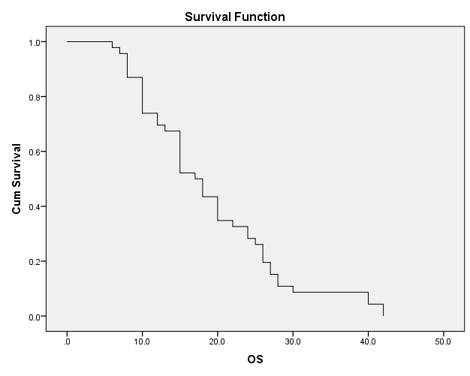
Months
Figure (1): Overall survival (OS) of patients. The median OS was 17 months.

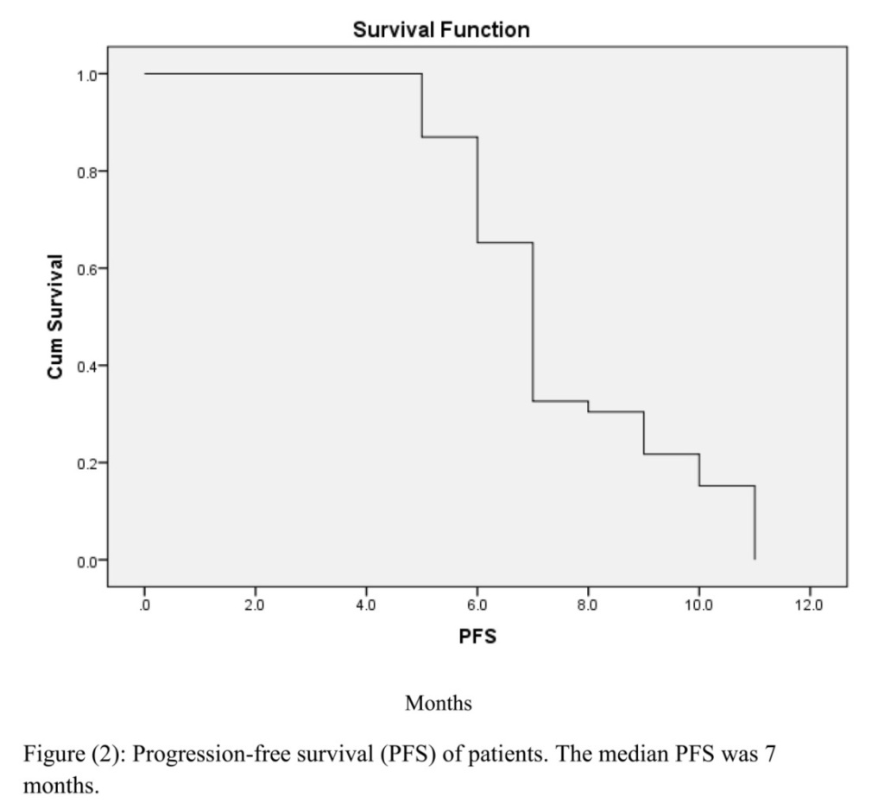

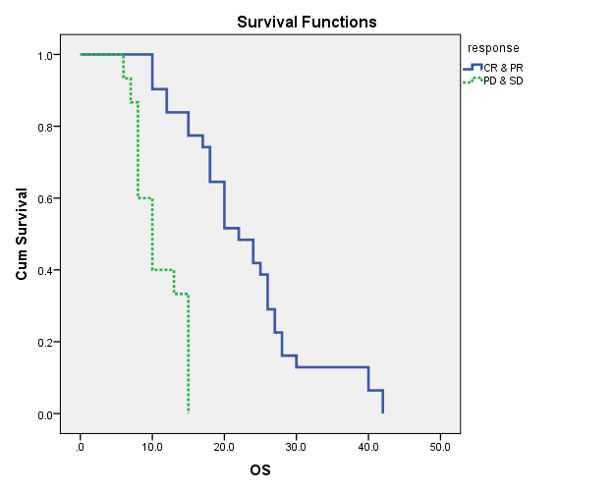
Figure (3): Overall survival (OS) curves stratified by clinical tumor response for the total patients. OS rates between responders (complete response + partial response {CR+PR}) and non-responders (stable disease + progressive disease {SD+PD}) groups (p=0.001).

4. Discussion
For patients with stage III unrespectable or inoperable non small cell lung cancer (NSCLC) who have adequate end organ function including pulmonary reserve, concurrent chemo-radiation is a standard of care ²⁰.
A meta-analysis confirmed that superior overall survival outcome observed with concurrent chemo-radiotherapy was related to better loco regional control. However, the high rates of loco regional, distant disease progression and the low 5-year overall survival (OS) rate are quite emerging ²⁰.
Most clinical trials employ a strategy of concurrent chemo-radiation for loco-regional control and systemic dose chemotherapy to prevent the development of distant metastatic disease. The contribution of consolidation chemotherapy with cisplatin+ docetaxel to survival rate was shown in meta-analysis done by Liu et al.²¹.
In the current study, we analyzed the treatment results of consolidation treatment with docetaxel and cisplatin after weekly administration of these agents concurrently with radiation in patients with locally advanced stage III NSCLC. The median progression-free survival (PFS) and OS time of all patients was 7 and 17 months respectively. These treatment outcomes were shorter than that of previously reported. Oh et al ²² reported a median survival of 27.6 months and Kayo et al.²³ reported a median PFS and OS of 14 and 22 months respectively.
Recently, Afsar et al. ¹⁸ performed a study to explore the effect of platinum and docetaxel-based chemo-radiation on survival and revealed a median OS of 29 months for stage IIIA and 21 months for stage IIIB. Shorter survival in the current study was probably due to the fact that most of the patients enrolled were stage IIIB and shorter follow-up periods.
As regard the response rate in the current study, the overall response rate (ORR) which include complete response (CR) + partial response (PR) it was 67% including 9% CR. Those treatment outcomes are comparable to the treatment results of the study done by Eroglu et al.²⁴ who reported an ORR 69%. Our results were higher than the results of the study done by Maas et al.²⁵ who reported an ORR 46%. The difference may be due to the low dose of radiotherapy in their study (45 Gy) because they proceeded to surgery after concurrent chemo radiation.
The ORR in the current study was also higher than the ORR of patients with locally advanced NSCLC in the study of Kaya et al.²³ who reported an ORR of 59%. The lower ORR in their study may be due to the higher percentage of patients with stage IIIB (75.9%).
The treatment toxicity in the current study was acceptable when compared with previous studies of concurrent chemo-radiation treatment. Esophagitis, neutropenia and pneumonitis ≥ grade 3 was 8.7%, 6.5% and 8.7% respectively which was lower than the results of the study of Afsar et al.¹⁸ who reported esophagitis in 13%, neutropenia in 9% and pneumonitis in 12% of patients as grade III/IV toxicity due to concomitant chemo-radiation. The difference may be due to younger age and lower response rate in the current study and chemotherapy schedule (weekly vs. every 3 weeks). Response to treatment (CR + PR versus others) was found to be a new predictor for grade ≥3 radiation pneumonitis ²⁶.
In the analysis of prognostic factors significantly associated with OS in NSCLC in our study were tumor stage and clinical tumor response. There are several known prognostic factors associated with OS in NSCLC such as tumor stage as in the study of Ademylwa et al.²⁷ as well as weight loss, performance status and pulmonary functions.
Another study done by Lee et al. ²⁸ demonstrated that clinical tumor response was significantly associated with long OS in patients treated with concurrent chemo-radiation for 3 different aims in locally advanced stage III, locally recurrent disease and postoperative gross residual NSCLC. This means that more radical tumor control will eventually be connected to improve survival in NSCLC.
To define the role of consolidation chemotherapy in locally advanced NSCLC, a recent phase III randomized trial was conducted by Ahn et al. ²⁹. All patients initially received weekly cisplatin+ docetaxel with concurrent radiotherapy followed by consolidation cisplatin and docetaxel versus observation alone. Consolidation therapy failed to prolong PFS, concurrent chemo radiotherapy alone should remain the standard of care.

Conclusion
Concurrent chemo-radiation with weekly docetaxel and cisplatin with thoracic radiotherapy followed by the same drugs for consolidation is a feasible treatment option for stage III non small cell lung cancer showing good clinical efficacy and tolerability with acceptable survival. The current study demonstrated that clinical response was a prognostic factor correlated with the improved overall survival. So every effort should be made to improve response of stage III NSCLC to chemo-radiation by a higher radiation dose, improving radiation technique, good choice of dugs used or incorporating novel or molecular targeted agents.

Acknowledgements
This work was supported by the department of Clinical Oncology and nuclear Medicine and colleagues who participated in manuscript revision, data collection statistical analyses, contribution of dosimetric data and care for study patients.

Corresponding author:
Dr. Hanan G. Mostafa
Department of Clinical Oncology and nuclear medicine, Faculty of Medicine, Assiut, Egypt
Email: mostafahanan36@yahoo.com

References
- Jemal A, Bray F, Center MM, et al. Global cancer statistics. CA Cancer J Clin 2011; 61: 69 –90.
- Parkin DM, Bray F, Ferlay J, et al. Global cancer statistics, 2002. CA Cancer J Clin 2005; 55: 74 –108.
- Govindan R, Page N, Morgensztern D, et al. Changing epidemiology of small-cell lung cancer in the United States over the last 30 years: Analysis of the surveillance, epidemiologic, and end results database. J Clin Oncol 2006; 24: 4539–4544.
- Collaborative Group, “Chemotherapy in non-small cell lung cancer: a meta-analysis using updated data on individual patients from 52 randomized clinical trials,” British Medical Journal 1995; 311 (7010): 899–909.
- Aupérin A, Le Péchoux C, Pignon JP, et al. “Concomitant radio-chemotherapy based. onplatin compounds in patients with locally advanced non-small cell lung cancer (NSCLC): a meta-analysis of individual data from 1764 patients,” Annals of Oncology 2006; 17 (3): 473–483.
- Curran WJ Jr, Paulus R, Langer CJ, et al. Sequential vs. concurrent chemo radiation for stage III Non-Small cell lung cancer: Randomized phase III trial RTOG 9410. J Natl Cancer Inst. 2011; 103(19):1452–1460. [PubMed: 21903745].
- Aupérin A, Le Péchoux C, Rolland E, et al.Meta-analysis of concomitant versus sequential radio chemotherapy in locally advanced non-small-cell lung cancer. Journal of Clinical Oncology. 2010; 28(13):2181–2190. [PubMed: 20351327].
- O’Rourke N, Roquéifiguls M, farrébernadَ N, Macbeth F. concurrent chemo radiotherapy in no small cell lung cancer. Cochrane Database Syst Rev. 2010; 6.
- Robinson LA, Ruckdeschel JC, Wagner H Jr, et al.Treatment of non-small cell lung cancer-stage IIIA: ACCP evidence-based clinical practice guidelines (2nd edition). Chest 2007; 132 (3 Suppl): 243S–265S.
- Pfister DG, Johnson DH, Azzoli CG et al. American Society of Clinical Oncology treatment of unresectable non-small-cell lung cancer guideline: update 2003. J ClinOncol 2004; 22: 330–353.
- Nyman J, Friesland S, Hallqvist A, et al.How to improve loco-regional control in stages IIIa-b NSCLC? Results of a three-armed randomized trial from the Swedish Lung Cancer Study Group. Lung Cancer 2009; 65: 62–67.
- Green MR, West H, Socinski MA, et al. Impact of the ASCO 2007 presentation of HOG LUN 01-24/USO-023 on the prescribing plans of American medical oncologists for patients with stage IIIB non-small cell lung cancer. J ThoracOncol 2009; 4: 983–987.
- Fournel P, Vergnene A, Robinet G, et al. Induction Or Consolidation Chemotherapy With Cisplatin (C) And Paclitaxel (P) Plus Concurrent Chemo- Radiation With Cisplatin And Vinorelbine (V) For Unresectable Non-Small Cell Lung Cancer Patients: Randomized Phase II Trial GFPC-GLOT-IFCT 02-01. J ClinOncol, 2006 ASCO Annual Meeting Proceedings Part I 2006; 24: 18S (June 20 Suppl), 7048.
- Garrido Lopez P, Rosell R, Massuti B, et al. Predictors of long-term survival in lung cancer patients (p) included in the randomized Spanish Lung Cancer Group 0008 phase II trial using concomitant chemo radiation with docetaxel (D) and carboplatin (Cb) plus induction (I) or consolidation (C) chemotherapy (CT) with docetaxel and gemcitabine (G). J ClinOncol 2008; 26: (May 20 Suppl; Abstr 7574).
- Hanna N. Current standards and clinical trials in systemic therapy for stage III lung cancer: What is new? Am SocClinOncolEdu Book. 2015; 35: e442-7.doi: 10.14694/ED Book_ AM. 2015.35. e442.
- Mason K, Staab A, Hunter N, et al.Enhancement of tumor radioresponse by docetaxel: involvement of immune system. Int J Oncol 2001; 18: 599–606.
- Pradier O, Rave-Frank M, Lehmann J, et al. Effects of docetaxel in combination with radiation on human head and neck cancer cells (ZMK-1) and cervical squamous cell carcinoma cells (CaSki). Int J Cancer 2001; 91: 840–845.
- Afsar C, Gunaldi M, Karaca F, et al.The effect of platinum based chemo radiotherapy on survival in locally advanced unresectable non-small cell lung cancer patients. J ClinOncol 2015; 33, (suppl; abstr e18538).
- Therasse P, Arbuck SG, Eisenhauer EA, et al. New guidelines to evaluate the response to treatment in solid tumors. European Organization for Research and Treatment of Cancer, National Cancer Institute of the United States, National Cancer Institute of Canada. J Natl Cancer Inst 2000; 92: 205-216.
- Auperin A, Le Pechoux C, Rolland E, et al. Metaanalysis of concomitant versus sequential radio chemotherapy in locally advanced non-small-cell lung cancer. J ClinOncol 2010; 28: 2181–2190.
- Liu T, Wu H, Zhuang X, Lu D, Cai R, Wang W. [A meta-analysis of platinum plus docetaxel or vinorelbine in the first-line treatment of advanced non-small cell lung cancer]. Zhongguo Fei Ai ZaZhi 2014; 17 (4): 327-35. Doi: 10.3779/j.issn. 1009-3419, 2014.04.07.
- Oh IJ, Kim KS, Kim YC, et al.A phase III concurrent chemo radiotherapy trial with cisplatin and paclitaxel or docetaxel or gemcitabine in unresectable non-small cell lung cancer: KASLC 0401. Cancer Chemother Pharmacol 2013; 72 (6): 1247-54. doi:10. 1007/s00280-013-2308-5.
- Kaya AO, Buyukberber S, Benekli M, et al. Concomitant chemo radiotherapy with cisplatin and docetaxel followed by surgery and consolidation chemotherapy in patients with unresectable locally advanced non-small cell lung cancer. Med Oncol. 2010; 27(1):152-7. doi: 10.1007/s12032-009-9186-z. Epub 2009 Feb 26.
- Eroglu C, Orhan O, Unal D, et al. Concomitant chemo radiotherapy with docetaxel and cisplatin followed by consolidation chemotherapy in locally advanced unresectable non‑small cell lung cancer. Annals of Thoracic Medicine 2013; 8 (2): 109-115.
- Maas KW,ElSharouniSY,Phernambucq EC, et al. Weekly chemo radiation (docetaxel/cisplatin) followed by surgery in stage III NSCLC; a multicentre phase II study. Anticancer Res. 2010; 30(10):4237-43.
- Dang J, Guang Li, Zang S, Zhang S, Yao L. Risk and predictors for early radiation pneumonitis in patients with stage III non-small cell lung cancer treated with concurrent or sequential chemo radiotherapy. Radiation Oncology 2014, 9:172.
- Ademuyiwa FO, Johnson CS, White AS, et al. Prognostic factors in stage III non-small-cell lung cancer. Clin Lung Cancer 2007; 8: 478-82.
- Lee DS, Kim YS, Kang JH, et al. Clinical Responses and Prognostic Indicators of Concurrent Chemoradiation for Non-small Cell Lung Cancer. Cancer Res Treat 2011; 43(1):32-41.
- Ahn JS, Ahn YC, Kim JH, et al. Multinational randomized phase III trial with or without consoldation chemotherapy using docetaxel and cisplatin after concurrent chemo radiation in inoperable stage III non-small-cell lung cancer: KCSG-LU05-04. J ClinOncol 2015; 33 (24): 2660-6. Doi: 10. 1200/JCO.2014.60.0130. Epub 2015 Jul 6.

Appendices
Abbreviations: CCRT-concurrent chemo-radiotherapy, NSCLC-non-small cell lung cancer, CR-complete response, PR-partial response, SD-stable disease, PD-progressive disease, RTOG-Radiation Therapy Oncology Group, PTV-planning target volume, RECIST- Response Evaluation Criteria in Solid Tumors, NCI CTCE-National Cancer Institute Common Toxicity Criteria, PFS-progression free survival, OS-overall survival. ORR-overall response rate.

2/17/2016

