Intravesical Gemcitabine in Bacillus Calmette-Guérin (BCG) refractory non muscle invasive bladder cancer

Ahmed Z Alattar¹ Nashwa Nawwar¹, Ahmad M. Alhosainy¹ Khalid Abdelwahab², Mohmed naguib² and Salem Khalil²

¹Clinical Oncology & Nuclear Medicine Department, Faculty of Medicine, Zagazig University Zagazig, Egypt
² Urology Departments, Faculty of Medicine, Zagazig University Zagazig, Egypt
ahmedenbedo@hotmail.com

Abstract: Objective: To evaluate the efficacy and safety of intravesical gemcitabine (GEM) in cases of non muscle invasive bladder cancer (NMIBC) refractory to Bacillus Calmette-Guérin (BCG). Patients and methods: This study included 45 patients with histologically proven NMIBC refractory to BCG therapy, who refused or were not-eligible for radical cystectomy of them 36 were evaluable. Patients' selection based upon European Association of Urology (EAU) guidelines 2011 definition of BCG refractory disease. Performance score (PS) <2, and adequate hematological profile. All patients were planned to receive consecutive 12 intravesical instillations of gemcitabine [2 g/100 mL twice weekly]. Cystoscopy and cytology were performed initially at 3 months with biopsy as clinically indicated, then repeated every 3 months till 24 months. The primary end point was the findings of cystoscopic examination at the 3-month evaluation. Secondary end points included +ve cytology-free survival, +ve cystoscopy- free survival and overall survival at the end of the study follow up period. Results: Intravesical GEM was well tolerated with no cases of treatment discontinuation due to adverse effects. Complete response (Negative cystoscopy and negative cytology) was achieved in 15 (41.7%) patients, of these five patients maintained this state until the end of the follow-up period. Failed intravesical GEM presented as positive cytology (7 patients), NMIBC (11 patients) and muscle invasive disease (3 patients). Over the follow-up period, the median +ve cytology-free survival time was 15 months, while median +ve cystoscopy-free survival time was 21 months and overall survival was 13.5 months. At the end of the study, After one year, 15 patients (41%) were free at cystoscopy. Of them 14 patients (93.3%) were free for cytology, the relapse free survival rate at one year was 39%, but was 14% only at 2 years, the progression free survival time was 21 months and its rate was 33%, and overall survival rate was 86.7%. Conclusion: IV GEM is well tolerated and sets hope for patients with NMIBC refractory to BCG who are willing to keep their bladders or were unfit for radical surgery. Nearly half of the patients survived for two years with their bladder free of tumors.
[Ahmed Z Alattar, Nashwa Nawwar, Ahmad M. Alhosainy Khalid Abdelwahab, Salem Khalil. Intravesical Gemcitabine in Bacillus Calmette-Guérin (BCG) refractory non muscle invasive bladder cancer. Cancer Biology 2016;6(1):20-25]. ISSN: 2150-1041 (print); ISSN: 2150-105X (online). http://www.cancerbio.net. 5. doi:10.7537/marscbj06011605.

Key words: superficial bladder cancer, intravasical gemcitabine

1. Introduction
About two thirds of bladder tumors discovered as superficial tumors including carcinoma in situ (Cis), Ta, and T1 disease, and are managed conservatively by resection (TUR), however two thirds of superficial tumors develop recurrence,¹ high risk Patients are treated with TUR followed by intravesical BCG instillations,.² and 20% to 30% of recurrent tumors will develop progressive disease either a higher stage or grade.³ BCG is the most effective therapy in the treatment of Cis and minimizes the progression rate ⁴; however, only seventy percent of patients respond to BCG, and one third of them will develop recurrent disease, which is associated with a dismal outcome.^{5,6}
Provided that the only accepted standard treatment for BCG refractory urothelial tumors is radical cystectomy, it deserves identification of active agents in this setting, instellation of chemotherapy after BCG can provide another response in selected patients who fails BCG instillation. In spite of that, many urologists recommend cystectomy in most cases of high-risk BCG failure ⁷. However some of these patients refuse radical surgery and some have medical unfitness, this was the base for seeking conservative approaches with other chemotheraputics in these patients. ⁸ ⁻¹⁶
2. Patients and methods
This study began on January 2011 in urology and clinical oncology departments Faculty of medcine Zagazig University. We included patients with histologically proven bladder superficial TCC, refractory to BCG therapy, BCG resistant disease was defined as recurrence 3 months after an induction cycle. BCG relapsing disease was deﬁned as disease recurrence after the patient was disease-free for 6 months. ¹ who were offered radical cystectomy but refused or were not fit for surgery. Patients were selected based upon EAU guidelines 2011 definition of BCG refractory disease ¹⁷. a performance score <2 according to the Eastern Cooperative Oncology Group (ECOG), adequate CBC. Thirty-Six patients completed the study. Patient’s evaluation included, complete medical history taking and physical examination, Blood chemistry, urogram computed tomography (CT)-, plain chest imaging. Complete urine analyses with culture and sensitivity were done on once weekly basis all through the treatment course. Clinical and laboratory assessments were done every three weeks. cystoscopy was performed 3 month after the end of intravesical GEM and for responsive cases it was repeated every three months for two years.
Intravesical gemcitabine
In all patients, an informed consent was obtained before starting treatment. Treatment started 4 to 6 weeks after the last transurethral resection (TURBT). Patients were planned to receive consecutive 12 intravesical instillations of gemcitabine bi weekly (Days 1 and 4) at a dose of 2 gm/100 mL. The bladder was completely evacuated initially at the time of catheterization for the instillation. Patients were instructed to avoid fluid intake 4 hours before treatment and to hold the drug for 1 hour after instillation with changing position every 10 minutes. Gemcitabine instillation was stopped if the patient developed neutropenic fever, bacteremia in the presence of neutropenia, grade 3 or 4 neutropenia or thrombocytopenia, High transaminases, or grade 4 bladder toxicity, but grade 3 bladder toxicity delays next instillation for one week.
Statistical Analysis:
Recurrence-free survival time (defined as the time from TURBT to the date of occurrence of the first recurrence) was estimated.
Tumor progression definition; an increase in stage or grade, and time to progression was defined as the time between TURBT and first progression.
Response to IV GEM instillation was reported as one of 3 categories, including 1) Complete response (CR) when no tumor was seen 3 months after treatment and the patient had negative cytology results, 2) Partial response (PR) when no tumor was seen at 3 months but the patient had positive cytology results, and 3) No response (NR) when there was a viable tumor 3 months after treatment. The primary endpoint was tumor recurrence rate at 6- month follow-up. Secondary endpoints were tumor progression rate, time to recurrence, time to progression, and toxicity.¹⁸
We estimated progression-, recurrence-free and overall survival using Kaplan-Meier methodology for survival estimation. ¹⁹
Continuous variables were expressed as the mean ± SD & median (range), and the categorical variables were expressed as a number (percentage). Positive cytology free survival was calculated as the time from CR to positive cytology or date last known negative cytology (censored). Positive cystoscopy free survival was calculated as the time from CR to positive cystoscopy or date last known negative cystoscopy (censored). Overall Survival (OS) time was calculated as the time from IV GEM administration to death or the most recent follow-up contact (censored). All statistics were performed using SPSS 22.0 for windows (SPSS Inc., Chicago, IL, USA) & MedCalc 13 for windows (MedCalc Software bvba, Ostend, Belgium).

3. Results:
Most of the patients were male (70%), with PS of 2 (39%), and less than 60 years (56%).

Table (1): patient's characteristics
 | No. | (%)
Age (year)
Mean ± SD | 58.19 ± 8.91
Median (Range) | 57.50 (41 – 72)
≤ 60 years | 20 | 55.6%
> 60 years | 16 | 44.4%
Gender
Male | 25 | 69.4%
Female | 11 | 30.6%
Tumor diameter
< 3cm | 13 | 36.1%
> 3cm | 11 | 63.9%
Stages  Ta  T1  Cis | - 44.5%  - 8.3%  - 47.2%
KPS
0 | 10 | 27.8%
1 | 12 | 33.3%
2 | 14 | 38.9%

Table (2): Outcome of the studied patients 6 months after intravesical Gem instellatin (N= 36)
-ve cystoscopy | -ve cytology (CR) | 15 (41.7 %)
 | +ve cytology (PR) | 7 (19.4 %)
+ve cystoscopy | superficial | 11 (30.6 %)
 | deep | 3 (8.3 %)
22 patients (61%) were free at cystoscopy after 6 months. Of them 15 patients (68%) were free for cytology.

Table (3): Follow-up of responders to maximal TURT & intravesical gemcitabine (N=15).
 |  | 3m & 6 m  (N=15) | 9 m  (N=15) | 12 m  (N=15) | 15 m  (N=14) | 18  (N=9) | 21 m  (N=8) | 24 m  (N=5)
-ve cystoscopy | -ve cytology | 15 | 15 | 14 | 9 | 8 | 5 | 5
 | +ve cytology | 0 | 0 | 1 | 5 | 1 | 1 | 0
+ve cystoscopy | superficial | 0 | 0 | 0 | 0 | 0 | 1 | 0
 | deep | 0 | 0 | 0 | 0 | 0 | 1 | 0

After one year, 15 patients (41%) were free at cystoscopy. Of them 14 patients (93.3%) were free for cytology, the relapse free survival rate at one year was 39%, but was 14% only at 2 years, the progression free survival time was 21 months and its rate was 33%.

Table (4): Recurrence free and overall survival time.
 | +ve cystoscopy free survival | +ve cytology free survival | Overall survival
Median(month) | not reached | 18 months | not reached
6 | 100% | 100% | 100 %
12 | 100% | 78.6% | 100 %
18 | 86.7% | 52.4% | 100 %
24 | 80% | 43.7% | 86.7%

At one year all patients were free at cystoscopy, but the cytology of 78.6% was free. While at 2 years 80% of patients were free at cystoscopy, but the cytology of 43.7% was free, the CR rate was 38.88%, 22.22%, and 13.88% at one year, 18 months, and 2 years respectively.

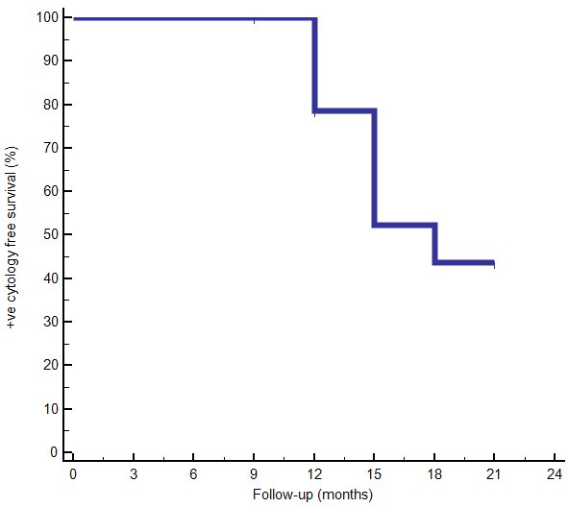 | 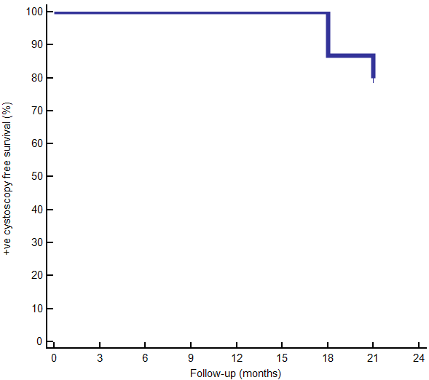
(a) | (b)
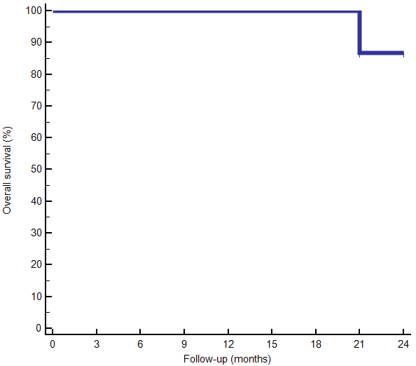
(c)
Figure (1): Kaplan–Meier plots of studied patients; (a) positive cytology free survival (b) positive cystoscopy free survival (c) overall survival At 2 years the cytology of 43.7%of patients were free, 80%were free at cystoscopy, and the over all survival was 86.7%.

4. Discussion
High risk superficial bladder cancer who fail BCG are treated by radical cystectomy or alternative intravesical therapy to prevent tumor recurrence and progression and to avoid surgical morbidity. Intravesical gemcitabine is an option that may add to the urologist’s options in achieving this strategy. ²⁰
in our study, there were 36 evaluable patients with BCG refractory high risk non invasive bladder cancer, underwent TURT, then intravesical instillation of gemcitabine 2gm on days 1and 4 for 6 weeks. Patients were evaluated by cystoscopy and cytology every three months. Fifteen patients (41.7%) maintained CR for 9 months while CR rates were 39%, 22%, and 14% at 12, 18, and 24 months respectively. These results are comparable to the published results ^{22, 25, 26, 27}. The relapse free survival rate at one year was 39%, it was lower than in Lorenzo et al ²⁵, and Skinner et al ²⁶, but the over all survival at 2 years was comparable to Sternberg et al ²⁷. we reported that the relapse free survival rate at one year was 39% while it was 28% at the SWOG study, at 2 year relapses free survival rate was 14% (5 patients) compared to 21 % by Skinner et al ²⁶. The recurrence rate at one years was 61 % (22 patients) compared to the results of Lorenzo et al who concluded that the 1 year recurrence rate was 52%
The safety of GEM intravescical administration up to 2,000 mg in 50 mL saline is well documented; IV GEM was first reported as a new treatment option for BCG-refractory non-muscle-invasive BC patients by Dalbagni et al.²¹. The same group reported a phase 2 studied the efficacy of GEM instillated intravesically for BCG-refractory patients who refuse cystectomy. With median follow-up 15 patients (50%) responded completely. However, the 2-year disease-free survival rate was only about 8% indicating that it is an effective agent but without a durable response
Bartoletti et al^{. 22} reported the results of a prospective multi centre study of intravesical gemcitabine (2 gm weekly x 6) after transurethral resection in 116 patients with refractory superficial bladder cancer), in all, with intermediate (24 BCG refractory) and high-risk (16 BCG refractory bladder cancer. after 12 months follow-up recurrence developed in 25% (6/24), in the BCG refractory intermediate- risk group, vs.56% (9/16) in the corresponding high-risk group ²².
Gunelli et al ²³ evaluated the intravesical gemcitabine in 40 patients with NMIBC (TaG3 – T1G3) who were BCG-refractory to whom TUR of the bladder was done and then intravesical instillation with 2 gm gemcitabine diluted in 50 mL saline on Days 1 and 3 x 6 weeks. Thirty-eight (95%) of patients maintained CR for 6 months after treatment. At a median follow-up of 28 months, recurrence rate was (35 %).
Mohanty et al ²⁴ intravesically treated 35 patients with ‘BCG failure’ with 2000 mg of gemcitabine x6 weeks. With a median follow-up of 18 months, 60% had CR, 31% recurred and three patients (9%) progressed.
Lorenzo et al ²⁵ investigated gemcitabine vs. BCG in a multi-center, prospective randomized study, in 80 high-risk patients who were refractory to BCG therapy and refusing or were not fit for cystectomy. Patients were randomized to gemcitabine (40 patients), or BCG (40 patients). Recurrence rate was 52.5% (21/40) for intravesical gemcitabine vs. 87.5% (35/40) for intravesical BCG. This difference was statistically significant (P = 0.002). The recurrence free survival rates at 2 years confirmed the significant difference (19% gemcitabine vs. 3% BCG; P < 0.008). No significant difference in the disease progression (33% vs. 37.5% P = 0.12). They concluded that Gemcitabine is an effective option as a salvage treatment for this category of patients who refuse cystectomy or not suitable. ²⁵
In the SWOG S0353 Skinner et al ²⁶, patients had recurrent non muscle invasive bladder cancer after at least 2 prior courses of BCG. Patients were treated with 2 gm gemcitabine in 100 cc normal saline intravesically weekly x 6 and then monthly to 12 months. 47 patients were evaluated for response. Of the evaluable patients 42 (89%) had high risk disease, 28% remained continuously free of disease at 1 year and 21% remained continuously free of disease at 2 years.
Sternberg et al ²⁷ retrospectively reviewed the records of patients treated with intravesical gemcitabine after bacillus Calmette-Guerin failure. They estimated progression-free, recurrence-free, and cancer specific survivals. Of 69 patients treated with intravesical gemcitabine 37 had BCG refractory disease. Median follow up in progression-free patients was 3.3 years. The full treatment course was completed as planned in 61 patients (88%), 27 patients had CR, 44%.
19 had PR 31%, and only 62% of the patients with CR (17/27 pts)/ were disease free at 12 months (28% of total).
conclusion:intravesical gemcitabin open a new horizon for BCG refractory NMIBC who refuse cystectomy, but it needs a large randomized study with big number of patients, and longer follow up comparing TURBT followed by intravesical gemcitabin vs. cystectomy.

References
- Hall MC, Chang SS, Dalbagni G et al: Guideline for the management of nonmuscle invasive bladder cancer (stages Ta, T1, and Tis): 2007 update. J Urol 2007; 178: 2314.
- Babjuk M, Oosterlinck W, Sylvester R et al: EAU guidelines on non-muscle-invasive urothelial carcinoma of the bladder, the 2011 update. Eur Urol 2011; 59: 997.
- Soloway MS: Overview of treatment of superficial bladder cancer. Urology 26:18-26, 1985.
- Dalbagni G, Herr HW: Current use and questions concerning intravesical bladder cancer group for superficial bladder cancer. Urol Clin North Am 27:137-146, 2000.
- Hudson MA, Herr HW: Carcinoma in situ of the bladder. J Urol 153:564-572, 1995.
- Herr HW, Badalament RA, Amato DA, et al: Superficial bladder cancer treated with bacillus Calmette-Guerin: A multivariate analysis of factors affecting tumor progression. J Urol 141:22-29, 1989.
- Babjuk M, Oosterlinck W, Sylvester R, Kaasinen E, Bohle A, Palou-Redorta J. EAU guidelines on non-muscle-invasive urothelial carcinoma of the bladder. Eur Urol. 2008;54:303-314.
- Joudi FN, O’Donnell MA. Second-line intravesical therapy versus cystectomy for bacille Calmette-Guerin (BCG) failures. Curr Opin Urol. 2004;14:271-275.
- Barlow LJ, Seager CM, Benson MC et al: Novel intravesical therapies for non-muscle-invasive bladder cancer refractory to BCG. Urol Oncol 2010; 28: 108.
- Yates DR and Roupret M: Contemporary management of patients with high-risk nonmuscle- invasive bladder cancer who fail intravesical BCG therapy. World J Urol 2011; 29: 415.
- Dash A, Pettus JA 4th, Herr HW et al: A role for neoadjuvant gemcitabine plus cisplatin in muscle invasive urothelial carcinoma of the bladder: a retrospective experience. Cancer 2008; 113: 2471.
- Jin JO, Lehmann J, Taxy J et al: Phase II trial of adjuvant gemcitabine plus cisplatin-based chemotherapy in patients with locally advanced bladder cancer. Clin Genitourin Cancer 2006; 5: 150.
- Lorusso V, Pollera CF, Antimi M et al: A phase II study of gemcitabine in patients with transitional cell carcinoma of the urinary tract previously treated with platinum. Italian Co-operative Group on Bladder Cancer. Eur J Cancer 1998; 34: 1208.
- Meliani E, Lapini A, Serni S et al: Gemcitabine plus cisplatin in adjuvant regimen for bladder cancer. Toxicity evaluation. Urol Int 2003; 71: 37.
- Scosyrev E, Messing EM, van Wijngaarden E et al: Neoadjuvant gemcitabine and cisplatin chemotherapy for locally advanced urothelial cancer of the bladder. Cancer 2012; 118: 72.
- Shelley M, Cleves A, Wilt TJ et al: Gemcitabine for unresectable, locally advanced or metastatic bladder cancer. Cochrane Database Syst Rev 2011; 4: CD008976.
- Lerner SP, Schoenberg MP and Sternberg CN: Textbook of Bladder Cancer. Abingdon, United Kingdom: Taylor & Francis 2006.
- MB Rausi, JA Witjas, D.Lamm et al;review of current guidelines and best practice recommendation for management of nonmuscle invasive bladder cancer by international bladder cancer group J Urol 2011; 186, pp.
- Guido Dalbagni, Paul Russo, Bernard Bochner, Leah Ben-Porat, et al Phase II Trial of Intravesical Gemcitabine in Bacille Calmette- Guérin– Refractory Transitional Cell Carcinoma of the Bladder J Clin Oncol. 2006 Jun 20;24(18):2729-34.
- Gray R: A class of K-sample tests for comparing the cumulative incidence of a competing risk. Ann Stat 16:1141-1154, 1988].
- Mike D. Shelley, Gabriel Jones, Anne Cleves, et al Intravesical gemcitabine therapy for non-muscle invasive bladder cancer (NMIBC): a systematic review B J U International 2 01 2 10 9, 4 9 6 – 5 05 review.
- Dalbagni G, Russo P, Sheinfeld J, et al. Phase I trial of intravesical gemcitabine in bacillus Calmette-Guerin-refractory transitional-cell carcinoma of the bladder. J Clin Oncol. 2002;20:3193-3198.
- Bartoletti R, Cai T, Gacci M et al. Intravesical gemcitabine therapy for superficial transitional cell carcinoma: results of a Phase II prospective multicenter study. Urology 2005; 66: 726–31.
- Gunelli R, Bercovich E, Nanni O et al: Activity of endovesical gemcitabine in BCG-refractory bladder cancer patients: a translational study. Br J Cancer 2007; 97: 1499 – 504.
- Mohanty NK, Nayak RL, Vasudeva P, Arora RP. Intravesicle gemcitabine in management of BCG refractory superficial TCC of urinary bladder-our experience. Urol Oncol 2008; 26: 616–9.
- Lorenzo G, Perdona S, Damiano R et al. Gemcitabine versus Bacillus Calmette-Guerin after initial Bacillus Calmette-Guerin failure in non-muscle invasive bladder cancer. Cancer 2010;116: 1893 – 900.
- Skinner EC, Bryan Goldman, Wael A. Sakr, Daniel P. Petrylak,: SWOG S0353: Phase II Trial of Intravesical Gemcitabine in Patients with Nonmuscle Invasive Bladder Cancer and Recurrence after 2 Prior Courses of Intravesical Bacillus Calmette-Gu_erin. The journal of urology Vol. 190, 1200-1204, October 2013.
- Sternberg Itay A., Guido Dalbagni, Ling Y. Chen, Sherri M. Donat, Intravesical Gemcitabine for High Risk, Nonmuscle Invasive Bladder Cancer after Bacillus Calmette-Gu_erin Treatment Failure j.juro.2013.04.120 Vol. 190, 1686-1691, November 2013.

2/17/2016

