**High or Low Ligation of the Inferior Mesenteric Artery during Curative Surgery for Rectal Cancer**

Ali Zedan1, Haisam Atta2, Adel gabr3, and Tareq Salah4

1Department of Surgical Oncology, South Egypt Cancer Institute (SECI), Assiut University, Egypt

2Department of Radiology / Oncoradiology South Egypt Cancer Institute (SECI), Assiut University, Egypt

3Department of Medical Oncology, South Egypt Cancer Institute (SECI), Assiut University, Egypt

4Department of Clinical Oncology, Faculty of Medicine, Assiut University, Egypt.

[alizedan73@yahoo.com](mailto:alizedan73@yahoo.com)

**Abstract**: Background: In rectal cancer surgery. The position of arterial ligation can affect genito-urinary function, bowel function, oncological outcomes, and the incidence of anastomotic leakageInlow ligation preservation of the autonomic nerve, increased blood supply, decrease in anastomotic leakage. Oncological safety and tension-free anastomosis remain drawbacks. High ligation decrease perfusion and innervation of the proximal limb allows for enbloc dissection of the node metastases at and around the origin of the IMANo conclusive evidence to. Improved survival Objective compare complication and Oncological outcomes between high and low tie of IMA Methods a retrospective analysis of 114 patients who were operated on for rectal cancer during the period of 5 years [1 January 2007 – 31 December 2011] at the south Egypt cancer Institute of Assuit University..In 38 patients (33.3%), a high ligation76 patients (66.7%) were treated low IMA ligation). in which the fatty tissue and metastatic nodes at the root of the inferior mesenteric are removed (Dumpy) The pathologic grade and stage of tumors was quite similar in both groups. Results Nine patients (24%) in the high tie (HT) group and twenty patients (26%) in the LT(low tie group)group received a defunctioning stoma. The mean number of lymph nodes harvested in the high tie group was 21 in the LT group, 18 (*p* = 0.35). The mean number of positive lymph nodes in the high tie group was 4 in the LT group, 3 (1–5); (*p* = 0.32). Two patients had positive lymph nodes at the root of IMA, one in the High tie group (2.7%) and one in the LT group (1.3) Urinary dysfunction (7.9%) in Low tie group and (10.5%) in high group *p* value (0.73). Sexual Dysfunction (10.5%) in LT group (13.2%) in a high group (0.76), Gastrointestinal Dysfunction (3.9%) in LT group, (5.3%) in a high group *p* value (1.0) Anastomotic leakage (5.3%) in LT group (7.9%) in a high group *p* value (0.68). Five years overall survival in low IMA = 78.2±2.7% versus 79.7±3.3%, *p* value = 0.98 (NS) Five years recurrence free survival in low IMA = 86.2±4.0% versus 86.3±6.1%, p value = 0.82 (NS) Recurrence (11.8%) in LT group, and (10.5%) in high group. Mortality occur in (2.6%) in LT group, and (2.6%) in high group. Conclusion. High ligation of the IMA does not significantly improve the survival, when high ligation is not necessary, we prefer low ligation. With the fatty tissue and metastatic nodes at the root of the IMA are removed.

[Ali Zedan, Haisam Atta,Adel gabr, and Tareq Salah. **High or Low Ligation of the Inferior Mesenteric Artery during Curative Surgery for Rectal Cancer.** *Cancer Biology* 2015;5(4):80-86]. (ISSN:2150-1041). <http://www.cancerbio.net>. 10. doi:[10.7537/marscbj050415.10](http://www.dx.doi.org/10.7537/marscbj050415.10).

**Keywords:**Rectal Cancer, Inferior Mesenteric Artery

**1. Introduction**

Since Miles and Moynihan respectively proposed low tie and high tie techniques for rectal carcinoma surgery in the same year (1908), until now the level of arterial ligation has been debated. Low ligation of the IMA as the ligation below the origin of the left colic artery 3-5 cm after the IMA emerges and high ligation as the ligation of the IMA at its aortic origin or any position proximal to the origin of the left colic artery.[1, 2] High ligation of the IMA is proved much easier than low ligation with no prolonged operative time or bleeding during the medial-to-lateral dissection.[1] The high tie lower anastomosis traction and worst vascularization of the stumps.[3]

While a tension-free anastomosis: also can be achieved in low tie resections by cutting the descending branch of Left colic artery(LA)[4]. Low-tie ligation was applicable in 80% of cases improve oxygenation of the anastomosis (especially in older people, degenerative disease), and might prevent anastomotic leakage and local recurrence associated due to insufficient blood supply of the proximal colon limb.[4-6]. damage to the inferior mesenteric plexus which forms a dense network around IMA paraortic trunks hypogastric nerve lesions are very often encountered during high ligation of the IMA with subsequent results on sympathetic nerve function (i.e., retrograde ejaculation and urinary incontinence), whereas the risk is considerably reduced with the low ligation.[4, 6, 7] Preservation of the autonomic nerve plexuses in high ligation of the IMA is preserving the pre-aortic connective tissue intact and dissecting the root of the IMA a certain distance. 0.5cm to 2cm away from its origin.[1] Low ligation limits the opportunity of lymph-nodes clearance at the origin of the IMA.[8] On the other hand high ligation is typically performed with an en bloc lymphadenectomy along with the IMA trunk including apical lymph nodes, allowing precise tumor staging and more accurate prognostic predictions.[2, 5]. Low tie technique is a less invasive, also with regard to colonic innervation and motility.[9] High ligation is more suitable for lymph node positive disease and pT3-pT4 tumors. Also it is beneficial in those cases when there are lymph node metastases at the root of IMA. On the contrary, low ligation cannot ensure sufficient radicality and lymphatic clearance, especially in case of metastases at the root of IMA, but it could be sufficient for pT1 tumors no nodal metastases and lymph node negative disease.[4, 9, 10]In 1959 Dumpy suggested a modified procedure instead of high ligation, in which fatty tissues and nodes were dissected free and excised in the angle between the IMA and aorta, and the artery was ligated below the left colic artery; this technique represented a compromise between the high and low ligation.[3] Tension on the anastomosis due to a short proximal colon limb leading to decreased perfusion and subsequent anastomotic leakage is a severe complication after rectal cancer surgery. Significant morbidity and mortality are reported and numerous risk factors have been identified.[9].

Resecting half the sigmoid and mobilizing the splenic flexure may leave LA intact. In 80% of cases, this would be sufficient to create a tension-free anastomosis. Although there is a 100% success rate by performing high-tie ligation [9].

High ligation is typically performed with an en bloc lymphadenectomy along with the IMA trunk including apical lymph nodes, allowing precise tumor staging and more accurate prognostic predictions.[11]

By this study we areaiming to compare the incidence of genito-urinary dysfunction, the incidence of anastomotic leakage and Oncological outcomes will be assessed in terms of retrieved lymph nodes, number of positive lymph nodes on the root of the inferior mesenteric artery, disease-free survival, overall survival, local recurrence, in high or low ligation of the inferior mesenteric artery.

**2. Materials and Methods**

A retrospective analysis of 114 patients. In 38 patients (33.3%), a high ligation (i.e., proximal to take off of the left colic artery) of the inferior mesenteric artery [figure 1](IMA) 76 patients (66.7%) were treated with ligation of the IMA just distal to the left colic artery (low IMA ligation). in which the fatty tissue and metastatic nodes at the root of the IMA are removed (Dumpy) [figure 2]who were operated on for rectal cancer during the period of 5 years (1 January 2007 – 31 December 2011) at the south Egypt cancer Institute of Assuit University.

The pathologic grade and stage of tumors was similar in both groups.

The anastomotic technique included single or double stapling, or hand-sewn anastomosis. Extended bowel resection may necessitate mobilization of the splenic flexure to achieve a tension free anastomosis.

A preoperative staging work up was performed using chest X-ray, abdominal computerized tomography (CT.) and Abdomeno-pelvic MRI. (figure 3) in addition to Colonoscopic correlation.

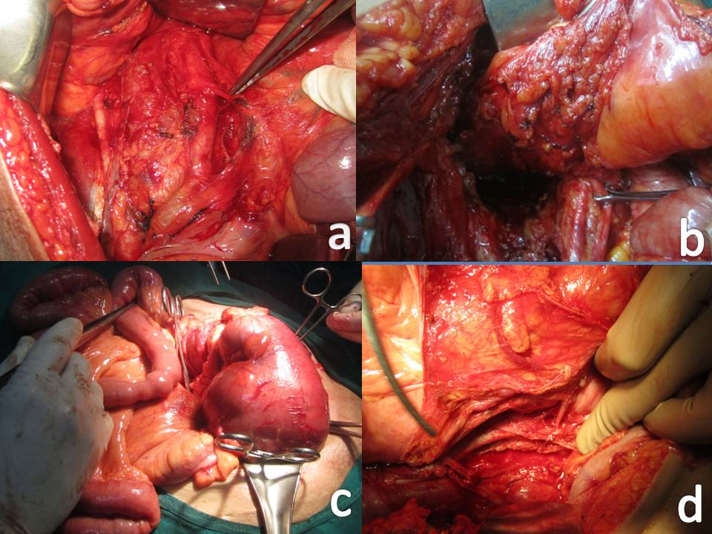

Figure (1) operative photos where (a) shows IMA 5 cmabove aortic Bifurcation, (b) shows total Mesorectal Excision, (c) shows Hartmann Resection in Intestinal Obstruction & (d) shows Left Colic Artery 3- 5 cm After IMA Emerges

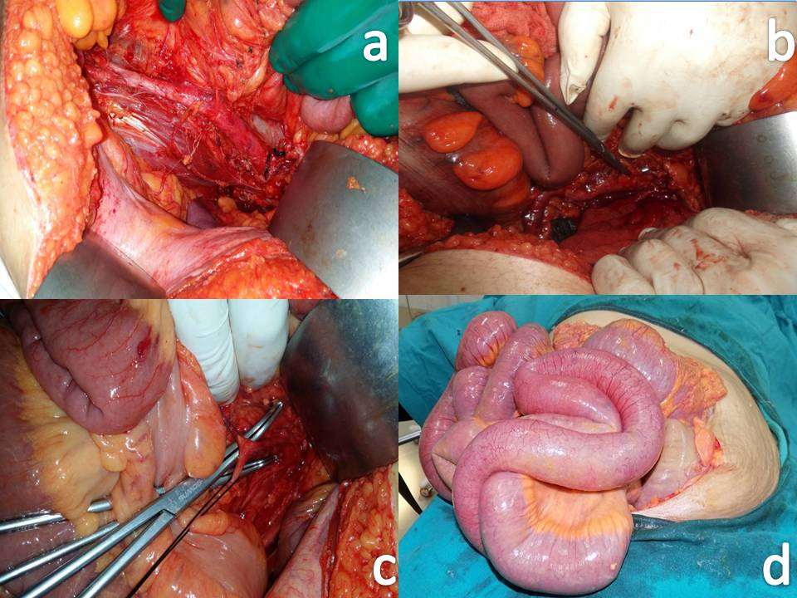

Figure (2) operative photos where (a) shows Hypogastric Autonomic nerves plexus, (b) shows High IMA Ligation,(c) shows Dumpy modification Low IMA ligation With root clearance& (d) shows intestinal obstruction secondary to advanced cancer rectum

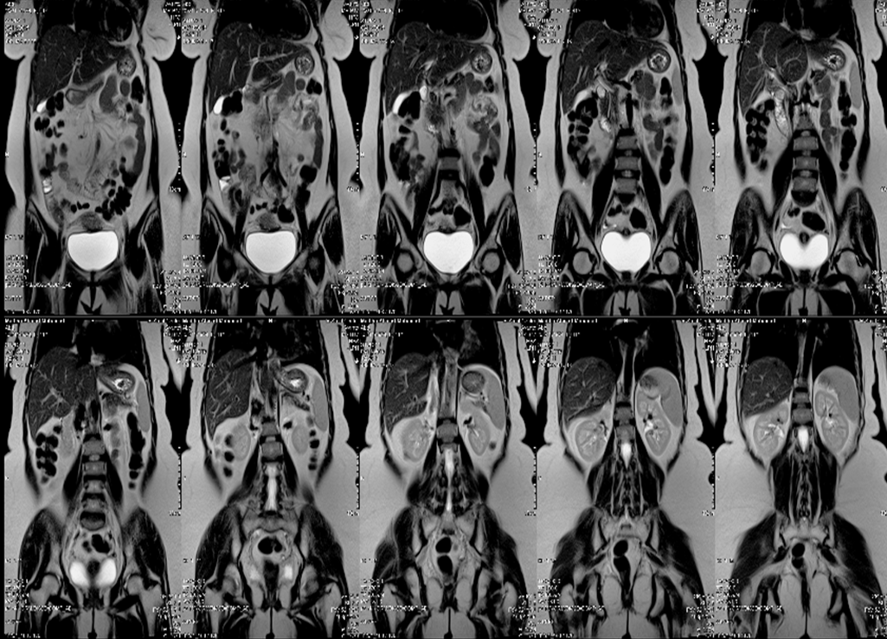

Figure (3): Coronal T2WI Abdomen an pelvis showing a case in a postoperative status with no residual masses or abdominal metastatic deposites.

Patients were followed-up every three months for the first two years in the postoperative period and every six months for up to five years thereafter. For the evaluation, a clinical examination, Carcino-embryonic Antigen (CEA) levels.

Surgical Techniques All patients underwent radical surgery for their primary rectal tumors according to the principles of total mesorectal excision. The IMA originated from the anterior surface of the abdominal aorta at the level about 5cm away from the bifurcation of abdominal aorta and ran ventrally and laterally into the sigmoid mesocolon. The surgical procedures of the preservation of the autonomic nerves in high ligation of the IMA Technical considerations outcomes of interest were length of the proximal limb, tension on the anastomosis, and anastomotic leakage. Adjuvant chemoradiotherapy was selectively provided for patients deemed on preoperative clinical or radiologic staging to have T3/T4 or N1/N2 disease.

After collecting all the data, 5-year survival, mean, mean lymph node harvest and the rate of complications were evaluated in both groups

Statistical methods employed in the study where all analyzed data were done using SPSS® (Statistical Package for Social Sciences) software version 21, IL, Chicago, USA. Numerical values were expressed as means or medians and standard deviation (SD) or range. Parametric and non- parametric t test compared means of 2 independent groups. Chi-square / Fisher exact test compared independent proportions. Survival was estimated using Kaplan Meier method and compared using Log rank test. P value is always 2 tailed and significant at 0.05.

**3. Results**

114 patient 69 males and 45 females(*p-* value 0.22).There was no significant statistical results among the patient characteristic or operative data as demonstrated in table(1).

Two patients had positive lymph nodes at the root of IMA, otherwise the recorded complications did not show significant statistical difference as in recorded in table (2)

Also No significant difference were recorded regarding the oncological outcome among the 2 groups of the study as demonstrated in table (3)

Table (1): operative data among study groups

|  |  |  |  |
| --- | --- | --- | --- |
|  | **Low tie group** | **high tie group** | *p***-value** |
| **Number of patients** | **76** | **38** | **0.22** |
| **Mean age (Years)** | **63** | **60** | **0.26** |
| **Operative data** |  |  |  |
| **Type of operation APR(Abdomenoperineal resection)** | **13.2%** | **19.7%** |  |
| **Hartmann’s** | **10.5%** | **9.2%** |  |
| **LAR(low anterior resection)** | **76.3%** | **71.1%** |  |
| **Mean operative time in minutes** | **170** | **186** |  |
| **Mean number of lymph node (range)** | **18**  **(8-33)** | **21**  **(9-36)** | **0.35** |
| **Positive lymph node** | **3**  **(1-5)** | **4**  **(1-9)** |  |
| **Length of specimen in cm** | **30** | **34** | **0.11** |

Table (2): complications among study groups

|  |  |  |  |
| --- | --- | --- | --- |
|  | **Low tie group** | **high tie group** | *p***-value** |
| **Patients with Defunctioning stoma (%)** | **20(26%)** | **9(24%)** |  |
| **Urinary dysfunction(%)** | **6(7.9%)** | **4(10.5%)** | **0.73** |
| **Sexual dysfunction(%)** | **8(10.5%)** | **5(13.2%)** | **0.76** |
| **GITdysfunction(%)** | **3(3.9%)** | **2(5.3%)** | **1.0** |
| **Wound infection (%)** | **3(3.9%)** | **2(5.3%)** | **1.0** |
| **Cardiopulmonary complications (%)** | **2(2.6%)** | **2(5.3%)** | **0.6** |
| **Anastomotic leakage** | **4(5.3%)** | **3(7.9%)** | **0.68** |

Table (3): oncological outcome among study groups

|  |  |  |  |
| --- | --- | --- | --- |
|  | **Low tie group** | **high tie group** | *p***-value** |
| **5 years overall survival** | **78.2%±2.7** | **79.7%±3.3** | **0.98** |
| **Five years recurrence survival(%)** | **9(11.8%)** | **4(10.5%)** |  |
| **Mortality** | **2(2.6%)** | **1(2.6%)** |  |



Figure (4): relation of survival to time to recurrence among study groups

**4. Discussion**

The debate regarding the level of ligation of the IMA dates back to the beginning of the twentieth century, when Moynian[10] recommended high ligation for sigmoid and rectum cancer. However, since the Oncological efficacy of high ligation of the IMA is not universally accepted,[7] greater incidence lymph node metastases in patients who are less

than 65 years old is due to the cancer presenting a more aggressive worse prognosis [7] in our study Mean age for LT group was 63 years and 60 years for High tie p value (0.26).

high ligation is considered to be technically more difficult and is a longer operation.[10] in our study the mean operation time was (170 minutes) for low group and 186 minutes for high tie (*p* =0.18).

The number of investigated lymph nodes is widely accepted as surrogate marker for the quality of the surgical resection. The number of at least 12 Lymph nodes has been established as a minimum for a sufficient evaluation more lymph nodes examined, the better postoperative staging is, which finally influences the patient’s prognosis.[12, 13] High ligation has an advantage over low ligation because of higher lymph node harvest.[10], no difference in the mean number of lymph nodes between high vs. low ligation of the IMA high ligation of the IMA is unnecessary to achieve a safe oncologic resection.[14] Lymphadenectomy extending to the origin of the inferior mesenteric artery even for low ligation provides data on the disease involvement of apical nodes.[14] The incidence of lymph node metastases at the origin of the IMA ranges from 1 to 5.5%.[7]

The high tie technique includes the apical group of lymph nodes at the root of IMA within the resection. However, the incidence of metastatic lymph nodes at the origin of IMA ranging from 0.3 to 8.6 percent. [4] Median number of lymph nodes harvested was 12.8 (range 6–93).[9] The number of harvested Lymph nodes is influenced by different factors. The surgical technique and the pathologist´s diligence of LN dissection are two of these. The immunological reaction to the tumor and the application of preoperative radiation therapy are another two. anatomic studies have revealed that as many as10 lymph nodes could be found between the origin of the left colic vessel and the origin of the IMA.[13, 15] In our study the mean number of lymph nodes harvested in the high tie group was 21 (range, 9–36); in the low tie group, 18 (range, 8–33) (p = 0.35). The mean number of positive lymph nodes harvested in the high tie group was 4 (1–9) in the low tie group, 3 (1-5) (*p* = 0.32). Two patients had positive lymph nodes at the root of IMA, one in the HT group (2.7%) and one in the LT group (1.3). P value = (0.43).

No evidence that high ligation confers an oncological advantage. Pezim[16] reporting no improvement in 5-year survival with proximal ligation. No reduction in local recurrence or metastases.[7, 17, 18] Pezim[16] for high ligation of the IMA (65.2% with low ligation versus 64.5% with high ligation).[7] Grinnel[19] curative stage-specific efficacy of high ligation, have been unable to demonstrate an benefit in patients with lymph node metastases.[7] no statistically significant impact on the 5-year survival rate as reported where a survival rate of 47% for low ligation as against 58.3% for high ligation. Grinnel[19] reports a 5.7% increase in the 5-year survival rate with high ligation of the IMA as compared to low ligation; but this difference is not statistically relevant.[7]

Our results comparable to that reported Five years overall survival in low IMA = 78.2±2.7% versus 79.7±3.3%, *p* value = 0.98 (NS) Five years recurrence free survival in low IMA = 86.2±4.0% versus 86.3±6.1%, *p* value = 0.82 (NS) Recurrence occur in 9 patients (11.8%) in low group, and 4 patients (10.5%) in high group *p* value = (1.0).

Anastomotic leakage is a frequently reported complication after rectal cancer surgery (2.5–26%) and is associated with high morbidity and mortality rates therefore tension-free anastomosis is crucial.[9] High ligation provides more proximal colon length thus ensuring better feasibility of anastomosis Anastomotic insufficiency caused by poor blood supply high ligation for elderly patients with possible atherosclerotic damage to middle colic or other arteries. Low ligation is favorable.[4, 6, 10, 20] In our study Anastomotic leakage occur in 4 patients (5.3%) in a low group and 3 patients (7.9%) in a high group *p* value (0.68).

In recent decades, many strategies aimed at lowering the incidence of anastomotic leakage. A protective stoma reduces the consequence of anastomotic failure, thereby preventing the numberof clinical leak.[9]. In our study. Nine patients (24%) in the high tie group and twenty patients (26%) in the low tie group received a defunctioning stoma.

Arterial ligation far from the hypogastric plexus could help in preserving pelvic autonomic functions, giving a better quality of life to patients. [14] With the improvement of oncologic results, the autonomic nerves preservation becomes more and more important for better postoperative quality of life in surgeries for colorectal cancer. Though the root of inferior mesenteric artery (IMA) is widely accepted as one of the crucial areas at risk of damage to the autonomic nerves, reliable surgical techniques of the autonomic nerves preservation in high ligation of the IMA has been vague for lacking of definite anatomical evidences. [1] Intraoperative damage of the SHP and HGNs may lead to the postoperative ejaculative and voiding disorders. Therefore, it is critically important to preserve the bilateral trunks of SHP in high ligation of the IMA.[1] high ligation of IMA would damage the sympathetic autonomic nerves.[21] and A car proposed that high ligation should be done 1-2cm distal from the origin of the IMA.[1, 4,22] damage to the inferior mesenteric plexus which forms a dense network around IMA is unavoidable in most cases with subsequent results on sympathetic nerve function (i.e., retrograde ejaculation and urinary incontinence).[9] Complication rates are also higher compared to low ligation.[7, 10] in our stud Urinary dysfunction occur 6 patients (7.9%) in low group and 4 patients (10.5%) in high group *p*value (0.73). Sexual Dysfunction occur in 8 patients (10.5%) in low group and 5 patients (13.2%) in a high group (0.76), Gastrointestinal (defecatory) dysfunction occur in 3 patients (3.9%) in low group, 2 patients (5.3%) in a high group *(p* value 1.0).

The 30-day mortality was 2%: The overall postoperative morbidity was 36% (36/100).(13) in our study Mortality occur in 2 patients (2.6%) in LT group, and in 1 patient (2.6%) in high group. CONCLUSIONS no significant difference in five-year survival rate operating time and other variables between the groups, both techniques give adequate oncological results low tie is anatomically less invasive with respect to circulation and autonomous innervation of the proximal limb of anastomosis. As a consequence, in rectal cancer surgery low tie with the fatty tissue and metastatic nodes at the root of the IMA are removed should be the preferred method.

Our study had several limitations. The number of patients in this study was small, which imposed limitations on statistical power. This was a retrospective analysis, which created the potential for selection bias. Further large, prospective investigations and long-term follow-up are required to evaluate the definite conclusions.

**References**

1. Yang X-F, Li G-X, Luo G-H, Zhong S-Z, Ding Z-H. New insights into autonomic nerve preservation in high ligation of the inferior mesenteric artery in laparoscopic surgery for colorectal cancer. Asian Pacific journal of cancer prevention: APJCP. 2013;15(6):2533-39.

2. Predescu D, Popa B, Gheorghe M, Predescu I, Jinescu G, Boeriu M, *et al.* The vascularization pattern of the colon and surgical decision in esophageal reconstruction with colon. A selective SMA and IMA arteriographic study. Chirurgia (Bucur). 2013;108(2):161-71.

3. Cirocchi R, Farinella E, Trastulli S, Desiderio J, Di Rocco G, Covarelli P, *et al.* High tie versus low tie of the inferior mesenteric artery: a protocol for a systematic review. World J Surg Oncol. 2011;9:147.

4. Lange MM, Buunen M, van de Velde CJ, Lange JF. Level of arterial ligation in rectal cancer surgery: low tie preferred over high tie. A review. Diseases of the colon & rectum. 2008;51(7):1139-45.

5. Lee JH, Jung SH, Kim HJ, Hwang JS, Kim JH, Shim MC. IMA-origin Lymph Node Metastasis in Left Colon Cancer. Journal of the Korean Society of Coloproctology. 2008;24(5):380-85.

6. Buunen M, Lange MM, Ditzel M, Kleinrensink G-J, Van de Velde CJ, Lange JF. Level of arterial ligation in total mesorectal excision (TME): an anatomical study. International journal of colorectal disease. 2009;24(11):1317-20.

7. Maschio A, Argenziano G, Pizza A, Sciascia V, Napolitano S, Santini L. Effects of high and low ligation on survival in patients operated for colorectal cancer. Chirurgia italiana. 2008;60(1):75-81.

8. Polistena A, Cavallaro G, D'Ermo G, Paliotta A, Crocetti D, Rosato L, *et al.* Clinical and surgical aspects of high and low ligation of inferior mesenteric artery in laparoscopic resection for advanced colorectal cancer in elderly patients. Minerva Chir. 2013;68:281-88.

9. Komen N, Slieker J, De Kort P, De Wilt J, Van der Harst E, Coene P-P, *et al.* High tie versus low tie in rectal surgery: comparison of anastomotic perfusion. International journal of colorectal disease. 2011;26(8):1075-78.

10. Vitkauskas V, Samalavičius NE, Vitkauskienė M. Five-year survival after sigmoid resection and low vascular ligation versus left hemicolectomy and high ligation for stage I–III sigmoid carcinoma: a retrospective study. Acta medica Lituanica. 2014;20(4).

11. Tsujinaka S, Kawamura Y, Tan K-Y, Mizokami K, Sasaki J, Maeda T, *et al.* Proximal bowel necrosis after high ligation of the inferior mesenteric artery in colorectal surgery. Scandinavian Journal of Surgery. 2012;101(1):21-25.

12. Vîlcea I, Vasile I, Mirea C, Meşina C, Enache S, Tenovici M. Sentinel lymph node study in colorectal cancer using serial sectioning and Hematoxylin-Eosin staining: importance and limitations. Rom J Morphol Embryol. 2011;52(1 Suppl):379-83.

13. Markl B, Schaller T, Krammer I, Cacchi C, Spatz H. Optimal lymph node harvest in neoadjuvantly treated colorectal cancer using methylene blue assisted lymph node dissection technique. NAJ Med Sci. 2013;6:51-56.

14. Mari G, Maggioni D, Costanzi A, Miranda A, Rigamonti L, Crippa J, *et al.* “High or low Inferior Mesenteric Artery ligation in Laparoscopic low Anterior Resection: study protocol for a randomized controlled trial” (HIGHLOW trial). Trials. 2015;16(1):21.

15. Märkl B, Rößle J, Arnholdt HM, Schaller T, Krammer I, Cacchi C, *et al.* The clinical significance of lymph node size in colon cancer. Modern Pathology. 2012;25(10):1413-22.

16. Pezim M, Nicholls R. Survival after high or low ligation of the inferior mesenteric artery during curative surgery for rectal cancer. Annals of surgery. 1984;200(6):729.

17. Kennedy R, Jenkins I, Finan PJ, Dehn T. Splenic flexure mobilisation for anterior resection performed for sigmoid and rectal cancer. Annals of The Royal College of Surgeons of England. 2008;90(8):638.

18. Al Asari S, Kim N. Robotic low ligation in rectal cancer: How we do it? OA Robot Surg. 2013;1(1):1-5.

19. Grinnell R. Results of ligation of inferior mesenteric artery at the aorta in resections of carcinoma of the descending and sigmoid colon and rectum. Surgery, gynecology & obstetrics. 1965;120:1031-36.

20. Trencheva K, Morrissey KP, Wells M, Mancuso CA, Lee SW, Sonoda T, *et al.* Identifying important predictors for anastomotic leak after colon and rectal resection: prospective study on 616 patients. Annals of surgery. 2013;257(1):108-13.

21. Höer J, Roegels A, Prescher A, Klosterhalfen B, Töns C, Schumpelick V. [Preserving autonomic nerves in rectal surgery. Results of surgical preparation on human cadavers with fixed pelvic sections]. Der Chirurg; Zeitschrift fur alle Gebiete der operativen Medizen. 2000;71(10):1222-29.

22. Açar HI, Kuzu MA. Important points for protection of the autonomic nerves during total mesorectal excision. Diseases of the Colon & Rectum. 2012;55(8):907-12.

12/12/2015