Environmental Risk Posed by Heavy Metal Concentration in the Tissue of Tympanotonus fuscatus from Calabar River, Nigeria.

George, Ubong Uwem.

¹Department of Zoology and Environmental Biology University of Calabar, Calabar, Cross River State, Nigeria.
*Corresponding author: talk2georgeubong@gmail.com

Abstract: Environmental pollution associated with heavy metal concentrations is an emerging issue in most developed and undeveloped countries. Calabar River has been reported to be open to several inputs from industrial activities within the environment. This research was therefore carried out to determine the heavy metal concentrations in tissues of Tympanotonus fuscatus within the following months (August, September and October, 2014). From the results it was found out that the mean concentration of heavy metal in month of August followed the trend: Zn>Cu>Fe>Cd>Pb>Cr, while in September: Fe>Cu>Zn>Pb>Cd>Cr and October trend was Fe>Cu>Zn>Pb>Cr>Cd. The high concentration of Zn (0.091 mg/l) in month of August can be attributed to dissolution of zinc from oil pipelines fixed across the water body by oil companies that are accumulated in tissues of T. fuscatus. Fe concentration was found to be higher as compared to other metals in month of September (0.073 mg/l) and October (0.075 mg/l) and can be traced to the use of iron coagulants or the corrosion of steel and cast iron pipes during the process of water distribution.
[George, U. U. Environmental Risk Posed by Heavy Metal Concentration in the Tissue of Tympanotonus fuscatus from Calabar River, Nigeria. Cancer Biology 2015;5(4):76-79]. (ISSN: 2150-1041). http://www.cancerbio.net. 9. doi:10.7537/marscbj050415.09.

Keywords: Environmental Risk, Heavy Metal, Concentration, Tissue, Tympanotonus fuscatus, Calabar River.

1. Introduction
Heavy metals pollution in the marine environment has deteriorate with years causing adverse effect on the marine ecosystem as observed in Calabar River, Nigeria. Heavy metals are known to be one of the severe pollutants in marine environment due to their high toxicity, persistence and bioaccumulation effects being detrimental to the environment (Pekey, 2006 and Nouri et al, 2006). Most of the heavy metals are present in seawater in trace concentrations, whereas excessive concentration can affect marine biota and pose risk to consumers of sea food (Turner, 1996).
Benthic macro-invertebrate assemblages and distribution frequently change in response to heavy metal pollution in predictable ways, thus their importance as biological criteria for evaluation of anthropogenic influences of aquatic ecosystem. Several marine organisms for examples periwinkles have the capacity to absorbed, bio-magnify and bioaccumulate contaminants like heavy metals, organics, polycyclic aromatic hydrocarbons and PCB in the environment. The accumulation of these contaminants may affect not only the productivity and reproductive capabilities of these organisms, but will invariably have adverse health effect on humans that feed on these marine organisms as a major source of protein (Davies et al, 2006). The periwinkle Tympanotonus fuscatus, is a mollusk of high economic value in Calabar River. It is known to be a good deposit feeder and bio-indicator of most heavy metals and hydrocarbon pollutions in the marine environment. Thus it is of vital importance that this study is conducted to ascertain the level of metal concentrations in the tissues of T. fuscatus commercial species (Biney, 1991; Okoye, 1991) and determine potentially hazardous levels which will affect human. It is on the basis of this that the present study examines the levels of accumulation of Zn, Fe, Cu, Cr, Pb and Cd in tissues of T. fuscatus in Calabar River.

2.0 Materials and methods
2.1. Study Area
The present study area is located in Cross River System, which lies geographically between latitude 04°30’13''N and longitude 08°30’06''E; and latitude 04°32’40''N and longitude 08°28’40''E, South Eastern Nigeria (Akpan, 2002) as shown in Fig 1. The river encloses Esuk Nsidung Calabar south Adiabo Bridge in Odukpani Local Government Areas. According to Etim and Enyenihi (1991) Calabar River is known to be the major tributary of the Cross River which originates from Oban hills Nigeria and flows through black shale and siltstone, clay, sand and silts deposits, before emptying into the estuary at Alligator Island. The approximate estimated area of Calabar River is 54,000 square kilometers and stretches about 25km to the south of the river. The Calabar River is hydro-dynamically homogenous. Dissolved particulate materials in-situ are transported by surface current from the estuary into Creeks and upper reaches of Calabar River within the commercial area of Esuk Nsidung to Adiabo-Bridge head during semi diurnal tide (Asuquo et al., 1999). The river is a major sink for toxic substances and undesirable materials through agricultural, industrial, and municipal discharges (Fig. 1).

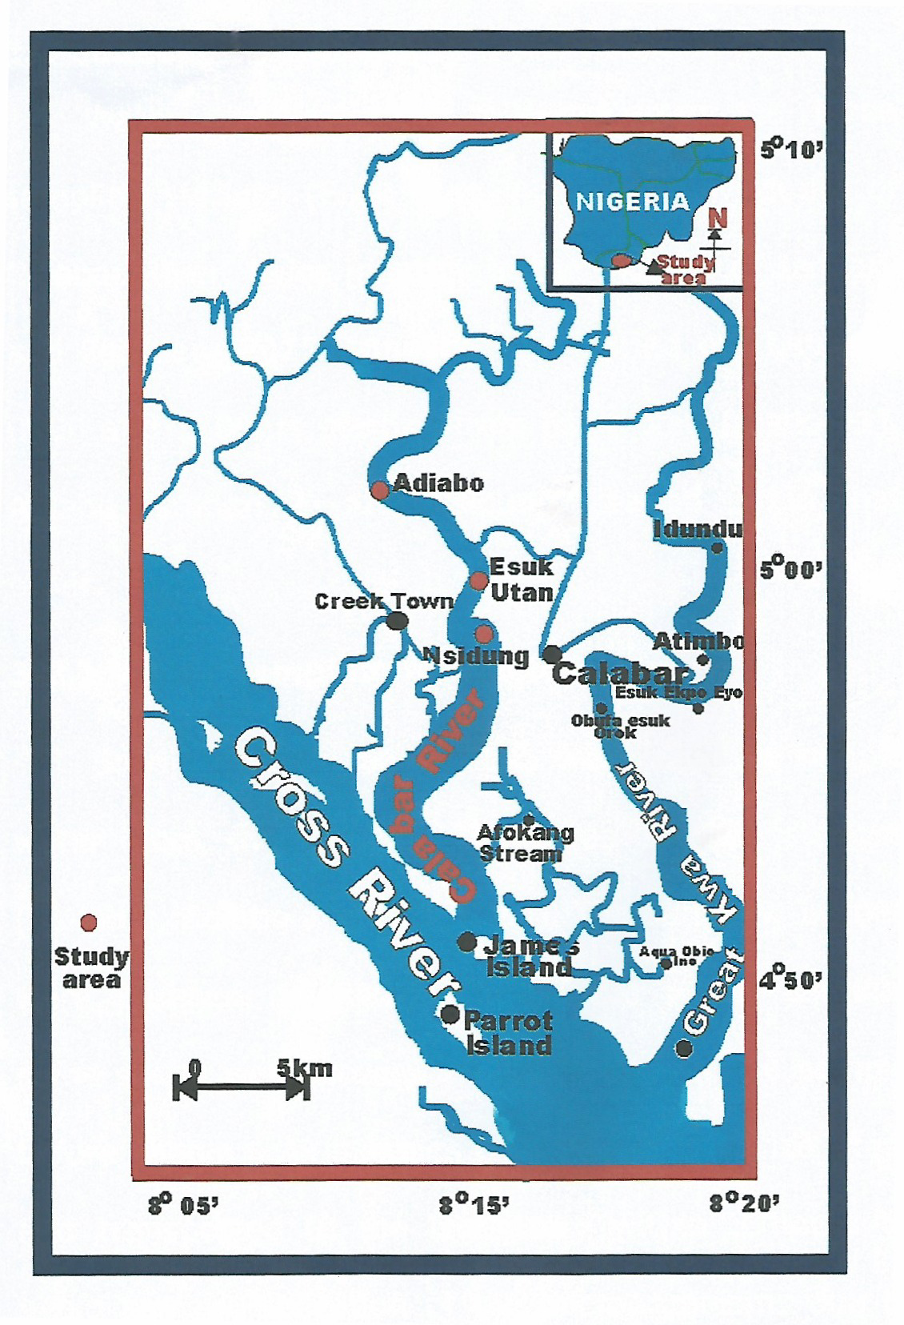
Fig. 1: Map of the Study Area

2.2. Sample collection
Tympanotonus fuscatus was purchased from landings of artisanal fishermen at Esuk Nsidung beach, Esuk utan and Adiabo-Bridge head from August to September 2014. The samples were placed immediately in poly-ethylene bags, put into isolated container of polystyrene icebox and then brought to the Ministry of Science and Technology, Uyo for further analysis.
2.3. Digestion and analytical procedures
Prior to analysis, the tissue was thawed and Four grams of the homogenized tissues from T. fuscatus were taken from each specimen and placed in 300 ml kjldahl digestion tubes. A digestion composition containing 6.0 ml of high purity nitric acid (Merck), 2 ml of hydrochloric acid (10 M) and 4 ml of hydrogen peroxide (35%) (Manutsewee et al., 2007) was added to each tube. Further analyses of heavy metal concentrations on digested samples (Fe, Cd, Cu, Pb, Zn and Cr) were carried out using Shimadzu Atomic Absorption Spectrophotometer (AAS) - AA 6300.

2.4. Data analysis
The Mean concentrations of heavy metals ± S.E.M. (the standard error of the mean) in l g/g wet weight were calculated and recorded. One- way analysis of variance (ANOVA) was used after the logarithmic transformation was done on the data to improve normality thereafter proceeded by Duncan multiple range test as multiple comparison procedure to ascertain whether the means of metal concentrations varied significantly among the sample tissues. Possibilities less than 0.05 were considered statistically significant (P <0.05) (Kamal et al., 2013). Statistical analysis was powered using (Minitab, Version 170).

3.0 Results and Discussion
3.1. Concentration of Heavy Metals in the tissue of Tympanotonus fuscatus from Calabar River (August, 2014). .
The heavy metal concentrations of Fe, Cd, Cu, Pb, Zn and Cr in the tissues of the analyzed Tympanotonus fuscatus species are presented in Table 1 for the month of August by mean values, standard errors and other calculated parameters. All results are expressed as mg/l. From the results vast variations were observed among the heavy metal concentrations in the tissues of T. fuscatus species. In the month of August Zn was observed to be the highest in the tissue of T. fuscatus and the lowest were Pb and Cd while Cr was not detected. This follows the trend: Zn>Cu >Fe >Cd>Pb>Cr. The high concentration of Zinc in the tissues of T. fuscatus can be attributed to dissolution of zinc from oil pipelines fixed across the water body by oil companies. Similar trend was reported in (WHO, 1993).
3. 2. Concentration of Heavy Metals in the tissue of Tympanotonus fuscatus from Calabar River (September, 2014).
As seen in Table 2, the concentration of heavy metal in the tissues of the analyzed Tympanotonus fuscatus followed the trend: Fe>Cu>Zn>Pb>Cd>Cr. Cd and Cr were not detected. Other calculated parameters are also shown in the table. Fe concentration was observed to be higher in the tissue of T. fuscatus as compared to other metal concentrations in the study species. WHO, 1993 postulated that Fe is one of the most abundant metals in the earth's crust, found in natural fresh waters at levels ranging from 0.5 to 50 mg/l. Fe present in water may be as a result of the use of iron coagulants or the corrosion of steel and cast iron pipes during the process of water distribution. Iron is an essential element in human nutrition. Estimates of the minimum daily requirement for iron depend on age, sex, physiological status, and iron bioavailability and range from about 10 to 50 mg/day (WHO, 1993).

Table1. Parameter results calculated for Heavy metal concentration in tissue of T. fuscatus (August, 2014)
Metals | Mean | Standard Error  of mean | Standard  Deviation | Coefficient  Of Variation | Minimum | Maximum
Fe | 0.039 | 0.0003 | 0.0006 | 1.49 | 0.038 | 0.039
Cd | 0.009 | 0.0003 | 0.0006 | 6.66 | 0.008 | 0.009
Cu | 0.040 | 0.0003 | 0.0006 | 1.46 | 0.039 | 0.040
Pb | 0.007 | 0.0010 | 0.0017 | 24.7 | 0.005 | 0.008
Zn | 0.091 | 0.0006 | 0.0010 | 1.10 | 0.090 | 0.092
Cr | ND | ND | ND | ND | ND | ND
ND- Not detected

Table 2: Parameter results calculated for Heavy metal concentration in tissue of T. fuscatus (September, 2014)
Metals | Mean | Standard Error  of mean | Standard  Deviation | Coefficient  Of Variation | Minimum | Maximum
Fe | 0.073 | 0.0009 | 0.0015 | 2.08 | 0.072 | 0.0750
Cd | ND | ND | ND | ND | ND | ND
Cu | 0.061 | 0.0012 | 0.0020 | 3.28 | 0.059 | 0.0630
Pb | 0.005 | 0.0012 | 0.0020 | 40.00 | 0.003 | 0.0070
Zn | 0.017 | 0.0007 | 0.0012 | 6.66 | 0.016 | 0.0180
Cr | ND | ND | ND | ND | ND | ND
ND- Not detected

3.3. Concentration of Heavy Metals in the tissue of Tympanotonus fuscatus (October, 2014) from Calabar River
This observation is similar to result obtained during the month of September, 2014 as shown in Table 3. Fe concentration was higher with mean value of 0.075, Cr was not detected. This attribute of Fe being the highest is as a result of the use of iron coagulants or the corrosion of steel and cast iron pipes during the process of water distribution (WHO, 1993). In October Fe concentration was also observed to be higher as compared to other metal concentrations in the study species. This follows the trend Fe>Cu>Zn>Pb>Cr>Cd. Cd and Cr were not detected. Figure 2 shows the summary of the mean variation in the concentrations of heavy metal observed in the tissue of T. fuscatus during the study duration (August – October, 2014).

4.0 Conclusion
The present study investigated heavy metals in tissues of periwinkles (Tympanotonus fuscatus) in Calabar River with the highest heavy metals presence noted in the soft tissue for Zn (0.091 mg/l) in the month of August, and Fe had concentration of 0.073 mg/l in the month of September and 0.075 mg/l in the month of October. For the month of August Cr was not detected while in the month of October Cd and Cr were also not detected. To reduce the concentration of this heavy metal in tissues of T. fuscatus stringent measures should be applied to help curtail discharge of waste into the water body by industries operating around the environment.

Table3: Parameter results calculated for Heavy metal concentration in tissue of T.fuscatus (October, 2014)
Metals | Mean | Standard Error  of mean | Standard  Deviation | Coefficient  Of Variation | Minimum | Maximum
Fe | 0.075 | 0.0006 | 0.0010 | 1.33 | 0.074 | 0.076
Cd | ND | ND | ND | ND | ND | ND
Cu | 0.072 | 0.0009 | 0.0015 | 2.13 | 0.070 | 0.073
Pb | 0.016 | 0.0006 | 0.0010 | 6.25 | 0.015 | 0.017
Zn | 0.037 | 0.0006 | 0.0010 | 2.70 | 0.036 | 0.038
Cr | ND | ND | ND | ND | ND | ND
ND- Not detected

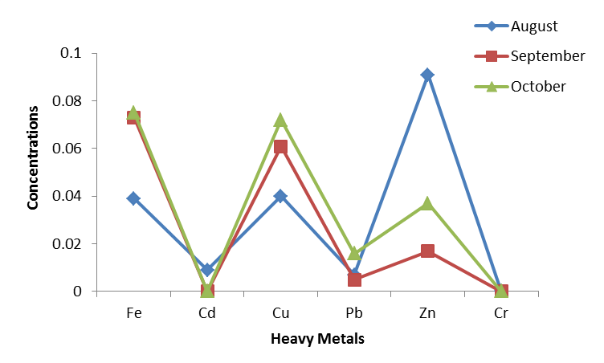
Fig 2: Summary of the Mean Variation of heavy Metal in the Tissue of T. fuscatus during the study duration (August – October, 2014).

References
- Akpan, E. R (2002). Heavy Metal trends in The Calabar River, Nigeria. Environ. Geol.,42: 47-51.
- Asuquo, F. E., Ogri, O. R. and Bassey, E. S. (1999) Distribution of heavy metals and total hydrocarbons in coastal waters and sediments of Cross River, South-eastern Nigeria. International Journal of Tropical Environment, 1 (2): 1 – 19.
- Biney C. A. (1991). The distribution of trace heavy metals in the kpong Headpond and lower Volta River Ghana. In perspectives in aquatic entomology (N. K. K. Shastree, ed) Marendre publishing House,Delhi, India.
- Davies O. A., Allison M. E. and Uyi, H. S. (2006). Bioaccumulation of heavy metals in water, sediment and periwinkle (Tympanotonus fuscatus var radula) from the Elechi Creek, Niger Delta. African Journal of Biotechnology. 5(10): 968-973.
- Etim, L. and Enyenihi, U.K. (1991) Annual cycle of condition and flood season spawning in Galatea Paradoxa (Born, 1977) from the Cross River, Nigeria. Tropical Freshwater Biology, 2: 243 – 248.
- Kamal J. Elnabris., Shareef K. Muzyed and Nizam M. El-Ashgar (2013). Heavy metal concentrations in some commercially important fishes and their contribution to heavy metals exposure in Palestinian people of Gaza Strip (Palestine). Journal of the Association of Arab Universities for Basic and Applied Sciences.13: 44-51.
- Manutsewee, N., Aeungmaitrepirom, W., Varanusupakul, P., Imyim, A., (2007). Determination of Cd, Cu, and Zn in fish and mussel by AAS after ultrasound-assisted acid leaching extraction. Food Chem. 101: 817–824.
- Nouri, J., Mahvi, A. H., Babaei, A., and Ahmadpour, E. (2006). Regional pattern distribution of groundwater fluoride in the Shush aquifer of Khuzestan County Iran. Fluoride, 39(4): 321–325.
- Okoye, BCO (1991). Heavy metals and organisms in the Lagos Lagoon, surface waters. Int. J. Environ. Stud., 38: 131-141.
- Pekey, H. (2006). The distribution and sources of heavy metals in Izmit Bay surface sediments affected by a polluted stream. Marine Pollution Bulletin, 52 (10): 1197 – 1208.
- Turner, A., 1996, Trace metals portioning in estuaries importance of salinity and particulate concentration. Marine Chemistry, 54: 27 – 39.
- W.H.O. (World Health Organization) (1993): Guidelines for Drinking Water Quality- Second Edition- Vol.1, Recommendations. WHO, Geneva. Pp. 39.

12/12/2015

