**Cyclophosphamide with Adjuvant Chemotherapeutic Drugs Induces Epigenetic Changes in Hepatocellular Carcinoma Cells**

Hussein Sabit1*, Arwa S. Abdel-Sattar1, Shimaa E. Abdel-Ghany2, Asmaa M. Abushady3, Osama A. M. Said1

1 College of Biotechnology, Misr University for Science and Technology, Giza, Egypt,

2 Research and Development Center, Misr University for Science and Technology, Giza, Egypt,

3 Department of Genetics, Fac. Agric., Ain Shams University, Cairo Egypt.

* Corresponding author: mailto: [hussein.sabit@must.edu.eg](mailto:hussein.sabit@must.edu.eg).

**Abstract**: Cancer remains the major health threat worldwide; therefore, the extensive search for potent cancer-controlling agents are still a big demand. Hepatocellular carcinoma (HCC) is a type of cancer widespread in the developing countries. In the present study, the role of Cyclophosphamide and drug combinations (including Erlotinib, Temozolomide, Vorinostat, and Sodium Phenylbutyrate) as DNA methyltransferase (DNMT) and Histone deacetylase (HDAC) inhibitors was evaluated. Two concentrations of each drug *i.e*., 3µM and 5µM for one incubation period of 72 h were applied. Trypan blue test was used to count the number of viable cells before and after treatments. DNA degradation assay was employed to evaluate the effect of Cyclophosphamide and a combination of drugs on the integrity of genomic DNA. Global methylation was also quantified *via* measuring the concentration of 5-Methylcytidin in the treated and un-treated HCC cells. Data obtained indicated that treating HCC cells with Cyclophosphamide either alone or in combination with other drugs has resulted in a significant decrease in the number of viable cells. Meanwhile, global DNA methylation data analysis showed that three combinations have resulted in hypomethylating the whole genome of HCC cells (Cyclophosphamide with Erlotinib, Cyclophosphamide with Sodium Phenylbutyrate, and Cyclophosphamide with Vorinostat). Although *in vitro* data need to be tested on the pre-clinical level, the best combination, Cyclophosphamide combined with Sodium Phenylbutyrate, might be recommended to be used in treating HCC *in vivo*.

[Hussein Sabit, Arwa S. Abdel-Sattar, Shimaa E. Abdel-Ghany, Asmaa M. Abushady and Osama A. M. Said. **Cyclophosphamide with Adjuvant Chemotherapeutic Drugs Induces Epigenetic Changes in Hepatocellular Carcinoma Cells.** *Cancer Biology* 2015;5(4):26-34]. (ISSN:2150-1041). <http://www.cancerbio.net>. 5. doi:[10.7537/marscbj050415.05](http://www.dx.doi.org/10.7537/marscbj050415.05).

**Keywords:** Hepatocellular carcinoma, HCC, Epigenetics, chemotherapeutic drugs.

**1. Introduction**

Cancer is a complicated disease that shows itself in various forms, all these forms were marked by the same uncontrolled proliferation of cells (Allen and Chen, 2013). Hepatocellular carcinoma (HCC) is viewed as the main reason for death worldwide in men and women with around 6% of all new cancer cases diagnosed around the world (Buonaguro *et al.,* 2013).

Tumors appear when mutations accumulate within cells and eventually prompt uncontrolled cell growth. These changes can be brought on by external factors, for example, hepatitis infection, or by internal factors, such as hypermethylation of tumor-silencing genes (Diederich *et al.,* 2014). HCC is an aggressive disorder with a high rate of mortality and morbidity (Anestopoulos *et al.,* 2015). If identified in the symptomatic stage, the patient has an untreated mean life expectancy of less than one month; even at this stage, the accessible medicines are constrained and ineffective (Lu *et al.,* 2014).

DNA methylation plays an important role in many biological events and is associated with various diseases (Liu *et al*., 2015). Several factors may directly or indirectly regulate the dynamic distribution of DNA methylation and demethylation between intergenic and intragenic gene regions, which means that thereby controlling gene expression (Jiang *et al.,* 2013). DNA methylation played a critical part in numerous biological events and is connected with different diseases (Liu *et al.,* 2015), and have an essential role in the regulation of gene expression, as it is the first epigenetic change to occur on a given DNA strand (Mathiyalagan *et al.,* 2014, Lopez-Ramirez and Nicoli, 2014).

CpG islands have direct ramifications for the understanding of DNA methylation patterns in typical conditions (Tao *et al.,* 2014) and in some normal illness states (Stefansson *et al.,* 2015), including cancer CpG island shores (Rhee *et al.,* 2013) and first exons (Rao *et al.,* 2013) is known to play crucial part in the gene expression patterns in all human malignancies.

DNA hypermethylation is characterized by hyperactivity of the DNA methyltransferase enzymes, over expression of DNMT3b, and concurrent methylation-dependent silencing of various epigenetic biomarker genes (Roll *et al.,* 2013). The methylation of promoter DNA sequences suppresses the binding of several transcription-related proteins (Paonessa *et al*., 2013). The methyl groups project into the major groove of DNA; through the direct interference of the binding of speciﬁc transcription factors that have methylated CpG(s) within their response elements (Hagiwara *et al.,* 2012; Haerter *et al*., 2014).

Cyclophosphamide (CP), works as an alkylating chemotherapeutic drug and is used in cancer therapy (Mittal *et al.,* 2014), by activating a robust innate anti-tumor immunity (Waxman and Wu, 2014). Although the advances of traditional therapies, such as surgery, transplantation, and use of radiotherapy, the prognosis of HCC neoplasm has not considerably improved over the past few years (Giordano and Columbano, 2014). Recent randomized clinical trials (RCTs) have demonstrated survival benefits for combination therapy (Gresham *et al.,* 2014). In addition, the study of epigenetic mechanisms of gene regulation offers a novel approach for innovative diagnosis and treatment of different types of cancer (Cock-Rada and Weitzman, 2013). However, the aim of the present study is to test the role of cyclophosphamide combined with different chemotherapeutic drugs in changing the genome-wide methylating profile in HCC cells.

**2. Materials and Methods**

**Cell line maintenance**

Hepatocellular carcinoma cell line (HepG2) was purchased from the Holding Company for Vaccines and Biological Products (VACSERA), Cairo, Egypt. The cells were maintained in RPMI 1640 media supplemented with 10% Fetal Bovine Serum (FBS) and 1% antibiotic mix. Cells were grown in humidified conditions with 5% CO2 at 37°C.

**Cell viability test**

Prior subjecting the cells to any treatment, Trypan blue test was performed to assess the number of viable cells. Briefly, 100 µL of cell suspension was mixed with 100 µL of trypan blue and the mix was applied to the haemocytometer slide and then measured under inverted microscope. Trypan blue was also performed after applying the chemotherapeutic drugs.

**Chemotherapeutic drugs**

Cyclophosphamide, Erlotinib, Sodium Phenylbutyrate, Vorinostat, and Temozolomide were purchased from Santa Cruz Biotech. (USA). A stock of both 3µM and 5µM of each drug was prepared and used for the treatment of the HCC cells.

**Drug application**

Five different drugs/drug combinations were applied. In a 12-well tissue culture plate, 1 x 106 cells/well was inoculated and left for 24 h before applying the drug/drug combinations. Combinations were mixed separately and added to the wells containing the HCC according to the design represented in Table (1).

**Table (1): The combination and the concentrations used in the present study.**

|  |  |  |  |  |  |  |  |  |  |  |  |  |
| --- | --- | --- | --- | --- | --- | --- | --- | --- | --- | --- | --- | --- |
| |  |  |  |  | | --- | --- | --- | --- | | C | CY (3µM) | CY +S (3µM ) | CY +E (3µM) | | CY +V (3µM) | CY +T (3µM) | CY (5µM) | CY +S (5µM) | | CY +E (5µM) | CY +V (5µM) | CY +T (5µM) | C | |

*C: Control, Cy: Cyclophosphamide, S: Sodium Phenylbutyrate, E: Erlotinib, V: Vorinostat, and T: Temozolomide.*

**DNA extraction**

Genomic DNA was extracted from treated and non-treated cells for the downstream analysis *i.e*., DNA degradation assay and methylation quantification in the malignant cells after being treated with the drugs. Extraction was done using Cell Biolab DNA extraction kit (USA) according to the kit’s instructions.

**DNA degradation assay**

After being extracted, a suitable volume of the eluted DNA was migrated on a 1.4% agarose gel. Gels were subjected to 5 V for 5 minutes and then to 120 V for about 30 min. Gels were photographed after being stained with Ethidium Bromide.

**Quantification of whole genome methylation**

Global methylation in the treated and un-treated cells was measured using MethylFlash quantification kit (Cell Biolabs, USA) with minor modifications. Briefly, the extracted genomic DNA was applied to the assay wells. Wells were washed and the capture antibody was added, and the chromatin was enzymatically sheared to allow the antibody to bind to the assay wells. The antibody was immunoprecipitated. The flouro assay solution was added after washing and then the signals were measured immediately at 580 nm using plate reader. A standard curve was generated to calculate the concentrations of 5-Methylcytidin in the treated and untreated samples (Figure 1).

**Statistical analysis**

Statistical analyses were conducted by SAS 9 software (SAS Institute, Cary, NC). The analysis was performed according to the following model:

yijk= µ+ai+bij+eijk

Where µ is the population mean, ai is the effect of each of the five different drugs/drug combinations and bij is the effect of the concentration within each treatment. The criterion for significance was set at *p*< 0.01 for all tests.

**3. Results and Discussion**

**Cell viability after treatment**

Trypan blue test was performed to measure the number of viable cells after being treated with the drug/drug combinations (Wang *et al.,* 2012). Figure (2) shows the differences in the number of viable cells between treated and untreated cells. The obtained data indicated that all of the treatments resulted in a significant decrease in the number of viable cells compared to the control (Table 2). It was shown elsewhere (Vives *et al.,* 2013; Kayal *et al.,* 2015; Mondi *et al.,* 2015) that the combined treatment of the malignant cells might result in prolonged effect and also in higher efficiency in terms of enforcing malignant cell to commit apoptosis. Our data indicated that out of the combined chemotherapeutics, Cyclophosphamide and Erlotinib (3µM), was the most efficient combination followed by Cyclophosphamide and Sodium Phenylbutyrate (5µM). Meanwhile, Cyclophosphamide alone (5µM) was more efficient in inducing apoptosis compared to its lower concentration (3µM). Data obtained indicated that not all the combinations had the same profile, as the HCC cells might undergo specific internal changes, which is combination- or dose-mediated (Morris *et al.,* 2013; de la Torre *et al.,* 2015). The obtained profile could be attributed to the fact that Cyclophosphamide, as DNMT inhibitor, perform its function by attenuating and/or inhibiting the enzymatic activity of DNMTs, and subsequently hypomethylate the HCC-related tumor suppressor gene, which led eventually to enforce the malignant cells to commit apoptosis (Bassiouny *et al.,* 2010; Zheng *et al.,* 2010). On the other hand, Erlotinib, as HDAC inhibitor, helps the maintenance of a specific level of acetylation in the promotor region of the HCC-related tumor suppressor genes. This mechanism has led to euchromatinize the promotor region and hence to accumulate the product of these genes, which in turn enforce the cells to commit apoptosis (Lai *et al.,* 2005; Choudhari *et al.,* 2007).

**Table (2): The mean values of Duncan's Multiple Range Test for cell viability of control and treated cells.**

|  |  |  |  |  |  |  |  |  |  |  |  |  |  |  |  |  |  |  |  |  |  |  |  |  |  |  |  |  |  |  |  |  |  |  |  |  |  |  |  |  |  |  |  |  |  |  |  |  |
| --- | --- | --- | --- | --- | --- | --- | --- | --- | --- | --- | --- | --- | --- | --- | --- | --- | --- | --- | --- | --- | --- | --- | --- | --- | --- | --- | --- | --- | --- | --- | --- | --- | --- | --- | --- | --- | --- | --- | --- | --- | --- | --- | --- | --- | --- | --- | --- | --- |
| |  |  |  |  | | --- | --- | --- | --- | | **Duncan Grouping** | **Mean** | **N** | **Treat./ Conc.** | | A | 387500 | 4 | C | | B | 264375 | 4 | CY+E (C2) | | C | 212500 | 4 | CY+S (C1) | | D | 187500 | 4 | CY+T (C2) | | D | 175000 | 4 | CY+T (C1) | | D | 175000 | 4 | CY (C1) | | D | 175000 | 4 | CY+V (C1) | | E | 137500 | 4 | CY+V (C2) | | E F | 125000 | 4 | CY (C2) | | G F | 112500 | 4 | CY+S (C2) | | G | 100000 | 4 | CY+E (C1) | |

*C: control, C1: concentration 3µM, C2: concentration 5µM, CY: Cyclophosphamide, S: Sodium Phenylbutyrate, T: Temozolomide, V: Vorinostst,and E; Erlotinib.*

**DNA degradation assay**

DNA fragmentation is considered a powerful tool to identify the effect of treating cell lines with chemotherapeutic drugs (Muller *et al*., 2010). The extracted genomic DNA was subjected to electrophoresis to assess the degradation of DNA due to the treatments. Figure (3) shows the smears of degraded DNA in different treatments.

As shown in Figure (3), all treatments have resulted in a severe degradation of the genomic DNA content of the cells. This DNA fragmentation might be due to the inactivation of caspase-associated DNase inhibitor (CADi) (Yuste *et al.,* 2005; Yan *et al.,* 2009), which releases the CAD to degrade DNA, or, on the other hand, via suppressing DNA repair mechanisms (Groselj *et al.,* 2013). Cyclophosphamide and other drugs might be involved in this mechanism (Sarder *et al.,* 2015). Data obtained showed that the combination of Cyclophosphamide with Erlotinib was very efficient in inducing DNA fragmentation. In addition, the combination of Cyclophosphamide and Vorinostat resulted in an obvious smear.

**Quantification of Global DNA methylation**

In the present study, the global methylation level in all treated and untreated HCC cells was evaluated. In this assay, 5-Methylcytidin concentration was measured as indicator for the occurrence of hypo/hypermethylation as a result of the treatments. The obtained data (Figure 4 and Table 3) showed that the HCC responded differently to the dose and combination of the applied chemotherapeutic drugs. As shown in Figure (4), the combination of Cyclophosphamide with Sodium Phenylbutyrate (3µM) has resulted in a significant hypomethylation, while using the same combination in a higher concentration (5µM) resulted in a significant hypermethylation (*P*< 0.01). The same profile was obtained when Cyclophosphamide combined with Erlotinib and Vorinostat was used, where the lower concentration (3µM) have led to hypomethylate the whole genome of HCC cells and the higher concentration (5µM) have oppositely hypermethylated the cell’s genome. This might be attributed to the synergetic action of Sodium Phenylbutyrate when combined with Cyclophosphamide. Several studies (Phillips and Griffin 2007; Iannitti and Palmieri, 2011; Gresham *et al.,* 2014) have indicated the same profile. Furthermore, seven drug/drug combinations have resulted in moderate to severe hypermethylation. One of the most effective drug combinations that activated the DNMT was the combination of Cyclophosphamide and Sodium Phenylbutyrate (5µM). This was concluded from the numbers of viable cells generated in the present study. The hypermethylation status profiled in the HCC cells might has been occurring in some anti-apoptotic gene, and this could enforce the cells to commit apoptosis (Hervouet *et al.,* 2010; Stone *et al.,* 2013).

**Table (3): Mean values of Duncan's Multiple Range Test for quantification of global DNA methylation.**

|  |  |  |  |  |  |  |  |  |  |  |  |  |  |  |  |  |  |  |  |  |  |  |  |  |  |  |  |  |  |  |  |  |  |  |  |  |  |  |  |  |  |  |  |  |  |  |  |  |
| --- | --- | --- | --- | --- | --- | --- | --- | --- | --- | --- | --- | --- | --- | --- | --- | --- | --- | --- | --- | --- | --- | --- | --- | --- | --- | --- | --- | --- | --- | --- | --- | --- | --- | --- | --- | --- | --- | --- | --- | --- | --- | --- | --- | --- | --- | --- | --- | --- |
| |  |  |  |  | | --- | --- | --- | --- | | **Duncan Grouping** | **Mean** | **N** | **Treat./ Conc.** | | A | 26536 | 4 | CY+S (C2) | | B | 17479 | 4 | CY+V (C2) | | C | 14401 | 4 | CY (C1) | | D | 11974 | 4 | CY+T (C2) | | E | 8067 | 4 | CY+T (C1) | | E | 7949 | 4 | CY (C2) | | F | 5521 | 4 | CY+E (C2) | | F | 4693 | 4 | C | | G | 4515 | 4 | CY+V (C1) | | H | 3254 | 4 | CY+E (C1) | | I | -2469 | 4 | CY+S (C1) | |

*C: control, C1: concentration 3µM, C2: concentration 5µM, CY: Cyclophosphamide, S: Sodium Phenylbutyrate, T: Temozolomide, V: Vorinostst,and E; Erlotinib.*

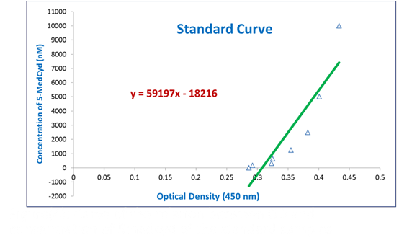

**Figure (1): A standard curve of the relationship between OD and concentration of 5-Methylcitidine.**

|  |
| --- |
|  |

**Figure (2): The differences in the number of viable cells between treated and untreated cells. C: Control, Cy: Cyclophosphamide, S: Sodium Phenylbutyrate, E: Erlotinib, V: Vorinostat, and T: Temozolomide. I: concentration of 3µM and II: concentration of 5µM.**

|  |
| --- |
|  |

**Figure (3): DNA degradation assay. C: Control, Cy: Cyclophosphamide, E: Erlotinib, T: Temozolomide, S: Sodium Phenylbutyrate, and V: Vorinostat.**



**Figure (4): Levels of 5-Methylcytidin in nM after treating HCC cells with different drugs. C: Control, Cy: Cyclophosphamide, S: Sodium Phenylbutyrate, E: Erlotinib, and T: Temozolomide. I: concentration of 3µM and II: concentration of 5µM.**

Data could also be viewed in a dose-wise perspective to elucidate the effect of the drug dose on the HCC cell proliferation (Figure 5). Meanwhile, the presented data indicated that applying Cyclophosphamide in lower concentration (3µM) resulted in hypermethylation of the whole genome of the hepatocellular carcinoma cells (Figure 6). The higher concentration of the same drug (5µM) yielded a lower methylation rate, despite being higher than the control. When combined with Sodium Phenylbutyrate in lower concentration (3µM), cyclophosphamide induced a severe hypomethylation, while when the same combination was applied in higher concentration (5µM), it induced severe hypermethylation.

This might indicate that the combination should be used in lower concentration (Greten *et al.,* 2010; Reguart *et al.,* 2014). In addition, when Cyclophosphamide was applied combined with Erlotinib, the lower concentration caused hypomethylation of the whole genome of the HCC cells, while the high concentration yielded more methyl groups added to the CpG dinucleotides. This also indicated that the desired hypomethylation pattern could be obtained by using the lower concentrations of the combined drugs. The same profile has been noticed when Cyclophosphamide was combined with other drugs, *i.e*., Vorinostat and Temozolomide (Zhang *et al.,* 2011).

Figure 6 shows the changes in global methylation patterns due to different treatments.

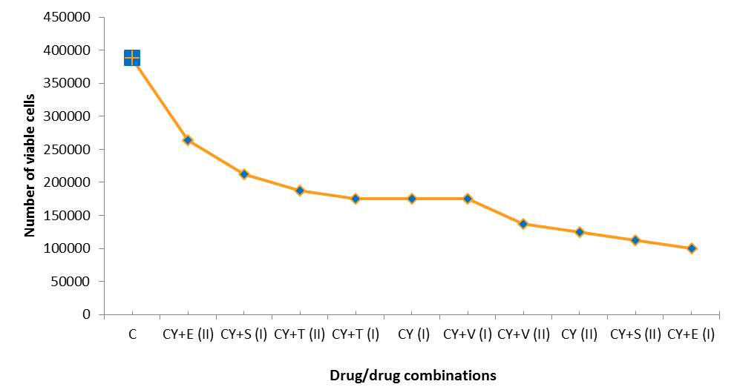

**Figure (5): The effect of different treatments on the viability of HCC cells arranged in a descending manner.**

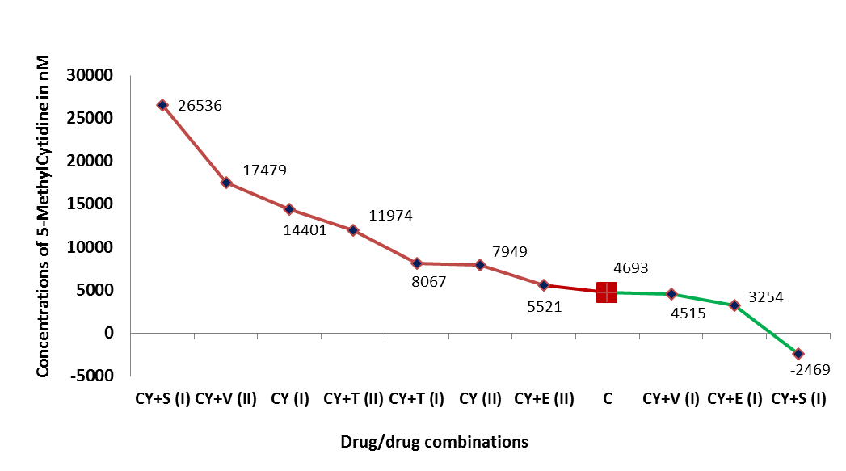

**Figure (6): The effect of different treatments on the concentrations of global 5-Methylcytidine.**

In conclusion, the hypo- and hypermethylation rates obtained were not able to assign a specific drug combination as the best one, but rather both mechanisms could lead to control the proliferation of the HCC cells. Although, *in vitro* data always need to be confirmed on the clinical level, the present study revealed that we could rely on the combination composed of Cyclophosphamide and Sodium Phenylbutyrate in *in vivo* treatment of HCC.

**References**

1. Allen C. and C. Chen. A review of the dietary flavonoid, kaempferol on human health and cancer chemoprevention. Food Chemistry. 2013; 2099-2107.
2. Anestopoulos I., G.P. Voulgaridou, A.G. Georgakilas, R. Franco, A. Pappa and M.I. Panayiotidis. Epigenetic therapy as a novel approach in hepatocellular carcinoma. Pharmacol Ther, 2015; 145, 103-119.
3. Bassiouny A.R., A. Zaky and H.M. Neenaa. Synergistic effect of celecoxib on 5-fluorouracil-induced apoptosis in hepatocellular carcinoma patients. [Ann. Hepatol.](http://www.ncbi.nlm.nih.gov/pubmed/21057160) 2010; 9(4): 410-418.
4. Buonaguro L., A. Petrizzo, M. Tagliamonte, M. Tornesello, and F. Buonaguro. Challenges in cancer vaccine development for hepatocellular carcinoma. EASL Journal of Hepatology. 2013; vol. 59 (j) 897–903.
5. Choudhari S., M. Khan, G. Harris, D. Picker, G. Jacob, T. Block and K. Shailubhai. Deactivation of Akt and STAT-3 signaling promotes apoptosis, inhibits proliferation and enhances sensitivity of HCC cells to an anti-cancer agent, Atiprimod. Cancer Res. 2007; 6(1): 112-121.
6. Cock-Rada A. and B. Weitzman. The methylation landscape of tumor metastasis. Biol. Cell. 2013; 105, 73-90.
7. de la Torre A., N.I. Castaneda, S. Contractor and A.M. Salazar. Use of low-dose cyclophosphaminde followed by low-dose tumoral radiation, intratumoral poly-ICLC combined with local-regional therapy, followed by systemic immune boosting with intramuscular poly-ICLC in patients with cancers of the liver. Journal of Clinical Oncology. 2015; Vol 33, No 3.
8. Diederich M., M. Dicato and M. Schnekenburger. Epigenetic modulators from ‘‘The Big Blue’’: A treasure to fight against cancer. [Cancer Lett.](http://www.ncbi.nlm.nih.gov/pubmed/24964131) 2014; 1; 351(2):182-197.
9. Giordano S. and A. Columbano. Met as a therapeutic target in HCC Facts and hopes. EASL Journal of Hepatology. 2014; 60 (2) 442–452.
10. Gresham G., G. Wells, S. Gill, C. Cameron and D. Jonker. Chemotherapy regimens for advanced pancreatic cancer: a systematic review and network meta-analysis. BMC Cancer. 2014, 14: 471.
11. Greten T.F., L.A. Ormandy, A. Fikuart, B. Höchst, S. Henschen, M. Hörning, M.P. Manns and F. Korangy. Low-dose cyclophosphamide treatment impairs regulatory T cells and unmasks AFP-specific CD4+ T-cell responses in patients with advanced HCC. J Immuno Ther. 2010, 33 (2):211-218.
12. Groselj B., N.L. Sharma, F.C. Hamdy, M. Kerr and A.E. Kiltie. Histone deacetylase inhibitors as radiosensitisers: effects on DNA damage signalling and repair. Br J Cancer. 2013; 108(4): 748–754.
13. Haerter O., C. Lovkvist, B. Dodd and K. Sneppen. Collaboration between CpG sites is needed for stable somatic inheritance of DNA methylation states. Nucleic Acids Res. 2014; 2235–2244.
14. Hagiwara K., H. Ito, T. Murate, Y. Miyata, H. Ohashi and H. Nagai. PROX1 over expression inhibits protein kinase C beta II transcription through promoter DNA methylation. Gene Chromosome Canc. 2012; 1024–1036.
15. Hervouet E., F.M. Vallette, and P.F. Cartron. Impact of the DNA methyltransferases expression on the methylation status of apoptosis-associated genes in glioblastoma multiforme. Cell Death Dis. 2010; 1(1): e8.
16. Iannitti T. and B. Palmieri. Clinical and Experimental Applications of Sodium Phenylbutyrate. Drugs R D. 2011 Sep; 11(3): 227–249.
17. Jiang Y., S. Liu, X. Chen, Y. Cao and Y. Tao. Genome-wide distribution of DNA methylation and DNA demethylation and related chromatin regulators in cancer. Biochim Biophys Acta. 2013; 1835(2):155-163.
18. Kayal S., D. Biswajit, S.L. Cyriac, B. Badhe, D. Kadambari, D. Bharathi, D. Swaruparani, S. Gopinath and K. Dhanraj. Comparison of neoadjuvant chemotherapy (NACT) with 5-fluorouracil, epirubicin (100mg), cyclophosphamide (FEC100) followed by docetaxel (D) (75mg) versus adriamycin and cyclophosphamide (AC) followed by docetaxel (100mg) in locally advanced breast cancer (LABC): A randomized clinical study. Journal of Clinical Oncology. 2015; Vol 33, No 15.
19. Lai J., C. Moser, I. Aderca, T. Han, and L.R. Roberts. The novel HDAC inhibitor apicidin induces apoptosis of hepatocellular carcinoma (HCC) cells and inhibits angiogenesis in HCC xenografts. Cancer Res. 2005; May 1, 65; 1260.
20. Liu S., W. Wei, C. Gao, Y. Xiong, Y. Zhang and Y. Pu. A fluorescence method for detection of DNA and DNA methylation based on graphene oxide and restriction endonuclease HpaII. Talanta. 2015; (13)1: 342–347.
21. Lopez-Ramirez M.A. and S. Nicoli. Role of miRNAs and epigenetics in neural stem cell fate determination. Epigenetics. 2014; 9, 90-100.
22. Lu D., C. Han and T. Wu. 15-PGDH inhibits hepatocellular carcinoma growth through 15-keto-PGE2/PPARγ-mediated activation of p21WAF1/Cip1. Oncogene. 2014; 33, 1101-1112.
23. Mathiyalagan P., S.T. Keating, X.J. Du and A. El-Osta. Interplay of chromatin modifications and non-coding rRNAs in the heart. Epigenetics. 2014; 9, 101-112.
24. Mittal B., S. Tulsyan, G. Agarwal and P. [Lal](http://www.ncbi.nlm.nih.gov/pubmed?term=Lal%20P%5BAuthor%5D&cauthor=true&cauthor_uid=24768782). Significant role of CYP450 genetic variants in cyclophosphamide based breast cancer treatment outcomes: a multi-analytical strategy. Clinica Chimica Acta 2014; 434:21–28.
25. Mondi A., M. Fabbiani, N. Ciccarelli, M. Colafigli, A. D'Avino, A. Borghetti, R. Gagliardini, R. Cauda, A. De Luca and S. Di Giambenedetto. Efficacy and safety of treatment simplification to atazanavir/ritonavir + lamivudine in HIV-infected patients with virological suppression: 144 week follow-up of the AtLaS pilot study. J. Antimicrob. Chemother. 2015; 70 (6): 1843-1849.
26. Morris P.G., N.M. Iyengar, S. Patil, C. Chen, A. Abbruzzi, R.J. Lehman, R. Steingart, K.C. Oeffinger, N. Lin, B. Moy, S.E. Come, E.P. Winer, L. Norton, C. Hudis and C.T. Dang. Longer-term cardiac safety and outcomes of dose dense (dd) doxorubicin and cyclophosphamide (AC) followed by paclitaxel (T) and trastuzumab (H) with and without lapatinib (L) in patients (pts) with early breast cancer (BC). (B. Journal of Clinical Oncology. 2013; Vol 31, No 15.
27. Muller M., E. Schleithoff, A. Koch, T. Schilling, S. Seitz, P. Krammer, G. Melino, F. Staib, A. Schuster, A. Teufel and W. Stremmel. Chemotherapy-induced apoptosis in hepatocellular carcinoma involves the p53 family and is mediated via the extrinsic and the intrinsic pathway. International Journal of Cancer. 2010; 1;126(9):2049-2066.
28. Paonessa F., S. Latiﬁ, H. Scarongella, F. Cesca and F. Benfenati. Speciﬁcity protein 1 (Sp1)-dependent activation of the synapsin I gene (SYN1) is modulated by RE1-silencing transcription factor (REST) and 5’-cytosine-phosphoguanine (CpG) methylation. J. Biol. Chem. 2013; 1; 288(5): 3227–3239.
29. Phillips J. A. and [B. E. Griffin](http://www.sciencedirect.com/science/article/pii/S0035920307002477). Pilot study of sodium phenylbutyrate as adjuvant in cyclophosphamide-resistant endemic Burkitt's lymphoma. Transactions of the Royal Society of Tropical Medicine and Hygiene. 2007; Vol. 101 (12):1265 –1269.
30. Rao X., J. Evans, H. Chae, J. Pilrose, S. Kim, P. Yan, R.L. Huang, H.C. Lai, H. Lin, Y. Liu, D. Miller, J.K. Rhee, Y.W. Huang, F. Gu, J.W. Gray, T.M. Huang and K.P. Nephew. CpG island shore methylation regulates caveolin-1 expression in breast cancer. Oncogene. 2013; 32, 4519-4528.
31. Reguart N., R. Rosell, F. Cardenal, A.F. Cardona, D. Isla, R. Palmero, T. Moran, C. Rolfo, M.C. Pallarès, A. Insa, E. Carcereny, M. Majem, J. De Castro, C. Queralt, M.A. Molina and M. Taron. Phase I/II trial of vorinostat (SAHA) and erlotinib for non-small cell lung cancer (NSCLC) patients with epidermal growth factor receptor (EGFR) mutations after erlotinib progression. Lung Cancer. 2014; 84(2):161-167.
32. Rhee J.K., K. Kim, H. Chae, J. Evans, P. Yan, B.T. Zhang, J. Gray, P. Spellman, T.H. Huang, K.P. Nephew and S. Kim. Integrated analysis of genome-wide DNA methylation and gene expression profiles in molecular subtypes of breast cancer. Nucleic Acids Res. 2013; 41, 8464-8474.
33. Roll J.D., A.G. Rivenbark, R. Sandhu, J.S. Parker, W.D. Jones, L.A. [Carey](http://www.ncbi.nlm.nih.gov/pubmed/?term=Carey%20LA%5BAuthor%5D&cauthor=true&cauthor_uid=24045095), C.A. [Livasy](http://www.ncbi.nlm.nih.gov/pubmed/?term=Livasy%20CA%5BAuthor%5D&cauthor=true&cauthor_uid=24045095) and W.B. [Coleman](http://www.ncbi.nlm.nih.gov/pubmed/?term=Coleman%20WB%5BAuthor%5D&cauthor=true&cauthor_uid=24045095). Dysregulation of the epigenome in triple-negative breast cancers: basal-like and claudin-low breast cancers express aberrant DNA hypermethylation. [Exp Mol Pathol.](http://www.ncbi.nlm.nih.gov/pubmed/24045095) 2013; 95(3): 276-287.
34. Sarder A., G. Rabbani, A.S.M.H.K. Chowdhury and M. Sobhani. Molecular Basis of Drug Interactions of Methotrexate, Cyclophos-phamide and 5-Fluorouracil as Chemotherapeutic Agents in Cancer Biomedical Research and Therapy. 2015; 2(2): 196-206.
35. Stefansson O.A., S. Moran, A. Gomez, S. Sayols, C. Arribas-Jorba, J. Sandoval, H. Hilmarsdottir, E. Olafsdottir, L. Tryggvadottir, J.G. Jonasson, J. Eyfjord and M. Esteller. A DNA methylation-based definition of biologically distinct breast cancer subtypes. Mol Oncol. 2015; 9, 555-568.
36. Stone A., M.J. Cowley, V.F. Mora, R.A. McCloy, C.M. Sergio, D. Gallego-Ortega , C.E. Caldon, C.J. Ormandy, A.V. Biankin , J.M. Gee, R.I. Nicholson, C.G. Print, S.J. Clark and E.A. Musgrove. BCL-2 hypermethylation is a potential biomarker of sensitivity to antimitotic chemotherapy in endocrine-resistant breast cancer. [Mol Cancer Ther.](http://www.ncbi.nlm.nih.gov/pubmed/23861345) 2013, 12(9):1874-1885.
37. Tao H., J.J. Yang, K.H. Shi, Z.Y. Deng and J. Li. DNA methylation in cardiac fibrosis: new advances and perspectives. Toxicology. 2014; 323, 125-129.
38. Vives M., M.M. Ginestà, K. Gracova, M. Graupera, O. Casanovas, G. Capella, T. Serrano, F. Vinyals and B.L. Saez. Metronomic chemotherapy following the maximum tolerated dose as a multi target antitumor therapy affecting angiogenesis, tumor dissemination, and cancer stem cells. Journal of Clinical Oncology. 2013; Vol 31, No 15.
39. Wang X., X. Wei, Q. Pang, and F. Yi. Histone deacetylases and their inhibitors: molecular mechanisms and therapeutic implications in diabetes mellitus. Acta Pharmaceutica Sinica B. 2012; Pages 387–395.
40. Waxman D. and J. Wu. Metronomic cyclophosphamide schedule-dependence of innateimmune cell recruitment and tumor regression in an implanted glioma model. Cancer Letters. 2014; 272–280.
41. Yan B., H. Wang, D. Xie, N. Wakamatsu, M.S. Anscher, M.W. Dewhirst, R.E.J. Mitchel, B.J. Chen and C.Y. Li. Increased skin carcinogenesis in caspase-activated DNase knockout mice. Carcinogenesis. 2009; 30 (10), 1776–1780.
42. Yuste J.V., I. Sánchez-López, C. Solé, R.S. Moubarak, J.R. Bayascas, X. Dolcet, M. Encinas, S.A. Susin and J.X. Comella. The Contribution of Apoptosis-inducing Factor, Caspase-activated DNase, and Inhibitor of Caspase-activated DNase to the Nuclear Phenotype and DNA Degradation during Apoptosis. The Journal of Biological Chemistry. 2005; 280, 35670-35683.
43. Zhang J., B. Yuan, F. Zhang, L. Xiong, J. Wu, S. Pradhan, Y. Wang. Cyclophosphamide perturbs cytosine methylation in Jurkat-T cells through LSD1-mediated stabilization of DNMT1 protein. Chem Res Toxicol. 2011; 21; 24 (11):2040-2043.
44. Zheng T., J. Wang, X. Song, X. Meng, S. Pan, H. Jiang and L. Liu. Nutlin-3 cooperates with doxorubicin to induce apoptosis of human hepatocellular carcinoma cells through p53 or p73 signaling pathways. J Cancer Res Clin Oncol. 2010; 136(10):1597-1604.

12/1/2015