Clinical outcomes of Basal versus Non-Basal clone in Triple Negative Breast Cancer patients

Ashraf F. Barakat¹, Fatma Z. Hussien¹, Dareen A. Mohamed² and Radwa M. Orbey²

Clinical Oncology¹ and Pathology Department², Tanta University

FatmaZ_555@yahoo.com

Abstract: Objective: The aim of this study was to investigate the co-expression of basal markers in triple negative breast cancer (TNBC) patients and to assess its impact on survival, disease free and overall (DFS and OS). Methods: This study was conducted on 51 patients with TNBC subtype who were treated from January 2009 until March 2013. All patients were evaluated by immunohistochemical analysis for steroid hormones (ER, PR, HER.2 & Ki 67) and basal markers (CK5/6 & EGFR). They were subsequently subdivided into two groups: basal group (n=24, 47.1%) and non-basal group (n=27, 52.9%). Basal markers expression were correlated with clinicopathological factors analyzed using the Chi square test and survival (DFS and OS) using kaplan -meier. Cox proportional hazard model was used to assess variables in multivariate analysis. Results: The mean age of all patients was 45.6 years. The median follow-up period was 27 months. Basal group showed 20/24 patients (83.3%) with positive CK5/6, 21/24 patients (87.5%) with positive EGFR and 17/24 patients (70.8%) with positive both CK5/6 and EGFR. For recurrent event, 23/24 patients (95.8%) in basal group versus 10/27 patients (37%) in non-basal group, P=0.001. For death event, 19/24 patients (79.2%) in basal group versus 5/27 patients (18.5%) in non-basal group, P=0.001. There were significant worsened survival with basal group compared to non-basal group (DFS and OS), P≤0.001. There was negative significant impact of all prognostic factors on DFS in basal group. Multivariate analysis revealed that rate of metastases (95% C1 (1.603-3.370), OR= 2.307, P=0.001), high grade (95% C1 (1.631-8.52), OR= 3.729, P=0.002) and positive Ki 67> 14% (95% C1 (0.029-0.634), OR=0.135, P=0.011) had retained their independent prognostic value for DFS with basal-like tumors. Conclusion: TNBC basal-like is a poor prognostic factor for DFS and OS, need more trials to support this prognostic power and allow the use of effective specific therapeutic targets to improve future image of this subtype.
[Ashraf F. Barakat, Fatma Z. Hussien, Dareen A. Mohamed and Radwa M. Orbey. Clinical outcomes of Basal versus Non-Basal clone in Triple Negative Breast Cancer patients. Cancer Biology 2015;5(4):6-16]. (ISSN: 2150-1041). http://www.cancerbio.net. 2

Keywords: Triple negative breast cancer, immunohistochemistry, Basal markers expression, CK5/6, EGFR, Survival.

1. Introduction

TNBC accounts for approximately 15% of breast cancers. TNBC lacks expression of the estrogen receptor (ER), progesterone receptor (PR) and human epidermal growth factor 2 receptor (HER2) protein ⁽¹⁾. Although an ER negative/PR negative/HER-2 negative (ER-/PR-/HER-2) or “triple negative” immunophenotype is considered sufficient to identify basal-like tumors, increasing evidence shows that “basal-like” and “triple negative” are not synonymous, when we talk about(triple-negative) breast cancer,we are mostly (but not entirely) talking about the basal-like molecular subtype⁽²⁾. Since there is currently no means of predicting which TNBC will relapse, identification of subpopulations of TNBC that are most at risk is vital for the clinical management of these breast cancer patients. Basal cytokeratins (CK) represent a large number of high molecular weight (HMW) cytokeratins mainly seen in the basal cell layers of stratified epithelium. Lack of expression of (ER/PR/HER-2) with expression of one or more high- molecular-weight/ basal cytokeratins (CK5/6, C K14 and CK17) and/or epidermal growth factor receptor EGFR (HER-1,c-erbB-1) expression are classified as basal phenotype⁽³⁻⁸⁾. No effective specific targeted therapy is readily available for TNBC with co-expression of basal markers ⁽⁹⁾. The Aim of This Work is to evaluate the expression of basal makers (CK5/6 and EGFR) among TNBC patients, correlated with different prognostic factors and survival (diseases free survival and overall survival) to be used to stratify patients with a highly heterogeneous disease such as TNBC.

2. Patients and methods
This retrospective study was conducted in Clinical Oncology Department and Histopathological Department, Tanta University January 2009 until March 2013. The study included 51 consecutively treated female patients with TNBC. This study conformed to the accepted ethical standard with approval code number (2029/ 08/ 13). All patients were assessed for the established clinical and histo-morphological factors. The steroid hormones status (ER, PR, HER-2, and Ki67) were evaluated by immunohistochemistry. EGFR and CK5/6 basal markers were evaluated by monoclonal antibodies. Fifty one TNBC patients (ER & PR expression were less than 10% of tumor nuclei and no overexpression of HER-2/neu) were classified into two sub-groups (basal group & non basal group) according to immunohistochemical expression of basal markers (CK5/6 and / or EGFR) correlated with different prognostic factors and survival (DFS &OS) with median follow up period 27 months. The tissue sections were revised for all the immunohistochemical analyses (ER, PR, HER2 & Ki67) and immuonohistochemical staining by CK5/6 and EGFR monoclonal antibodies (Mouse monoclonal antibody, Ab, 86974) and (EGFR1, E30, Mouse monoclonal antibody, DAKO) respectively. Immunoreactivity was regarded as positive if more than 1% of the tumor cells showed cytoplasmic membrane reactivities. The sections were semiquantitavily assessed for EGFR expression intensity. Intensity of staining was scored as: 0 (negative): No cytoplasmic membrane EGFR staining; 1+: weak cytoplasmic membrane EGFR staining; 2+: moderate cytoplasmic membrane EGFR staining; 3+: strong cytoplasmic membrane EGFR staining.
Immunoreactivity was regarded as positive for CK5/6 if any cytoplasmic and /or membranous invasive carcinoma cell staining. CK5/6-positive and/or EGFR-positive expression in cases of triple negative breast cancer was defined as the basal-like subtype, on the other hand, CK5/6-negative and EGFR-negative expression in cases of triple-negative breast cancer was defined as the non-basal-like subtype. The collected data was organized, tabulated and statistically analyzed using SPSS software statistical computer package version 21. Patient characteristics were compared using Chi- square test. Two tailed P values less than or = 0.05 were considered significant. Survival plots and cumulative survival probabilities were estimated using the Kaplan-Meier method and the Cox proportional hazards model was used for multivariate analysis.

3. Results
At the time of the primary treatment, none of the patients had any evidence of local or distant metastases. The expression of CK5/6 and EGFR were negative for 27/27 patients of non-basal group. The expression of CK5/6 in basal group was positive in 20/24 patients (83.3% within basal group) Fig. (1-2-3) and was negative in 4/24 patients (16.7%within basal group) Fig.(4). The expression of EGFR was negative in 3/24 patients (12.5% within basal group) Fig.(5) and positive (+1) in 7 patients (29.2% within basal group) Fig.(6), positive (+2) in 5 patients (20.8%) within basal group) Fig.(7), and (+3) in 9 patients (37.5% within basal group) Fig.(8), as summarized in table (1).Both CK5/6 and EGFR were positive in 17 patients, CK5/6 +ve and EGFR+1, +2 &+3 were 4 patients (57.1% within EGFR+1), 5 patients (100% within EGFR+2) and 8 patients (88.9% within EGFR+3) respectively, as summarized in table (2). The tumor's, patient's and treatments characteristics were matched in both study groups except for Ki67 (p=0.008) and rate of metastasis (p=0.001). Mean age of the whole study population was (45.67) years (range, 23-65) years. All patients underwent surgical local treatment, received anthracycline - based chemotherapy regimens and radiotherapy, table (3).

Table (1) Immunohistochemical expression of basal makers (CK5/6 and EGFR) among 51 TNBC patients
Basal makers |  | Basal group |  | Non basal group
 |  | n  24 | % | n  27 | %
CK5/6 | Negative  Positive | 4  20 | 16.7  83.3 | 27  0 | 100  0
EGFR | Negative  Positive (+1)  Positive(+2)  Positive(+3) | 3  7  5  9 | 12.5  29.2  20.8  37.5 | 27  0  0  0 | 100  0  0  0

Table (2) Immunohistochemical expression in 17 patients of basal group with positive both (CK5/6 & EGFR)
Basal group | Positive 1  EGFR | Positive 2  EGFR | Positive 3  EGFR
positive CK5/6 number | 4 | 5 | 8
% within CK5/6 | 20% | 25% | 40%
% within EGFR | 57.1% | 100% | 88.9%

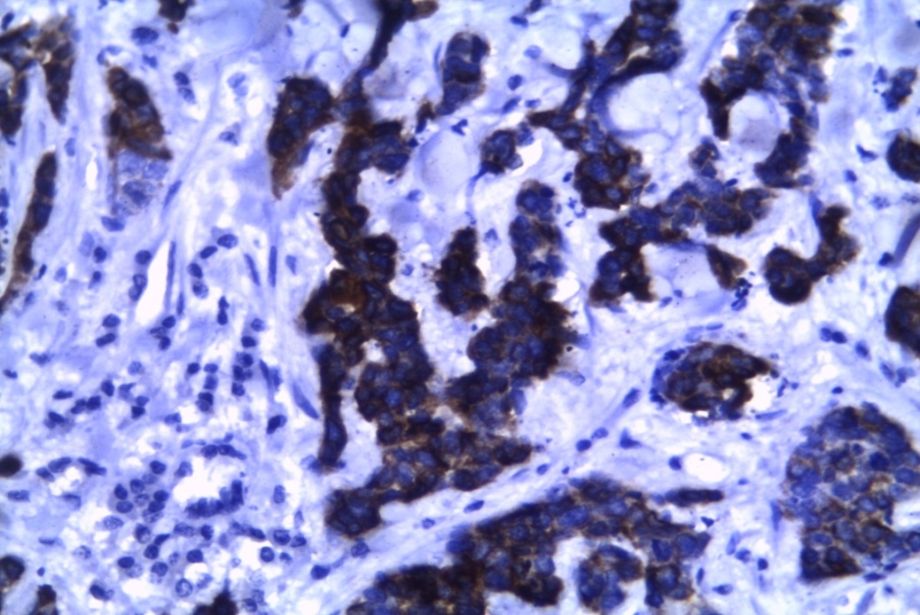
Fig. (1) Positive cytoplasmic staining of Ck5/6 in invasive ductal carcinoma breast (streptovidin biotin X400).

Table (3): Patients characteristics among study population (basal and non- basal)
Patients characteristics |  | Basal |  | Non basal |  | Chi-square
 |  | n(24) | % | n(27) | % | X² |  | P
Age Less than 45  More than45 |  | 7  17 | 29.2  70.8 | 5  22 | 18.5  81.2 | 0.801 |  | 0.371
Mean of age (SD; Range) |  | 45.667 (11.48680; 23-65)
Menopausal | Premenopausal  Postmenopausal | 10  14 | 41.7  58.3 | 11  16 | 40.7  59.3 |  | 0.004 | 0.947
Tumor size | T1  T2  T3  T4 | 3  13  5  3 | 12.5  54.2  20.8  12.5 | 6  9  8  4 | 22.2  33.3  29.6  14.8 |  | 2.394 | 0.495
Lymph node | N0  N1  N2  N3 | 8  9  6  1 | 33.3  37.5  25  4.2 | 13  6  5  3 | 48.1  22.2  18.5  11.1 |  | 2.714 | 0.438
Stage 1  Stage 2  Stage 3 |  | 3  13  8 | 12.5  54.2  33.3 | 5  9  13 | 18.5  33.3  48.1 |  | 2.249 | 0.325
Histology | Invasive ductal  Invasive lobular  Other | 20  1  3 | 83.3  4.2  12.5 | 21  2  4 | 77.8  7.4  14.8 |  | 0.325 | 0.850
Grade | 1  2  3 | 1  12  11 | 4.2  50  45.8 | 2  17  8 | 7.4  63  29.6 |  | 1.498 | 0.473
Ki 67% | ≥14%  <14% | 22  2 | 91.7  8.3 | 16  11 | 59.3  40.7 |  | 7.026 | 0.008
CA15.3 | High value  Normal value | 8  1 6 | 33.3  66.7 | 13  14 | 48.1  51.9 |  | 1.151 | 0.283
Surgery | MRM  CBS | 12  12 | 50  50 | 12  15 | 44.4  55.6 |  | 0.157 | 0.692
Chemotherapy | FEC  TEC  Sequential FEC & single T | 10  5  9 | 41.7  20.8  37.5 | 15  4  8 | 55.6  14.8  29.6 |  | 0.997 | 0.607
1st event (n= 33) |  | 23 | 95.8 | 10 | 37 |  | 23.9 | < 0.001
2nd event (n=24) |  | 19 | 79.2 | 5 | 18.5

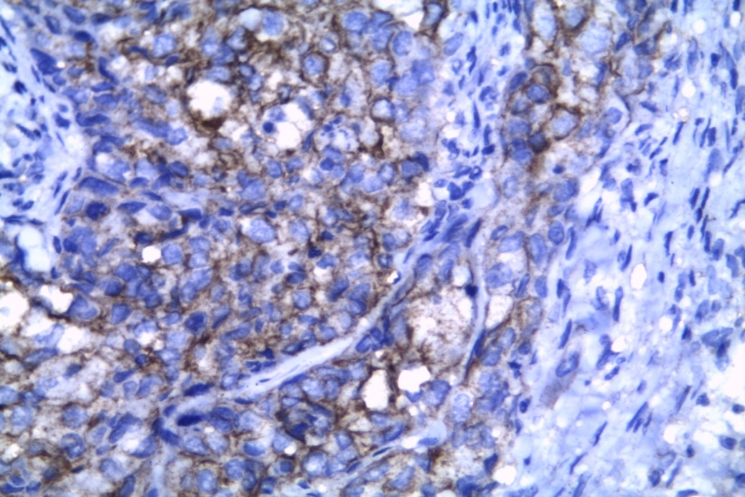
Fig. (2) Positive membranous staining of Ck5/6 in invasive ductal carcinoma breast (streptovidin biotin X400).
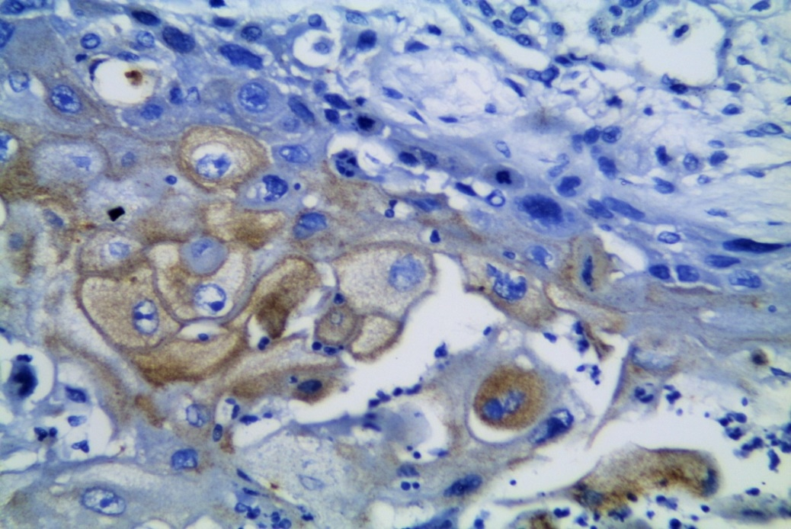
Fig. (3) Positive cytoplasmic/membranous staining of Ck5/6 in metaplastic carcinoma breast (streptovidin biotin X400).
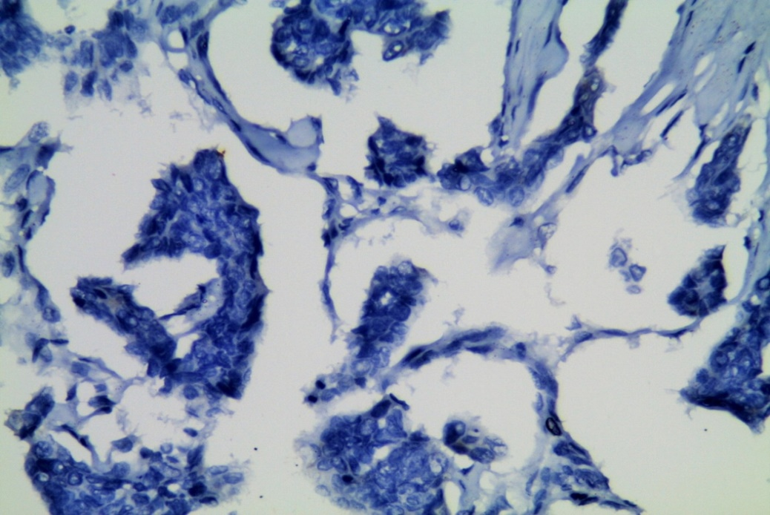
Fig. (4) Negative staining of CK5/6 of invasive ductal carcinoma breast (streptovidin biotin X400).
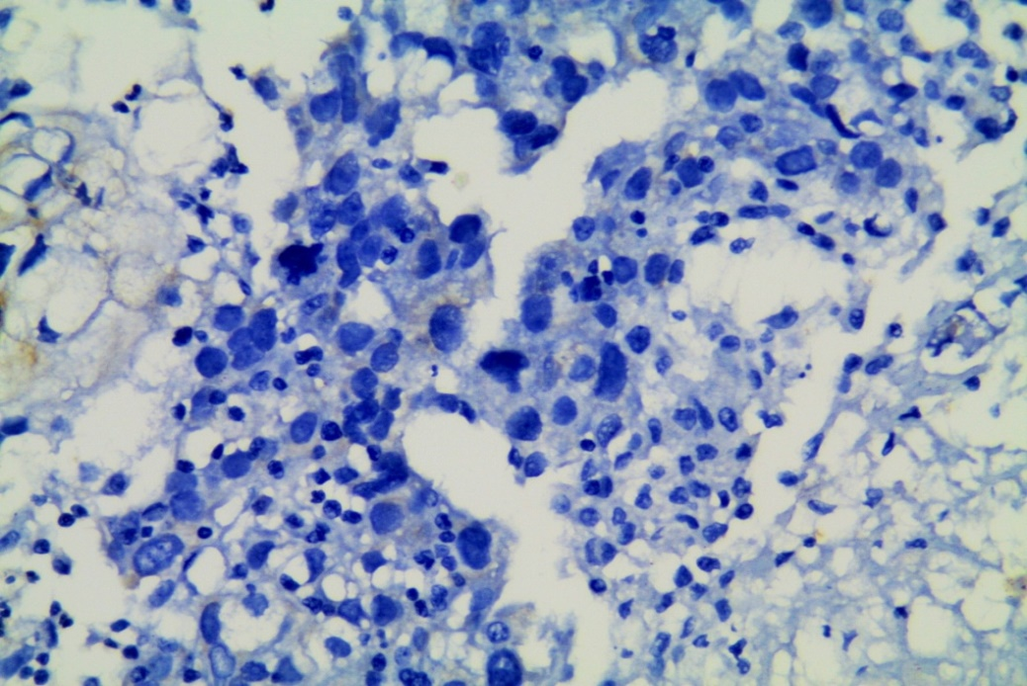
Fig. (5) Negative staining of EGFR of invasive ductal carcinoma breast (streptovidin biotin X400).

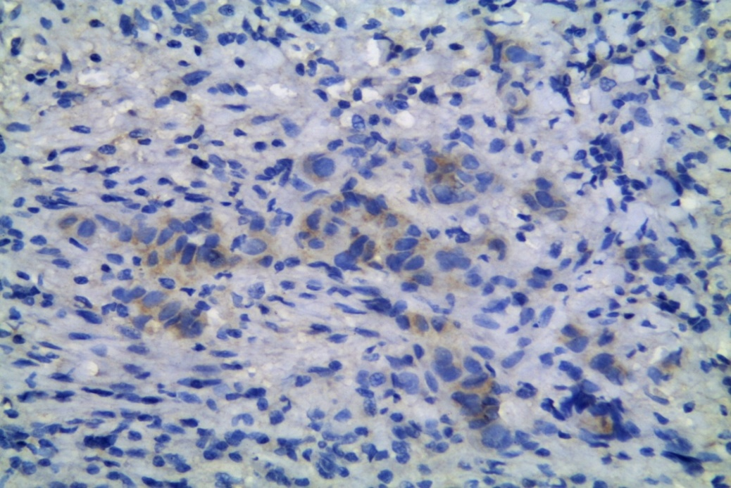
Fig. (6) Positive cytoplasmic staining of EGFR (+1) in invasive ductal carcinoma breast (streptovidin biotin X400).

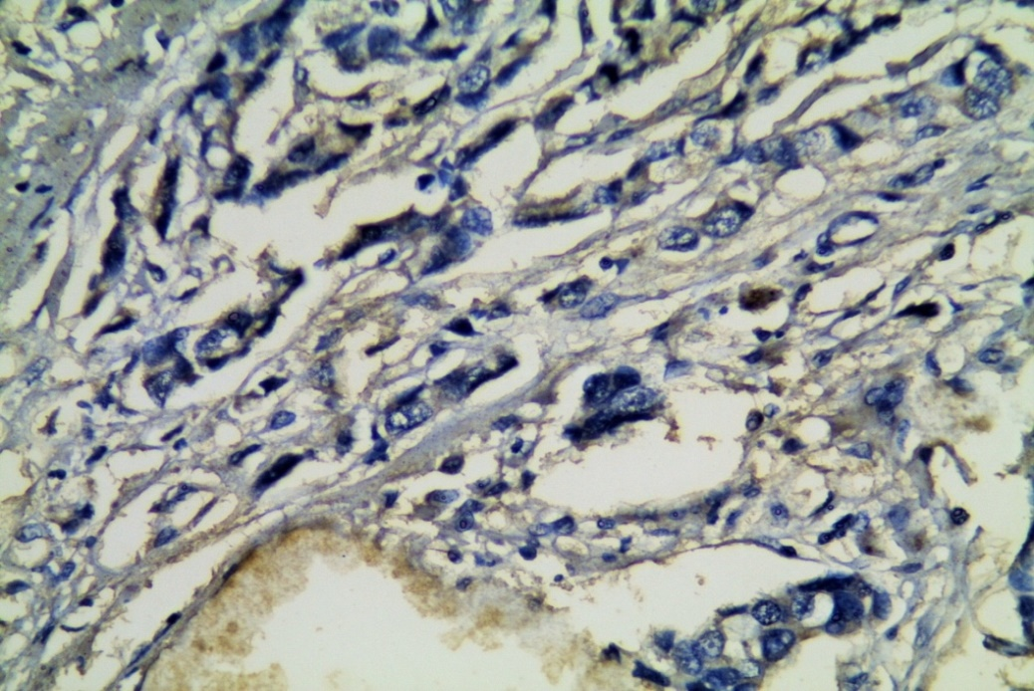
Fig. (7) Positive cytoplasmic staining of EGFR (+2) in invasive lobular carcinoma breast (streptovidin biotin X400).

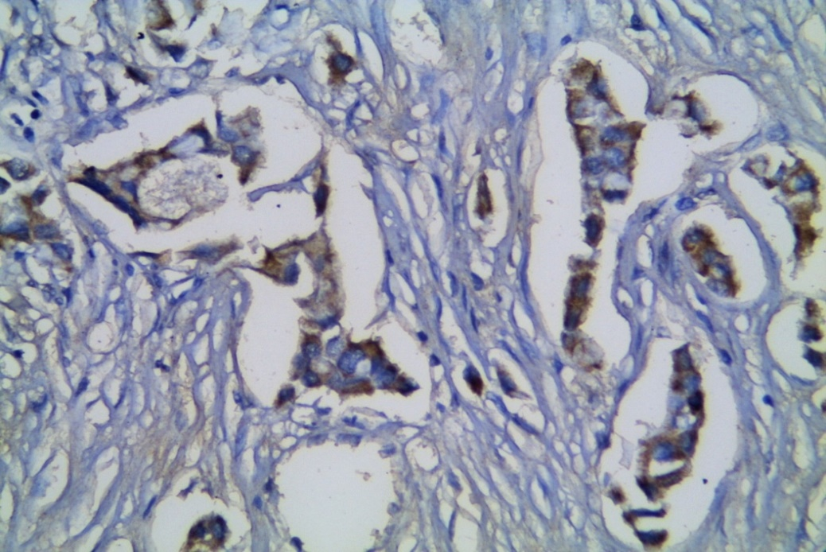
Fig. (8) Positive cytoplasmic/membranous staining of EGFR (+3) in invasive ductal carcinoma breast (streptovidin biotin X400).

Regarding the follow up, the median follow up period of the current study was 27 months (range, 9-42) months, 33/51 patients (64.71%) in the whole study population were relapsed(local and distant). In basal group 23/24 patients (95.83%) versus 10/27 patients (37.03%) in non -basal group showed event of relapse, p=0.001, tables (3&4). For death event 24/51 patients (47.1%) in the whole study population, 19/24 patients (79.2%) in basal group versus 5/27 patients (18.5%) in non- basal group, p= 0.001, table (3). For overall survival (OS), in basal group the median OS was 21 months ranging from (11 month- 37month), 1-year OS was 95.7%%, 2-year OS was 37.5%. For non -basal group the median OS was 35 months ranging (9 month - 42 month), 1- year OS was 100 %, 2- year OS was 90.7%. There were significant differences between both group (P≤0.001), Log Rank (28.290), on expense of basal group, Fig.(9). For diseases free survival (DFS), in basal group the median DFS was 11months ranging from (7 month-24 month), 1-year DFS was 27.8%, 2 -year DFS was zero%. As regard non basal group the median DFS was 23 months ranging (11 month -42 month), 1-year DFS was 83.9%, 2-year DFS was 69.9%. There was significant difference between two groups (P≤0.001), Log Rank (32.610), on expense of basal group, Fig. (10). There were negative significant correlation for all clinicopathological factors (age, menopausal status, tumor size, lymph node, stage, histology, grade, Ki67,CA15.3 and rate of metastases) for 1-&2- year DFS in relapsed basal group TNBC patients (23/24),table (5&6). Multivariate survival analysis (Cox Regression) of significant prognostic factors revealed that rate of metastasis (95% CI (1.603-3.320),OR = 2.307, P=0.001) (Fig. 11a,b,c,d&e),high grade (95% CI (1.631-8.526), OR=3.729, P=0.002) and positive Ki67 ≥ 14% (95% CI (0.029 -0.634), OR= 0.135, P= 0.011) (Fig. 12a&b) were independent factors and were the most significant risk parameters affect DFS with basal-like subtype, table (7).

Table (4) Sites and pattern of relapse among the study groups
Relapse sites |  | Basal |  | Non basal |  | Chi-square
 |  | n (24) | % | n (27) | % | X² | P
Metastasis | Non  Bone  Brain  Lung  Liver  Local recurrence | 1  5  2  10  2  4 | 4.2  20.8  8.3  41.7  8.3  16.7 | 17  4  3  1  1  1 | 63  14.8  11.1  3.7  3.7  3.7 | 23.93 | ≤0.001

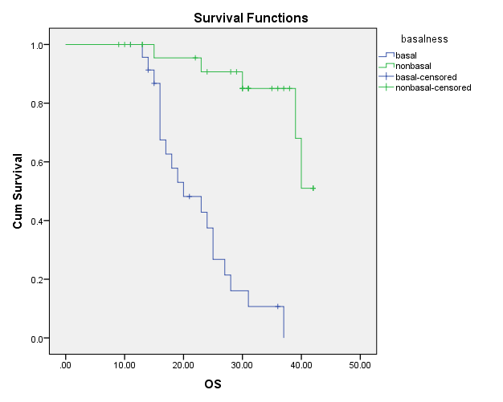
Fig. (9) OS according to basal markers expression in both groups "basal& non basal TNBC patients".
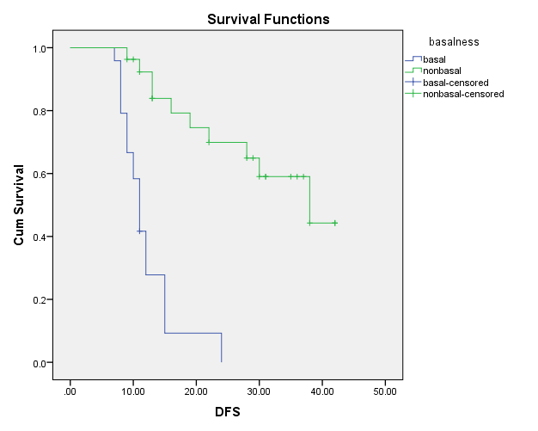
Fig. (10) DFS according to basal markers expression in both groups "basal& non basal TNBC patients".

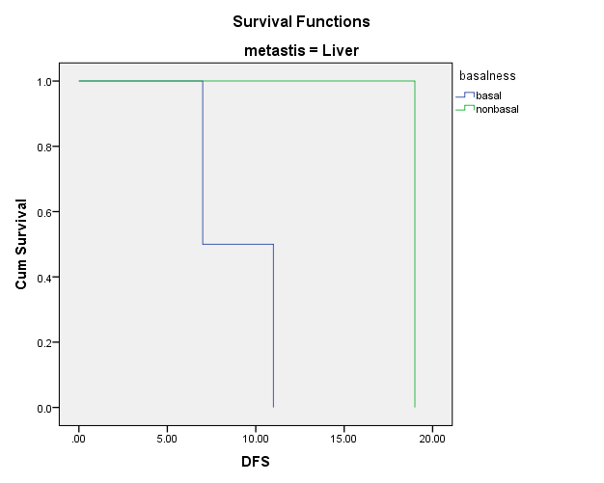 | 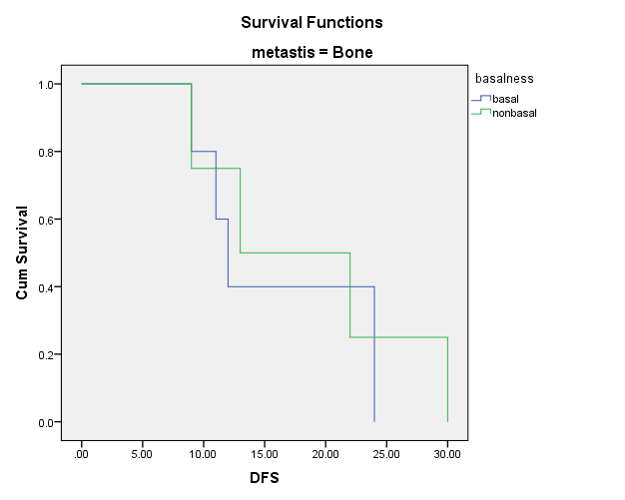
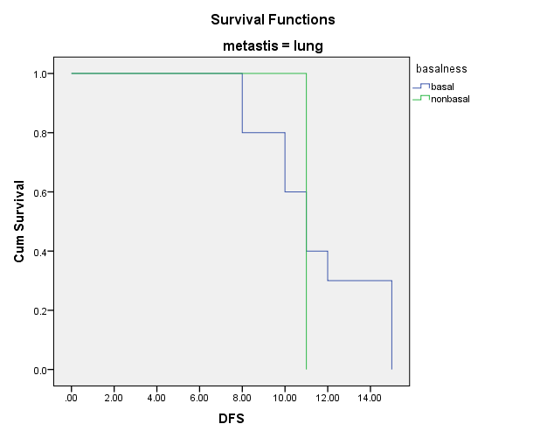 | 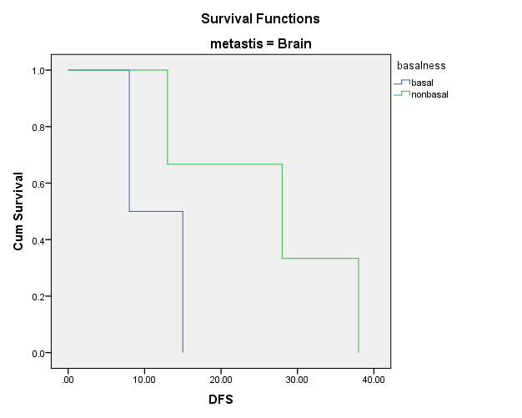
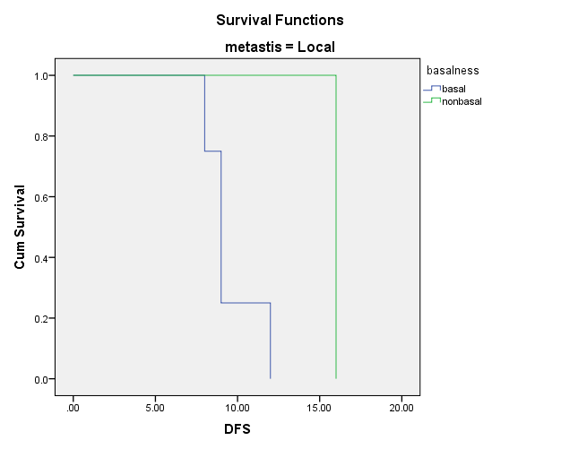
Fig (11 a, b, c, d &e) DFS and metastatic sites (p= 0.001)

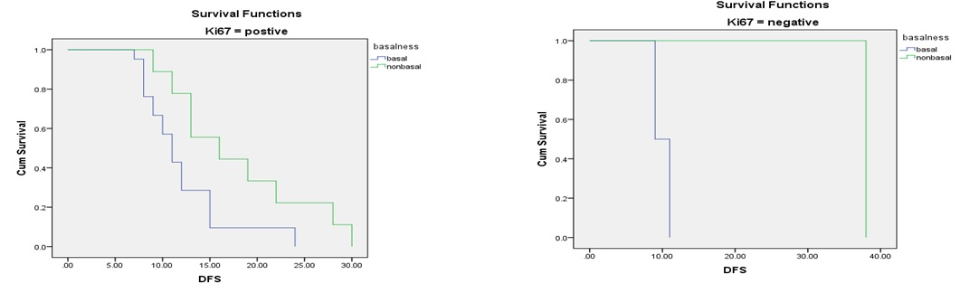
Fig. (12 a&b) DFS and Ki-67% (P=0.016).

Table (5) Patients characteristics in relapsed study population (basal and non- basal)
Patients characteristics |  | Basal |  | Non basal |  | Log-Rank
 |  | n  23 | % | n  10 | %
Age | ≤45  >45 | 7  16 | 30.4  69.6 | 1  9 | 10  90 | 6.811
Menopausal | Premenopausal  Postmenopausal | 10  13 | 43.5  56.5 | 2  8 | 20  80 | 5.570
Tumor size | T1  T2  T3  T4 | 2  13  5  3 | 8.7  56.52  21.7  13.04 | 2  5  2  1 | 20  50  20  10 | 6.211
Lymph node | N0  N1  N2  N3 | 7  9  6  1 | 30.43  39.13  26.1  4.35 | 4  3  2  1 | 40  30  20  10 | 4.172
Stage 1  Stage 2  Stage 3 |  | 2  13  8 | 8.7  56.5  34.78 | 1  5  4 | 10  50  40 | 5.504
Histology | Invasive ductal  Invasive lobular  Other | 19  1  3 | 82.61  4.35  13.04 | 7  1  2 | 70  10  20 | 7.070
Grade | 1  2  3 | 1  11  11 | 4.347  47.826  47.826 | 1  7  2 | 10  70  20 | 5.631
Ki67% | ≥ 14%  <14% | 21  2 | 91.3  8.7 | 9  1 | 90  10 | 5.826
CA15.3 | High value  Normal value | 8  15 | 34.8  65.2 | 6  4 | 60  40 | 6.165
Surgery | MRM  CBS | 12  11 | 52.2  47.8 | 6  4 | 60  40 | 7.862
Chemotherapy | FEC  TEC  Sequential FEC & single T | 10  4  9 | 43.5  17.4  39.13 | 7  2  1 | 70  20  10 | 6.324
Radiotherapy received |  | 23 | 100 | 10 | 100 | 7.352
Metastasis  Bone  Brain  Lung  Liver  Local recurrence |  | 5  2  10  2  4 | 21.7  8.7  43.5  8.7  17.4 | 4  3  1  1  1 | 40  30  10  10  10 | 3.014

Table (6) Diseases free survival (DFS) analysis correlated to different clinicopathological factors in relapsed (33/51) patients of both study groups
Patients characteristics |  | DFS of Basal group |  | DFS of Non basal group |  | P-value
 |  | 1 year | 2 years | 1 year | 2 years
Age | ≤45  >45 | 14.3%  28.2% | Zero%  Zero% | Zero %  66.7% | Zero%  33.3% | 0.009
Menopausal | Premenopausal  Postmenopausal | 10%  38.5% | Zero%  Zero% | 50%  62.5% | Zero %  37.5% | 0.018
Tumor size | T1  T2  T3  T4 | Zero%  23.1%  40%  Zero% | Zero%  Zero%  Zero%  Zero% | 100%  60%  Zero %  100 % | 50 %  20%  Zero%  Zero% | 0.013
Lymph node | N0  N1  N2  N3 | 28.6%  11.1%  33.3%  Zero% | Zero%  Zero%  Zero%  Zero% | 75%  100%  50%  Zero% | 25%  33.3 %  Zero %  Zero % | 0.041
Stage 1  Stage 2  Stage 3 |  | Zero %  23%  37.5% | Zero%  Zero%  Zero% | 100%  80%  25% | 100%  40 %  Zero % | 0.019
Histology | Invasive ductal  Invasive lobular  Other | 31.6%  Zero%  Zero% | Zero%  Zero%  Zero% | 57.1%  100 %  50% | 28.6%  Zero%  Zero % | 0.008
Grade | 1  2  3 | 100%  36.4%  18.2% | Zero%  Zero%  Zero% | 100 %  71.4%  50% | Zero%  42.9%  Zero% | 0.018
Ki67% | ≥14%  <14% | 28.6%  Zero% | Zero%  Zero% | 55.6%  100% | 22.2%  100% | 0.016
CA15.3 | Positive  Normal | 25%  26.7% | Zero%  Zero% | 66.7%  50% | 16.7%  25% | 0.013
Surgery | MRM  CBS | 25%  27.3% | Zero %  Zero % | 50%  75% | 16.7%  25% | 0.005
Chemotherapy | FEC  TEC  Sequential FEC & single T | 10%  50%  33.3% | Zero %  Zero %  Zero % | 57.1%  50%  100% | 28.6%  Zero %  Zero % | 0.012
Metastasis | Bone  Brain  Lung  Liver  Local recurrence | 40%  Zero %  30%  Zero %  Zero % | Zero %  Zero %  Zero %  Zero %  Zero % | 50%  66.7%  Zero %  100%  100% | 25%  33.3%  Zero %  Zero %  Zero % | 0.043

Table (7): Multivariate survival analysis (Cox Regression) of significant prognostic factors
independents factor | Sig | OR | 95% CI for Exp (B)
 |  |  | Lower | Upper
Metastasis | ≤0.001 | 2.307 | 1.603 | 3.320
Grade | 0.002 | 3.729 | 1.631 | 8.526
Ki 67% | 0.011 | 0.135 | 0.029 | 0.634

4. Discussion
The present retrospective study was carried out on 51 Female Patients suffering TNBC. They were chosen for the research depending on the quality of the blocks and the presence of full clinical profiles. In the current study using immunohistochemical analysis, Ck5/6 was expressed in 20/51 patients (39.2%), EGFR was expressed in 21/51 patients (41.2%) and both were expressed together in 17/51 patients (33.3%) consequently TNBC basal- like group was 24/51 (47.1%) patients versus 27/51 (52.9%) patients as non -basal group depend on expression of at least one of the basal markers EGFR and/or CK5/6 in agreement with Rakha EA et al 2009 ⁽¹⁰⁾ and Ryden L et al 2010 ⁽¹¹⁾ reported that over 40% of TNBC basal-like subtype overexpress EGFR, and its presence has been commonly associated with worse prognosis and also, Yutaka Yamamoto et al 2009 ⁽¹²⁾ reported that basal-like subtype was detected in 46% (n=22/48) of triple-negative cancers while our results in disagreement with Fulford et al, 2007 ⁽¹³⁾, Chen et al, 2009 ⁽¹⁴⁾, Chidambharam Choccalingam et al 2012 ⁽⁴⁾, Ying Liu et al 2012⁽¹⁵⁾, Chandrika Rao et al 2013 ⁽¹⁶⁾ who reported that (20%), (12%), (67.7%), (77.7%)& (74%) of TNBC to be basal respectively. In the present study matched patient’s characteristics for both groups such as age, menopausal status, tumor size, lymph node, histological types, grade, stage, chemotherapy protocols, serum level of CA15.3, surgery and radiotherapy. While there were positive significant relation for Ki-67 and rate of metastasis with basal group patients (P= 0.008, P≤0.001) respectively similar to ^{(12, 17).}
In the present study metastases (local & distant) developed in 33/51 patients (64.7%), 23/24(95.8%) cases in basal group compared with 10/27 (37%) cases in non- basal group in disagreement with Rakha et al 2009 ⁽¹⁰⁾ studied on total (n = 1,944), who reported that distant metastases developed in (37%) cases of basal compared with (26%) cases in non-basal tumors, our explanation may be due to small sample size. As regard pattern of metastasis,the most common metastasis sites in the present study were Lung, bone, brain, liver and local recurrence (41.7%,20.8%,8.3%,8.3%&16.7% versus 3.7%,14.8%,11.1%,3.7%&3.7%) in basal and non-basal groups respectively with significant differences between two groups (P≤0.001) similar to Franca Podoa et al 2010 ⁽¹⁸⁾ & Laura J et al 2014 ⁽⁷⁾ where TNBC has more than 20% greater incidence of visceral metastasis compared to the other breast cancer subtypes, which commonly metastasize to bone and also, Rakha et al 2009⁽¹⁰⁾ reported that basal type showed more frequent metastasis to brain and lung but less frequently metastasize to other lymph node groups than non-basal tumor (P=0.03) & AYe AYe Thike 2010⁽¹⁹⁾ studied on 653 triple negative breast cancers (TNBC) follow-up ranged from 1 to 185 months (mean 88, median 84months), and reported that basal showed more frequent metastasis to lymph node (30%), lung (28%), brain (14%) than non-basal tumors lymph node (30%), lung (28%), brain (10%) while Ying Liu et al 2012 ⁽¹⁵⁾ studied on total number 1259 patients, in the 229 cases of operable TNBC with 5 years follow up reported that no difference between basal and non- basal in pattern of metastasis (P= 0.523). The mean age in the present study was 45.7years, SD ± 11.48680 ranging (23-65), 1- and 2 -year DFS were lower in basal versus non basal with significant difference (P≤0.001) similar to Tanja Ovcaricek et al 2011 ⁽²⁰⁾ studied on 269 TNBC, the median follow-up was 5.9 years and reported that the median age of the patients was 55 years (range 23-88.5) and in the univariate analysis age was found to have significant impact on DFS (P=0.009) but in disagreement with AYe AYe Thike et al 2010 ⁽¹⁹⁾ who reported that age (median 52, range 25-89) has no significant impact on DFS (P=0.407).
In the present study,as regard menopausal status most patients of basal group were post menopause, 1- and 2-year DFS was lower in basal versus non basal (38.5% & Zero%) and (62.5% & 37.5%) respectively with significant difference (P=0.018), in accordance with Yutaka Yamamoto et al 2009 ⁽¹²⁾ who reported that most patients were postmenopausal and Tanja Ovcaricek et al 2011⁽²⁰⁾ also reported that most patients were postmenopausal with insignificant impact on DFS (p=0.172). In the present study,as regard tumor size the most predominant was T2 in basal group, 1- and 2- year DFS were lower in basal versus non basal (23.1 % & zero%) and (60% & 20%), the difference was significant (P=0.013), similar to AYe AYe Thike et al 2010 ⁽¹⁹⁾ and Tanja Ovcaricek et al 2011⁽²⁰⁾ who reported that larger tumor size more than 2 cm was the commonest with significant impact on DFS (P=0.003) & (P= 0.004) respectively, but in disagreement with Rebecca Dent et al 2009 ⁽²¹⁾ who studied on 962 women with TNBC, 116 cancers were basal (12%), 845 were non basal (88%), and 1 could not be classified as either basal or non-basal and was excluded (HR, 1.15; 95% CI, 0.60-2.22) and also, Yutaka Yamamoto et al 2009 ⁽¹²⁾ who reported that tumors >2 cm in size not a predictor of distant disease recurrence (p= 0.078). In the current study, as regard lymph node involvement, 1 -and 2 -year DFS were lower in basal versus non basal groups, the difference was significant (P=0.041), in harmony with Rebecca Dent et al 2009 ⁽²¹⁾ (P=0.02), Jun Mo Kim et al 2009 ⁽²²⁾ studied on 643 invasive breast carcinoma samples 165 cases (25.7%) were TNBCs, the median follow-up period of the patients was 66 months (range, 6-230months), (p=0.01), (P=0.0023) ⁽¹²⁾, (P=0.017) ⁽¹⁹⁾ and (P=<0.001) ⁽²⁰⁾ who reported negative significant correlation between lymph node status and DFS in univariat analysis.
In the present study, as regard stage the most predominant presentation was stage 2 in basal group, 1- year and 2- year DFS were lower in basal versus non basal (23% & zero%) and (80%&40%) respectively the difference was significant (P=0.019), in harmony with Atika Dogra et al 2014⁽⁹⁾ studied on a total of 67 cases of TNBC and reported that stage 2 was most common and had significant impact on DFS, P=(0.023). In the present study, as regard histological types the most predominant type in basal group was infiltrating duct carcinoma, 1-year and 2 -year DFS were lower in basal versus non basal (31.6%&zero%) and(57.1%&28.6%) respectively the difference was significant (P=0.008),in harmony with Eman et al 2011 ⁽²³⁾ studied on 50 cases TNBC, ductal carcinoma (IDC/NOS) (44 cases),mixed ductal and lobular carcinoma (4cases), one case was invasive lobular carcinoma(ILC) and one case was atypical medullary carcinoma and Neelam Sood et al 2014 ⁽²⁴⁾ studied on 36 female patients with TNBC and reported that invasive ductal carcinoma was the most predominant histological type. In the current study, as regard histological grade the most predominant in basal group was high grade 2&3, 1-and 2 -year DFS were lower in basal versus non basal (36.4 % & zero %) and (71.4 %,42.9%) for grade 2, (18.2% & zero%) and (50% & zero%) for grade 3 respectively, the differences were significant (P=0.018) while AYe AYe Thike et al. 2010 ⁽¹⁹⁾ and Asli Cakir et al 2012 ⁽²⁵⁾, reported that only grade 3 was the most predominant with negative correlation with DFS in univariate analysis, p=(0.006) and Tanja Ovcaricek et al 2011⁽²⁰⁾ reported also that grade 3 was the most predominant but with no impact on DFS in univarait analysis, P=(0.315). In the present study, DFS was higher in non-basal group versus basal group with anthracycline-based regimens with significant difference (P=0.012), similar to Jun Mokim et al 2009 ⁽²²⁾ who reported that patients who received anthracycline-based adjuvant chemotherapy had significant impact on DFS (p=0.01) but not in harmony with Tanja Ovcaricek et al. 2011⁽²⁰⁾ who reported that anthracycline-based adjuvant chemotherapy had no significance on DFS, (P=0.234). In the present study,as regard Ki67, 21/24 patients (87.5%) were positive in basal group, 1-year and 2-year DFS were lower in basal versus non basal (28.6% & zero%) and (55.6% & 22.2%) respectively the difference was significant (P=0.016) similar to Ivana Mrklic et al 2013⁽²⁶⁾ studied on 1849 patients out of 124 TNBC, 83 patients that had not received preoperative chemotherapy and had available paraffin blocks were included in further analyses, the mean follow-up was 43 months (range 2–95), median 39 months and reported that Ki67 proliferation index was significantly associated with shorter disease-free survival (DFS) (P<0.001) and Keam et al 2011⁽²⁷⁾ studied on 370 patients, 109 patients were classified as TNBC, with a median follow-up duration of 33.6 months, 33 relapse events occurred, and 20 patients died of disease progression and reported that high Ki67 expression was significantly associated with poor DFS (P= 0.005) & also, Haitao Li et al 2015⁽²⁸⁾ support the prognostic power of Ki67.
In the present study,as regard CA15.3 serum level, in spite of 15/24 patients (65.2%) presented with normal value as regard reference level in basal group, 1-year and 2- year DFS were lower in basal versus non basal (26.7% & zero%) and (50% & 25%) respectively, similar to San- gang Wu 2013⁽²⁹⁾ studied on a total of 470 patients,63 (13.5%) as triple-negative and reported that most cases had preoperative normal CA15.3 (85.7%), and in disagreement with Y Lee et al 2009 ⁽³⁰⁾ studied on total number 2,907 patients, 622 patients (21.4%) had TNBC were followed for a median of 54 months (range 1-76 months) and reported that the most predominant CA15.3 estimated was high as regard reference level. In the present study,as regard metastatic sites, the most common were (lung, bone, local recurrence, brain and liver, respectively), 1-and 2- year DFS were lower in basal versus non basal (30% & Zero%) & (Zero%, Zero%) for lung,(40 % & zero %) and (50% & 25%) for bone metastasis, (zero% & zero%) & (100% & Zero%) for local recurrence and liver, (zero % & zero %) & (66.7% & 33.3%) respectively the differences were significant (P=0.043), in harmony with Katarzyna Pogoda et al 2013 ⁽³¹⁾ studied on 2,534 patients and 228 patients (9 %)were TNBC (ER/PR/HER2-negative), 6 years observation with median DFS and OS were not reached at the time of analysis, and 6-year DFS and OS were 68 and 62 %, respectively and reported that most common site of metastasis were 15 % in the brain, 14 % in the lungs, 11 % in the bones and14 % had loco-regional relapse and Ying Liu et al 2012 ⁽¹⁵⁾ who reported that basal group had shorter DFS than non-basal group,(P= 0.045). In the present study, significant 1-and 2- year DFS in non-basal group compared to basal one whatever type of surgery MRM or CBS, Abdulkarim BS et al 2011 ⁽³²⁾ studied on TNBC were identified from a cancer registry in a single institution (n=768) with median follow-up of 7.2 years and reported that CBS showed lower risk of local recurrence compared with MRM with or without radiotherapy with no significance. In the present study, although all cases received postoperative radiotherapy, still 1- and 2- year DFS were lower in basal versus non basal groups, (23.8 % & 83.9 %) and (zero %,69.9%) respectively with significant difference (P≤0.001), Xingxing chen et al 2013 ⁽³³⁾ studied on 553 TNBC patients, median follow-up of 65 months (range, 1–140 months) and reported that post mastectomy radiotherapy (PMRT) was associated with significantly longer DFS times (P=0.023). In the present study multivariate analysis revealed that the independent factors and the most significant risk parameters affect survival with basal-like tumors were metastasis (P=0.00, OR= 2.307, 95%CI 1.603 - 3.320), grade (P=0.002, OR= 3.729, 95%CI 1.631-8.526) and Ki67% (P=0.011, OR= 0.135, 95%CI 0.029- 0.634) in agreement with Che Lin et al 2012⁽³⁴⁾ studied on 2858 breast cancer patients in Taiwan, of whom 416 (14.6%) had triple-negative breast cancer, reported that grade is independent factor in multivariate analysis (P=0.003), and Ivana Mrklic et al 2013 ⁽²⁶⁾ reported that expression of Ki 67% is independent factor in multivariate analysis (P= 0.008). In the present study the driving worse clinical outcomes power appeared globally with basal markers expression for DFS, where patients in basal group of TNBC showed shorter significant disease-free survival (P ≤0.001), Log Rank (33.906), median DFS in basal group was 11 months (7-24 months) versus 23 months (11-42 months) in non-basal group,1- year DFS in basal versus non basal were (27.8% & 83.9%) respectively, 2- years DFS in basal versus non basal were(zero% & 69.9%) respectively similar to Rebecca Dent et al 2007 ⁽³⁵⁾, Emad A et al 2009 ⁽¹⁰⁾, Yutaka Yamamoto et al 2009 ⁽¹²⁾ and Ying liu et al 2012 ⁽¹⁵⁾ reported that Patients with basal-like subtype of triple-negative cancer showed shorter disease-free survival with significant, P -values = 0.03, P=< 0.0001, P = 0.0049 and P = 0.045 respectively, also Atika Dogra et al 2014⁽⁹⁾ reported that the mean disease free survival (DFS) in groups basal and non-basal were 30.0 and 37.9 months respectively &basal group had more aggressive clinical course than that of non-basal with shorter insignificant statistical difference. Also for OS, patients with basal group of triple-negative cancer showed shorter overall survival with significant difference (P ≤0.001), Log Rank (29.117), median OS in basal group was 21 months (11-37 months) versus 35 months (9-42 months) in non-basal group,1- year OS in basal versus non basal were (95.7% & 100% months) respectively,2 -year OS in basal versus non basal were (37.5% &90.7%) respectively, in agreement with Rebecca Dent et al 2007 ⁽³⁵⁾, (P= < 0.001), Yutaka Yamamoto et al 2009 ^{(12),} (P = 0.0283), Ying liu et al 2012 ⁽¹⁵⁾, (P = 0.041) and Laura J et al 2014 ⁽⁷⁾ who reported that patients with basal group of triple-negative cancer showed shorter overall survival, and also Atika Dogra et al 2014⁽⁹⁾ reported that mean overall survival (OS) were 31.93 and 38.5 months for basal versus non basal substrates respectively with insignificant statistical difference.

Conclusions
Expression of basal markers in TNBC population can determine drivers of metastasis and high light on subset of patients with aggressive clinical course behavior, shorter DFS and OS thus need individualize tailored treatment rather than one size fits all. More studies in larger set of basal-like TNBC patients my possibly help in confirming the current study results and focused how to increase the ship survivors in TNBC population.

References:
- Darina Vuong, Peter TSimpson, Benjamin Green, et al. Molecular classification of breast cancer. Virchows Arch 465:1-14 (2014).
- Eric P Winer, Lisa A Carey, George W Sledge, et al. Triple-Negative Breast Cancer: Current Approaches & New Frontiers. Medscape Oncology (2010).
- Sunil Badve, David J Dabbs, stuart J Schnitt, et al. Basal-like and Triple – negative Breast cancers. Mod pathol 24(2): 157-167(2011).
- Chidambharam Choccalingam, Lakshmi Rao, Sruti Rao, et al. Clinico-Pathological Characteristics of Triple Negative and Non Triple Negative High Grade Breast Carcinomas with and Without Basal Marker (CK5/6 and EGFR) Expression at a Rural Tertiary Hospital in India Breast Cancer: Basic and Clinical Research 6, 21–29(2012).
- Fernando N Aguiar, Henrique N Mendes, Cinthya S Cirqueira, et al. Basal cytokeratin as a potential marker of low risk of invasion in ductal carcinoma in situ. clinics. DOI: 10.6061/ (05)010 (2013).
- Patrizia Mancini, Antonio Angeloni, Emanuela Risi, et al. Standard of Care and Promising New Agents for Triple Negative Metastatic Breast Cancer.Cancer 6, 2187-2223 (2014).
- Laura J Porro, Amy A Mrazek, Techksell M et al. Triple Negative Breast Cancer: A Review of Clinicopathologic Characteristics And Treatment Options. The Open Breast Cancer Journal 6, 1-8 (2014).
- Andrew T Baker, Andrei Zlobin, Clodia Osipo, et al. Notch-EGFR/HER2 bidirectional crosstalk in breast cancer.Front Oncol, doi: 10.3389/fonc.2014.00360. (12 December 2014).
- Atika Dogra, Dinesh Chandra Doval, Manjula Sardana, et al. Clinicopathological Characteristics of Triple Negative Breast Cancer at a Tertiary Care Hospital in India. DOI 10.7314/APJCP.15.24.10577(2014).
- Rakha EA, Elsheikh SE, Aleskandarany MA, et al. Triple-negative breast cancer: distinguishing between basal and non-basal subtypes. Clin Cancer Res 15: 2302-10 (2009).
- Ryden L, Jirstrom K, Haglund M, et al. Epidermal growth factor receptor and vascular endothelial growth factor receptor 2 are specific biomarkers in triple-negative breast cancer. Results from a controlled randomized trial with long-term follow up. Breast Cancer Res Treat 120: 491-8(2010).
- Yutaka Yamamoto, Mutsuko Ibusuki, Masahiro Nakano, et al. Clinical significance of basal-like subtype in triple-negative breast cancer.Breast Cancer 16:260–267 DOI 10.1007/s12282-009-0150-8 (2009).
- Fulford LG JS, Reis-Filho K, Ryder C, et al. "Basal-like grade III invasive ductal carcinoma of the breast: patterns of metastasis and long-term survival". Breast Cancer Res 9(1): R4 (2007).
- Chen, M.H., G.W. Yip, G.M. Tse, et al. "Expression of Basal Keratins and Vimentin in Breast Cancers of Young Women Correlates With Adverse Pathologic Parameters". Modern Pathology 21(9): 1183-1191(2009).
- Ying Liu, Qiu-Ying Jiang, Tao Xin, et al. Clinical Significance of Basal-like Breast Cancer in Chinese Women in Heilongjiang Province. Asian Pacific J Cancer Prev 13, 2735-2738 (2012).
- Chandrika Rao, Jayaprakash Shetty, Kishan Prasad HL, et al. immunohistochemical Profile and Morphology in Triple – Negative Breast Cancers. Journal of Clinical and Diagnostic Research. Vol-7(7): 1361-1365(2013).
- Boyle P. Triple-negative breast cancer: epidemiological considerations and recommendations. Ann Oncol 23 (Suppl6): vi 7-12(2012).
- Franca Podoa, Lutgarde M.C. Buydensb, Hadassa Deganic, et al. Triple-negative breast cancer: Present challenges and new perspectives. Molecular Oncology 4 (2010).
- Aye Aye Thike, MMedSci, Jabed Iqbal, et al. Triple Negative Breast Cancer: Outcome Correlation With Immunohistochemical Detection of Basal Markers, Am J Surg Pathol 34:956–964 (2010).
- Tanja Ovcaricek, Snjezana Grazio Frkovic, Erika Matos, et al. Triple negative breast cancer – prognostic factors and survival. Radiol Oncol 45(1): 46-52(2011).
- Rebecca Dent, Wedad M Hanna, Maureen Trudeau, et al. Time to Disease Recurrence in Basal-Type Breast Cancers Effects of Tumor Size and Lymph Node Status. Cancer 115:4917–23.DOI: 10.1002/cncr.24573 (2009).
- Jun Mo Kim, Tae Yoon Hwang, Su Hwan Kang, et al. Prognostic Significance of Basal Markers in Triple-negative Breast Cancers. J Breast Cancer Mar 12(1):4-13 (2009).
- Eman Hassan Ibrahim, Amina Abdalla Zidan, Bahaa Bedier Ghanam, et al. Phenotypic Evaluation of The Basal-Like Subtype of Breast Carcinoma. Research Journal of Medicine and Medical Sciences 6(1): 23-34, ISSN 1816-272X (2011).
- Neelam Sood and Jitendra Singh Nigam. Correlation of CK5 and EGFR with Clinicopathological Profile of Triple-Negative Breast Cancer. Hindawi Publishing Corporation Pathology Research International Article ID 141864, 6 pages.10.1155/2014/141864(2014).
- Asli Cakir, Ipek Isik Gonul,Omer Uluoglu, et al. A comprehensive morphological study for basal-like breast carcinomas with comparison to non-basal-like carcinomas. Diagnostic Pathology 7:145 (2012).
- Ivana Mrklic´ a, Vesna C´ apkunb, Zenon Pogoreli´cc, et al. Prognostic value of Ki-67 proliferating index in triple negative breast carcinoma. Pathology – Research and Practice 209. 296– 301 (2013).
- B Keam, SA lm, KH lee, et al. ki67 can be used for further classification of triple negative breast cancer into two subtypes with different response and prognosis breast cancer res 13 (2), 203(2011).
- Haitao Li, Hinghua Han, Yingxin Liu, et al. Ki67as a predictor of poor prognosis in patients with triple- negative breast cancer. On Col Lett. Jan, a(1):149-152(2015).
- San-gang Wu, Zhen-yu He, Juan Zhou, et al. Serum levels of CEA and CA15-3 in different molecular subtypes and prognostic value in Chinese breast cancer. The Breast xxx (2013) 1-6.Elsevier Ltd. science direct (2013).
- Y Lee, S Kwon, B Ko, et al. Triple Negative Breast Cancer Has a Worse Prognosis within 3 Years after Treatment Compared to Non-Triple Negative Breast Cancer. Res 69(24 Suppl):Abstract nr 4044(2009)
- Katarzyna Pogoda, Anna Niwin´ska, Magdalena Murawska, et al.Analysis of pattern, time and risk factors influencing recurrence in triple-negative breast cancer patients. Med Oncol 30:388 DOI 10.1007/s12032-012-0388-4 (2013).
- Abdulkarim BS, Cuartero J, Hanson J, et al. Increased risk of locoregional recurrence for women with T1-2N0 triple-negative breast cancer treated with modified radical mastectomy without adjuvant radiation therapy compared with breast-conserving therapy. J Clin Oncol 29:2852-2858(2011).
- Xingxing Chen, Xiaoli YU, Jiayi Chen, et al. Radiotherapy Can Improve the Disease-Free Survival Rate in Triple-Negative Breast Cancer Patients with T1–T2 Disease and One to Three Positive Lymph Nodes After Mastectomy. The Oncologist 18:141–147 (2013).
- Che Lin, Su Yu Chien, Shou Jen Kuo, et al. A 10-year Follow-up of Triple-negative Breast Cancer Patients in Taiwan. Jpn J Clin Oncol doi:10.1093/jjco/hyr196 (2012).
- Rebecca Dent, Maureen Trudeau, Kathleen I Pritchard, et al. Triple-Negative Breast Cancer: Clinical Features and Patterns of Recurrence. Clin Cancer res 13: 4429-4434(2007).

10/23/2015

