Multiple myeloma in Africa: review of an under-diagnosed carcinoma

Muhammad Sagir Shehu ¹, Idris Abdullahi Nasir ², Anthony Uchenna Emeribe ³, Jessy Thomas Medugu ²

^{1.} Immunology Unit, Department of Medicine, Ahmadu Bello University, PMB 05 Zaria, Kaduna State, Nigeria
^{2.} Department of Medical Laboratory Science, University of Maiduguri, PMB 1069 Maiduguri, Borno state, Nigeria.
^{3.} Department of Medical Laboratory Science, University of Calabar, PMB 1115 Calabar, Cross River State, Nigeria
Email address: eedris888@yahoo.com

Abstract: Multiple myeloma (MM) is a blood carcinoma and gammopathy that develops in the bone marrow. Normal antibody-producing plasma cells transform into malignant myeloma cells. MM is the most common hematologic cancer in African descends. Previous MM findings suggest low survival rate in blacks. In MM, malignant cells crowd out and inhibit the production of normal blood cells and antibodies in the bone marrow. Since, this condition has been established as a common blood cancer, it is crucial for healthcare professionals in African nations to consider MM in differential diagnosis of blood-related disorders. This mini-review summarized pertinent key concepts of epidemiology, diagnosis and state of affairs of multiple myeloma in Africa with the aim to suggest the need to use the information herewith to incorporate MM international best pathological practice.
[Muhammad Sagir Shehu, Idris Abdullahi Nasir, Anthony Uchenna Emeribe, Jessy Thomas Medugu. Multiple myeloma in Africa: review of an under-diagnosed carcinoma. Cancer Biology 2015;5(4):1-5]. (ISSN: 2150-1041). http://www.cancerbio.net. 1

Keywords: Multiple myeloma; Immunopathology; Blood cancer; diagnosis; Africa

1.0 Introduction
Multiple myeloma (MM) is a blood cancer and gammopathy that develops in the bone marrow (figure 1). In myeloma, normal antibody-producing plasma cells transform into malignant myeloma cells. These cells produce large quantities of an abnormal immunoglobulin called monoclonal (M) protein. MM accounts for approximately 13.4% of all hematologic malignancies (Rajkumar, 2011).
The proliferation of plasma cells in MM may interfere with the normal production of blood cells, resulting in leukopenia, anemia, and thrombocytopenia (Shah, 2015). The cells may cause soft-tissue masses (plasmacytomas) or lytic lesions in the skeleton. Feared complications of MM are bone pain, hypercalcemia, renal failure, and spinal cord compression. The aberrant antibodies that are produced lead to impaired humoral immunity, and patients have a high prevalence of infection, especially with encapsulated organisms such as Pneumococcus. The overproduction of these antibodies may lead to hyperviscosity, amyloidosis, and renal failure (Shah, 2015).
The incidence of multiple myeloma (MM) is known to vary according to ethnicity. However, the differences in clinical characteristics between ethnic groups are not well-defined (Kim et al., 2014). In Asian countries, although the incidence of MM has been lower than that of Western countries, there is growing evidence that MM is increasing rapidly (Kim et al., 2014). It is a common hematologic malignancy, with 103,826 new cases and 72,453 deaths annually, comprising 0.8% and 1% of all cancers, respectively (Ferlay et al., 2010).
There have been reports describing the clinical profiles as well as the cytogenetic characteristics of MM in Asia, with some studies revealing unique findings in their national cohorts (Zhang et al., 2010; Lai et al., 2012). The American Cancer Society (ACS) estimates that about 26,850 new cases of MM (14,090 in men and 12,760 in women) will be diagnosed in 2015. In the United States, the lifetime risk of getting MM is one in 143 (0.7%). About 11,240 deaths from MM (6,240 in men and 5,000 in women) are expected to occur in 2015 (American Cancer Society, 2015). The age-adjusted annual incidence of MM is 4.3 cases per 100,000 white men, 3 cases per 100,000 white women, 9.6 cases per 100,000 black men, and 6.7 cases per 100,000 black women (Kyle and Rajkumar, 2009).
Studies in Africa indicate MM to represent 8.2% of all blood cancers (Alao et al., 2010). MM has been shown to be slightly more common in men than in women, and is twice as common in Blacks compared with Caucasians (Waxman et al., 2010; Landgren and Weiss, 2009). The median age of patients with MM is 68 years for men and 70 years for women. Only 18% of patients are younger than 50 years, and 3% of patients are younger than 40 years. The male-to-female ratio of MM is approximately 3:2 (Waxman et al., 2010).
In the United States, African Americans are twice as likely as whites to have myeloma, with a ratio of 2:1. Myeloma is rare among people of Asian descent, with an incidence of only 1-2 cases per 100,000 population. According to a study of the ethnic disparities among patients with MM, Hispanics had the youngest median age at diagnosis (65 years) and whites had the oldest (71 years). Asians had the best overall survival rates, while Hispanics had the worst (Ailawadhi et al., 2012). Sadly, there are no consistent epidemiologic data in Africa. In developing African nations late presentations and occurrence of complications adversely affects survival. Current opinions indicate individualized treatment involving assessment of the genetic mutation peculiar to each patient (Madu et al., 2014).
Since MM has been established as a common blood cancer, it is crucial for healthcare professionals in African nations to consider MM in differential diagnosis of blood-related disorders. This mini-review summarized pertinent key concepts of the epidemiology, diagnosis and management of multiple myeloma, suggest the need to use the information herewith to incorporate MM international best pathological practice for African nations.

2.0 Method
This was a mini-review of relevant published articles using extensive literature search made through PubMed and Google scholar on the concepts of epidemiology, diagnosis and management of multiple myeloma with special interest on African countries
2.1 Summary of results from internet search

Search engine | Number of hits (n) | No. included for study | No. excluded from study
PubMed | 40888 | 12 | 40876
Google Scholar | 5930 | 11 | 5919

2.2 Review criteria
Findings that strictly related to basic pathogenesis and epidemiology of multiple myeloma and its association with Africans were used for this study. Any study findings outside the scope of the topic were excluded.

3.0 Review and Discussion
MM is the second most common blood cancer, after non-Hodgkin’s lymphoma. To date, no cause for myeloma has been identified. Research suggests possible associations with a decline in the immune functions, some occupations, exposure to certain chemicals and radiation. However, there are no strong associations, and in most cases, MM develops in individuals who have no known risk factors. MM may also be the result of several factors acting together (Multiple Myeloma Research Foundation, 2012).
Unlike other malignancies that metastasize to bone, the osteolytic bone lesions in myeloma exhibit no new bone formation (Roodman et al., 2009). Osteopathy is the main cause of morbidity and can be detected on routine advanced skeletal radiographs (Regelink et al., 2013). Other major clinical manifestations are anemia, hypercalcemia, renal failure, and an increased risk of infections.
The diagnosis of myeloma requires: (1) 10% or more clonal plasma cells on bone marrow examination or a biopsy proven plasmacytoma (figure 2) and (2) evidence of end-organ damage that is felt to be related to the underlying plasma cell disorder (Kyle and Rajkumar, 2009). In addition, the presence of 60% or more clonal plasma cells in the marrow are also considered myeloma even in absence of end-organ damage (Rajkumar et al., 2011). When multiple myeloma is suspected clinically, patients should be tested for the presence of proteinuria, Bence-Jones protein and M proteins, (Katzmann et al., 2006).
Depending on an individual’s disease severity and wishes, treatment plans may be designed to meet one or more different goals. Many therapies are available for myeloma and it is important to note that there is no one “standard therapy” for myeloma (Multiple Myeloma Research Foundation, 2012).
In order to initiate therapy, patients must meet criteria for myeloma therapy. In earlier trials, treatment of asymptomatic patients with SMM was associated with a benefit in progression free survival but not overall survival (Witzig et al., 2013). However, a recent randomized trial found that early therapy with lenalidomide and dexamethasone in patients with high risk MM can prolong overall survival (Mateos et al., 2013). Although these results need further confirmation, they indicate the potential benefit of early intervention in selected asymptomatic patients. In some cases transplantation of bone marrow may be indicated for MM patients. However, Current opinions indicate individualized treatment involving assessment of the genetic mutation peculiar to each patient (Madu et al., 2014).
The treatment approaches that are often referred to as standard are those used because of strong scientific evidence of their effectiveness. Some treatments may be more potent against disease but cause more side effects.
In addition to treatment of the disease, supportive care is provided to alleviate symptoms related to both the disease and its treatment. Prognosis in myeloma depends on host factors (age, performance status, co-morbidities), stage, disease aggressiveness, and response to therapy (Russell and Rajkumar, 2011).
3.1 Diagnosis of multiple myeloma in Africa
Cancer has been a leading cause of morbidity and mortality in Africa and will surpass infectious diseases within the next 30 years if current trends continue (Gopal et al., 2012). Among all cancers that exist in Africa, hematologic malignancies have emerged as a major cause of patients suffering and death. Non-Hodgkin lymphoma (NHL), leukemia, Hodgkin lymphoma (HL), and multiple myeloma together accounted for 8.7% of incident cancer diagnoses and 9.9% of cancer deaths in 2008, with NHL being the sixth most common cancer in the continent (Ferlay et al., 2008).
Treatment of MM in resource-rich settings is increasingly associated with unprecedented rates of long-term cure and control (Gopal et al.., 2012). However, despite MM increasing impact; mechanisms for diagnosis and treatment in Africa are grossly inadequate. Moreover, services are concentrated within major population centers in more economically advanced countries, despite the fact that 63% of the population lived in rural areas in 2010 (World Bank, 2012).
Diagnostic hematopathology remains limited, and laboratory professionals’ scarcity is of critical shortage in Africa. Cytogenetic, molecular, and FISH techniques, which are core elements of hematopathology in the developed societies, are nonexistent in over 95% healthcare facilities in Africa. Hematopathologists and specialist medical laboratory scientists were too few at the national level with inadequate numbers of trainees, and suffered from limited reference materials and training opportunities.

4.0 Conclusion and Recommendation
MM is second most common hematologic malignancies. It occurs more frequently with increasing age and develops twice as often among black individuals than among white individuals. The diagnosis requires a coordinated and appropriate testing that span across radiography and all specialties of pathology. There are scanty and inconsistent data on the epidemiology of multiple myeloma in host of many African nations due to gross under-reporting and poor healthcare delivery systems. These have led to poor disease management and control strategies. Extensive researches need to be done to elucidate phenomenon responsible for the acclaimed greater prevalence in Blacks.
Supplementary files:

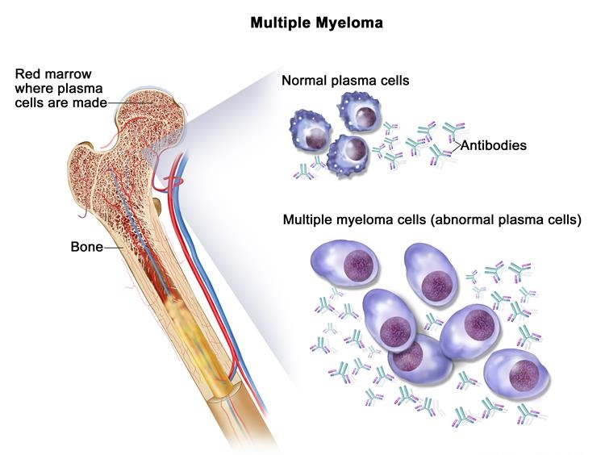
Fig. 1: Plasma cell neoplasm Source: Winslow, 2014

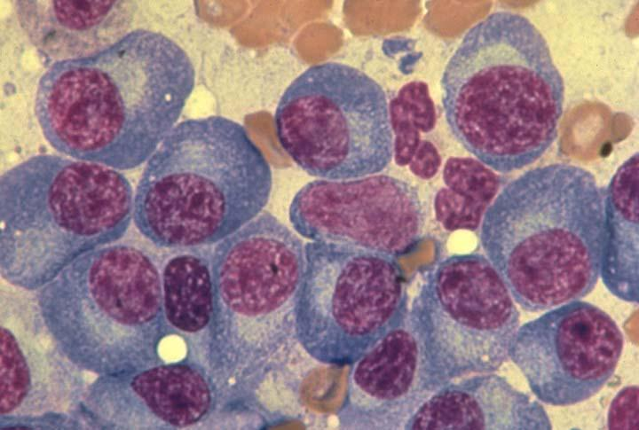
Fig. 2: Bone marrow aspirate demonstrating plasma cells of multiple myeloma. Note the blue cytoplasm, eccentric nucleus, and perinuclear pale zone (or halo). Source: The American Society of Hematology, 2002.

Corresponding author:
Idris Abdullahi Nasir
Department of Medical Laboratory Science
University of Maiduguri
PMB 1069 Maiduguri
Borno State, Nigeria
Email: eedris888@yahoo.com

References
- Ailawadhi S, Aldoss IT, Yang D, Razavi P, Cozen W, Sher T, et al. Outcome disparities in multiple myeloma: a SEER-based comparative analysis of ethnic subgroups. Br J Haematol. 2012; 8(2): 66-71.
- Alao OO, Bazuaye GN, Halim NK, Omoti CE. The epidemiology of Hematological malignancies at the University of Benin Teaching Hospital: A tern-year Retrospective Study. Int J epidemiol. 2010; 9 (2) 34-45.
- Ferlay J, Shin HR., Bray F, Forman D, Mathers C, Parkin D. GLOBOCANv1.2, Cancer Incidence and Mortality Worldwide: IARC CancerBase No. 10. 2008. [Accessed October 2, 2015]. http://globocan.iarc.fr.
- Gopal S, Wood AW, Lee SJ, Shea TC, Naresh KN, Kazembe G. Meeting the challenge of hematologic malignancies in sub-Saharan Africa. Blood. 2012; 119(22):5078-5087.
- Katzmann JA, Dispenzieri A, Kyle R, Elimination of the need for urine studies in the screening algorithm for monoclonal gammopathies by using serum immunofixation and free light chain assays. Mayo Clin Proc. 2006; 81: 1575–1578.
- Kim K, Lee JH, Kim JS, Min CK, Yoon SS, et al. Clinical profiles of multiple myeloma in Asia—An Asian Myeloma Network study. American J Hemat. 2014; Vol. 89, No. 7; 751-756.
- Kyle RA, Gertz MA, Witzig TA. Review of 1,027 patients with newly diagnosed multiple myeloma. Mayo Clinic Proc. 2003; 78:21–33.
- Kyle RA, Rajkumar SV. Criteria for diagnosis, staging, risk stratification and response assessment of multiple myeloma. Leukemia. 2009; 23:3–9.
- Lai YY, Huang XJ, Cai Z. Prognostic power of abnormal cytogenetics for multiple myeloma: a multicenter study in China. Chin Med J (Engl). 2012; 125:2663–2670.
- Landgren O, Weiss BM. Patterns of monoclonal gammopathy of undetermined significance and multiple myeloma in various ethnic/racial groups: support for genetic factors in pathogenesis. Leukemia 2009;23:1691–1697.
- Madu AJ, Ocheni S, Nwagha TA, Ibegbulam OG, Anike US. Multiple myceloma in Nigeria: An insight to the clinical, laboratory features and outcomes. Nig J Clin Pract. 2014; 17 (2) 212- 217.
- Mateos MV, Herndandez MT, Giraldo P. Lenalidomide plus dexamethasone for high-risk smoldering multiple myeloma. N Engl J Med. 2013; 369:438–447.
- Multiple Myeloma Research Foundation; USA. 2012.
- Rajkumar SV. Treatment of multiple myeloma. Nat Rev Clin Oncol. 2011; 8:479–491.
- Rajkumar SV, Larson D, Kyle RA. Diagnosis of smoldering multiple myeloma. New Engl J Med. 2011; 365:474–5.
- Regelink JC, Minnema MC, Terpos E. Comparison of modern and conventional imaging techniques in establishing multiple myeloma-related bone disease: A systematic review. Br J Haematol. 2013;162:50–61.
- Roodman GD. Pathogenesis of myeloma bone disease. Leukemia. 2009; 23:435–441.
- Russell SJ, Rajkumar SV. Multiple myeloma and the road to personalized medicine. Lancet Oncol. 2011. 12:617–619.
- Shah D. Multiple myeloma. Medscape. 2015. http://emedicine.medscape.com/article/204369-overview.
- Waxman AJ, Mink PJ, Devesa SS, Anderson WF, Weiss BM. Racial disparities in incidence and outcome in multiple myeloma: a population-based study. Blood. 2010; 116 (25): 5501-5506.
- What Are the Key Statistics About Multiple Myeloma? American Cancer Society. Available at http://www.cancer.org/cancer/multiplemyeloma/detailedguide/multiple-myeloma-key-statistics. Accessed: March 1, 2015.
- Witzig TE, Laumann KM, Lacy MQ. A phase III randomized trial of thalidomide plus zoledronic acid versus zoledronic acid alone in patients with asymptomatic multiple myeloma. Leukemia 2013;27:220–225.
- World Bank. Agriculture and rural development, 2012 [Accessed October, 2015]. http://data.worldbank.org/topic/agriculture-and-rural-development.
- Zhang L, Qi JY, Qi PJ. Comparison among immunologically different subtypes of 595 untreated multiple myeloma patients in northern China. Clin Lymphoma Myeloma Leuk. 2010; 10:197–204.

10/13/2015

