**Immunohistochemical B-cell markers as current prognostic factors in DLBCL patients**

Fatma Z Hussein1, Eiman A Hasby2 and Esam A abozina1

Department of Clinical Oncology1 and Department of Pathology2, Faculty of Medicine, Tanta University

fatmaz_555@yahoo.com

**Abstract: Objective:** The aim of this study was to identify the prognostic and predictive relevance of CD10, BCL6 and MUM1/IRF4 rearrangements and protein expression in a sample of patients with diffuse large B-cell lymphomas (DLBCL).

**Methods:** This retrospective study was conducted on 60 patients with DLBCL who were treated between January 2009 and September 2013 in Clinical Oncology Department of Tanta University Hospitals. All patients were evaluated by immunohistochemical (1HC) analysis for (CD10, BCL6 and MUM1/IRF4) protein expression. Based on the algorism of Hans et al 2004 patients were biologically subdivided into two groups: Germinal center B-cell (GCB) (n= 30, 50%) and non- GCB phenotypes (n=30, 50%) correlated with IP1score system using CH1-square test and survival (Failure – free and overall) (FFS & OS) using Kaplan- meier.

**Results:** the median age of the present study population was 49.9 years. The median follow- up period was 35 months. Twenty-eight patients (28/60, 47%) were IHC staining positive for CD10, 30 patients (30/60, 50%) were IHC staining positive for BCL6 and 30 patients (30/60, 50%) were IHC staining positive for MUM1/IRF4. Both study groups were matched for age, sex, stage, and treatment protocols received. For response to treatment no significant difference in between both study groups ; however, there was higher objective response rate (CR+PR) in GCB than non-GCB groups,( 74% versus 54%, P=0.309) respectively. Survival analysis based on IHC revealed that inferior outcomes in 3-year OS and FFS with non-GCB versus GCB groups (17% versus 67%, P=0.001) for OS and (44% versus 79%, P= 0.002) for FFS respectively. The statistical analysis at univariate level revealed that non- GCB subgroup did worse independent of IP1 score system. Great negative significant difference was found in the 3-year FFS of non-GCB patients with omission of target therapy (29% versus 75%. P=0.001).

**Conclusion:** Biological markers (CD10, BCL6 and MUM1/IRF4) over protein expression were necessary for antigen receptors driven B-cell proliferation and associated with adverse prognosis and high predictive value independently of the IPI score in DLBCL patients. The number of ongoing clinical studies attests to the search for novel targeted agents tailored toward these specific molecules.

[Fatma Z Hussein, Eiman A Hasby and Esam A abozina.**Immunohistochemical B-cell markers as current prognostic factors in DLBCL patients.** *Cancer Biology* 2015;5(3):149-158]. (ISSN:2150-1041). <http://www.cancerbio.net>. 12. doi:[10.7537/marscbj050315.12](http://www.dx.doi.org/10.7537/marscbj050315.12).

**Keywords:** diffuse large B-cell lymphoma, Hans algorithm, germinal center B-cell like DLBCL, non-germinal center B-cell – like DLBCL, immunohisto- chemistry.

**1. Introduction:**

Diffuse large B-cell lymphoma (DLBCL) is the most common type of aggressive non-Hodgkin's lymphoma (NHL) representing approximately 30-40% of adult NHL*(Arnold S Freedman 2015)*(1). The International Prognostic Index (IPI) is widely used for risk stratification of DLB CL, predict different prognosis using five clinical factors that are age > 60 versus ≤60, An Arbor stage I-II versus III-IV, number of extra-nodal sites of disease > 2 versus < 2, performance status ( PS) 0-1 versus > 2 and serum lactate dehydrogenase (LDH) level normal versus > 1 times normal in the training samples ,then four risk groups were defined as follows: 0 or 1 as low risk, 2 as low- intermediate risk, 3 as high- intermediate risk and 4 or 5 as high risk , these four risk groups had distinctly different rates of complete response (CR), disease-free survival (DFS) and OS *(2013 ASH Annual Meeting)*(2). However, even within these IPI risk groups, a variability in outcome has been observed. Thus, finding new tools to better classify DLBCL patients into different prognostic subgroups is important. DLBCL is a heterogeneous disease, as the microarray analysis showed that patients with DLBCL expressing a gene expression profile (GEP) of germinal center B cells (GCB) have a longer survival than patients of activated B cells (ABC). Since the clinical utility is limited by high cost of microarray analysis, many algorithms were introduced to stratify DLBCL based on the IHC expression profile of CD10 *(Pileri SA 2011)*(3), BCL6 (B-cell/lymphoma 6) *(Falini B et al 2012)*(4) , and MUM1/ IRF4 (multiple myeloma-1/interferon regulatory factor-4) *(Natkunam Y et al 2011)*(5). In DNA microarray studies, mRNA expression of CD10 and BCL6 is suggested to be correlated with GCB phenotype, while MUM1/IRF41 mRNA expression is associated with non-GCB phenotype *(Hans, et al 2004 & Ying Huang, et al 2012)*(6,7).This conclusion was the motive to conduct the present study, address immunohistochemical B-cell markers (CD10-Bcl6-MuM1/IRF4) expression, their association with different prognostic factors including international prognostic index (IPI) risk categorization and their impact on survival (overall survival and failure free survival) in DLBCL patients.

**2. Materials and methods:**

**Patients:**

This retrospective study was carried out on 60 pathologically diagnosed DLBCL patients treated at Clinical Oncology Department, Tanta University Hospitals between January 2009 and September 2013. The study conformed to the accepted ethical standard with approval code number (2030/08/13). All medical files of the patients were gathered and reviewed carefully for the extent of disease, established clinical and histo-morphological factors. Twenty- eight patients received chemotherapy alone CHOP/21 days ( cyclophosphamide, doxorubicine, vincristine and prednisone), 32 patients received immuno-chemotherapy R-CHOP/21 days (Rituximab) and 21 patients received involved field radiotherapy either with chemotherapy or immuno- chemotherapy.

**Immunohistochemistry Study:**

Immunohistochemical staining were performed in Pathological Department on formalin-fixed, paraffin embedded, 4µ sections from patients samples, mouse monoclonal primary antibodies against CD10 (Lab Vision Catalogue # MS-728 - R7), Bcl-6 (Lab Vision Catalogue # MS-1114-R7), and MUM-1 (Dako Clone # MUM1p) were performed at room temperature. The scoring was based on the algorithm described by *Hans CP et al. (2004)*(6) and validated by others, *Berglund M et al. (2005)*(8) *& van Imhoff GW et al. (2006)*(9). Accordingly, the samples were scored positive for CD10, Bcl-6, and MUM-1, if 30% or more of the tumor cells were stained with an antibody. The cases were assigned to GCB group if CD10 alone or together with Bcl-6 was positive. If both CD10 and BCL-6 were negative, the cases were considered to be non-GCB group. If CD10 was negative and Bcl-6 positive, the classification was based on MUM-1expression: if MUM-1was negative, the cases were assigned to GCB group, whereas MUM-1–positive cases joined non-GCB group.

**Treatment Response and Survival Evaluation:**

Assessment of treatment efficacy was made according to RECIST: *(Nishino M et al 2010)*(10) Complete Response (CR): complete disappearance of all target lesions for a period of at least one month. Partial Response (PR): At least 30% decrease in the sum of the longest diameter of measurable lesions (target lesions), taking as reference the baseline sum of the longest diameter. Stationary Disease (SD): Failure to attain CR/PR or PD. Progressive Disease (PD): Any new lesion one or more or increase by 20% or more in the sum of the longest diameter of measurable lesions ( target lesions) taking as reference the smallest sum of longest diameter recorded since the treatment started.

B-cell markers expression were correlated with different prognostic factors including IPI scoring system and survival (FFS&OS) with median follow- up period 35 months( range 8- 50 months). Analysis of data was carried using the Statistical Program for Social Science version 15 (SPSS Inc., Chicago, IL., USA). Description of quantitative variables were expressed as mean, standard deviation, and range, and description of qualitative variables were expressed as number and percent. Chi-square test (χ2) was used to compare between groups regarding the presence of B symptoms, PS scale, affected extra nodal sites number, disease stage, high LDH level. Overall survival (OS) was calculated from the date of diagnosis until last follow- up or death from any cause. Failure free survival (FFS) was calculated from the start of therapy to the date of disease progression, relapse, or disease-or treatment-related death . Statistical analysis was performed at the univariate level by means of Kaplan-Meier techniques, Log-rank test was used to calculate *p*-value.

**3. Results:**

**Immunohistochemistry Results:**

With the aid of IHC staining study among 60 patients pathologically proved DLBCL in the present study, 28 patients were IHC staining positive for CD10 ,BCL6 & negative for MUM1 classified as GCB group. Among the remaining 32 patients, 30 were IHC staining positive for MUM1 and negative for BCL6 and CD10 classified as non GCB group. The remaining 2 patients with IHC staining negative for MUM1, positive for BCL6 and negative CD10 was classified as GCB (Table 1) (Figure 1&2).

**Table 1.** Expression of B Cell markers in all 60 subjected DLBCL patients

|  |  |  |  |  |
| --- | --- | --- | --- | --- |
| B cell marker | Positive | | Negative | |
| n | % | N | % |
| CD10 | 28 | 46.7 | 32 | 53.3 |
| BCL6 | 30 | 50 | 30 | 50 |
| MUM1/IRF4 | 30 | 50 | 30 | 50 |

**Patients, Treatment and Disease characteristics:**

The clinical data, including the five clinical parameters that comprise the IPI scoring system (age, an arbor stage, LDH serum level, extra-nodal presentation and PS) with age ranged from 22-79 years (median, 49.9+10.8 years) in the whole study population. The follow up period ranged from 8-50 months (median, 35 months). The GCB and non -GCB groups were matched as regard to age, sex distribution and stage of disease and treatment protocols received. However ,there were significant patients with low risk and low-intermediate risk IPI scores in the GCB subgroup versus non-GCB group (93% versus 26%, p=0.022) respectively, in contrast to significant patients with high- intermediate risk and high risk IPI scores in the non- GCB subgroup versus GCB subgroup (73% versus 7%, p=0.0001) respectively. In spite of 22 patients (74%) in GCB group versus 16 patients (54%) in non -GCB were responders (CR+PR) and 8 patients (26%) versus 14 patients (46%) were non responders (SD+PD) in GCB and non-GCB groups respectively, there was insignificant statistical difference in treatment response (p=0.309).Patients, treatment and disease characteristics for both study groups (GCB& non GCB) were listed in Table 2.

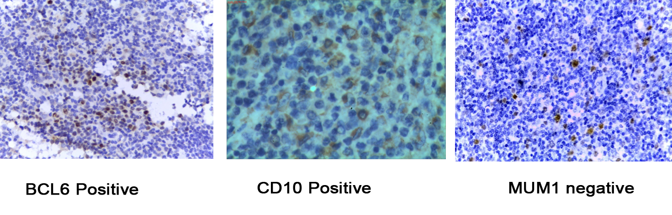

**Figure 1.** For GCB phenotype



**Figure 2.** For non- GCB phenotype

**Survival analysis and Response to treatment:**

To evaluate the prognostic efficacy of the three B-cell markers, we performed survival analysis based on the individual markers alone and in combination. Median OS in GCB group was 43 months (range, 8-50) versus 20 months in non-GCB group (range, 9-43). Median FFS in GCB group was 33 months (range, 5-43) versus 18 months in non-GCB group (range,3-41) According to the current status (n=22, 73%) patients in non- GCB group versus (n=10, 33%) patients in GCB group were died (p=0.002). First, we evaluated 3-year OS and FFS with significant difference in outcome was observed between the two groups. According to the Kaplan-Meier estimates, the 3- year OS rates were 67% versus 17% (p=0.001) in GCB and non-GCB groups respectively (Figure 3). Similarly, the 3- year FFS was 79% versus 44% (p=0.002) in GCB and non-GCB groups respectively (Figure 4). Therefore, we confirmed a proof- of - survival with GCB phenotype in the present study. CR +PR rates in the GCB and non-GCB subgroups were (n=22, 74%) versus (n=16, 54%) respectively but without significant value (p=0.309).

**IPI prognostic power with GCB and Non- GCB groups:**

We also explored the prognostic significance of IPI scoring system, instead of individual included factors in IPI and sub-grouped the patients into LR (IPI score 0&1), LIR ( IPI score 2), HIR (IPI score 3), and HR( IPI score 4&5) within GCB & non- GCB groups in responders (CR+PR) . In GCB group, 11,11,0 and 0 patients had low IPI scores respectively. The 3- year FFS was 80%, 86%, 0% & 0% for IPI scores respectively (P=0.308). In the non- GCB group, 4, 4, 5 and 3 patients had low and high IPI scores respectively. The 3- year FFS was 80%, 86%, 67% & 17% for IPI scores respectively ( p= 0.039). Statistical analysis at the univariate level showed that with the IHC-defined GCB phenotype, clinical characters such as males, young patients, and early stages were associated with a significantly favorable survival rate, independently of other IPI parameters. Whereas these factors were not independently significant prognostic factors in non-GCB group (Figure 5, 6, 7, 8), (Table 3).

**Survival in GCB or Non-GCB groups treated with or without rituximab therapy:**

Among the GCB subgroup, no significant difference was found in the 3- year FFS of patients treated with or without target therapy which were (83% and 74%, p=0.229). However, there were great significant differences in the 3-year FFS of non- GCB patients treated with or without target therapy (75% versus 29%, p= 0.001) (Figure 9, 10), (Table 3). Therefore, we demonstrated that subgrouping determined by the cell of origin on the basis of IHC successfully predicted the prognosis of DLBCL patients treated with the standard regimen.

**Table 2.** Patients, treatment and disease characteristics in both GCB and non GCB groups

|  |  |  |  |  |  |  |
| --- | --- | --- | --- | --- | --- | --- |
| Characteristics | Total No.: 60 | | | | *Chi Square* | |
| Germinal | | Non-germinal | | X2 | *P-value* |
| N 30 | % | N 30 | % |
| Age: |  | |  | | 0.271 | *0.602* |
| Median age | (22-72) | | 49.9+10.8 | |  |  |
| Gender |  |  |  |  |  |  |
| M | 16 | 53 | 18 | 60 | 0.271 | *0.602* |
| F | 14 | 47 | 12 | 40 |
| Current status |  |  |  |  |  |  |
| Alive | 20 | 67 | 8 | 27 | 9.642 | *0.002* |
| Dead | 10 | 33 | 22 | 73 |
| Stage at presentation |  |  |  |  |  |  |
| I | 16 | 53 | 9 | 30 | 3.35 | *0.067* |
| II | 10 | 33 | 11 | 37 |
| III | 4 | 13 | 10 | 33 |  |  |
| I PI risk scoring groups |  |  |  |  |  |  |
| Low R (LR) | 12 | 40 | 4 | 13 | 29.200 | *0.003\** |
| LIR | 16 | 53 | 4 | 13 |
| HIR | 2 | 7 | 6 | 20 |
| High R (HR) | 0 | 0 | 16 | 53 |
| B Symptoms |  |  |  |  |  |  |
| Yes | 6 | 20 | 16 | 53 | 7.179 | *0.007* |
| No | 24 | 80 | 14 | 47 |
| Target therapy |  |  |  |  |  |  |
| Yes | 16 | 53 | 16 | 53 | 0.0 | *1.000* |
| No | 14 | 47 | 14 | 47 |
| RTH |  |  |  |  |  |  |
| Yes | 10 | 33 | 11 | 37 | 0.072 | *0.787* |
| No | 20 | 67 | 19 | 63 |
| Response to treatment |  |  |  |  |  |  |
| CR | 12 | 41 | 8 | 27 | 2.735 | *0.309* |
| PR | 10 | 33 | 8 | 27 |
| SD | 4 | 13 | 4 | 13 |
| *PD* | *4* | *13* | *10* | *33* |

* Significant

**Table 3.** The correlation of 3-year FFS and prognostic factors in patients with objective response (CR & PR) in GCB and non GCB groups.

| **Patients characters** | **3-year FFS** | | ***Chi Square*** | |
| --- | --- | --- | --- | --- |
| **Germinal N=22** | **Non-germinal N=16** | **X2** | ***P-value*** |
| IPI score system: |  |  |  |  |
| Low Risk LR | 80 % | 80 % | 4.259 | *0.039\** |
| Low-Intermediate Risk LIR | 86 % | 86 % |
| High-Intermediate Risk HIR | - | 67% |
| High Risk HR | - | 17% |
| Sex: |  |  |  |  |
| M | 80 % | 44 % | 8.098 | *0.004\** |
| F | 73 % | 44 % |
| B. Symptoms |  |  |  |  |
| Yes | 88 % | 33 % | 6.957 | *0.082* |
| No | 71 % | 57 % |
| Target therapy |  |  |  |  |
| Yes | 83 % | 75 % | 13.677 | *0.001\** |
| No | 74 % | 29 % |
| Radiotherapy |  |  |  |  |
| Yes | 89 % | 61 % | 12.760 | *0.001\** |
| *No* | *38 %* | *25 %* |

* Significant.

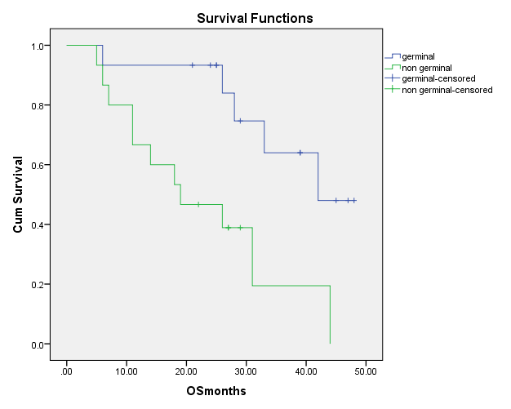

**Figure 3.** 3- year Overall survival (OS) rate in both GCB and non GCB group (P = 0.001)

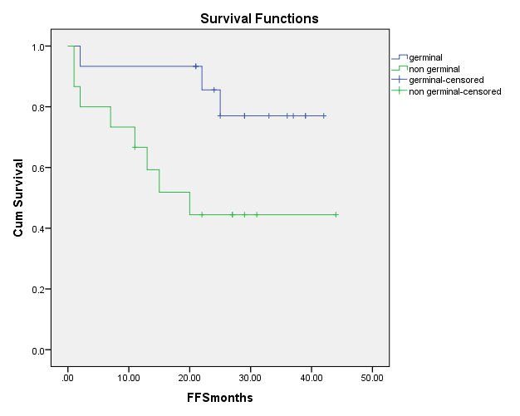

**Figure 4.** 3-year Failure free survival (FFS) rate in both GCB and non GCB (P =0.002)

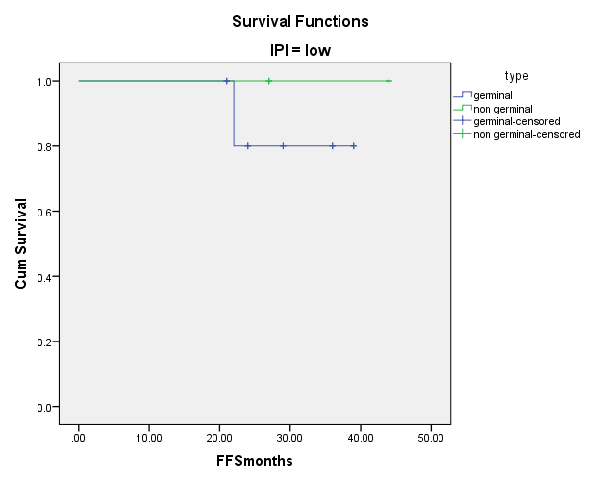

**Survival Functions**

**IPI= low**

**Figure 5.** 3-year FFS of LR- IPI in GCB and non-GCB groups

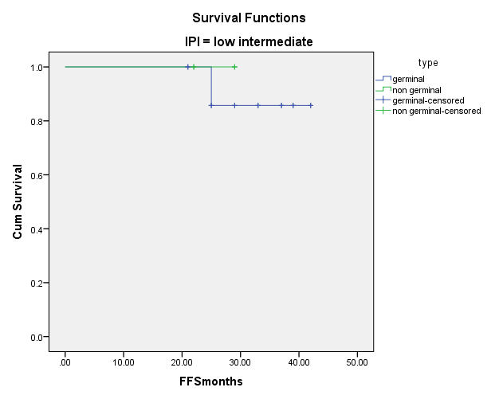

**Survival Functions**

**IPI= low intermediate**

**Figure 6.** 3-year FFS Of LIR-IPI in GCB and non-GCB groups

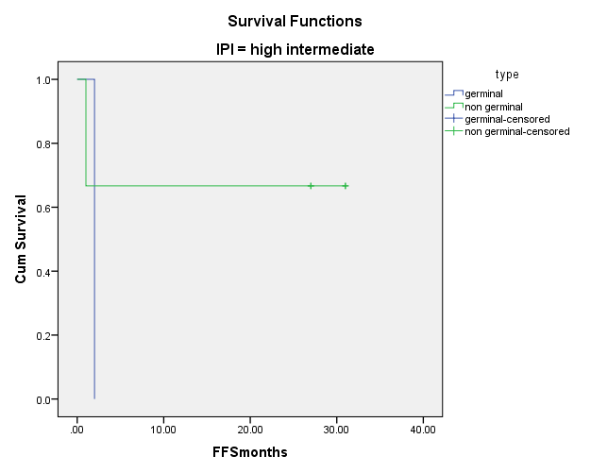

**Survival Functions**

**IPI= high intermediate**

**Figure 7.** 3-year FFS Of HIR-IPI in GCB and non-GCB groups

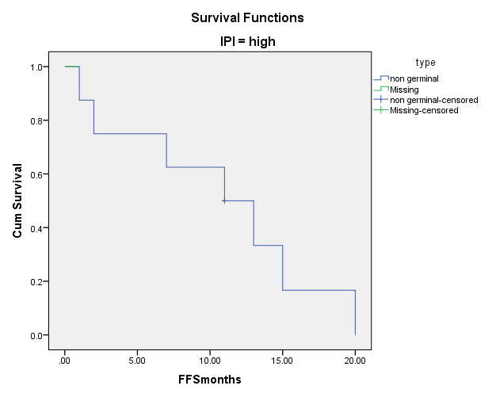

**Survival Functions**

**IPI= High**

**Figure 8.** 3-year FFS Of HR –IPI in GCB and non-GCB groups

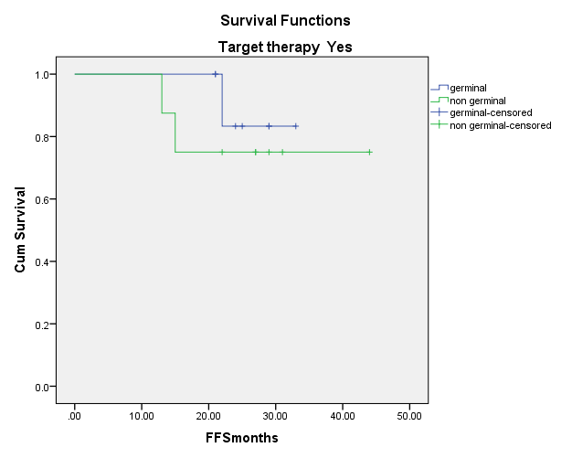

**Figure 9.** 3-year Failure free survival (FFS ) rate in the presence of target therapy in both GCB and non GCB group (P=0.229)

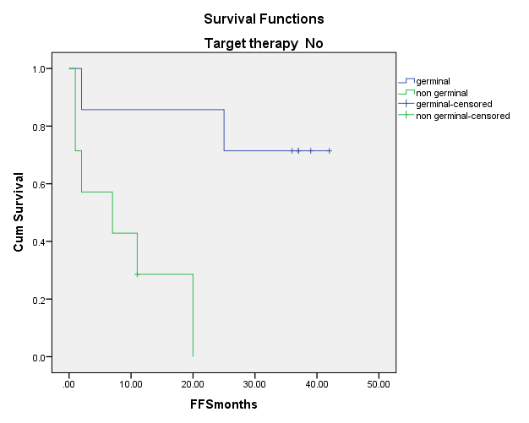

**Figure 10.** 3-year Failure free survival (FFS ) rate in the absence of target therapy in both GCB and non- GCB group (P=0.001)

**4. Discussion:**

DLBCL is a fast-growing, aggressive form of NHL .DLBCL is fatal if left untreated; but with timely and appropriate treatment, approximately 70% of all patients can be cured *(Arnold S Freedman, et al. 2015)*(1). Recently, a significant improvement of the outcome has been obtained by combining a monoclonal anti-CD20 antibody, rituximab with chemotherapy *(Habermann TM, et al. 2006)*(11). Despite the advances, response to treatment is heterogeneous and outcome is often unpredictable. Furthermore, treatment is costly. These facts raise the need to identify more accurately the patients who might benefit from target therapy. In DLBCL, International Prognostic Index (IPI) is considered to be the most important prognostic factor for survival, and therefore the strongest indicator for identification of high-risk patients, who are unlikely to be cured with standard chemotherapy *(Salles G, et al. 2011)*(12). However, age, performance status, stage, number of extra nodal involvement, and LDH level, which constitute the parameters of IPI, do not provide any information of the biologic features of DLBCL, nor predict the response to therapies *(Catherine Thieblemont 2013)*(13). Recently, these results have been translated into a clinically applicable approach using immunohistochemistry, based on the expression of Bcl-6, CD10, and MUM1, subsequently DLBCL can be subdivided into GC and non-GC subtypes, which have been shown to be important outcome predictors for chemotherapy-treated patients *(Natkunam Y,et al.2011)*(5).

Because of the ability of recently developed IHC staining technique to classify DLBCL into GCB and non-GCB

The current retrospective study was conducted and included 60 patients, 30 of them were GCB, DLBCL while the other 30 were non- GCB, DLBCL based on *Hans, et al. (2004)*(6). IPI scoring system in the current study including the five prognostic factors showed 73% versus 7% of patients presented with HIR &HR in non GCB and GCB respectively (p=0.001), patients > 60 years were 60% versus 53% in non -GCB versus GCB group respectively (P= 0.602). This was in agreement with *Wolfram Klapper, et al. (2012)*(14), however *Liu YH, et al. (2008)*(15) reported that a peak age in the sixth decade occurs equally in both GCB and non GCB groups. Males were more common than females in the non -GCB versus GCB groups 60% versus 53%, respectively with insignificant difference (P=0.602), in agreement with that reported by *Luciano J, et al (2008)*(16). Higher PS > 2 among non-GCB group than GCB one representing 53% versus 20%, respectively (p=0.007) in agreement with *Liu YH, et al. (2008)*(15) & *Saad, et al. (2010)* (17). Late presentation, stage III, was more common in non-GCB than GCB group and it was 33% versus 13% respectively (P = 0.067), in agreement with *Berglund M, et al. (2005)*(8), however, *Zhang Zizhen, et al. (2013)*(18) reported that early presentation was more common in non GCB group but also with no statistical significance. Another controversy was reported by *Heidi Nyman, et al (2007) & Ivana Ilic, et al. (2009)*(19,20) who found that either early or late disease stage presented equally in both groups . Extra nodal presentation ≥ 2 sites was common in non-GCB than GCB group 60% versus 33% respectively, (P=0.038). However these results were different from those reported by *Kai Fu, et al. (2008)*(21) who found that extra-nodal presentation whether more or less than 2 sites presented equally in both groups on a study performed on 243 de novo DLBCL patients. B symptoms were associated with 53% of patients of the non -GCB group and 20% of GCB group with statistical significant difference (p=0.007), in harmony with *Berglund, M et al. (2005)*(8), however, *Zhang Zizhen, et al (2013)*(18) found no association of B symptoms with either groups. High serum LDH level was more common in non -GCB group 87% versus 47% in GCB group respectively (P =0.001), similar to aforementioned results of *Liu, YH et al. (2008)*(15) *& Saad, et al. (2010)*(17). Regarding treatment response, higher objective response rate (CR & PR) and lower non responders (SD& PD) were achieved in GCB group 74% & 26% respectively versus 54% & 46% in the non GCB group respectively (p = 0.309), in harmony with *Saad et al. (2010)*(17), however *Ivana Ilic, et al. (2009)*(20) reported similar clinical outcome of patients in both groups , This could be due to early presentation of selected cases.

Regarding survival, the 3- year overall survival rates were better for GCB than non-GCB group and they were 67% and 17% respectively (p = 0.001). For failure free survival, the 3- year FFS rates were better among GCB than non GCB group and it was 79% and 44% respectively (p = 0.002) ,similar to aforementioned results, *Sharon L. Barrans, et al. (2002)*(22), *Hoeller S, et al. (2010)*(23), *Heidi Nyman, et al (2007)*(19), *Ritsuko Seki, et al. (2009)*(24), *Saad, et al (2010)*(17) *& Visco C, et al (2012)*(25),supported the negative impact of non-GCB group on survival. However, *Lluı́s* *Colomo, et al. (2003)*(26), *John Linderoth, et al. (2003)*(27)*& Wilson WH, et al. (2008)*(28) had found no difference in survival between the GCB and non-GCB groups.

Regarding impact of molecular classification of DLBCL with different variables on survival, for age, the 3-year FFS rates were better in the GCB group than non- GCB group at any age range whether >60 or ≤60 years, this difference was statistically significant, (p = 0.003). However ***Wolfram Klapper, et al (2012)***(14) reported that prognostic significance of the molecular subtypes of DLBCL is independent of the patient age. Regarding gender, sex was clearly had no impact on FFS within each GCB and non -GCB groups, however there was significant positive survival with GCB group irrespective to gender (p=0.004). This was in agreement with ***Akiko Miyagi, et al (2012)***(29) who found no association of gender with survival in either groups. Also, serum LDH level, there was no significant difference regarding the impact of serum LDH on survival in GCB group, however the current results showed lower FFS rates for patients with high serum LDH among non GCB group, in agreement with *Akiko Miyagi, et al. (2012)*(29). In the current study, as regard the five prognostic variables of IPI risk categorization there was statistically significant impact on survival (p=0.039) irrespective to molecular basis ,in agreement with[*Shen Yang*](http://link.springer.com/search?facet-creator=%22Shen+Yang%22), *et al. (2009)*(30), *Akiko Miyagi Maeshima, et al. (2012)*(29), *Adam J. Olszewski (2014)*(31), *Zheng Zhou, et al. (2014)* (32) for GCB group all responders had low risk IPI without significant survival difference with non-GCB group, however, the non-GCB group did worse independent of IPI scoring system.

In our series, for patients treated without the addition of rituximab, the 3-year FFS in the GCB subgroup was significantly better than that in the non-GCB subgroup (74% versus 29%, p=0.001). However, such a difference did not exist in patients treated with immunochemotherapy, which suggests that the expression of germinal center markers does not correlate with a more favorable outcome in the rituximab era. The addition of rituximab improved markedly the clinical outcome among the non- GCB group only. The mechanism is unknown but a chemosensitizing effect of the antibody was suggested in previous study *(Koivula S, et al 2011)*(33). Many clinical studies have demonstrated that the poor outcome of ABC-like DLBCL might relate to the constitutive activation of the nuclear factor kappa *β* pathway *(Davis R E, et al 2001)*(34). Lymphoma cell culture studies also showed that rituximab may suppress the constitutively active NF-kB pathway in the non-GCB-type DLBCL via significantly upregulating RKIP expression, resulting in decreased activity of the NF-kB pathway and diminishing NF-kB DNA- binding activity *(Lam LT, et al. 2008*(35) *& Yeung K, et al 2000*(36)*)* and further leading to the enhanced sensitivity of chemotherapy, in agreement with *Nyman, et al. (2007)*(19), *Seki R, et al. (2009)*(24), *Ying Huang, et al. (2012)*(7) *&* *Yan Li, et al. (2014)*(37) where they found that the additional benefit of rituximab confined only to patients with IHC defined non-GCB DLBCL but not to those with GCB DLBCL and reported no difference in survival between GCB and non-GCB subgroups in the post-rituximab era, which implies that the addition of rituximab eliminates the prognostic significance of the classification of DLBCL on the basis of the cell of origin. However, *Zu-Guang Xia, et al. (2010)*(38) *& Kai Fu, et al. (2008)*(21) reported that improved outcome in patients treated with chemo-immunotherapy in both GCB and non-GCB subtypes.

**Conclusions:**

DLBCL is a clinically and biologically heterogeneous group associated with diverse response to optimal therapy, choice of treatment is still based on clinical features only. Recent identification of GCB-like and ABC-like DLBCL subtypes, gain insight of these molecular characteristics, predicting a subset of patients with poor survival who can hopefully benefit from addition of rituximab with cost effectiveness. New entities with clinical relevance are emerging. In the near future, this have a major impact on defining the most appropriate treatment to propose to patients with DLBCL.

**References:**

1. Arnold S Freedman, Jonathan W Friedberg (2015): patient information: Diffuse large B cell lymphoma in adult (Beyond the Basics). Up to date, 30-6-2015 release: 23.7-C23.210.
2. 2013 ASH Annual Meeting : Lymphoma Hub Coverage Dec 6, 2013 , vitamin D . supplementation improves outcomes in DLBCL in elderly patients on Rituximab ..International prognostic index (2014): age- adjusted and revised IP1 for differs large B-cell lymphoma. (last up dated: Aug 15) lymphoma hub.
3. Pileri SA, Ascani S, Sabatini E et al (2011): The pathologist's view point. Part II-aggressive lymphomas. Haematologica; 85: 1308–21.
4. Falini B, Mason DY (2012): Proteins encoded by genes involved in chromosomal alterations in lymphoma and leukemia: clinical value of their detection by immunocytochemistry. Blood: 99:409-426.
5. Natkunam Y, Warnke RA, Montgomery K et al (2011): Analysis of MUM1/IRF4 protein expression using tissue microarrays and immunohistochemistry. Mod Pathol: 14:686-694.
6. Hans CP, Weisenburger DD, Greiner TC et al (2004): Confirmation of the molecular classification of diffuse large B-cell lymphoma by immunohistochemistry using a tissue microarray. Blood.; 103: 275-282
7. Ying Huang, Sheng YE, Yabing CAO et al (2012): outcome of R-CHOP or CHOP regimen for Germinal center and non- germinal center subtypes of DLBCL of Chinese patients. The scientific world Journal, Article ID 897179: pages 7.
8. Berglund M, Thunberg U, Amini RM et al (2005): Evaluation of immunophenotype in diffuse large B-cell lymphoma and its impact on prognosis. Mod Pathol:18:1113-1120.
9. Van Imhoff GW, Boerma EJ, van der Holt B et al (2006): Prognostic impact of germinal center-associated proteins and chromosomal breakpoints in poor risk diffuse large B-cell lymphoma. J Clin Oncol :24:4135-4142.
10. Nishino M, Jagannathan JP, Ramaiya NH et al (2010): Revised RECIST guideline version 1.1: What oncologists want to know and what radiologists need to know. AJR Am J Roentgenol : 195 (2): 281-9.
11. Habermann TM, Weller EA, Morrison VA et al (2006): Rituximab-CHOP versus CHOP alone or with maintenance rituximab in older patients with diffuse large B-cell lymphoma. J Clin Oncol : 24:3121-3127.
12. Salles G, de Jong D, Xie W et al (2011): Prognostic significance of immunohistochemical biomarkers in diffuse large B-cell lymphoma: a study from the Lunenburg Lymphoma Biomarker Consortium. Blood :117(26):7070-8.
13. Caterine Thieblemont and Josette Briere (2013): MYC, BC 12, BCL 6 in DLBCL: impact for clinicls in the future?
14. Wolfram Klapper, Markus Kreuz, Christian W Kohler et al (2012): Patient age at diagnosis is associated with the molecular characteristics of diffuse large B-cell lymphoma. LYMPHOID NEOPLASIA .
15. Yan-Hui Liu, Fang-Ping Xu, Heng-Guo Zhuang et al (2008): Clinicopathologic significance of immunophenotypic profiles related to germinal center and activation B-cell differentiation in diffuse large B-cell lymphoma from Chinese patients. Human Pathology: 39, 875–884.
16. Luciano J Costa, Andrew L Feldman, Ivana N Micallef et al (2008): Germinal center B (GCB) and non-GCB cell-like diffuse large B cell lymphomas have similar outcomes following autologous haematopoietic stem cell transplantation. British Journal of Haematology, 142: 404–412.
17. Abeer A Saad, Nahla M Awed, Zeinab M Abdel-Hafeez et al (2010): Prognostic value of immunohistochemical classification of diffuse large B-cell lymphoma into germinal center B-cell and non-germinal center B-cell subtypes. Saudi Med J :31(2):135-141.
18. Zhang Zizhen, Cao Hui, Shen Yanying (2013): Correlation Between Immunophenotype Classification and Clinicopathological Features in Chinese Patients with Primary Gastric Diffuse Large B-Cell Lymphoma. Pathol Oncol Res : 19:317–322.
19. Heidi Nyman, Magdalena Adde, Marja-Liisa Karjalainen-Lindsberg et al (2007): Prognostic impact of immunohistochemically defined germinal center phenotype in diffuse large B-cell lymphoma patients treated with immunochemotherapy. 109(11): 4930-4935.
20. Ivana Ilic´, Zdravko Mitrovic´, Igor Aurer et al (2009): Lack of prognostic significance of the germinal-center phenotype in diffuse large B-cell lymphoma patients treated with CHOP-like chemotherapy with and without rituximab. Int J Hematol: 90:74–80.
21. Kai Fu, Dennis D Weisenburger, William WL Choi et al (2008): Addition of Rituximab to Standard Chemotherapy Improves the Survival of Both the Germinal Center B-Cell–Like and Non–Germinal Center B-Cell–Like Subtypes of Diffuse Large B-Cell Lymphoma. J Clin Oncol 26:4587-4594.
22. Sharon L Barrans, Simon Crouch, Mathew A Care et al (2012): Whole genome expression profiling based on paraffin embedded tissue can be used to classify DLBCL and predict clinical outcome. British Journal of Haematology, vol 159 Issue 7. Abstract.
23. Hoeller S, Schneider A, Haralambieva E et al (2010): FOXP1 protein overexpression is associated with inferior outcome in nodal diffuse large B-cell lymphomas with non-germinal centre phenotype, independent of gains and structural aberrations at 3p14.1. Histopathology.;57(1):73–80.
24. Ritsuko Seki, Koichi Ohshima, Tomoaki Fujisaki et al (2009): Blackwella Prognostic impact of immunohistochemical biomarkers in diffuse large B-cell lymphoma in the rituximab era. The official journal of the Japanese Cancer Associations. 100(1): 1842-1847.
25. Visco C, Li Y, Xu-Monette ZY, Miranda RN (2012): Comprehensive gene expression profiling and immunohistochemical studies support application of immunophenotypic algorithm for molecular subtype classification in diffuse large B-cell lymphoma: a report from the International DLBCL Rituximab-CHOP Consortium Program Study :26(9):2103-13.
26. Colomo L, Lopez-Guill ermo A, Perales M et al (2003): Clinical impact of the differentiation profile assessed by immunophenotyping in patients with DLBCL .Blood , 101. 78-84.
27. Johan Linderoth, Mats Jerkeman, Eva Cavallin-Ståhl et al (2003): Immunohistochemical Expression of CD23 and CD40 May Identify Prognostically Favorable Subgroups of Diffuse Large B-cell Lymphoma. Clinical Cancer Research. (9):722–728.
28. Wilson WH, Dunleavy K, Pittaluga S et al (2008): Phase II study of dose-adjusted EPOCH and rituximab in untreated diffuse large B-cell lymphoma with analysis of germinal center and post-germinal center biomarkers. J Clin Oncol.; 26(16):2717-24.
29. Akiko Miyagi Maeshima, Hirokazu Taniguchi, Suguru Fukuhara et al. (2012): Bcl-2, Bcl-6, and the International Prognostic Index are prognostic indicators in patients with diffuse large B-cell lymphoma treated with rituximab containing chemotherapy. The official journal of the Japanese Cancer Associations. 103(10): 1898-1904.
30. Sehn LH, Berry B, Chhanabhai M et al (2007): The revised international prognostic index (R-IPI) is a better predictor of outcome than the standard IPI for patients with diffuse large B-cell lymphoma treated by R-CHOP. Blood :109:1857-61.
31. Adam J Olszewski (2014): 1308 utility of the international prognostic index (IPI), revised IPI and a model – Based score for risk stratification of DLBCL in the national cancer data base (NCDB). December 6, 2014, 56th ASH Annual meeting and exposition , san Francisco, CA .
32. Zhen Zhou, Laurie H Sehn, Alfred W et al (2014): An enhanced International Prognostic Index (NCCN-IPI) for patients with DLBCL treated in the rituximab era. Blood Journal 123:6:37-842.
33. Koivula S, Valo E, Araunio P et al (2011): "Rituximab regulates signaling pathways and alters gene expression associated with cell death and survival in DLBCL, Oncology reports, vol 25, no 4 pp. 1183-11950.
34. Davis RE, Brown KD, Siebenlist U et al (2001): "constitutive nuclear factor kB activity is required for survival of activated B-cell like DLBCL cells, Journal of Experimental medicine, vol 194, no 12, pp 1861-1874.
35. Lam LT, Brown RE, Sieben U et al (2008): "compensatory 1K Kα activation of classical NF-KB signaling during 1kk β inhibition identified by an RNA interference sensitization screen", proceedings of the National Academy of Sciences of the United States of America, vol 105, no 52, pp 20798-20803.
36. Yeung K, Janosch P, Mcferran B et al (2000): mechanism of suppression of the RAF/MEK/ extra cellular signal- regulated kinase pathway by the Raf kinase inhibitor protein " molecular and cellular biology, vol 20, no 9, PP 3079-3085.
37. Yan Li, Maimaitili Yimamu, Xiaomin Wang et al (2014): Addition of rituximab to a CEOP regimen improved the outcome in the treatment of non-germinal center immunophenotype diffuse large B cell lymphoma cells with high Bcl-2 expression Int J Hematol : 99:79–86.
38. Zu-Guang Xia, Zi-Zhen Xu, Wei-Li Zhao et al. (2010): The prognostic value of immunohistochemical subtyping in Chinese patients with de novo diffuse large B-cell lymphoma undergoing CHOP or R-CHOP treatment. Ann Hematol 89:171–177.

11/16/2015