An investigation study on SNP frequency of rs1127354 and rs7270101 in ITPA gene of infertile patients

Fahime Mollaahmadi, Mehrdad Behmanesh, Ashraf Moini

Faculty of biological science, Tarbiat Modares University
FahimeMollaahmadi@chmail.ir

Abstract: Infertility is a relatively common problem that affects couples worldwide. It is estimated that approximately 1 in 6 couples will experience difficulties in reproducing, defined as a failure to conceive after two years of unprotected sexual intercourse. The molecular and genetic factors underlying the cause of infertility remain largely undiscovered. In human, ITPA, an inosine triphosphatase (ITPase), has been reported to hydrolyze (d) ITP and XTP to the corresponding nucleoside monophosphates and pyrophosphates. An understanding of the role of ITPA in human cells is important because in humans, some variants of ITPA are reported to be associated with decreased ITPase activity. The human genomic DNA of all patients was extracted from peripheral blood cells using salting out method in order to determine the single nucleotide polymorphism (SNP) of ITPA (rs1127354). SNP genotyping was performed by RFLP-PCR. This study sought to to investigate and clarify, for the first time, the understanding of this genetic association in a cohort of infertile patients. This study explored the association between inosine triphosphatase (ITPA) Functional variants; SNPs rs1127354 (missense variant in exon 2) and rs7270101 (splicing-altering SNP in second intron), and the development of infertility, and explored the relationship between ITPA variants and therapeutic response. It seems that rs1127354 / rs7270101 variants could be a genetic determinant for defective gametogenesis or decreased fertility.
[Fahime Mollaahmadi, Mehrdad Behmanesh, Ashraf Moini. An investigation study on SNP frequency of rs1127354 and rs7270101 in ITPA gene of infertile patients. Cancer Biology 2015;5(3):15-28]. (ISSN: 2150-1041). http://www.cancerbio.net. 3

Keywords: ITPA, SNP, infertility

- Introduction
Infertility is the inability of couples to prevent pregnancy after one year of unprotected intercourse, and one in every six couples are said to be included (1). More pregnancies that occur when near the 6 days before ovulation (about the fourteenth day of the menstrual cycle) is a small number of pregnancies occur after the day of ovulation. Fertility in men and women at the age of 24 is the maximum and then decreases. 15% of couples fail to conceive despite trying to get pregnant within a year. 20% of all cases of infertility are due to male infertility and only 30 to 40% of cases the cause of infertility in both men Is.

1-1- Epidemiology of Infertility
Infertility prevalence rate in the country is 20.2% of the global average of 12 to 15% is far In the cities, rates of 9/19 and in rural areas 22 percent. This high percentage is the prevalence of the whole country, because, according to the World Health Organization (WHO) Infertility in the world average is 12 to 15 percent. The average age of first pregnancy, women in the country is 21.1 years in cities and in rural areas the average age of first pregnancy of 21.2 years 20.4 years. The average age of men in the country at the time of marriage was 25.4 years and the average age of women at marriage is based on studies conducted in urban areas and 25.6 in rural areas is 24.1 years.
About 30% of All Couples At Iran At Reproductive years Your infertility Experience (2). Analysis of systematic From 277 Poll Health epidemics Infertility (National, regional and global) Since 1990 Show that 48.5 million Couples are able to Having children During 5 years At 2010 was (3). Infertility issues are also evident in developing countries, and not having children has a negative psychological consequences and leads to social turmoil there. Nearly 70 million couples worldwide are infertile and assisted reproductive technology is expensive, especially in developing countries not afford infertility (4).
Researches a urologist and researcher in the field of infertility prevalence of infertility in Iran in Iranian couples show that the total amount of about eight percent. The above study is the result of three years of study on 12 thousand and 285 couples in 30 provinces of the country, the examples have been chosen cluster. The couples in the age group 15 to 50 years and in four age groups 15-24, 25-29, 30-39 and 40-50 years were classified and evaluated. 74% of infertile married and 26 percent were divorced, 81 percent of urban and 19 percent rural, 69 percent were housewives and 31% were employed. In addition, 25% of infertile and fertile women were highly educated 38/6 percent.
Infertility, including two primary types (infertility since married) and secondary (after a period of infertility, fertility) is. The results showed that the total fertility rate in Iran is about eight percent, which is 4.6% of primary infertility and secondary infertility, it is 3.4. Infertility rate in the age group 15-24 years, 2.5% and 1.5% of secondary age group 25-29 years, 2.9% and 2% of secondary infertility, the age group 30 to 39 years (3.3%) and primary infertility 3.3% of the age group 40 to 50 years and 10% of secondary and primary and secondary is seven percent. Based on the results obtained, illiteracy doubled the risk of infertility increases the risk of infertility in people with high school education are nearly three times those who are university graduates. The rate of infertility among couples with primary education and 1.4 times those with a college education He said. Race (white, black, blond, etc.) and body mass index did not increase or decrease the infertile couples. Women smokers, 2.2 times that of women smokers are faced not with infertility. Also, women who smoke before, but it had left a year and 2/1 of women who did not smoke, the risk of infertility in them. The risk of infertility among men who are smokers, non-smokers and 2.3 times in men and 2.5 men who quit smoking one year after they have passed. Based on these results, the risk of ovarian and tubal infertility among women who have had surgery three times the normal female. 2.3 times the risk of infertility among couples urban rural couples. The rate of infertility among men who have to inject anabolic hormones gym or 2.8 Astrvnyd drugs such action against those who did not.
The best reproductive age for women between 23 and 24 years, the rate gradually reduced to the extent that at the age of 30 years less. Fertility after age 35 due to a drop in the number of eggs and their quality is reduced. Because of the prevalence of infertility and, if pregnancy occurs after age 35, the risk of complications to the mother and fetus more. Also from this age, the success rate of infertility treatments will be less. Men's fertility decreases after the age of 40 years. Pregnancies after age 35 are complications. The prevalence of abortion after more than 35 years since it began to lose its quality eggs, also increases risk of miscarriage. In pregnancies after 30 years, the risk of high blood pressure and diabetes during pregnancy increases the risk. It also increases the risk of fetal malformations. In addition, fetal growth problems and other illnesses are also mother and fetus in pregnancies after age 35 threatened.
Several different causes of infertility In many cases, infertility may have more than one cause. Common causes of infertility include abnormal sperm (35%), ovulation disorders (25%), pelvic adhesions, a Ndvmtryvz, fallopian tube defects uterine problems (25%) And 5% to 10% of couples in particular can not be recognized as a cause of infertility. (5).

2. Materials and Methods

2-1- Solutions and buffers
And buffer solutions used in this study are as follows:

Prepare a solution of EDTA (0.5 M & pH = 8) the volume of one liter
EDTA | 1/186 g
NaOH | 20 grams
Deionized distilled water twice | The final volume of 1 liter

The above-EDTA twice distilled deionized water to 800 ml in a clean glass container and a magnetic stirrer were added. Then by adding tablets NaOH, pH 8 solution was reached. After the pH of the solution to 8 reaches its final volume by adding water twice distilled brought a liter, then the pressure psi 15 autoclave for twenty minutes and was kept at room temperature.
Enzymes:
- RT (Reverse Transcriptase) To construct cDNA
- Limiting enzyme of XmnI (Pdmnl) For genotyping SNPs in rs7270101 And rs1127354 Used.

2.2. Kits
1. Purification kit DNA (Amynsan companies) of the company (Bio Basic EZ-10 Spin Column DNA Gel Extraction Kit) For mining DNA Of blood was used.
2. Kit for purification of RNA (the company Cinnagen) RNX name was used for RNA extraction from blood.
3. Hot Taq MasterMix for PCR amplification kit was used.
4. EvaGreen MasterMix for realtime PCR kit was used.

2.3. Furniture
Microtubes (0.2 ml, 0.5 ml, 1.5 ml), Falcon (15 ml), tubes containing EDTA, human, graduated cylinder, balance, filter paper, the sampler (yellow, blue, crystal).

2.4 Methods

Collecting blood samples
Samples from infertile couples who referred to Royan Institute, Center for Infertility Clinic in Tehran in 1393 was taken. Control samples were from patients themselves or their close relatives had no history of infertility. After sampling, the ethylene diamine tetra-acetic acid-containing tubes (EDTA) Was used as an anti-coagulation. 5 ml tubes containing peripheral blood slowly EDTA Was transferred. It should be noted that sampling is a written permission from patients and healthy. To investigate the expression of tissue samples from infertile couples the cause of recurrent miscarriage (more than 3 abortions) were prepared. Aborted fetuses less than 12 weeks by the mother in the sample container and the ice was delivered at the right temperature and quickly to the laboratory for extractionRNA Moved.

2.5. Steps (according protein Cinnagen Cole):
- One ml RNX ^{plus} (Company Cinnagen) frozen Hmvzhnayzh was added to the microtube containing the sample, and after 5 to 10 seconds Vertex, were kept at room temperature for 5 minutes.
- 200 ml of chloroform were added to the solution, gently shake was given 15 seconds to a milky solution becomes homogeneous. Milky solution is a sign of protein denaturation.
- The sample was incubated on ice for 5 minutes.
- Samples for 15 min at 4 ° C and away 12000 rpm Were centrifuged.
- Upon completion of the centrifugation, three phases were formed, the upper phase containing a transparent liquid RNA Is. Slowly the phase separated and transferred to a new microtube. Protein DNA There are middle and lower phases so as to avoid contamination with protein DNA Must be very carefully and slowly to the upper phase is the new micro tubes.
- The top phase was transferred volumes cold isopropanol was added and the mixture was incubated for 20 min on ice. (At this stage in order to achieveRNA More, the samples overnight at -20 ˚ C Was held.)
- Samples at 4 ° C and away 12000 rpm Was centrifuged for 15 minutes. The white precipitate action RNA In the bottom of the microtube was formed.
- The top phase was discarded and 500 ml 75% ethanol was added to precipitate the removal of sediment from the bottom of micro tubes, each of which were for a few seconds vortex.
- Samples at 4 ° C 7500 rpm Was centrifuged for 8 minutes. Only to be washed ethanol precipitate.
- The supernatant was discarded. By tilting up micro tubes were allowed to precipitate at room temperature to dry.
- Depending on the amount deposited in the appropriate volume (30 - 50 ml) of deionized water treated with DEPC Solved.
- In order to solve better RNA Samples for 5 minutes at 55 ˚ C Incubated.
- Micro tubes containing RNA At ˚C 80 were kept.
    - Qualitative and quantitative study RNA Extracted
After extracting RNA, the quantity and quality was determined by spectrophotometry and agarose gel electrophoresis.

Spectrophotometry
To determine the concentration, absorbance of the solution at 260 nm was measured RNA RNA concentration is indicated. To determine the purity of RNA from Ratio Used.

Agarose gel electrophoresis
RNA sample obtained chemically Intact and biologically standard quality, the special banding pattern on agarose gel shows. 18S and 28S ribosomal RNA bands indicate the presence of the RNA is intact. Examples of excellent quality, at least smear above, between and below these bands show and 28S band intensityalmost 18S is a double bond. 28S and 18S bands lack a clear indication of RNA degradation by the enzyme is RNAase, especially if the smear on the bottom of the gel.

Expression of the gene variants ITPA
In this study, the reaction Real-time RT-PCR was performed on the basis of SYBR Green techniques. The primers were designed and prepared.

Design and preparation of primers
For amplification of the gene variants ITPA It was designed primers. Primers are designed using the software Gene Runner Was performed in Software OligoWere also Czech. The primers designed Blast And specificity of the binding sites in the human genome was confirmed. In order to prevent the proliferation of those products PCR Caused by infection DNA Their genome, upstream primers were designed on the boundary between exons, thus the difference in the size of the piece Tksyrshvndh, product RT-PCR Will be recognizable. Also, since the main purpose of this study was to investigate the expression of genes using a technique Real Time-RT PCR It was, we tried as much as possible the size of the fragments is small. Primers designed and built by the company was taken over Lyvflyz·h powder.

Table 1: primers designed to determine the expression of two gene variants ITPA
Replicating sequence | Sequence | Called oligo
192 bp | 5 -AAGAAGCTGGAGGAGGTCG -3 | Forward ITPA Var 1
 | 5 - TCCAAGGGCATTGAAGCACAG - 3 | Reverse ITPA Var 1
190 bp | 5 - GGCGGCCTCATTGGTCGT TC - 3 | Forward ITPA Var 2
 | 5 - TCCAAGGGCATTGAAGCACAG - 3 | Reverse ITPA Var 2

For the preparation of primers including the amount recommended by the manufacturer, deionized distilled water was added to each primer so that eventually the concentrations of all primers at 100 pmol / μ l Respectively. The dilution of 5 mM solution was prepared and was used as a working solution. Primer solutions were stored at -20 ° C. In order to ensure specificity of amplified products and achieve proper fusing temperature of primers, for each of them on a cDNA, PCRTemperature gradient was made.

2-6 reverse transcription reaction (Reverse Transcription)
After the cDNA, RNA should be on it. All steps of cDNA synthesis was performed in microtubes RNAase Free and ice.

Table 2: Materials for any volume of 20 ml Reaction cDNA synthesis
Primer oligo dT (5μg / μl) | 1 ml
RNA was extracted samples as a template | Due to the concentration of RNA was extracted
Double distilled water treated with DEPC | The final volume of 12 ml
Enzyme 5X RT buffer [Fermentase] | 4 ml
Mix dNTP (10mM) [fermentase] | 3 ml
RNAase enzyme inhibitors [Fermentase] | 8/0 ml
Enzyme RT (200 unit / μl [fermentase]) | 8/0 ml

2.7 steps
- In micro tubes for the synthesis of cDNA, depending on the concentration of RNA, the right amount of it was poured, necessary for determining the concentration of RNA to cDNA synthesis is using a spectrophotometer. After removing the right amount of RNA, an oligo dT as a primer ml, and 5.0 mlRNAase Inhibitor was added to it with double distilled water treated with DEPC to the volume of 12 ml was reached, and then for 10 minutes at 70 ° C was placed in a thermocycler. By doing this RNA secondary structures can be disassembled.
- During these 10 minutes, the mixture Reaction Buffer was prepared. The new micro tubes in a 4 ml (5X), Reaction buffer 3 ml 10mM dNTP, 5/0 ml and 8.0 ml enzyme RNAase Inhibitor was poured and mixed well. At the end of 10 minutes, 8 ml micro tubes was removed and the mixture Reaction Buffer was added to it. The reaction mixture was then spin and vortex for two hours at 42 ° C was placed in the machine. The temperature Extension and cDNA synthesis is carried out. CDNA synthesis for the next steps in -20 or -80 oC.

- Results

3.1 Sampling and patient information
A total of 164 blood samples from infertile patients (41 males and 118 females) and 180 blood samples of healthy individuals (48 men and 132 women) and 6 embryos were collected. The mean age of patients 9/7 ± 4/31 and the mean age of control group was 2/6 ± 1/28. In tissue samples after extraction RNA And preparation cDNA, Samples of variant gene expression ITPA Were evaluated and blood samples after extraction DNA Intron and exon abundance of two common polymorphisms ITPa Were examined.
In the case of DNA, 75% of patients were female and 25% were male ratio 4.3: 1 female to male shows. According to medical records, 72% of primary infertility and secondary infertility was 28%. Number 32 male and 68 female healthy volunteers who had no history of any disease. The mean age of patients and the mean age of control group 9/6 ± 7/31 6/9 ± 8/26 years. In patients, the cause of infertility, 4/35 male factor%, 1.34%, polycystic ovarian syndrome and 2/12% had a history of recurrent miscarriage. Two control groups of the population living in Tehran.

3.2 The genomic DNA
500 mL of peripheral blood were used for DNA extraction. All the samples Blood purification kit DNA (Amynsan companies) of the Company (Bio Basic EZ-10 Spin Column DNA Gel Extraction Kit) for extracting DNA from whole blood were extracted. Quality DNA samples were analyzed on 1% agarose gel. Single-band indicates the quality of the extracted DNA. Concentration of 100 ng of DNA with a spectrophotometer identified and extracted from the solution for PCR was used.

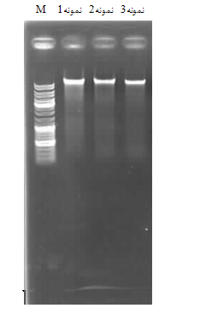
Figure 1: Genomic DNA was extracted samples By qualitatively analyzed on agarose gel

3.2.1. Temperature gradient PCR results for genotyping primer
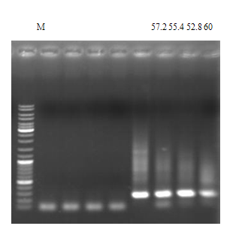
Figure 2: PCR Temperature gradient of 256 bp fragment of polymorphism rs1127354. Temperature in degrees Celsius.

To determine the proper temperature bonding primers, PCR primer pairs for each of the temperature gradient between Snape was performed (Figures 3-2 and 3-3). Temperature range, according to the company producing the sheet guide primers and thermal Software GeneRunner was proposed. Table 3-1 Selectedoptimal temperature for each Snape shown.

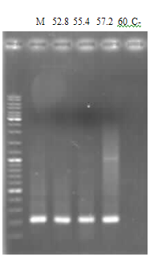
Figure 3: PCR to amplify a fragment of 204 bp temperature gradient polymorphism rs7270101. Temperature in degrees Celsius. C- negative control.

Table 3: Selected optimal temperature for each Snape
Tm Optimum (° C) | Temperature range (° C) | Size (bp) | SNP
55 | 60-8 / 52 | 256 | rs1127354
55 | 60-8 / 52 | 204 | rs7270101

3-2-2- Digestion with restriction enzymes
Both Snape PCR product as directed enzyme XmnI were digested overnight at 37 ° C and on. The size of the fragments (bp) expected in the presence of different alleles for each listed in Table 3-2 Snape. Enzymatic digestion products were used in 12% acrylamide gel (Fig. 1 and 3).

Table 4: Parts of digestion
Homozygous mutant | Heterozygote | Wild type | Uncut | SNP
256 | 28 + 228 + 256 | 28 + 228 | 256 | rs1127354
29 + 175 | 29+ 175+ 204 | 204 | 204 | rs7270101

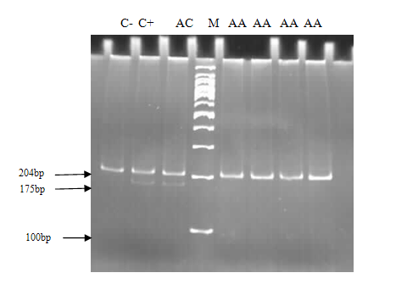
Figure 4: Results of enzyme digestion to Snape rs7270101. Fragments PCR Using specific primers, enzymes XmnI For overnight Digested and then on PAGEWere analyzed.
AA = wild type, CC = homozygous mutant, AC = heterozygote, C + = control +, C- = control –

3.3. gene expression in the fetus aborted recovery system
The parent embryo rs1127354 Both were heterozygous familial than not. Embryos at 12-8 weeks of pregnancy abortions are:
- The first embryo of a miscarriage after a healthy child (8 years old), a spontaneous abortion at eight weeks pregnant and had an ectopic pregnancy.
- The second was the result of an aborted fetus after a successful pregnancy
- Third embryo of a miscarriage after two successful pregnancy (a girl and a boy) was
- The fourth baby was the result of RPL for the third time
- The second abortion was the fifth fetal outcome
- Six embryos of a IUFD, A Blighted, And three abortions in the seventh and sixth weeks.
- Gene MSH2 None of the samples showed no significant expression.

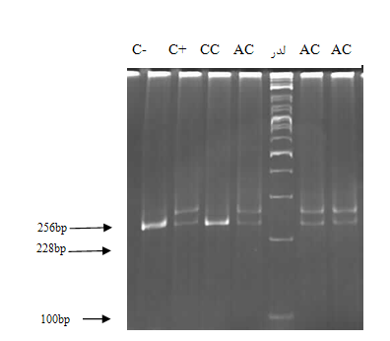
Figure 5: Results digestion for SNPs rs1127354. PCR fragments with specific primers, enzymes XmnI for overnight digestion and then analyzed on PAGE.

Figure 6: Comparison of gene expression based on the ΔCt obtained Itpa per fetuses

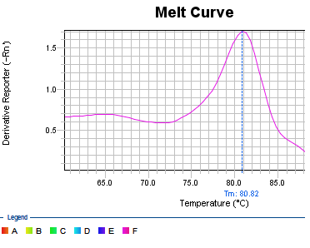
Figure 7: Diagram Melt Curve The amplified gene Itpa

Figure 8: Comparison of gene expression MTH1 According to ΔCt Obtained in any of embryos

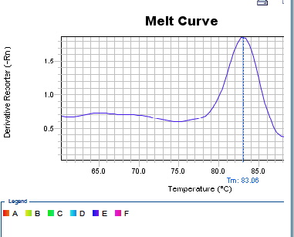
Figure 9: Diagram Meltcurve The amplified gene MTH1

Figure 10: Comparison of gene expression OGG1 on ΔCt achieved in the fetal sample

3.4 The statistical analysis

Hardy-Weinberg equilibrium in patients and healthy for Snape
To assess the deviations from Hardy-Weinberg equilibrium in patients and healthy for Snape studied the chi-square test ¹ with a significant level of p≤ 0.05 and 2 degrees of freedom was used. The results of any significant deviation from Hardy-Weinberg equilibrium was observed in the proportions predicted. The patient and control populations for desired Snape were in Hardy-Weinberg equilibrium.

Table 5: Genotype and allele frequencies for the Snape rs7270101 And balance HW Healthy group
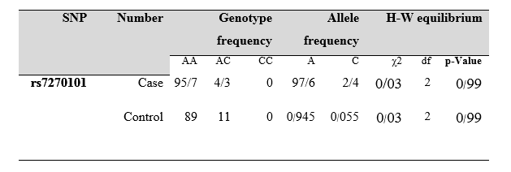

Table 6: Genotype and allele frequencies for the Snape rs1127354 And balance HW Healthy group
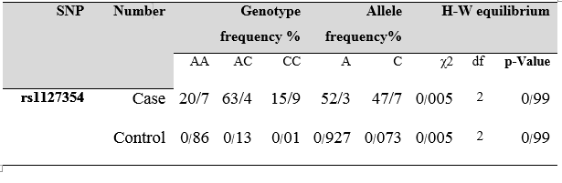

Genotypic and allelic frequencies for the Snape studied in patients

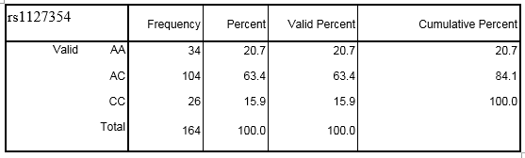
AA = homozygous normal, AC = heterozygous, CC = homozygous mutant

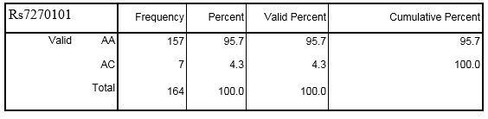

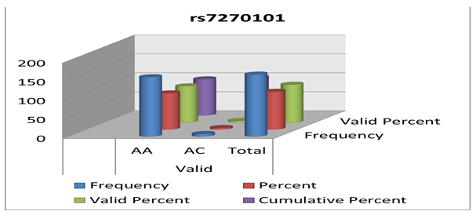

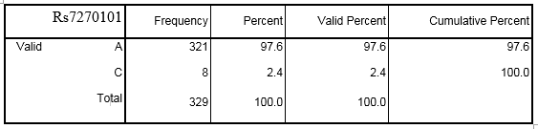

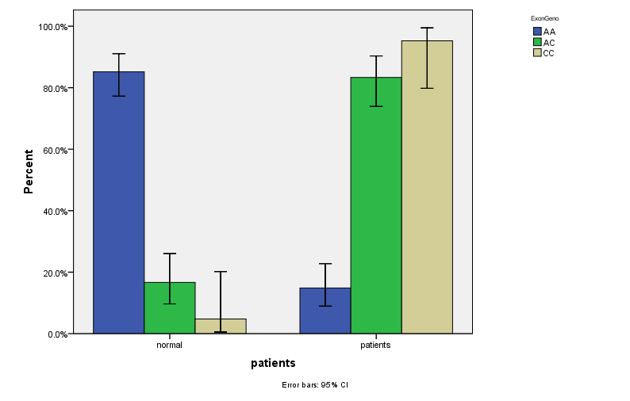
Figure 11: Compare genotypic frequencies of polymorphisms in exon normal and infertile (Rs1127354)

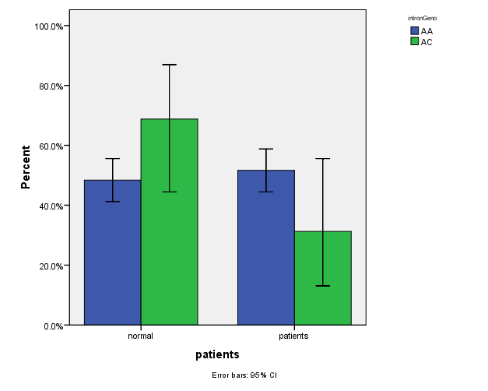
Figure 12: Comparison of normal and infertile genotypic frequencies of polymorphisms of introns (Rs7270101)

Snap significant differences in rs1127354 (P value <0.000) between genotypic frequencies of normal and mutant homozygous and heterozygous infertility can be seen in as 28.66 and 114.66 against pathogenic (infertility) is increased and so is likely to be made Polymorphism considered one of the causes of infertility.

Table 7: compare genotypic frequencies in normal and infertile Snape rs 7270101 using regression analysis
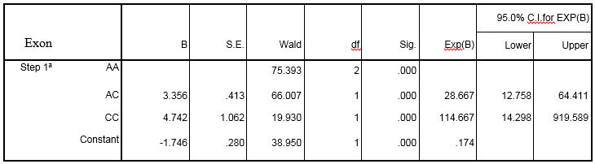
Snap significant differences in rs7070101 (Pvalue: 0.127) between the control group and genotype frequency of infertility is found.

- Conclusions and recommendations

4.1 Infertility
The failure and repeat hormonal treatments and assisted reproductive therapies in addition to damaging psychological effects on couples and families, many health complications following the use of steroids will. The world of the treatments by targeting the main causes and mechanisms involved in the regulation of genes is going to reduce the complications. Infertility in as many candidate genes have been studied, but there are few studies to evaluate the effective genes.Genetic infertility is very complex and depends on many factors. Genetic factors can produce germ cells, gametes exposure can affect fetal growth and development. Genetic disorders are genetic, are monogenic or multifactorial. Knowledge and understanding of the genetic background of infertility and pharmaceutical regimens by providing safer and easier and more effective to help people with physical health. Reproductive physiology processes endocrine, paracrine and autocrine fashion several. All these processes are regulated by a large number of genes and discrepancies in each of these pathways can lead to infertility.
Two mechanisms associated with defects caused by mutations P32T ITPA there. The first is related to the mechanism of splicing. In Asplasyng sequence protected with SnRNAs splicing sites are identified. In addition conserved sequences, other sequences are also Asplasyng elements Asplasyng extinguisher intron / exon (ESS / ISS) and reinforcing elements Asplasyng intron / exon (ESE / ISE). Serine and arginine-rich sequence by proteins (proteins SR) and heterogeneous nuclear Rybvnvklyvprvtyyn (hnRNP) are identified. Reinforce or inhibit the binding of these proteins are Asplasyng.

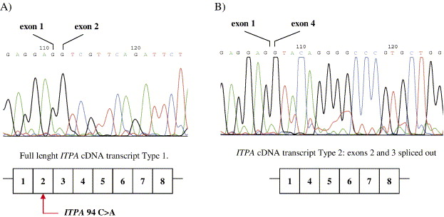
Figure 13: Details for the sequence cDNA of ITPA. A) cDNA sequence of ITPA gene that is naturally trimming. B) sequencing of cDNA gene exons 2 and 3 has been removed due to incorrect premises have.

In exon 2, upstream of real Asplasyng '5 + 1 position (border of exon - intron), two Asplasyng '5 secret 19+ and 35+ in the position identified by sequence homology to the real Asplasyng. In normal circumstances these two places Asplasyng secret cells due to ESS in exon 2 are disabled. The ESS includes P32T polymorphism also. Despite the normal allele A, ESS has been active and is therefore used only the real Asplasyng. In the event of mutation and the mutant allele C, ESS damaged and one or both Asplasyng Asplasyng real secret to be used. MRNA and protein production followed a wrong result Asplasyng is incomplete without exon two and three, and as a result of enzyme activity is lost. In variants 94 C> A no mRNA has been observed that only exon 2 is removed.This shows that exon 3 Asplasyng Asplasyng dependent exon 2 and exon 2 Asplasyng factors affecting the production copy is lacking exon 2 and 3. Substitution of the amino acid proline instead Anyn vegetables and protein mutant protein's three-dimensional deformation of the normal form of the enzyme is more prone to damage. At 42 ° C reduced the mutant protein shows greater stability, if the stability of the natural form of the enzyme is not much variance. Intron 2, a small intron is 92 bp 3 crotch theoretical. By changing adenine protection in one of the points of divergence, Asplasyng mRNA defect is fixed by removing the exon 3 protein is produced. Compound heterozygous polymorphisms in intron and exon includes both enzyme activity was reduced to only 10% of the enzyme activity remains. Under these conditions, the enzyme activity only over exon is heterozygous. Heterozygous combination with a higher frequency of homozygous 94C> A occurs.

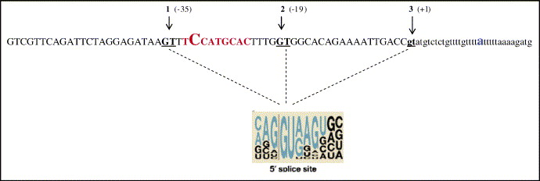
Figure 14: part of ITPA gene status hidden premises (5 - SS) shows. Exon and intron 2 of 2 capital letters are shown in lowercase letters. Off trimming exons are shown in red. ITPA c.94C> A large font is shown. Below 5 - ss line is drawn. (3) where the actual flash and flash trimming positions 1 and 2 show the hidden tools.

In 2007 Arenas & Associates announced the formation of normal and mutant subunit dimer inappropriate the catalytic activity of the enzyme is reduced (31). 32 protein amino acid proline protection of society and the hinge region of alpha - helix is 2. Of the amino acid proline Torre rules instead, leading to mistakes folding alpha - Helix 2 and thus the tendency of the enzyme to the substrate is reduced and the action of the enzyme is impaired. The nucleotide substitution affect the secondary structure of proteins forming the dimer subunit mutant and normal is incomplete. Stenmark et al in 2007 to disruption of protein structure and ultimately the loss of its catalytic properties P32T mutation confirmed (32).
Hreting findings and colleagues in 2010 with proposals by Stenmark did not fit. The new findings show that the protein has a mutation ITPase P32T, a functional protein, but catalytic properties and less stable than the naturally occurring protein and therefore reduced the amount of enzyme in the cell. This amino acid change reduced the operating result by 45 percent. The Hreting offers and colleagues, proline 32 in Luppy protein on the outer surface and the substrate binding pocket of the dimer get away. Proline 32 by page β (5 amino acids) of the active site loops of amino acids, Asp-41 and Glu-44 are separated. Proline changed to change the loop Torre rules of Glu-44 / Asp-41 and thus κcat and reduced protein stability, but the link between the subunits of the protein is not Hmvdaymr me down. In addition, this change makes the loop consisting of Asp-41 / Glu-44 to be prone to eating wrong and destroyed proteolysis. Hreting and partners in support of the theory wrong Asplasyng have suggested that it reduces the amount of copies to be P32T (33). So it seems that the main reason for decreased activity in the ITPA is mRNA. Asplasyng mistake to reduce the expression of the enzyme and its sustainability, and as a result of increased activity ITP ITPA through inhibition of the substrate is reduced. Substrate inhibition constant (Ki) is equal to 277μM approximately 9 Km of the enzyme.

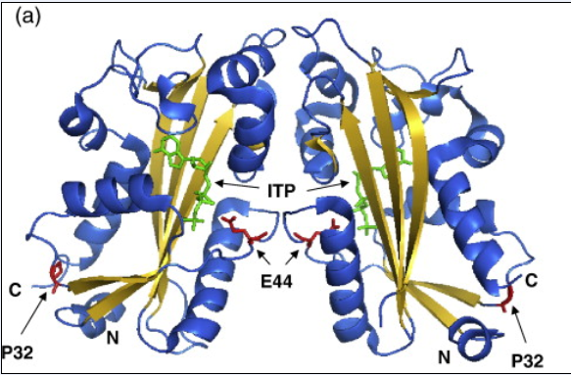
Figure 15: Protein ITPA human. Location P32T in the crystal structure ITPase is human. P32T red and ITP are shown in green.

4.2 Prevalence of genotypic and allelic
Correct replication of DNA for genome stability and preventing the development of cancer is essential. The presence of modified nucleotides in DNA are a great threat to the integrity of the genome. The human genome are associated with harmful agents out of the cell and environmental factors, such as ionizing radiation, a chemical Mvtazhnhay or intracellular factors such as oxidative stress and inflammation damaged. Many of these factors also damage the nucleotide pool. In addition, cell metabolism (such as increased lipid peroxidation and oxidative stress) also causes pollution nucleotide pool of nucleotides is unusual. Unusual nucleotide analog has a range of natural nucleotide bases as byproducts of cellular metabolism or oxidation bases Damynasvn produced. Analogs byribonucleoside triphosphate into DNA by DNA polymerase as dioxane. These analogs are identified by the system and the subsequent failure to repair DNA increases. If the nucleotides unusual escape repair system, pairing bases mistake occurs and the replication mutations accumulate over the next cycle. Defects in the support systems (mutations and polymorphic variation), the recombination and mutagenicity too much, resulting in genomic instability and eventually cancer, is formed.
And psychological stress and environmental pollutants can also cause an increase in reactive oxygen and nitrogen species are. If a person is in trouble repair system and remove free radicals, the compounds can ill person to predispose neurons. Studies have shown that one of the immediate effects of oxidative stress in living cells, is deamination nucleotides. The occurrence of oxidative stress and appearing Damynh nucleotides in the cell, enzymes to eliminate the effect of these nucleotides are active in them. Among these enzymes can be named ITPase. Many studies on the effects of OS At Fertility Women With Intervention At The pathophysiology of preeclampsia, Hydatid mole, birth defects caused by radical Free And Other conditions Like Abortions There is. Many studies have shown that the OS has a role in the pathophysiology of infertility and assisted reproductive techniques. There is some evidence that oxidative stress Atyvpatvzhnz endometriosis, infertility and tubal factor infertility is idiopathic role. Status Antioxidants can be early development of the embryo changes Factors Overwrite the key and thus Correction Gene expression influence. We assume that mutations in the gene ITPA can predispose one to infertility. Two SNPs on the ITPA gene loss of function of the enzyme, resulting in the accumulation of ITP in red blood cells. So a lot of these SNPs in the patient and control groups were compared.
In this study, the population studied in both healthy patients and balance the Hardy-Weinberg equilibrium were tested. Any deviation from this balance maybe a sign of the existence of subgroups of the population, immigration, sample error of natural selection against the allele or genotype or certain. The prevalence of genotypic and allelic observed in our sample may not show the frequency of actual base population but represent changes in subgroups. To study the Hardy-Weinberg equilibrium in a population, the difference between the observed and the genotypic markers expected significant level of p <0.05 with the chi-square test checked out. The chi-square test H0 is no significant difference between the ratio of the observed and expected genotype in the population under study. So if Snape studied p <0.05 then H0 is rejected and not accepted, and the study population is in Hardy-Weinberg equilibrium.
Results of this study confirmed our hypothesis about the impact on gene function in the field of infertility or reduced fertility and abortion ITPA has. But the intensity of the function of other genes can also be related to genetic or other factors.

References
- Fujimoto, M. and T. Naka, SOCS1, a Negative Regulator of Cytokine Signals and TLR Responses, in Human Liver Diseases. Gastroenterol Res Pract, 2010. 37 (3): p. 613-21.
- Dutta, R. and BD Trapp, Gene expression profiling in multiple sclerosis brain. Neurobiol Dis, 2012.45 (2): p. 108-14.
- Brynedal, B., et al., Gene expression profiling in multiple sclerosis: a disease of the central nervous system, but with relapses triggered in the periphery? Neurobiol Dis, 2010. 37 (3): p. 613-21.
- Satoh, J., et al., T cell gene expression profiling identifies distinct subgroups of Japanese multiple sclerosis patients. J Neuroimmunol, 2006. 174 (1-2): p. 108-18.
- Huang, QC, et al., [SOCS1 knockdown sensitize anti-tumor activity of IFN-alpha2a-NGR]. Xi Bao Yu Fen Zi Mian Yi Xue Za Zhi, 2010. 26 (5): p. 412-5.
- Ferrero, S., V. Remorgida, and PL Venturini, Endometriosis. Clin Evid (Online), 2010. 174 (1-2): p. 108-18.
- Okeke, TC, LC Ikeako, and CC Ezenyeaku, En dometriosis. Niger J Med, 2011. 20 (2): p. 191-9.
- Shah, K., et al., The genetic basis of infertility. Re production, 2003. 126 (1): p. 13 - 25.
- Hong, J., et al., Gene expression profiling of relevant biomarkers for treatment evaluation in multiple sclerosis. J Neuroimmunol, 2004. 152 (1-2): p. 126-39.
- Mycko, MP, et al., Microarray gene expression profiling of chronic active and inactive lesions in multiple sclerosis. Clin Neurol Neurosurg, 2004. 106 (3): p. 223-9.
- Steinman, L., Multiple sclerosis and gene expression profiling. Adv Exp Med Biol, 2001. 490: p. 109-12.
- Liu, L., et al., Potent antitumor activity of oncolytic adenovirus-mediated SOCS1 for hepatocellular carcinoma. Gene Ther, 2012. 106 (3): p. 223-9.
- Satou, R., et al., Interferon-gamma biphasically regulates angiotensinogen expression via a JAK-STAT pathway and suppressor of cytokine signaling 1 (SOCS1) in renal proximal tubular cells. FASEB J, 2012. 106 (3): p. 223-9.
- Hirschfield, GM, et al., Association of primary biliary cirrhosis with variants in the CLEC16A, SOCS1, SPIB and SIAE immunomodulatory genes. Genes Immun, 2012.
- di Iasio, MG, et al., SOCS1 is significantly up-regulated in Nutlin-3-treated p53 (wild-type) B chronic lymphocytic leukemia (B-CLL) samples and shows an inverse correlation with miR-155. Invest New Drugs, 2012. 106 (3): p. 223-9.
- Song, S., et al., Tumour-derived IL - 10 within tumour microenvironment represses the antitumour immunity of Socs1-silenced and sustained antigen expressing DCs.Eur J Cancer, 2012. 106 (3): p. 223-9.
- Doti, N., et al., New mimetic peptides of Kinase Inhibitory Region (KIR) of SOCS1 through focused peptide libraries. Biochem J, 2011.
- Ilangumaran, S., et al., Increased generation of CD8 single positive cells in SOCS1-deficient thymus does not proportionately increase their export. Immunol Lett, 2010. 132 (1-2): p. 12-7.
- Zhang, J., et al., Role of SOCS 1 in tumor progression and therapeutic application. Int J Cancer, 2011. 106 (3): p. 223-9.
- Takahashi, R., et al., SOCS1 is essential for regulatory T cell functions by preventing loss of Foxp3 expression as well as IFN- {gamma} and IL-17A production. J Exp Med, 2011. 208 (10): p. 2055-67.
- Delgado-Ortega, M., S. Melo, and F. Meurens, Expression of SOCS1-7 and CIS mRNA in porcine tissues. Vet Immunol Immunopathol, 2011. 144 (3-4): p. 493-8.
- Collins, EL, et al., Inhibition of SOCS1 - / - lethal autoinflammatory disease correlated to enhanced peripheral Foxp3 + regulatory T cell homeostasis. J Immunol, 2011. 187 (5): p. 2666-76.
- Yu, CR, et al., Suppressor of cytokine signaling-1 (SOCS1) inhibits lymphocyte recruitment into the retina and protects SOCS1 transgenic rats and mice from ocular inflammation. Invest Ophthalmol Vis Sci, 2011. 52 (9): p. 6978-86.
- Guillem, V., et al., Functional polymorphisms in SOCS1 and PTPN22 genes correlate with the response to imatinib treatment in newly diagnosed chronic-phase chronic myeloid leukemia. Leuk Res, 2012. 36 (2): p. 174-81.
- Vandenbroeck, K., et al., A cytokine gene screen uncovers SOCS1 as genetic risk factor for multiple sclerosis. Genes Immun, 2011. 13 (1): p. 21-8.
- Gui, Y., et al., SOCS1 controls liver regeneration by regulating HGF signaling in hepatocytes. J Hepatol, 2011. 55 (6): p. 1300-8.
- Russell, RC, et al., Loss of JAK2 regulation via a heterodimeric VHL-SOCS1 E3 ubiquitin ligase underlies Chuvash polycythemia. Nat Med, 2011. 17 (7): p. 845-53.
- Zuvich, RL, et al., Interrogating the complex role of chromosome 16p13.13 in multiple sclerosis susceptibility: independent genetic signals in the CIITA-CLEC16A-SOCS1 gene complex. Hum Mol Genet, 2011. 20 (17): p. 3517-24.
- Sachithanandan, N., et al., sensitivity to LPS and palmitic acid Macrophage deletion of Socs1 Increases in systemic inflammation and hepatic insulin resistance and results. Diabetes, 2011. 60 (8): p. 2023-31.
- Carow, B., et al., Silencing suppressor of cytokine signaling-1 (SOCS1) in macrophages improves Mycobacterium tuberculosis control in an interferon-gamma (IFN-gamma) -dependent manner. J Biol Chem, 2011. 286 (30): p. 26873-87.

9/22/2015

