Ocular manifestations as the initial presentation of plasmablastic lymphoma: a diagnostic challenge and review of literature

Ali MatarAlzahrani¹, Eman Al Mussaed ², Waleed Al Bissi³, Mohamed RajebHabibullah³, Sultan Alotaibi⁴ and Ghaleb Elyamany^{3, 5} *

¹ Department of Oncology, Prince Sultan Military Medical City, Riyadh, Saudi Arabia
²Department of Basic Science, Hematopathology Division, Princess NourahBintAbdulrahman University, College of Medicine, Riyadh, Saudi Arabia
³ Department of Central Military Laboratory and Blood Bank, Prince Sultan Military Medical City, Riyadh, Saudi Arabia
⁴Department of Adult Clinical Hematology and Stem cell Therapy, Prince Sultan Military Medical City, Riyadh, Kingdom of Saudi Arabia
⁵Department of Hematology, Theodor Bilharz Research Institute, Giza, Egypt
ghalebelyamany@yahoo.com

Abstract: Plasmablastic lymphoma (PBL) is a rare aggressive mature B-cell neoplasms, frequently involving the jaw and oral mucosa in HIV-positive patients, however, a number of cases have been reported in extra-oral sites. HIV-negative PBL has not been extensively reported. Overall, the oral cavity represents the primary site of origin in 51% of the cases, while 20% of extra-oral PBL involve the lymph nodes. PBL remains a diagnostic challenge due to its peculiar morphology and an immunohistochemical profile similar to plasma cell myeloma. PBL is also a therapeutic challenge with a clinical course characterized by a high rate of relapse and death. There is no standard chemotherapy protocol for treatment of PBL; however, cyclophosphamide, doxorubicin, vincristine, and prednisone (CHOP), or CHOP-like regimens have been the back bone while more intensive regimens are possible options. Although PBL has been reported from countries across the world, including from Asian countries such as India and Thailand, few reported cases from Saudi Arabia in the English-language literature. Here, we report a rare case of PBL young male without immunodeficiency diseases, HIV negative presenting with Ocular manifestation as a first presenting feature.
[Ali Matar Alzahrani, Eman Al Mussaed, Waleed Al Bissi, Mohamed Rajeb Habibullah, Sultan Alotaibi and Ghaleb Elyamany. Ocular manifestations as the initial presentation of plasmablastic lymphoma: a diagnostic challenge and review of literature. Cancer Biology 2015;5(3):1-6]. (ISSN: 2150-1041). http://www.cancerbio.net. 1

Key words: Plasmablastic lymphoma, eye, HIV, outcome

1.Introduction
Plasmablastic lymphoma (PBL) was first reported in 1997 by Delecluse and colleagues, who described a series of sixteen diffuse large B-cell lymphomas of the oral cavity occurring in the clinical setting of HIV/AIDS and Epstein–Barrvirus (EBV) infections with unique immunohistochemical features [1].
PBL is an aggressive subtype of non-Hodgkin’s lymphoma, which frequently arises in the oral cavity of human immunodeficiency virus (HIV) infected patients [1, 2].
PBL shows diffuse proliferation of large neoplastic cells resembling B-immunoblasts with an immunophenotype of plasma cells [3].
HIV- negative PBL has not been extensively reported and due to the rarity of this disease, the natural history of PBL in HIV- negative patients is much less understood [4].A number of cases have been reported in extra-oral sites, including nasopharynx, stomach, small bowel, anus, lung, skin, soft tissues, heart and the spermatic cord [5], furthermore; several cases of primarily nodal PBL have also been described. There is no standard chemotherapy protocol for treatment of PBL; cyclophosphamide, doxorubicin, vincristine, and prednisone (CHOP), or CHOP-like regimens have been the back bone while more intensive regimens such as cyclophosphamide, vincristine, doxorubicin, high dose methotrexate/ifosfamide, etoposide, high-dose cytarabine (CODOX-M/IVAC), or dose-adjusted-etoposide, prednisone, vincristine, cyclophosphamide, and doxorubicin (DA-EPOCH) are possible options. [6].
The diagnosis of PBL remains a diagnostic challenge given its rarity, peculiar morphology and an immunohistochemical profile similar to PCM. Additionally, there is a wide differential diagnosis within the subgroup of DLBCL and PCM with plasmablastic morphology that is still a common problem because of the lack of a distinctive phenotype. [7] Distinction between extramedullaryplasmablastic neoplasms remains critical for patient management, and correlation with clinical findings is essential. [8] Here we report a very rare case of PBL in an immunocompetent young patient presenting with eye manifestation as a first presenting feature.

2.Materials and Methods
H&E Specimens
Lymph node and BM specimens from the patient were handled routinely. Immunostains were performed on formalin-fixed, paraffin-embedded tissue with a Ventana automated immunostainer (Ventana Medical Systems Inc, Tucson, Ariz). Immunostains performed were CD45, CD3, CD4, CD8, CD5, CD7, CD20, CD79a, CD34, TdT, PAX-5, CD10, CD38, CD138, EMA, MUM1, CD56, CD23, BCL2, BCL6, Alk protein, CD30, Ki-67, kappa and lambda light chains. Appropriate positive and negative controls were employed.

Cytogenetic Analysis
Standard cytogenetic preparations were made. At least 20 metaphases were analyzed using Giemsa-trypsin staining analyzed to exclude clonal abnormalities. Karyotypes were interpreted according to the International System for Cytogenetic Nomenclature (ISCN) guidelines.
Interphase fluorescence in situ hybridization (FISH) was performed according to the manufacturer's instructions. At least 100 interphase nuclei were analyzed, and if needed, the metaphases were also analyzed.

Flow CytometricImmunophenotypic Methods
BM samples was assessed by multicolor flow cytometry using a large panel of antibodies, including CD2, cytoplasmic and surface CD3, CD4, CD5, CD7, CD8, CD10, CD19, CD20, CD22, cytoplasmic CD79a, CD13, CD15, CD33, CD11c, CD14, CD64, CD38, CD34, CD117, CD138, terminal deoxynucleotidyltransferase (TdT), and myeloperoxidase (MPO).

3. Case Presentation and Results
A 31 year-old male presented complaining of swelling of the right eye and double vision with blurring of vision one month ago; this was associated with on and off fever, night sweats, anorexia and loss of weight. No past history of relevant diseases.
On examination: The patient was clinically stable. He had right eye proptosis with ecchymosis, not tender with normal optic disc examination. He had bilateral cervical, l supraclavicular, axillary and inguinal lymphadenopathy, smooth rubbery and mobile with an intact skin. He also had hepatomegaly, smooth rubbery non-tender with blunted edge. Patient was noted to have right face parathesia involving right forehead and cheek.
On admission CBC showed a WBC 9.3 x 10^{9 /}L, hemoglobin 10.5gm/dl, platelets 630 x10⁹ /L, LDH 10450 U/L, normal liver and coagulation profile except serum. Viral screen was negative for HIV, hepatitis B and C virus, cytomegalovirus and Epstein barr viruses.
Computed tomography (CT) finding for brain showed soft tissue lesions within the right orbit involving the retrobulbar fat superomedially and along the optic nerve (figure 1). A soft tissue mass was also identified in the right paracavernous region. CT for chest, abdomen and pelvis showed extensive mediastinal, cervical, axillary, paratracheal lymphadenopathy. Para-aortic iliac and inguinal lymphadenopathy was also noted. Patient started radiotherapy for the right eye for a total of 1800cGy (each session 180 daily for a total of 10) in a trial to preserve his eye sight. Inguinal lymph node biopsy, bone marrow aspirate and biopsy were performed; and as it demanded a lot of work to reach a final diagnosis for both specimens, reports were delivered after 10 days, during that time patient condition was deteriorating. Patient was started on allopurinol then rasbiuricase and supportive therapy together with dexamethasone 8mg three times daily( tds). As patient condition was progressing, dexamethasone dose was increased to 20 mg twice daily. The patient condition continued to deteriorate and picture of disseminated intravascular coagulopathy (DIC) are clinically and by laboratory data was suspected.
Lymph node biopsy was reported as PBL. Lymph node was effaced and showed diffuse infiltration by abnormal large lymphoid cells with rounded nuclei, prominent nucleoli and abundant basophilic cytoplasm resembling immunoblast with plasmacytic differentiation; immunohistochemistry (IHC) showed positivity for CD45, CD10, Lambda, CD38, CD138, EMA, MUM1 and with weak focal staining for PAX-5 and >70% of cells were Ki-67 positive. Negative markers included: CD3, CD4, CD8, CD5, CD7, CD20, CD79a, CD34, TdT, CD56, CD23, BCL2, BCL6, Alk protein, CD30 and kappa light chain.
Bone marrow was hypercellular and infiltration by abnormal lymphoid cells similar to lymph node. Flow cytometry analysis showed these abnormal cells were positive for CD45 dim, CD10,CD38 and CD138 and lambda light chain restriction and negative for CD34, HLA-DR, CD19, CD20, CD56, CD117, T-cell and myeloid markers.
Conventional cytogenetic studies showed normal karyotype (46, XX) and FISH was negative MYC gene rearrangement. The patient condition rapidly deteriorated and he died 2 week later after starting CHOP protocol.

Table 1: The immunophenotyping differentiating PBL from other neoplasms
Parameter | PBL | Burkitt | Anaplastic  DLBCL | PEL | ALK + DLBCL | PCM/Plasmacytoma | PLASMBLASTIC PCM/Plasmacytoma
Clinical presentation | frequently oral cavity | Often extranodal (jaws and orbits) | Wide variety of presentations | Involves body cavity | Wide variety of presentations | BM (Extramedulary in plasmacytoma) | BM (Extramedulary in plasmacytoma)
Immunocompetency | +/- | ++ | +++ | +/- | + | ++ | ++
Association with HIV | +++ | ++ | ++ | +++ | - | - | -
Association with HHV8 | +/- (usually -) | - | - | + | - | - | -
LCA | +/- | + | + | +/- | +/- | +/- | +/-
B-Cell Markers  CD20  CD79a | -  +/-  ( usually -) | +  + | +  + | +/-  - | -  - | -  +/- (usually -) | -  +/- (usually -)
CD138  CD56 | +  +/-  ( usually -) | -  Rare + | -  Rare + | +  Rare + | -  +/- | +  Usually + | +  Usually +
Ki67 | High >70% | High  >90% | High  <90% | High  >80% | High  >80% | Low | High  >70%
other | BLIMP1+ | CD10  + | BCL-6  Usually + | CD30  Usually + | ALK+ | Serum M-spike CRAB | Serum M-spike  CRAB

CRAB: hypercalcemia, kidney disease, anemia, and bone lytic lesions

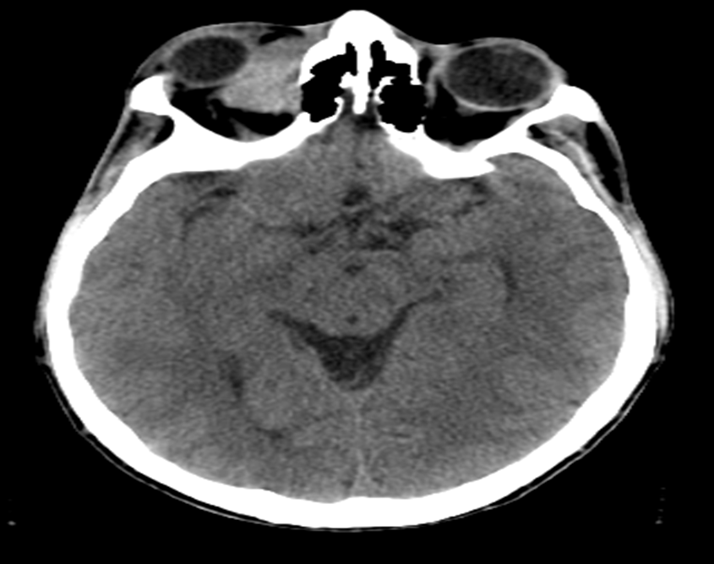
Figure (1): CT of the brain showing soft tissue density masses involving extraconal and intraconal compartment of right orbit with slight forward and lateral displacement of right eye globe.

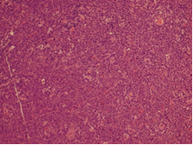
Figure (2): (A) Low power of Lymph node showed absence of normal nodal architecture and replacement with sheets of large atypical lymphoid cells (hematoxylin-eosin staining).
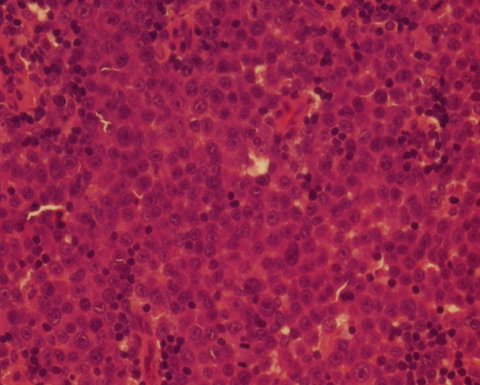
Figure (2): (B) High power, the tumor cells have features of immunoblasts; they are large with a vesicular chromatin and frequently prominent central nucleoli. Rare smaller neoplastic cells with plasmacytic differentiation are also noted (H&E)

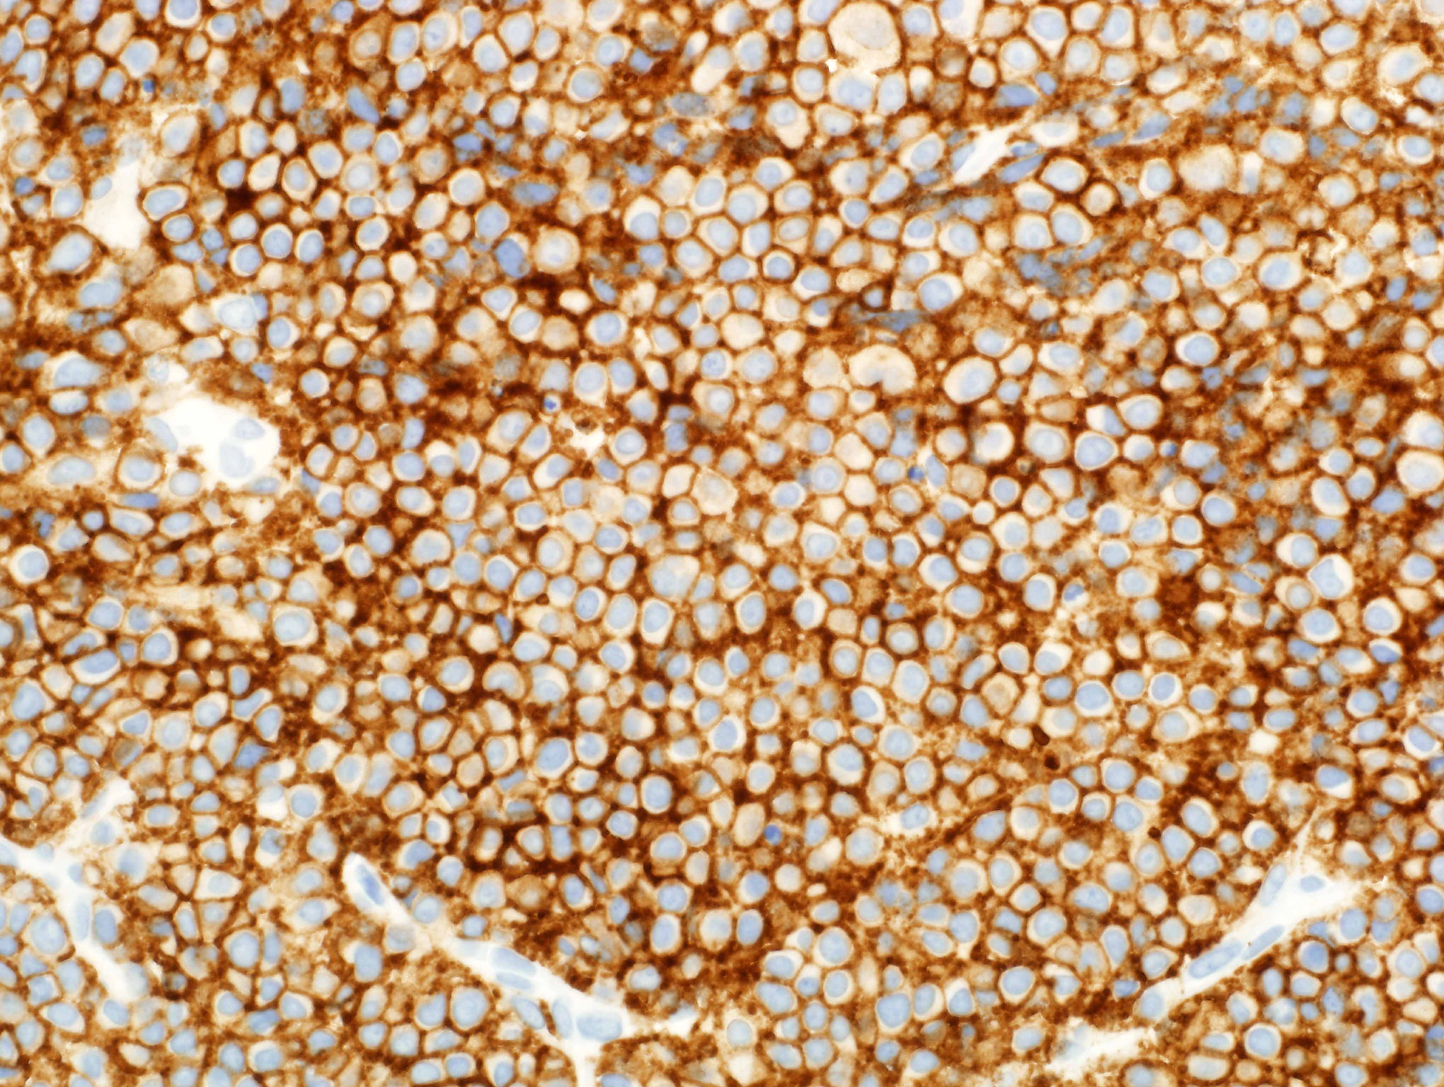
Figure (3): A

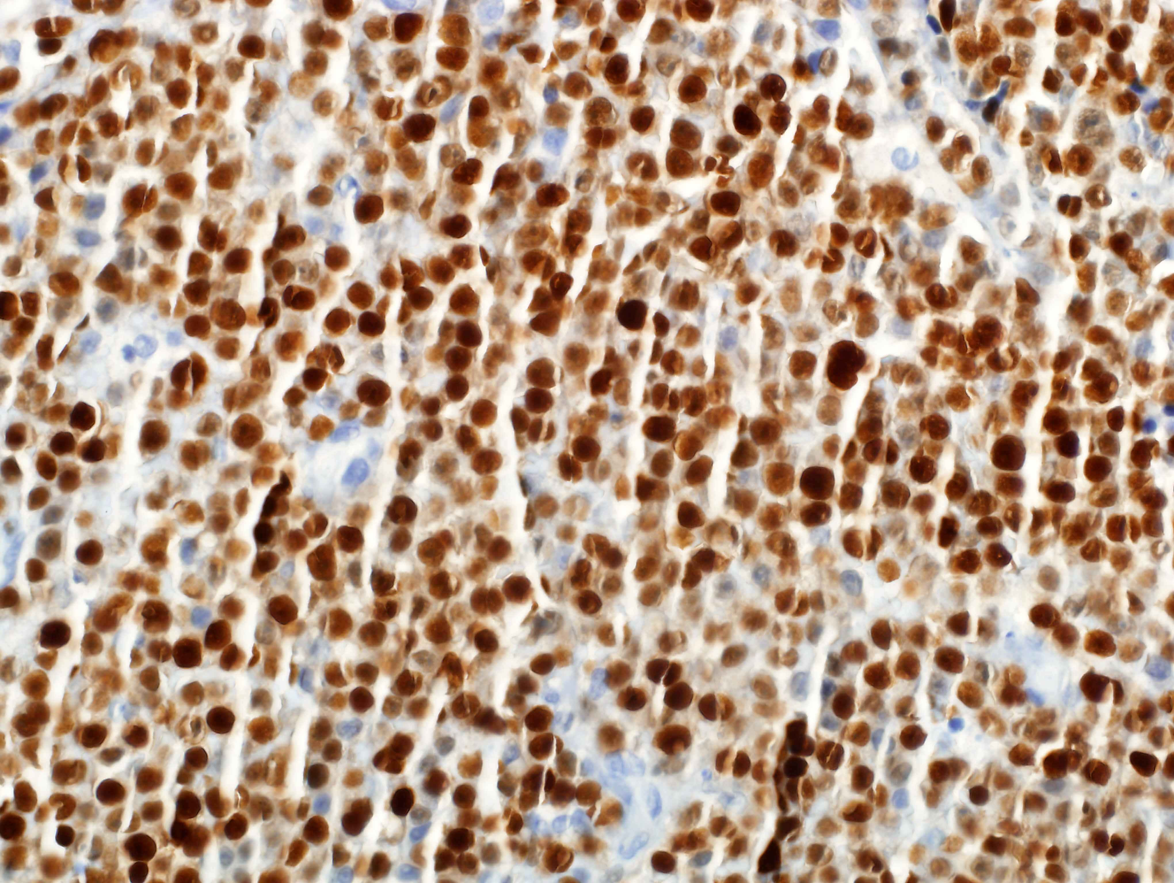
Figure (3): B

4. Discussion
PBL is an unusual subtype of human immunodeficiency virus (HIV)-related diffuse large B-cell lymphoma (DLBCL) that was first described in the oral cavity. HIV-related lymphomas are frequently associated with Epstein-Barr virus (EBV). Recently, dual infection with EBV and human herpesvirus 8 (HHV8) has been demonstrated in PBL. So far, a few cases of PBL occurring in an HIV-negative patient have been documented and all of them were associated with immunosuppression status and/or EBV infection [4].
The patient in the present report is EBV and HHV8-negative PBL occurring in an immunocompetent HIV-negative young male with no previous relevant medical history. While there have been reports of PBL in HIV-negative patients [9] and at extra-oral sites, accurate diagnosis of such cases is difficult.
PBL is characterized by cellular proliferation of large atypical cells with immunoblastic, or plasmablastic with plasmacytic features, whereas plasmacytoma typically consists of mature plasma cells. In addition, the extremely high proliferation rate of PBL is unusual for plasmacytoma [1, 10].
The majority of patients with PBL are middle-aged adult with a mean age at presentation of 39 years in HIV-positive patients and 58 years in HIV-negative patients [11].
The histopathological features are frequently ambiguous, thus rendering the correct diagnosis quite difficult. Diagnosis requires a properly evaluated tissue biopsy of mass lesion or lymph node. Excisional biopsy is the gold standard; however, when the site of the disease is difficult to access, core needle biopsy and fine needle aspiration (FNA) may be performed in conjunction with appropriate ancillary techniques for the diagnosis and differential diagnosis. [6]
The differential diagnosis includes immunoblastic DLBCL and other lymphoid neoplasms with plasmacytic features such as ALK-positive DLBCL, primary effusion lymphoma (PEL) both classic (body cavity-based) and solid (extracavitary) variants, Burkitt lymphoma (BL) with plasmacytoid differentiation and plasmablasticplasmacytoma/myeloma Table1 [12, 13]. Differentiation from plasmacytoma/myeloma particularly with anaplastic/plasmablastic morphology is the most difficult issue in the differential diagnosis and morphologic distinction is not always possible. In practice, the distinction between PBL and plasmablastic PCM frequently depends on clinical correlation. [14, 15]
PBL is a therapeutic challenge with a clinical course characterized by a high rate of relapse and death. A standard therapy has not yet been established. Treatment usually consists of chemotherapy with or without consolidation radiation and hematopoietic stem cell transplantation.[16] Various chemotherapy regimens include cyclophosphamide, doxorubicin, vincristine, and prednisone (CHOP), R-CHOP, and cyclophosphamide, vincristine, doxorubicin, high dose methotrexate/ifosfamide, etoposide, high-dose cytarabine (CODOX-M/IVAC) [17, 18].
Due to disappointing response and survival rates, the NCCN guidelines recommend against CHOP in favor of more intensive regimens, such as infusional EPOCH, HyperCVAD, or CODOX-M/IVAC [17]. However, Castillo and colleagues evaluated treatment outcomes in patients receiving CHOP, CHOP-like regimens and more intense regimens. They reported no statistical difference in the overall survival between the less and more intensive treatment regimens, although only a quarter of the patients reported in the literature have been treated with more intensive regimens than CHOP. [18].
In recently published cases, bortezomib has shown promising results in PBL [19- 22]. Although most of these responses were not sustained, bortezomib represents a new therapeutic option for PBL. Owing to improved gene transfer technology, novel adoptive cellular therapies have been developed. Adoptive transfer of tumor-reactive T cells into cancer patients with the intent of inducing a cytotoxic anti-tumor effector response and durable immunity has long been proposed as a novel therapy for a broad range of malignancies [23, 24].

Conclusion
Plasmablastic lymphoma is a distinct type of NHL, that most frequently affects the oral tissue of HIV-positive patients and that usually behaves very aggressively. Both its clinical and histopathological features are frequently ambiguous, thus rendering the correct diagnosis quite difficult in the absence of an exhaustive integration of clinical, morphological, phenotypic and molecular features. The diagnosis of such neoplasm might be even more challenging in the setting of extra-oral localisations and in immunocompetent patients

Competing Interests
The author declares that he has no competing interests

Corresponding author
Ghaleb Elyamany
MD, MSc, PhD, FRCPC Consultant Hematopathology, Prince Sultan Military Medical City PO Box 7897, Riyadh 11159, Kingdom of Saudi Arabia
FAX 01 4783033
E-mail: ghalebelyamany@yahoo.com

References
- Delecluse HJ, Anagnostopoulos I, Dallenbach F, Hummel M, Marafioti T, Schneider U, Huhn D, Schmidt- Westhausen A, Reichart PA, Gross U, Stein H. Plasmablastic lymphomas of the oral cavity: a new entity associated with the human immunodeficiency virus infection. Blood 1997: 89: 1413–1420.
- Colomo L, Loong F, Rives S, Pittaluga S, Martı´nez A, Lo´pez-Guillermo A, Ojanguren J, Romagosa V, Jaffe ES, Campo E. Diffuse large B-cell lymphomas with plasmablastic differentiation represents a heterogeneous group of disease entities. Am J SurgPathol 2004: 28: 736–747.
- Stein H, Harris NL, Campo E. Plasmablasticlymphoma.In: Swerdlow SH, Campo E, Harris NL, et al, eds. WHO Classification of Tumours of Haematopoietic and Lymphoid Tissues. 4th ed. Lyon, France: IARC Press; 2008:256-257.
- Jane Jijun Liu, Ling Zhang, Ernesto Ayala, Teresa Field, Jose L. Ochoa-Bayona, Lia Perez, Celeste M. Bello, Paul A. Chervenicket al.: Human immunodeficiency virus (HIV)-negative plasmablastic lymphoma: A single institutional experience and literature review.
- Dong HY, Scadden DT, de Leval L, Tang Z, Isaacson PG, Harris NL. Plasmablastic lymphoma in HIV-positive patients.an aggressive Epstein–Barr virus-associated extramedullaryplasmacytic neoplasm. Am J Surg Pathol 2005; 29: 1633–1641.
- Elyamany G, Eman Al Mussaed E, Alzahrani AM. Plasmablastic Lymphoma: A Review of Current Knowledge and future directions. Adv Hematol. 2015 (In Press).
- Jaffar SA, Pihan G, Dezube BJ, Pantanowitz L. Differentiating HIV-associated lymphomas that exhibit plasmacellular differentiation. HIV AIDS Rev. 2005;4:43-49.
- Thakral C, Thomas L, Gajra A, Hutchison RE, Ravizzini GC, Vajpayee N. Plasmablastic lymphoma in an immunocompetent patient.J Clin Oncol. 2009 Sep 1;27(25):e78-81.
- Castillo, J.J., Winer, E.S., Stachurski, D., Perez, K., Jabbour, M., Milani, C., Colvin, G., and Butera, J.N. Clinical and pathological differences between human immunodeficiency virus-positive and human immunodeficiency virus-negative patients with plasmablastic lymphoma. Leuk. Lymphoma.2010; 51, 2047–2053.
- Bogusz AM, Seegmiller AC, Garcia R, Shang P, Ashfaq R, Chen W. Plasmablastic lymphomas with MYC/IgH rearrangement: report of three cases and review of the literature. Am J Clin Pathol. 2009 ;132(4):597-605.
- Castillo J, Pantanowitz L, Dezube BJ. HIV-associated plasmablastic lymphoma: lessons learned from 112 published cases. Am J Hematol. 2008;83:804-809.
- Elyamany G, Alzahrani AM, Aljuboury M, Mogadem N, Rehan N, Alsuhaibani O, Alabdulaaly A, Al-Mussaed E, Elhag I, AlFiaar A. Clinicopathologic features of plasmablastic lymphoma: Single-center series of 8 cases from Saudi Arabia. Diagn Pathol. 2015 Jun 25;10:78.
- Rafaniello Raviele P, Pruneri G, Maiorano E. Plasmablastic lymphoma: a review. Oral Dis 2009: 15: 38–45.
- Campo E, Chott A, Kinney MC, Leoncini L, Meijer CJ, Papadimitriou CS, et al. Update on extranodal lymphomas. Conclusions of the Workshop held by the EAHP and the SH in Thessaloniki, Greece. Histopathology. 2006 Apr;48(5):481-504.
- Vega F, Chang CC, Medeiros LJ, Udden MM, Cho-Vega JH, Lau CC, et al. Plasmablastic lymphomas and plasmablastic plasma cell myelomas have nearly identical immunophenotypic profiles. Mod Pathol. 2005 Jun;18(6):806-15.
- Saraceni C, Agostino N, Cornfield DB, Gupta R. Plasmablastic lymphoma of the maxillary sinus in an HIV-negative patient: a case report and literature review.Springerplus. 2013 Apr 3;2(1):142.
- Castillo, J.J., Winer, E.S., Stachurski, D., Perez, K., Jabbour, M., Milani, C., Colvin, G., and Butera, J.N. Prognostic factors in chemotherapy-treated patients with HIV-associated plasmablastic lymphoma. Oncologist. 2010;15, 293–299.
- NCCN Practice Guidelines in Oncology. AIDS-related B-cell lymphomas (AIDS-2). Available at http://www.nccn.org/professionals/physician_gls/PDF/nhl.pdf. Accessed on November 27, 2010.
- Cao C, Liu T, Zhu H, Wang L, Kai S, Xiang B. Bortezomib contained chemotherapy and thalidomide combined with CHOP (Cyclophosphamide, Doxorubicin, Vincristine, and Prednisone) play promising roles in plasmablastic lymphoma:acase report and literature review.Clin Lymphoma Myeloma Leuk. 2014;14 (5):e145-50.
- Yan M, Dong Z, Zhao F, Chauncey T, Deauna-Limayo D, Wang-Rodriguez J, Liu D, Wang HY, Pilz R. CD20 positive plasmablastic lymphoma with excellent response to bortezomib combined with rituximab. Eur J Haematol. 2014 Jul;93(1):77-80.
- Dasanu CA, Bauer F, Codreanu I, Padmanabhan P, Rampurwala M. Plasmablastic haemato-lymphoid neoplasm with a complex genetic signature of Burkittlymphoma responding to bortezomib.HematolOncol. 2013 Sep;31(3):164-6.
- Lipstein M, O'Connor O, Montanari F, Paoluzzi L, Bongero D, Bhagat G. Bortezomib-induced tumor lysis syndrome in a patient with HIV-negative plasmablasticlymphoma. Clin Lymphoma Myeloma Leuk. 2010 Oct;10(5):E43-6.
- Brentjens RJ, Curran KJ. Novel cellular therapies for leukemia: CAR-modified T cells targeted to the CD19 antigen. Hematology Am Soc Hematol Educ Program. 2012;2012:143-51
- Turtle CJ: Chimeric antigen receptor modified T cell therapy for B cell malignancies. Int J Hematol. 2014 Feb;99(2):132-40.

7/27/2015

