Predictive Value of CT Virtual Endoscopy and Multiplaner Reformatting in Laryngeal and Hypopharyngeal Carcinoma

Hoda Mahmoud Abd Elwahab¹; Nadia Abd Elsater Metwally¹ and Noha Abd Elshafy AlSaid²

¹Radiodiagnosis Department, Faculty of Medicine (For Girls), Al-Azhar University, Cairo, Egypt
²Radiodiagnosis Department, National Cancer Institute, Cairo University, Cairo, Egypt
Dr.hani.hammam@gmail.com,hodawaleed@hotmail.com

Abstract: Objective: To evaluate the role of CT virtual endoscopy and multiplanar reformatting as a non-invasive imaging tool for assessment of laryngeal and hypopharyngeal carcinomas in comparison with the conventional laryngoscopic findings. Design: Prospective study. Patients and Methods: Included (50) patients with suspicious of laryngeal or hypopharyngeal carcinoma, referred from the otolaryngology department, in the period from (2012 to 2013) they were(30) males and (20) females, with an age ranging from (30 to 85) years old. The patients were divided into two groups: group I patients with larangeal carcinoma group II patients with hypopharyngeal cancer and results were analyzed. Results: Axial images of helical CT clearly demonstrate the location, the size and the extent of laryngeal and hypopharyngeal carcinoma, while MPR and 3D images are useful in displaying the three dimensional images and anatomical relation of the tumor. CTVL can clearly display the mucosal surface structures of the larynx and hypopharynx and it is a good complementary method of direct laryngoscopy. Conclusion: Although it is an invasive procedure requiring general anesthesia and ineffective beyond areas of luminal stenosis, direct laryngoscopy is the gold standard for viewing laryngeal pathologies. Multislice CT is crucial in the assessment of laryngeal pathologies including subglottic area, anterior and posterior commissures, paraglottic, pre-epiglottic spaces, cartilage and extra laryngeal structures.CT virtual larangoscopy and multiplanar reformatting were useful in evaluating and staging laryngeal and hypophyrangeal carcinoma.
[Hoda Mahmoud Abd Elwahab; Nadia Abd Elsater Metwally and Noha Abd Elshafy AlSaid. Predictive Value of CT Virtual Endoscopy and Multiplaner Reformatting in Laryngeal and Hypopharyngeal Carcinoma. Cancer Biology 2015;5(2):35-46]. (ISSN:2150-1041). http://www.cancerbio.net. 5

Keywords: CT virtual endoscopy, multiplanar reformatting, laryngeal carcinoma and hypopharyngeal carcinoma.

1. Introduction
Cancers larynx constitute about (25%) of all head and neck malignancies. They commonly present in adults between (50-70) years with a strong male predominance. Over (90%) of these cancers are squamous cell carcinomas (SCC). Tobacco smoking and alcohol are important risk factors (Varsha et al., 2012).
Majority of these are readily identified at endoscopy. CT imaging assess the submucosal and loco-regional tumor extent of the SCC which improves staging accuracy and influences treatment decisions. Imaging also provides information about the nodal disease, the systemic metastases and the recurrent.

2. Patients and Methods
This study was carried out in the Radiology department in both Al Zahraa University Hospital and National Cancer Institute during the period between (2012-2013). Fifty (50) patients referredfrom, Otolarangology dept.with suspicious of laryngeal and hypo pharyngealcarcinoma were examined by MSCT and virtual laryngoscopy (CTVL) as a routinework up beforeundergoing direct endoscopic examination.

Inclusion criteria
- All patients referred with clinical suspicion of cancer larynx and proved to be T2 – T4 lesion on CT scan.
- All patients with clinical suspicion of cancer hypopharynx and proved to be T2 –T4 lesion on CT scan.
- Primary or recurrent cases.
- Both sexes were included.
- No age predilection.

Exclusion criteria:
All patients proved to be T1 lesion of the larynx and hypopharynx.
Poor diagnostic quality images due to patient non-cooperation.

Patients’ preparation:
All patients were fasting for (6-8hours) before the procedure. Application of intravenous line and removal of metallic objects.

Image acquisition:
Standard CT protocol was performed at axial images on a multislice helical CT scanner using bright speed 16 slice after intravenous injection of (50-90ml), (according to patient’s weight) nonionic contrast agent. Patients were asked to breath quietly and the scans were performed in a cranio-caudal direction, from skull base to the thoracic inlet, the scanning time ranged from (8 to 12 second).
The data were reconstructed into (1.25mm) slice images, resulting in a total of (200–250) slices. The threshold value for voxels was selected by (-600 to 600 HU) that was appropriate to differentiate mucosal structure and soft tissue of the larynx and trachea.
Virtual laryngoscopy images were evaluated simultaneously with axial CT as well as coronal and sagittal multiplanar reformatted (MPR) images via Shaded Surface Display (SDD) software package. Cranio-caudal directions used to evaluate mucosal irregularity by the mass, degree of luminal narrowing and vocal cord involvement while coudo-cranial direction used to inspect subglottic extension.

Image interpretation
Group 1
According to Harnsberger et al. (2004) diagnosis of laryngeal carcinoma in CT scan defined as:
At thesupraglottic level a smoderately enhancing infiltrating mass (involving epiglottis, AE fold + false vocal cord) invading the deep tissues with adenopathy andcartilage invasion.
At theglottis level, asymmetric soft tissue thickening of the true vocal cord with or without enhancing infiltrative or exophytic mass. Anterior or posterior commissure invasion is suspected when it is more than 1 mm thickness.
At the subglottic level, carcinoma diagnosed as prominent soft tissue density within the airway at the level of cricoid cartilage it may be invasive or exophytic enhancing mass.
Cartilage sclerosis at any of the three levels may be periostitis related to adjacent tumor or true cartilage invasion. While sagittal cuts were evaluated for PES (pre-epiglottic space) and AC (anterior commissure), coronal cuts were evaluated for (luminal narrowing and subglottic extension).

Group 2
According to Harnsberger et al. (2004) diagnosis of hypopharyngeal defined as moderately enhancing invasive mass involving (pyriform sinus, posterior hypopharyngeal wall or post cricoid region). Sagittal cuts were examined for the lower limits of the mass, the esophageal extension as well as pre-vertebral space and posterior pharyngeal wall.

For both groups:
Lymph nodes were examined in coronal cuts in conjunction with axial cuts for malignant criteria: increase in size more than (15mm) at level I and more than (10 mm) at other levels, central break down or evidence of extracapsular spread.

Local staging
Based on TNM scales of American Joint Committee of Cancer (AJCC) 2010.

Statistical analysis was done by using SPSS (statistical program for social science version 12) as follows: Description of quantitative variables as mean, standard deviation (SD) and range, Description of qualitative variables as number and percentage, Chi-square test was used to compare qualitative variables between groups, Fisher exact test was used instead of chi-square test when one expected cell less than or equal (5). P-value (>0.05) insignificant, P value (<0.05) significant, P–value (<0.01) highly significant (Miller and Knapp, 1992).

3.Results
From a total of (50) patients studied, (10) patients were excluded due to different reasons.(40) patients with laryngeal and hypopharyngeal carcinoma were included after evaluation by MDCT virtual laryngoscopy and data compared with finding of direct laryngoscopy. Squamous cell carcinoma was the histological result in all cases.30(75.0%) patients having laryngeal carcinomas were included in group (I), 26(86.7%) of these patients were male and 4 (13.3%) were female, with age ranging from (43 to 85) years (mean + SD = 60.2+11.5 years). All 10 (25%)patients having hypopharyngeal carcinoma included in group (II) were female (100%), with age ranging from (30 to 70) years (49.8+13 years).The most common initial complaint in group (I) was hoarseness of voice in all patients (100%). This was associated with stridor in 7(23.3%) patients, and with dysphagia in3 (10%) patients. While in group (II) initial complaint was dysphagia in all 10(100%) cases with hoarseness of voice in 2 (20%)cases.
The distribution of laryngeal lesions was 18 (60%) transglottic. Fig. (1-1). 8(26.7%) supraglottic. Fig.(3-1). 3(10%) glottis. Fig.(2-1).And 1 (3.3%) stomal recurrence. Among the (10) tumors originating from the hypopharynx, 5 (50%)were originating in the pyriform sinuses and 5 (50%) from the postcricoid region.

Tumor staging, lymph node involvement and tumor extension were represented in table (1,2,3.4)

Table (1): Distribution of group I (laryngeal carcinoma) & group II (hypopharyngeal carcinoma) as regards tumor staging.
% | No | Variables
13.3%  23.3%  63.3% | 4  7  19 | Stage (group I)  II  III  Iva
100% | 10 | Stage (group II)(IVa)

Table (2): Distribution of group I (laryngeal carcinoma) & group II (hypopharyngeal carcinoma) as regards T score.
% | No | Variables
23.3%  53.3%  23.3% | 7  16  7 | T-score (group I)  T2  T3  T4a
80%  20% | 8  2 | T-score (group II)  T3  T4a

Table (3): Distribution of group I (laryngeal carcinoma) & group II (hypopharyngeal carcinoma)as regards lymph nodes staging.
% | No | Variables
6.7%  13.3%  36.7%  43.3% | 2  4  11  13 | LNs (group I)  N0  N1  N2b  N2c
30%  70% | 3  7 | LNs (group II)  N2b  N2c

Table (4) : Distribution of patients in group I and II as regards tumoral extension:
Hypopharyngeal neoplasms (group II) |  | Laryngeal neoplasms (group I)
% | No | % | No
20% | 2 | 66.7% | 20 | Preepiglottic fat space
50% | 5 | 73.3% | 22 | Paraglottic/parapharyngeal fat space
20% | 2 | 40% | 12 | Cartilage invasion
20% | 2 | 26.7% | 8 | Extra-laryngeal/ extrapharyngeal spread
80%, 20% | 8 upper esophagus. 2 postcricoid | 73.3% | 22 subglottis | Lower limit

Accidentally discovered extra-laryngeal neck pathologies were recorded in both groups as follows: 3(7.5 %) cases multinodular goiter was found, in one case marked in (1) case thrombosis of the left internal jugular.
Eight patients had previously undergone treatment. 2 (5%) in partial laryngectomy, 5 (12.5 %) had undergone emergency tracheostomy for relieve of stridor. In group (II), 1(2.5 %) patient received radiotherapy.
Comparing results of CTVL and direct laryngoscopy in group I (laryngeal carcinoma):
Virtual endoscopy allowed correct identification of all exophytic lesions, but was unable to depict a flat neoplasm on the right vocal cord in (1) case that was, diagnosed by axial scans due to enhancement of pathological tissues.
Regarding mucosal surface irregularity VE failed identification in 8 (26.7%) cases which were clearly reported as positive by direct endoscopy. This proved to be a significant statistical difference (p= < 0.05) with (73.3%) sensitivity for CTVL compared to direct endoscopy.
Regarding identification of anterior commissure invasion a statistically significant difference (p= < 0.05) was positively infiltrated in (22) cases by CT virtual laryngoscopy criteria. 5(22.7%) of these cases were reported by direct laryngoscopy as clear and 1 (4.5%) of them couldn’t be evaluated by direct laryngoscopy, remaining (8) cases were negative in CT, direct laryngoscopy detected infiltration of the anterior commissure in 2 (25%) of them.Table 5. Fig. (1-1) a.
Table (5): Comparison between direct laryngoscopy and CTVL as regards anterior commissure involvement. Chi-square test (X²). S= significant.
P | X² | CT  NegativePositive |  | Endoscope
<0.05  S | 6.9 | 5(22.7%) | 6(75%) | Negative
 |  | 16(72.7%) | 2(25%) | Positive
 |  | 1(4.5%) | 0 | Can’t
Both virtual and direct laryngoscopy were highly concordant in identifying posterior commissure invasion (p = < 0.001) which was detected by both modalities in (5) cases and missed by direct laryngoscope in (2) cases (14.3%). Table (6).

Table (6): Comparison between endoscope and CTVL as regards posterior commissure involvement. Chi-square test (X²).HS= highly significant.
P | X² | CT  Negative Positive |  | Endoscope
<0.001  HS | 24 | 1(14.3%) | 23(100%) | Negative
 |  | 5(71.4%) | 0 (0%) | Positive
 |  | 1(14.3%) | 0 (0%) | Can’t
Regarding subglottic extension of the tumor, statistically highly significant difference (p=<0.001) in favor of CTVL, as it reported subglottic extension in (22) cases, direct endoscope reported (3) cases of them (13.6%) as negative and couldn’t evaluate (1) (4.5%). Table (7). Fig.(1-1)c.

Table (7): Comparison between endoscope and CTVL as regards subglottic extension of the tumor. Chi-square test (X²).HS= highly significant.
P | X² | CT  NegativePositive |  | Endoscope
<0.001  HS | 18 | 3(13.6%) | 8(100%) | Negative
 |  | 18(81.8%) | 0 | Positive
 |  | 1(4.5%) | 0 | Can’t
Direct endoscopy however was more valuable in identifying vocal cord involvement, as cord fixation, statistically significant differences between both modalities (p= < 0.001). Table (8).Fig.(1-1) a & fig. (2-2) (a,b).

Table (8): Comparison between direct endoscope and CTVL as regards vocal cords involvement. Chi-square test (X²). HS= highly significant.
P | X² | CT  NegativePositiveCan’t |  |  | Endoscope
<0.001  HS | 23 | 0 | 3(14%) | 8(100%) | Negative
 |  | 0 | 16(76%) | 0 | Positive
 |  | 1(100%) | 2(10%) | 0 | Can’t

Table (9): Comparison between direct endoscope and CTVL as regards extent to post cricoid region. Fisher exact test. NS= non significant.
P | CT  Negative Positive |  | Endoscope
>0.05  NS | 0 (0%) | 0 (0%) | Negative
 | 10(100%) | 0 (0%) | Positive

Comparing results of CTVL and direct laryngoscopy in group II (hypopharyngeal carcinoma)
Regarding involvement of thepyriform sinus of the hypopharyngeal was a statistically significant association (p= < 0.05) between direct endoscope and CTVL, as all the negative cases by endoscope were also negative by CTVL with only 1 (16.7%) case detected by direct endoscope to be positive seen by CT to be negative. Fig. (5-1) a.
A significant concordance (p= > 0.05) between the two modalities involvement of the posterior pharyngeal wall. Fig.(5-1)c. The only case that positive by endoscope proved to be positive by CTVL, while (2) of the 9 (22.23%) cases that were free by endoscope were positive by CTVL.
There was excellent correlation (p= > 0.05) between direct endoscope and CTVL regarding extension to the postcricoid region with all cases diagnosed as positive involvement with both modalities. Table (9). Fig. (5-1)b.

Case No. (1): Male patient (49) years old, presented with hoarsness of voice over (one) year and dysphagia. Diagnosis: Lt. transglottic carcinoma stage IVa.
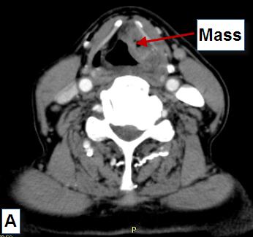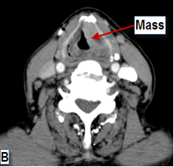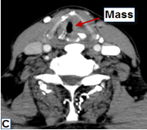
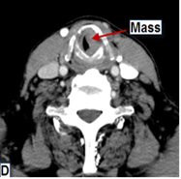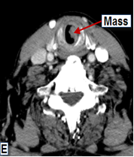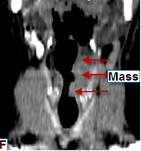
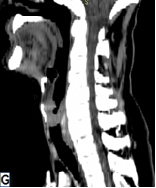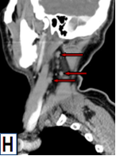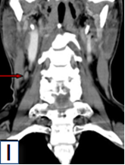
Fig. (1-1): CT images have shown left side transglottic mass extending upwards to the left epiglottis & aryepiglottic fold (A-B), downwards to the left true vocal cord as well as anterior commissure (C) with subglottic extension (D-E). (F) Coronal reformatted CT image has revealed infiltration of the left paraglottic space with subglottic extension. (G) Sagittal reformatted CT image has revealed infiltration of the pre-epiglottic space. (H) Sagittal and (I) coronal reformatted images have shown left side multiple enlarged deep cervical lymph nodes.

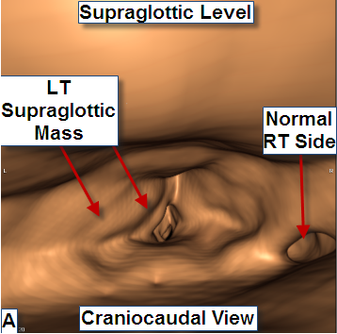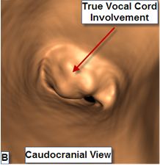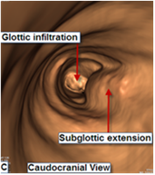
Fig. (1-2): Virtual laryngoscopy images have revealed left supraglottic mass lesion involving the aryepiglottic fold with surface irregularity in cranio-caudal direction (A). True vocal cord infiltration and subglottic extension are clearly seen in (B-C) caudo-cranial direction.

Case No. (2): Male patient, (65) years old, presented with progressive hoarsness of voice. Diagnosis transglottic (glottic and subglotic extension) stage IVa.
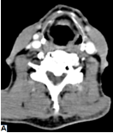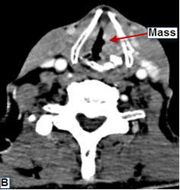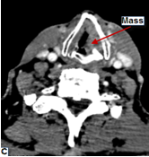
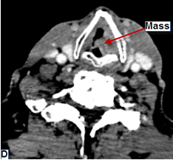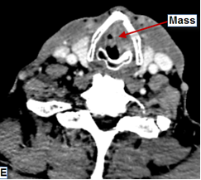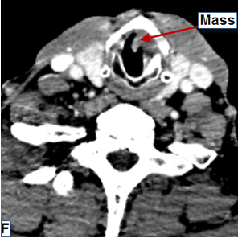
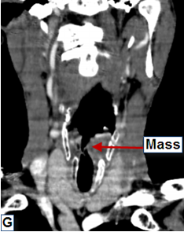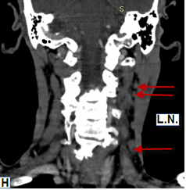
Fig.(2-1): The axialCT images have shown:(A) cleararyepiglottic folds, (B-C-D) soft tissue massinvolving the left true vocal cord with thickened anteriorcommissure and encroachment on the lumen. (E-F) have revealed subglottic extension. Coronal reformatted images have shown left glottic mass lesion with subglottic extension (G) as well as ipsilateral multiple enlarged deep cervical lymph nodes (H).
Mass

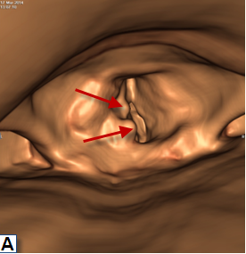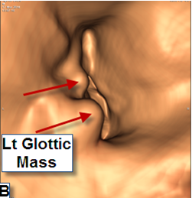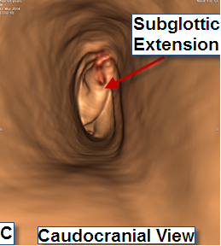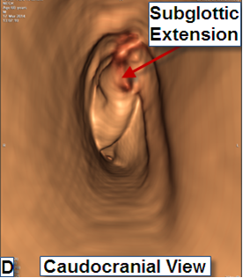
Fig. (2-2): Virtual laryngoscopy images: (A-B) cranio-caudal direction images have revealed right true vocal cord mass lesion with surface irregularity and thickened anterior commissure. (C-D) caudo-cranial direction images have shown subglottic extension.

Case No.(3): Male patient (73) years old, presented by dysphagia. Diagnosissupraglottic carcinoma stage III.

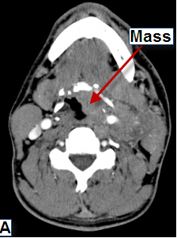 | 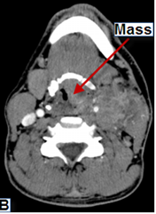 | 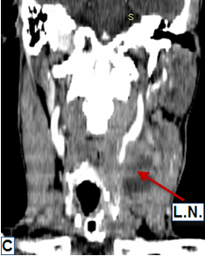 | 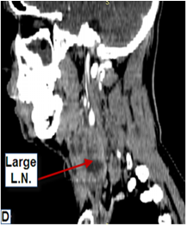
Fig. (3-1): (A-B) axial CT images have shown large mass arising from the epiglottis and invading the pre-epiglottic as well as paraglottic spaces. Coronal (C) and sagittal (D) MPR images have revealed large ipsilateral deep cervical lymph nodes.

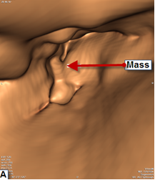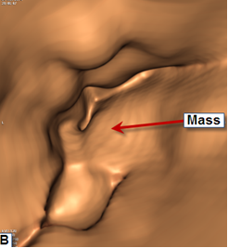
Fig. (3-2): (A-B)Virtual laryngoscopy images (cranio-caudal direction) have revealed left epiglottic mass lesion encroaching on the lumen.

Case No. (4): Female patient (50) years old, with progressive dysphagia. Diagnosis Lt. pyniform fossa carcinoma stage IVa.

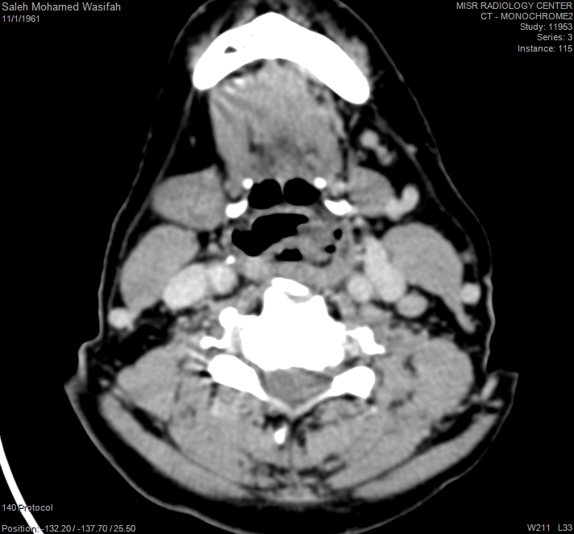
B
A
Fig. (4-1) (A & B): CT axial cuts have shown showing mass at the left pyriform fossa.
Pyriform fossa
Post cricoid

Paraglottic space
A
Lower limit
B
Fig. (4-2): (A) coronal reformatted image has revealed infiltration of the left paraglottic space. (B) Sagittal reformatted image has shown clear pre-epiglottic space with detection of the lower limit of the mass opposite D1 vertebral body.

B
A
Fig. (4-3): Bilateral deep cervical lymph node enlargement is noted in the coronal image (A) at left side and in the sagittal image (B) at the right side.
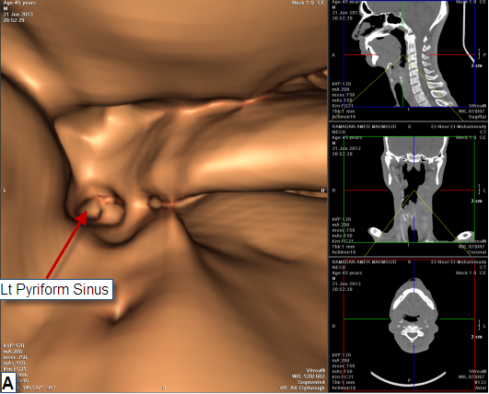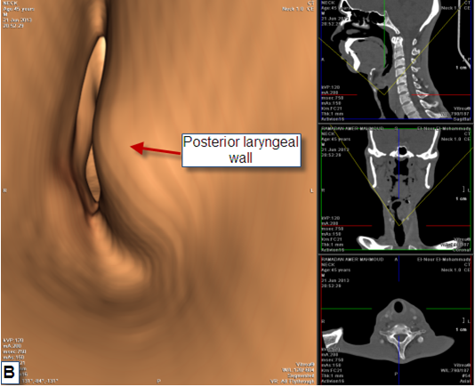
Fig. (4-4): Virtual laryngoscopy cranio-caudal image (A) is showing surface irregularity with evidence of mass lesion obliterating the left pyriform sinus (A) and indenting the posterior laryngeal wall (B).

Case No. (5): Female patients, (30) years old, presented with progressive dysphagia and horsness of voice. Diagnosis Lt pyriform fossa carcinoma stage IVa.
Mass in the left pyriform fossa
A
Mass in post cricoid
B
Mass in upper esophagus
C
Fig. (5-1): axial CT cuts showing the mass arising from left pyriform sinus (A) extending to the post cricoid region (B) and the posterior pharyngeal wall down to the esophagus (C).

Lower limit
Fig. (5-2): sagittal reformatted image reveals the lower limit of the mass opposite D1/D2.
B
A
Fig. (5-3) (A & B): coronal reformatted images are showing multiple enlarged deep cervical lymph nodes.
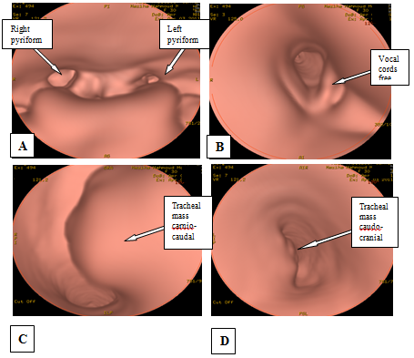
Fig. (5-4): Virtual laryngoscopy has shown obliteration of the left pyriform sinus in cranio-caudal image (A) with free vocal cords cranio-caudal image (B), yet another exophytic lesion is noted from mucosa of the trachea at the level of D1 vertebra (C & D).

4.Discussion

In our study (6) times more men were affected with laryngeal carcinoma than women. The mean age of patients with laryngeal cancer was (60) years. The mean age of patients with hypopharyngeal carcinoma was (49.8)years and all patients were females. The overall rate of occurrence of laryngeal carcinoma was (3) times greater than that of hypopharyngeal cancer. Patients often present with voice changes, sore throat, swallowing difficulty, or neck mass.
SCC typically begins in the inner laryngeal and hypopharyngeal surfaces and presents in three different types; infiltrative, bulky or mixed. Local dissemination can be found on mucosa surfaces or when there is deep invasion of structures with consequent submucosal extension. It is a potentially curable tumor,the survival rates depend on early diagnosis, and adequate treatment for each situation (Varsha et al., 2012).
The extent of the tumor has substantial impact on treatment decisions for laryngeal cancer. Early T1 and T2 tumors of the glottis and supraglottis can be treated with laser excision, while in more advanced tumors, total or partial laryngectomy may be indicated. (Gilbert et al., 2010).
The aim of therapy is to conserve laryngeal function while achieving the best life expectancy and quality of life for patients. Because of the variety of therapeutic options which based on tumor extension, imaging plays a key role in the staging of laryngeal cancer (Gilbert et al., 2010).

Direct laryngoscopy is the most important examination for the pre-therapeutic management. Its visualization of the mucosa and biopsy availability counteracts its disadvantages such as being invasive, requiring operator experience as well as failure to observe lesions beyond stenosis or obstruction (Beser et al., 2009). Moreover, not all patients can tolerate the rigid laryngoscope especially those with a sensitive gag reflex and patients suffering from stridor (Martins et al., 2011).
Cross-sectional imaging, using spiral CT and post-processing of imaging data, may offer an additional evaluation tool for those difficult clinical situations and provide additional information that cannot be obtained with direct laryngoscopy.

Direct, laryngoscopy alone may not be sufficient in some cases to judge the extent of infiltrative processes of a tumor, for this reason CT is often used to supplement laryngoscope.
CTVL which is computer-generated, three dimensional reconstruction, easy to be performed and can aid in depicting disorders of the large airways without additional radiation or cost other than added time in post-processing (Byrne et al., 2005).

Souzaet al. (2007) in their study done on (60) patients with laryngeal and hypopharyngeal carcinoma stated that all the cases with pathologically detected subglottic extension were correctly detected by CT a positive predictive value of (100%) and accuracy of 95%. This correlates with axial CT combined with MPR had higher ability to evaluate this area than laryngoscopy alone especially if the tumor is large enough to occlude the air filled lumen.

Therefore, direct endoscopy couldn’t evaluate the lower extent of the tumor while CTVL could. Significant agreement between CTVL and direct laryngoscopy was found in our study regarding the evaluation of hidden areas in the hypopharynx (pyriform sinuses and posterior pharyngeal wall).

MPR clearly depicted the infiltration of the paraglottic space and was also useful in detecting subglottic extent of the tumor. Sagittal MPR could directly investigate the involvement of the pre-epiglottic space and anterior commissure.

However, the study has revealed that very small lesions such as vocal cord nodules could not be visualized clearly by CTVL. Moreover, the motion artifacts resulting from patient swallowing during scanning influence the quality of imaging.
Recent developments in multidetector row computed tomography (MDCT) provide better anatomic resolution within a shorter acquisition time and wider anatomic coverage of the larynx helps to delineate the extent of laryngeal carcinoma, accurately demonstrates gross cartilage invasion, especially in the presence of extra laryngeal tumor spread which is important factor for accurate staging and optimal treatment planning.

Virtual laryngoscopy, based on perspective volume rendering, is a non invasive, valid method which delivers anatomical impressions in viewing angle, thus assessment of the surrounding structures, tumor extension and the lymph node metastases is possible simultaneously with the axial CT image.
Comparing the results of direct endoscopy and CTVL we found a highly significant concordance between the two modalities regarding detection of primary subsite of the tumor in patients with laryngeal carcinoma.
CTVL had a relatively low sensitivity regarding detection of mucosal irregularity compared to direct endoscopy. Direct endoscopy was more valuable in identifying vocal cord involvement, diagnosed as cord fixation. Unlike traditional endoscopy VL cannot be used for biopsy with no possibility of therapeutic intervention.

Conclusion

Virtual laryngoscopy and multiplaner reformatting are noninvasive and reliable techniques that provide visualization of endolaryngeal surfaces and tumor extension. It may be beneficial in staging laryngeal and hypopharyngeal carcinoma as well as planning the most appropriate surgical procedure.

References

Beser M, Gultekin E, Yener M, Zeybek ME, et al. (2009): Detection of laryngeal tumors and tumoral extension by multislice computed tomography-virtual laryngoscopy (MSCT-VL). Eur Arch Otorhinolaryngol, 266, pp.1953–1958.

Byrne AT, Walshe P, McShane D and Hamilton S (2005): Virtual laryngoscopy: preliminary experience. Eur J Radiol, 56, pp. 38–42.
- Gilbert K, Dalley R, Maronian N and Anzai Y. (2010): Staging of Laryngeal Cancer Using 64-Channel Multidetector Row CT: Comparison of Standard Neck CT with Dedicated Breath-Maneuver Laryngeal CT. AJNR Am J Neuroradiol, 31, pp. 251–56.
- Harnsberger H R, Wiggins R H, Hudgins P.A, Michel M A, et al. (2004): Diagnostic imaging Head and neck. Ric Harnsberger (ed). Canada: AMIRSYS Inc. 1st edition; part III-3: 18-35.

Martins MJB, Aguiar CV, Jmnior JFN, Abreu JPS, Feijlo MX, Jatai I , et al. (2011): Preoperative planning using 3D reconstructions and virtual endoscopy for location of the frontal sinus. Int Arch Otorhinolaryngol, 15 (1), pp. 48–53.

Miller C and Knapp R (1992): Clinical epidemiology and biostatistics. 3rd ed. Maryland: Williams & Wilkins.

Souza R, Barros N, Oliveira PJ, Souza TO, et al. (2007): Value of computed tomography for evaluating the subglottis in laryngeal and hypopharyngeal squamous cell carcinoma. Sao Paulo Med J., 125(2), pp. 73-6.
- Varsha MJ, Vineet W and Suresh K Mukherji (2012): Imaging in laryngeal cancers. Indian J Radiol Imaging Jul -Sep; 22(3): 209–226.

6/16/2015

