Synthesis and Spectroscopic Studies of and as Anti-cancer Agent

Golpar Golmohammadzadeh¹, Shahriar Ghamamy², Sajjad Sedaghat², Soheil Zabihi³

- Faculty of Pharmacology, Sari University,Sari,Iran
- Department of Chemistry,Faculty of Science, Islamic Azad University,Malard Branch,
Malard, Iran
- Department of Chemistry, Faculty of Science, Ardabil Branch, Islamic Azad University,
Ardabil, Iran

Abstract: Two new organophosphorus compounds,Sodium trichloroperoxophosphate (STFBOB) and Sodium trichlorotiosolphatophosphate (STCTSP) were synthesized from the reaction between and with respectively. Their chemical composition are characterized obviously by spectroscopic methods such az IR and UV/Vis techniques. Also one of this new compounds (STFPOB)has showed excellent anti canceractivity against 742 (Colon adenocarcinoma)cell lines.
[Golpar Golmohammadzadeh, Shahriar Ghamamy, Sajjad Sedaghat, Soheil Zabihi. Synthesis and Spectroscopic Studies of and as Anti-cancer Agent. Cancer Biology 2014;4(4):56-58]. (ISSN: 2150-1041). http://www.cancerbio.net. 8

Keywords: Organophosphorous, anticancer.. Sodium trichloroperoxophosphate. IR.UV-Vis

1. Introduction
In the past five decades,numerous structurally different Organophosphorous compounds have been synthesized and characterized . The chief commercial source is phosphate rock,an impure massive form of carbonate-bearing apatite.Estimates of the total phosphate rock in the Earth’s crust average about 50,000,000,000 tones,of which North Africa contains two-thirds, and Russia and the United States most of the remaining third. this estimate includes only ore sufficiently rich in phosphate for conversion of useful product by present methods.Vast quatities of material lower in phosphorus content also exist.
Because the P:N ratio found in manure is much higher than P:N ratio required by plants, excessive P application has occurred resulting in elevate soil P concentrations .The phosphorus chemistry has been developed in recent year as one of the most important branches of science. Many biological processes such as energy transfer,bone synthesis , amino acidecynthesis,and methabolism require phosphorus and phosphate esters .
Organophosphorous chemistry corresponding science of the properties and reactivity of Organophosphorous compounds. Also they have been used as pesticides and chemical warefare nerve agents..Phosphorus sorption and precipitation of P from dissolved to solid forms .Presently; more than 100 different OP’s are used worldwide as insecticides..
Chemotherapeutic agents are cytotoxic drugs used to treat cancer that functions by targeting fast growing cells and by blocking some critical element of the cell division process impairing mitosis as well as promoting apoptosis.Because of the similarity of the structures of the synthesized ligand and complexes to the compounds used as chemotherapeutic drugs,they’re in vitro cytotoxicity effects were carried out using MTT assay method.Therefore in this investigations,two novel organo phosphoruse compounds with formula and were synthesized by IR and UV-Vis teqniques.because of mentioning reasons the anticancer activity of STFPOB is discussed clearly.

Material and Methods:
All of the materials used in this study were prepared from Merck company.They include: and and and hexane wwith 99% purity.Solvent that was used for reactions were purified and dried by standard procedures.Infrared spectra were recorded as KBr on a Bruker Tensor model 450 spectrometer and UV/Vis spectra were recorded by CamspeeCompany Wpabio Wave,model 350.
Both of these compounds prepared by dissolving powdered (0.32gr/1.41mmol)in proportional amount of (0.4,0.14ml).
Sodium trichloroperoxophosphate (STFPOB)
UV-Vis in , ë/nm : 280,227.
Sodium trichloroperoxophosphate (STCTSP)
IR (KBr) () : 640.26 (, 552.51 ,449-11 ,1118.78 .UV-Vis in , ë/nm : 279,229.
Cell culture
The 742(Colon adenocarcinoma)cell lines is used for treatment with the dugs,It was grown at 37˚ C in at atmosphere containing 5% , with RPMI-1640 MEDIUM HEPES Modification with L-glutamine and 25mM HEPES (SIGMA-ALDRICH CHEMIE GmbH)supplemented with 10% heat-inactivated fetal bovine serum (FBS) (Gibco), 2.7% sodium.
Antitumor activity
In chemotherapy,when a tumor is exposed to anticancer agents,the percentage of tumor cells which are killed would be proportional to drug dosage (20%-90%).Some specific anticancer drugs destruct cell reproduction via cellular tools.Researches indicate indicate that the maximum effect occurs during the S phase of DNA and RNA synthesis or during the mitosis process for some herbal alkaloidal anticancer agents which directly effect on cell cycle stages are called cell-cycle nonspecific anticancer agents.They usually have a long-term effect on cell which ends up in cell destructions.
because of the similarity of the structures of the synthesized ligand and complexes to compounds used as chemotherapeutic drugs, they’re in vitro cytotoxicity effects were carried out using MTT assay method.Results are absoulutely novel.studied cell lines including 724 (colon cancer cells).they were dissolved in DMSO in three different concentrations.
Toxicity of ligand and complexes were different.some were cytotoxic in high concentrations while the others showed cytotoxic effects in low concentrations.Also in some cases,the complexes showed higher cytotoxic effects in comparison with ligand.The result may be due to the presence of metal in the complexes.Apparently,the complexes prevented cellular proliferation and thus to lead this death (Figure 5-7).Therefore,this compound (STFPOB) is suggested as suitable models for novel antitumor drug designs.

Result and Discussion:
The present contributions aim to build experimental for preparation two novel phosphorus compounds with formula and .These products could be easily prepared in good yield by combination of mentioned components with phosphorus trichloride as follows:

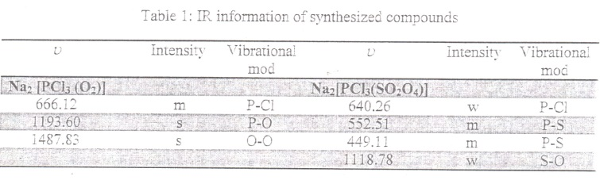

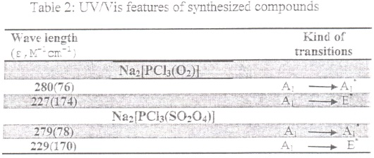

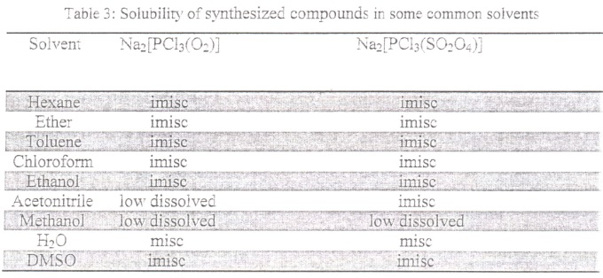

Listed compounds were characterized by IR,UV/Visible techniques (Figure 1-4).in vibrational spectru of them all of the expectable bands have been seen.The most important of these bands are related to tensile motion of P-CI and P-O links (in 666 and 1193 for (STFPOB) and tensile motion of P-CI links (in 640,550 and 449 for STCTSP).
All data of vibrational specteru of this compounds are given in Tablel completely.
As its observable in 2,UV/Visible spectru of STFPBO and STCTSP has 2 transitions.
There are two transitions in wave length 280 and 279 nm respectively that link to charge transitions.
For the solubility of these synthesized compound there are no many data,as it shown in Table 3both of them are soluble in but they are in hexane,ather,toluene,chloroform and DMSO.

Acknowledgement
The authors would like to thanks Dr.Gh.Rezaei Behbahani for his valuable discussions.

References:
- Braun,R.D.,1987. Intruduction to instrumental Analysis.McGraw-Hill:New York.
- Christian,G.D,J.E.O’Reilly (eds),1986.
- Ewing,G.W,1985.instrumental Method of chemical Analysis.
- Pote,D.H.,T.C.Daniel,A.N. sharplley.,P.A.
- Sengupta, S.K.O.P. Pandy., G.P.Rao., Vishen, P. (2002). Efficiency of Organophoshphorous derivatives containing drugs, 8: 293-302.

12/13/2014

