LONG LIVE!... (A New theory on “YOGA”)

M.Arulmani, B.E.; V.R.Hema Latha, M.A., M.Sc., M.Phil.

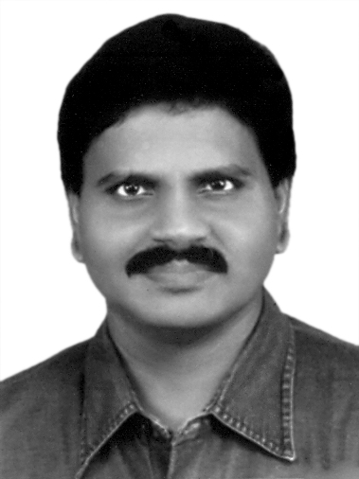  M.Arulmani, B.E.  (Engineer)  m.arulmani58@gmail.com | 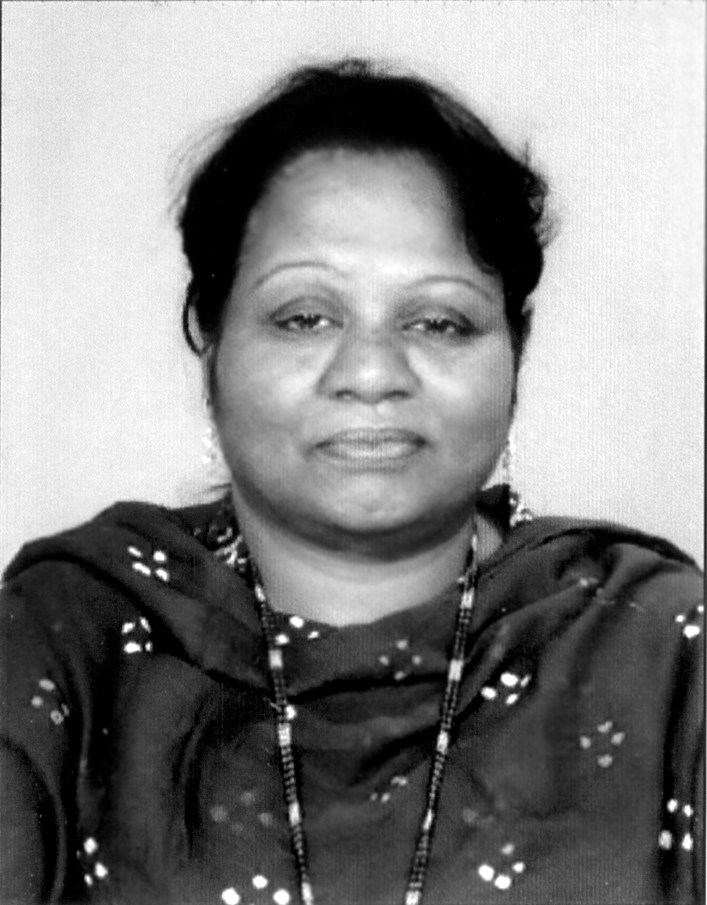  V.R.Hema Latha, M.A., M.Sc., M.Phil.  (Biologist)  vrhemalatha58@gmail.com

- Abstract:
This scientific research article focus that the Philosophy of “YOGA” shall be considered as closely associated with the prehistoric “HERBAL INDO TRIO DRUG” which enabled human life sustained for thousands of years without any “Disease”. The “YOGA” shall also be called as “IMMUNE” or “DIVINE DRUG”. In proto Indo-Europe language the divine drug (Trinity) shall also be called as “YOKAM” or “THAMIL MARUNTHU”.
It is further focused that the philosophy of Ancient medicine shall be considered prepared based on three-in-one domain formula of immunity for up keeping of Total Health system.

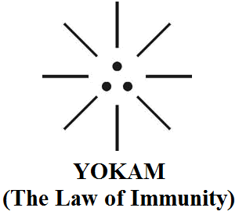

During the course of Expanding universe the growth of various radiations such as alpha, Beta, Gamma and birth of various microbes like Bacteria, Virus, Fungi, the Ancient human races might switch over to adopt various forms of other alternative Medicines like Allopathy, Homeopathy, Unani etc. for immunization of human health system.
“YOKAM shall be considered as DRUG (Organic) rather than MEDICINE (Inorganic). Yokam shall mean IMMUNE rather than STAMINA ”
- M. Arulmani, Tamil Based Indian
[M.Arulmani, B.E.; V.R.Hema Latha, M.A., M.Sc., M.Phil. LONG LIVE!... (A New theory on “YOGA”)
. Cancer Biology 2014;4(4):42-47]. (ISSN: 2150-1041). http://www.cancerbio.net. 6

- Key Words:
  - Philosophy of “Perfect health”?...
  - Philosophy of “Immunity”?...
  - Philosophy of “Yoke”?...
  - Etymology of word “Disease”?...
  - Etymology of word “Sin”?...
  - Etymology of word “Yoga”?...

- Introduction:
Indo mythology focus that the ancient saints lived for thousands of years with perfect health based on herbal medicine. Religious Texts like Bible, Quran also focus that “ADAM” has lived for about 930 years. Further case study shows that the ancient practice of Yoga pertain to the period of Indus valley civilization (2500BCE) prior to Vedic culture (15000BCE). There are various theories exists about various forms of Yoga practice.
The article focus that the irregular food system like variety of oil based food, fast food etc. without any physical work might have spoiled the health system rather than changing in environmental conditions. Present global survey shows that about 60% individual earnings goes for mere medical treatment and consistently reducing the average life of Human.
This research attempts to focus that systematic Natural herbal Medicine can improve the “Immunity” of human system.

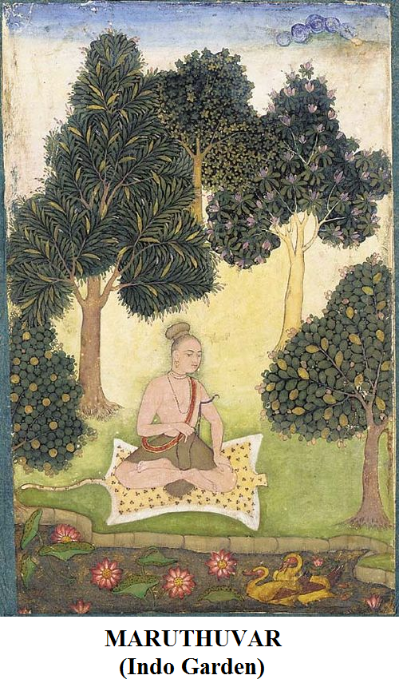

“HERBAL DRUG” is like “NATIONAL PEACE”. “SYNTHETIC MEDICINE” is like “BORDER SECURITY FORCE”.
- Author

- Hypothesis and Narrations
- Philosophy of Perfect Health?...
It is hypothesized that the philosophy of perfect health shall be considered related to improving immunity of human cell in three fundamental domain of Body, Mind, Heart. The perfect balance among three domain shall be considered as the state of ‘Perfect Health’. It is hypothesized that the Ancient Indo Trio Medicine “THIRIKADUKAM” shall be considered as the Divine Drug (Trinity) for perfect health and living for thousands of years.

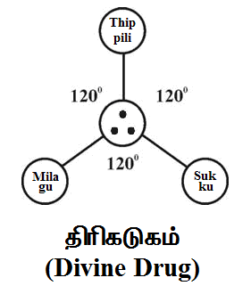

i) Dry Ginger consider controls Body immunity (HORMONE Regulation)
ii) Pepper consider controls mind immunity (DNA Regulation)
iii) Long Pepper consider controls Heart immunity (RNA Regulation)
It is further focused that Thirikadukam shall also be considered as Science of ethics which controls three-in-one fundamental traits of human say MORAL, CONDUCT, CHARACTER.
- Philosophy of Immunity?...
It is hypothesized that Thirikadukam shall be considered as divine plant of earth planet descended from white planet (white Mars) from the natural plant family of ACEAE (Having only three chromosome) evolved of J-Radiation which shall be considered as free from organic elements like hydrogen, carbon, nitrogen, ozone .

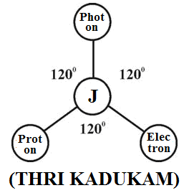

- Proton is like pepper (common sense)
- Electron is like dry ginger (intelligence)
- Photon is like long pepper (intuition)
- J-Radiation is like immunity (Soul)
- Philosophy of Yoke?...
It is hypothesized that the Philosophy of “YOKE” shall be considered as SOUL connecting THREE-IN-ONE elements of human system i.e. body, mind, heart.

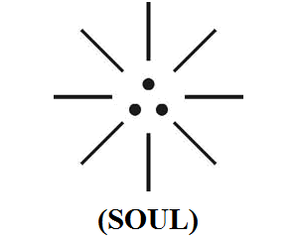

- Pepper is like DEMOCRACY (proton influenced)
- Dry Ginger is like POLITICS (electron influenced)
- Long Pepper is like JUSTICE (photon influenced)
- Etymology of word “Disease”?...
It is hypothesized that the word Disease might be derived from Proto Indo Europe word Thiriam, Thirayam.
i) Thiriam shall mean “perfect immunity”
ii) Thirayam shall mean “Imbalanced immunity”
iii) Thirani shall mean “Strong person”
- Etymology of word “SIN”?...
Case study shows that the word “SIN” refers to an offence against “GOD” (or) against a religious (or) moral laws.
It is hypothesized that the word ‘SIN’ might be derived from Proto Indo Europe root word “CHIN”. CHIN shall mean “SOUL” which connects three-in-one elements of Human immunity system (i.e.) MANAM, CHINAM, YOKAM.
i) MANAM shall mean Mind related immunity
ii) CHINAM shall mean Body related immunity
iii) YOKAM shall mean Heart related immunity
“It is hypothesized that the state of change of SOUL in the expanding universe might have resulted various diseases due to imbalance in MIND, BODY, HEART of human system. Varied SOUL shall mean origin of various types of BLOOD of human system”.
…Author
- Philosophy of word “YOGA”?...
Case study shows that YOGA refers to a system of exercise for controlling body and breathing called “Yogic techniques”. Yogi is referred to an expert in teaching (or) philosophy of Yoga.
It is hypothesized that the etymology of word “Yoga”, ”Yoke” might be derived from Proto Indo Europe Root “YOKAM”. Yokam shall mean IMMUNITY. Further Yokam shall be considered as integral part of SOUL connecting YOKAM (Heart), CHINAM (Body), MANAM (Mind).
It is hypothesized Thirikadukam shall be considered as the Divine Drug controls body, mind, heart simultaneously for keeping perfect health “Thiri Devi” shall mean “MOTHER OF DRUG”

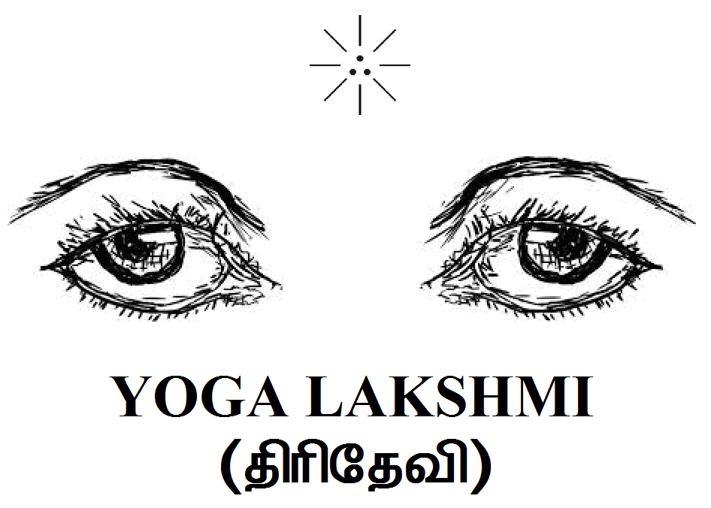

It further focused that the proto Indo Europe root word concerned with various Human Health system shall be indicated as below.
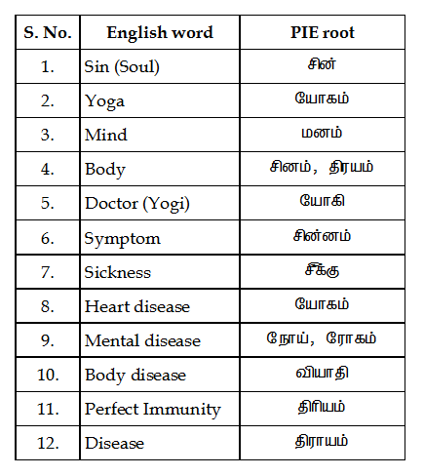

- Philosophy of Thirukkural?...
It is hypothesized that the philosophy of Thirukkural might be derived from the philosophy of Thirikadukam.

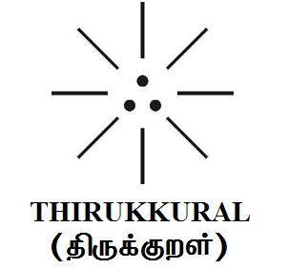

- “ARAM” is like THIPPILI (Long pepper)
- “PORUL” is like MILAKU (Pepper)
- “INBAM” is like CHUKKU (Dry ginger)
- Adam, Eve consumed Thirikadukam?...
It is hypothesized that before taking forbidden fruit Adam, Eve shall be considered as holy person lived in white planet (white Mars) and considered eating only apple with little grape wine rather than Chicken-65, Mutton cola, varieties of Sambar, Rasam. After eating forbidden fruit they might have descended to Earth planet and consumed divine drug Thirikadukam. The impact of Thirikadukam shall be narrated as below.
- Ancient population lived for thousands of years
- Ancient population gave birth to hundreds of children due to impact of Thirikadukam
- Ancient population did not have problem of caesarian birth
- Ancient population constructed Egyptian pyramid
- Ancient population did not have heart disease
- Ancient population did not have diabetic
- Ancient population did not have cancer

- Conclusion:
It is focused that Thirikadukam shall be considered as fundamental Divine Drug essential for balanced health as well as improved Immunity of human health. The Philosophy of Yoga in Sanskrit shall be considered as ALTERNATIVE MEDICINE for improving the immunity of human health system.

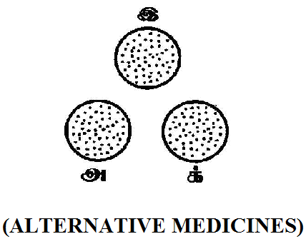

- Right dot - Mental Balance
- Left dot - Physical Balance
- Centre dot - Heart Balance
“The Philosophy of various Yogi techniques such as Raja Yoga, Hatha Yoga, Karma Yoga, Anu Yoga, Kiriya Yoga etc., might be derived from the philosophy of YOGAM (Thirikadukam)”
…Author

- Previous Publication:
The philosophy of origin of first life and human, the philosophy of model Cosmo Universe, the philosophy of fundamental neutrino particles have already been published in various international journals mentioned below. Hence this article shall be considered as extended version of the previous articles already published by the same author.
- Cosmo Super Star – IJSRP, April issue, 2013
- Super Scientist of Climate control – IJSER, May issue, 2013
- AKKIE MARS CODE – IJSER, June issue, 2013
- KARITHIRI (Dark flame) The Centromere of Cosmo Universe – IJIRD, May issue, 2013
- MA-AYYAN of MARS – IJIRD, June issue, 2013
- MARS TRIBE – IJSER, June issue, 2013
- MARS MATHEMATICS – IJERD, June issue, 2013
- MARS (EZHEM) The mother of All Planets – IJSER, June issue, 2013
- The Mystery of Crop Circle – IJOART, May issue, 2013
- Origin of First Language – IJIRD, June issue, 2013
- MARS TRISOMY HUMAN – IJOART, June issue, 2013
- MARS ANGEL – IJSTR, June issue, 2013
- Three principles of Akkie Management (AJIBM, August issue, 2013)
- Prehistoric Triphthong Alphabet (IJIRD, July issue, 2013)
- Prehistoric Akkie Music (IJST, July issue, 2013)
- Barack Obama is Tamil Based Indian? (IJSER, August issue, 2013)
- Philosophy of MARS Radiation (IJSER, August 2013)
- Etymology of word “J” (IJSER, September 2013)
- NOAH is Dravidian? (IJOART, August 2013)
- Philosophy of Dark Cell (Soul)? (IJSER, September 2013)
- Darwin Sir is Wrong?! (IJSER, October issue, 2013)
- Prehistoric Pyramids are RF Antenna?!... (IJSER, October issue, 2013)
- HUMAN IS A ROAM FREE CELL PHONE?!... (IJIRD, September issue, 2013)
- NEUTRINOS EXIST IN EARTH ATMOSPHERE?!... (IJERD, October issue, 2013)
- EARLY UNIVERSE WAS HIGHLY FROZEN?!... (IJOART, October issue, 2013)
- UNIVERSE IS LIKE SPACE SHIP?!... (AJER, October issue, 2013)
- ANCIENT EGYPT IS DRAVIDA NAD?!... (IJSER, November issue, 2013)
- ROSETTA STONE IS PREHISTORIC “THAMEE STONE” ?!... (IJSER, November issue, 2013)
- The Supernatural “CNO” HUMAN?... (IJOART, December issue, 2013)
- 3G HUMAN ANCESTOR?... (AJER, December issue, 2013)
- 3G Evolution?... (IJIRD, December issue, 2013)
- God Created Human?... (IJERD, December issue, 2013)
- Prehistoric “J” – Element?... (IJSER, January issue, 2014)
- 3G Mobile phone Induces Cancer?... (IJERD, December issue, 2013)
- “J” Shall Mean “JOULE”?... (IRJES, December issue, 2013)
- “J”- HOUSE IS A HEAVEN?... (IJIRD, January issue, 2014)
- The Supersonic JET FLIGHT-2014?... (IJSER, January issue, 2014)
- “J”-RADIATION IS MOTHER OF HYDROGEN?... (AJER, January issue, 2014)
- PEACE BEGINS WITH “J”?... (IJERD, January issue, 2014)
- THE VIRGIN LIGHT?... (IJCRAR, January issue 2014)
- THE VEILED MOTHER?... (IJERD, January issue 2014)
- GOD HAS NO LUNGS?... (IJERD, February issue 2014)
- Matters are made of Light or Atom?!... (IJERD, February issue 2014)
- THE NUCLEAR “MUKKULAM”?... (IJSER, February issue 2014)
- WHITE REVOLUTION 2014-15?... (IJERD, February issue 2014)
- STAR TWINKLES!?... (IJERD, March issue 2014)
- “E-LANKA” THE TAMIL CONTINENT?... (IJERD, March issue 2014)
- HELLO NAMESTE?... (IJSER, March issue 2014)
- MOTHERHOOD MEANS DELIVERING CHILD?... (AJER, March issue 2014)
- E–ACHI, IAS?... (AJER, March issue 2014)
- THE ALTERNATIVE MEDICINE?... (AJER, April issue 2014)
- GANJA IS ILLEGAL PLANT?... (IJERD, April issue 2014)
- THE ENDOS?... (IJERD, April issue 2014)
- THE “TRI-TRONIC” UNIVERSE?... (AJER, May issue 2014)
- Varied Plasma Level have impact on “GENETIC VALUE”?... (AJER, May issue 2014)
- JALLIKATTU IS DRAVIDIAN VETERAN SPORT?... (AJER, May issue 2014)
- Human Equivalent of Cosmo?... (IJSER, May issue 2014)
- THAI-e ETHIA!... (AJER, May issue 2014)
- THE PHILOSOPHY OF “DALIT”?... (AJER, June issue 2014)
- THE IMPACT OF HIGHER QUALIFICATION?... (AJER, June issue 2014)
- THE CRYSTAL UNIVERSE?... (AJER July 2014 issue)
- THE GLOBAL POLITICS?... (AJER July 2014 issue)
- THE KACHCHA THEEVU?... (AJER July 2014 issue)
- THE RADIANT MANAGER?... (AJER July 2014 issue)
- THE UNIVERSAL LAMP?... (IJOART July 2014 issue)
- THE MUSIC RAIN?... (IJERD July 2014 issue)
- THIRI KURAL?... (AJER August 2014 issue)
- THE SIXTH SENSE OF HUMAN?... (AJER August 2014 issue)
- THEE… DARK BOMB?... (IJSER August 2014 issue)
- RAKSHA BANDHAN CULTURE?... (IJERD August 2014 issue)
- THE WHITE BLOOD ANCESTOR?... (AJER August 2014 issue)
- THE PHILOSOPHY OF “ZERO HOUR”?... (IJERD August 2014 issue)
- RAMAR PALAM?... (AJER September 2014 issue)
- THE UNIVERSAL TERRORIST?... (AJER September 2014 issue)
- THE “J-CLOCK”!... (AJER September 2014 issue)
- “STUDENTS” AND “POLITICS”?... (IJERD October 2014 issue)
- THE PREGNANT MAN?... (AJER September 2014 issue)
- PERIAR IS ATHEIST?... (IJSER September 2014 issue)
- A JOURNEY TO "WHITE PLANET”?... (AJER October 2014 issue)
- Coming Soon!... (AJER October 2014 issue)
- THE PREJUDICED JUSTICE?... (IJERD October 2014 issue)
- BRITISH INDIA?... (IJSER October 2014 issue)
- THE PHILOSOPHY OF “HUMAN RIGHTS”?... (IJERD October 2014 issue)
- THE FOSTER CHILD?... (AJER October 2014 issue)
- WHAT DOES MEAN “CRIMINAL”?... (IJSER October 2014 issue)
- 1000 YEARS RULE?... (AJER November 2014 issue)
- AM I CORRUPT?... (IJSER November 2014 issue)
- BLACK MONEY?... (AJER November 2014 issue)
- DEAD PARENTS ARE LIVING ANGELS?... (IJERD November 2014 issue)
- MICHAEL IS CHIEF ANGEL?... (AJER November 2014 issue)

Reference
- Intensive Internet “e-book” study through, Google search and Wikipedia.
- M.Arulmani, “3G Akkanna Man”, Annai Publications, Cholapuram, 2011.
- M. Arulmani; V.R. Hemalatha, “Tamil the Law of Universe”, Annai Publications, Cholapuram, 2012.
- Harold Koontz, Heinz Weihriah, “Essentials of management”, Tata McGraw-Hill publications, 2005
- M. Arulmani; V.R. Hemalatha, “First Music and First Music Alphabet”, Annai Publications, Cholapuram, 2012.
- King James Version, “Holy Bible”.
- S.A. Perumal, “Human Evolution History”.
- “English Dictionary”, Oxford Publications.
- Sho. Devaneyapavanar, “Tamil first mother language”, Chennai, 2009.
- Tamilannal, “Tholkoppiar”, Chennai, 2007.
- “Tamil to English Dictionary”, Suravin Publication, 2009.
- “Text Material for E5 to E6 upgradaton”, BSNL Publication, 2012.
- Nakkiran, “Dravidian mother”, Chennai, 2007.
- Dr. M. Karunanidhi, “Thirukkural Translation”, 2010.
- “Manorama Tell me why periodicals”, M.M. Publication Ltd., Kottayam, 2009.
- V.R. Hemalatha, “A Global level peace tourism to Veilankanni”, Annai Publications, Cholapuram, 2007.
- Prof. Ganapathi Pillai, “Sri Lankan Tamil History”, 2004.
- Dr. K.K. Pillai, “South Indian History”, 2006.
- M. Varadharajan, “Language History”, Chennai, 2009.
- Fr. Y.S. Yagoo, “Western Sun”, 2008.
- Gopal Chettiar, “Adi Dravidian Origin History”, 2004.
- M. Arulmani; V.R. Hemalatha, “Ezhem Nadu My Dream” - (2 Parts), Annai Publications, Cholapuram, 2010.
- M. Arulmani; V.R. Hemalatha, “The Super Scientist of Climate Control”, Annai Publications, Cholapuram, 2013, pp 1-3.

11/16/2014

