Unfolded protein response activity and cell cycle analysis in K562 cell line

Ali Bazi¹, Mehran Gholamin^{2,} Mohamadreza Keramati^{1, 4}, Mahdi Esmailzade²

¹ Cancer molecular pathology research center, Imam Reza hospital, faculty of medicine, Mashhad University of Medical Sciences, Mashhad, Iran
²Division of Human Genetics, Immunology Research Center, Avicenna Research Institute, Mashhad University of Medical Sciences, Mashhad, Iran
³ Cancer molecular pathology research center, Imam Reza hospital, faculty of medicine, Mashhad University of Medical Sciences, Mashhad, Iran (Email; keramatimr@mums.ac.ir).

Abstract: Bakground: UPR (Unfolded protein response) is a potent intracellular signaling pathway originating from endoplasmic reticulum(ER). UPR activation results in a generalized improvement in cell function under stress sates and increase resistance of cells to pathologic stimulus. In case of failure of accommodation to stress, UPR activates apoptotic routes in order to remove unhealthy cells. Role of UPR in a diverse spectrum of disorders including various cancers has been established. Although UPR has been widely investigated in many studies, its effects on cell cycle has been poorly understood. Material and methods: In this research, we examined effects of two common ER stress inducers, tapasigargin (Tg), tunciamycin (Tm), individually and in combination with oxidative stress on UPR activation and cell cycle kinetics in K562 cell line. In this regard, we used PCR to assess Xbp1 expression, major UPR target gene, and Propidium iodide (PI) staining and flow cytometric analysis to evaluate cell cycle. Results: We observed that Tg, Tm and oxidative stresses, individually and in different combinations with each other activate UPR signaling in cells, although we did not observe major effects on cell cycle. Discussion: it seems that UPR activation, although may affect different signaling pathways within cells, do not influence the cell cycle progression in K562 cell line.
[Ali Bazi, Mehran Gholamin, Mohamadreza Keramati, Mahdi Esmailzade. Unfolded protein response activity and cell cycle analysis in K562 cell line. Cancer Biology 2014;4(4):22-25]. (ISSN: 2150-1041). http://www.cancerbio.net. 3

Keywords: ER stress, unfolded protein response, K562 cell line, cell cycle analysis

Introduction
Endoplasmic reticulum (ER) stress is resulted from participation of a large load of unfolded proteins in inter corpuscular space of ER(1). Molecular chaperons have the duty of folding proteins and preventing them from abnormal structural configurations. As a result of folding failure, a combination of cellular signaling pathways, entitled as unfolded protein response (UPR) are operated within injured or stressed cell(2). UPR is mediated by three main ER membrane proteins: IRE1 (Inositol-requiring protein 1), PERK (protein kinase R-like ER kinase) and ATF6 (activating transcription factor 6)(3). IRE1 constitutes a major UPR barch which acts through transformation of an inactive 442 base pair transcript of Xbp1 (unspliced Xbp1; uxbp1) to an actively translatable 416 base pair transcript of Xbp1 (spliced; sXbp1) (4, 5). Subsequently, sXbp1 translocate to nucleus and induce UPR target genes(6).
Final role of these pathways is to accommodate cells to stress causing situation. Also, UPR has the capability to program target cells to death in extreme conditions. Activity of UPR and expression of UPR target genes have been studied in many disorders including a variety of common neoplastic diseases. UPR interacts with broad range of molecules related to various other signaling routes within cells. Ras, a well khown proto oncogene mediating many roles in controlling cell cycle progression, has activated UPR in human lung and prostate cancer cells(7). Protein kinase C (PKC) which plays wide roles in various signaling sequences including cell cycle controlling pathways in all cells can influence UPR activity in multiple manners. Its been shown that PKC activity could inhibit UPR downstream signaling molecules (8). PKC also participate as a main regulating mechanism to UPR induced apoptosis in neural cells (9). Beta catenin signaling, a major growth controlling pathway, have also been described as a key comportment of PKC influences on UPR activation (10). Role of PKC- UPR signaling axis is demonstrated in regulating cell growth of neoplastic plasma cells in multiple myelom (MM), a devastating hematologic malignancy(11). Role of Ca²⁺ and its associated functional protein, calmodulin, is critical in many physiological responses of cells to their environments and especially cell cycle modulators. ER stress and UPR are reciprocally interacting with Ca²⁺ hemostasis and cellular Ca²⁺ traffic(12). Action of chaperons within ER is essentially dependent on Ca²⁺ availability in cells (13). Although UPR target genes have extensively studied in recent years, intensive researches to identifying new targets with new impacts on cell function are carrying out(14). Very recently, an interesting study revealed that two cell cycle checkpoints controlled through ER stress are present in cells which are highly in association with p53, a major cell cycle regulator molecule(15). Also, the role of cellular proteolytic machinery in adjustment of ER stress signaling and cell cycle progression has been described (16). Reports of cell cycle arrest in carcinoma cell lines have been mentioned (17, 18). However, relationships between ER stress signaling and cell cycle progression is largely unclear and more investigation are demanded in this field. Here, we examined effects of a combinations ER stress inducers in associate with oxidative stress on UPR activation and cell cycle kinetics in K562 cell line. We used tapasigargin (tg) (which cause ER Ca²⁺ hemostasis aberration), tunicamycin (Tm) (which interfere with protein glycosylation and folding properties) and H₂O₂ (hydrogen peroxide) to induce stresses. Xbp1 expression and splicing was evaluated by reverse transcriptase (RT) PCR and cell cycle analysis was carried out using Propidium iodide (PI) staining and flow cytometric analysis. Although Xbp1 expression and splicing status indicated strong UPR activation, cell cycle status did not change in K562 cell line following UPR activation. Therefore, it seems that effects of UPR activation on cell cycle is affected with other potential mechanisms that may act in concert with UPR signaling to regulate cell growth.

Materials and methods
This study was managed by Avicenna Research Institute and Cancer molecular pathology research center, Imam Reza Hospital of Mashhad University of Medical Sciences, 2014.
Cell culture
K562 cell line (Pastor Institute, Iran) was cultured in RPMI1640 medium supplemented with 5 % FBS (Gibco) and 1% pen-strep. Cells were incubated in 5% CO2 condition. After confirmation of 95% cell viability through trypan blue staining, cells were treated in first three groups with Tg, Tm and H₂O₂ individually in 5 µg/l, 0.1 µM and 3 µM respectively. In second three groups, combinations of H₂O₂+Tg, H₂O₂+Tm and Tg+Tm were utilized. In each of six groups, cells were subjected to treatments for 8 hours.
RNA extraction: Total RNA was extracted using total RNA extraction kit (Parstous, Iran) in order to manufacture instructions. At least 1 million cells in each well were used to obtaining good quality RNA. Quality of extracted RNA was confirmed by observation of ribosomal RNA on 2% agaros gel electrophoresis.
cDNA synthesis: cDNA was synthesized using cDNA synthesis kit (Parstous) in order to manufacture instructions. cDNA synthesis was confirmed by RT-PCR on housekeeping GAPDH gene.
Polymerase chain reaction (PCR): PCR reaction was performed in a reaction mixture containing 1 pmol primer Xbp1, able to recognize both sXbp1 and uXbp1 (forward: 5- CCTTGTAGTTGAGAAC CAGG-3 and reverse: 5- -GGGGCTTGGTATATATGTGG-3, Denazist), 0.3 µl Taq DNA polymerase and 0.5 µl dNTP, 2 µl 10X buffer and 1.4 µl mgcl2(1.5 mM). Temperature profile was used as 94$℃$, 10 minutes, 60 $℃,$30 seconds, 72 $℃,$30 seconds and final 72 $℃$ for 10 minutes. Reaction was conducted for 40 cycles and products were assessed on 4% agarose gel to identify Xbp1 splicing and to evaluate its expression intensity.
Flow cytometric analysis:
Treated cells were incubated in Propidium iodide (sigma aldrich) for 30 minutes in dark. Then cells were evaluated to assess DNA content and cell cycle using flow cytometry. All tests were performed in triplicate.

Results
ER stress activates UPR in K562 cell line
In three individual stress groups; Tg, Tm and H₂O₂ expression and splicing status of Xbp1 was observed, however, shifting to strong spliced form was detected in states with much stronger stresses; H₂O₂+Tg, H₂O₂+Tm and Tg+Tm (Figure1).
Cell cycle progression in K562 cell line is independent of UPR activity
Flow cytometric assessment of cell cycle analysis revealed that in none of six examined groups, cell cycle status was not a subject of UPR activity and ER stress (Figure 2).

Discussion
Regulation of cell cycle is a prominent aspect of a cell life, controlling growth, proliferation and differentiations of all kinds of cells (19, 20). Yet, many factors that affect cell cycle kinetics are unclear. Interaction of cell cycle regulating molecules with other cellular molecular complex exerts hallmarking impacts on cell fate. In order to examine effects of UPR activation on cell cycle progression in K562 cell line, we treated these cells with three common ER stress inducers and then assessed cell cycling. We observed that in these cells, cell cycle may be independent of ER stress modulations.

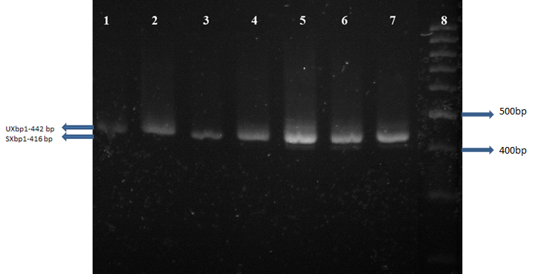
Figure 1. Xbp1 expression and splicing different individual and combinational stress conditions.
Control (line 1, 0.01% DMSO) Individuals (line 2, H₂O₂; line 3, Tg; line 4 Tm), Simultaneous combinational (line 5, H₂O₂+Tm; line 6, H₂O₂+Tg; line 7, Tm+Tg),
Lines 8 show 100 bp ladder. Our results revealed that. Our results showed that splicing state of Xbp1 has changed from unspliced (uXbp1- 442bp) in control groups to spliced (sXbp1-416 bp) form in ER stress conditions.

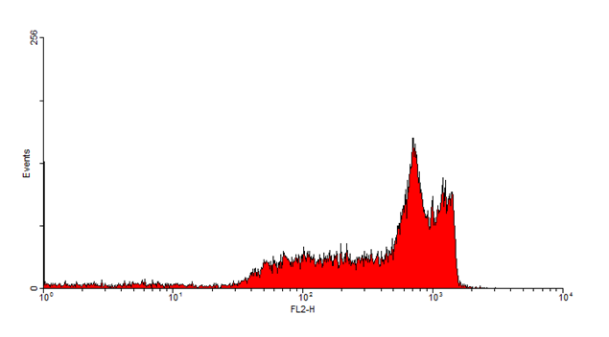
Figure 2. In Propidium iodide staining of control cells. All treated cells showed similar staining patterns.

Acknowledgement
Special thanks to mums.

References
1. Chakrabarti A, Chen AW, Varner JD. A review of the mammalian unfolded protein response. Biotechnology and bioengineering. 2011;108(12):2777-93.
2. Walter P, Ron D. The unfolded protein response: from stress pathway to homeostatic regulation. Science. 2011;334(6059):1081-6.
3. Diehl JA, Fuchs SY, Koumenis C. The cell biology of the unfolded protein response. Gastroenterology. 2011;141(1):38-41. e2.
4. Hampton RY. ER stress response: getting the UPR hand on misfolded proteins. Current Biology. 2000;10(14):R518-R21.
5. Koumenis C, Wouters BG. “Translating” Tumor Hypoxia: Unfolded Protein Response (UPR)–Dependent and UPR-Independent Pathways. Molecular Cancer Research. 2006;4(7):423-36.
6. Ron D, Walter P. Signal integration in the endoplasmic reticulum unfolded protein response. Nature reviews Molecular cell biology. 2007;8(7):519-29.
7. Guo J, Zhu T, Luo LY, Huang Y, Sunkavalli RG, Chen CY. PI3K acts in synergy with loss of PKC to elicit apoptosis via the UPR. Journal of cellular biochemistry. 2009;107(1):76-85.
8. Lee W, Kim D, Boo J, Kim Y, Park I-S, Mook-Jung I. ER stress-induced caspase-12 activation is inhibited by PKC in neuronal cells. Apoptosis. 2005;10(2):407-15.
9. Anantharam V, Kanthasamy A, Choi CJ, Martin DP, Latchoumycandane C, Richt JA, et al. Opposing roles of prion protein in oxidative stress-and ER stress-induced apoptotic signaling. Free Radical Biology and Medicine. 2008;45(11):1530-41.
10. Raab MS, Breitkreutz I, Tonon G, Zhang J, Hayden PJ, Nguyen T, et al. Targeting PKC: a novel role for beta-catenin in ER stress and apoptotic signaling. Blood. 2009;113(7):1513-21.
11. Manni S, Brancalion A, Tubi LQ, Colpo A, Pavan L, Cabrelle A, et al. Protein Kinase CK2 Protects Multiple Myeloma Cells from ER Stress–Induced Apoptosis and from the Cytotoxic Effect of HSP90 Inhibition through Regulation of the Unfolded Protein Response. Clinical Cancer Research. 2012;18(7):1888-900.
12. Periasamy M, Kalyanasundaram A. SERCA pump isoforms: their role in calcium transport and disease. Muscle & nerve. 2007;35(4):430-42.
13. Pratt WB, Toft DO. Regulation of signaling protein function and trafficking by the hsp90/hsp70-based chaperone machinery. Experimental Biology and Medicine. 2003;228(2):111-33.
14. Benedetti C, Fabbri M, Sitia R, Cabibbo A. Aspects of gene regulation during the UPR in human cells. Biochemical and biophysical research communications. 2000;278(3):530-6.
15. Thomas SE, Malzer E, Ordóñez A, Dalton LE, Liniker E, Crowther DC, et al. P53 and translation attenuation regulate distinct cell cycle checkpoints during endoplasmic reticulum (ER) stress. Journal of Biological Chemistry. 2013;288(11):7606-17.
16. Chen M, Gutierrez GJ, Ze'ev AR. Ubiquitin-recognition protein Ufd1 couples the endoplasmic reticulum (ER) stress response to cell cycle control. Proceedings of the National Academy of Sciences. 2011;108(22):9119-24.
17. Gagliostro V, Casas J, Caretti A, Abad JL, Tagliavacca L, Ghidoni R, et al. Dihydroceramide delays cell cycle G1/S transition via activation of ER stress and induction of autophagy. The international journal of biochemistry & cell biology. 2012;44(12):2135-43.
18. Kim HS, KONG KA, Chung H, Park S, Kim MH. ER stress induces the expression of Jpk, which inhibits cell cycle progression in F9 teratocarcinoma cell. Annals of the New York Academy of Sciences. 2007;1095(1):76-81.
19. Weinberg RA. The retinoblastoma protein and cell cycle control. Cell. 1995;81(3):323-30.
20. Kamb A, Gruis NA, Weaver-Feldhaus J, Liu Q, Harshman K, Tavtigian SV, et al. A cell cycle regulator potentially involved in genesis of many tumor types. Science. 1994;264(5157):436-40.

11/9/2014

