A Novel CAD System for Breast Cancer Detection

Osama R.Shahin ¹, Hamdy M. Kelash², Gmal Mahrous², Osama S. Farag Allah²

^{1.} Physic and Mathematic Department, Faculty of Engineering, Helwan University, Egypt
^{2.} Department of Computer science and Engineering, Faculty of Electronic Engineering, Menoufia University, Menouf, 32952, Egypt
E-mail: Osama.Shahin@ymail.com

Abstract: As breast cancer is considered the most fatal one of all cancer types according to recent findings, many researchers all over the world are interested to develop CAD (computer aided diagnoses) systems as a second opinion for the radiologists. Therefore this paper aims to develop a preprocessing scheme for the detection and classification of breast cancer in mammogram images. The scheme proposed consists of two main phases. Firstly, detection phase. In this phase we used a template-matching procedure. These templates are defined according to the shape, and brightness of the tumor masses. Several steps including thersholding, labeling and masking, filtering were suggested to enhance the tumor's intensity compared to the surrounding background blood vessels which appear very similar to tumor in mammogram images. Convert the image into binary one was needed to calculate the properties for all objects in the image. According to the diameter property of the label image, the 2D Gaussian template will design. So we had a dynamic diameter template according to the specific mammogram image. A new template matching algorithm using cross-correlation method is implemented in this work. Cross-correlation algorithm operates well on two-dimensional images and gives the best result for the matching process. Secondly, feature extraction phase. In this phase a new algorithm for classifying mammograms by using an evolutionary approach known as signatures- distances from the centroid to all points on the boundary of the region of interest (ROI) as a function of a polar angle θ. The signature of a closed boundary is a periodic function, repeating itself on an angular scale of 2π. Then encode and describe this closed boundary to arbitrary function through 1-D (radial) Fourier expansion coefficients. The method was tested over several images from the image a database taken from MIAS (Mammogram Image Analysis Society, UK), that provides a standardized classification for mammographic studies. This system demonstrates good correlation with the likelihood of breast malignancy. The algorithm works faster so that any radiologist can take a clear decision about the appearance of calcifications by visual inspection. The implementation of the algorithm was carried out using MATLAB codes programming and thus is capable of executing effectively on a simple personal computer with digital mammogram as accumulated data for assessment.
[Osama R.Shahin, Hamdy M. Kelash, Gmal Mahrous, Osama S. Farag Allah. A Novel CAD System for Breast Cancer Detection. Cancer Biology 2014;4(3):1-10]. (ISSN: 2150-1041). http://www.cancerbio.net. 1

Keywords: Mammogram, Gaussian distribution, Template matching, Fourier series.

1. Introduction
Breast cancer is a disease where abnormal cells grow in an uncontrolled way. It is the most common cause of death among middle age-women. The World Health Organization’s International Agency for Research on Cancer in Lyon, France, has estimated that more than million women worldwide died due to breast cancer each year [1]. The symptoms of breast cancer include breast mass, change in shape and dimension of breast, differences in the color of breast skin, breast aches and gene changes etc. The damage that cancerous tumors cause to various important organs in the body can lead to serious illness, so the earlier the cancers are detected, the better treatment can be provided. Mammography helps in early detection and it plays a very important role in cancer treatment and allows a faster recovery for most of the patients [2-3]. Masses are lesions more difficult to detect in mammograms because the features of a mass are similar to those of the normal breast parenchyma. In general, mass shape can be round, oval, lobular or irregular, and margins can be circumscribed or speculated. There are many features that can be classified the masses into benign or malignant. Benign masses are typically smooth and distinct, and their shapes are similar to the round. On the other hand malignant masses are irregular and their boundaries are usually blurry. A mammogram is basically distinct with four levels of the intensities: background, fat tissue, breast parenchyma and calcifications with increasing intensity [4-5]. Due to the large number of patients in centers and various medical units and the need for continuous monitoring of such diseases, it has developed several computer-aided diagnosis approaches to automated diagnostic systems in the past decade to try to solve this problem. Figure 1 shows a typical block diagram for the proposed CAD system.

Medical

Report
Original Image
Mass Detection

Classification

Feature Extraction

Figure 1: Different steps of a typical CAD system for cancer detection

In general, the various terminologies used to determine the performance of a CAD system are defined as follows:

(1)
(2)
The remainder of the paper is organized as follows: The proposed algorithm is described in section 2. Experimental results are shown in section 3 finally, we conclude the paper in section 4.

2. Proposed Algorithm
All the mammogram images are preprocessed to remove the noise such as image background, labels [6-7]. The data sets of the proposed method are divided into a) training images and b) test images.

Phase 1: Detection Phase
This phase consists of more than one step that can be summarized as follows:-

Step 1: Image Enhancement
There are two possible approaches to enhance mammographic features. One is to increase the contrast of suspicious areas and the other is to reduce their background variations [8]. Their method is based on adaptive neighbourhood processing with a set of contrast enhancement functions or an optimal one to enhance the contrast of mammographic features. In our work, we enhance the images by reducing the background variations while preserving the contrast of suspicious areas in the images. Conventional low-pass filtering techniques are inappropriate for enhancing mammograms, because they tend to blur the image an cause further loss of tumor edges. The non-linear filter like a median filter is particularly suitable for enhancing medical images due to ability to provide both noise reduction and edge preservation. To apply median filtering to a digital picture, we replace the value at a pixel by the median of the values in a neighbourhood of the pixel. Given a set of n numbersand we define the ordered set. The median of the set is given then by

(3)

Two – dimensional median filters can be defined for arbitrary sizes and shapes of filter windows W(i,j), such as line segments, squares, circles, and crosses.

Step 2: Labeled Image
The information of the pixels inside the gray level image which is the input image not needed in this step. Only we need to know the dimension of the various subjects inside the image. Labeled images are integer images where the values correspond to different regions. i.e., region 1 is all of the pixels which have value 1; region two is the pixels with value 2, and so on. By convention, region 0 is the background and often handled differently.

Step 3: Bounding Box
In this step the calculation of the smallest rectangle containing each label object is achieved. This step was required to reject the noise and the other nonsuspicious areas, because they contacting a minimum number of pixels comparable with suspicious areas. The tumor intensity decreases gradually from its centre towards its boundaries so that it occupies a large area comparable with the other nonsuspicious areas.

Step 4: Template Creation
In this paper, a model with specific features was created to match the tumor candidate. Features of the model are based on our study of real tumors’ features. A Tumor is a semi-circular object with variable intensities, tumor intensities decrease gradually from its center towards its boundaries, as a result of that intensities distribution inside a tumor follows a Gaussian distribution model Figure 2. So, 2D-Gussian Model was created with dynamic diameter according to dimension of the bounding box for that obtained in the last step that they can match different tumors’ sizes and shapes.This model with different radii was illustrated in Figure 3.

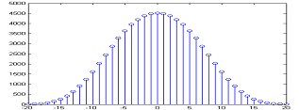
Figure 2: Gaussian distribution of pixels intensities for Gaussian circle model with 40 pixels diameter.
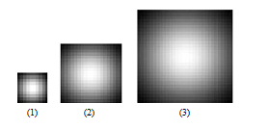
Figure 3: Three Gaussian Models templates with different sizes, (1) is a Gaussian circle with 10 pixels diameter, (2) 20 pixels diameter,(3) 30 pixels diameter.

Step 5: Similarity Measure
There is a need to measure the similarity between a true suspicious area and the template. For this purpose, we require a similarity measure. Hence, the normalized cross-correlation measure is used. Suppose that “S“ is an image of size L*L array of pixels, each taking one of k gray level, and W be the M*M template with M<<L. Each M*M sub image of S can be uniquely referenced by its upper left corner co-ordinates (i,j). The normalized cross- correlation measure is defined by:
(4)

Where, µ_{w} is the mean of the template, and µs is the mean of the sub-image centered at image point (i,j).The template matching operation gives the output in which, each pixel value is the result of cross correlating the template and the sub-image centered at that point. These values should be interpreted such that suspicious areas are detected and nonsuspicious areas are rejected.
Phase 2: Feature Extraction
The automatic massive lesions feature extraction algorithm can be summarized in the following steps:

Step 1: Detect Region of Interests (ROIs)
These regions can be easily detected in an image if the area has sufficient contrast from the background. In this phase, the detection algorithm that discussed in phase 1 was applied. Once the Region of Interest (ROI) is automatically extracted, A Sobel filter was applied on the image to detect the edges of the region of interest (ROI). The ROI is the tumor of the digital mammogram and the goal is to isolate this area from the image. A dilation operation was performed after filtering to connect edges. Dilation was followed by filling the remaining holes of the ROI.

Step 2: Determine Centroid for Any (ROI)

(5)
(6)
The centroid () is the average of the pixels location in a region R, Where:
r: Locations of the rows in a region R.
c: Locations of the columns in a region R.
A: Area of the region R

Step 3: Boundary Signature
Calculate the distances from the centroid to the all points on the boundary of the region of interest (ROI) as a function of a polar angle θ. A signature is the representation of a 2-D boundary as a 1-D function. The signature of a closed boundary is a periodic function, repeating itself on an angular scale of 2π. Such distance called Radial Distance (RD), see Figure 4.
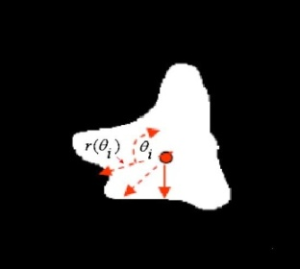
Figure 4: Radial Distance Measure (RDM)

Step 4: Evaluation of Fourier Expansion
Encode this closed boundary by an arbitrary function through 1-D (radial) Fourier expansion coefficients. One simple and neat way to encode and describe a closed boundary to arbitrary and accuracy is through a 1-D (radial) Fourier expansion. The signature can be expressed in real or complex form as follows:

(7)
The shape can be parametrically encoded by the real Fourier expansion coefficients .These coefficients can easily be calculated through use of the orthogonality relations for Fourier series [9]. The real coefficients for a radial signature are given by:
(8)
(9)

Typically, a good approximation to the shape can be encoded using a relatively small number of parameters, and more terms can be included if higher accuracy is required. The use of radial Fourier expansions can, however, become problematic on complicated boundary shapes, particularly those in which the boundary ‘meanders back’ on itself.The signature function r(θ) may not be single valued, there being two or more possible radial values for a given value of θ. In such cases, the choice of which value of r(θ) to select is somewhat arbitrary and the importance of these unavoidable ambiguities will depend on the specific application. In general, however, strongly meandering boundaries. The Fourier descriptors calculated according to Equations [8-9] are certainly translation invariant. This follows because the radial distance in the signature is calculated with respect to an origin defined by the centroid coordinates of the boundary. Multiplication of the signature by an arbitrary scale factor is reflected in the same scale factor multiplying each of the individual Fourier coefficients. A form of scale invariance can thus be achieved most simply by dividing the signature by its maximum value (thus fixing its maximum value as one). The extraction features that can be calculated from the last two steps are:
- Number of zero crossing: the mean value of the radial distances r(θ) can be taken as a reference axis, so it is easy to find the number of points which the r(θ) passing through this axis.
- The Fourier expansion coefficient also used as important feature because these values increased with the complexity of the boundary (signature) and conversely.
- Find the mean value and the variance for the first 200 Fourier expansions, Where:

(10)
(11)
(12)
(13)
Step 5: Features Classifications
Classify the massive lesion according to the values of last extraction features that obtained in the previous step. A flowchart of the whole algorithm for the breast masses classification is shown in Figure 5.
ROI Extraction and Sizing
Boundary Extraction by Sobel Filter
Signature of the Boundary
Fourier expansion coefficients “Features extraction”
Massive Classification
 | 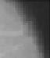 | 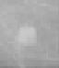
 | 
 | 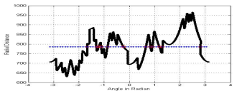
Figure 5: A complete flowchart of the whole algorithm for the breast masses classification.

3. Results
In this work, we utilized a common available benchmark dataset that provided from online mammogram database (MIAS database) [11], firstly the result for the phase of tumor detection using a modified template matching was depicted below.

- Evaluation Criteria for Features Characterization Method:
Malignant tumor starts small and grows. As they get larger, they become more conspicuous and have more opportunity to show their character.
It should be clear that many factors influence the appearance of tumors on images, and although there are some common features of malignancies, there is also a great deal of variation that depends on the tissue and the tumor type. Characteristic features are more likely to be found in large tumors. Small tumors may not have many of the features of malignancy and may even manifest themselves only by secondary effects such as architectural distortion. Tables [1] summarize all tumors’ data and information (features).

- Detection of the tumor using Gaussian Template Model
Creating a template that resemble to a Gaussian distribution that doped with all the fundamental features of the tumor that discussed before. By this way the process of matching technique based on image performance index was ready to detect the shape of the tumor very well. Tables [2, 3] summarize template matching process with different kinds of tumors.

Table 1: Shows values of different features of tumors
Tumor Type | Tumor  Number | Area | Elongation | Eccentricity | Diameter | Circularity | Compactness
Benign | Tumor  1 | 189 | 0.7858 | 0.6184 | 15.512 | 0.7134 | 0.5606
Benign | Tumor  2 | 331 | 0.6315 | 0.7753 | 20.529 | 0.7325 | 0.4626
Benign | Tumor  3 | 105 | 0.8564 | 0.5163 | 11.562 | 1.0789 | 0.9240
Benign | Tumor  4 | 289 | 0.7787 | 0.6273 | 19.182 | 0.8266 | 0.6437
Benign | Tumor  5 | 67 | 0.7981 | 0.6026 | 9.2362 | 0.8917 | 0.7116
Benign | Tumor  6 | 58 | 0.7981 | 0.7405 | 8.5935 | 0.9203 | 0.7345
Benign | Tumor  7 | 56 | 0.7441 | 0.6680 | 8.4440 | 1.0218 | 0.7604
Malignant | Tumor  8 | 372 | 0.7940 | 0.6080 | 21.763 | 0.4802 | 0.3812
Malignant | Tumor  9 | 636 | 0.6659 | 0.7640 | 28.456 | 0.7883 | 0.5249
Malignant | Tumor  10 | 836 | 0.5035 | 0.8640 | 32.625 | 0.6547 | 0.3297
Malignant | Tumor  11 | 239 | 0.8017 | 0.5978 | 17.4443 | 0.7717 | 0.6187
Malignant | Tumor  12 | 561 | 0.9291 | 0.3698 | 26.726 | 0.7401 | 0.6876
Malignant | Tumor  13 | 640 | 0.6488 | 0.8012 | 28.708 | 0.7269 | 0.4716
Malignant | Tumor  14 | 603 | 0.6133 | 0.7898 | 27.708 | 0.4208 | 0.2581

Table 1 (Cont.): Shows values of different features of tumors
Tumor Type | Tumor  Number | Perimeter | Mean Intensity | Max Intensity | Min Intensity | Solidity
Benign | Tumor  1 | 57.6985 | 156.7407 | 237 | 77 | 0.8832
Benign | Tumor  2 | 75.3553 | 162 | 227 | 100 | 0.9220
Benign | Tumor  3 | 34.9706 | 164.2653 | 255 | 83 | 0.9906
Benign | Tumor  4 | 66.2843 | 155.2653 | 209 | 112 | 0.9414
Benign | Tumor  5 | 30.7279 | 168.6500 | 228 | 112 | 0.9306
Benign | Tumor  6 | 28.1421 | 174.5625 | 251 | 93 | 0.9063
Benign | Tumor  7 | 26.2426 | 166.4054 | 255 | 108 | 0.9655
Malignant | Tumor  8 | 98.6690 | 157.1034 | 228 | 105 | 0.7470
Malignant | Tumor  9 | 100.6890 | 154.5976 | 224 | 76 | 0.9568
Malignant | Tumor  10 | 126.6690 | 155.9608 | 220 | 89 | 0.9268
Malignant | Tumor  11 | 62.3848 | 154.4308 | 220 | 87 | 0.9447
Malignant | Tumor  12 | 97.5980 | 153.2941 | 224 | 75 | 0.9242
Malignant | Tumor  13 | 105.1838 | 162.7207 | 217 | 95 | 0.7988
Malignant | Tumor  14 | 134.1838 | 167.6667 | 221 | 130 | 0.7872

Secondly the result for the phase of tumor features extraction and classification using a signature process was showed below. Figure 6 shows an example of an original image containing a mass lesion, and the results of the classification procedure. Figure 7 show these resulted signatures. Table 4 shows an example of the feature values that described above. The value of each feature at its corresponding image is also illustrated. Results show a high classification rate. Thus the feature-set formed is well suited for any CAD system. Also these features have an additional advantage of involving less computational complexity, translation invariant. This follows because the radial distance in the signature was calculated with respect to an origin defined by the centroid coordinates of the boundary. This can prove helpful in increasing efficiency of any CAD system. Also the geometrical and statistical features for the same images were calculated in Tables [5, 6] for predefined size, but Tables [7, 8] illustrated these features with different sizes. Most of these features were completely different conversely for the proposed features. Finally figures [8-10] depicted the percentage of classification in two cases.

Table 2: Template Matching Process “Benign”
Tumor  Process | Tumor  1 |  | Tumor  2
Gray level Image | 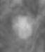 |  | 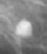
Image After elimination all non suspicious areas. |  |  | 
Bounding Box Values | [435.5 375.5 240.0 205.0] |  | [343.5 389.5 328.0 289.0]
Centroids | [542.5158 483.1107] |  | [512.0013 539.0718]
Centroids Measured by the Radiologists | [544.0000 485.0000] |  | [514.0000 542.0000]
Result of correlation Process | 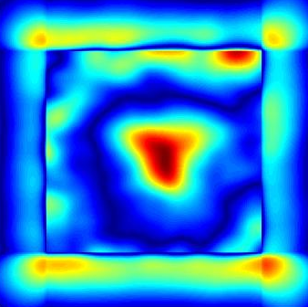 |  | 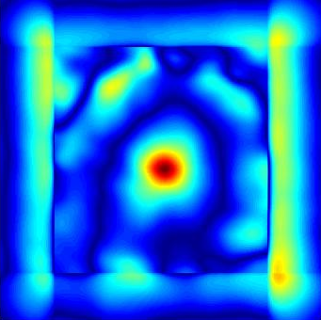
Result of Template Matching | 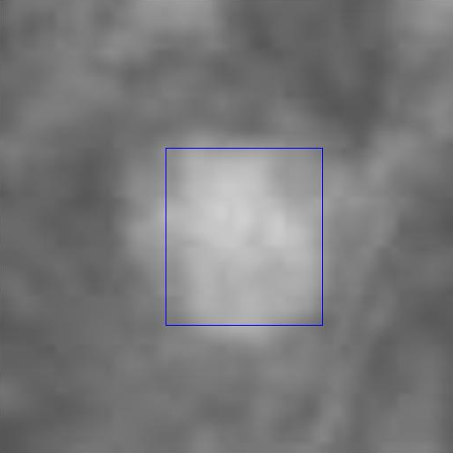 |  | 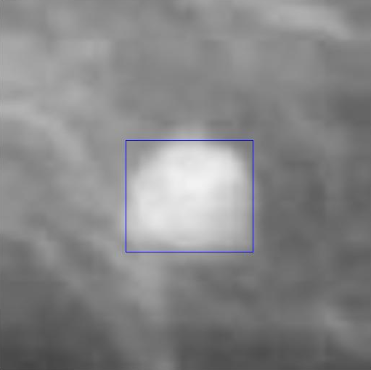
Table 3: Template Matching Process “Malignant”
Tumor  Process | Tumor  3 |  | Tumor  4
Gray level Image | 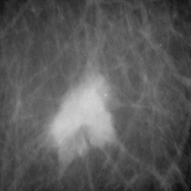 |  | 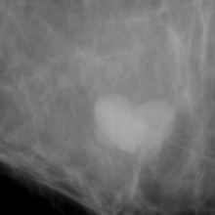
Image After elimination all non suspicious areas. |  |  | 
Bounding Box Values | [280.5 449.5 308.0 304.0] |  | [452.5 453.5 367.0 267.0]
Centroids | [ 443.8250 611.0213] |  | [627.5508 581.9715]
Centroids Measured by the Radiologists | [ 445.0000 613.0000] |  | [625.0000 582.0000]
Result of Correlation Process | 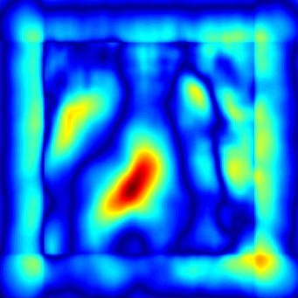 |  | 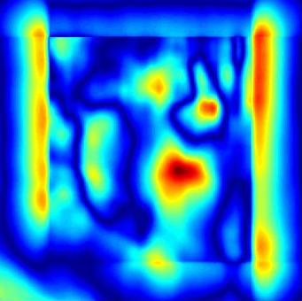
Result of Template Matching | 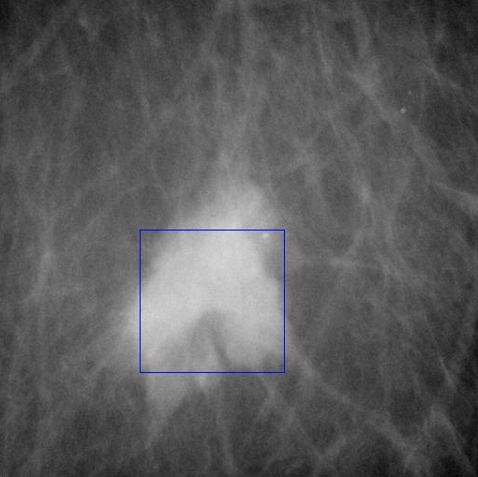 |  | 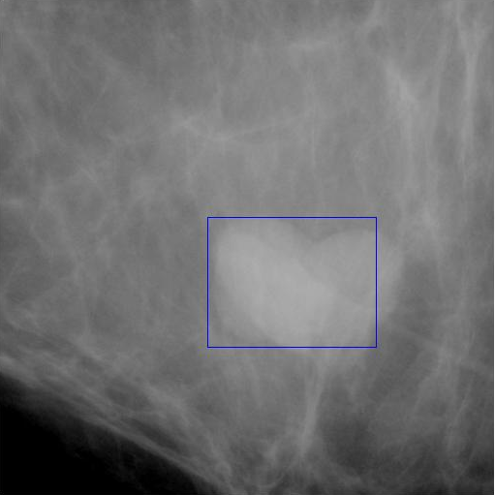
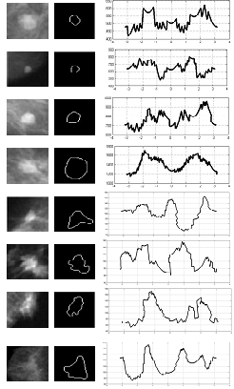
(a) (b) (c)
Figure 6: (a) Mammographic ROI, (b) Boundary of
ROI, (c) Signature pattern.
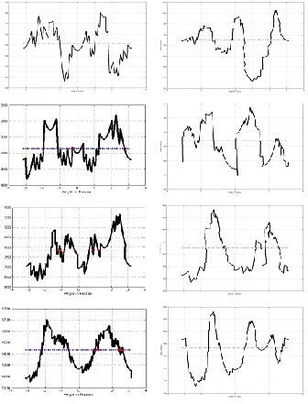
(a) (b)
Figure 7: Curve Signature “ relation between Radial distance ri and corresponding angles θi “ (a) Benign Signature “Average number of zero crossing=17”, (b) Malignant Signature “Average number of zero crossing=23”
From Figures [6, 7] and from Table 4 we detected the following points that are summarized in Table 6.

Table 5: Summary of Proposed features results for any size or orientation
Massive Lesion | Mean value | Variance value | Number of zero crossing
Benign | ≈2.8741 | ≈24.4381 | 17
Malignant | ≈9.5741 | ≈373.9001 | 23

Table 6: Summary of Geometric Features for the massive lesion in Database
Benign | Average Area | Average Perimeter | Average Roundness | Average Compactness
Benign | 120.1001 | 35.4511 | 1.0491 | 1.0223
Malignant | Average Area | Average Perimeter | Average Roundness | Average Compactness
Malignant | 591.8001 | 105.1529 | 0.6562 | 0.8062

Table 7: Summary of Geometric Features for the massive lesion with different sizes
Benign | Average Area | Average Perimeter | Average Roundness | Average Compactness
Benign | 650.3428 | 120.4515 | 1.0245 | 1.0353
Malignant | Average Area | Average Perimeter | Average Roundness | Average Compactness
Malignant | 999.4558 | 367.4456 | 0.6722 | 0.8572

Table 8: Summary of Statistical Features for the massive lesion with different sizes
Benign | μ | σ2 | σ | Smoothness | Skewness | Uniformity
Benign | 45.7357 | 5003.5776 | 68.3707 | 0.9989 | 12.5738 | 1.2445
Malignant | μ | σ2 | σ | Smoothness | Skewness | Uniformity
Malignant | 60.7771 | 7659.6481 | 85.8973 | 0.9998 | 4.5887 | 1.9111

Table 9: Summary of Statistical Features for the massive lesion in Database
Benign | μ | σ2 | σ | Smoothness | Skewness | Uniformity
Benign | 20.7337 | 1067.5767 | 29.3707 | 0.9979 | 7.6738 | 2.2407.
Malignant | μ | σ2 | σ | Smoothness | Skewness | Uniformity
Malignant | 40.7406 | 5295.6981 | 70.7061 | 0.9997 | 2.5889 | 2.1115.

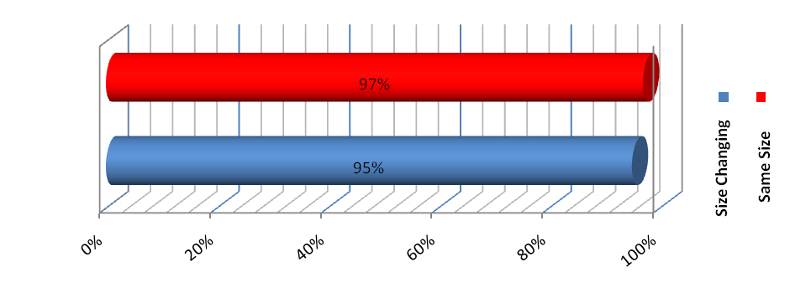

Figure 8: Classification percentage with Statistical features

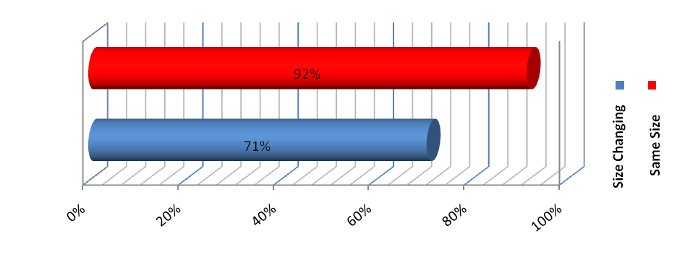
Figure 9: Classification percentage with Geometric features

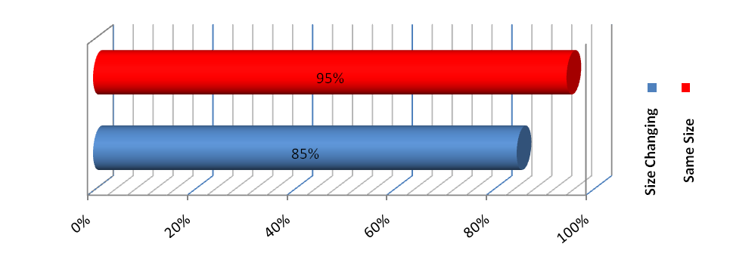

Figure 10: Classification percentage with Propsed Features

4. Conclusion
The computer should not be considered a “black box” that renders judgment on an image in a consistent but arbitrary manner. Indeed, the computerized methods that exist have been developed over the span of many years by scientific and medical researchers who have incorporated the various facets of image acquisition and interpretation into computer algorithms. Within these algorithms, concepts from physics, anatomy, pathology, statistics, and computer science are integrated to provide a metric for computer vision based on the imaging parameters and visual cues that serve as the foundation for human-vision interpretation of medical images by radiologists. So far no CAD system is 100% perfect (i.e., 100% true positives with 0% false positives), the key is to get the false-positive rates low enough that the radiologist does not get frustrated with an overabundance of false reports and can easily disregard obviously false locations. As long as radiologists recognize the limitations of CAD and their own limitations, the use of CAD will serve quite nicely as a reliable second reader. Radiologists need to integrate CAD into their normal reading procedure, without changing their normal search and detection behaviors to any great extent. Careful and thorough search of images and lesions will be necessary no matter how accurate CAD systems get.
The selection of Gaussian template increased the sensitivity among the tumor detection. It is based on studying tumor features and collect as large information as possible about tumors. There are two types of features, first type is the morphological features that are related to the physical properties of the tumor (Area, Perimeter, Circularity…etc), second type is pixel-based features that are related to the intensities (pixels) values of the tumor. The created model was a 2D Gaussian model with three automatic diameters. Then by using the correlation template matching for input images we detect the location of the tumor irrespective of its type, Benign or Malignant. The algorithm works faster so that any radiologist can take a clear decision about the appearance of tumors by visual inspection of digital mammograms. The performance of the algorithm was tested over several images and the validations of results by visual inspection were done by an expert radiologist. Also, the system has given good detection rate as high as 95 per cent. In the scope of feature extraction a preliminary investigation toward the implementation of a complete CAD system for the early detection of breast cancer, in this paper we present an algorithm for the classification and features extraction of micro-calcifications. We find that the statistics features like the mean ad variance is helpful in masses lesions classification due to the wide range between these values in case of benign and malignant, some features like zero crossing was necessary but not sufficient to differentiate between the calcification in mammograms.

Corresponding Author:
Osama R.Shahin
Department of Physics and Mathematics
Helwan University, Cairo, Egypt
E-mail: Osama.Shahin@ymail.com

References
- World health organization, http:// www.who.int/cancer/en.
- National Cancer Institute in Cairo, http://www.nci.edu.eg/.
- Hala Al-Shamlan and Ali El-Zaart "Feature Extraction Values for Breast Cancer Mammography Images", International Conference on Bioinformatics and Biomedical Technology 2010.
- Shi,R. X.J. Min, L.M. Hu, " Approaches for automated detection and classification of masses in mammograms" Pattern Recognition Volume 39, Issue 4, April 2006;Pages 646–668.
- Odyssey Li, H.,Technol., “ Fractal modeling and segmentation for the enhancement of micro calcifications in digital mammograms”, Medical Imaging, IEEE Transactions on Issue Date: Dec. 1997 ;vol 16, Issue: 6, On page(s): 785 - 798.
- Shanthi S. Murali Bhaskaran V., "Computer Aided System for Detection and Classification of Breast Cancer" International Journal of Information Technology, Control and Automation (IJITCA) Vol.2, No.4, October 2012.
- SHUK-MEI LAI, XIAOBO LI, and WALTER F.BISCHOF, “On Techniques for Detecting Circumscribed Masses in Mammograms”, IEEE Transactions on medical Imaging. Vol. 8, No. 4, Dec. 1989.
- Adam Krzyzak‏،T. Kasvand‏،Ching Y. Suen‏, “Computer Vision and Shape Recognition”, World Scientific Publication Co. Pte. Ltd 1989.
- Chris Solomon, Sch Toby Breckon, “Fundamentals of Digital Image Processing A Practical Approach with Examples in Matlab”, John Wiley & Sons, Ltd 2011.
- Osama Shahin R., Gamal Attiya," Classification of Mammograms Tumors Using Fourier Analysis", IJCSNS International Journal of Computer Science and Network Security, VOL.14 No.2, February 2014.

7/25/2014

