Role of multislice CT in evaluation of pancreatic cancer

Zeinab ali⁽¹⁾ and Wael Alhoseny⁽²⁾

¹ Radiology department, Menofya University; ² Mehalla hepatology teaching hospitals
amro_ghannam@yahoo.com

Abstract: Objective: The aim of this study was to determine the role of multidetector computed tomography (MDCT) in evaluation and prediction of pancreatic tumors resectability. Patients and methods: The study included 40 patients who had pancreatic masses, 18 males and 22 females, and their age range was 18–86 years with a mean age of 57 years. All the patients underwent non-contrast and contrast enhanced Multi-slice CT using a 16-slice machine. The gold standard for diagnosis was histopathology and operative data. Results: Adenocarcinoma as reported by pathological studies was found in 18 patients, cyst adenocarcinoma in 2 patients, infiltrative periampullary adenocarcinoma in 4 patients, intraductal papillary mucinous tumor in 2 patients, mucinous cyst adenocarcinoma in one patient, solid pseudopaplillary neoplasm in 2 patients and mucinous cystadenoma in 4 patients. According to MDCT criteria 21 patients were considered suitable for tumor resection and 16 patients were considered inoperable with unresectable tumor, 5 out of the 21 operable patients was unresectable during operation due to 1 missed liver metastasis, 1 missed omental deposit, 1 missed of superior mesenteric vein invasion, 1 missed lymph node metastasis and 1 missed duodenal invasion.Conclusion: Contrast-enhanced multiphase pancreatic imaging by multislice computerized tomography (MSCT) with its postprocessing techniques represents the image of choice for diagnosis and predicting pancreatic masses and resectability.
[Zeinab ali and Wael Alhoseny. Role of multislice CT in evaluation of pancreatic cancer. Cancer Biology 2014;4(2):67-78]. (ISSN: 2150-1041): (ISSN: 2150-105X (online). http://www.cancerbio.net. 9

Key Words: pancreatic cancer, multislice CT,pancreatic adenocarcinoma

1. Introduction:
Pancreatic cancer is the fourth most frequent cause of cancer-related death. The incidence is increasing and the overall survival has altered little in recent years (Smith et al., 2004)(1).
The overall five years survival rate of pancreatic cancer range from 0.4% to 4%, the lowest for any cancer. Currently surgical resection offers the best chance of cure, however more than 80% of patients present with advanced and unresectable disease. The key to increase resection rates of pancreatic cancer lies with early diagnosis (Takhar et al., 2006) (2).
Recent improvements in imaging techniques have made it possible to improve the diagnostic accuracy for detection, staging, and indicating surgical resectability of pancreatic cancer (Ghaneh et al., 2007)(3).
Multislice CT is currently considered as the best single modality for the diagnosis of pancreas;2tic cancer as it provides excellent image quality (Ishigaki et al., 2003) (4).
Multislice CT is the most efficient non invasive technique in the assessment of pancreatic cancer, multislice CT allows excellent visualization of the pancreatic cancer during the different stages of contrast enhancement, thereby facilitates detection of small pancreatic lesions and evaluation of peripancreatic structures. 3D multiplaner reformatted images can be used to solve different diagnostic problems and to help communicate finding to clinicans (Nino et al., 2005)(5).
The aim of this study was to determine the role of multidetector computed tomography (MDCT) in evaluation and prediction of pancreatic tumors resectability.

2. Patients and methods
2.1. Population
This study included fourty patients with clinical and laboratory findings of pancreatic mass (22 males;8s and 18 females) or as a follow-up study for pancreatic cancer referred to the CT unit in Tanta university hospital and Tanta cancer center in the period from February 2012 to October 2013 and their ages ranging from 18 to 86 years with mean age: 57 years. Patients with chronic renal impairment (high serum creatinine) or previous allergy to the contrast media were excluded from the study. An informed consent was obtained from all patients after full explanation of the benefits and risks of the procedure.

2.2. Methods
All patients were subjected to careful history taking, general and abdominal examination, laboratory and serological examinations, abdomino-pelvic ultrasound and multidetector computed tomography.

2.3. Abdomino-pelvic ultrasound
Trans-abdominal ultrasound was the initial test. Ultrasonographic examination was done for all patients searching for signs of pancreatic mass. Scanning was done using 3.5 and 5 MHz curvilinear transducers (B-K Medica) after an overnight fast. The liver, gallbladder, pancreas, intrahepatic and extrahepatic bile ducts were evaluated. Any additional findings namely, ascites, enlarged lymph nodes were also evaluated.

2.4. MDCT technique
This study was performed using a 16 slice multi detector CT (Somatom, E-motion 16, Siemens Healthcare; Germany).
Low residue diet was prescribed 24 h before the procedure and the patient was instructed to come to CT unit after completing fasting for about 4–6 h before examination. Reassurance and brief explanation of the procedure to the patient were given. All patients were examined in supine position, each patient was instructed to remain stable and do not move during examination. Also suspended breathing during scanning time was important.

2.4.1. Oral contrast regimen
Opacification of the gastrointestinal tract with oral contrast material was given routinely before CT scanning; one liter of diluted 2–4% non ionic contrast material was administered in three divided doses before the examination. The diluted contrast was prepared from 20 ml of non ionic contrast completed by 1000 ml of water, two doses of 400 ml of this diluted contrast was given orally 10 and 4 h before the examination and another 200 ml was given when the patient was on the scanner before starting the examination. The first dose was given to facilitate filling of distal small intestine and colon, the second dose was given to fill the proximal ileum and jejunum and the third cup was given when the patient is on the scanner to assure optimal filling of the stomach and duodenum. Precontrast scanning was acquired in all patients; it was performed from the level of diaphragmatic copula to the level of symphysis pubis for scanning of the whole abdomen.

2.4.2. Post contrast regimen
After the end of precontrast CT examination, post contrast scan was done after automatic injection of 100 ml non-ionic iodinated contrast ultravist 300 (300 mg iodine/ml)) at a rate of 5 ml/s into the antecubital vein, the volume of contrast medium was based on the patients’ weight. The volume of contrast medium delivered was 2 ml per kg of body weight with an average of 100–150 ml. The arterial phase starts 20–35 s after the start of injection of contrast medium. The porto-venous and the delayed phase began 70 and 180 s after initiation of the contrast injection, respectively then image data were reconstructed and sent to a workstation.

2.4.3. The scan parameters
The scan parameters are tube current 120 kV and 400 mA, slice thickness 5 mm, collimation of 0.6 mm, pitch 0.6, 0.6-s gantry rotation time and table speed of 7.5–10 mm per rotation during a single breath-hold acquisition of 15–25 s.

2.5. Image analysis
Multislice computerized tomography allows examination of the pancreas with thin slice thickness (1 mm) or less during a short time of a single breath hold with high quality images.
This allows application of different pancreatic scanning protocols, the best of which is a three phase protocol. The arterial phase is helpful for detection of hypervascular tumors, and obtaining CT angiography of peripancreatic vasculature to determine vascular involvement. The parenchymatous and portal venous phases are important for detection of hypovascular tumors that represent nearly all pancreatic carcinoma, and for detection of liver metastasis. Almost all of pancreatic adenocarcinomas are unresectable. MSCT is useful to prevent an unnecessary Whipple procedure (resection of the distal stomach, duodenum, and part or all of pancreas). Any of the following findings are CT signs of unresectability: liver metas.

2.6. Statistical analysis
The diagnostic efficacy of MDCT in the prediction of pancreatic masses and signs of unresectability was evaluated and compared with histopathological and surgical findings which were considered the gold standard of reference. Data entry was done by SPSS version 16 and analyzed by the same software. A P value <0.05 was considered significant.

3. Results:
Fourty patients with pancreatic masses were evaluated during the period from February 2012 to October 2013 with the multi detector CT study. The final diagnosis obtained depends on histopathological biopsy and operative data. This study included 40 patients (18 males and 22 females), with the commonest age of pancreatic masses between 60 and 70 years as shown in Table 1. As regards multislice CT manifestations of the pancreatic masses, well defined margins are detected in 15 cases, while the remaining 25 cases appeared with ill defined margins, 18 cases appeared hypodense, and 3 cases appeared hyperdense. 22 patients showed homogenous enhancement, 18 patients showed heterogeneous enhancement. Only one case showed calcification, these data are shown in Table 2. Other multislice CT findings associated with pancreatic masses were intrahepatic biliary radicals dilatation which appeared in 9 patients, dilated pancreatic duct appeared in 7 patients, 12 patients showed dilated common bile duct, hepatic metastasis was detected in 12 patients, 4 patients showed duodenal invasion, and 7 patients showed enlarged lymph nodes. 7 patients showed vascular invasion. This is shown in Table 3. The studied 40 patients were subjected to histopathological study. Intra-operative true-cut biopsy was done for 8 patients, percutaneous CT guided needle biopsy was done for 12 patients, percutaneous US guided biopsy was done for 15 patients, and ERCP biopsy was done in the remaining 5 patients. Pancreatic ductal adenocarcinoma appeared in 18 patients, cyst adenocarcinoma in 2 patients, infiltrative periampullary in 4 patients, intraductal papillary mucinous tumor in 2 patients, mucinous cyst adenocarcinoma in 1 patient, spindle cell sarcoma in 1 patient, lymphoma in 3 patients, mucinous cyst adenoma in four patients, solid pseudo-papillary neoplasms in two patients and neuroendocrine neoplasms in 3 patients as shown in Table 4.
According to predicting resectability by using the multislice CT on the studied 40 patients, 24 patients were considered suitable for tumor resection and 16 patients were considered inoperable with unresectable tumor, 5 out of the 24 operable patients was unresectable during operation due to One patient showed superior mesenteric vein invasion, another patient showed single hepatic supcapsular focal lesion, another case showed omental nodule, 1 patient showed missed enlarged LN adherent and posterior to mass and the remaining case was seen infilterating the duodenal wall, results as shown in Tables 5.

Table (1 ): Age and sex of the studied 40 patients with pancreatic neoplasms
Age group | Male | Female | Total Number of patients | Percentage  %
Age group | Number of patients | Number of patients | Total Number of patients | Percentage  %
>20-20  <20-30  <30-40  <40-50  <50-60  <60-70  <70-80  <80----- | 0  1  1  5  6  4  0  1 | 1  3  1  5  4  7  1  0 | 1  4  2  10  10  11  1  1 | 2.5  10  5  25  25  27.5  2.5  2.5
Total | 18(45%) | 22(55%) | 40 | 100%

Table(2) : Different multislice CT manifestation of the pancreatic masses detected in the 40 cases.
Multislice CT manifestation | No. of patients | Percentage (%)
Margin :  - Ill defined  - Well defined | 25  15 | 62.5%  37.5%
Density :  - Mixed  - Hypodense  - Hyperdense | 19  18  3 | 47.5%  45%  7.5%
Pattern of enhancement:  - Homogenous  - Heterogenous | 22  18 | 55%  45%
Calcification | 1 | 2.5%

Table 3:- Show different multislice CT ﬁndings associated withpancreatic masses detected in the studied 40 patients.
Multi-slice CT Finding | No. of patients
Liver deposits | 12
CBD dilatation | 12
Peri-pancreatic invasion  - Gastric bed invasion  - Omental nodule  - Duodenal infilteration  - Perirectal mass | 9  2  2  4  1
Ascites | 9
LN infilteration | 7
Vascular invasion  - Portal vein invasion  - Superior mesenteric vein invasion  - splenic vein invasion  - splenic artery invasion  - Superior mesenteric artery invasion | 7  2  2  1  1  1
Pancreatic duct dilatation | 7
Splenic deposits | 4

Table (4) Comparison between Multi-slice CT with histopathological results in detection of pancreatic lesions
Final diagnosis | No of patients by CT | Percentage  % | X2 | P. value | patients No by histo-pathology
- Malignant  - Adenocarcinoma  - Infilterating periampullary  - Lymphoma  - Cystadenocarcinoma  - Intraductal papillary mucinous  - Mucinous cystadenocarcinoma  - Spindle cell sarcoma | 27  18  3  3  1  1  1  0 | 87.5  100  75  100  50  50  100  0 | 32.023 | <0.001 | 31  18  4  3  2  2  1  1
- Benign  - Mucinous cystadenoma  - Solid pseudopapillary neoplasm | 4  3  1 | 66.6  75  50 | 26.111 | <0.05* | 6  4
 |  |  |  |  | 2
- Neuroendocrine neoplasm | 1 | 33.3 | 12.650 | >0.05 | 3
Total | 32 | 87.5% |  |  | 40

Table (5) Comparison between multi-slice CT and Surgical Findings of resectability in the studied patients with pancreatic neoplastic lesions.
 | Resectable | Non-resectable | True  +ve | False  +ve | True  -ve | False  -ve | Sensitivity | Specificity
Multi-slice CT | 24 | 16 | 16 | 0 | 19 | 5 | 76.19 | 100
Surgery | 19 | 21 | 21

Case No. (1)
*History and clinical presentation:
A 62 years male patient presented by jaundice, vomiting and epigastric pain.
*CT findings :
(A)-Pre-contrast CT:
scan showed pancreatic head mass (white arrow).
(B & C)-Post-contrast CT:
Scan showed a small ill defined relatively mildly enhanced pancreatic head mass (white arrow), marked dilatation of the C.B.D and the pancreatic duct(black arrows) also GB is markedly distended (open arrow).
(D)-Curved multi planar reformatting:
Showed dilated intrahepatic bile ducts and CBD (black arrow) that end abruptly by the mass (white arrow).
*Biopsy reveled: pancreatic adenocarcinoma.

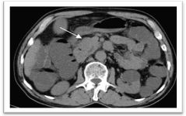  A |  | 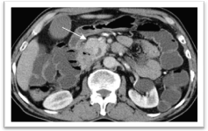  B
(A) Axial non contrast CT | (B) Axial contrast enhanced CT at portal phase

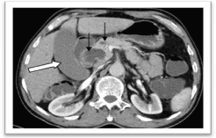  C | 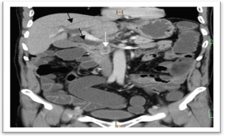  D
(C) Axial contrast enhanced CT at portal phase at higher level | (D) Curved multiplanar reformatting projection
Figure (1)
Case No. ( 2 )
*History and clinical presentation
A62 years male patient presented by dyspepsia
*CT findings :
Triphasic CT study :
showed well defined lesion with marginal calcification at the site of pancreatic tail (black arrow) appear no significant enhancement at the arterial (a) venous (b) or delayed phases. Right hepatic lobe hypovascular metastatic focal lesion (white arrow).
*Biopsy reveled:
pancreatic mucinous cystadenocarcinoma.

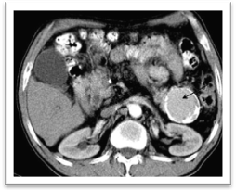 | 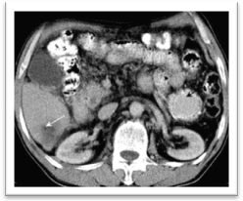
(A) Axial contrast enhanced CT at arterial phase. | (B) Axial contrast enhanced CT at portal phase.
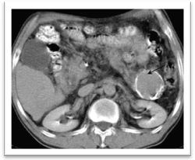
(B) Axial contrast enhanced CT at portal phase
Figure (2)

Case No. (3)
*History and clinical presentation:
A 67 years female patient presented by abdominal pain,anorexia,weight loss and jaundice.
*CT finding :
Triphasic CT study:
- Non enhancing pancreatic head mass (black arrow) which invading the superior mesenteric vein(arrow head).
- Dilated intrahepatic billiary radicals with dilated CBD (white arrow)
- Enlarged peripancreatic lymph node (open arrow).
*Biopsy reveled:
pancreatic adenocarcinmoma.

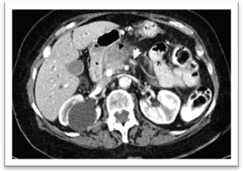 | 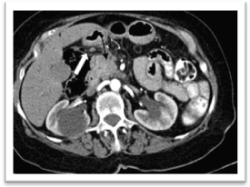
(B) Axial contrast enhanced CT at portal phase | (A)Axial contrast enhanced CT at arterial phase.
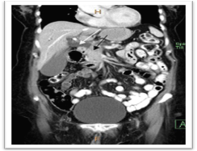 | 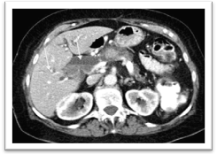
(D) Curved multiplanar reformatting projection | (C) Axial contrast enhanced CT at portal phase at ahigher level
Figure (3).

Case No. (4)
*History and clinical presentation:
A 60 years old male patient presented with epigastric pain and jaundice
*CT finding :
Post contrast enhanced CT :
Axial contrast enhanced CT during arterial ( A) & portal (B) phases and coronal oblique showing an ill defined irregular shape non enhancing lesion at pancreatic head ( white arrow ) with dilated CBD (open arrow ) (C) and dilated intrahepatic biliary radicals ( black arrow ) (D).
*Biopsy reveled:
pancreatic adenocarcinmoma

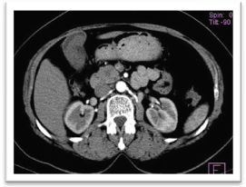 | 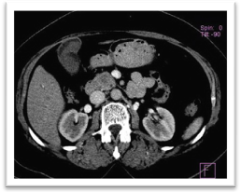
(A)Axial contrast CT (arterial) | (B) Axial contrast CT (portal)
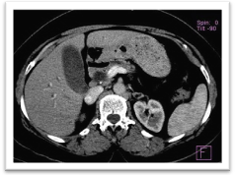 | 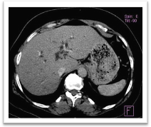
(C) Axial contrast CT (portal) | (D) Axial contrast CT (portal)
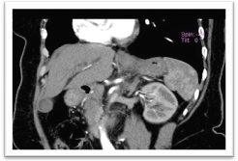 | 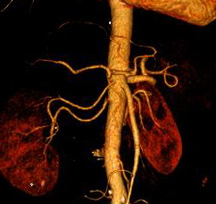
(E) Coronal oplique | (F) Volume rendering.
Figure (4)

Case No. (5)
*History and clinical presentation:
A 40 years male patient presented by abdominal pain, dyspepsia.
*CT finding:
Post contrast CT

Showed bulky head of pancreas showing a non enhanced mass during arterial phase (A) and portal phase (B) and coronal oblique (E) (Black arrwos) associated with small hepatic metastatic focal lesion (C) (open arrow) and gall bladdr stone (D) ( white arrow).
*Biopsy reveled:
pancreatic adenocarcinmoma

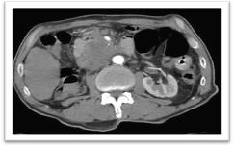 | 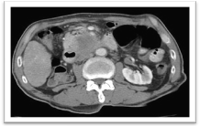
(A) Axial contrast CT (arterial) | (B) Axial contrast CT (portal)
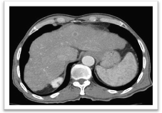 | 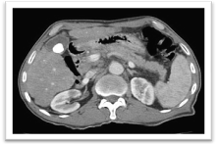
(C) Axial contrast CT (portal) | (D) Axial contrast CT (portal)
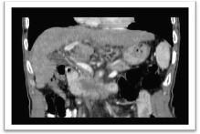 | 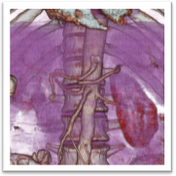
(E) | (F)
Fig. (5)

Case No. (6)
*History and clinical presentation
A 60 years male patient presented by abdominal pain and vomiting.

*Post contrast CT & MPR showed :
Pancreatic tail complex cystic & solid mass (black arrow) with enhancing solid component.
*Biopsy reveled: cystadenocarcinoma.

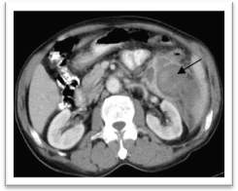 | 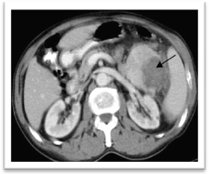
(B) Axial contrast CT (portal at lower level) | (A) Axial contrast CT ( arterial)
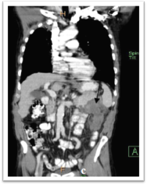
(C) Curved multiplanar reformatting projection
Figure (6)

4. Discussion:-
When pancreatic mass is suspected clinically, various imaging modalities
have been employed for further evaluation of this mass. The use of non-
invasive techniques including US and CT permits a more frequent diagnosis of pancreatic neoplasticlesions (6).
Recent improvements in imaging techniques have made it possible to improve the diagnostic accuracy for detection, staging, and indicating surgical resectability of pancreatic cancer (7).
Multislice CT is the most efficient non invasive technique in the assessment of pancreatic cancer, it allows excellent visualization of the pancreatic cancer during the different stages of contrast enhancement, thereby facilitates detection of small pancreatic lesions and evaluation of peripancreatic structures (8).
In our study, our data were obtained from clinical examination, real time ultrasonography, multislice CT and finally histopathological examination.
In this study, pancreatic neoplasms are more common in females 55% than males 45%, This comes in agreement with Arora M. 2009(9) who stated that their participants had a median age at baseline of 51 years (range, 38–77 years), and 55% were female and 45% male.And also comes in agreement with Parkin DM. 2011(10) who stated that cancer pancreas more common in women than men with median age 55 years.
This come in disagreement with Duell EJ.2012 (11)who reported that pancreatic cancer was more common in men (56%) than in women (44%)
The age group mostly affected by pancreatic neoplasm in this study is 60–70 years. John et al. (12) found that those aged 60 <80 years are the most affected group with pancreatic neoplasms and uncommon in those younger than 40 years. In this study, pain is the most common complaint. It accounts for 55% of the examined patients. Jaundice was the second common complaint in 40% of patients. This is similar to the statement of Takhar et al. (2) and differs from the result of Russel et al. (13) who stated that obstructive jaundice was seen in 85% of patients. John et al. (12) also stated that obstructive jaundice is seen in 75% of patients and about 46% of their patients were presented with pain and jaundice.
In our study multislice CT could identify 20 (50%) solid, 16 (40%) cystic and 4 (10%) mixed lesions. Curry et al. (14) stated that cystic pancreatic tumor accounts for only 1% of the pancreatic neoplasm. Becker and Stommer (15) reported that 60% of pancreatic tumors occupied the head of pancreas, 10% the body, about 5% the tail and the remaining 25% were diffusely involved, in our study 47.5% of tumors occupied the head of the pancreas, 20% the body, 12.5% the tail and 7.5% the body and tail, 7.5% at body and neck, 2.5% at the head and body and 2.5% manifested by diffuse infiltration. In our study adenocarcinoma as reported by pathological studies was the most common pathological finding in about 45% of the patients, this is in agreement with Cascinu et al. (16) who stated that adenocarcinoma accounts for up to 70% of the pancreatic malignancies.
In this study, the most common reported associated extra pancreatic finding is dilated intra hepatic biliary radical which is seen in 18 patients (30%), this sign is seen in patients with head masses. John et al. (12) stated that ductal dilatation occurs in 58% of patients with pancreatic neoplasm and ductal dilatation proximal to the obstructing tumors was detected in approximately 88% of pancreatic head tumors and 60% of body tumors. Liver metastasis could be detected by multi slice CT in 12 patients (30%). This comes in agreement with Murfitt (17) who stated that metastasis to the liver occurs in approximately 17–55% of the patients. In the absence of distal distant metastasis, vascular invasion is the single most common criterion detected in patients with pancreatic lesions. Detection of vascular invasion is a key to the surgeon in preoperative planning because the posterior lateral surface of the portal and superior mesenteric vein if invaded can be evaluated by surgical procedure as advanced pancreatic tumor (Vargas et al. (18)). In our study we reported 21 (52.5%) patients with pancreatic cancer who had unresectable tumors and 19 (47.5%) patients had resectable tumors, and the causes of unresectability were hepatic metastasis, distant lymph nodes involvement, vascular invasion and ascites. This comes in agreement with Li et al. (19) who stated that about 25–30% of patients have resectable disease at the time of presentation. In conclusion, Contrast-enhanced multiphase pancreatic imaging by multislice computerized tomography (MSCT) with its postprocessing techniques represents the image of choice for diagnosis and predicting pancreatic masses and resectability.

References:
- Smith S.L, Rajan P.S. (2004): Imaging of pancreatic adenocarcinoma with emphasis on multislice CT. The Ipswich Hospital NHS Trust, Ipswich, Suffolk, UK. simon.smith@ipsh-tr.anglox.nhs.uk Clin Radiol; 59(1):26-38.
- Takhar A.S., Palaniappan P., Dhingsa R., and Lobo D.N.: Recent developments in diagnosis of pancreatic cancer. BMJ 2006;329: 668-673.
- Ghaneh P, Costello E, Neoptolemos JP.: Management of pancreatic cancer. Gut. 2007 August 1,2007;56(8):1134-52.
- Ishiguchi T, Ota T, Naganawa S, Fukatsu H, Itoh S, IshigakiT(2003): CT imaging of pancreatic cancer. Department of Radiology, Aichi Medical University, (21) p: 480-1195, Japan
- Nino M., Tamm E.P., Charnsangavej C., and Jeffrey R.S.: Multislice CT and advanced post processing techniques for the evaluation of pancreatic neoplasms, Abdom Imaging 2005;28:366-377
- Nelson RC, Brink JA. Helical computed tomography of the abdomen and pelvis. In: Silverman PM, editor. Multislice CT (MSCT): a practical approach to clinical protocols. Philadelphia:
- Lippincott Williams and Wilkins; 2002. p. 169–80.
- Kloppel G. Mixed exocrine–endocrine tumors of the pancreas. Sem Diagn Pathol 2000;17:104–8.
- Sohn TA, Yeo CJ, Cameron JL, et al. Renal cell carcinoma metastatic to the pancreas: result of surgical management. J Gastrointest Surg 2001;5:346–51.
- Arora M, Weuve J, Fall K, Pedersen NL, Mucci LA An exploration of shared genetic risk factors between periodontal disease and cancers: a prospective co-twin study…..Am J Epidemiol. 2010 Jan 15;171(2):253-9.
- Parkin DM, Boyd L, Walker LC. The fraction of cancer attributable to lifestyle and environmental factors in the UK in 2010. Summary and conclusions. Br J Cancer 2011; 105 (S2):S77-S81; doi: 10.1038/bjc.2011.489
- Duell EJ, Lucenteforte E, Olson SH, et al. Pancreatitis and pancreatic cancer risk: a pooled analysis in the International Pancreatic Cancer Case-Control Consortium (PanC4). Ann Oncol 2012; 23(11):2964-70. doi: 10.1093/annonc/mds140.
- John K, Robert MK, Udo PS, et al., Pancreas, adenocarcinoma.E Medicine 2005 [July 6].
- Russell RC, Williams NS, Bulstrode CK. The pancreas. Bailey &Love’s, short practice of surgery. London: Arnold; 2000. p.987–1006.
- Curry CA, Eng J, Horton KM, et al. CT of primary cystic pancreatic neoplasm. AJR 2000;175:99–103.
- Becher V, Stommer P. Pathology and classification of tumors of the pancreas. In: Trede M, Carters DC, editors. Surgery of thepancreas. Edinburgh: Churchill living Stone; 1993. p. 867–902.
- Cascinu S, Falconi M, Valentini V, et al. Pancreatic cancer: esmo clinical practice guidelines for diagnosis, treatment and follow-up. Ann Oncol 2010;21(Suppl. 5):v55–8.
- Murfitt J. The pancreas. In: Sutton, editor. Text book of radiology and medical imaging. London: Churchill Livingstone; 2004. p. 1079–98.
- Vargas R, Nino-Murcia M, Trueblood W, et al. MDCT in pancreatic adenocarcinoma: prediction of vascular invasion and resectability using a multiphasic technique with curved planer reformations. AJR 2004;182:419–25.
- Li D, Xie K, Wolff R, et al. Pancreatic cancer. Lancet 2004;363:1049–57.

6/22/2014

