THE ALTERNATIVE MEDICINE?...
(A new theory on “Mars Therapy”)

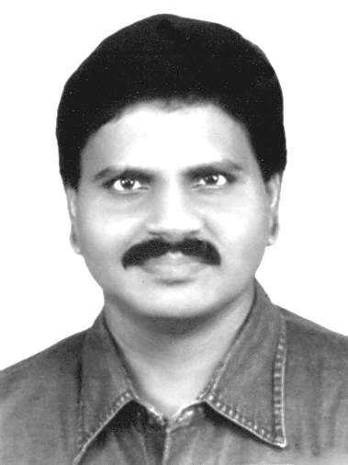  M.Arulmani, B.E.  (Engineer)  m.arulmani58@gmail.com | 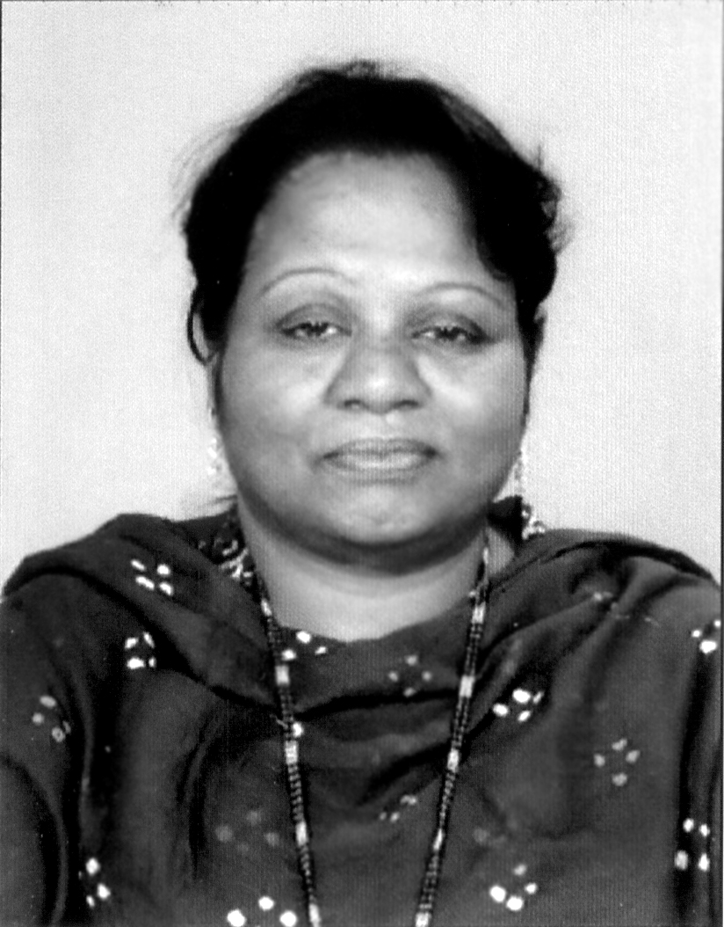  V.R.Hema Latha, M.A., M.Sc., M.Phil.  (Biologist)  vrhemalatha58@gmail.com

- Abstract:
This Scientific research article focus that the Prehistoric Tamil based Indians lived in “MARS PLANET” shall be considered as having high “Immunity” and free from dreaded disease like Cancer, Aids, Measles, Smallpox, Ebola, Rubella, Jaundice, Blood Pressure, etc.

The high Immune system shall be considered derived due to exposure to “J–RADIATION” and Balanced environmental situation. The J-RADIATION shall also be called as, “THE-e” (or) “Virgin Light”. The J-RADIANTION shall be considered Composed of fundamental Particles Photon, Electron, Proton having “Zero mass”. The fundamental particles shall be called as “Mul-e” or “e-Mu”
(i)
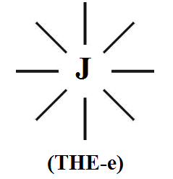

(ii)
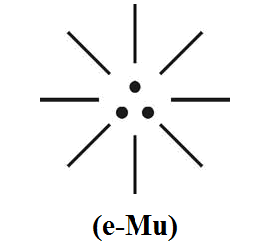

During the course of time in the expanding Universe the human Immunity system shall be considered gradually reduced and infected with “New diseases” due to increased pollution and growth of various radiations, atoms, molecules which led to unbalanced environment.
The birth of New diseases led the human brain to search for new medicines from “Natural Herbal Plants” called “ALTERNATIVE MEDICINE” (MULIGAI MARUNTHU) which is considered as parent origin to modern medicine like orthodox, conventional, functional medicines.
The Alternative Medicine shall also be called in Prehistoric Tamil as “ACHI VAITHIAM”. Achi shall mean “Mother of Mars” (or) “Mother of Medicine” having three balanced effects say diet (mind), exercise (body), meditation (soul).

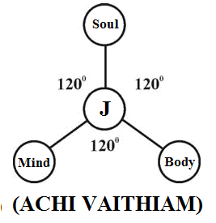

“The Philosophy of Patti Vaithiam, Naattu Marunthu, Mooligai Maruthuvam, Siddha, Homeopathy, Auruedic, Unani, Acupuncture, Allopathy, Naturopathy, R.S. Pathy, might be derived from the philosophy of “THE – E” (OR) “achi vaithiAm”.
– Author.
[M.Arulmani, B.E., V.R.Hema Latha, M.A., M.Sc., M.Phil. THE ALTERNATIVE MEDICINE?...(A new theory on “Mars Therapy”). Cancer Biology 2014;4(1):64-81]. (ISSN: 2150-1041): (ISSN: 2150-105X (online). http://www.cancerbio.net. 6

- Key Words:
  - Philosophy of “ANGEL”
  - Philosophy of “sin diseasE”
  - Philosophy of “MUL – E”
  - Philosophy of “THEIR”
  - Philosophy of “DR”
  - Philosophy of “TELEPATHY”
  - Philosophy of “THRI KADUKAM”
  - Philosophy of “Ayes, Noyes, Poyes”
  - Philosophy of “THREE – ETCHAI”
  - Philosophy of “holistic medicine”
  - Philosophy of “THERAPY”
  - Philosophy of “MARS MEDICINE”.

- Introduction:
Archeological evidence indicates that human were using medicinal plants during Paleolithic period approximately 60,000 years ago. In ancient Egypt around 1500 BC over 850 plant medicines exists including garlic.

It is focused that Modern human having “46 Chromosomes” (23 Pairs) shall be considered as diseased human or trisomy syndrome human. Whereas the Prehistoric Tamil based Indians lived in “MARS PLANET” shall be considered as highly healthy having only “THREE CHROMOSOME” and “THREE GENE” on origin and derived one each from Photon, Electron, Proton from “J-RADIATION” (MARS MEDICINE).
The “MARS” Populations shall also be called as “Divine Populations” (or) “ANGELS”. In prehistoric time MARS shall also mean EZHEM the land origin of prehistoric human dwelling place.

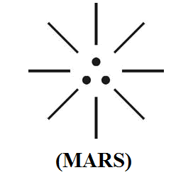

The MARS Populations (Angles) shall be defined within the following scope.
- Mars Populations shall mean “Single Minded”
- Mars Populations shall mean “Sincere”
- Mars Populations shall mean “Non Dowry Receiver”
- Mars Populations shall mean “Non Tax evaders”
- Mars Populations Shall Mean “White Account Holder”
- Mars Populations Shall Mean “Non – Alcoholic”

Further, during the course of Time the 2nd, 3rd generations human started violating the “moral law” of Ancestors which enabled & acquiring additional “Chromosome” and “Genes” due to thirsty act. The growth of additional chromosomes, genes enabled human to lose “Immunity System” due to Imbalance in stress on “MIND” “BODY” “SOUL” of Human system. Higher the level of chromosome, genes shall mean lower the Immune system.
Further, it is speculated that the later human population effectively used their brain and derived prehistoric “alternative Medicine” from three fundamental Natural Plants (Muligai) called “THRI KADUKAM”. The Thri kadukam shall also mean natural plants and alternative medicine to “J–Radiation” (MARS Medicine). Case study shows that the history of herbalism is closely associated with history of medicine from prehistoric time until the development of germ theory of disease in 19th century.

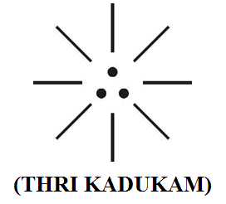

It is further focused that the Mars Populations shall be considered as highly “diet conscious” and restricted to food of “Natural grains” and not fond of food like “THALI MEAL” involving RASAM, SAMBAR and hundreds of items as side-dishes. It is further speculated that switch over to “Crop Grains” from Natural grains might have influenced degrading of Immune system and gave birth to new modern disease like Cancer, Aids, Diabetics, Mental Stress, Nervous disorder etc.,

“Ancient Tamil Patriotic shall mean Practicing only Tamil Naturopathic Medicine “THRI KADUKAM” and Preventing other modern medicines like conventional, orthodox, Allopathic, Homeopathic, Acupuncture treatment for their disease.”
- Author.

- Previous Publication:
The philosophy of origin of first life and human, the philosophy of model Cosmo Universe, the philosophy of fundamental neutrino particles have already been published in various international journals mentioned below. Hence this article shall be considered as extended version of the previous articles already published by the same author.

    - Cosmo Super Star – IJSRP, April issue, 2013
    - Super Scientist of Climate control – IJSER, May issue, 2013
    - AKKIE MARS CODE – IJSER, June issue, 2013
    - KARITHIRI (Dark flame) The Centromere of Cosmo Universe – IJIRD, May issue, 2013
    - MA-AYYAN of MARS – IJIRD, June issue, 2013
    - MARS TRIBE – IJSER, June issue, 2013
    - MARS MATHEMATICS – IJERD, June issue, 2013
    - MARS (EZHEM) The mother of All Planets – IJSER, June issue, 2013
    - The Mystery of Crop Circle – IJOART, May issue, 2013
    - Origin of First Language – IJIRD, June issue, 2013
    - MARS TRISOMY HUMAN – IJOART, June issue, 2013
    - MARS ANGEL – IJSTR, June issue, 2013
    - Three principles of Akkie Management (AJIBM, August issue, 2013)
    - Prehistoric Triphthong Alphabet (IJIRD, July issue, 2013)
    - Prehistoric Akkie Music (IJST, July issue, 2013)
    - Barack Obama is Tamil Based Indian? (IJSER, August issue, 2013)
    - Philosophy of MARS Radiation (IJSER, August 2013)
    - Etymology of word “J” (IJSER, September 2013)
    - NOAH is Dravidian? (IJOART, August 2013)
    - Philosophy of Dark Cell (Soul)? (IJSER, September 2013)
    - Darwin Sir is Wrong?! (IJSER, October issue, 2013)
    - Prehistoric Pyramids are RF Antenna?!... (IJSER, October issue, 2013)
    - HUMAN IS A ROAM FREE CELL PHONE?!... (IJIRD, September issue, 2013)
    - NEUTRINOS EXIST IN EARTH ATMOSPHERE?!... (IJERD, October issue, 2013)
    - EARLY UNIVERSE WAS HIGHLY FROZEN?!... (IJOART, October issue, 2013)
    - UNIVERSE IS LIKE SPACE SHIP?!... (AJER, October issue, 2013)
    - ANCIENT EGYPT IS DRAVIDA NAD?!... (IJSER, November issue, 2013)
    - ROSETTA STONE IS PREHISTORIC “THAMEE STONE” ?!... (IJSER, November issue, 2013)
    - The Supernatural “CNO” HUMAN?... (IJOART, December issue, 2013)
    - 3G HUMAN ANCESTOR?... (AJER, December issue, 2013)
    - 3G Evolution?... (IJIRD, December issue, 2013)
    - God Created Human?... (IJERD, December issue, 2013)
    - Prehistoric “J” – Element?... (IJSER, January issue, 2014)
    - 3G Mobile phone Induces Cancer?... (IJERD, December issue, 2013)
    - “J” Shall Mean “JOULE”?... (IRJES, December issue, 2013)
    - “J”- HOUSE IS A HEAVEN?... (IJIRD, January issue, 2014)
    - The Supersonic JET FLIGHT-2014?... (IJSER, January issue, 2014)
    - “J”-RADIATION IS MOTHER OF HYDROGEN?... (AJER, January issue, 2014)
    - PEACE BEGINS WITH “J”?... (IJERD, January issue, 2014)
    - THE VIRGIN LIGHT?... (IJCRAR, January issue 2014)
    - THE VEILED MOTHER?... (IJERD, January issue 2014)
    - GOD HAS NO LUNGS?... (IJERD, February issue 2014)
    - Matters are made of Light or Atom?!... (IJERD, February issue 2014)
    - THE NUCLEAR “MUKKULAM”?... (IJSER, February issue 2014)
    - WHITE REVOLUTION 2014-15?... (IJERD, February issue 2014)
    - STAR TWINKLES!?... (IJERD, March issue 2014)
    - “E-LANKA” THE TAMIL CONTINENT?... (IJERD, March issue 2014)
    - HELLO NAMESTE?... (IJSER, March issue 2014)
    - MOTHERHOOD MEANS DELIVERING CHILD?... (AJER, March issue 2014)
    - E–ACHI, IAS?... (AJER, March issue 2014)

- Hypothesis:
- Philosophy of e- Pathy? …
It is hypothesized that “e-Pathy” shall be referred to conductive Balanced environment and human exposure to J-Radiation Mars Therapy. The J-Radiation shall be considered composed of three-in-one fundamental particles called “Virgin Light” therapy or “e-Mu”.

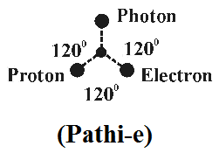

During the course of time the band of UV, RF, IR radiations evolved shall be considered pertain three distinguished families say (i) The-e, (ii) Thri–e, (iii) Thre-e

The philosophy of so called α, β, γ radiations in quantum physics shall be considered and three distinguished families derived from the philosophy of “THE–e”. The philosophy of various diseases shall also be considered as derived due to impact of three generation radiations and deviation of genetic structure of human.

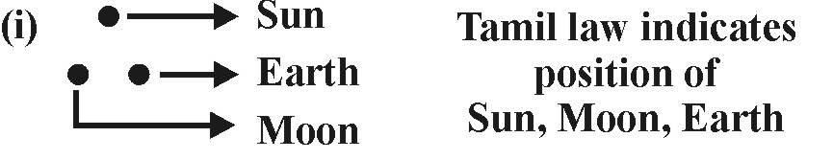
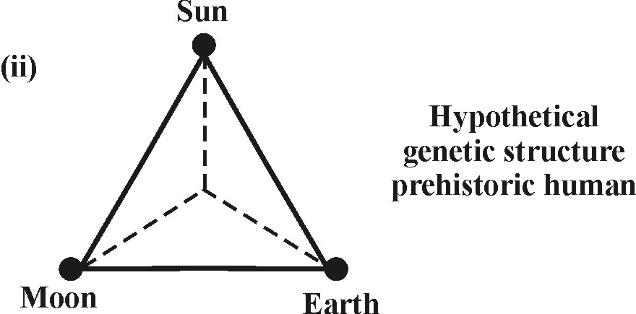
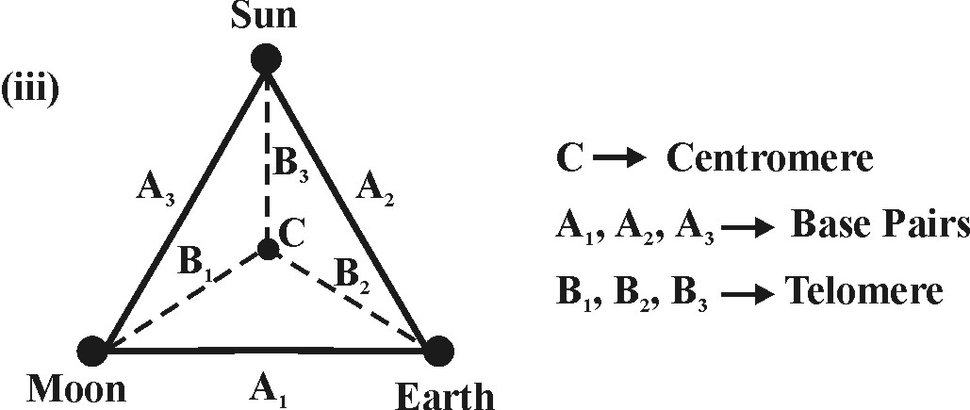

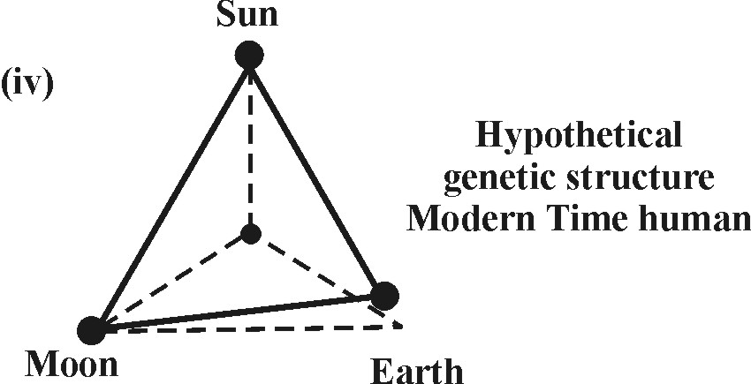

- Philosophy of Mars Medicine? . . .
It is hypothesized that the prehistoric Tamil based Indians lived in MARS planet (ENDOS) already formulated science of diagnosing disease under fundamental three domain.

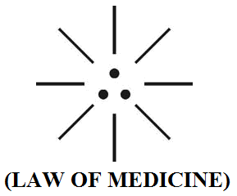

              - Right dot – Proton (like fungal region)
              - Left dot – Electron (Bacteria region)
              - Center dot – Photon (Virus region)

The Philosophy of path, pathos, pathogen might be derived form the Philosophy of PATHI-e.
- Author

- Philosophy of Ayes, Noyes, Poyes? . . .
It is hypothesized that the fundamental partials shall be considered having definite polarity +ve, -ve, Neutral effect which result in production of +ve, -ve, Neutral effect on “Immunity” on system of medicines.

- Photon (Ayes) - Neutral Impact
- Electron (Noyes) - - ve Impact
- Proton (Poyes) - + ve Impact

The Philosophy of Noyes might be derived from the prehistoric Tamil phonetics Noye-e. Noye-e shall mean disease.
- Author

- Philosophy of “SIN” ? . . .
It is hypothesized that during expanding universe the fundamental Particles Photon, Electron, Proton shall be considered gaining “Mass” and associated “Colours” in the three Nuclear Ages, geological periods which resulted increased “gene” level in human system during Space and Time. It is focused that in Prehistoric Tamil, the “GENE” shall be called as “PAVAM”. Considered as gained from three domain SUPAVAM, MUKAPAVAM, AKKAMPAVAM). The philosophy of “gene growth” shall be considered derived due to various bad acts like Dowry receipt, Tax evading, alcoholic drink, etc.

(i)
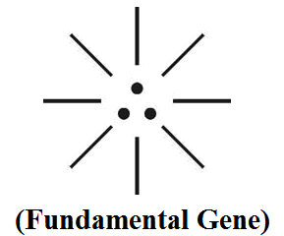
(ii)
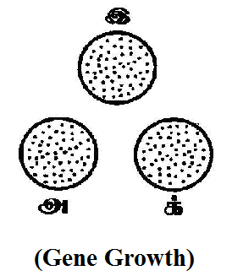

- Supavam Like “Photon” enriched (like RNA)
- Akkampavam Like “Electron” enriched (like HORMONE)
- Mukapavam Like “Proton” enriched (like DNA)
“The word “SIN” might be dialectically Pronounced as “GENE”. In Prehistoric Tamil “SIN” shall be called as “ETCHAI” “chikitchai” shall mean Therapy (or) Treatment (Etchai).

- Philosophy of SIN-free human? …
It is focused that “SIN” shall be considered as the worst disease that cancer. It is further hypothesised that the human populations lived in “MARS PLANET” shall be considered as “Sin free human”. In other words the “ANGEL” Populations who had only three chromosome, associated with 3 gene shall be called Sin free human (or) “Disease free human”.

It is further hypothesized that the formation “MOLE” in human shall be considered as “Natural Emboss” which indicates the state of Sinful human. It is focused that the angel populations lived in MARS PLANET do not have any “Mole” and absolutely Immune to all disease. The philosophy of Mole might be derived from the philosophy of “Mul-e”.

“The Angel populations shall also be called as “HCNO” free human. The mole shall be started forming in the human after formation of HCNO (Hydrogen, Carbon, Nitrogen, Ozone) in the early Universe”.
-Author.

- Biblical Adam, Eve had mole? …
It is hypothesized that the Biblical Adam, Eve might not have Mole on their skin before eating forbidden fruit. Subsequently Mole might be formed after eating forbidden fruit and become “Mole human” or HCNO based human. Mole shall also mean “Sin Skin”.

- What is the Medicine for curing “sin disease”? …
It is speculated that no alternative Medicine in the World for Cure “Sin disease” except J- RADIATION”. The J-Radiation environment exists only in “MARS” Region and not on “EARTH” region. J-Radiaion shall be considered as fundamental “Mars Medicine” or “J-Medicine”

“The Philosophy of “MIRACLE” shall be closely considered as downloading “J-RADIATION” telepathically for relief.

Case study slows that Mole refers to Molecular mass of Natural Water 18.015. Mole is a unit of measurement used in chemistry to express amounts of a chemical substance defined as the amount of any substance that contains as many as elementary entities (atom, molecule, ion, electron) as there are atoms in 12 grams of Pure Carbon-12 the isotopes of carbon with relative atomic mass. This corresponds to “Avogadro Constant” which has a value of 6.022 x 10 – 23 elementary entities of the substance. This is one of the base units of International system of units. The concentration of a solution is commonly expressed by its “Molarity” defined as the number of moles of the dissolved substance per litre of solution.

It is focused that the philosophy of “Mole” might be derive & from the philosophy of “MUL–e”.

“The Presence of mole in the human skin shall be considered as the natural Identification Mark of “CELL MASS” (Composed of Photon, Electron, Proton) of Individual”.
– Author

- Philosophy of Thri kadukam?...
It is hypothesized the “Thri kadukam” shall be considered as the Prehistoric “Alternative Medicine” to J-Radiation in the early universe for curing “later diseases”.

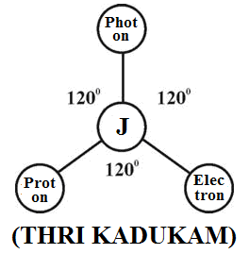

- Thippil-e like Photon enriched
- Sukku (Dry Ginger) like Electron enriched
- Milagu (Pepper) like Proton enriched

- Hypothetical Narration
  - Philosophy of English word “DR”?...
Case study shows that the Abbreviation of English word refers to indicate Higher University Qualification as “Doctor of Philosophy” (or) “Doctor” who is doing Medical Profession.

It is hypothesized that the Ancient “DRAVIDIAN” (INDOS) shall be considered as expert in Ancient “INDO TRIO MEDICINE” (Siddha, Auruveda, Unani). It is focused that “DR” shall mean acronym for “DRAVIDIAN”.

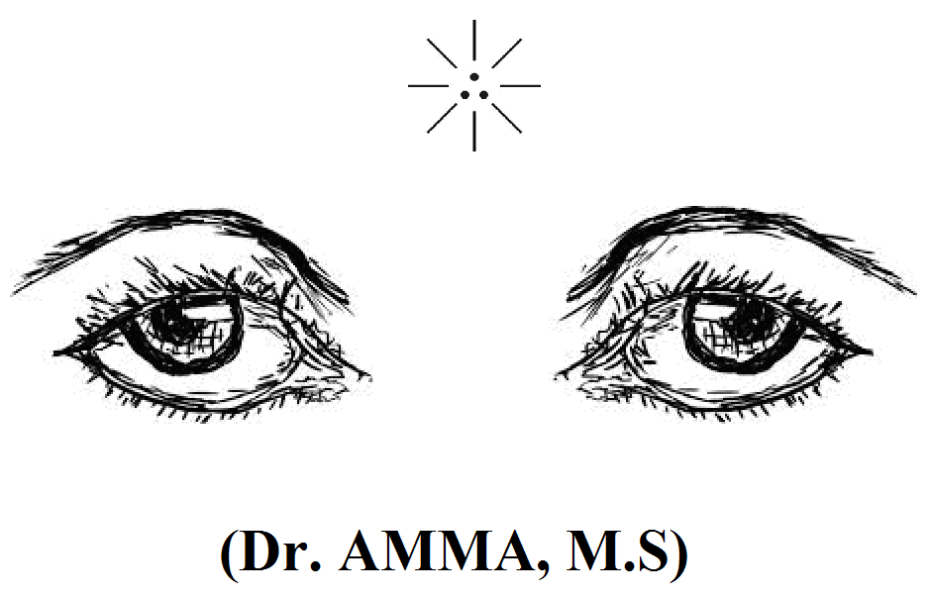

              - Dr shall mean DRAVIDA
              - Amma stands for MOTHER OF DRAVIDIAN
              - M.S stands for SCIENCE OF MEDICINE
“Dr. AMMA” shall be considered as the mother of Indo medicine or mother of Dravidian. The philosophy of ancient Greek “Hippocrates” (Father of Medicine) might be derived from the Philosophy of “Dr. AMMA”. Dr. AYYAR shall be considered as the father of Dravidian.
- Author

It is further focused that Dr. Amma, Dr. Ayyar might have constructed the Egyptian pyramids based on the Cosmo model for maintaining effective environmental health.

  - Philosophy of English word Doyen? …
The words Doyen, Doyenne refers to most experienced member of a group (or) Profession. It is focused that the philosophy of Doyen might be derived from the philosophy of “DRAVIDIAN” populations of “INDO”. INDO shall mean family name of Dravidian races”.

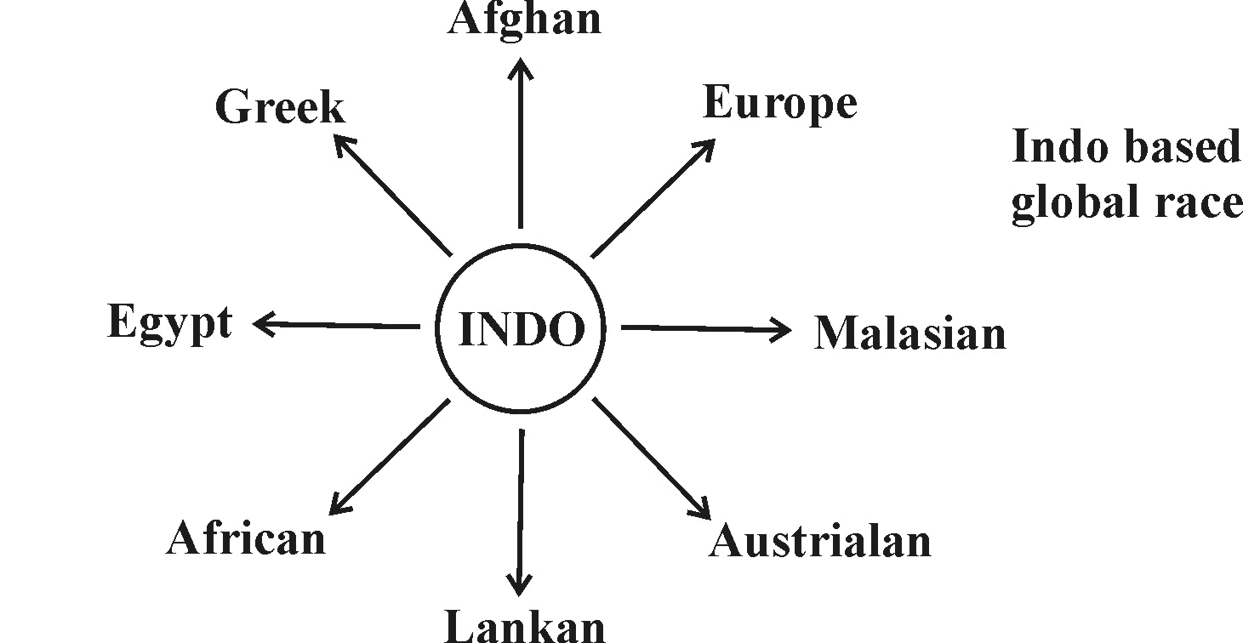

  - Philosophy of word “Their”? …
It is hypothesized that the philosophy of word Thee, The, their might be derived from the philosophy of prehistoric Tamil phonetics “THE-e” (J–Radiation). Thee, Their shall mean “Solution to the problem” (Theervu).

  - Philosophy of word “Therefore”? …
In English the word “Therefore” used to indicate the logical result of something that has been just mention of Previously. It is focused that it might be derived from the philosophy of “The-e”, “Mul-e”.It is focused that the philosophy of Thee, Theology, Theme, Therapy, Thesis might be derived from the philosophy of “Thee” (J – Radiation).

  - Philosophy of word Patho?...
The word “Patho” refers to development of disease. It is focused that the philosophy of Pathos, Pathology, Patho-gen might be derived from the philosophy of Prehistoric Tamil Phonetics “Pathi-e”. Pathi-e shall mean “Radiation”.

  - Philosophy of symbol “RX”?...
Case study shows that the Medical Profession Doctor used to indicate the symbol “RX” before the Prescription. There are so many theories for this. It is hypothesized that “RX” shall man “ACHI” (Ayes) the “Mother of Mars” (or) “Mother of fundamental Medicine”

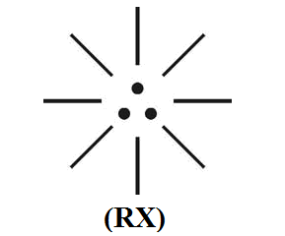

  - Philosophy of R.S. Pathy?...
Case study shows that “R.S.Pathy” (Natural Product of Eucalyptus) is a Traditional Medicine invented by Dr.R.S.Pathy an eminent Siddha Doctor in 1900. This Medicine Popularly known as “Family Doctor” gives relief for cold, Flu, Headache, (due to Sinusitis) and Tiredness and swelling (due to Painful foints).

It is hypothesized that the Philosophy of “Pathy” might be derive & from the Philosophy Prehistoric Tamil Phonetics “THAILAM” Thailam shall mean Natural Herbal liquid derived from J-Radiation(Mul-e)

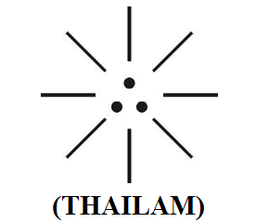

  - Philosophy of Anacin, Crocin, Metacin?...
It is focused that the Philosophy might be derived from the philosophy of “Sin disease” cure therapy “J-Radiation”. “SIN” shall be considered as three dimentional Disease related to Body, Mind, Soul “

  - Philosophy of Mars land, Martian? …
It is focused that the philosophy of Mars land, Martian might be derived from the philosophy of “ACHI” populations lived in Prehistoric land before descended to “EARTH PLANET”.

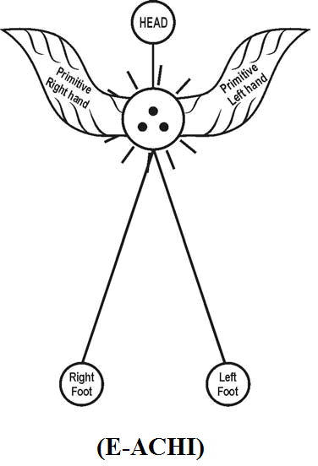

E-ACHI shall mean, “EZHEM ACHI” called as mother of medicines (MARUTHUVA ACHI-e).
- Author

  - Philosophy of Word Drug?...
Case study shows that “Drug” is considered and illegal medicine used to make Patient unconscious (or) Sleepy. Druggie shall mean a person who takes illegal drugs regularly. It is hypothesized that the Drug shall be considered as Natural Herbal medicine (Free from chemicals) derived from the philosophy of “Mul – e” (e.g.) Thalidomide.

“The Achi populations shall be considered as lived under most peaceful environment under “subconscious” Divine state with “closed eyes”.
- Author

  - Philosophy of Thalassotherapy? …
The Thalassotherapy refers to the use of “Sea Water” as beauty (or) health treatment. The Philosophy of Sea Water therapy might be derived from the Philosophy of J – Radiation” exposure.

“J- Radiation shall be considered as the “SOUL” of all Medicines” composed Three-in-one fundamental Particles”.
- Author.

  - Philosophy of Marram Grass? . . .
It is focused that Marram grass shall be considered as the one of the Herbs of alternative Medicine at latter period after “Thrikadukam” Medicine.

  - Philosophy of word “Patois”?...
The concept of “Patois” considered originated from Old French refers to describe the non-standard regional languages.

It is hypothesized that the philosophy of Patois might be derived from the philosophy of Pre-historic Tamil phonetics “PATHI-e”. “PATHI-e” shall be considered as mars medical language means Radiation, Rays.

“The philosophy of word Allopathy, Homeolpathy, Naturopathy, might be derived from the philosophy of “Pathi-e”. The philosophy of Patri-archy shall also mean Divine population lived under Prehistoric pollution free radiation or “MARS RADIATION”.
– Author

  - Philosophy of Acronym “MARS?”…
Case study shows that MARS is considered as acronym refers to diverse field of scientific area.
- Medical And Related Science
- Military Affiliate Radio System
- Molecular Absorbent Recirculating system
- Museum Astronomical Resource Society

It is hypothesized that “MARS” shall be considered as Plural form represents Prehistoric Divine Society lived in MARS PLANET. (e.g.) Thaimar, Thanthaimar, Annanmar, Akkamar, Thevamar, Pillaimar, Ayyamar, Gurumar, Anumar.

  - Philosophy of Acronym MAR?...
The Acronym “MAR” refers to “Medical Administration Record”. MAR is the part of Patients Permanent Record and their legal of Drugs administered to the patients in the Hospital. It is commonly referred to a “Drug Chart” and the electronic version shall be referred to “e-MAR”. The philosophy of MAR might be derived from the prehistoric Tamil Phonetics “MARUTHUVAR”. Maruthuvar shall mean Doctor practicing medicine.

  - Philosophy of Environment Health?...
Thank God… and Nature… for given valuable wisdom to human to find out “alternative medicine” in variety of ways for restoration of Health and succeeding the life. But what is the reason for Health disorder?... How disease evolved?...
i) Disease is act of GOD/Nature?
ii) Disease is act of Human involve improper mother’s feed to
child?
iii) Disease is act of Human involve improper diet in food?

On first line analysis Health disorder shall be considered due to asymmetry in Human Parameter MIND, BODY, SOUL. If these Parameters are symmetric, then, there may not be any Health disorder on disease.
Secondly after achieving proper symmetry among parameters, Do Human not under sick?... Disease?...

No… No… No…

Though Human is highly symmetric, some time become diseased or sick due to impact of external means such as act of cyclone, heavy flood, forest fire, Volcanic act, Lightning effect, Earthquake, Mechanical injury, etc.

It is hypothesized that “Environmental Health” is very important and Environment symmetry shall be considered as the fundamental requirement for maintaining good Health of human and other life system such as Animals, Plants, Microbes, etc.

It is hypothesized that in the early Universe the ACHI populations shall be considered as expert in Astronomy and could effectively diagnose and control the relative position of SUN, EARTH, MOON, in the Universe and kept the Environment always under “healthy condition”. A huge structures like Egyptian Pyramids might have been constructed for these purpose and whereas the so called modern human when started living on earth planet could not do so and hence human and other life system is considered subject to “Severe Health Hazard”.

  - What is the ultimate solution?...
It is focused by the Author that global level contribution among scientists, leaders, philosophers are required first to tune for joint technical effort required for proper alignment of SUN, EARTH, MOON in their respective axis for sustainability of Life for another “1000 years”.

  - CASE STUDY ON MEDICINE SCIENCE
Case study on some of principles of various medicinal practices are indicated. It is focused that all the Principles shall be considered derived from the philosophy of fundamental particle “Mul-e”.

i) Telepathy:
Telepathy is the ability that allows two people to talk to one and other using the power of thought. As a result of doing concentration exercises as well as meditation alongwith further understanding of mind. Telepathy is one of the things that a person will develop to a greater extent. Every one experiences telepathy through the daily routines. When a person you are speaking with fails to remember a word to describe what they are talking about, you will give it to them or vice-versa. This is because the mind communicates in pictures. Even though the person may not remember the proper word at a time, they are holding the picture in mind and you are receiving it.

Communication between minds by some means other than sensory perception. Communication between two people of thoughts, feelings, desires, etc. involving mechanisms that can not be understood in terms of known scientific laws, also called thought transference. Telegnosis refers to alternative belief system, knowledge about distant events alleged to have been obtained without the use of any normal sensing mechanisms. Telegnosis is apparent knowledge of distant events without using sensory perceptions.

ii) Medicine:
A science or practice of diagnosis, treatment and prevention of disease often to exclude surgery. A drug or other preparation of the treatment are prevention of diseases. The branch of medical science deal with non-surgical techniques. Some thing that treats or prevents the sympathy of diseases.

iii) Spiritual medicine:
A entheogen is a psycho active substance used in a religious, shamanic or spiritual context. Entheogen can supplement many diverse practices for transcendence and revelation, including meditation, psychonautics, psychedelic and visionary artpsychedelic therapy and magic.

iv) Holistic medicine:
It is a form of healing that considers whole person body, mind, spirit and emotions in the quest for optimal health and wellness. According to the holistic medicine philosophy one can can adjust optimal health, a primary goal of the holistic medicine practice, by gaining proper balance in life (physical, emotional and spiritual balance).

v) Surgery:
The treatment of injuries or disorders of the whole body by incision or manipulation especially with instruments. The branch of medicine that deals with diagnosis and treatment of injury, deformity and diseases by manual and instrumental means.

vi) Naturopathy:
A system of “alternative medicine” based on the theory that diseases can be successfully treated or prevented without the use of drugs by techniques, such as control of diet, exercises and massage.

vii) Homeopathy:
A system of complementary medicine in which diseases are treated by minute doses of natural substances that in larger amounts would produce symptom of the disease.

viii) Siddha medicine:
Siddha Medicine is a type of ancient traditional Indian Medicine. It has been practiced for thousands of years by Tamil People. Many Scholars teach that Siddha is the oldest known form of medicine. Some practionars believe that Siddha Medicine was delivered to human, from the Gods and some claim that it a path to immotality. This form of medicine is part of a trio of Indian Medicines that includes Ayurveda and Unani. Siddha Medicine is most similar to Ayurveda. They fail to seek create balance between three doshas which are vata (wind), pitta (dile) and kapha (Phlegm). Siddha medical focuses on diet and life style to both prevent and cure diseases. It is a spiritual and physical approach to health uploading belief that a health spirit needs to a healthy body.

ix) Threekadugam:
Ancient Tamil know about trauma care, disaster handling, rehabilitating support and active emergency management says Dr. Siddha Seshayyan. Threekadugam, Sukku (Dry Ginger), Milagu (Pepper) and Thippili (Pepper Longum) are three medicinal products, a combination of these three have been widely used by ancient Tamil to keep away all diseases. Threekaduga chooranam is used even today.

x). Therapy:
Therapy is intended to relieve or heal a disorder. The treatment of physical, mental, social disorders are diseases. Physio therapy is a branch of rehabilitative medicine aimed at helping patients to maintain, recover or improve their physical abilities. Physio therapy also means the treatment of any pain, disease or injury by physical means.

xi) Alternative Medicine:
Any of range of medical therapies that are not regarded as a orthodox by the medical profession such as herbalism, naturopathy and crystal healing. The practice of medicine without the use of drugs and may involve herbal medicines or awareness for bio feed back or acupuncture.

Xii) Drugs:
A medicine or other substance are as psychological effect ingested or otherwise introduced into the body. A Chemical substance used in the treatment, cure, prevention or diagnosis of disease or otherwise enhance physical and mental well-being. As per federal law any substance listed in any of the recognized items as chemical substance as pharmaceutical items.

- CONCLUSION:
It is focused that in the modern world most of disease could not be treated effectively due to improper diagnosis (or) wrong Diagnosis. The “ACHI NAADI” refers to the science of exact diagnosis about cause of disease by measuring the “Pulse Rate”.
The philosophy of “Pulse” might be derived from the philosophy of Prehistoric Tamil Phonates “Pal-e”. Pal-e shall mean Prehistoric oscillation rate of fundamental white particles photon, Electron, Proton (Zero mass).

Pal-e shall be referred to the “threshold” reference of Prehistoric base Pulse rate. Further in Prehistoric time the Achi Populations do not have any “BLOOD PRESSURE PROBLEM” and having standard pulse rate of 60 PPM.

In the expanding Universe the standard BP rate shall be considered consistently gets varied to higher level in three geological Periods as described
- Achi Population (Angel) - 60 PPM
- Ist generation - 70 PPM
- 3rd generation - 80 PPM
- 3rd generation - 90 PPM

It is focused that human undergoes thousands of Pulse rate variation every minute and this can be sensed through rate of “eye twinkling” and each state shall be considered as “logic of Message”.

It is further focused the “Absolute Sleep State” shall be considered as the constant Pulse rate a state of “Zero Pulse” shall be considered as “Absolute Peace”.

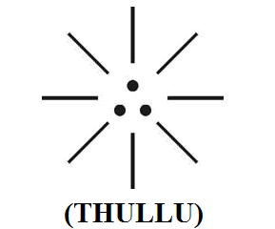

“The philosophy of Diagnosis might be derived from the philosophy of Prehistorice Tamil Phonetics Thullu, Thudippu. Thullu, Thudippu shall mean consistent variation in Particle Oscillation”.
- Author.

- REFERENCE
- Intensive Internet “e-book” study through, Google search and wikipedia
- M.Arulmani, “3G Akkanna Man”, Annai Publications, Cholapuram, 2011
- M. Arulmani; V.R. Hemalatha, “Tamil the Law of Universe”, Annai Publications, Cholapuram, 2012
- Harold Koontz, Heinz Weihriah, “Essentials of management”, Tata McGraw-Hill publications, 2005
- M. Arulmani; V.R. Hemalatha, “First Music and First Music Alphabet”, Annai Publications, Cholapuram, 2012
- King James Version, “Holy Bible”
- S.A. Perumal, “Human Evolution History”
- “English Dictionary”, Oxford Publications
- Sho. Devaneyapavanar, “Tamil first mother language”, Chennai, 2009
- Tamilannal, “Tholkoppiar”, Chennai, 2007
- “Tamil to English Dictionary”, Suravin Publication, 2009
- “Text Material for E5 to E6 upgradaton”, BSNL Publication, 2012
- A. Nakkiran, “Dravidian mother”, Chennai, 2007
- Dr. M. Karunanidhi, “Thirukkural Translation”, 2010
- “Manorama Tell me why periodicals”, M.M. Publication Ltd., Kottayam, 2009
- V.R. Hemalatha, “A Global level peace tourism to Veilankanni”, Annai Publications, Cholapuram, 2007
- Prof. Ganapathi Pillai, “Sri Lankan Tamil History”, 2004
- Dr. K.K. Pillai, “South Indian History”, 2006
- M. Varadharajan, “Language History”, Chennai, 2009
- Fr. Y.S. Yagoo, “Western Sun”, 2008
- Gopal Chettiar, “Adi Dravidian Origin History”, 2004
- M. Arulmani; V.R. Hemalatha, “Ezhem Nadu My Dream” - (2 Parts), Annai Publications, Cholapuram, 2010
- M. Arulmani; V.R. Hemalatha, “The Super Scientist of Climate Control”, Annai Publications, Cholapuram, 2013, pp 1-3

3/22/2014

