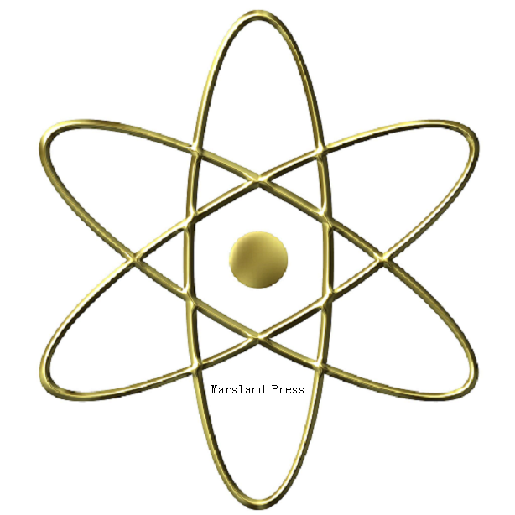C
B

iology
ancer

Cancer Biology

ISSN: 2150-1041 (print); 2150-105X (online)

Volume 3 - Number 4 (Cumulated No. 12), December 25, 2013

Marsland Press

PO Box 180432, Richmond Hill, New York 11418, USA

http://www.cancerbio.net

editor@sciencepub.net

347-321-7172

