Conservative Breast Surgery In Early And Locally Advanced Breast Cancer

Tamer A. ElBakary, Salah ElDin A. ElGohary, Magdy M. Elgendy, Ashraf F. Barakat*, & Samar Galal Younes*

Department of Surgical Oncology, *Department of Clinical Oncology, Tanta University.
Correspondence to: Tamer A. ElBakary
E-mail: telbakary@yahoo.com
Phone number: 0020122775338
Mail Address: Omar Zaafan Street, Ibn-Elhaytham Tower

Abstract: Aim: to evaluate efficacy of breast conservation surgery in loco-regional control of early & locally advanced breast surgery. Methods: the study included 2 groups; group A: 30 patients with early breast cancer & group B: 32 patients with 33 locally advanced breast cancer which were furtherly subdivided into 2 subgroups: 1-FAC group: 24 patients with 25 breast cancer received 3 cycles of FAC regimen, 2-TAC group: 8 patients received 3 cycles of TAC regimen. Group A patients were submitted to quadrentectomy & axillary evacuation, group B patients were submitted to quadrentectomy & axillary evacuation or modified radical mastectomy according to their response to neoadjuvant chemotherapy. Results: In group A, 1 patient developed local recurrence & submitted to completion mastectomy, in group B, overall response to neoadjuvant chemotherapy was 54.5%. 14 patients in group B underwent breast conservation surgery, 18 patients underwent modified radical mastectomy, 5 patients in group B developed treatment failure. Conclusion: breast conservation surgery is safe surgical technique for local control of both early & locally advanced breast cancer after downstaging by neoadjuvant chemotherapy. Neoadjuvant chemotherapy has significant anti-tumour activity & it increases the ability to perform breast conservation surgery.
[Tamer A. ElBakary, Salah ElDin A. ElGohary, Magdy M. Elgendy, Ashraf F. Barakat, & Samar Galal Younes. Conservative Breast Surgery In Early And Locally Advanced Breast Cancer. Cancer Biology 2011;1(1):18-25]. (ISSN: 2150-1041). http://www.cancer-biology.org.

Keywords: Breast conservation surgery, neoadjuvant chemotherapy.

Introduction
Randomized controlled trials over the past two decades have now established that mastectomy and breast conserving surgery are equivalent in terms of survival (veronesi et al, 2002).Breast conservation surgery can be used also for treatment of locally advanced breast cancer after downstaging by the use of neoadjuvant chemotherapy. Neoadjuvant chemotherapy for breast cancer was initially used during the seventies of the last century in locally advanced or inoperable disease in order to achieve surgical resection. It was then extended to operable breast cancer with a view to downstaging tumours to facilitate breast conserving surgery. Increasingly, it is being considered as a treatment for earlier-disease stage (Charfare et al, 2005). Neoadjuvant chemotherapy serves as an in vivo sensitivity test, it decreases the incidence of growth spurt at the site of micrometastasis after primary tumour resection & it facilitates the study of cancer biology with the same overall survival & recurrence-free survival rates as the adjuvant chemotherapy (Ikeda et al , 2002).Although the chemotherapy regimens have varied widely among studies, most clinical trials have used anthracycline-based regimens e.g. a combination of 5-fluorouracil, doxorubicin & cyclophosphamide (FAC). These regimens are generally prefered because of the higher response rate observed in the metastatic setting (Esteva & Hortobagyi, 1999). The appearance of taxanes has stimulated new excitement in this field, not only because of their high level of activity against metastatic breast cancer as single agents, but also because of their lack of cross-resistance with other drugs, including anthracyclines (Goble & Bear, 2003).

Patients & Methods:
This prospective study included two groups:
Group A : included 30 patients with early breast cancer ( T1,2 N0, M0, or T0,1,2 N1, M0)
Group B : included 32 female patients with 33 locally advanced breast cancer (one patient was presented with bilateral disease) ( stage IIB: T3 N0 M0, stage IIIA: T0,1,2 N2 M0 & T3 N1,2 M0, & stage IIIB: T4 N0,1,2 M0, or stage IIIC: any T N3 M0) admitted into The Oncology Unit, General Surgery Department, and Clinical Oncology Department, Tanta University Hospital. All the patients were informed by this study & written consents were taken from cases underwent surgery.
Eligible patients had to meet the following criteria: (a) at least 18 years of age (b) satisfactory liver and renal function, (c) life expectancy ≥9 months, (d) WHO performance score of 0–1 and ability to understand medical advice, and (e) full clinical-pathological examination and good staging for the patients including mammography, mammosonography, tissue diagnosis that was obtained by FNAC or open biopsy, & evaluation of the cardiac status by ECG & echo-cardiogram done for all the patients before the start of the anthracycline-based chemotherapy regimens, after the third cycle , and at the end of chemotherapy to detect any cardiac toxicity.
Exclusion criteria included: Karnofsky performance status scale < 70, age greater than 75 years or less than 18 years, complete bowel obstruction or the presence of symptomatic brain metastases, ventricular arrhythmia, congestive heart failure, or documented myocardial infarction, inadequate bone marrow function (WBC count < 3.0 x 109/L or platelet count < 100 x 109/L), inadequate renal function (serum creatinine of no more than 1.25 x upper normal limit or creatinine clearance < 60 mL/min/1.73 m2), and inadequate liver function (serum bilirubin of no more than 1.25 x upper normal limit).
On completion of all of these investigations, the patients of group A were submitted to quadrentectomy & axillary evacuation, while patients of group B were subdivided into 2 groups:
1- FAC group: included 24 patients presented with 25 breast cancers. These patients received neoadjuvant chemotherapy in the form of 3 cycles of FAC regimen (5-flourouracil 500 mg/ m2 I.V. day 1, adriamycin 50 mg/ m2 I.V. day 1, & cyclophosphamide 500mg/ m2 I.V. day 1) with 21 days interval between each two successive cycles.
2- TAC Group: included 8 premenopausal patients with relatively more advanced disease e.g extensive lymph node involvement, with suspicion of presence of micrometastases. They received 3 cycles of TAC regimen (docetaxel 75 mg/ m2 as a one hour I.V. infusion day 1, adriamycin 50 g/m2 I.V. day 1, and cyclophosphamide 500mg / m² I.V. day 1) with 21 days interval between each 2 successive cycles. These patients were pre-medicated with 8 mg of oral dexamethasone twice daily for 5 days, starting 1 day prior to docetaxel administration. Growth factor support with granulocyte colony stimulating factor (G-CSF) e.g. fligrastim (Neupogen) was provided to patients who developed neutropenia with or without fever (and was initiated prophylactically to those patients on subsequent cycles).
After each cycle of the neoadjuvant chemotherapy, every patient was examined for the size of the tumour & the regional lymph nodes status. After the third cycle of the neoadjuvant chemotherapy, bilateral mammography & breast ultrasonography were done. The response to the neoadjuvant chemotherapy was categorized according to

Dixon et al (1998) classification:
-Complete clinical response (CR): complete disappearance of the tumour both clinically & mammographically.
-Partial response (PR): decrease of 50% or more in the total tumour size.
-No response (NR) : decrease of less than 50% or increase of less than 25% in total tumour size.
-Progressive disease (PD): increase of 25% or more in total tumour size.

The patients who responded to induction chemotherapy & downstaged to the extent that make them eligible for breast conservation surgery were submitted to quadrantectomy and axillary evacuation. These patients showed the following tumour characteristics:
1- Complete resolution of skin edema.
2- Residual tumour size of less than 5 cm.
3- No evidence of multicenteric disease.
4- Absence of extensive lymph nodes involvement or extensive microclafication on mammographic examination.
On the other hand, the patients who failed to respond to the neoadjuvant chemotherapy e.g. patients with NR & PD were submitted to modified radical mastectomy (MRM).

Adjuvant treatment:
After removal of the stiches, patients of group A received 6 cycles, while patients of group B received 3 cycles of FAC regimen as an adjuvant therapy.
After completion of chemotherapy, radiotherapy was given using ⁶⁰Co starting 1 week after the 6th cycle of chemotherapy. Radiotherapy was given to the preserved breast and supraclavicular lymph nodes after conservative breast surgery (CBS) , while it was given to the chest wall and supraclavicular lymph nodes after MRM. The total dose of radiotherapy was 50 Gy for every patient divided into 25 fractions each fraction was 2 Gy given daily for 5 days each week for 5 weeks. After this dose, patients with CBS received a boost dose of 10 Gy delivered to the tumour bed divided into 5 fractions, each fraction was 2 Gy given daily for 5 days.
ER+ve premenopausal patients & all postmenopausal patients (either ER+ve or ER-ve) received tamoxifen in the dose of 20 mg daily for 5 years starting after completion of radiotherapy.

Follow up of the patients:
Every patient was followed up on 3-months basis in the 1st postoperative year & at 6-months intervals later on. On each follow up visit, mammography (bilateral after CBS and on the contralateral breast after MRM), Chest X-ray, pelvi-abdominal ultrasonography were also done. MRI was selectively requested for 1 case to role in or out local recurrence after CBS.
C.A. 15.3 and isotope bone scan was requested for all cases one year after the operation and at one year intervals later on during the follow up period. However, it was requested at shorter intervals if needed.

Results:
The response to the neoadjuvant chemotherapy in group B was assessed both clinically & mammographically. The overall response was 54.5% (18/33). As shown in table 3, the overall response rate in the FAC group was 52% (13/25) while it was 62.5% (5/8) in the TAC group. One patient of those who received the FAC regimen developed complete clinical response. Seventeen patients (12 in the FAC group & 5 in the TAC group) showed partial response; thirteen out of them underwent breast conservation surgery, while the remaining 4 patients (3 in FAC group & 1 in TAC group) showed partial response but not to the degree that make them eligible for breast conservation surgery, so, they underwent modified radical mastectomy. Hence, patients who underwent CBS represented 44% (14/32) of the patients included in group B.
Fifteen patients (12 in FAC group & 3 in TAC group) showed no response (NR). Progressive disease (PD) was not recorded in either regimens.
Table 4 shows that before induction chemotherapy T3 & T4 tumours represented 96% (24/25) in FAC group & 100% (8/8) in TAC group. This ratio is markedly decreased to 60% (15/25) for the FAC group & 50% (4/8) for the TAC group after induction chemotherapy. This change in the tumour size was found to be statistically significant (P = 0.004 for the FAC regimen & 0.046 for the TAC regimen).
With the use of the neoadjuvant chemotherapy, 10 cases (40%) in FAC group & 4 cases (50%) in TAC group were downstaged to T0, T1,& T2 allowing breast conservation surgery.

Table 5 shows that N2 & N3 tumours represented 24% (6/25) in FAC group & 37.5% (3/8) in TAC group before the neoadjuvant chemotherapy. This ratio was reduced after neoadjuvant chemotherapy to 8% (2/25) in FAC group & 0% (0/8) in TAC group. N0 nodes represented 0% (0/25) before & 16% (4/25) after the neoadjuvant chemotherapy in FAC group, while they represented 0% (0/8) before & 12.5% (1/8) after neoadjuvant chemotherapy in TAC group. N1 nodes represented 76% (19/25) before & the same percentage after neoadjuvant chemotherapy in FAC group, while they represented 62.5% (5/8) before & 87.5% (7/8) after neoadjuvant chemotherapy in TAC group. However, this change in the nodal state was found to be significant only for the FAC regimen ( P = 0.007) & not for the TAC regimen ( P = 0.059).
Follow up results: With a follow up period ranged from10 to 36 months, treatment failure developed in 1 patient in group A (3.3%) who developed local breast recurrence & submitted to completion mastectomy, while in group B treatment failure occurred in 5 patients (15.5%). Three patients were included in the TAC group: one patient developed lung metastasis, another one developed a new primary cancer in the contralateral breast, & the third one developed chest wall reccurence & opposite breast & bone metastasis. Treatment failure developed in 2 patients of the FAC group: one patient developed chest wall recurrence & the other one developed bone metastasis.

Table 1:Patients Characteristics
Patient characteristic | Group A  (No=30) |  | Group B(No=32 with 33 cancers)
Patient characteristic | No | % | No | %
Age in years  < 35  35- < 45  > 45 | 5  9  16 | 17  30  53 | 7  9  16 | 22  28  50
Menstrual status  Premenopausal  Postmenopausal | 18  12 | 60  40 | 15  17 | 47  53
Marital status  Married  single | 22  8 | 73  27 | 23  9 | 72  28
Normal lactation  +ve  -ve | 17  13 | 57  43 | 19  13 | 59  41
Oral contraceptives  + ve history  - ve history | 13  17 | 43  57 | 12  20 | 37.5  62.5
History of breast lesions  breast abscess  Excision of benign mass | 1  1 | 3  3 | 0  0 | 0  0
Family history  + ve  - ve | 6  24 | 20  80 | 5  28 | 15  85

Table 2:Tumour Characteristics
Tumour characteristic | Group A  (No=30) |  |  |  | Group B (No=32 with 33 cancers)
Tumour characteristic | No | % |  |  | No | %
Clinical presentation :  Breast mass | 29 | 97 |  |  | 32 | 97
N0 | 13 |  | 43 |  | 0 | 0
N1 | 17 |  | 57 |  | 24 | 73
N 2 | 0 |  | 0 |  | 7 | 21
N3 | 0 |  | 0 |  | 2 | 6
Skin ulceration | 0 |  | 0 |  | 1 | 3
Skin redness | 0 |  | 0 |  | 2 | 6
Skin edema | 0 |  | 0 |  | 8 | 24.5
Laterality:
Right breast
Laterality:  Right breast | 18 |  |  | 60 | 23 | 70
Left breast | 12 |  |  | 40 | 9 | 27
Bilateral | 0 |  |  | 0 | 1 | 3
Primary tumour site:
Upper outer quadrant
Primary tumour site:  Upper outer quadrant | 19 |  |  | 63 | 14 | 42.5
Upper inner quadrant | 5 |  |  | 17 | 8 | 24.5
Lower outer quadrant | 2 |  |  | 7 | 5 | 15
Lower inner quadrant | 4 |  |  | 13 | 2 | 6
Retroareolar region | 0 |  |  | 0 | 2 | 6
Occupying more than one quadrant | 0 |  |  | 0 | 2 | 6

Table 3. The clinical response after neoadjuvant chemotherapy in group B
Clinical response | F.A.C.  Group | T.A.C.  Group | Total
Complete response | 1 (4) | 0 (0) | 1
Partial response | 12 (48) | 5 (62.5) | 17
No response | 12 (48) | 3 (37.5) | 15
Progressive disease | 0 (0) | 0 (0) | 0
Total | 25 (100) | 8 (100) | 33

Table 4. Tumour size assessment
Tumour size (T) | Group A | Group B
Tumour size (T) | Group A | F.A.C. regimen |  | T.A.C. regimen
Tumour size (T) | Group A | Before (%) | After (%) | Before (%) | After (%)
T0 | 1 | 1 (4) | 2 (8) | 0 (0) | 0 (0)
T1 | 14 | 0 (0) | 3 (12) | 0 (0) | 3 (37.5)
T2 | 15 | 0 (0) | 5 (20) | 0 (0) | 1 (12.5)
T3 | 0 | 16 (64) | 10 (40) | 5 (62.5) | 2 (25)
T4 | 0 | 8 (32) | 5 (20) | 3 (37.5) | 2 (25)
Total | 30(100) | 25 (100) | 25 (100) | 8 (100) | 8 (100)

Table 5. Nodal state assessment

Nodal State (N) | Group A(%) | Group B
Nodal State (N) | Group A(%) | F.A.C. regimen |  | T.A.C. regimen
Nodal State (N) | Group A(%) | Before (%) | After (%) | Before (%) | After (%)
N0 | 13(43) | 0 (0) | 4 (16) | 0 (0) | 1 (12.5)
N1 | 17(57) | 19 (76) | 19 (76) | 5 (62.5) | 7 (87.5)
N2 | 0 | 5 (20) | 2 (8) | 2 (25) | 0 (0)
N3 | 0 | 1 (4) | 0 (0) | 1 (12.5) | 0 (0)
Total | 30(100) | 25 (100) | 25 (100) | 8 (100) | 8 (100)

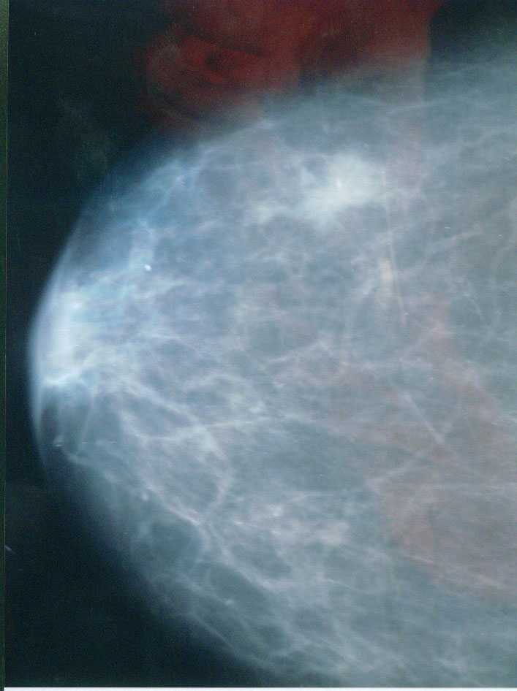

- Figure 1: A mammogram shows T1 tumour.

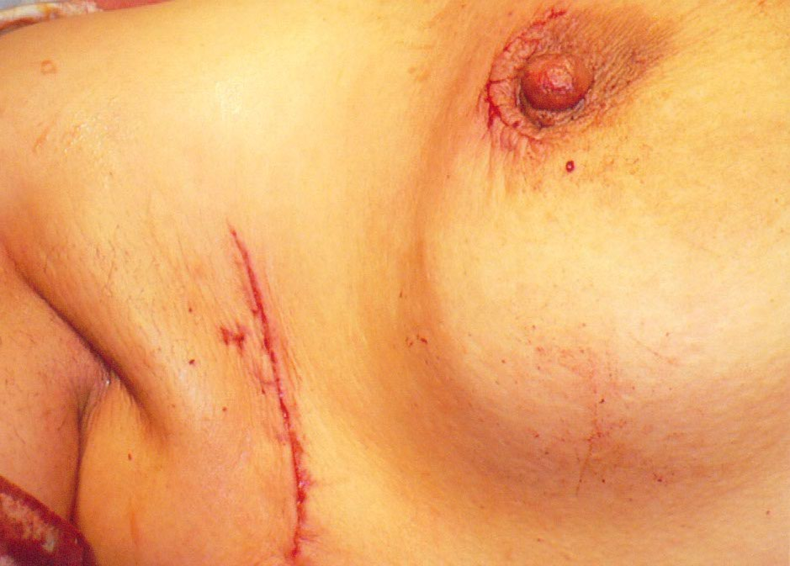

- Figure 2: Incisions for conservative breast surgery.

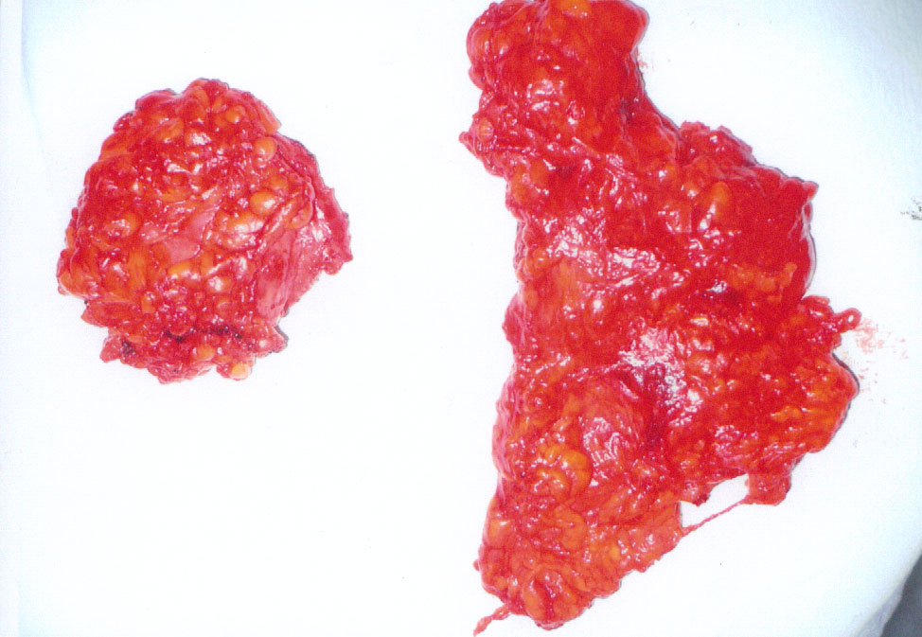

- Figure 3: The removed specimen from the breast & the axilla.

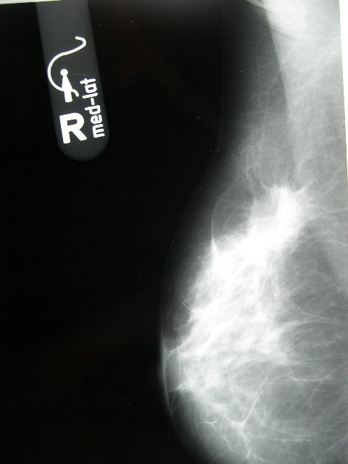
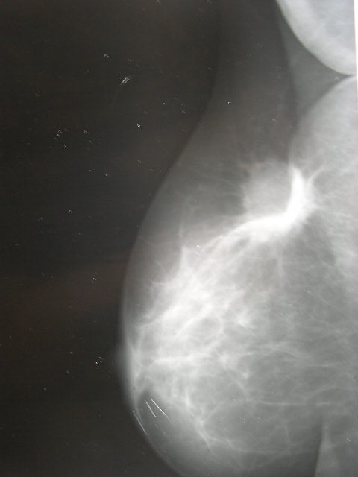

Figure 4a Figure 4b

- Figure 4: a- A mammogram of breast mass before neoadjuvant treatment
b- A mammogram of the same mass after neoadjuvant treatment with partial response

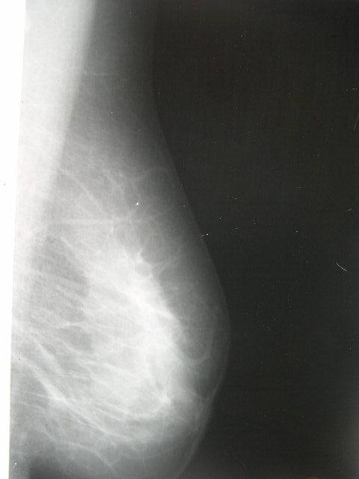
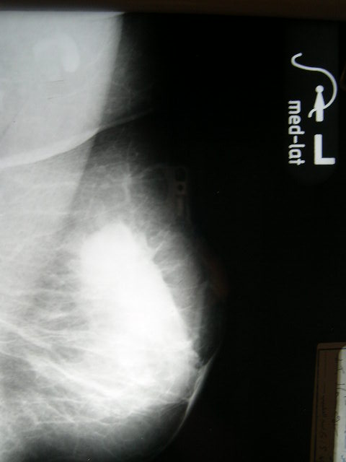

Figure 4a Figure 4b
- Figure 5: a- A mammogram of breast mass before neoadjuvant treatment
b- A mammogram of the same mass after neoadjuvant treatment with complete response

Discussion:
Breast conserving therapy (BCT) including postoperative irradiation of the remaining breast tissue is generally accepted as the best treatment for the majority of patients with early-stage breast cancer (Tinterri et al, 2009). In recent years, an increasing number of patients with locally advanced breast cancer (LABC) are being treated with neoadjuvant chemotherapy, followed by breast conservation surgery with axillary dissection and radiation as a part of the multimodality management ( Tewari et al, 2009).
Neoadjuvant chemotherapy is now accepted to be a standard milestone in the treatment of locally advanced breast cancer as it induces down staging in a significant proportion of cases and renders inoperable cases amenable for curative resection (El-Didi et al., 2000).
In the present study, patients age ranged between 27 & 69 years with a mean age of 47.2+10.44 years. The premenopausal patients represented 53.2% of all the patients. Pierga et al (2000) reported a mean age of 47 years & 75% of their patients were premenopausal, while Yoshimoto et al (2004) reported a mean age of 53 years & only 44.6% of the patients were premenopausal. Neoadjuvant chemotherapy was given to 32 patients in the present study. The overall response rate to neoadjuvant chemotherapy was 54.5%; one patient with CR (3%) & 17 patients with PR (51.5%). These results are consistent with Kim et al (2004) who reported that the overall response rate to neoadjuvant chemotherapy is 60% (4% CR & 56% PR). However, extreme reports came from Ciarmiello et al (1998) who reported a low overall response rate of only 38.5%, & Abraham et al (1996) Who reported a high overall response rate of 83% (28% CR & 55% PR). The tumour shrinkage after neoadjuvant chemotherapy was statistically significant for both FAC (P = 0.004) & TAC (P = 0.046) regimens. The change in the nodal state was statistically significant only in the FAC regimen (P = 0.007).
After neoadjuvant chemotherapy, 14 patients became suitable candidates for breast conservation surgery. These patients represent 44% of the patients who received neoadjuvant chemotherapy. These results are supported by Rouzier et al (2004) who used anthracycline-based neoadjuvant chemotherapy for 594 patients with invasive breast cancer who were ineligible for breast conservation surgery & they found that 287 (48%) of them became eligible for breast preservation. However, lower figures were reported by other authors. Danforth et al (1998) conducted their study on 126 patients with locally advanced breast cancer who received neoadjuvant chemotherapy. They found that 42 (33%) of them were downstaged to the extent that breast conservation surgery became a feasible technique for them. In another study, Hortobagyi et al (2000) reported that only 23% of patients with locally advanced breast cancer are good candidates for breast conservation surgery after neoadjuvant chemotherapy provided that they are carefully selected.
Liu et al (2009) reported 5-year local relapse-free rate of 98.3% for patients presented with early breast cancer. This is compatible with the results of our study that showed a local treatment failure rate of 3.3% for group A patients. However, some other studies showed a higher local relapse rates like Nasr et al (2009) who reported local failure rate of 14.3%.
In the present study, 5 patients (15.5%) of group B developed treatment failure during the follow up period. These results are comparable to those of Shen et al (2004) who conducted a study on 33 patients with stage IIIB & IIIC breast cancer treated with neoadjuvant chemotherapy followed by lumpectomy & they found that the 5-year disease-free survival was 70%. Also, Inaji et al (2002) found local recurrence rate of 4.7% after conservative breast surgery in patients with locally advanced breast cancer.
The results of this prospective study demonstrated that conservative breast surgery could be performed safely for patients presented with early breast cancer as well as those presented with locally advanced breast cancer after down staging with neoadjuvant chemotherapy. Neoadjuvant chemotherapy has significant anti-tumour activity, and it increases the ability to perform breast conservation surgery with the same overall & disease free survival rates as the adjuvant chemotherapy.

References:
- Abraham DC., Jones RC., Jones SE., et al (1996): Evaluation of neoadjuvant chemotherapeutic response of locally advanced breast cancer by magnetic resonance imaging. Cancer; 78, 1: 91 - 100.
- Charfare H., Limongelli S., & Purushotham AD. (2005): Neoadjuvant chemotherapy in breast cancer. Br. J. Surg.; 92, 1: 14 - 23.
- Ciarmiello A., Del Vecchio S., Silvestro P., et al (1998): Tumour clearance of technetium 99m- sestamibi as a predictor of response to neoadjuvant chemotherapy for locally advanced breast cancer. J. Clin. Oncol.; 16, 5: 1677 - 1683.
- Danforth DN., Zujewski J., O,Shaughnessy J., et al (1998): selection of local therapy after neoadjuvant chemotherapy in patients with stage IIIA, B breast cancer. Ann. Surg. Oncol.; 5, 2: 150 - 158.
- Dixon JM., Sainsbury JRC., Masterton G., et al (1998): Handbook of Diseases of The Breast, 2nd edition. Churchill Livingstone. London.
- El-Didi MH., Moneer MM., Khaled HM., & Makarem S. (2000): Pathological assessement of the response of locally advanced breast cancer to neoadjuvant chemotherapy & its implications for surgical management. Sur. Today; 30: 249 - 254.
- Esteva FJ. & Hortobagyi GN. (1999): Locally advanced breast cancer. Hoemat. Oncol. Clin. N. Am.; 13, 2: 457 - 472.
- Goble S. & Bear H. (2003): Emerging rule of taxanes in adjuvant & neoadjuvant therapy for breast cancer: the potential & the questions. Surg. Clin. North Am.; 83: 943 - 971.
- Hortobagyi GN., Singletary SE., & Strom EA. (2000): Treatment of Locally Advanced & Inflammatory Breast Cancer. In: Diseases of The Breast, 2nd edition, edited by Harris JR., Lippman ME., Morrow M., & Osborne CK. Lippincott Williams & Wilkins. Philadelphia: 645 - 660.
- Ikeda T., Jinno H., Matsu A., et al (2002): The role of neoadjuvant chemotherapy for breast cancer treatment. Breast Cancer; 9,1: 8 - 14.
- Inaji H., Komoike Y., Motomura K., et al (2002): Breast-conserving treatment after neoadjuvant chemotherapy in large breast cancer. Br. J. Cancer; 9, 1: 20 - 25.
- Kim R., Osaki A., Tanabe K., & Toge T. (2004): Neoadjuvant chemotherapy for locally advanced breast cancer with stage IIIB. Oncol. Rep.; 11,6: 1265 – 1272.
- Liu J., Hao XS., Fang ZY., et al (2009): Long term results of breast conservation in Chinese women with breast cancer. Breast J. 15(3): 296-298.
- Nasr E., Nasr D., Azoury Y., et al (2009): Outcome & prognostic factors in the conservative treatment of breast cancer. J. Med. Liban. 57(2): 130-134.
- Pierga JY., Mouret E., Dieras V., et al (2000): Prognostic value of persistent node involvement after neoadjuvant chemotherapy in patients with operable breast cancer. Br. J. Cancer; 83, 11: 1480 - 1487.
- Rouzier R., Mathieu MC., Sideris L., et al (2004):Breast conserving surgery after neoadjuvant anthracycline-based chemotherapy for large breast tumours. Cancer; 101, 5: 918 - 925.
- Shen J., Valero V.,& Buchholz TA. (2004): Effective local control & long-term survival in patients with T4 locally advanced breast cancer treated with breast conservation therapy. Ann. Surg. Oncol.; 11, 9: 854 - 860.
- Tewari M., Krishnamurthy A., & Shukla HS. (2009): Breast conservation in locally advanced breast cancer in developing countries: wise or waste. Surg. Oncol.;18(1):3-13.
- Tinterri c., Gatzmeier W., Zanini V., et al (2009): Conservative surgery with & without radiotherapy in elderly patients with early-stage breast cancer: a prospective randomized multicentre study. Breast; 18(6): 373-377.
- Veronesi U., Cascinelli N., Mariani L., et al (2002): Twenty year follow up of randomized study comparing breast conserving surgery with radical mastectomy for early breast cancer. N. Engl. J. Med.; 347: 1227-1232.
- Yoshimoto M., Tada K., Hori H., et al (2004): Improvement in the prognosis of Japanese breast cancer patients from 1946 - 2001: an institutional review. Jpn. J. Clin. Oncol.; 34, 8: 457 - 462.

8/25/2011

