THE VEILED MOTHER?...

(A new theory on Passover and Eucharist)

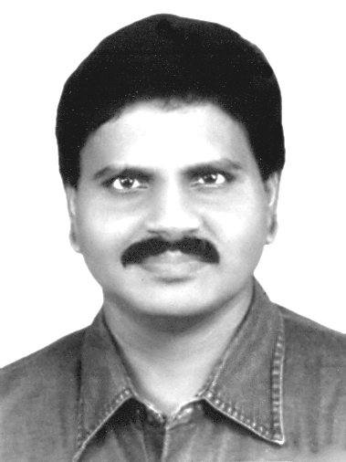  M.Arulmani, B.E.  (Engineer)  m.arulmani58@gmail.com | 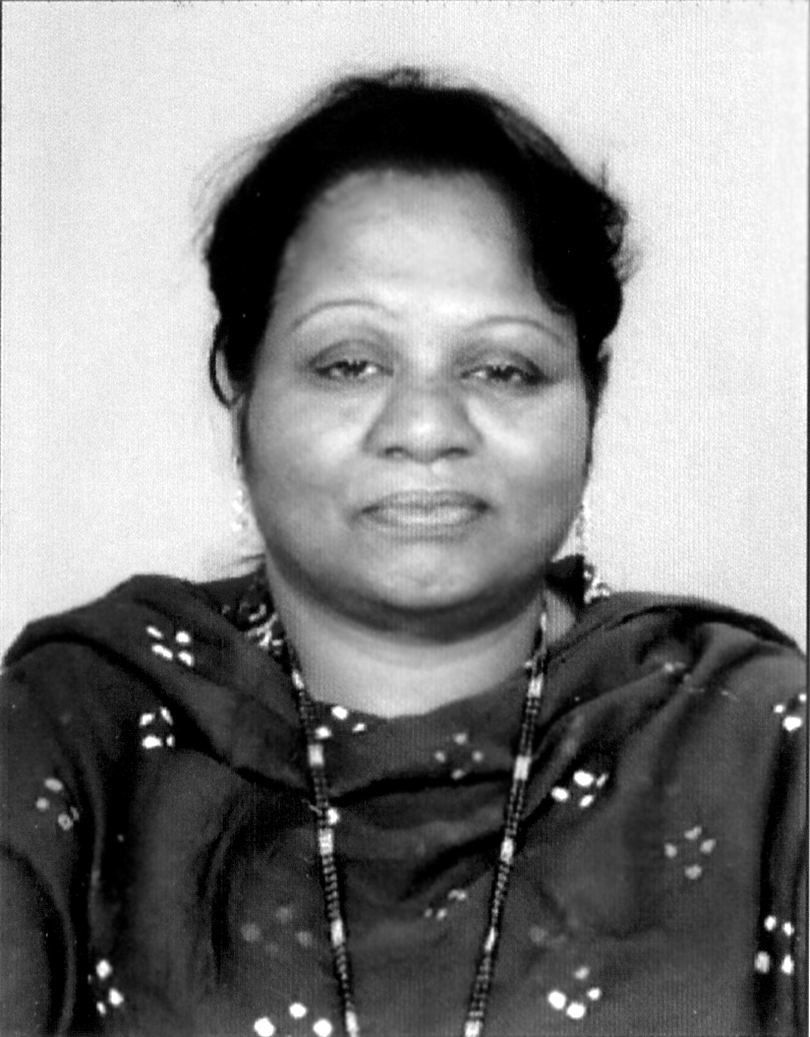  V.R.Hema Latha, M.A., M.Sc., M.Phil.  (Biologist)  vrhemalatha58@gmail.com

Abstract: In Christian theology “Mother Mary” is considered as an ordinary person and not considered as a Divine element. Of course in catholic Institution Mary is respected to some extent but in Protestant, Apostolic churches Bishops and other Pastors are saluted and given more weightage than the “Beloved mother”. In this scientific research article it is focused that Mother Mary shall not be neglected in the “Divine plan” of God and shall be considered as “Three – in – one” element in the “Sacramental Journey” and “Redemption Act” of GOD. It is emphasized that “JESUS” and “MARY” Shall be considered as Two Holy elements of the “YOKE” connected to the “HEART” of the “FATHER”. This research focused that in Divine plan of God the word “CHRIST” shall be considered as the “FAMILY NAME”. “JESUS CHRIST” shall mean JESUS pertains to “CHRIST FAMILY”. Further it is emphasized that Christ shall be considered as the 3rd generation family in the total plan of God. Adam, Noah shall be considered as the 1st and 2nd Generation population. In 3rd generation populations Christ shall be considered as the 1st family composed of Three-in-one Divine element.
- VIRGIN “FATHER”
- VIRGIN “MOTHER”
- VIRGIN “SON”
[M.Arulmani, B.E., V.R.Hema Latha, M.A., M.Sc., M.Phil. THE VEILED MOTHER?.(A new theory on Passover and Eucharist)Academ Arena 2014;6(1):32-48]. (ISSN 1553-992X). http://www.sciencepub.net/academia. 5

Key Words:
1) Philosophy of Word “JESUS”
2) Philosophy of Word “LORD”
3) Philosophy of Word “FATHER”
4) Philosophy of Word “HOLY SPIRIT”
5) Philosophy of Word “CHRIST”
6) Philosophy of Word “PASS OVER”
7) Philosophy of Word “EUCHARIST”
8) Philosophy of Word “VEIL”
9) Philosophy of Word “AVE”
10) Philosophy of Word “MARY”
11) Philosophy of Word “TABERNACCE”
12) Philosophy of Word “VIRGIN SEED”
13) Philosophy of Word “VIRGIN FAMILY”
14) Philosophy of Word “NEW COVENANT”
15) Philosophy of Word “SON OF MAN”
16) Philosophy of Word “SON OF GOD
17) Philosophy of Word “TEMPLE”
18) Philosophy of Word “CHURCH”
19) Philosophy of Word “LEFT HAND OF GOD”
20) Philosophy of Word “TRIBE”
21) Philosophy of Word “NEW JERUSALEM”
22) Philosophy of Word “J-KIGNDOM”

“SON” shall be considered as the “Divine Seed” of Father which is “incarnated” in the womb of Mother and become human.

(a)
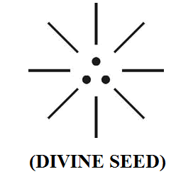
(b)
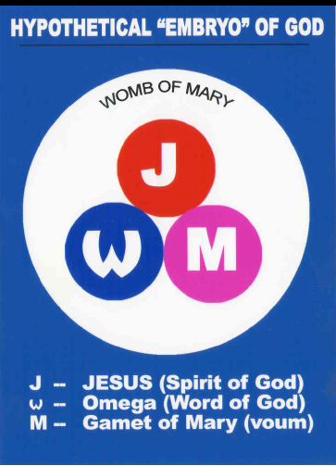
It is speculated that the new theory focused in this research is expected to solve so many misconceptions in the current “TRINITY” concept in theological belief of “Father, Son, Holy spirit”. In Divine “Christ” family can mother be eliminated?.... can a family exist without mother?... It is focused that Jesus shall be considered as single independent person and considered as god and born as SON through Christ family as a human to save the human.

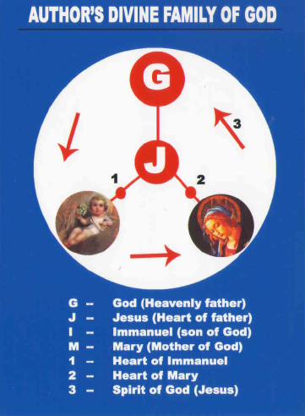

This research further focused that in the “Eucharist feast” (Last supper) JESUS considered made the disciples as “Images of JESUS” through his Flesh and Blood and made Twelve “Model Jesus” in the redemption plan.

“Eucharist feast shall be considered as the process of “Transformation” by departing the evil spirits among human disciples and transformed into “Images of Jesus” in “Christ family” for act of saving human”
- Author.
It is focused that in some churches “Passover feast” is confused with “Eucharist feast” and Holy food during Holy communion being served only to the respective denomination of church. It is suggested that Passover feast shall be shared to all the people sinners irrespective of “Denomination of Church”.

“Passover feast shall mean Holy food offered for act of “Departing evil spirit” from the human and cultivate “Hope of Life”.
- Author

- Introduction:
It is focused that “GOD” has so loved the world and created Universe and human for his “Joy”. But Human started asking God who are you to Control me?....
God was Very much upset… and some how he wanted to run the “show”!… and guiding his children not lovingly but as a matter of “DEBT”!!...

God made “covenant” with their children in many occasion but nothing was fruitful. It is not the aim of God to destroy the children who created, but to “save” them all through his grace so that no one is “lost”. Alternatively it can be stipulated that God is so grateful rather than strictly enforcing his “LAW” in the Divine plan.

At one stage God made “New covenant” as “3rd generation law” with them after relaxing his standard. God made the rule of Baptism, Passover Eucharist as a matter of guiding factor for regulation but still their children are with “stiff Neck”. God wants to fulfill the law and not to destroy anyone.

Finally the God plans to go for “NEW EARTH” called as “J-NADU”. The “J-NADU” shall also mean “NEW JERUSALEM” for cultivating “everlasting life” with new “Divine plan”.

- Previous Publication:
The philosophy of origin of first life and human, the philosophy of model Cosmo Universe, the philosophy of fundamental neutrino particles have already been published in various international journals mentioned below. Hence this article shall be considered as extended version of the previous articles already published by the same author.

    - Cosmo Super Star – IJSRP, April issue, 2013
    - Super Scientist of Climate control – IJSER, May issue, 2013
    - AKKIE MARS CODE – IJSER, June issue, 2013
    - KARITHIRI (Dark flame) The Centromere of Cosmo Universe – IJIRD, May issue, 2013
    - MA-AYYAN of MARS – IJIRD, June issue, 2013
    - MARS TRIBE – IJSER, June issue, 2013
    - MARS MATHEMATICS – IJERD, June issue, 2013
    - MARS (EZHEM) The mother of All Planets – IJSER, June issue, 2013
    - The Mystery of Crop Circle – IJOART, May issue, 2013
    - Origin of First Language – IJIRD, June issue, 2013
    - MARS TRISOMY HUMAN – IJOART, June issue, 2013
    - MARS ANGEL – IJSTR, June issue, 2013
    - Three principles of Akkie Management (AJIBM, August issue, 2013)
    - Prehistoric Triphthong Alphabet (IJIRD, July issue, 2013)
    - Prehistoric Akkie Music (IJST, July issue, 2013)
    - Barack Obama is Tamil Based Indian? (IJSER, August issue, 2013)
    - Philosophy of MARS Radiation (IJSER, August 2013)
    - Etymology of word “J” (IJSER, September 2013)
    - NOAH is Dravidian? (IJOART, August 2013)
    - Philosophy of Dark Cell (Soul)? (IJSER, September 2013)
    - Darwin Sir is Wrong?! (IJSER, October issue, 2013)
    - Prehistoric Pyramids are RF Antenna?!... (IJSER, October issue, 2013)
    - HUMAN IS A ROAM FREE CELL PHONE?!... (IJIRD, September issue, 2013)
    - NEUTRINOS EXIST IN EARTH ATMOSPHERE?!... (IJERD, October issue, 2013)
    - EARLY UNIVERSE WAS HIGHLY FROZEN?!... (IJOART, October issue, 2013)
    - UNIVERSE IS LIKE SPACE SHIP?!... (AJER, October issue, 2013)
    - ANCIENT EGYPT IS DRAVIDA NAD?!... (IJSER, November issue, 2013)
    - ROSETTA STONE IS PREHISTORIC “THAMEE STONE” ?!... (IJSER, November issue, 2013)
    - The Supernatural “CNO” HUMAN?... (IJOART, December issue, 2013)
    - 3G HUMAN ANCESTOR?... (AJER, December issue, 2013)
    - 3G Evolution?... (IJIRD, December issue, 2013)
    - God Created Human?... (IJERD, December issue, 2013)
    - Prehistoric “J” – Element?... (IJSER, January issue, 2014)
    - 3G Mobile phone Induces Cancer?... (IJERD, December issue, 2013)
    - “J” Shall Mean “JOULE”?... (IRJES, December issue, 2013)
    - “J”- HOUSE IS A HEAVEN?... (IJIRD, January issue, 2014)
    - The Supersonic JET FLIGHT-2014?... (IJSER, January issue, 2014)
    - “J”-RADIATION IS MOTHER OF HYDROGEN?... (AJER, January issue, 2014)
    - PEACE BEGINS WITH “J”?... (IJERD, January issue, 2014)
    - THE VIRGIN LIGHT?... (IJCRAR, January issue 2014)

- Hypothesis:
- “God” has so loved, and created the Universe and the Earth including all matters and human for their prosperity. The creator shall be considered as having Immense level of Dark matter, Dark Energy required for creation and considered created everything through “HOLY SPIRIT” of this “Breath”. The Holy Spirit shall also be called as “J-RADIATION”. The J-Radiation shall be considered as having “creation effect” composed of most fundamental Neutrino Particles PHOTON, ELECTRON PROTON having “Zero mass” but having definite gender characteristics, Electric, Magnetic, optic, and polarity properties. The fundamental particles shall also be called as “GOD PARTICLES”.
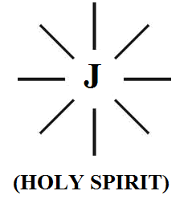
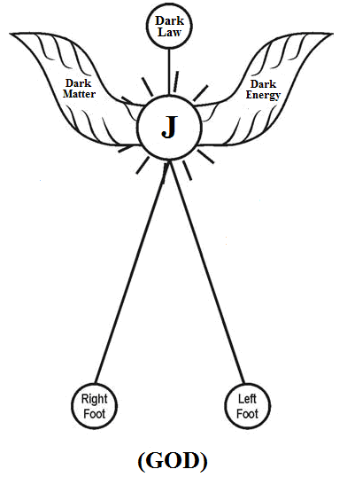

The “Heart” of God shall be called as “Jesus”.
- Author
- During “Divine Plan” of God three kinds of “Human families” shall be considered “evolved” in three “Nuclear age” and geological periods. The three families evolved after initial creation shall be considered having three different genetic variation.
  - Initial Creation - “LORD” family
  - “ANGEL”- 1st generation family
  - “NOAH” – 2nd generation family
  - “CHRIST”- 3rd generation family
- It is Hypothesized that “CHRIST” shall be considered as 3rd generation family. The “First” family origin in “CHRIST” shall be considered as a “Very small family” composed of only three members called FATHER, MOTHER, SON. This first Christ family shall be called as “Divine Family” and the “son” was considered incarnated through “word” of GOD. The three members shall be considered living within the same house in different chamber separated by a “Transparent” white thin wall called “VEIL”. Further the three Divine members shall be considered as under strong “Bondage” and can’t be separated.
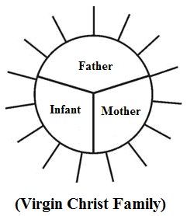
It is focused that three members shall be considered existing as three-in-one fundamental particles in “J-RADIATION”.
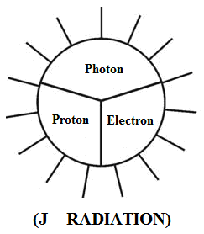

The Philosophy of “VEIL” shall also be considered equivalent to “CELL WALL” in Biological science comparing of three-in-one cell parameters “DNA” “HARMONE” and “RNA”. It is focused that the Father, Mother Son in Trinity Divine “CHRIST FAMILY” shall be considered as follows.
- Father - “RNA” (Photon)
- Mother - “HARMONE” (Electron)
- Son - “DNA” (Proton)

- In “Divine Plan” of God it shall be stipulated that the spirit of God has become “LORD” first in “Creation” and from “LORD” family three subsequent families “ANGEL” “NOAH”, “CHRIST” shall be considered evolved.

- The philosophy of “PASSOVER” feast shall be considered as the annual feast in “Jews” customs right from “MOSES” for “departing evil spirits” then and there during “redemption journey”. The procedure for eating “unleavened bread”, Bitter Herbs, singing special songs, observing the feast for seven days, during evening and night especially on Thursday evening and Friday full moon day etc. shall be considered as pre-preparation work before sending out the “evils” from the affected persons. (Leviticus 23:5, Exodus 12:11, 13:3, Num 9:11)

It is focused that the procedure followed during Passover shall be considered as different in different occasions as follows due to variations in genetics of populations in three “Nuclear age”.

i) Slain of first male born - 1st generation
ii) Eating unleavened bread &
bitter herb (matzo and maror) - 2nd generation
iii) Eucharist feast (Bread and Wine) - 3rd generation

The philosophy of “Passover” shall be defined within the following scope.
- To commemorate the joy of liberation from slavery act from Pharaoh of Egypt.
- To commemorate the “symbol” of incidence just like splitting of “Red Sea” during Journey to “Canaan Land”.
- To enjoy the “seven days holidays” at the cost of government.

- The etymology of word “Passover” is believed to have derived from Greek word “PESACH”, Pesach shall mean “skipping” (or) “leaving away”. At one stage the Passover was also observed through sacrificing the so called “paschal Lamb”.

It is hypothesized that the etymology of word “Pesach (u)” might be derived from prehistoric “TAMIL CUSTOM” and “Tamil Phonetics” “PISSASU”. Pissasu shall mean “EVIL SPIRIT”. In Tamil custom bitter herb Neem leave, sacrifice of Lamb (KAVU), music of “Kodanki”, conducting ritual during evening for three days especially “Friday” shall be considered closely associated with departing “evil spirits”.

- It is focused that the 3rd generation Passover called as “EUCHARIST” shall be considered as different from conventional “Passover feast”. It is focused that all conventional Passover procedure such as compulsory circumcision, eating unleavened bread sacrifice of paschal lamb etc. shall be considered overcome by “Sacramental Lamb Jesus”, through “NEW COVENANT” by act of “LOVE”, “MERCY” “TRUTH” by adoring “Jesus”.

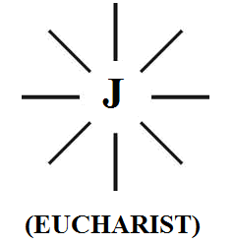

The philosophy of “Eucharist feast” conducted by “JESUS” during last supper to 12 disciples shall be hypothetically defined within the following scope.
- To depart the “evil spirits” from the disciples
- To prepare them to be as “sacramental Lamb”
- To transform them as “IMAGE OF JESUS”.

“The priests during “Eucharist” shall be considered as “Image of Jesus” and they can offer their “body” and “Blood” to the all the persons who come forward in the “MASS” irrespective of caste, creed, religion, denomination so that they can get rid off from “evil spirits”.
- Author

- The philosophy of “MARY” shall mean “RADIATION”. The etymology of “VEIL” “AVE” shall mean “VIRGIN LIGHT”. In Biblical language “AVE MARY” “VEIL MARY” shall mean MARY covered with “HOLY SPIRIT” (OR) “WHITE MOTHER”.

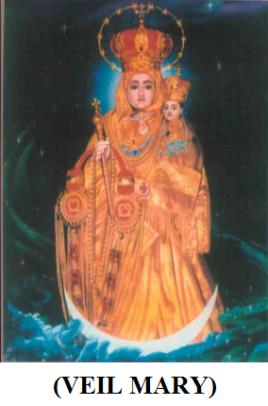

- It is focused that JESUS shall mean the God of “Universal Christ Church”. The Universal Church in the Divine plan of God shall be composed of three integral parameter i.e. TEMPLE (BASILICA), TABERNACLE (Judgment), CHURCH (CONGREGATION). The Universal Church shall also be called as “J-KINGDOM”.

(i)
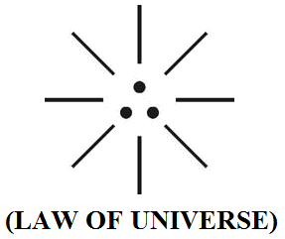
(ii)
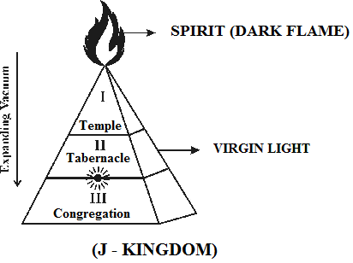

Region I – Perfect vacuum region (Anti-Neutrinos radiation)
Region II – Partial vacuum region (Neutrinos radiation)
Region III – Observable Vacuum region (EMR radiation)

- Hypothetical Narration
  - What is the name of GOD?...
In Christian theology the name of creator is indicated as “GOD” (or) “LORD GOD”. But nowhere the name of GOD (or) LORD is defined. What is the name of GOD?... The created GOD must have some name?...

Further in Christian theology the name “JESUS” is normally referred to mean as “SON” and derived its origin in New Testament. It is focused that the creator GOD name shall be called as “JESUS”. JESUS shall mean creator who created everything through “J-RADIATION” emanated from His “HEART”. JESUS shall also mean “DARK HUMAN”. The philosophy of word “LORD” shall mean to indicate the Family name of initial creation.

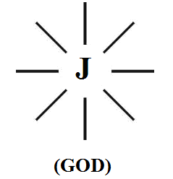

It is focused that in the “Divine plan” of GOD, JESUS might have “Transformed” into “Trinity state” and become Three-in-one “GOD” i.e. Jesus transformed to exist as Father, Mother, Son. In Divine plan the word “Jesus” shall be defined within the following scope of biblical understanding.
- Jesus shall mean “New covenant”
- Jesus shall mean “Three-in-one personality”
- Jesus shall mean Integral part of “Father”, “Mother”, “Son”
- Jesus shall mean Ist congregation in “CHRIST FAMILY”
(1)
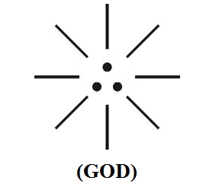
(2)

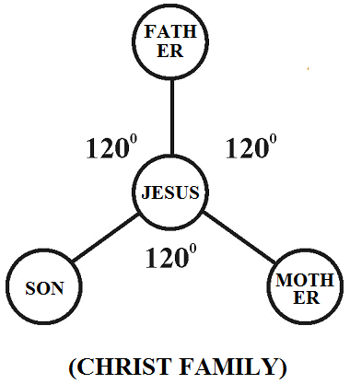
  - Philosophy of word “LORD”?...
In Christian theology the philosophy of word “LORD” is not clearly defined. It is focused that LORD shall mean “family name” of initial creations i.e. all the initial creation shall be considered of “Supreme Status”.

  - Philosophy of word “CHRIST?....
In Christian theology the philosophy of word “Christ” is not clearly defined. Christ shall mean 1st family name of 3rd generation human populations. Christ shall also be considered as the “HOLY TEMPLE” of all churches.

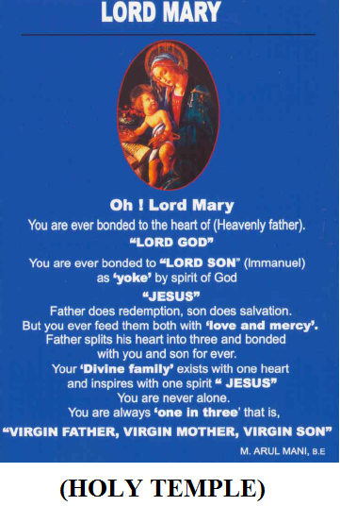

  - Philosophy of “Passover” and Eucharist?...
In Christian theology the philosophy of distinguished meaning of Passover, Eucharist is not clearly defined.
- “PASSOVER” shall mean associated with “DEPARTING EVIL SPIRITS”
- “EUCHARIST” shall mean “STATE OF TRANSFORMATION INTO BECOME IMAGE OF JESUS”

  - Philosophy of word “Son of Man”?...
In Christian theology the philosophy of “Son of man” is not clearly defined. It is focused that “son of man” in Divine plan of God shall mean “Immanuel Infant” who is considered as Integral part of “JESUS” and belong to “CHRIST FAMILY”.

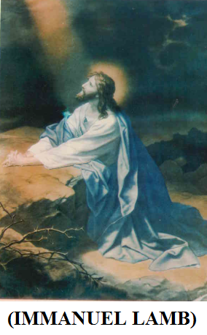

  - Philosophy of word “Son of God”?...
In Christian theology the philosophy of word “Son of God” is not clearly defined. It is focused that in the Divine plan of God “JESUS” is considered as Three-in-one persons, composed of “FATHER”, “MOTHER”, “SON”.

“In general Father or Son of God shall always mean “JESUS” who may be “LORD” (or) “CHRIST” (or) “GOD””.
  - Author.

  - Who is the left hand of JESUS?....
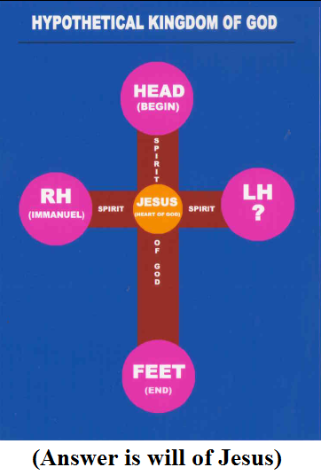
  - Veilankanni is New Jerusalem?...
(1)
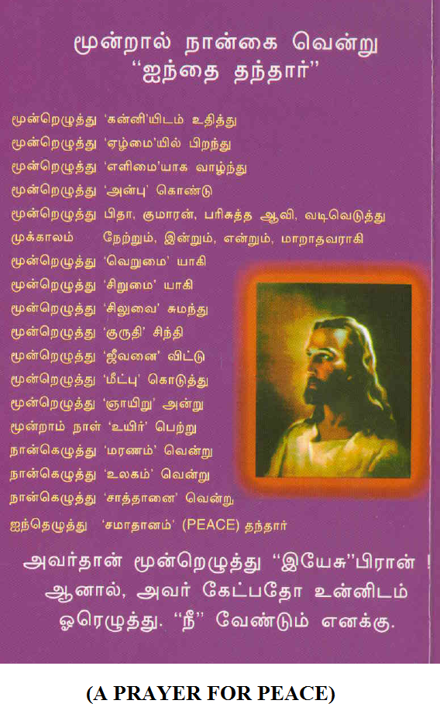

(2)
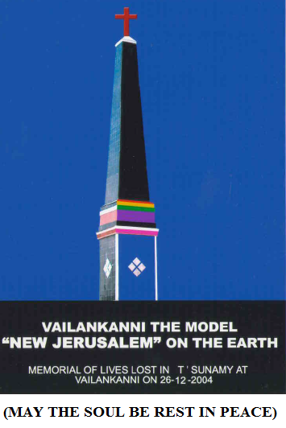
  - Divine plan of God?....
The Divine plan of God shall be hypothetically divided into Principal five categories as follows:
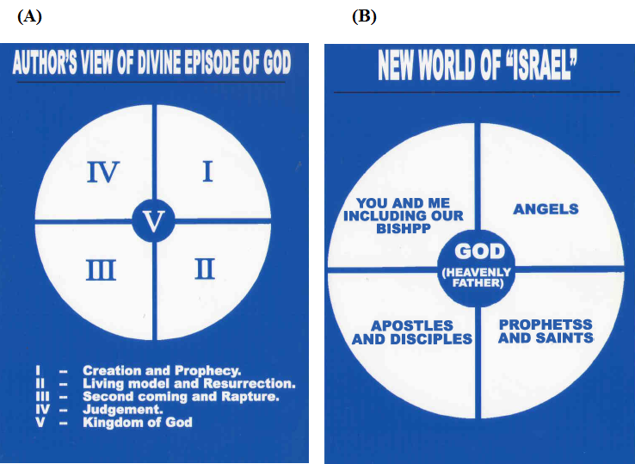

  - Understanding about Apparitions?...
In the Divine plan of God Apparition shall be narrated within the following scope
i. Apparition may be de defined as the sense of perceptible vision (or) appearance of son, the virgin mother angels (or) saints
ii. Apparition alternatively defined as the “Vision of the supernatural” mode as visible to human beings.
iii. In more simple way apparition shall be stared as the “Vision of God to the chosen people”

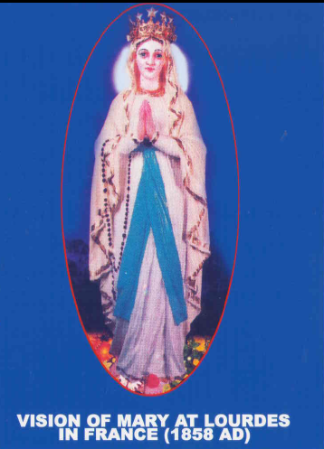

  - Meaning of will of God?...
A herb of Rose is having full of flowers. All the flowers are good and beautiful by birth on the herb. Bur only few deserved flowers touch the feet of God. Other flowers don’t get opportunity to touch the feet of God. This is the “WILL OF GOD” (GRACE) (APC 22:12 , Is 66:13, Mt 5:7)

  - Philosophy of word “TRIBE”?
The philosophy of word “Tribe” is not clearly defined in conventional Theology many. Some Christians have thought that the word “Tribe” is associated with “Castism”. It is focused that the word Tribe shall be considered as “FAMILY NAME” originated from “NOAH” origin. In other words it shall be stipulated that NOAH belongs to ‘Tribe family”. The 12 Tribes of ISRAEL shall mean the Twelve sons of Israel belong to “Tribe Family”. Thousands of Races shall be considered existing with in the Tribe.

  - Eucharist feast gives Peace?...
The philosophy of word Peace shall nor be considered as a simple word. It has in depth “logic”. The word peace shall be considered as Integral part of Three in one logic (i.e) “PASSION”, “AFFECTION”, “LOVE”.
- “PASSION” is live “FATHER” (Law)
- “AFFECTION” is live “MOTHER” (Mercy)
- “LOVE” is like “SON” (Grace)

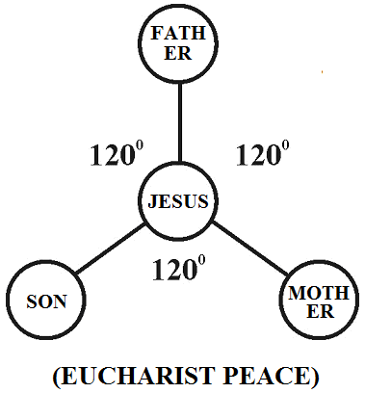

It is focused that the invisible TRINITY “JESUS” shall be considered as present in every feast of “Eucharist”.

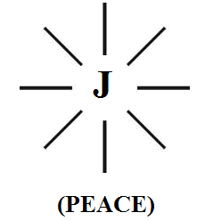

- CONCLUSION:
“SON”, THE DIFFUSED LIGHT OF “JESUS”, “MARY” THE FILAMENT OF “LAMP”
- Author

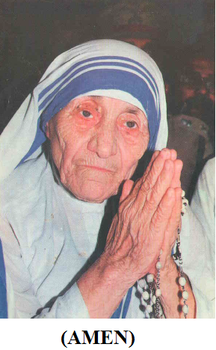
- REFERENCE
1) The Holy Bible
King James Version - International Bible Society, Canada
2) The Dictionary of Boble - Jhon L. Mckenzie, SJ
3) The Marian Diamension in post
conciliar Theology with a - Fr. Rev. R.K. Samy Marian
particular focus in some Christologies Institute Veilankanni
and Ecclesiologies
4) Mary in our search for fullness of
Life - Fr. Rev. R.K. Samy
5) The Church in India in Search of a
New Identity - Kurien Kunnupuram SJ,
NBCLC, Bangalore.
6) New Testament old Testament an
Introduction - Pulavar Sundararajan
7) Jesus Christ, World of Father - Theological–Historical Commission,
For the great jubilee year 2000
8) Saints way - Rev. R.S. Amalraj, SJ Dindigul
9) New Answers to old Questions - Tanjore Domi Chennai
10) Western Sun (Life History of
Fr. Leveh) - Rev. Ir. Y.S. Yahoo, SJ Oriyur, Sivaganga.
11) Pope Benedict XVI - Fr. M.K. Paul, SSP, Mimbai
12) Formulae and definitions in
Biology - Asian Publishers, delhi
13) Thirukkural Couplets - Rev. E.J. Robinson
14) Veilankanni, the earthly sion - Fr.Rev. R.K. Samy
15) Shrine History, Veilankanni - Shrine Publications July – 2005
16) A Global level Peace Tourism to
Veilankanni (Thesis report for M.Phil) - V.R. Hemalatha Madurai (2007)

1/18/2013

